**Hypothesis Testing Exercise**

TeleCall uses 4 centers around the globe to process customer order forms. They audit a certain % of the customer order forms. Any error in order form renders it defective and has to be reworked before processing. The manager wants to check whether the defective % varies by centre. Please analyze the data at *5%* significance level and help the manager draw appropriate inferences

Sol: α == 0.05 (95% Confidence)

Y == Discrete

X == Discrete

Since there are more than 2 variable we will perform Chi-Square test

**Chi-Square test**

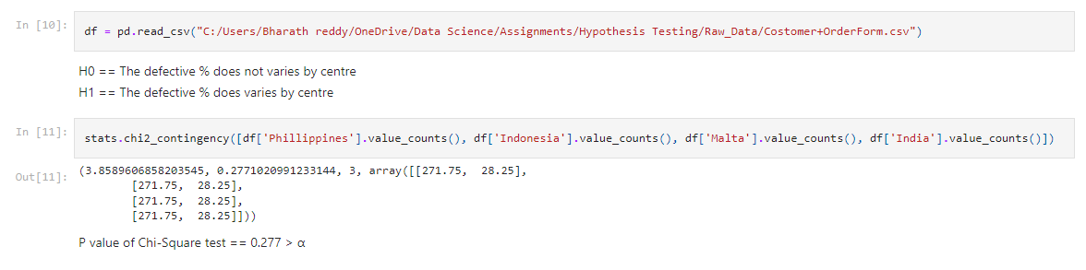

**failed to reject null hypothesis**

**all centers have same defective%**