**Hypothesis Testing Exercise**

A F&B manager wants to determine whether there is any significant difference in the diameter of the cutlet between two units. A randomly selected sample of cutlets was collected from both units and measured? Analyze the data and draw inferences at 5% significance level. Please state the assumptions and tests that you carried out to check validity of the assumptions.

Sol:

α == 0.05 (95% Confidence)

Y == Continious

X == Discrete

Is Y1 and Y2 normal ?

H0 = Y1 and Y2 are normal

H1 = Y1 and Y2 are not normal

**Normality Test**

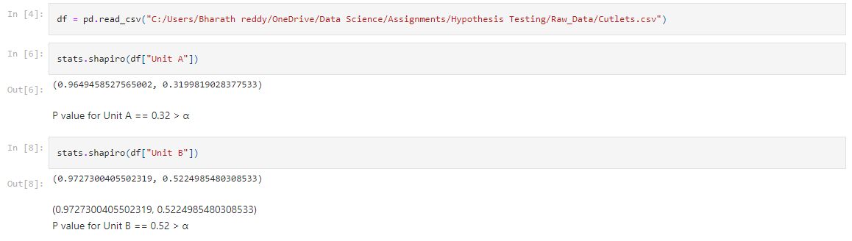

HO is accepted

Y1 and Y2 are normal

**Variance Test**

variances=0.70536 , pvalue =0.3136

Failed to reject null hypothesis

**Pairdd test**

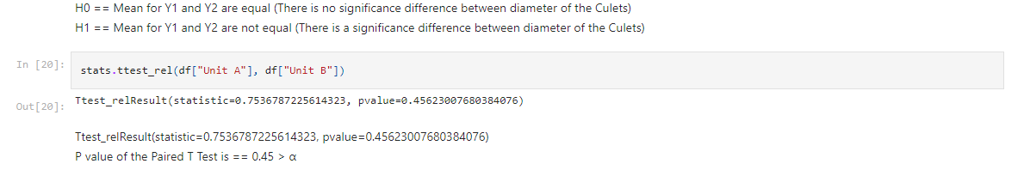

HO is accepted

Both have same Diameter