**Hypothesis Testing Exercise**

A hospital wants to determine whether there is any difference in the average Turn Around Time (TAT) of reports of the laboratories on their preferred list. They collected a random sample and recorded TAT for reports of 4 laboratories. TAT is defined as sample collected to report dispatch.

Analyze the data and determine whether there is any difference in average TAT among the different laboratories at 5% significance level.

Sol:

α == 0.05 (95% Confidence)

Y == Continious

X == Discrete

Is Y1, Y2, Y3 and Y4 normal ?

H0 = Y1, Y2, Y3 and Y4 are normal

H1 = Y1, Y2, Y3 and Y4 are not normal

**Normality test**

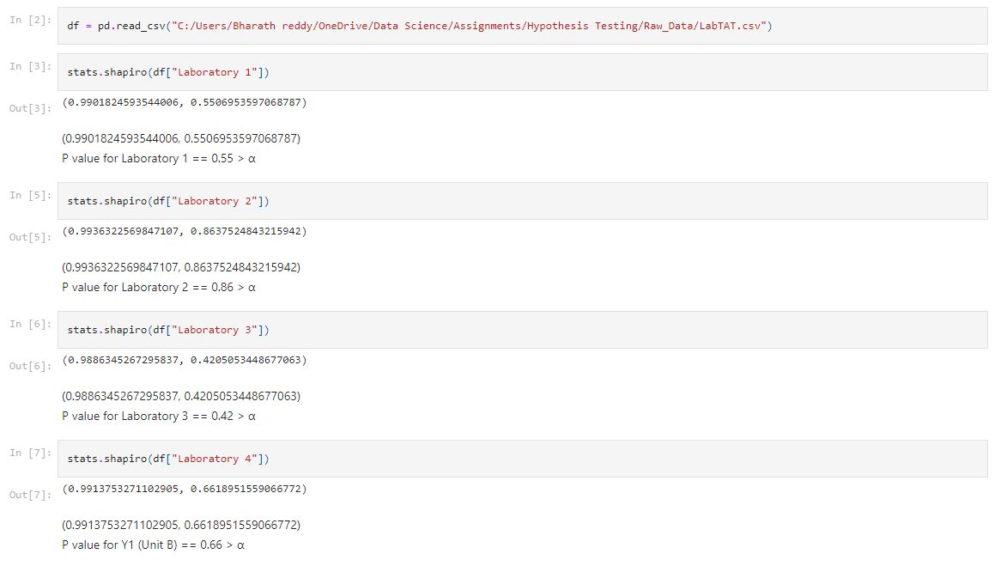

HO is accepted

Y1, Y2, Y3 and Y4 are normal

**Variance**

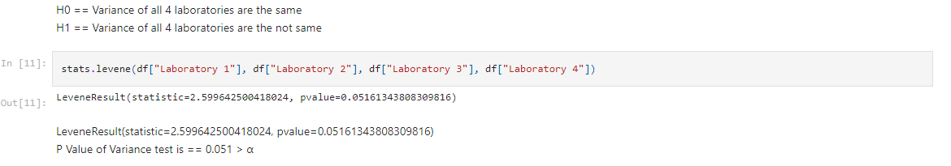

HO is accepted

We will perform oneway test now

**Oneway Test**

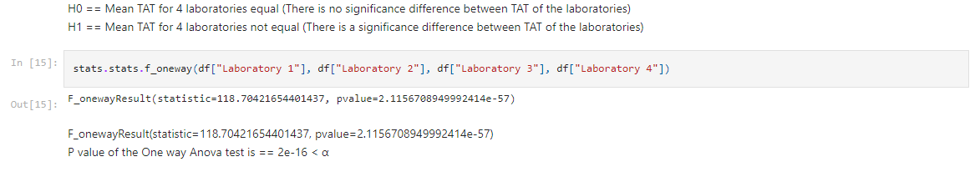

H1 is accepted

So Turn Around Time between laboratories are not equal.