PhishGuard: Intelligent Phishing Detection System

Overview
**PhishGuard** is an advanced cybersecurity application designed to detect and prevent phishing attacks across two main vectors: **Malicious URLs** and **Deceptive Emails**.
Instead of relying solely on blacklists (which fail against new, "zero-day" attacks), PhishGuard combines real-time threat intelligence with Machine Learning models that analyze the fundamental structure and behavior of links and emails to identify malicious intent.

1. System Architecture
The project follows a standard modern web architecture separating the user interface from the analysis engine.
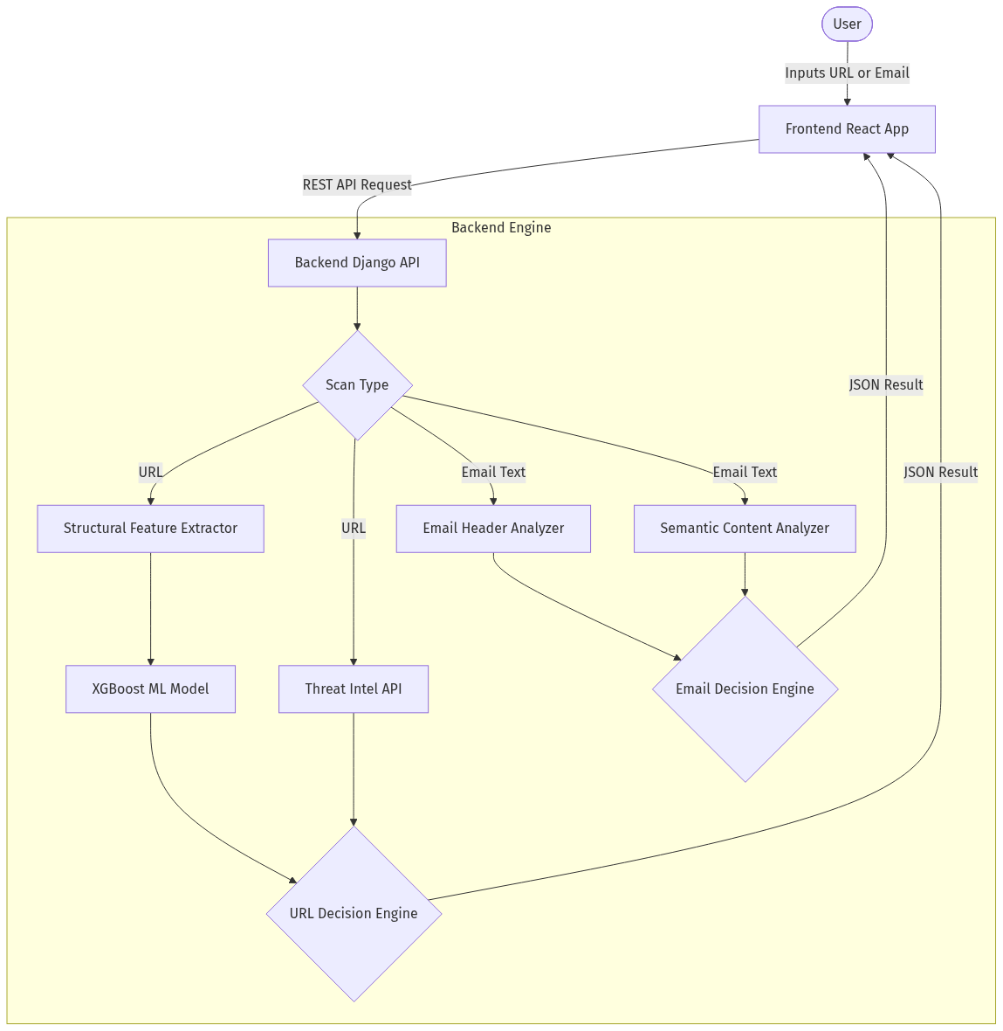

2. How URL Analysis Works
When a user submits a URL, PhishGuard does not just check if it's "known to be bad." It performs a deeply analytical inspection.

Flowchart: URL Detection Logic
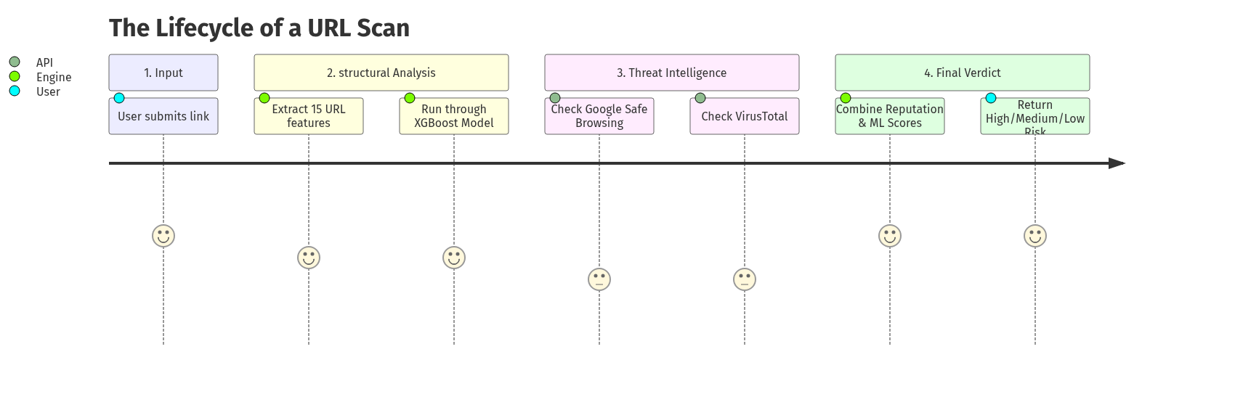

The Two Pillars of URL Detection:
**A. Feature Extraction (The "What does it look like?" test)**
We use a Python script to mathematically analyze the URL for 15 suspicious characteristics. Phishers often use tricks that legitimate sites don't.
- **IP Address in URL:** (`http://192.168.1.1/login`) Legitimate sites use domains.
- **Abnormal Length:** Very long URLs are used to hide the true destination.
- **Too many subdomains:** (`login.support.apple.verification.com`)
- **'@' Symbol:** Causes the browser to ignore everything before the '@'.
- **Prefix/Suffix ('-'):** (`apple-support.com`) Typosquatting technique.
**B. Reputation APIs (The "Who knows about it?" test)**
We query global databases (Google Safe Browsing & VirusTotal). If millions of users have already reported the site as a scam, we instantly block it.
*Important Logic Rule*: If the APIs say a URL is "Safe" (because it's brand new and hasn't been reported yet), but our Feature Extraction spots 3 or more highly suspicious characteristics, **our Machine Learning overrides the API** and flags it as Phishing. This is how we catch zero-day attacks!

3. How the Machine Learning Layer Works
PhishGuard employs an **XGBoost (eXtreme Gradient Boosting)** Classifier trained on thousands of legitimate and phishing URLs.

Why XGBoost?
XGBoost is a decision-tree-based ensemble Machine Learning algorithm. It is highly efficient, handles non-linear relationships well, and excels at structured/tabular data (like our 15 extracted URL features).

The ML Pipeline
- **Feature Extraction Processing**: When a URL is entered, a Python routine parses it into a 1-dimensional array of 15 integers (1s and 0s).
* *Example*: `[1, 0, 1, 0, 0... 1]` (e.g., 1 for "Uses IP Address", 0 for "No @ symbol").
- **Model Inference**: This 15-feature matrix is passed perfectly into the pre-trained `XGBoostClassifier.sav` model.
- **Probability Scoring**: Instead of returning a simple "Yes/No", the model returns a **Confidence Score** (e.g., 85% confident this is phishing).
- **Decision Thresholds**: Using a specific threshold logic, the backend categorizes the score into a severity bucket (High Risk, Suspicious, Safe) and visualizes the confidence on the frontend Dashboard.

4. How Email Analysis Works
Phishing emails rely on psychological manipulation (Social Engineering) and technical spoofing (pretending to be someone else). PhishGuard analyzes both the "envelope" and the "letter."

Flowchart: Email Detection Logic
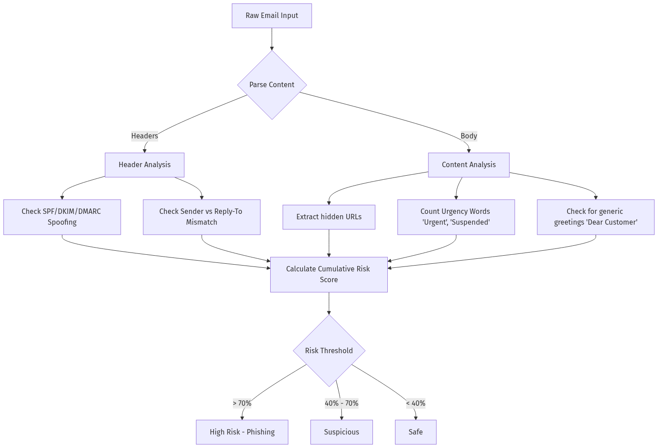

The Two Pillars of Email Detection:
**A. Header Analysis (Technical Check)**
We parse the invisible metadata appended to the top of every email. We specifically look for sender mismatches—for example, the email displays "PayPal Support" but the actual hidden return path is `hacker@random-domain.xyz`.
**B. Semantic Content Analysis (Psychological Check)**
Phishers use predictable tactics to make victims panic or click without thinking.
- **Urgency & Threat:** "Your account will be terminated in 24 hours."
- **Financial Lures:** "Attached is the invoice you requested."
- **Credential Harvesting:** "Click here to verify your password."
We run the email body through a heuristic scanner that adds risk points for every psychological trigger found.

5. Key Technologies Used
- **Frontend Interface:** React.js (JavaScript) with Vanilla CSS (Theme-toggleable Dark/Light modes)
- **Backend Server:** Django REST Framework (Python)
- **Machine Learning:** Scikit-Learn (XGBoost Classifier, Random Forest)
- **Data Processing:** Pandas, NumPy (For array manipulation and URL feature matrices)
- **External APIs:** Google Safe Browsing API, VirusTotal API

6. Summary for Presentation Delivery
- *"PhishGuard isn't just a blacklist checker. It's a dual-engine AI system."*
- *"By combining real-world Threat Intelligence with algorithmic structural analysis, we can catch brand new phishing sites perfectly designed to evade standard firewalls."*
- *"Our email analyzer mimics the thought process of a cybersecurity expert, scanning both the technical headers for spoofing and the written text for psychological manipulation."*

