DAY 3
SET 2 - INSURANCE CLAIMS PORTAL
Business Scenario | An insurer is building a self-service portal where customers lodge claims, upload supporting documents and track settlement status.
JIRA PROJECT EVIDENCE
List view - four Epics, thirteen Stories and five supporting documentation Tasks.
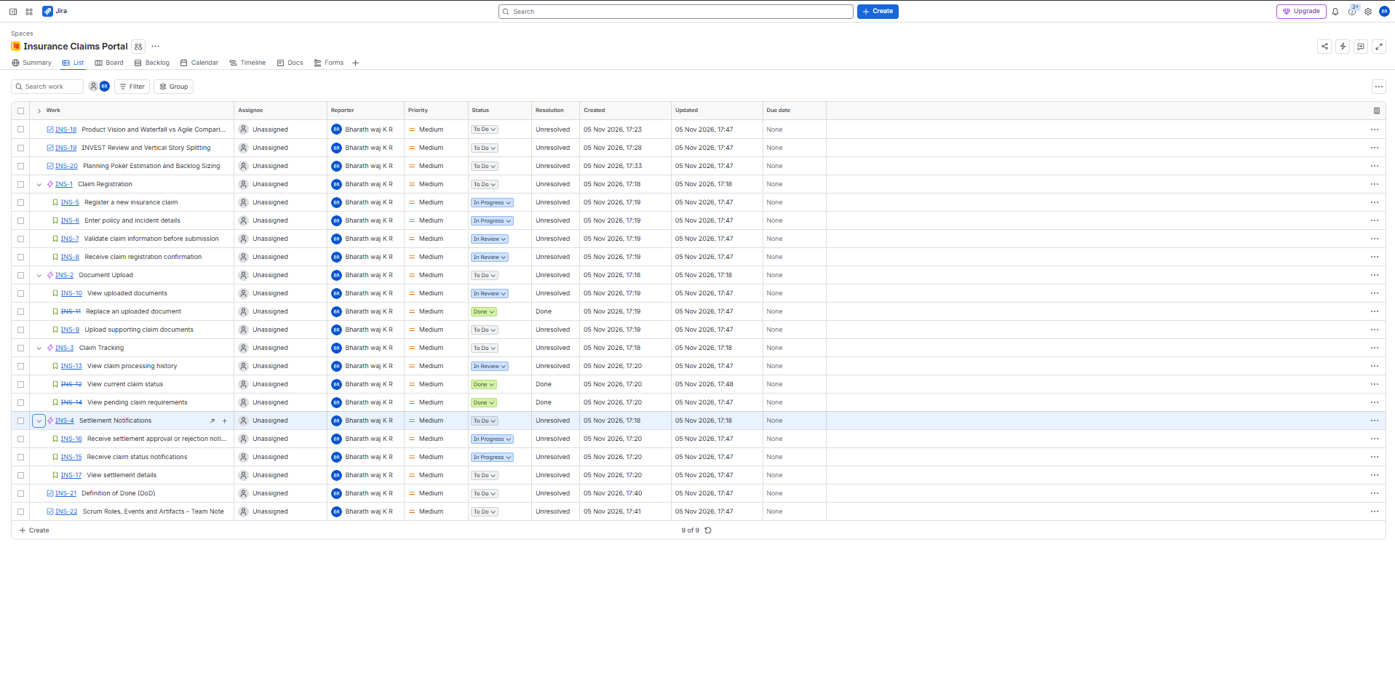
Board view - To Do, In Progress, In Review and Done workflow columns.
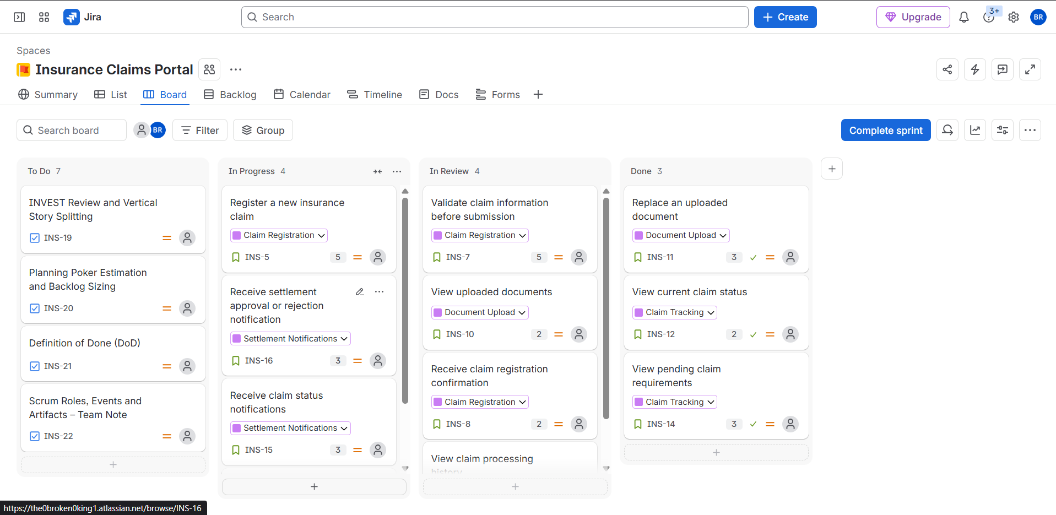

BACKLOG AND ESTIMATED STORY POINTS
The Jira backlog contains four Epics and thirteen Stories. The exported Jira CSV records a Story Point estimate for each Story. All thirteen Stories have Medium priority in the captured export.
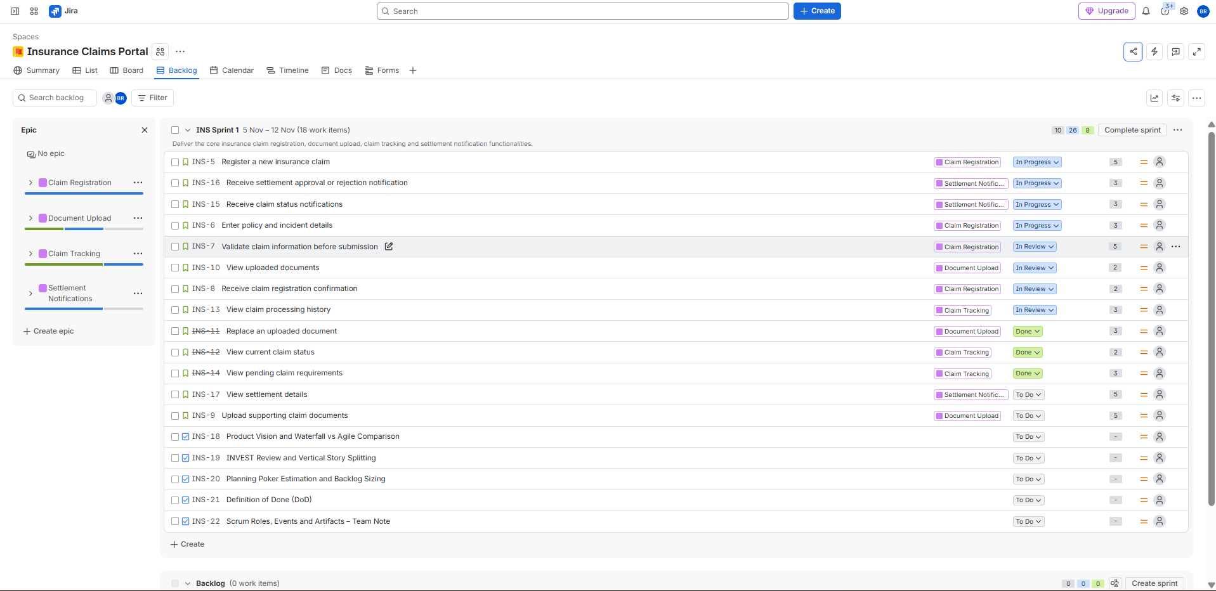
Backlog view - INS Sprint 1 (18 work items in the captured view, including 13 Stories and five supporting Tasks).
Estimated backlog table
Issue | Epic | Story | Points | Jira status
INS-5 | Claim Registration | Register a new insurance claim | 5 | In Progress
INS-6 | Claim Registration | Enter policy and incident details | 3 | In Progress
INS-7 | Claim Registration | Validate claim information before submission | 5 | In Review
INS-8 | Claim Registration | Receive claim registration confirmation | 2 | In Review
INS-9 | Document Upload | Upload supporting claim documents | 5 | To Do
INS-10 | Document Upload | View uploaded documents | 2 | In Review
INS-11 | Document Upload | Replace an uploaded document | 3 | Done
INS-12 | Claim Tracking | View current claim status | 2 | Done
INS-13 | Claim Tracking | View claim processing history | 3 | In Review
INS-14 | Claim Tracking | View pending claim requirements | 3 | Done
INS-15 | Settlement Notifications | Receive claim status notifications | 3 | In Progress
INS-16 | Settlement Notifications | Receive settlement approval or rejection notification | 3 | In Progress
INS-17 | Settlement Notifications | View settlement details | 5 | To Do
 | TOTAL | 13 Stories across four Epics | 44 | Story points
Epic subtotals: Claim Registration = 15; Document Upload = 10; Claim Tracking = 8; Settlement Notifications = 11. Total = 44 story points.

1. PRODUCT VISION
To develop a secure and user-friendly insurance claims portal that allows customers to register insurance claims, upload supporting documents, monitor claim progress and receive settlement updates. The portal aims to simplify the claims process, improve transparency and provide customers with timely information about their claims.
2. WATERFALL VERSUS AGILE COMPARISON
WATERFALL  Waterfall follows a sequential development approach. Requirements, design, development and testing are completed in predefined phases. Changes after a phase is completed can be difficult and costly, making it less flexible when claim rules or customer needs change. | AGILE  Agile follows an iterative approach. Work is divided into smaller increments, and the team reviews requirements, gathers feedback and improves the product regularly. This supports earlier validation and gradual delivery of the portal capabilities.
Why Agile suits this programme
Agile suits the Insurance Claims Portal because requirements may change in response to customer feedback, policy conditions and business rules. Incremental delivery allows the team to build claim registration, document upload, tracking and settlement notifications in manageable stages. Regular reviews help identify validation problems early and improve the customer experience.
3. PRODUCT BACKLOG STRUCTURE
- Claim Registration - capture policy and incident information, validate submissions and confirm claim registration.
- Document Upload - upload, view and replace supporting documents.
- Claim Tracking - view current status, processing history and pending requirements.
- Settlement Notifications - receive claim status and settlement updates, and view settlement details.
The Jira List view and exported CSV show the four Epics with thirteen linked Stories.

4. CLAIM REGISTRATION - USER STORIES AND ACCEPTANCE CRITERIA
The four Claim Registration Stories include Given / When / Then acceptance criteria. Positive paths and validation or failure paths are covered below.
INS-5 - Register a new insurance claim
As a customer, I want to register a new insurance claim, so that I can initiate the claim settlement process.
Scenario 1: Successful claim registration
Given: The customer has a valid insurance policy.
When: The customer submits the required claim information.
Then: The system registers the claim and generates a unique claim ID.
Scenario 2: Invalid policy
Given: The customer enters an invalid or expired policy number.
When: The customer attempts to register the claim.
Then: The system rejects the submission and displays an appropriate validation message.
INS-6 - Enter policy and incident details
As a customer, I want to enter my policy and incident details, so that the insurer can understand the circumstances of my claim.
Scenario 1: Enter valid details
Given: The customer is completing the claim registration form.
When: The customer enters valid policy and incident information.
Then: The system accepts the entered information.
Scenario 2: Mandatory information missing
Given: The customer is filling in the claim form.
When: The customer leaves mandatory fields empty and submits the form.
Then: The system highlights the missing fields and prevents submission.
INS-7 - Validate claim information before submission
As an insurance customer, I want the system to validate my claim information before submission, so that I can correct errors and submit accurate details.
Scenario 1: Valid claim information
Given: The customer has entered all mandatory claim details.
When: The system validates the information.
Then: The system allows the customer to proceed with claim submission.
Scenario 2: Validation failure
Given: The customer has entered incomplete or incorrect claim information.
When: The customer attempts to submit the claim.
Then: The system displays the relevant validation errors and prevents submission until the errors are corrected.
INS-8 - Receive claim registration confirmation
As a customer, I want to receive confirmation after registering my insurance claim, so that I know my claim has been successfully submitted.
Scenario 1: Successful confirmation
Given: The customer has submitted a valid insurance claim.
When: The system successfully registers the claim.
Then: The system displays a confirmation message containing the claim ID.
Scenario 2: Claim registration failure
Given: The customer has submitted the claim details.
When: The system fails to register the claim.
Then: The system displays an appropriate error message and does not show a successful registration confirmation.

5. INVEST REVIEW AND VERTICAL STORY SPLITTING
The final backlog was reviewed against the six INVEST criteria. The purpose of the review was to identify broad or overlapping requirements and refine them into smaller customer-facing stories.
I - Independent | Each Story should have minimal dependency on other Stories.
N - Negotiable | The Story should allow discussion and refinement with the team.
V - Valuable | Each Story should provide value to the customer or business.
E - Estimable | The team should understand the scope well enough to estimate its effort.
S - Small | The Story should be small enough to complete within a Sprint.
T - Testable | The Story should have clear acceptance criteria that can be verified.
Vertical splitting examples
Example 1 - Manage claim documents
Original oversized Story: “As a customer, I want to manage my claim documents, so that I can provide and maintain all supporting information.”
- INS-9 - Upload supporting claim documents.
- INS-10 - View uploaded documents.
- INS-11 - Replace an uploaded document.
Reason: Each revised Story provides a separate customer-visible capability that can be implemented and tested independently.
Example 2 - Track insurance claim progress
Original oversized Story: “As a customer, I want to track my insurance claim, so that I can understand its progress.”
- INS-12 - View current claim status.
- INS-13 - View claim processing history.
- INS-14 - View pending claim requirements.
Reason: The original requirement combines multiple customer needs. The vertical slices deliver individually useful functions, rather than splitting the work into frontend, backend or database layers.
Story-wise INVEST review - final refined backlog
Story | I | N | V | E | S | T
INS-5 Register a new insurance claim | Pass | Pass | Pass | Pass | Pass | Pass
INS-6 Enter policy and incident details | Pass | Pass | Pass | Pass | Pass | Pass
INS-7 Validate claim information | Pass | Pass | Pass | Pass | Pass | Pass
INS-8 Receive registration confirmation | Pass | Pass | Pass | Pass | Pass | Pass
INS-9 Upload supporting documents | Pass | Pass | Pass | Pass | Pass | Pass
INS-10 View uploaded documents | Pass | Pass | Pass | Pass | Pass | Pass
INS-11 Replace uploaded document | Pass | Pass | Pass | Pass | Pass | Pass
INS-12 View current claim status | Pass | Pass | Pass | Pass | Pass | Pass
INS-13 View claim processing history | Pass | Pass | Pass | Pass | Pass | Pass
INS-14 View pending claim requirements | Pass | Pass | Pass | Pass | Pass | Pass
INS-15 Receive claim status notifications | Pass | Pass | Pass | Pass | Pass | Pass
INS-16 Receive settlement approval/rejection notification | Pass | Pass | Pass | Pass | Pass | Pass
INS-17 View settlement details | Pass | Pass | Pass | Pass | Pass | Pass
The Jira INVEST review records all thirteen final Stories as passing the six criteria after the vertical refinements.

6. PLANNING POKER ESTIMATION AND BACKLOG SIZING
All thirteen Stories were estimated using the Fibonacci story-point values 1, 2, 3, 5, 8 and 13. Story points represent relative effort, complexity and uncertainty, not working hours.
Reference Story
INS-12 - View current claim status (2 Story Points). This was selected as the reference because it has a focused scope, clear customer value and straightforward acceptance criteria. Other Stories were compared with this baseline.
Estimation outlier and discussion
Story: INS-9 - Upload supporting claim documents.
Estimate considered | Assumption | Discussion
3 points | Basic upload only | This estimate assumed a minimal file-selection and upload flow.
5 points | Upload plus validation | This estimate included upload validation and error handling.
8 points | Additional file complexity | This estimate allowed for additional format and upload complexity.
Resolution: the recorded planning estimate was 5 points after clarifying the intended initial scope to include upload validation and error handling. The values above document the estimation spread and its rationale.
Backlog size
13 | 44 | 4
Stories | Total story points | Epics
Epic subtotals: Claim Registration 15 points; Document Upload 10 points; Claim Tracking 8 points; Settlement Notifications 11 points. The total of 44 points is verified against the Story Point Estimate values in the Jira CSV export.
7. DEFINITION OF DONE (DoD)
A Story is considered Done only when all applicable completion standards are satisfied and the functionality meets the agreed quality level.
- All agreed acceptance criteria are satisfied.
- Development work is completed.
- Code review is completed.
- Unit testing is completed successfully.
- Integration testing is completed successfully.
- Claim registration validation and error handling are verified.
- Customer data and claim information access are checked.
- No known critical defects remain.
- Relevant documentation is updated.
- The completed functionality is demonstrated and verified.

8. SCRUM ROLES, EVENTS AND ARTIFACTS
This one-page note explains how Scrum accountabilities, events and artifacts support delivery of the Insurance Claims Portal.
Scrum roles / accountabilities
PRODUCT OWNER  - Defines the Product Goal.  - Maximises product value.  - Orders and clarifies the Product Backlog.  - Ensures the team understands priorities. | SCRUM MASTER  - Establishes Scrum understanding.  - Facilitates Scrum practices.  - Helps remove impediments.  - Supports team effectiveness. | DEVELOPERS  - Plan and complete Sprint work.  - Build and maintain quality.  - Collaborate towards the Sprint Goal.  - Deliver a usable Increment.
Scrum events
Event | Purpose
Sprint | A fixed-length period in which the team works towards the Sprint Goal.
Sprint Planning | The team agrees why the Sprint is valuable, what can be completed and how the work will be approached.
Daily Scrum | Developers inspect progress towards the Sprint Goal and adapt the plan for the next day.
Sprint Review | The team and stakeholders inspect the Increment and discuss adaptations to the Product Backlog.
Sprint Retrospective | The Scrum Team identifies ways to improve quality and effectiveness.
Scrum artifacts and commitments
PRODUCT BACKLOG  An ordered list of product requirements and improvements.  Commitment: Product Goal | SPRINT BACKLOG  The Sprint Goal, selected Product Backlog items and the plan for delivering them.  Commitment: Sprint Goal | INCREMENT  A usable, valuable outcome that meets the Definition of Done.  Commitment: Definition of Done
Application to the Insurance Claims Portal
- The Product Owner orders claim registration, document upload, claim tracking and settlement notification work by value and need.
- The Scrum Master supports Scrum events, removes impediments and helps the team improve its way of working.
- Developers refine, estimate and deliver selected Stories while meeting the Definition of Done.
- Sprint Planning sets the Sprint Goal; Daily Scrums inspect progress; Sprint Reviews gather stakeholder feedback; Retrospectives identify improvements.
- The Product Backlog and Sprint Backlog make planned work transparent, while the Increment represents usable completed functionality.
Conclusion: Scrum provides an iterative way to develop the Insurance Claims Portal, with clear accountabilities, regular inspection and adaptation, and transparent work artifacts.

