DAY 2
Problem Solving Techniques and Data Structures - II
Set 2 - Insurance Claims Processing
Q1: Binary Search Tree for Claim IDs
I inserted the claim IDs into a BST. I used inorder, preorder and postorder to visit the same tree in three different ways.
Sample Input:
claim_ids = [105, 103, 108, 101, 104, 107, 110]
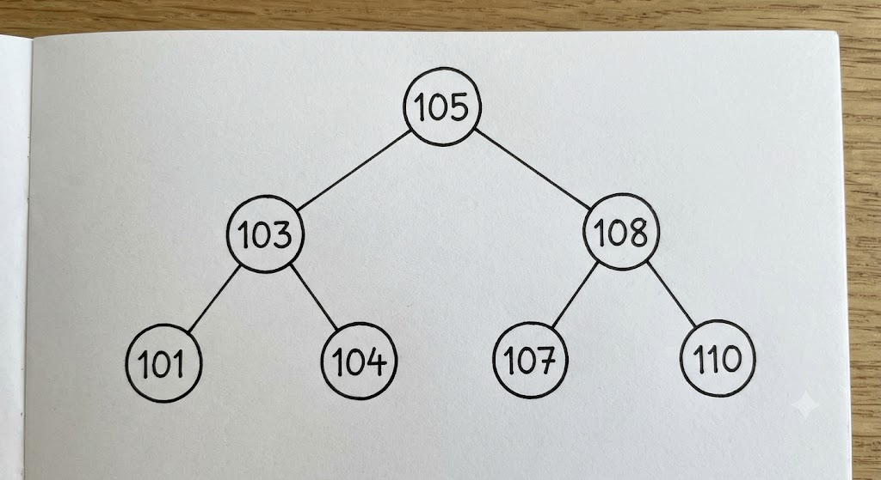
Pseudocode - Insert and Search:
INSERT(root, value)
IF root is NULL:
CREATE a new node with value
RETURN the new node
IF value < root.data: root.left = INSERT(root.left, value)
ELSE IF value > root.data: root.right = INSERT(root.right, value)
RETURN root
SEARCH(root, target)
IF root is NULL: RETURN NOT FOUND
IF root.data == target: RETURN FOUND
IF target < root.data: RETURN SEARCH(root.left, target)
ELSE: RETURN SEARCH(root.right, target)
Pseudocode - Three Traversals:
INORDER(root): IF root is NULL: RETURN
INORDER(root.left)
PRINT root.data
INORDER(root.right)
PREORDER(root): IF root is NULL: RETURN
PRINT root.data
PREORDER(root.left)
PREORDER(root.right)
POSTORDER(root): IF root is NULL: RETURN
POSTORDER(root.left)
POSTORDER(root.right)
PRINT root.data
Output:
Inorder: 101, 103, 104, 105, 107, 108, 110
Preorder: 105, 103, 101, 104, 108, 107, 110
Postorder: 101, 104, 103, 107, 110, 108, 105
Q2: Hashing for Duplicate and Near-Duplicate Claims
I normalised the policy number before checking it. This helps me catch the same policy even when the letters use different cases or there are extra spaces.
Pseudocode:
NORMALIZE_POLICY(policy):
REMOVE spaces from policy
CONVERT policy to uppercase
RETURN policy
CHECK_CLAIMS(claims):
CREATE an empty HASH MAP
FOR each claim:
claim_id = claim.id
raw_policy = claim.policy_number
policy = NORMALIZE_POLICY(raw_policy)
date = NORMALIZE_DATE(claim.incident_date)
key = (policy, date)
IF key is not in HASH MAP:
CREATE an entry with raw_variants = {raw_policy} and claim_ids = [claim_id]
ELSE IF raw_policy is in HASH_MAP[key].raw_variants:
PRINT "Duplicate claim", claim_id
ELSE:
PRINT "Near-duplicate claim", claim_id
ADD raw_policy to raw_variants and claim_id to claim_ids
END FOR
Sample Input:
claims = [
(105, "POL101", "2026-10-01"), (103, "POL102", "2026-10-02"),
(108, "POL103", "2026-10-03"), (101, "POL101", "2026-10-01"),
(110, "POL 102", "2026-10-02"), (107, "pol103", "2026-10-03")
]
Output:
Duplicate Claim ID: 101
Near-Duplicate Claim ID: 110
Near-Duplicate Claim ID: 107
Q3: Directed Graph for Claim Approval Stages
I represented the claim stages as a directed graph. The surveyor can send a claim back for reassessment, so I included that loop to test cycle detection.
Sample Input:
Claim Registration: [Claim Assessment]
Claim Assessment: [Surveyor Assignment]
Surveyor Assignment: [Settlement, Claim Assessment]
Settlement: []
Pseudocode - Shortest Path Using BFS:
BFS_SHORTEST_PATH(graph, start, target):
CREATE an empty queue, visited set and parent map
ADD start to queue and visited
parent[start] = NULL
WHILE queue is not empty:
current = REMOVE from queue
IF current == target: BREAK
FOR each neighbour in graph[current]:
IF neighbour is not visited:
ADD neighbour to visited
parent[neighbour] = current
ADD neighbour to queue
IF target is not visited: PRINT "Path not found" and RETURN
BUILD the path by following parent from target to start
REVERSE path and PRINT it
Pseudocode - Directed Cycle Detection Using DFS:
DFS_CYCLE(graph, node, visited, recursion_stack):
ADD node to visited and recursion_stack
FOR each neighbour in graph[node]:
IF neighbour is not visited:
IF DFS_CYCLE(neighbour, visited, recursion_stack) is TRUE: RETURN TRUE
ELSE IF neighbour is in recursion_stack: RETURN TRUE
REMOVE node from recursion_stack
RETURN FALSE
CREATE empty visited and recursion_stack sets
FOR each node in graph:
IF node is not visited AND DFS_CYCLE(...) is TRUE: RETURN TRUE
RETURN FALSE
Output:
Shortest path: Claim Registration -> Claim Assessment -> Surveyor Assignment -> Settlement
Cycle detected: Yes (Claim Assessment -> Surveyor Assignment -> Claim Assessment)
Q4: Sliding Window for Daily Claim Spikes
I used a counter to find the longest continuous period where claims are more than 100 per day.
Sample Input:
claims_per_day = [120, 90, 130, 110, 150, 80, 140]
limit = 100
Pseudocode:
FIND_LONGEST_STREAK(claims_per_day, limit):
current_streak = 0
max_streak = 0
FOR each daily_count in claims_per_day:
IF daily_count > limit:
current_streak = current_streak + 1
max_streak = MAX(max_streak, current_streak)
ELSE:
current_streak = 0
PRINT max_streak
Output:
Longest consecutive days: 3
Q5: Two Pointers to Merge Regional Claim Lists
Both regional lists are already sorted. I use one pointer for each list and add the smaller value to the merged list, so there is no extra sorting step.
Sample Input:
office_A = [101, 104, 109, 115]
office_B = [100, 102, 110, 118, 120]
Pseudocode:
MERGE_SORTED_LISTS(A, B):
i = 0, j = 0
merged = empty list
WHILE i < length(A) AND j < length(B):
IF A[i] <= B[j]:
ADD A[i] to merged; i = i + 1
ELSE:
ADD B[j] to merged; j = j + 1
WHILE i < length(A): ADD A[i] to merged; i = i + 1
WHILE j < length(B): ADD B[j] to merged; j = j + 1
PRINT merged
Output:
[100, 101, 102, 104, 109, 110, 115, 118, 120]

