DAY 3
SET 3 - HOSPITAL APPOINTMENT BOOKING APPLICATION
Business Scenario | A hospital group wants a mobile application for booking, rescheduling and cancelling doctor appointments, with reminder notifications.

JIRA PROJECT EVIDENCE
The HOSP space contains four Epics and twelve linked Stories. The captured List view shows priorities, statuses and Story Point estimates; the Board view shows the four workflow columns.
List view - four Epics, twelve Stories, priorities, status and Story Point estimates.
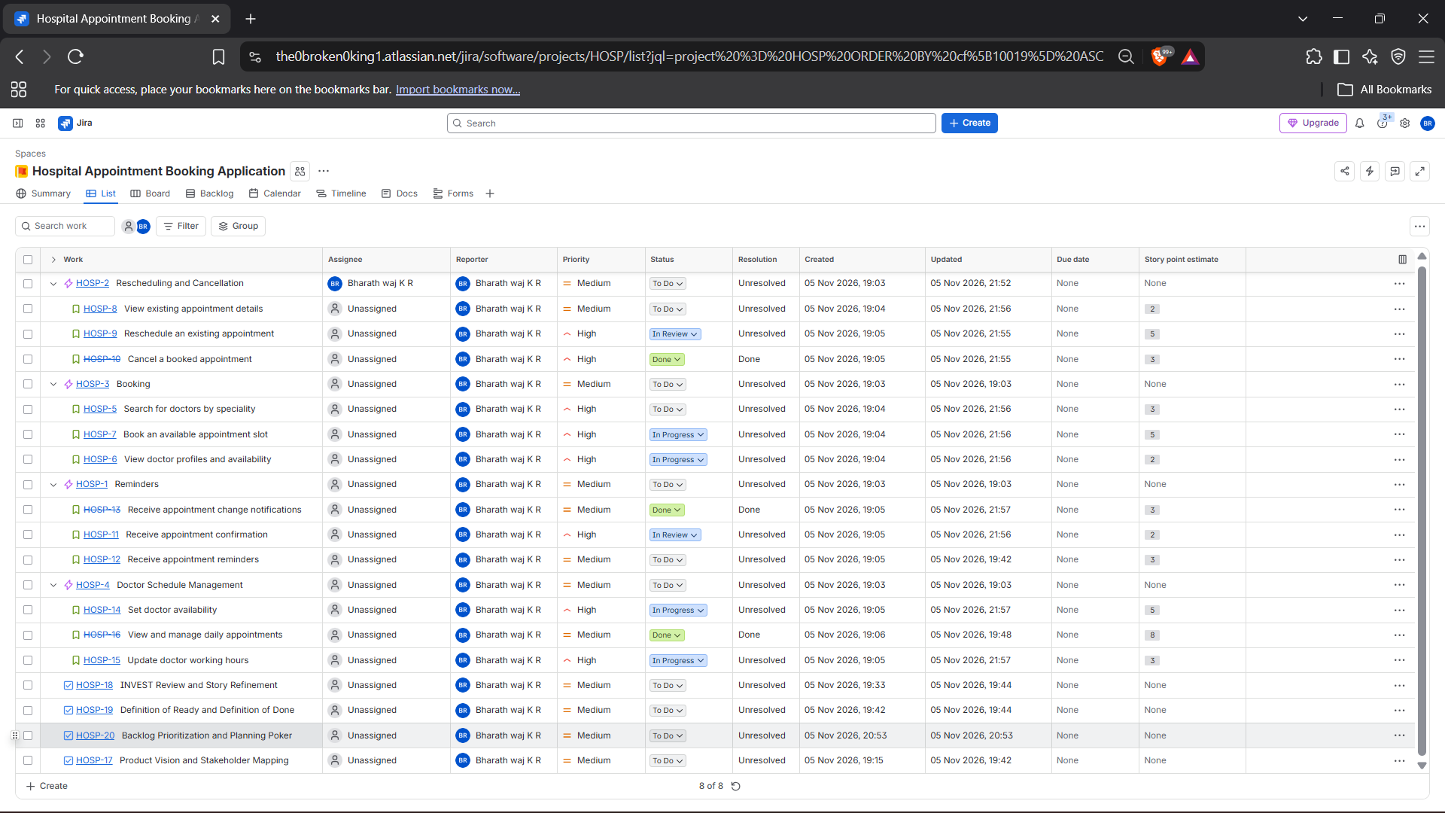
Board view - To Do, In Progress, In Review and Done workflow columns.
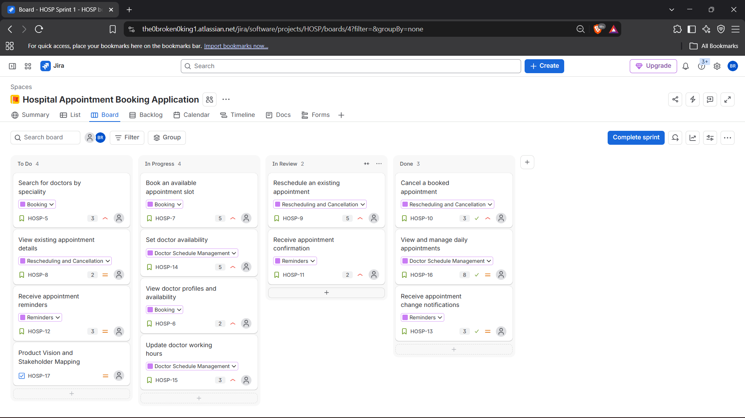
The accompanying Jira CSV export was used to cross-check issue keys, work types, summaries, priorities and statuses. Story Point values shown in this document were transcribed from the Jira List view.

BACKLOG AND PRIORITISED STORY POINTS
The backlog contains four Epics and twelve Stories. Business Value and Effort are assessed separately, and the Jira Priority field records the resulting High or Medium priority. Story estimates use the Fibonacci values 1, 2, 3, 5, 8 and 13.
Issue | Epic | Story | Business  Value | Effort | Priority | Points | Jira status
HOSP-5 | Booking | Search for doctors by speciality | High | Medium | High | 3 | To Do
HOSP-6 | Booking | View doctor profiles and availability | High | Low | High | 2 | In Progress
HOSP-7 | Booking | Book an available appointment slot | High | High | High | 5 | In Progress
HOSP-8 | Rescheduling & Cancellation | View existing appointment details | Medium | Low | Medium | 2 | To Do
HOSP-9 | Rescheduling & Cancellation | Reschedule an existing appointment | High | Medium | High | 5 | In Review
HOSP-10 | Rescheduling & Cancellation | Cancel a booked appointment | High | Low | High | 3 | Done
HOSP-11 | Reminders | Receive appointment confirmation | High | Low | High | 2 | In Review
HOSP-12 | Reminders | Receive appointment reminders | Medium | Medium | Medium | 3 | To Do
HOSP-13 | Reminders | Receive appointment change notifications | Medium | Medium | Medium | 3 | Done
HOSP-14 | Doctor Schedule Management | Set doctor availability | High | High | High | 5 | In Progress
HOSP-15 | Doctor Schedule Management | Update doctor working hours | High | Medium | High | 3 | In Progress
HOSP-16 | Doctor Schedule Management | View and manage daily appointments | High | High | Medium | 8 | Done
 |  | TOTAL BACKLOG |  |  |  | 44 | 12 Stories

Epic subtotals
Epic | Subtotal
Booking | 10 points
Rescheduling and Cancellation | 10 points
Reminders | 8 points
Doctor Schedule Management | 16 points
The total estimated backlog is 44 Story Points. The statuses in the table match the captured Jira List view; the Board screenshot reflects the same work items across the four workflow columns.

1. PRODUCT VISION
To develop a user-friendly hospital appointment booking application that allows patients to search for doctors, view their availability, book appointments, reschedule or cancel existing appointments, and receive timely reminders. The application aims to simplify appointment management, reduce manual scheduling efforts and improve communication between patients and healthcare providers.

2. STAKEHOLDER IDENTIFICATION AND MAPPING
The stakeholders are mapped to the Scrum accountabilities or customer group according to their role in the Hospital Appointment Booking Application.
Stakeholder | Mapped role | Responsibility / expectation
Hospital management representative | Product Owner | Defines business objectives, orders the Product Backlog and ensures the application meets hospital requirements.
Scrum facilitator | Scrum Master | Facilitates Scrum events, supports Scrum practices and helps remove impediments.
Frontend developer | Developer | Builds the patient-facing application screens and appointment flows.
Backend developer | Developer | Implements booking, availability, rescheduling, cancellation and notification services.
QA engineer | Developer | Verifies acceptance criteria, tests appointment workflows and reports defects.
Patients | Customer | Search for doctors, book appointments, reschedule or cancel visits and receive reminders.
Doctors | Customer | Review their schedules and provide accurate appointment availability.
Receptionists | Customer | Assist patients with appointment scheduling and access appointment information.

Stakeholder expectations
- Hospital management expects efficient appointment scheduling and fewer manual booking activities.
- Patients expect an easy booking process, accurate slot availability and timely reminders.
- Doctors expect reliable schedules and visibility into daily appointments.
- Receptionists expect clear appointment information to support patients.
- The delivery team expects clear priorities, testable requirements and timely stakeholder feedback.

Conclusion
Mapping stakeholders to Product Owner, Scrum Master, Developer and Customer groups clarifies accountability and helps the team understand the needs of patients, doctors and hospital staff.

3. BOOKING AND CANCELLATION - ACCEPTANCE CRITERIA
The following Stories use Given / When / Then acceptance criteria. The booking section includes the required negative case in which the selected appointment slot has already been taken.
HOSP-7 - Book an available appointment slot
As a patient, I want to book an available appointment slot, so that I can schedule a visit with my chosen doctor.
Scenario 1: Successful appointment booking
Given: The patient has selected an available doctor and appointment slot.
When: The patient confirms the appointment with valid details.
Then: The application creates the appointment and displays a booking confirmation.
Scenario 2: Slot already taken
Given: The patient has selected an appointment slot, and another patient has already booked that slot.
When: The patient attempts to confirm the appointment.
Then: The application rejects the booking.
Then: A message indicates that the selected slot is no longer available.
Then: The application shows other available appointment slots.
Scenario 3: Missing patient details
Given: The patient has selected an available appointment slot.
When: The patient submits the booking without mandatory information.
Then: The application displays validation messages and prevents the booking.
HOSP-9 - Reschedule an existing appointment
As a patient, I want to reschedule an existing appointment, so that I can choose a different suitable date and time.
Scenario 1: Successful rescheduling
Given: The patient has an existing appointment and a new slot is available.
When: The patient selects the new slot and confirms the change.
Then: The application updates the appointment and displays a rescheduling confirmation.
Scenario 2: Selected slot already taken
Given: The patient has selected a new appointment slot, and that slot has already been booked.
When: The patient confirms the rescheduling request.
Then: The application rejects the change and displays an appropriate message.
HOSP-10 - Cancel a booked appointment
As a patient, I want to cancel a booked appointment, so that I can release a slot when I am unable to attend.
Scenario 1: Successful appointment cancellation
Given: The patient has an existing confirmed appointment.
When: The patient selects Cancel Appointment and confirms the cancellation.
Then: The application cancels the appointment and updates its status.
Scenario 2: Patient changes their mind
Given: The patient has opened the cancellation confirmation screen.
When: The patient chooses not to proceed with cancellation.
Then: The application retains the existing appointment.
Scenario 3: Cancellation confirmation
Given: The patient has successfully cancelled an appointment.
When: The cancellation is completed.
Then: The application displays a cancellation confirmation to the patient.
Additional Given / When / Then criteria for doctor search and doctor availability are recorded on HOSP-5 and HOSP-6 in Jira.

4. INVEST REVIEW
Each Story is checked against the six INVEST principles: Independent, Negotiable, Valuable, Estimable, Small and Testable. The review identifies two Stories that need clearer scope or acceptance conditions.
I - Independent | The Story should have minimal unnecessary dependency on other Stories.
N - Negotiable | The Story should allow discussion and refinement with the team.
V - Valuable | The Story should provide value to patients, doctors or the hospital.
E - Estimable | The team should be able to understand and estimate the effort.
S - Small | The Story should be manageable within a Sprint.
T - Testable | The Story should have clear, verifiable acceptance criteria.

Story-wise INVEST review
Story | I | N | V | E | S | T
HOSP-5 Search doctors by speciality | Pass | Pass | Pass | Pass | Pass | Pass
HOSP-6 View doctor profiles and availability | Pass | Pass | Pass | Pass | Pass | Pass
HOSP-7 Book an available appointment slot | Pass | Pass | Pass | Pass | Pass | Pass
HOSP-8 View existing appointment details | Pass | Pass | Pass | Pass | Pass | Pass
HOSP-9 Reschedule an existing appointment | Pass | Pass | Pass | Pass | Pass | Pass
HOSP-10 Cancel a booked appointment | Pass | Pass | Pass | Pass | Pass | Pass
HOSP-11 Receive appointment confirmation | Pass | Pass | Pass | Pass | Pass | Pass
HOSP-12 Receive appointment reminders | Pass | Pass | Pass | Pass | Pass | Pass
HOSP-13 Receive appointment change notifications | Pass | Pass | Pass | Pass | Pass | Pass
HOSP-14 Set doctor availability | Pass | Pass | Pass | Pass | Pass | Refine
HOSP-15 Update doctor working hours | Pass | Pass | Pass | Pass | Pass | Pass
HOSP-16 View and manage daily appointments | Refine | Pass | Pass | Pass | Refine | Refine
Review basis: the table reflects a backlog-level review of the recorded Story summaries and the acceptance criteria captured for booking and cancellation. “Refine” marks scope or testability that should be clarified before implementation.

5. STORY REFINEMENT
Two Stories were identified for refinement because their wording leaves the expected behaviour too broad or insufficiently verifiable.

Example 1 - HOSP-14: Set doctor availability
Original Story: As a doctor, I want to set my availability, so that patients can book appointments.
Issue: “Set availability” does not specify what the doctor changes or what result should be visible to patients.
Revised Story: As a doctor, I want to mark specific appointment slots as available for selected dates and times, so that patients can book only the slots I have opened.
Testable outcome: When a doctor marks a valid date and time slot as available, that slot appears as bookable in the patient-facing availability view.

Example 2 - HOSP-16: View and manage daily appointments
Original Story: As a doctor, I want to view and manage daily appointments, so that I can organise my schedule.
Issue: “View and manage” combines multiple actions and does not define which appointment operation is included.
Revised Story: As a doctor, I want to view the daily appointment schedule for a selected date, so that I can see the appointments assigned to me.
Testable outcome: When a doctor selects a date, the application displays the appointments scheduled for that doctor on that date.
The revised wording narrows the initial Stories to specific, independently verifiable outcomes. Further actions such as editing or cancelling appointments remain represented by their own Stories.

6. BUSINESS VALUE VERSUS EFFORT PRIORITISATION
Business Value estimates the benefit to patients and hospital operations. Effort estimates relative implementation complexity. High-value, lower-effort work is prioritised early, while larger items are planned with their effort and dependencies in view.
Business Value | Effort | Stories
High | Low | HOSP-6, HOSP-10, HOSP-11
High | Medium | HOSP-5, HOSP-9, HOSP-15
High | High | HOSP-7, HOSP-14, HOSP-16
Medium | Low | HOSP-8
Medium | Medium | HOSP-12, HOSP-13
Jira Priority is High for HOSP-5, HOSP-6, HOSP-7, HOSP-9, HOSP-10, HOSP-11, HOSP-14 and HOSP-15; Medium for HOSP-8, HOSP-12, HOSP-13 and HOSP-16.

7. PLANNING POKER AND STORY-POINT ESTIMATION
The twelve Stories were estimated using the Fibonacci scale: 1, 2, 3, 5, 8 and 13. Story Points represent relative effort, complexity and uncertainty; they are not an hour conversion.

Reference Story
HOSP-8 - View existing appointment details (2 Story Points). This Story was selected as a reference because it has a focused scope, a clear patient benefit and a straightforward outcome: displaying the details of an existing appointment.

Planning Poker discussion example
Story: HOSP-16 - View and manage daily appointments.
Estimate considered | Assumption | Discussion
5 points | View a simple list of appointments. | This assumes a basic daily schedule view.
8 points | View, filter and organise daily appointments. | This reflects the broader scope suggested by “view and manage”.
13 points | Complex scheduling changes and additional management actions. | This assumes more behaviours than the Story currently defines.
Resolution: For the current backlog estimate, 8 points is retained as the proposed value. The refinement section narrows the Story to a daily schedule view; if that narrower scope is adopted in Jira, the team should re-estimate it in a fresh Planning Poker round.

Backlog size
12 | 44 | 4
Stories | Total Story Points | Epics

Story Points versus hours
STORY POINTS | HOURS
Relative measure of effort, complexity and uncertainty. Used to compare the size of Stories and support team planning. | Measure of elapsed work time or time spent. Used for time tracking and scheduling.
A five-point Story does not mean five hours of work. The relationship between Story Points and delivery time is learned from the team’s own experience and velocity, not assumed in advance.

8. DEFINITION OF READY AND DEFINITION OF DONE
The team uses the following checklists to decide whether a Story is sufficiently understood to enter a Sprint and whether completed work meets the agreed quality standard.
DEFINITION OF READY (DoR) | DEFINITION OF DONE (DoD)
☐ The user story has a clear description. | ☐ Development is completed.
☐ The business value is identified. | ☐ Code review is completed.
☐ Acceptance criteria are documented. | ☐ Unit testing is completed successfully.
☐ Dependencies are identified. | ☐ All agreed acceptance criteria are satisfied.
☐ Doctor availability and slot requirements are understood. | ☐ Booking, rescheduling and cancellation are tested.
☐ The Story has been estimated by the team. | ☐ The already-taken slot scenario is verified.
☐ Required information and test conditions are available. | ☐ Appointment notifications are verified.
☐ The Story is small enough to complete within a Sprint. | ☐ No critical defects remain.
 | ☐ Relevant documentation is updated.
 | ☐ The Product Owner has accepted the completed functionality.

Application to the Hospital Appointment Booking Application
The DoR ensures each appointment Story has clear requirements, slot rules and test conditions before Sprint Planning. The DoD ensures booking, rescheduling, cancellation, doctor availability and reminder functionality are reviewed and verified before a Story is considered complete.

Conclusion
The prioritised backlog, Planning Poker estimates, INVEST refinement and DoR / DoD checklists provide a consistent basis for planning and delivering the Hospital Appointment Booking Application. The Jira List and Board views provide a visible record of the Stories and their workflow states.

