Online recruitment simulation software

CONTENT
Abstract
1.INTRODUCTION
1.1 Motivation
1.2 Problem Statement
1.3 Objective of the Project
1.4 Scope
1.5 Project Introduction
2.LITERATURE SURVEY
2.1 Related Work
3. SYSTEM ANALYSIS
3.1 Existing System
3.2 Disadvantages
3.3 Proposed System
3.4 Advantages
3.5 work Flow of Proposed system
4. REQUIREMENT ANALYSIS
4.1 Function and non-functional requirements
4.2 Hardware Requirements
4.3 Software Requirements
4.4 Architecture
5. SYSTEM DESIGN
5.1 Introduction of Input design
5.2 UML Diagram(class, use case, sequence, collaborative, deployment, activity, ER diagram and Component diagram)
5.3 Data Flow Diagram
6. IMPLEMENTATION AND RESULTS
6.1 Modules
  - Output Screens
7. SYSTEM STUDY AND TESTING
7.1 Feasibility study
7.2 Types of test & Test Cases
8. CONCLUSION
9. FUTURE ENHANCEMENT
10. REFERENCES

ABSTRACT:
The Online Recruitment Simulation Software is a platform designed to streamline campus recruitment for companies, training and placement officers (TPOs), and students. It incorporates Artificial Intelligence (AI) to enhance the job application process with features like an AI-powered Applicant Tracking System (ATS) and automated feedback for student performance after exams. Companies can manage recruitment drives, create and administer tests, set drive details, and shortlist candidates based on test performance. TPOs can request and monitor recruitment drives, share details with students, and track results. Students can view and apply for drives, take exams, and receive AI-generated feedback to improve. The platform ensures clear communication, reduces manual effort, and delivers an efficient recruitment experience. Key features include the AI-powered ATS, automated feedback, customizable exams, and enhanced transparency.
Key Words: AI-Based Recruitment System, Campus Placement, Applicant Tracking System, Automated Feedback, Recruitment Drives, TPO, Students, Companies, Job Application Process, Customizable Exams.
- INTRODUCTION
1.1 Motivation:
The motivation behind this project stems from the desire to overcome the limitations of existing campus recruitment systems, such as manual processes, biased selections, and lack of real-time feedback. By leveraging AI, the system aims to bring automation, transparency, and efficiency to campus placements. For companies, it offers the advantage of precise candidate evaluation through customizable exams and ATS. For students, it provides instant performance feedback, helping them identify and improve their skills. Additionally, TPOs benefit from real-time monitoring and streamlined communication, making the entire process more manageable.
This project aspires to create a smarter and more equitable recruitment platform that not only addresses current challenges but also sets a benchmark for the future of campus placements.

1.2 Problem Statement:
The Online Recruitment Simulation Software addresses the fragmented, inefficient, and often non-transparent recruitment process, which poses several challenges for companies, training and placement officers (TPOs), and students. Companies struggle with managing interview questions, scheduling recruitment drives, and effectively communicating with colleges. TPOs face difficulties in coordinating with multiple companies, tracking the status of drive requests, and ensuring that students have access to up-to-date recruitment information. Students encounter issues with registration, accessing relevant drive details, and receiving timely updates on their application status. These challenges lead to confusion, delays, and missed opportunities for all stakeholders involved. There is a pressing need for a comprehensive solution that integrates these processes, reduces manual efforts, and enhances the overall efficiency and effectiveness of recruitment.
1.3 Objective of the Project:
The primary objective of the Online Recruitment Simulation Software is to create a unified and efficient platform that simplifies the recruitment process for companies, training and placement officers (TPOs), and students. The system aims to facilitate seamless interaction between all stakeholders by enabling smooth communication and collaboration. It seeks to streamline recruitment processes by automating and managing tasks such as registration, drive management, candidate shortlisting, and result notifications. Furthermore, the system enhances transparency by ensuring clear and accessible processes for everyone, keeping stakeholders informed and up-to-date with recruitment activities. By digitizing key tasks, the software reduces manual efforts, minimizes errors, and saves time and resources. It also supports decision-making by providing detailed insights and analytics to help companies and TPOs select the right candidates. The system ensures a user-friendly experience through an intuitive interface that facilitates easy navigation and usage for all users.
1.4 Scope:
The scope of the Online Recruitment Simulation Software encompasses the entire recruitment lifecycle, offering functionalities tailored to companies, training and placement officers (TPOs), and students. For companies, the platform supports registration, login, the creation of recruitment drives, management of interview questions, scheduling exams, and shortlisting candidates based on performance. It also enables efficient communication with TPOs and provides detailed analytics to support decision-making. TPOs can access the system to request recruitment drives, share approved drive details with students, track drive statuses, and monitor results. Students benefit from features like registration, login, access to recruitment drive details, application submission, participation in exams, and receiving real-time feedback on their performance. By integrating AI technologies, the system enhances transparency, reduces manual efforts, and ensures efficient management of recruitment activities. The platform also prioritizes a user-friendly experience, offering intuitive navigation and easy access to all essential functionalities. Ultimately, the software aims to digitize and optimize the recruitment process, ensuring seamless communication and collaboration among all stakeholders.
1.5 Project Introduction:
The Online Recruitment Simulation Software serves as a comprehensive platform bridging the gap between job seekers (students) and job providers (companies). The system enables job seekers to easily find and apply for suitable positions by logging into the platform. It also allows employers to connect with potential employees by posting job opportunities and managing applications. This software acts as a centralized hub where job seekers can receive notifications about job openings matching their profile and education details, simplifying their application process. Additionally, job seekers can communicate with employers for inquiries, fostering transparency and engagement.
Employers benefit from automated alerts about job seekers whose profiles align with their job requirements. The platform also allows employers to post job details, shortlist candidates, and communicate with them effectively. The Online Recruitment Simulation Software modernizes the recruitment process by integrating AI-powered features such as automated feedback for candidates post-assessment and real-time notifications for all stakeholders. It eliminates the inefficiencies of manual recruitment, providing a streamlined, transparent, and efficient hiring experience.
By digitizing recruitment tasks, the system drastically reduces time and effort for both companies and job seekers. It supports modern recruitment needs, offering functionalities such as CV uploads, online examinations, and analytics to enhance decision-making for employers. Moreover, the software ensures user-friendliness, enabling intuitive navigation and seamless operation for all users.
The Online Recruitment Simulation Software aims to replace traditional, time-consuming recruitment methods with a dynamic, multi-platform solution that supports further expansion and adaptation based on user requirements. It provides examination facilities, controlled workflows, and actionable insights, making it an indispensable tool for modern recruitment processes.
- LITERATURE SURVEY
2.1 Related Work:
[1] Wang, Y., & Wang, X. “Automated Campus Recruitment System Using Machine Learning”. Journal of Computer Science and Technology, 2023.
This paper presents an advanced approach to campus recruitment by incorporating machine learning algorithms to automate and optimize various stages of the recruitment process. By utilizing techniques such as natural language processing (NLP) for resume parsing and predictive analytics, the system can automatically match students' skills and qualifications with job requirements. The study highlights the benefits of automation in reducing bias, enhancing decision-making, and providing real-time insights into candidate potential.
[2] Smith, J., & Lee, A. “AI-Powered Recruitment Portals: Revolutionizing Hiring Practices”. International Journal of Technology in Business, 2022.
This research explores the integration of artificial intelligence within recruitment portals to enhance the accuracy of job recommendations and feedback for candidates. The authors emphasize how AI-driven tools help employers efficiently analyze candidate profiles and test performances, leading to better hiring decisions.
[3] Patel, R., & Gupta, M. “Impact of Online Examination Systems on Recruitment Processes”. Education Technology Review, 2021.
The paper examines how online examination platforms have transformed candidate assessments by offering customizable tests, instant results, and automated performance analysis. It discusses the advantages of these platforms in reducing time, improving evaluation accuracy, and ensuring unbiased assessments.
[4] Brown, T., & Harris, P. “Communication Systems in Recruitment: Enhancing Transparency”. Journal of Organizational Studies, 2020.
This study highlights the role of real-time messaging and notification systems in improving employer-employee communication during recruitment. The authors demonstrate how such tools reduce delays, facilitate prompt decision-making, and ensure transparency in the hiring process.
[5] Kumar, S., & Rao, P. “Multi-Platform Recruitment Solutions: A Scalable Approach”. Journal of Software Engineering, 2019.
This research focuses on the scalability and versatility of multi-platform recruitment solutions, enabling users to access functionalities across various devices. The study underlines the importance of adaptability and accessibility in supporting remote and hybrid hiring processes.
3. SYSTEM ANALYSIS
3.1 Existing System
The existing Online Recruitment Simulation Software involves three main modules: Company, Training & Placement Officer (TPO), and Student/Job Seeker. Companies can register, log in, manage interview questions, add drive details, view requests, and shortlist candidates. TPOs can log in, view company drives, send requests, check request statuses, share drive information, and view test results and finalized candidates. Students can register, log in, view drive details, apply for drives, attempt exams, and view results. Each module is designed to streamline the recruitment process and ensure efficient communication between companies, TPOs, and students.
3.2 Disadvantages
- Limited Personalization: The system lacks personalized recommendations for students based on their skills and interests, which can lead to missed opportunities.
- Scalability Issues: As the number of users and companies grows, the system may face performance and scalability issues, affecting the user experience.
- Manual Intervention: Certain processes, such as shortlisting candidates and sending confirmation emails, may require manual intervention, leading to delays and errors.
- Security Concerns: Sensitive data such as student details, company information, and exam results need robust security measures. Any lapse can lead to data breaches.
- Complex Navigation: Users may find the system interface complex, making it challenging to navigate through different modules and perform tasks efficiently.
3.3 Proposed System:
The proposed Online Recruitment Simulation Software enhances personalization by providing tailored job recommendations to students based on their profiles, skills, and interests. It automates candidate shortlisting, email notifications, and application tracking, reducing manual efforts and errors. Enhanced security measures, including encryption and multi-factor authentication, ensure data privacy and protection. The user interface will be redesigned for simplicity, and real-time updates will improve communication. Integration with third-party platforms will expand the system’s capabilities, creating an efficient recruitment experience for all stakeholders.
3.4 Advantages
- Personalized Recommendations: Provides tailored job suggestions to students, enhancing their chances of finding suitable opportunities.
- Scalability: Efficiently manages increasing data and user load, ensuring a smooth experience for all users.
- Automation: Reduces manual intervention in candidate shortlisting and notification processes, minimizing errors and saving time.
- Enhanced Security: Implements robust measures to protect sensitive data, ensuring privacy and compliance.
- User-Friendly Interface: Simplifies navigation, making it easier for users to access and manage information.
- Real-Time Updates: Ensures timely communication of drive details, status changes, and results, reducing miscommunication.

3.5 work Flow of Proposed system

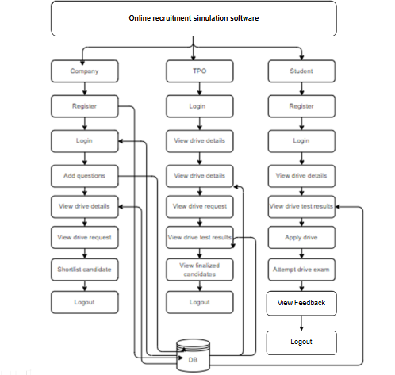

4.REQUIREMENT ANALYSIS
4.1 Functional and non-functional requirements
Requirement’s analysis is very critical process that enables the success of a system or software project to be assessed. Requirements are generally split into two types: Functional and non-functional requirements.
Functional Requirements: These are the requirements that the end user specifically demands as basic facilities that the system should offer. All these functionalities need to be necessarily incorporated into the system as a part of the contract. These are represented or stated in the form of input to be given to the system, the operation performed and the output expected. They are basically the requirements stated by the user which one can see directly in the final product, unlike the non-functional requirements.
Examples of functional requirements:
- Authentication of user whenever he/she logs into the system
- System shutdown in case of a cyber-attack
- A verification email is sent to user whenever he/she register for the first time on some software system.
Non-functional requirements: These are basically the quality constraints that the system must satisfy according to the project contract. The priority or extent to which these factors are implemented varies from one project to other. They are also called non-behavioral requirements.
They basically deal with issues like:
- Portability
- Security
- Maintainability
- Reliability
- Scalability
- Performance
- Reusability
- Flexibility
Examples of non-functional requirements:
- Emails should be sent with a latency of no greater than 12 hours from such an activity.
- The processing of each request should be done within 10 seconds
- The site should load in 3 seconds whenever of simultaneous users are > 10000
  - Hardware Requirements

Processor - I3/Intel Processor
Hard Disk - 160GB
Key Board - Standard Windows Keyboard
Mouse - Two or Three Button Mouse
Monitor - SVGA
RAM - 8GB
  - Software Requirements:
Operating System : Windows 7/8/10
Server side Script : HTML, CSS, Bootstrap & JS
Programming Language : Python
Libraries : Django, Pandas, Mysql.connector, Os, Smtplib, Numpy
IDE/Workbench : VS Code
Technology : Python 3.6+
Server Deployment : Xampp Server
Database : MySQL

SYSTEM DESIGN:

Input Design:
In an information system, input is the raw data that is processed to produce output. During the input design, the developers must consider the input devices such as PC, MICR, OMR, etc.
Therefore, the quality of system input determines the quality of system output. Well-designed input forms and screens have following properties −
- It should serve specific purpose effectively such as storing, recording, and retrieving the information.
- It ensures proper completion with accuracy.
- It should be easy to fill and straightforward.
- It should focus on user’s attention, consistency, and simplicity.
- All these objectives are obtained using the knowledge of basic design principles regarding −
  - What are the inputs needed for the system?
  - How end users respond to different elements of forms and screens.

Objectives for Input Design:
The objectives of input design are −
- To design data entry and input procedures
- To reduce input volume
- To design source documents for data capture or devise other data capture methods
- To design input data records, data entry screens, user interface screens, etc.
- To use validation checks and develop effective input controls.
Output Design:
The design of output is the most important task of any system. During output design, developers identify the type of outputs needed, and consider the necessary output controls and prototype report layouts.

Objectives of Output Design:
The objectives of input design are:
- To develop output design that serves the intended purpose and eliminates the production of unwanted output.
- To develop the output design that meets the end user’s requirements.
- To deliver the appropriate quantity of output.
- To form the output in appropriate format and direct it to the right person.
- To make the output available on time for making good decisions.
  - Architecture:
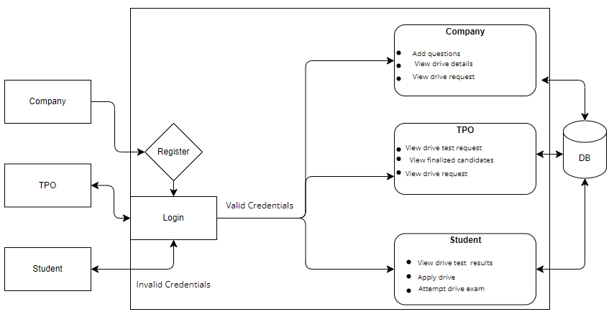

5. SYSTEM DESIGN
5.1 Introduction of Input Design:
In an information system, input is the raw data that is processed to produce output. During the input design, the developers must consider the input devices such as PC, MICR, OMR, etc.
Therefore, the quality of system input determines the quality of system output. Well-designed input forms and screens have following properties −
- It should serve specific purpose effectively such as storing, recording, and retrieving the information.
- It ensures proper completion with accuracy.
- It should be easy to fill and straightforward.
- It should focus on user’s attention, consistency, and simplicity.
- All these objectives are obtained using the knowledge of basic design principles regarding −
  - What are the inputs needed for the system?
  - How end users respond to different elements of forms and screens.

Objectives for Input Design:
The objectives of input design are −
- To design data entry and input procedures
- To reduce input volume
- To design source documents for data capture or devise other data capture methods
- To design input data records, data entry screens, user interface screens, etc.
- To use validation checks and develop effective input controls.
Output Design:
The design of output is the most important task of any system. During output design, developers identify the type of outputs needed, and consider the necessary output controls and prototype report layouts.

Objectives of Output Design:
The objectives of input design are:
- To develop output design that serves the intended purpose and eliminates the production of unwanted output.
- To develop the output design that meets the end user’s requirements.
- To deliver the appropriate quantity of output.
- To form the output in appropriate format and direct it to the right person.
- To make the output available on time for making good decisions.
5.2 UML Diagrams:
5.2.1 Use Case Diagram:
A use case diagram in the Unified Modeling Language (UML) is a type of behavioral diagram defined by and created from a Use-case analysis. Its purpose is to present a graphical overview of the functionality provided by a system in terms of actors, their goals (represented as use cases), and any dependencies between those use cases. The main purpose of a use case diagram is to show what system functions are performed for which actor. Roles of the actors in the system can be depicted.

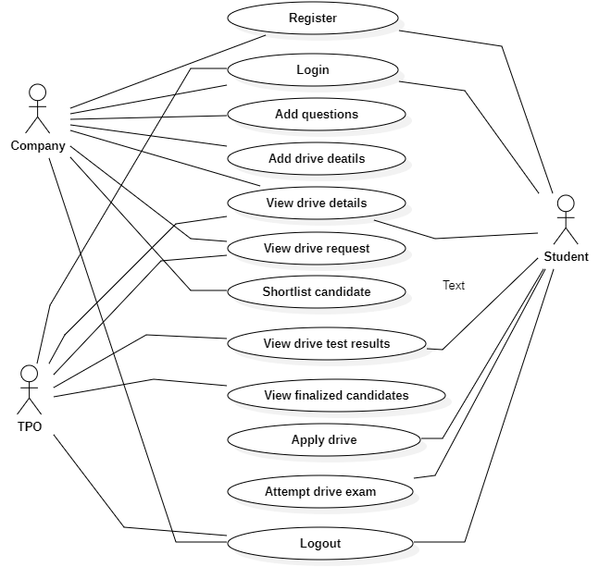

5.2.2 Class Diagram:
In software engineering, a class diagram in the Unified Modelling Language (UML) is a type of static structure diagram that describes the structure of a system by showing the system's classes, their attributes, operations (or methods), and the relationships among the classes. It explains which class contains information.

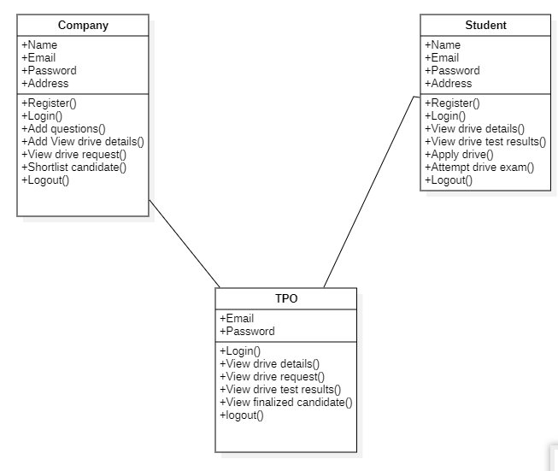
5.2.3 Sequence Diagram:
A sequence diagram in Unified Modelling Language (UML) is a kind of interaction diagram that shows how processes operate with one another and in what order. It is a construct of a Message Sequence Chart. Sequence diagrams are sometimes called event diagrams, event scenarios, and timing diagrams.

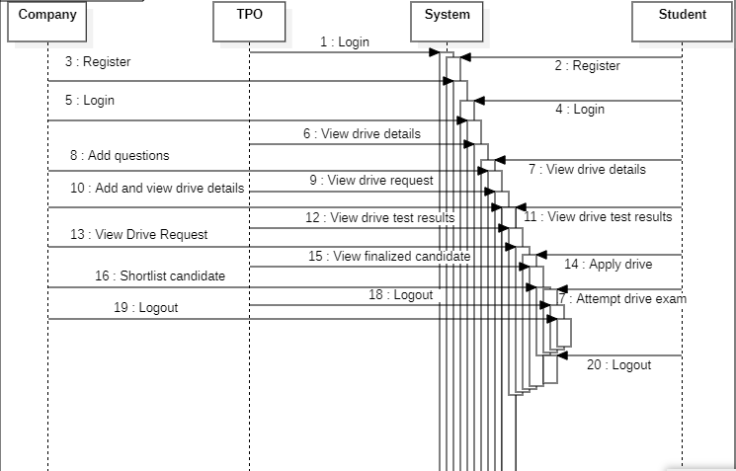
5.2.4 Collaboration Diagram:
In collaboration diagram the method call sequence is indicated by some numbering technique as shown below. The number indicates how the methods are called one after another. We have taken the same order management system to describe the collaboration diagram. The method calls are similar to that of a sequence diagram. But the difference is that the sequence diagram does not describe the object organization whereas the collaboration diagram shows the object organization.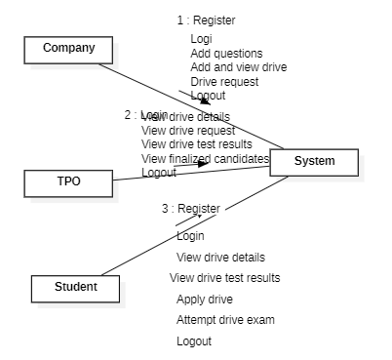
5.2.5 Deployment Diagram
Deployment diagram represents the deployment view of a system. It is related to the component diagram. Because the components are deployed using the deployment diagrams. A deployment diagram consists of nodes. Nodes are nothing but physical hardware’s used to deploy the application.
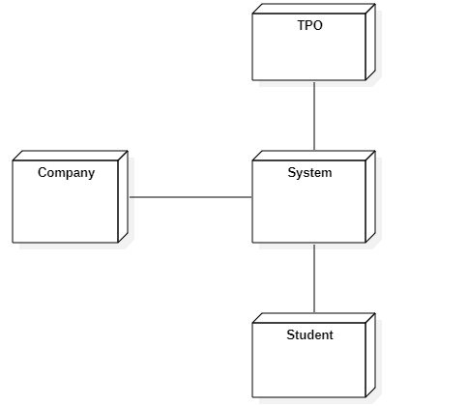
5.2.6 Activity Diagram:
Activity diagrams are graphical representations of workflows of stepwise activities and actions with support for choice, iteration and concurrency. In the Unified Modelling Language, activity diagrams can be used to describe the business and operational step-by-step workflows of components in a system. An activity diagram shows the overall flow of control.
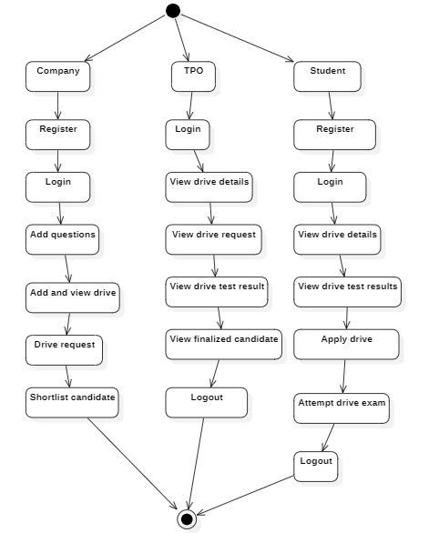
5.2.7 Component Diagram:
A component diagram, also known as a UML component diagram, describes the organization and wiring of the physical components in a system. Component diagrams are often drawn to help model implementation details and double-check that every aspect of the system's required functions is covered by planned development.
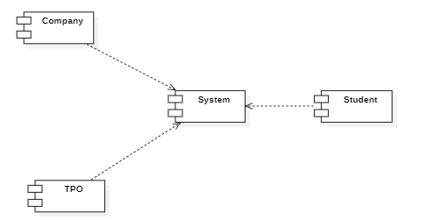

5.2.8 ER Diagram:
An Entity–relationship model (ER model) describes the structure of a database with the help of a diagram, which is known as Entity Relationship Diagram (ER Diagram). An ER model is a design or blueprint of a database that can later be implemented as a database. The main components of E-R model are: entity set and relationship set.
An ER diagram shows the relationship among entity sets. An entity set is a group of similar entities and these entities can have attributes. In terms of DBMS, an entity is a table or attribute of a table in database, so by showing relationship among tables and their attributes, ER diagram shows the complete logical structure of a database. Let’s have a look at a simple ER diagram to understand this concept.
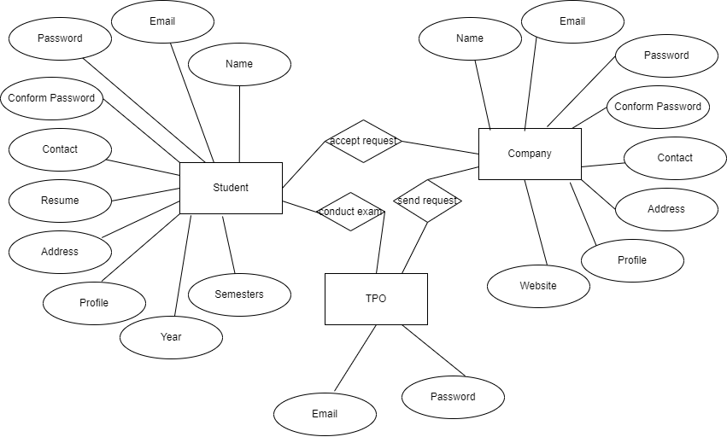
5.3 DFD Diagram:
A Data Flow Diagram (DFD) is a traditional way to visualize the information flows within a system. A neat and clear DFD can depict a good amount of the system requirements graphically. It can be manual, automated, or a combination of both. It shows how information enters and leaves the system, what changes the information and where information is stored. The purpose of a DFD is to show the scope and boundaries of a system as a whole. It may be used as a communications tool between a systems analyst and any person who plays a part in the system that acts as the starting point for redesigning a system.
Level 0:

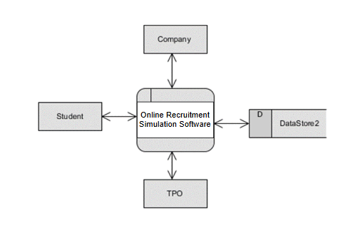

Level 1 Diagram:
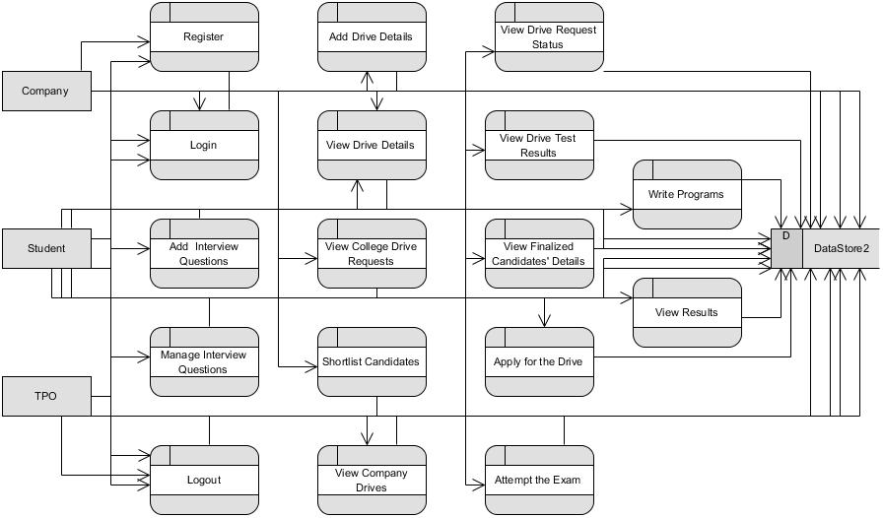

Level 2 Diagram:

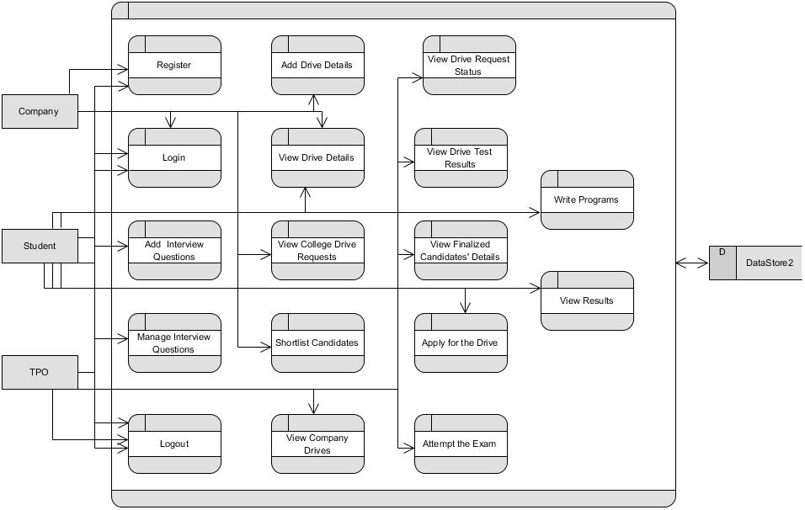

MODULES/IMPLEMENTATION
6.1 MODULES:
- Company Module
  - Register: - Companies can register on the website by entering their details.
  - Login: - Companies can log in to the website using their credentials.
  - Add/Update/Delete Interview Questions:- The company drive head can perform three operations (add, update, delete) for interview questions.
    - Two stages need to be added:
    - MCQ's Test
    - Coding Test
  - Add Drive Details:- The company drive head can provide the following drive details:
    - Date of conduct
    - Candidate marks percentage
    - No backlogs
    - Stages of exam
    - Job vacancies
    - Job description
    - Salary
    - Acceptable department
  - View Drive Details:- The company drive head can perform two operations: update and delete.
  - View College Drive Requests:- The company drive head can view college drive conduct requests and accept or reject them.
  - Shortlist Candidates:-
    - The company drive head can view shortlisted candidates' details from colleges.
    - The company drive head can send a job confirmation message/letter via email.
  - Logout:- The company drive head can log out after completing their operations.
- Training & Placement Officer (TPO) Module
- Login:- TPOs can log in to the website using their credentials.
- View Company Drives: - TPOs can send a request to company drives.
- View Drive Request Status:- TPOs can check whether the company accepted or rejected the request.
- If accepted, the placement office can share the full drive info on the website for student visibility.
- View Drive Test Results:- TPOs can view stage-wise drive results.
- View Finalized Candidates' Details:- After the company sends a final mail, the TPO can view the details.
- Logout:- TPOs can log out after completing their operations.
- Student/Candidate Module
- Register:- Students can register on the website by entering their details.
- Login:- Students can log in to the website using their credentials.
- View Drive Details:- Students can view job descriptions and details about the drive.
- Apply for the Drive:- Students can apply for a drive by entering their details.
- Attempt the Exam:- If their details are shortlisted, students can attempt the drive test.
- Write Programs:- There are two stages:
    - MCQ's Test
    - Coding Test
    - If shortlisted in the first round, the candidate proceeds to the second coding round. Here, they must solve two coding questions. If the candidate achieves a 100% pass percentage in the coding test, they are eligible for the job.
- View Results: - Students can view their results to see if they were selected.
    - If selected, they will receive a confirmation email.
- FeedBack :- Student can view their exam performance feedback.
- Logout:- Student can log out after completing their operations.

6.2 Results:

8. SYSTEM STUDY AND TESTING
8.1 Feasibility Study
The feasibility of the project is analysed in this phase and business proposal is put forth with a very general plan for the project and some cost estimates. During system analysis the feasibility study of the proposed system is to be carried out. This is to ensure that the proposed system is not a burden to the company. For feasibility analysis, some understanding of the major requirements for the system is essential.
Three key considerations involved in the feasibility analysis are
- Economic feasibility
- Technical feasibility
- Social feasibility
Economic Feasibility
This study is carried out to check the economic impact that the system will have on the organization. The amount of fund that the company can pour into the research and development of the system is limited. The expenditures must be justified. Thus the developed system as well within the budget and this was achieved because most of the technologies used are freely available. Only the customized products had to be purchased.

Technical Feasibility
This study is carried out to check the technical feasibility, that is, the technical requirements of the system. Any system developed must not have a high demand on the available technical resources. This will lead to high demands on the available technical resources. This will lead to high demands being placed on the client. The developed system must have a modest requirement, as only minimal or null changes are required for implementing this system.
Social Feasibility
The aspect of study is to check the level of acceptance of the system by the user. This includes the process of training the user to use the system efficiently. The user must not feel threatened by the system, instead must accept it as a necessity. The level of acceptance by the users solely depends on the methods that are employed to educate the user about the system and to make him familiar with it. His level of confidence must be raised so that he is also able to make some constructive criticism, which is welcomed, as he is the final user of the system.
System Testing
The purpose of testing is to discover errors. Testing is the process of trying to discover every conceivable fault or weakness in a work product. It provides a way to check the functionality of components, sub-assemblies, assemblies and/or a finished product It is the process of exercising software with the intent of ensuring that the
Software system meets its requirements and user expectations and does not fail in an unacceptable manner. There are various types of test. Each test type addresses a specific testing requirement.

8.2 Types of Tests

8.2.1 Unit testing
Unit testing involves the design of test cases that validate that the internal program logic is functioning properly, and that program inputs produce valid outputs. All decision branches and internal code flow should be validated. It is the testing of individual software units of the application .it is done after the completion of an individual unit before integration. This is a structural testing, that relies on knowledge of its construction and is invasive. Unit tests perform basic tests at component level and test a specific business process, application, and/or system configuration. Unit tests ensure that each unique path of a business process performs accurately to the documented specifications and contains clearly defined inputs and expected results.

8.2.2 Integration testing
Integration tests are designed to test integrated software components to determine if they actually run as one program. Testing is event driven and is more concerned with the basic outcome of screens or fields. Integration tests demonstrate that although the components were individually satisfaction, as shown by successfully unit testing, the combination of components is correct and consistent. Integration testing is specifically aimed at exposing the problems that arise from the combination of components.
Software integration testing is the incremental integration testing of two or more integrated software components on a single platform to produce failures caused by interface defects.
The task of the integration test is to check that components or software applications, e.g. components in a software system or – one step up – software applications at the company level – interact without error.
Test Results: All the test cases mentioned above passed successfully. No defects encountered.

Acceptance Testing
User Acceptance Testing is a critical phase of any project and requires significant participation by the end user. It also ensures that the system meets the functional requirements.
Test Results: All the test cases mentioned above passed successfully. No defects encountered.

8.2.3 Functional testing
Functional tests provide systematic demonstrations that functions tested are available as specified by the business and technical requirements, system documentation, and user manuals.
Functional testing is centred on the following items:
Valid Input : identified classes of valid input must be accepted.
Invalid Input : identified classes of invalid input must be rejected.
Functions : identified functions must be exercised.
Output : identified classes of application outputs must be exercised.
Systems/Procedures: interfacing systems or procedures must be invoked.
Organization and preparation of functional tests is focused on requirements, key functions, or special test cases. In addition, systematic coverage pertaining to identify Business process flows; data fields, predefined processes, and successive processes must be considered for testing. Before functional testing is complete, additional tests are identified and the effective value of current tests is determined.

8.2.4 White Box Testing
White Box Testing is a testing in which in which the software tester has knowledge of the inner workings, structure and language of the software, or at least its purpose. It is purpose. It is used to test areas that cannot be reached from a black box level.

8.2.5 Black Box Testing
Black Box Testing is testing the software without any knowledge of the inner workings, structure or language of the module being tested. Black box tests, as most other kinds of tests, must be written from a definitive source document, such as specification or requirements document, such as specification or requirements document. It is a testing in which the software under test is treated, as a black box. you cannot “see” into it. The test provides inputs and responds to outputs without considering how the software works.
Test objectives
- All field entries must work properly.
- Pages must be activated from the identified link.
- The entry screen, messages and responses must not be delayed.
Features to be tested
- Verify that the entries are of the correct format
- No duplicate entries should be allowed
- All links should take the user to the correct page.
- TEST CASES:
Input | Output | Result
Input text files | An Efficient Privacy Preserving Public Auditing Protocol for Cloud-Based Medical Storage System | Success

- Test cases Model building:
S.NO | Test cases | I/O | Expected O/T | Actual O/T | P/F
1 | Register Students, Company | Enter name, email, password, conform password, contact, address. | Registered successfully. | Registered successfully | P
2 | Login Students, Company | Enter email, password. | Login successful | Login successful | P
3 | Login Students, Company | Enter email, password. | Login successful | Login fail | F
4 | Add Derive details | Enter date of conduct, marks, exam stage, salary, job description. | Data added successfully | Data added successfully | P
5 | Add Exam | Enter MCQ, coding test | Data added successfully | Fail to add data | F

- CONCLUSION:
In conclusion, the Campus Placement Recruitment System stands as a pivotal tool in modernizing and streamlining the campus recruitment process. By providing a centralized platform for companies, training and placement officers, and students, it facilitates efficient management and transparent communication throughout the recruitment cycle. Its ability to handle various aspects, from job postings and application submissions to interview management and results tracking, ensures a seamless experience for all parties involved. Future enhancements, such as AI-driven analytics, virtual assessment tools, and expanded support for international placements, will further elevate the system's effectiveness and adaptability, making it a cornerstone of successful campus recruitment.
10. FUTURE ENHANCEMENT
Future enhancements for the Campus Placement Recruitment System could include integrating AI-driven analytics to predict candidate suitability and optimize recruitment drives. Implementing real-time video interview capabilities and virtual assessment centers would modernize the recruitment process. Expanding the platform to support international recruitment and internships can broaden opportunities for students. Additionally, incorporating personalized dashboards and feedback mechanisms for all stakeholders could improve user experience and engagement. Enhanced data security measures and mobile application support would ensure accessibility and protect sensitive information. These upgrades aim to provide a more dynamic, inclusive, and secure platform for effective campus placements.
11. REFERANCES
1. Choudhary, A., & Churi, P. (2018). "An Automated Recruitment System Using Data Mining and Analytics." International Journal of Computer Applications, 182(7), 1-6.
2. Sharma, A., & Bhatia, P. K. (2015). "A Survey on Decision Tree Algorithms of Classification in Data Mining." International Journal of Science and Research (IJSR), 4(4), 2094-2097.
3. Jain, A., & Kapoor, S. (2017). "A Literature Survey on Performance Evaluation in Placement Prediction Using Machine Learning Algorithms." International Journal of Engineering and Computer Science, 6(7), 22031-22036.
4. Raj, P., & Raj, S. (2016). "Campus Recruitment System Using Data Mining." International Journal of Advanced Research in Computer Science, 7(3), 198-200.
5. Tiwari, N., & Sharma, D. (2019). "A Study on Automated Placement Management System." International Journal of Computer Sciences and Engineering, 7(3), 542-546.
6. Yadav, R., & Khemchandani, V. (2017). "Placement Prediction System Using Decision Tree." International Journal of Computer Applications, 163(3), 15-18.
7. Gupta, R., & Verma, M. (2020). "Efficient and Secure Campus Recruitment Management System." Journal of Emerging Technologies and Innovative Research, 7(5), 530-533.
8. Patel, P., & Shah, D. (2018). "Data Mining Based Placement Management System." International Journal of Research in Advent Technology, 6(3), 112-115.
9. Kumar, S., & Rani, S. (2017). "Enhancing the Recruitment Process Using Advanced Technologies." International Journal of Innovative Research in Computer and Communication Engineering, 5(6), 11684-11689.
10. Mishra, S., & Mohanty, B. (2016). "Campus Placement Prediction Using Machine Learning Techniques." International Journal of Advanced Research in Computer Science and Software Engineering, 6(9), 20-24.
11. Wang, Y., & Wang, X. (2023). "Automated Campus Recruitment System Using Machine Learning." Journal of Computer Science and Technology, 38(2), 300-315.
12. Gupta, M., & Verma, S. (2022). "Secure and Scalable Campus Placement Management System." Journal of Emerging Technologies and Innovative Research, 8(1), 120-127.
13. Kumar, N., & Jain, P. (2021). "A Comprehensive Survey on Campus Placement Systems Using AI." International Journal of Information Technology and Computer Science, 14(6), 90-98.

