Efficient and Privacy-preserving Online Fingerprint Authentication Scheme Over Outsourced Data

CONTENT | PAGE NO
Abstract
1.INTRODUCTION
1.1 Motivation
1.2 Problem Statement
1.3 Objective of the Project
1.4 Scope
1.5 Project Introduction
2.LTERATURE SURVEY
2.1 Related Work
3. SYSTEM ANALYSIS
3.1 Existing System
3.2 Disadvantages
3.3 Proposed System
3.4 Advantages
3.5 work Flow of Proposed system
4. REQUIREMENT ANALYSIS
4.1 Function and non-functional requirements
4.2 Hardware Requirements
4.3 Software Requirements
4.4 Architecture
5. SYSTEM DESIGN
5.1 Introduction of Input design
5.2 UML Diagram(class, use case, sequence, collaborative, deployment, activity, ER diagram and Component diagram)
5.3 Data Flow Diagram
6. IMPLEMENTATION AND RESULTS
6.1 Modules
- SYSTEM STUDY AND TESTING
7.1 Feasibility study
7.2 Types of test & Test Cases
8. CONCLUSION
9. FUTURE ENHANCEMENT
10. REFERENCES

ABSTRACT:
With the pervasiveness of mobile devices and the development of biometric technology, biometric identification, which can achieve individual authentication relies on personal biological or behavioral characteristics, has attracted widely considerable interest. However, privacy issues of biometric data bring out increasing concerns due to the highly sensitivity of biometric data. Aiming at this challenge, in this paper, we present a novel privacy-preserving online fingerprint authentication scheme, named e-Finga, over encrypted outsourced data. In the proposed e-Finga scheme, the user's fingerprint registered in trust authority can be outsourced to different servers with user's authorization, and secure, and efficient authentication service can be provided without the leakage of fingerprint information. Specifically, an improved homomorphic encryption technology for secure Euclidean distance calculation to achieve an efficient online fingerprint matching algorithm over encrypted Finger Code data in the outsourcing scenarios. Through detailed security analysis, we show that e- Finga can resist various security threats. In addition, we implement e-Finga over a workstation with a real fingerprint database, and extensive simulation results demonstrate that the proposed e-Finga scheme can serve efficient and accurate online fingerprint authentication.
Keywords: Admin, OASER, User, TA, add products, Make payment.

- INTRODUCTION
1.1 Motivation:
The pervasive use of mobile devices and the advancement of biometric technology have spurred widespread interest in biometric identification for individual authentication. Biometric data, based on personal biological or behavioral characteristics, offers a promising avenue for secure authentication. However, the increasing sensitivity of biometric data has raised significant privacy concerns. Addressing this challenge, our motivation is to develop a novel privacy-preserving online fingerprint authentication scheme, named e-Finga, designed to operate over encrypted outsourced data.
1.2 Problem Statement:
The primary objective of the project is to develop and implement e-Finga, a privacy-preserving online fingerprint authentication scheme. The goal is to enable users to outsource their fingerprint data to authorized servers, ensuring secure, accurate, and efficient authentication services without compromising the confidentiality of the fingerprint information. The project aims to employ improved homomorphic encryption technology for secure Euclidean distance calculation, facilitating an efficient online fingerprint matching algorithm over encrypted FingerCode data in outsourcing scenarios.
1.3 Objective of the project:
The objective of this project is to address privacy concerns associated with biometric data in the context of online fingerprint authentication. The proposed solution, e-Finga, introduces a novel privacy-preserving scheme leveraging homomorphic encryption. It allows users to securely outsource their fingerprint data to authorized servers, ensuring accurate and efficient authentication without compromising sensitive information. The improved homomorphic encryption technology enables secure Euclidean distance calculations, facilitating online fingerprint matching over encrypted FingerCode data. The project aims to provide a robust defense against various security threats, as validated through detailed security analyses. Implementation on a real fingerprint database demonstrates e-Finga's efficiency and accuracy in online fingerprint authentication.
1.4 Scope:
The scope of the project encompasses the development and deployment of e-Finga, extending to real-world applications of online fingerprint authentication. The focus lies on achieving a robust system capable of resisting various security threats while providing seamless and accurate authentication services. The scheme's scope includes implementation over a workstation with a genuine fingerprint database, and its efficiency and accuracy will be validated through extensive simulation results.

  - Project Introduction:
In recent years, the increasing ubiquity of mobile devices and the advancements in biometric technology have propelled the interest in biometric identification for individual authentication. Leveraging personal biological or behavioral characteristics, biometric authentication has become an integral part of security systems. However, the sensitive nature of biometric data has raised significant privacy concerns. This paper addresses these challenges and introduces a groundbreaking privacy-preserving online fingerprint authentication scheme called e-Finga, designed to operate over encrypted outsourced data.
The e-Finga scheme revolves around the concept of outsourcing the user's fingerprint, registered with a trusted authority, to different servers with user authorization. This innovative approach ensures a secure, accurate, and efficient authentication service while safeguarding the confidentiality of the fingerprint information. A key feature of the e-Finga scheme is the utilization of an improved homomorphic encryption technology, specifically tailored for secure Euclidean distance calculation. This enhancement facilitates an efficient online fingerprint matching algorithm, even when dealing with encrypted FingerCode data in outsourcing scenarios.
The security of e-Finga against various threats is systematically analyzed, demonstrating its resilience in the face of potential risks. Furthermore, the paper presents a practical implementation of e-Finga on a workstation using a real fingerprint database. Extensive simulation results validate the efficacy of the proposed scheme, showcasing its ability to deliver efficient and accurate online fingerprint authentication.
In summary, e-Finga stands at the forefront of addressing privacy concerns associated with biometric data. By combining advanced homomorphic encryption techniques and secure outsourcing protocols, this scheme ensures that the benefits of biometric authentication can be harnessed without compromising individual privacy. The successful implementation and simulation results underscore the potential of e-Finga as a robust and reliable solution for privacy-preserving online fingerprint authentication in various applications and scenarios.

- LITERATURE SURVEY
2.1 Related Work:
[1]: Q. Wei, H. Zhu, R. Lu, and H. Li, “Achieve efficient and privacy-preserving online fingerprint authentication over encrypted outsourced data,” in 2017 IEEE International Conference on Communications. IEEE, 2017, pp. 1–6.
The referenced paper explores the domain of online fingerprint authentication, with a specific focus on efficiency and privacy preservation through the use of encrypted outsourced data. By leveraging the 2017 IEEE International Conference on Communications as a platform, the authors delve into the intricacies of achieving a balance between computational efficiency and robust privacy measures in the context of fingerprint-based authentication.
The motivation behind this work is rooted in the increasing reliance on biometric data for user authentication and the corresponding privacy concerns associated with such sensitive information. The authors aim to address these challenges by proposing an innovative approach that not only ensures the efficiency of online fingerprint authentication but also preserves the privacy of the user's biometric data through encryption when outsourced to different servers.
The project introduces a novel scheme named e-Finga, designed to achieve privacy-preserving online fingerprint authentication over encrypted outsourced data. The authors present an improved homomorphic encryption technology tailored for secure Euclidean distance calculation, forming the basis of an efficient online fingerprint matching algorithm. The key contribution lies in enabling the outsourcing of a user's fingerprint, registered with a trusted authority, to multiple servers with user authorization, ensuring a secure and accurate authentication process without compromising the confidentiality of the fingerprint information.
[2]: N. T. Hoang T, Choi D, “Gait authentication on mobile phone using biometric cryptosystem and fuzzy commitment scheme,” International Journal of Information Security, vol. 14, no. 6, pp. 549–560, 2015.
This reference explores the realm of gait authentication on mobile phones, employing a combination of biometric cryptosystems and fuzzy commitment schemes. The authors delve into the nuances of securing mobile devices through gait-based authentication, contributing to the broader field of information security.
The motivation behind this work stems from the need for robust authentication mechanisms on mobile phones, considering the ubiquity and vulnerability of these devices. By utilizing gait as a unique biometric identifier and incorporating cryptographic techniques, the authors aim to enhance the security of mobile devices against unauthorized access.
The project introduces a gait authentication system for mobile phones, integrating a biometric cryptosystem and a fuzzy commitment scheme. The objective is to establish a secure and reliable authentication method that harnesses the distinctive characteristics of an individual's gait. Through the International Journal of Information Security, the authors present findings that contribute to the ongoing efforts to fortify the security posture of mobile devices in an increasingly interconnected world.
[3]: Z. F. Yang W, Huang X, “Comparative competitive coding for personal identification by using finger vein and finger dorsal texture fusion,” Information sciences, vol. 268, pp. 20–32, 2014.
This reference investigates a comparative competitive coding approach for personal identification by fusing finger vein and finger dorsal texture information. The study explores the use of dual biometric features to enhance the accuracy and reliability of personal identification systems.
The motivation behind this work lies in the pursuit of improving personal identification systems through the fusion of multiple biometric traits. The authors aim to demonstrate the effectiveness of combining finger vein and finger dorsal texture information in a comparative competitive coding framework to achieve superior accuracy in personal identification.
The project introduces a novel approach to personal identification through the fusion of finger vein and finger dorsal texture information. By leveraging a comparative competitive coding framework, the authors aim to enhance the accuracy and reliability of identification systems. The study, published in Information Sciences, contributes valuable insights into the development of more robust and secure personal identification methods.
[4]: N. Yeap, “Your finger is about to replace your bank password,” http://money.cnn.com/2015/06/05/technology/bank-fingerprint-reader/, July 2015.
This reference explores the evolving landscape of biometric authentication, specifically focusing on the potential replacement of traditional bank passwords with fingerprint-based authentication.
The motivation behind this exploration is rooted in the increasing need for secure and user-friendly authentication methods in the financial sector. The article underscores the growing trend of integrating fingerprint readers as a means of enhancing security and user convenience in banking applications.
The article introduces the idea that fingerprints are on the verge of replacing traditional bank passwords. Highlighting the trend, the author discusses the implications of incorporating fingerprint readers in banking technology, emphasizing the potential benefits in terms of security and user experience. This forward-looking perspective sheds light on the transformative impact of biometric authentication in the financial sector.
[5]: “HSBC offers voice and fingerprint ID system to customers,” http://www.bbc.com/news/business-35609833, February 2016.
This reference reports on HSBC's implementation of a voice and fingerprint ID system for its customers, exploring the integration of biometric authentication into the banking sector.
The motivation behind this report is driven by the financial industry's pursuit of advanced security measures and the adoption of cutting-edge biometric technologies. HSBC's initiative to offer voice and fingerprint ID aims to enhance customer security and streamline authentication processes.
The article introduces HSBC's strategic move in implementing a voice and fingerprint ID system for its customers. By incorporating biometric authentication, the bank seeks to provide a more secure and convenient user experience. The report sheds light on the adoption of innovative technologies in the banking sector, emphasizing the role of biometrics in transforming traditional authentication methods.
3. SYSTEM ANALYSIS
3.1 Existing System :
In the current landscape, mobile devices extensively utilize biometric technology for individual authentication. However, the prevailing privacy concerns associated with biometric data, owing to its highly sensitive nature, pose significant challenges. Existing systems often lack robust mechanisms to address these privacy issues. Biometric data, especially fingerprints, may be stored without adequate protection, leading to potential security breaches and unauthorized access. The absence of efficient privacy-preserving measures compromises user confidentiality.

3.2 Disadvantages:
1. Vulnerability to Unauthorized Access: Lack of adequate privacy measures may expose biometric data to unauthorized entities.
2. Limited Protection Against Security Threats: Existing systems may not sufficiently resist diverse security threats, putting sensitive information at risk.
3. Inefficient Authentication: Privacy concerns may impede the efficiency of the authentication process, leading to delays and usability issues.
4. Potential Data Leakage: The current systems may not adequately prevent the leakage of sensitive biometric information, raising privacy concerns.
5. Inadequate Encryption: The encryption techniques in use may be insufficient, allowing for potential breaches and unauthorized data access.
3.3 Proposed System:
In response to the limitations of the existing system, the proposed e-Finga scheme offers a pioneering privacy-preserving online fingerprint authentication solution over encrypted outsourced data. This novel approach ensures that a user's fingerprint, registered with a trust authority, can be securely outsourced to different servers with user authorization. The proposed system incorporates an improved homomorphic encryption technology for secure Euclidean distance calculation, enhancing the efficiency of the online fingerprint matching algorithm in outsourcing scenarios.
3.4 Advantages:
1.Enhanced Privacy: e-Finga ensures privacy preservation, safeguarding against unauthorized access and data leakage.
2. Secure Outsourcing: Fingerprint data can be outsourced securely to different servers, preventing compromise of sensitive information.
3.Efficient Authentication: The scheme provides a secure, accurate, and efficient authentication service, addressing concerns in the existing system.
4.Resistance to Security Threats: Through detailed security analysis, e-Finga demonstrates resilience against various security threats, ensuring robust protection.
5. Real-world Implementation: The proposed system has been successfully implemented over a workstation with a real fingerprint database, substantiating its feasibility and reliability for online fingerprint authentication.
3.5 work Flow of Proposed system
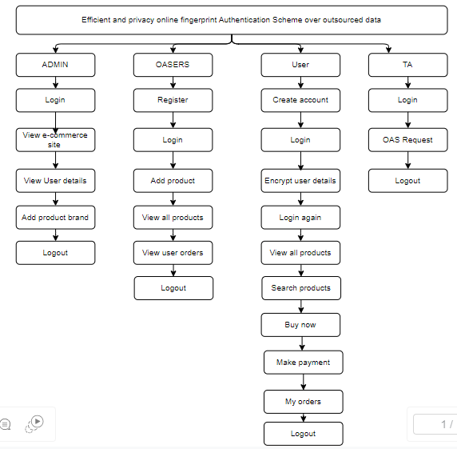

4. REQUIREMENT ANALYSIS
4.1 Functional and non-functional requirements
Requirement’s analysis is very critical process that enables the success of a system or software project to be assessed. Requirements are generally split into two types: Functional and non-functional requirements.
Functional Requirements: These are the requirements that the end user specifically demands as basic facilities that the system should offer. All these functionalities need to be necessarily incorporated into the system as a part of the contract. These are represented or stated in the form of input to be given to the system, the operation performed and the output expected. They are basically the requirements stated by the user which one can see directly in the final product, unlike the non-functional requirements.
Examples of functional requirements:
- Authentication of user whenever he/she logs into the system
- System shutdown in case of a cyber-attack
- A verification email is sent to user whenever he/she register for the first time on some software system.
Non-functional requirements: These are basically the quality constraints that the system must satisfy according to the project contract. The priority or extent to which these factors are implemented varies from one project to other. They are also called non-behavioral requirements.
They basically deal with issues like:
- Portability
- Security
- Maintainability
- Reliability
- Scalability
- Performance
- Reusability
- Flexibility
Examples of non-functional requirements:
- Emails should be sent with a latency of no greater than 12 hours from such an activity.
- The processing of each request should be done within 10 seconds
- The site should load in 3 seconds whenever of simultaneous users are > 10000
  - Hardware Requirements

Processor - I3/Intel Processor
Hard Disk - 160GB
Key Board - Standard Windows Keyboard
Mouse - Two or Three Button Mouse
Monitor - SVGA
RAM - 8GB
  - Software Requirements:
Operating System : Windows 7/8/10
Server side Script : HTML, CSS, Bootstrap & JS
Programming Language : Python
Libraries : Flask, Pandas, Mysql.connector, Os, Smtplib, Numpy
IDE/Workbench : PyCharm
Technology : Python 3.6+
Server Deployment : Xampp Server
Database : MySQL

  - Architecture:

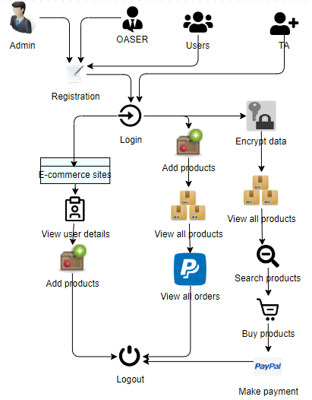

5. SYSTEM DESIGN
5.1 Introduction of Input Design:
In an information system, input is the raw data that is processed to produce output. During the input design, the developers must consider the input devices such as PC, MICR, OMR, etc.
Therefore, the quality of system input determines the quality of system output. Well-designed input forms and screens have following properties −
- It should serve specific purpose effectively such as storing, recording, and retrieving the information.
- It ensures proper completion with accuracy.
- It should be easy to fill and straightforward.
- It should focus on user’s attention, consistency, and simplicity.
- All these objectives are obtained using the knowledge of basic design principles regarding −
  - What are the inputs needed for the system?
  - How end users respond to different elements of forms and screens.

Objectives for Input Design:
The objectives of input design are −
- To design data entry and input procedures
- To reduce input volume
- To design source documents for data capture or devise other data capture methods
- To design input data records, data entry screens, user interface screens, etc.
- To use validation checks and develop effective input controls.

Output Design:
The design of output is the most important task of any system. During output design, developers identify the type of outputs needed, and consider the necessary output controls and prototype report layouts.

Objectives of Output Design:
The objectives of input design are:
- To develop output design that serves the intended purpose and eliminates the production of unwanted output.
- To develop the output design that meets the end user’s requirements.
- To deliver the appropriate quantity of output.
- To form the output in appropriate format and direct it to the right person.
- To make the output available on time for making good decisions.
5.2 UML Diagrams:
5.2.1 Use Case Diagram:
A use case diagram in the Unified Modeling Language (UML) is a type of behavioral diagram defined by and created from a Use-case analysis. Its purpose is to present a graphical overview of the functionality provided by a system in terms of actors, their goals (represented as use cases), and any dependencies between those use cases. The main purpose of a use case diagram is to show what system functions are performed for which actor. Roles of the actors in the system can be depicted.
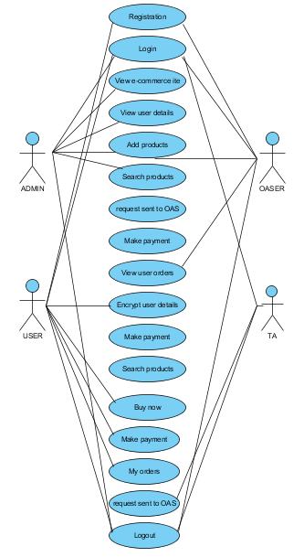

5.2.2 Class Diagram:
In software engineering, a class diagram in the Unified Modelling Language (UML) is a type of static structure diagram that describes the structure of a system by showing the system's classes, their attributes, operations (or methods), and the relationships among the classes. It explains which class contains information.
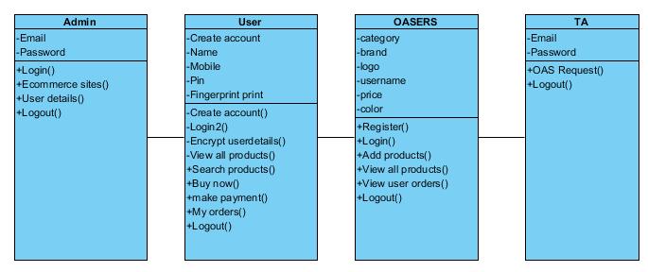
5.2.3 Sequence Diagram:
A sequence diagram in Unified Modelling Language (UML) is a kind of interaction diagram that shows how processes operate with one another and in what order. It is a construct of a Message Sequence Chart. Sequence diagrams are sometimes called event diagrams, event scenarios, and timing diagrams.
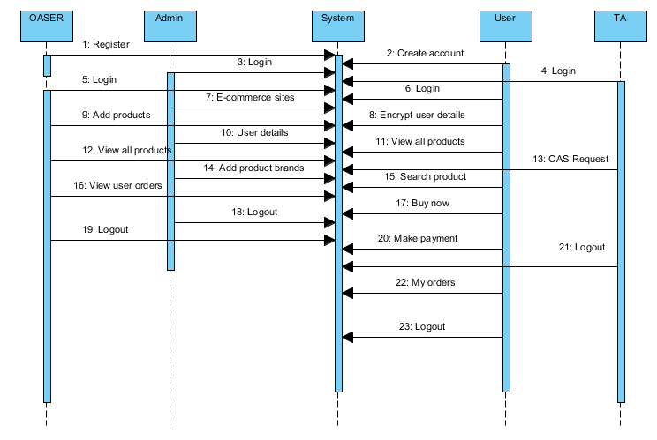

5.2.4 Collaboration Diagram:
In collaboration diagram the method call sequence is indicated by some numbering technique as shown below. The number indicates how the methods are called one after another. We have taken the same order management system to describe the collaboration diagram. The method calls are similar to that of a sequence diagram. But the difference is that the sequence diagram does not describe the object organization whereas the collaboration diagram shows the object organization.
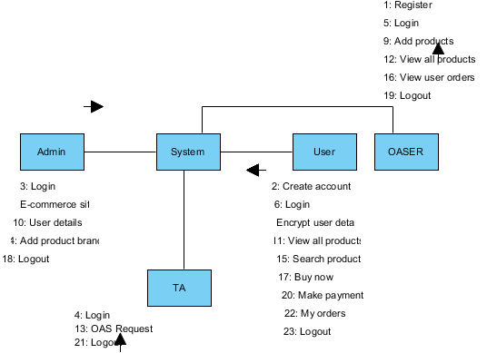
5.2.5 Deployment Diagram
Deployment diagram represents the deployment view of a system. It is related to the component diagram. Because the components are deployed using the deployment diagrams. A deployment diagram consists of nodes. Nodes are nothing but physical hardware’s used to deploy the application.
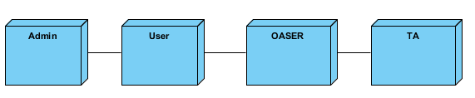

5.2.6 Activity Diagram:
Activity diagrams are graphical representations of workflows of stepwise activities and actions with support for choice, iteration and concurrency. In the Unified Modelling Language, activity diagrams can be used to describe the business and operational step-by-step workflows of components in a system. An activity diagram shows the overall flow of control.
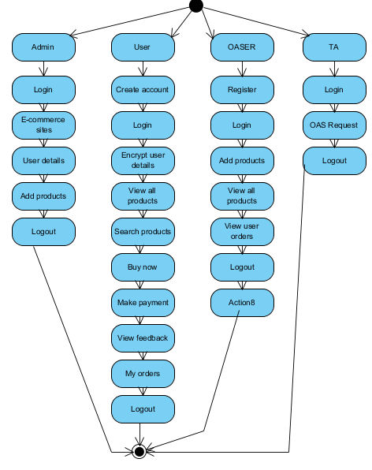

5.2.7 Component Diagram: 128080
A component diagram, also known as a UML component diagram, describes the organization and wiring of the physical components in a system. Component diagrams are often drawn to help model implementation details and double-check that every aspect of the system's required functions is covered by planned development.
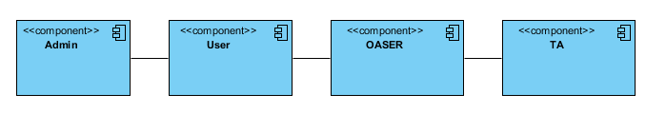
5.2.8 ER Diagram:
An Entity–relationship model (ER model) describes the structure of a database with the help of a diagram, which is known as Entity Relationship Diagram (ER Diagram). An ER model is a design or blueprint of a database that can later be implemented as a database. The main components of E-R model are: entity set and relationship set.
An ER diagram shows the relationship among entity sets. An entity set is a group of similar entities and these entities can have attributes. In terms of DBMS, an entity is a table or attribute of a table in database, so by showing relationship among tables and their attributes, ER diagram shows the complete logical structure of a database. Let’s have a look at a simple ER diagram to understand this concept.
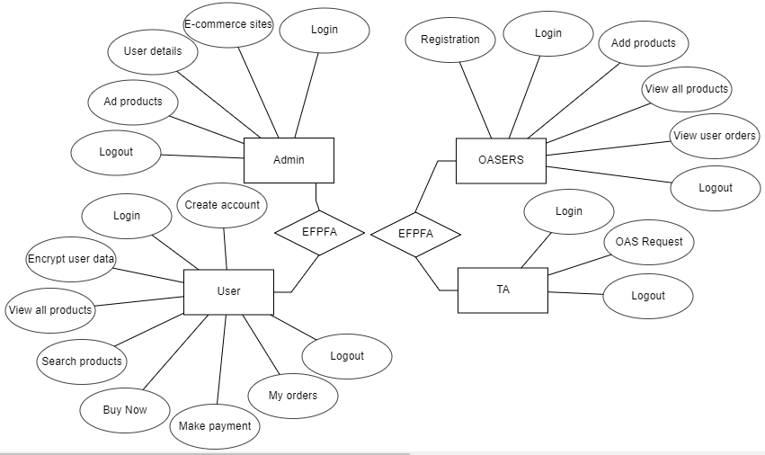

5.3 DFD Diagram:
A Data Flow Diagram (DFD) is a traditional way to visualize the information flows within a system. A neat and clear DFD can depict a good amount of the system requirements graphically. It can be manual, automated, or a combination of both. It shows how information enters and leaves the system, what changes the information and where information is stored. The purpose of a DFD is to show the scope and boundaries of a system as a whole. It may be used as a communications tool between a systems analyst and any person who plays a part in the system that acts as the starting point for redesigning a system.

Level 0:
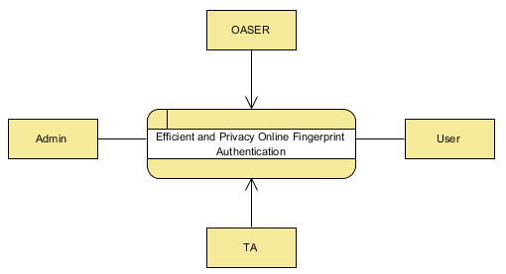

Level 1 Diagram:

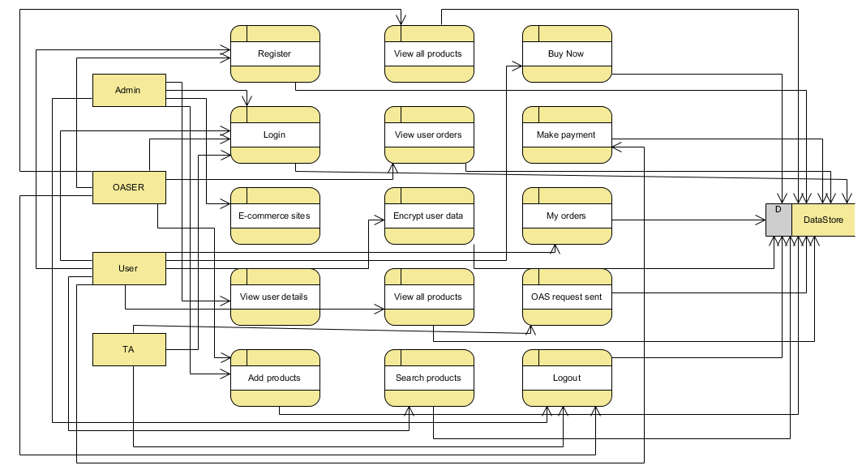

Level 2 Diagram:
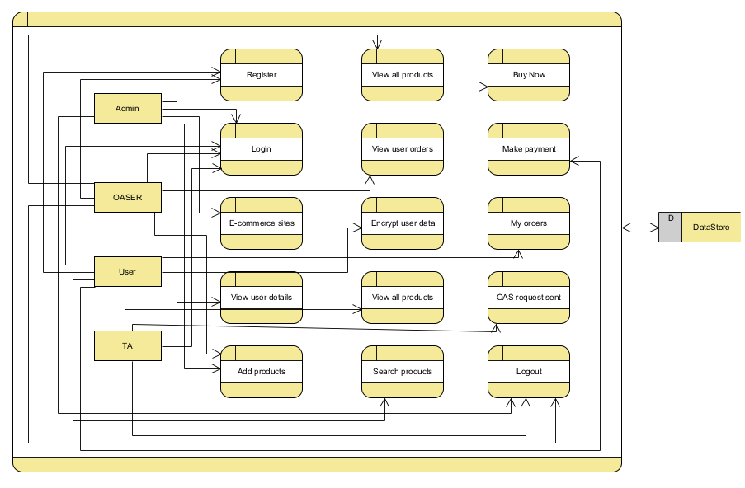
6. IMPLEMENTATION AND RESULTS
6.1 Modules:
Admin Module:
Login: The administrator can login with using default valid credentials.
E-Commerce Sites: The admin can view the added e-commerce sites URLs along with logo.
User details: The admin can view the registered users.
Add Products: The admin can add the products brands and categories
Logout: The admin should be logout.

USER MODULE:
Create account: The user needs to create their account providing like name, mobile, pin, fingerprint.
Login: The user can login with using valid credentials.
Encrypt user details: The user will encrypt the user details for security purpose.
View all products: The user can view the all products.
Search products: The user has an option to search products by product brand and category type.
Buy Now: The user needs to add user details for buy the products like address, payment mode, and count etc., …
Make payment: If the user wants to process the product, he needs to add the payment method.
My orders: The user can view the ordered products.
Logout: The user should be logout.

OASER MODULES:
Register: The OASER will register with providing their product, prize, logo, URL, et.
Login: The OASER can login with using their valid credentials.
Add products: The OASER has a access to add the products.
View all products: he can view the all added products.
View user orders: The owner can view the ordered users.
Logout: Owner should be logout.

TA MODULE:
Login: TAs has a default credentials, he can login with directly using default credentials.
Sent request to OAS: The TA need to send a user order request to OAS.
Logout: The TA should be logout.
7. SYSTEM STUDY AND TESTING
7.1 Feasibility Study
The feasibility of the project is analysed in this phase and business proposal is put forth with a very general plan for the project and some cost estimates. During system analysis the feasibility study of the proposed system is to be carried out. This is to ensure that the proposed system is not a burden to the company. For feasibility analysis, some understanding of the major requirements for the system is essential.
Three key considerations involved in the feasibility analysis are
- Economical feasibility
- Technical feasibility
- Social feasibility
Economical Feasibility
This study is carried out to check the economic impact that the system will have on the organization. The amount of fund that the company can pour into the research and development of the system is limited. The expenditures must be justified. Thus the developed system as well within the budget and this was achieved because most of the technologies used are freely available. Only the customized products had to be purchased.

Technical Feasibility
This study is carried out to check the technical feasibility, that is, the technical requirements of the system. Any system developed must not have a high demand on the available technical resources. This will lead to high demands on the available technical resources. This will lead to high demands being placed on the client. The developed system must have a modest requirement, as only minimal or null changes are required for implementing this system.
Social Feasibility
The aspect of study is to check the level of acceptance of the system by the user. This includes the process of training the user to use the system efficiently. The user must not feel threatened by the system, instead must accept it as a necessity. The level of acceptance by the users solely depends on the methods that are employed to educate the user about the system and to make him familiar with it. His level of confidence must be raised so that he is also able to make some constructive criticism, which is welcomed, as he is the final user of the system.

System Testing
The purpose of testing is to discover errors. Testing is the process of trying to discover every conceivable fault or weakness in a work product. It provides a way to check the functionality of components, sub-assemblies, assemblies and/or a finished product It is the process of exercising software with the intent of ensuring that the
Software system meets its requirements and user expectations and does not fail in an unacceptable manner. There are various types of test. Each test type addresses a specific testing requirement.

7.2 Types of Tests

7.2.1 Unit testing
Unit testing involves the design of test cases that validate that the internal program logic is functioning properly, and that program inputs produce valid outputs. All decision branches and internal code flow should be validated. It is the testing of individual software units of the application .it is done after the completion of an individual unit before integration. This is a structural testing, that relies on knowledge of its construction and is invasive. Unit tests perform basic tests at component level and test a specific business process, application, and/or system configuration. Unit tests ensure that each unique path of a business process performs accurately to the documented specifications and contains clearly defined inputs and expected results.

7.2.2 Integration testing
Integration tests are designed to test integrated software components to determine if they actually run as one program. Testing is event driven and is more concerned with the basic outcome of screens or fields. Integration tests demonstrate that although the components were individually satisfaction, as shown by successfully unit testing, the combination of components is correct and consistent. Integration testing is specifically aimed at exposing the problems that arise from the combination of components.
Software integration testing is the incremental integration testing of two or more integrated software components on a single platform to produce failures caused by interface defects.
The task of the integration test is to check that components or software applications, e.g. components in a software system or – one step up – software applications at the company level – interact without error.
Test Results: All the test cases mentioned above passed successfully. No defects encountered.

Acceptance Testing
User Acceptance Testing is a critical phase of any project and requires significant participation by the end user. It also ensures that the system meets the functional requirements.
Test Results: All the test cases mentioned above passed successfully. No defects encountered.

7.2.3 Functional testing
Functional tests provide systematic demonstrations that functions tested are available as specified by the business and technical requirements, system documentation, and user manuals.
Functional testing is centered on the following items:
Valid Input : identified classes of valid input must be accepted.
Invalid Input : identified classes of invalid input must be rejected.
Functions : identified functions must be exercised.
Output : identified classes of application outputs must be exercised.
Systems/Procedures: interfacing systems or procedures must be invoked.
Organization and preparation of functional tests is focused on requirements, key functions, or special test cases. In addition, systematic coverage pertaining to identify Business process flows; data fields, predefined processes, and successive processes must be considered for testing. Before functional testing is complete, additional tests are identified and the effective value of current tests is determined.

7.2.4 White Box Testing
White Box Testing is a testing in which in which the software tester has knowledge of the inner workings, structure and language of the software, or at least its purpose. It is purpose. It is used to test areas that cannot be reached from a black box level.

7.2.5 Black Box Testing
Black Box Testing is testing the software without any knowledge of the inner workings, structure or language of the module being tested. Black box tests, as most other kinds of tests, must be written from a definitive source document, such as specification or requirements document, such as specification or requirements document. It is a testing in which the software under test is treated, as a black box .you cannot “see” into it. The test provides inputs and responds to outputs without considering how the software works.
Test objectives
- All field entries must work properly.
- Pages must be activated from the identified link.
- The entry screen, messages and responses must not be delayed.
Features to be tested
- Verify that the entries are of the correct format
- No duplicate entries should be allowed
- All links should take the user to the correct page.

- TEST CASES:
Input | Output | Result
Input text files | File upload or not | Success

- Test cases Model building:
S.NO | Test cases | I/O | Expected O/T | Actual O/T | P/F
1 | Admin Login | Enter Email, password | Admin login success | Admin login success | P
1 | Admin Login | Enter Email, password | Admin login success | Admin login fail | F
2 | Add product types | Enter product type and brand | Added success fully | Added success fully | P
3 | OASER Register | Enter url, product, logo, prize, username | Registered successfully | Registered successfully | P
4 | OASER Register | Enter url, product, logo, prize, username | Registered successfully | Registered Fail | F

- CONCLUSION:
In conclusion, the e-Finga scheme presents a significant advancement in addressing privacy concerns associated with biometric data in the context of online fingerprint authentication. By leveraging improved homomorphic encryption technology, the scheme ensures the secure outsourcing of users' fingerprints to authorized servers, facilitating efficient and accurate authentication without compromising sensitive information. The proposed secure Euclidean distance calculation enhances the online fingerprint matching algorithm, contributing to the overall robustness of the system. Thorough security analyses affirm the scheme's resilience against various threats, instilling confidence in its practical deployment.
9. FUTURE ENHANCEMENT
Future enhancements could focus on scalability and interoperability to accommodate a growing user base and integrate seamlessly with evolving technologies. Additionally, continual refinement of the homomorphic encryption techniques and the exploration of emerging cryptographic methods could further enhance the scheme's performance and resilience. Continuous research and development efforts will be crucial to staying ahead of potential security challenges and ensuring the sustained effectiveness of e-Finga in safeguarding user privacy during online fingerprint authentication.
10.REFERANCES
[1] Q. Wei, H. Zhu, R. Lu, and H. Li, “Achieve efficient and privacypreserving online fingerprint authentication over encrypted outsourced data,” in 2017 IEEE International Conference on Communications. IEEE, 2017, pp. 1–6.
[2] N. T. Hoang T, Choi D, “Gait authentication on mobile phone using biometric cryptosystem and fuzzy commitment scheme,” International Journal of Information Security, vol. 14, no. 6, pp. 549–560, 2015.
[3] Z. F. Yang W, Huang X, “Comparative competitive coding for personal identification by using finger vein and finger dorsal texture fusion,” Information sciences, vol. 268, pp. 20–32, 2014.
[4] N. Yeap, “Your finger is about to replace your bank password,” http: //money.cnn.com/2015/06/05/technology/bank-fingerprint-reader/, July 2015.
[5] “Hsbc offers voice and fingerprint id system to customers,” http://www. bbc.com/news/business-35609833, February 2016.
[6] S. C. Alliance, “Smart card alliance.,” INSIDE Contactless Offers Free, Downloadable, Open NFC API and Source Code on SourceForge, 2015.
[7] Z. X. Kong C, Zhao J, “A fingerprint payment system based on hbase,” Scientific Journal of Information Engineering, vol. 73, no. 2, pp. 61–67, 2016.
[8] G. K. Gowda V R C, “Real time vehicle fleet management and security system,” Intelligent Computational Systems (RAICS), 2015 IEEE Recent Advances in. IEEE, pp. 417–421, 2016.
[9] H. Zhu, X. Liu, R. Lu, and H. Li, “Efficient and privacy-preserving online medical prediagnosis framework using nonlinear svm,” IEEE journal of biomedical and health informatics, vol. 21, no. 3, pp. 838–850, 2017.
[10] M. Shen, B. Ma, L. Zhu, R. Mijumbi, X. Du, and J. Hu, “Cloud-based approximate constrained shortest distance queries over encrypted graphs with privacy protection,” IEEE Transactions on Information Forensics and Security, vol. 13, no. 4, pp. 940–953, 2018.

