FLOOD MONITORING AND EARLY WARNING SYSTEM

OBJECTIVE:

To design the flood monitoring or water level monitoring by using Tinkercad software and design the platform receive and analyse the water level from IoT sensor and issue flood warnings when necessary.

REQUIREMENTS:

System with Tinkercad Software

OPERATION:

* Create own account in Tinkercad Software
* Create a new project
* Select Components such

1. Ultrasonic Distance Sensor(HC-SR04)
2. Arduino Uno
3. 1xLED(Red)
4. 1xLED(Green)
5. 1xLED(Blue)
6. Bread board
7. Resistors(10k ohm)

* Connect all the components as well as given circuit diagram Fig.1.
* Write a code to given circuit diagram

int distance=0;

int red=6;

int blue=5;

int green=4;

long readUltrasonicDistance(int triggerPin, int echoPin)

{

pinMode(triggerPin, OUTPUT);

digitalWrite(triggerPin,LOW);

delayMicroseconds(2);

digitalWrite(triggerPin,HIGH);

delayMicroseconds(10);

digitalWrite(triggerPin,LOW);

pinMode(echoPin,INPUT);

return pulseIn(echoPin,HIGH);

}

void setup()

{

pinMode(4, OUTPUT);

pinMode(5, OUTPUT);

pinMode(6, OUTPUT);

}

void loop()

{

distance=0.01723\*readUltrasonicDistance(10,11);

if(distance>=200)

{

digitalWrite(4, HIGH);

digitalWrite(5, LOW);

digitalWrite(6, LOW);

delay(2000);

}

if(distance>100 && distance<200)

{

digitalWrite(4, LOW);

digitalWrite(5, HIGH);

digitalWrite(6, LOW);

delay(2000);

}

if (distance<=100)

{

digitalWrite(4, LOW);

digitalWrite(5, LOW);

digitalWrite(6, HIGH);

delay(2000);

}

}

* Start simulation
* And Analyse the water level by using led colour variation

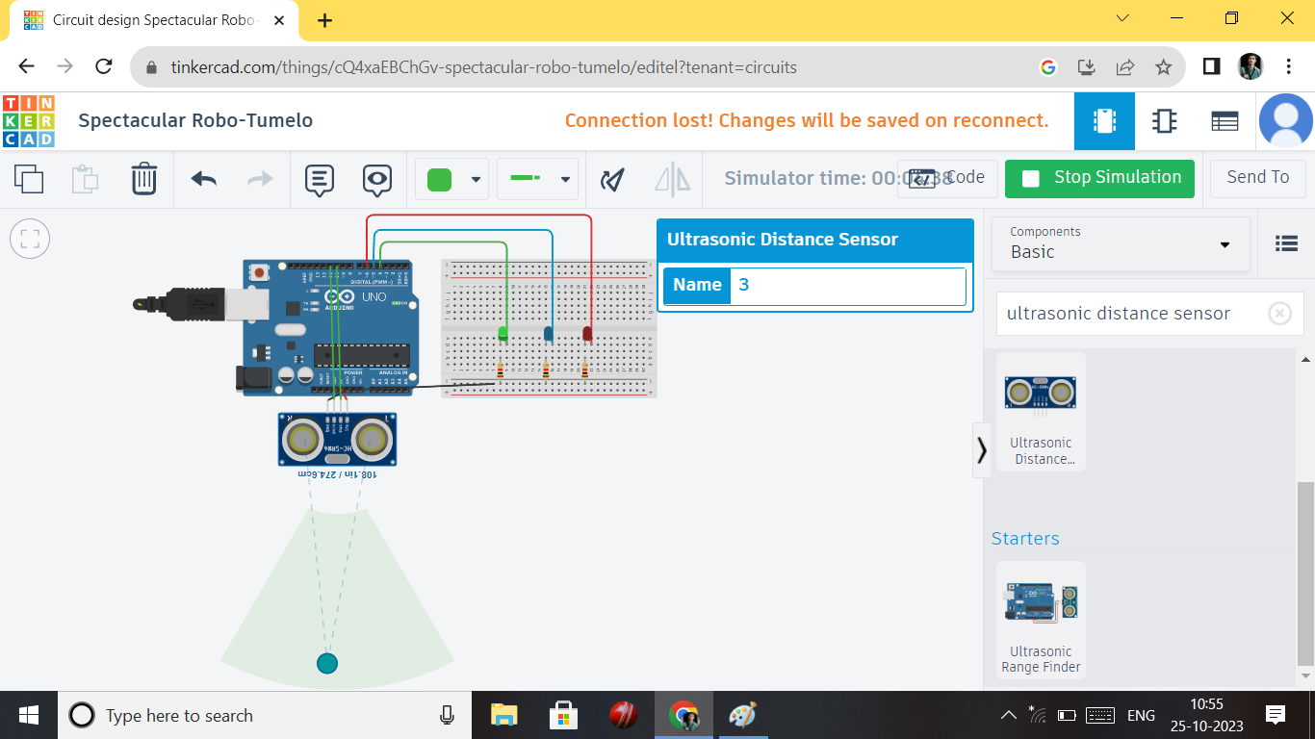

Fig.1.Water level above 200m

* The above cicuit diagram fig.1. illustrate ,When the Water level above 200m the green LED is HIGH or ON.otherwise the red and blue LED are LOW or OFF. It is safe zone not a Problem.

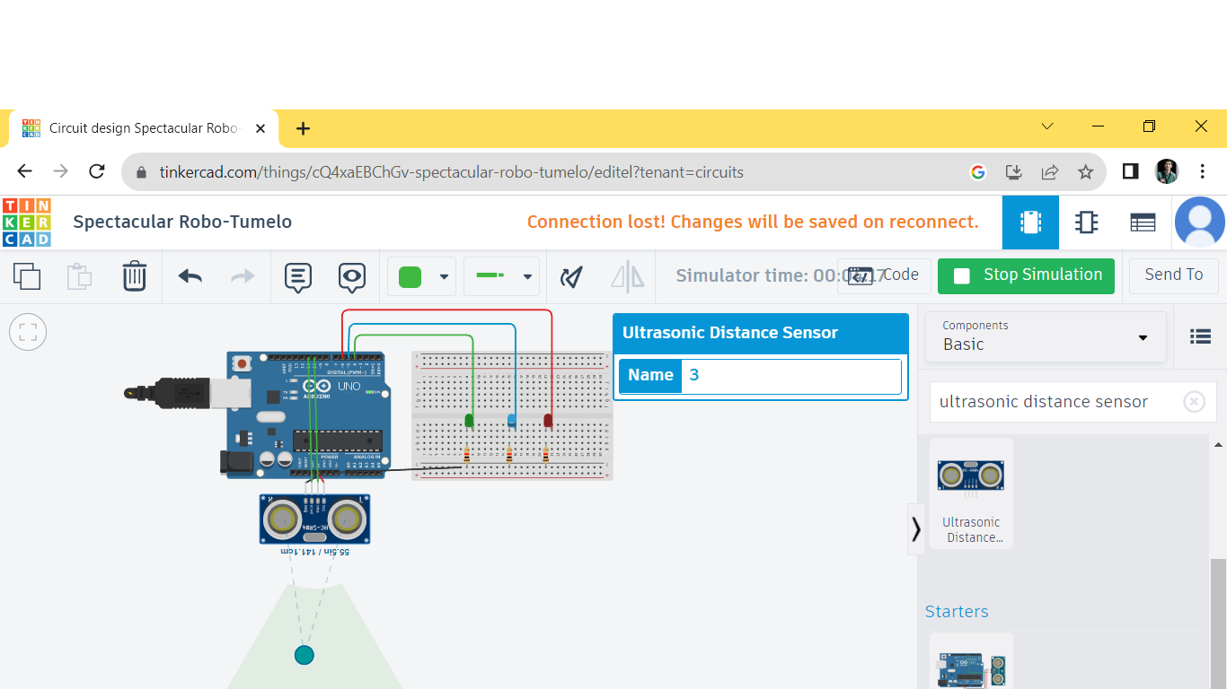

Fig.2.when water level 100m to 200 m

* The above circuit diagram Fig.2. illustrate,when water level 100m to 200 the blue LED is HIGH or ON. Otherwise the red and green LED are LOW or OFF. It is warning for the water level was arise and come close to living area.

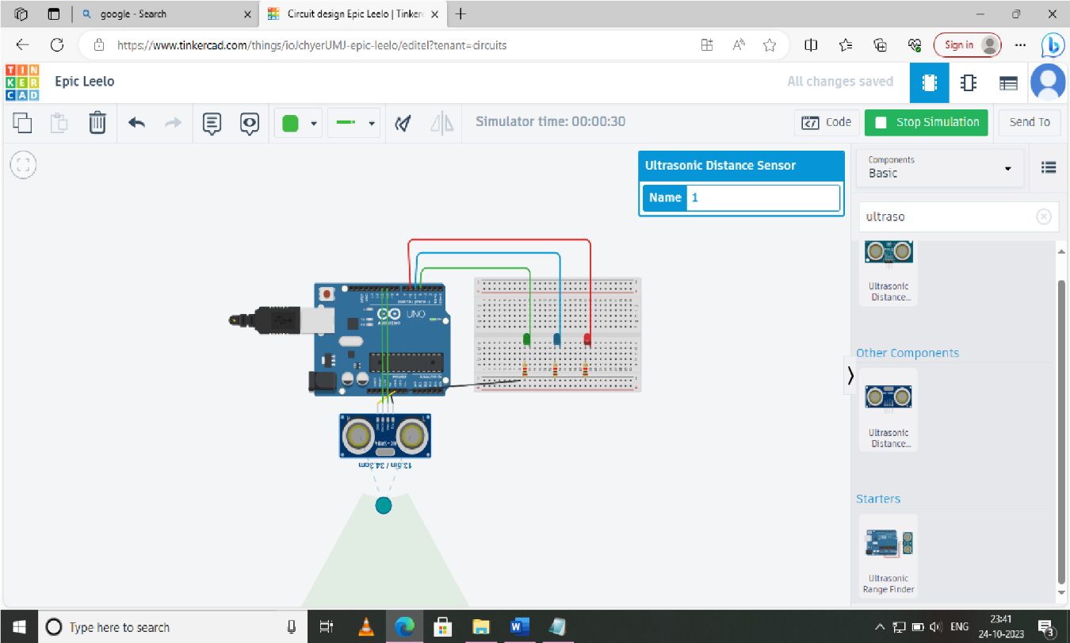

Fig.3.When water level belove 100 m

The above circuit Fig.3. illustrate, when water level is below 100 m when the red LED is HIGH or ON. Otherwise the blue and green LED are LOW or OFF. It is dangerous level.