Publishing api product yaml files to API Manger using git ,gitHub and Jenkins

1. git local repository commands to push files to github central respository

- git init
- git add product.yaml
- git commit -m “ commiting files”
- git push origin branchname

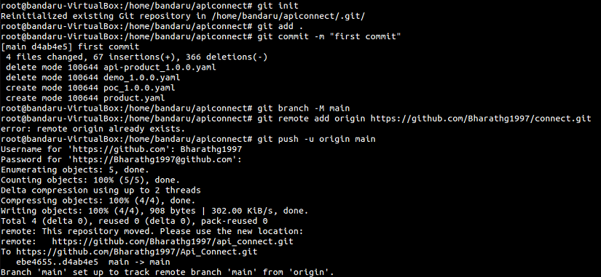

2. Next, In Jenkins creating job using freestyle project

- In source code management section select git option

- In Repository url field give github repository url where you pushed files

- In branch to build field give the branch name(i.e., master or main)
which you used for github repository url

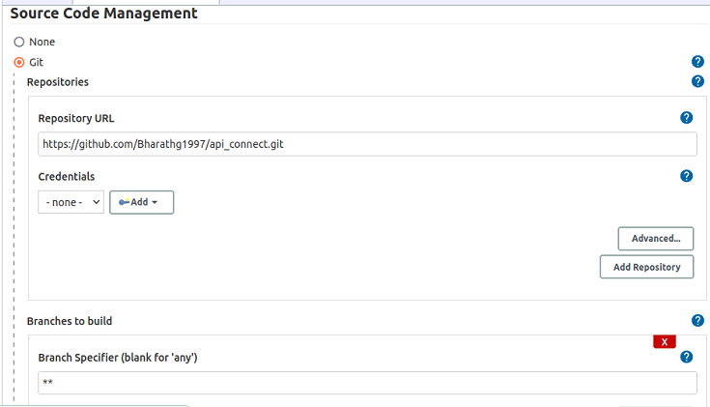

3. Next,Go to Build section and select Execute shell command

- apic login --server ${APIC_SERVER}--username $USERNAME --password $PASSWORD

- apic publish $PRODUCT.YAMLFILE --catalog $CATALOG_NAME --organization $ORGANIZATION_NAME --server ${APIC_SERVER}

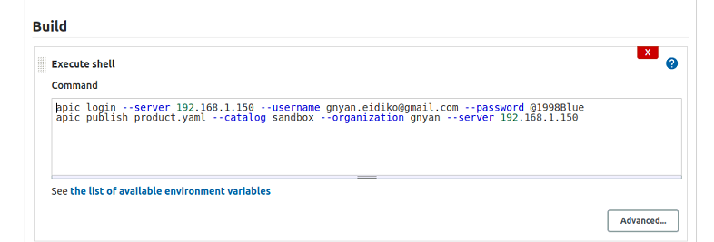
4. Logged in, using the same server you are trying to publish to:
- apic login --username $USERNAME --password $PASSWORD --server ${APIC_SERVER}

- The user needs to have publisher permissions in that organization, in the specific catalog you are trying to publish the product to (Product Manager is the default role name for that)

