



Build & Deploy

Self-Hosted Runner



GIT

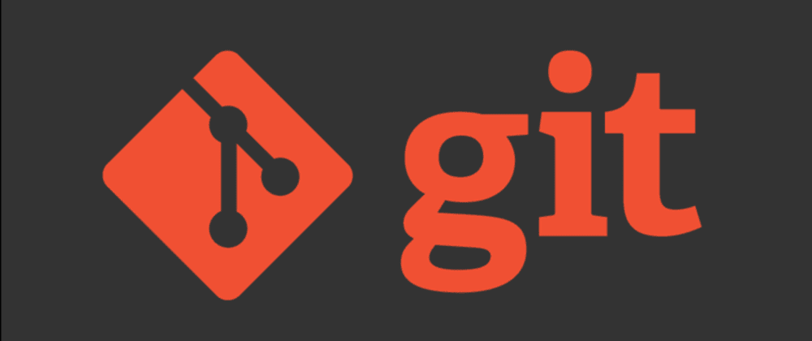

IBM ACE TOOLKIT