**Binding Credentials**

* Go to Jenkins and select freestyle project
* Next goto BuildEnvironment and select user secret text(s) or files(s)
* And then provide username and password.
* In credentials tab select specific credentials and add credentials

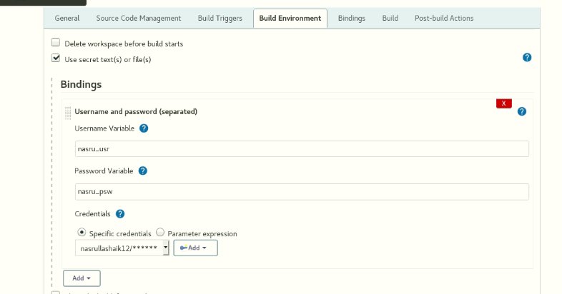

**Docker and Jenkins :**

**Command:**

* usermod -aG docker jenkins
* cat /etc/group | grep docker



**Command:**

* sudo usermod -aG group user



* sudo usermod -s /bin/bash jenkins 
* sudo passwd Jenkins



* sudo usermod -aG openshiftadmin Jenkins



* sudo chmod 770 username



* su Jenkins



* Create artifacts folder -🡪 mkdir /home/openshiftadmin/Artifacts



* After creating exit from Jenkins



* Sudo chmod -R 700 Artifacts



**Command:**

* docker images
* docker login -u <username> -p <password>

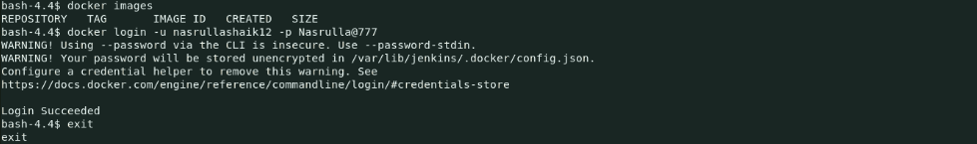

**Command:**

* systemctl restart Jenkins
* systemctl status Jenkins

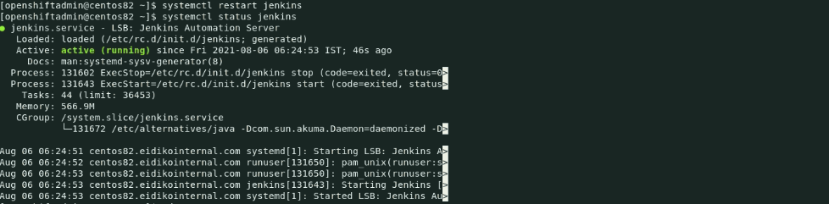

**Add openshiftadmin into root:**

**Command:**

* usermod -aG root openshiftadmin

**Add Jenkins user into openshiftadmin:**

**Command:**

* usermod -aG openshiftAdmin jenkins

**Adding ace path in .bash_profile:**

* Add /root/data/ace-11.0.0.7/server/bin/mqsiprofile folder into **.bash_profile**

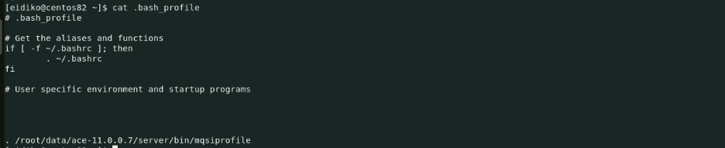

**Run .bash_profile:**

**Command:**

* . .bash_profile