

Build & Deploy



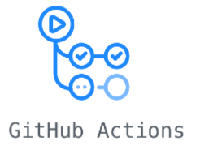

Self-Hosted Runner

GIT

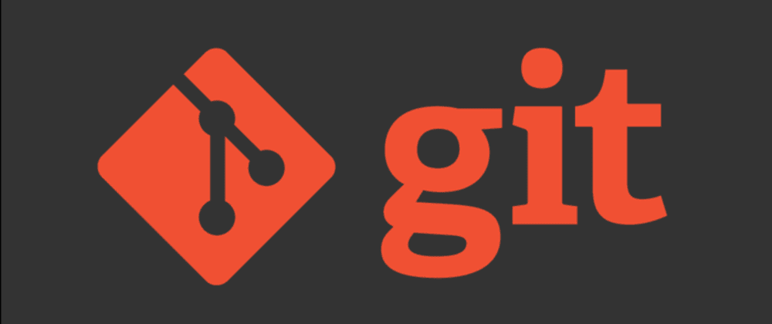

IBM ACE TOOLKIT

