**GITLAB**

* GitLab is a web-based Git repository that provides free open and private repositories. It is a complete DevOps platform that enables professionals to perform all the tasks in a project—from project planning and source code management to monitoring and security.
* Here we have created folder with name BARS and PI.
* In BARS Folder we are storing bar files and in PI Folder storing the IIb Application
* And also using that project url in Jenkins for creating bar file.
* Below commands that shows how to push files to gitlab project
* And using Jenkins url for creating bar file as shown in the image.

**Steps:**

* Login into GitLab the page will appear like this.

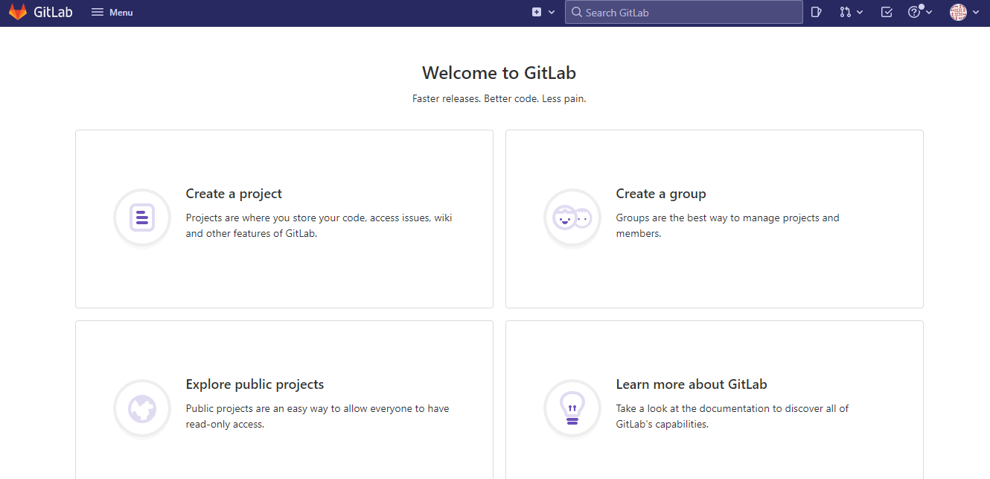

* Next,Click on create a project and then click on Create blank project.

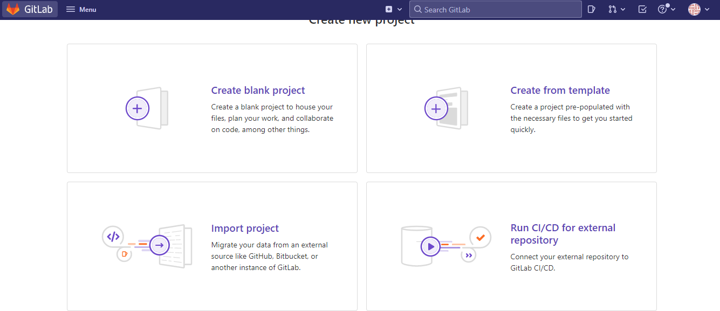

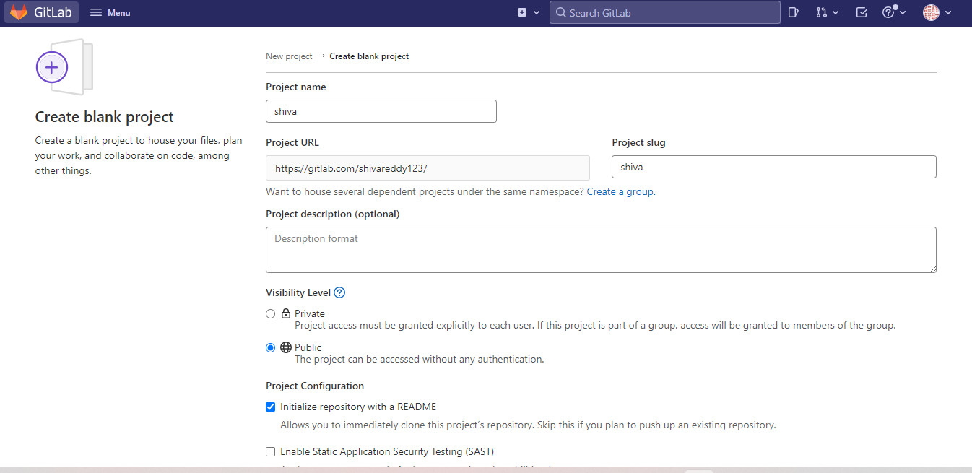

* Click create project.

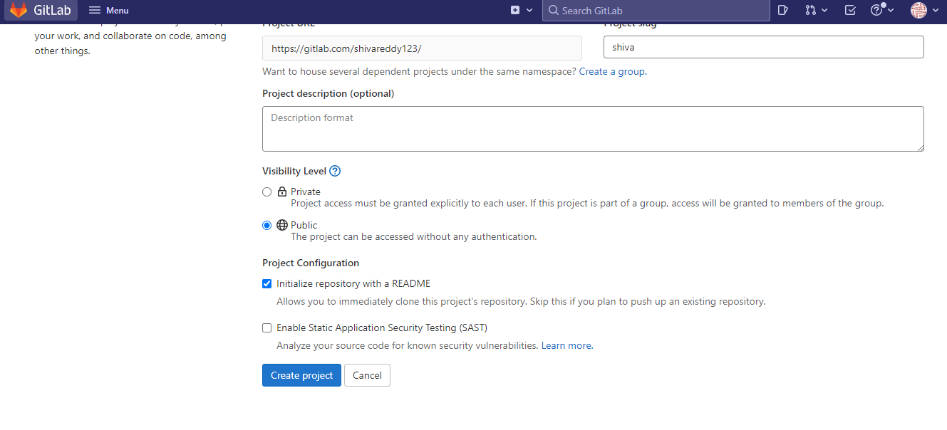

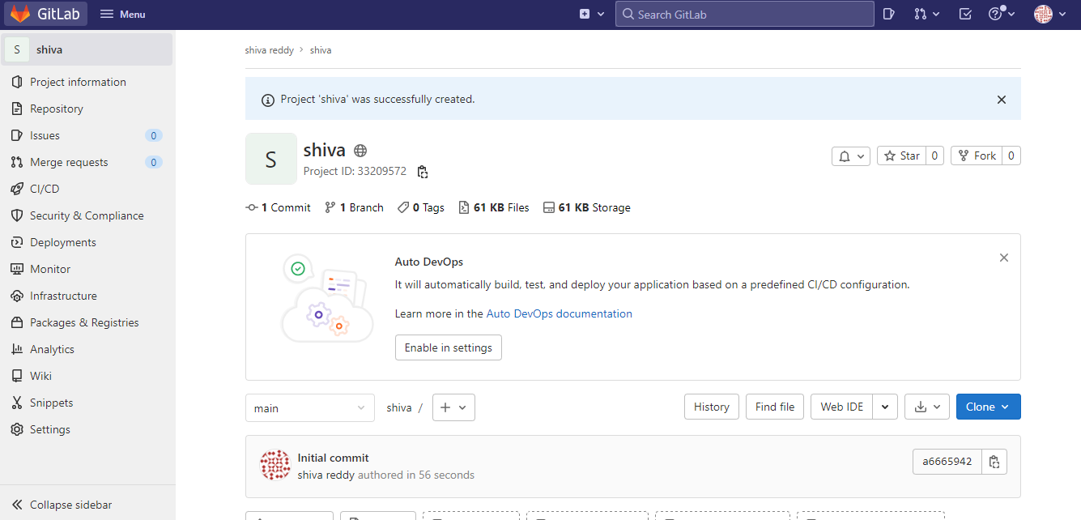

**Commands for Pushing application in PI folder, barflies in BARS folder in project:**

* git init ---> Initializing folder in local repository



* git add <filename> 🡪 Adding a file



* git commit -m “message” 🡪 saving a file to local repository 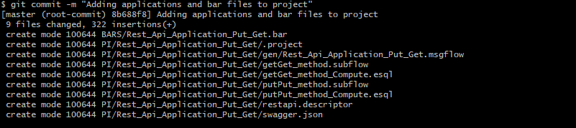
* git remote add origin https://gitlab.com/shivareddy123/new_project.git



* git push origin master

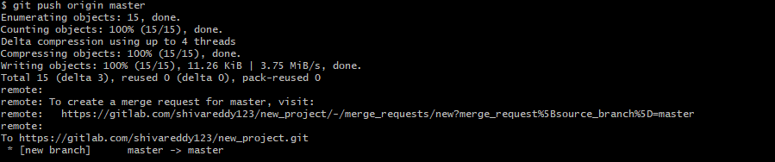

* Check into project whether files are pushed or not.

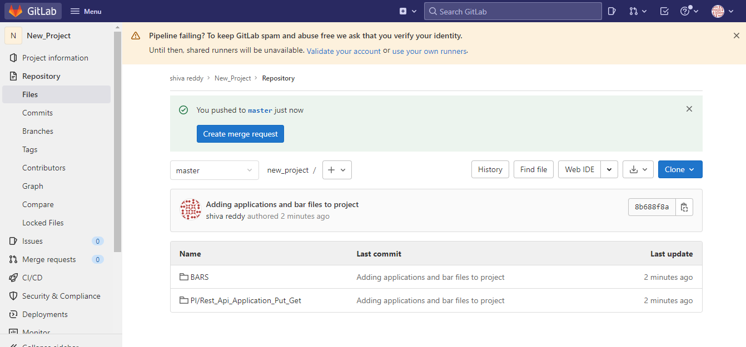

* Under bars folder we have stored bar file

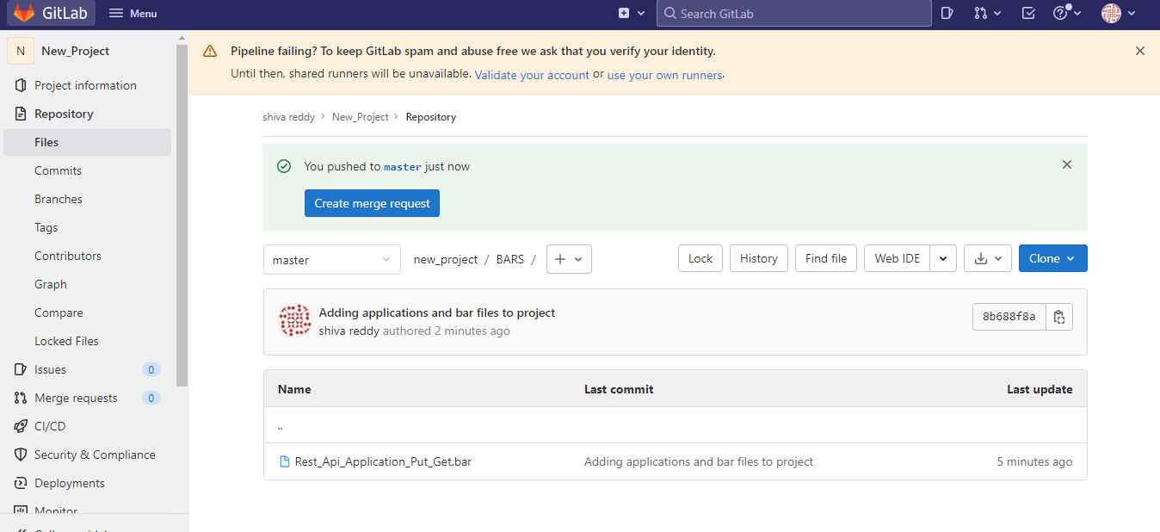

* In PI folder we have IIB Application

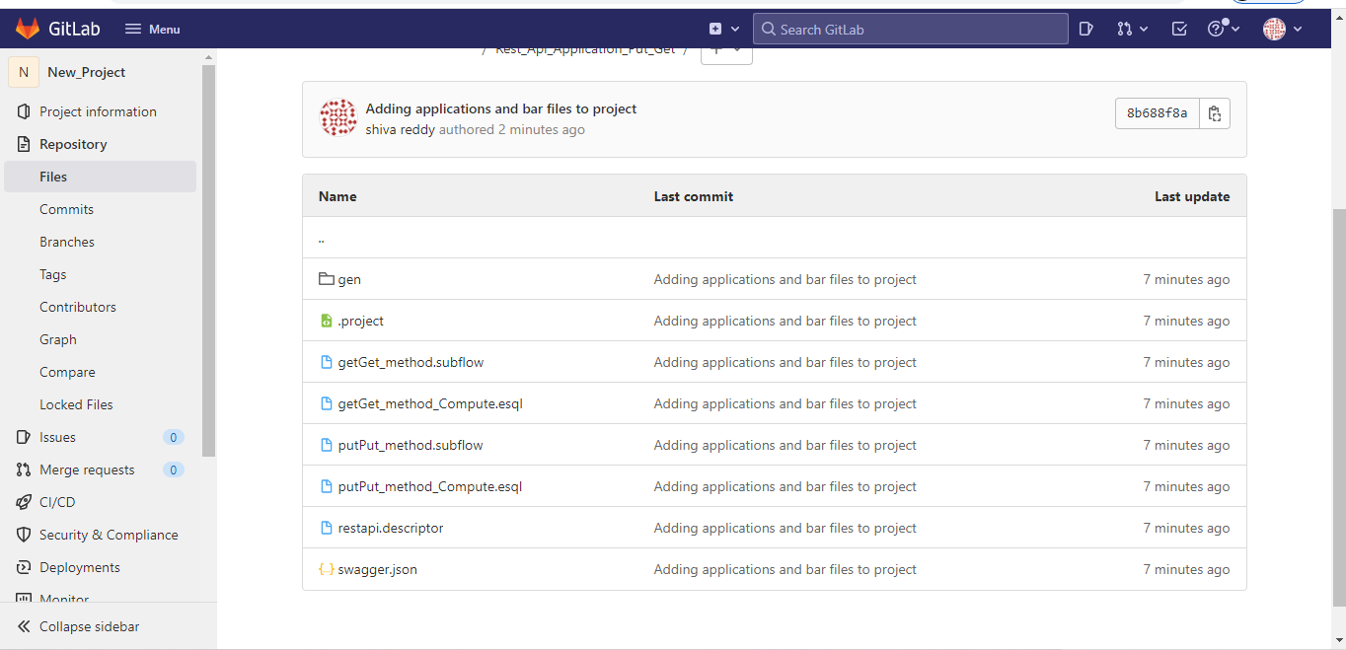

* And we are using that project url in Jenkins for creating bar file as shown in below.

