## INSTALLATIONS

### Subscription-manager

subscription-manager is a client program that registers a system with the Certificate-Based Red Hat Network.

#### Reason:

Check the status is the system registered with a valid subscription.

#### Command:

$   subscription-manager status

#### Reason:

The register command registers a new machine to the entitlement service .if not then register and provide username and password to register.

#### Command:

$   subscription-manager register

#### Reason:

The subscribe command allocates a specific subscription to the machine.

#### Command:

$   subscription-manager subscribe

#### Reason:

You can use the yum update command to update applications installed on a system. If you run the command without any package names specified, it will update all packages on the system.

#### Command:

$   sudo yum update



Then press Y for further continuation for updating packages

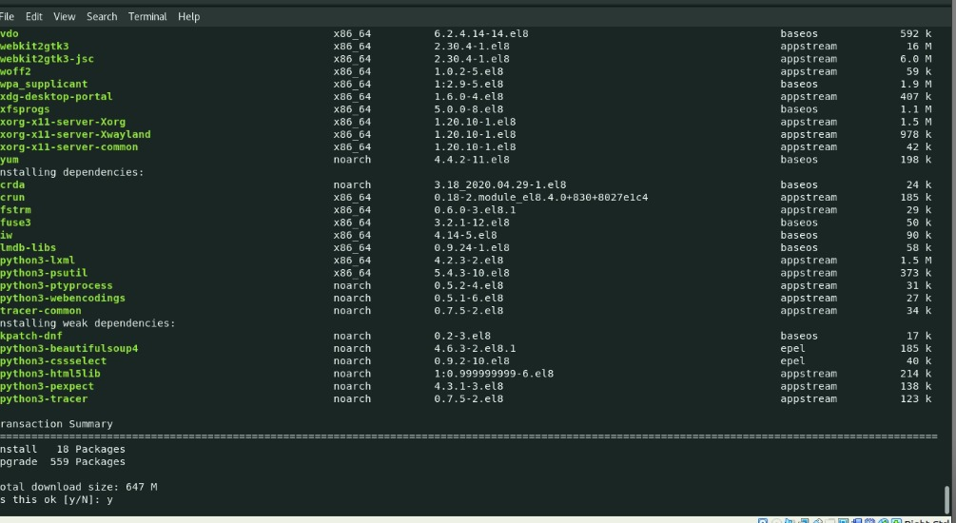

### Git Installation:

#### Reason:

Git allows you to keep track of your code changes, revert to previous stages, work simultaneously on multiple branches, and collaborate with your fellow developers.

#### Reason:

You can use yum install git command to install git in your local system.

#### Command:

$   sudo yum install git



Then press y for installing git

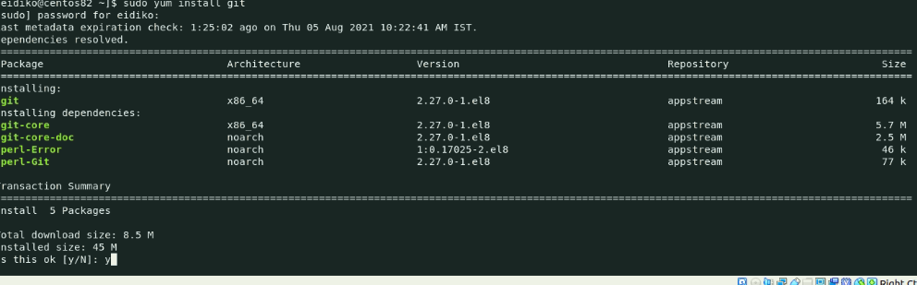

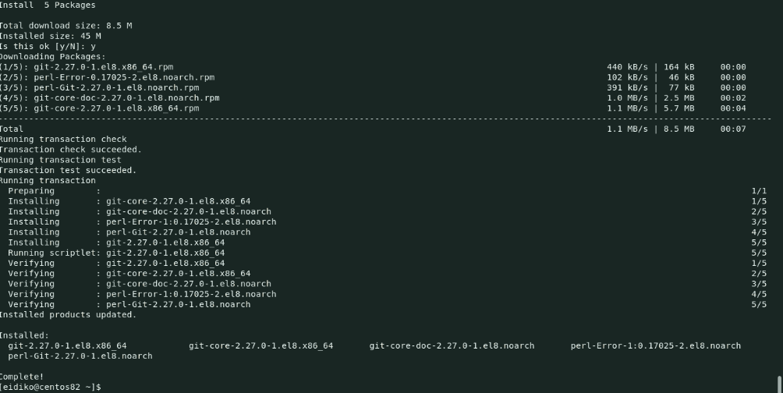

After successful Installation check whether git is installed or not using below command.

#### Reason:

Checking git version.

#### Command:

$   git –version

### 

### Installation of Xvfb

Xvfb or X virtual framebuffer is a display server implementing the X11 display server protocol. Xvfb performs all graphical operations in virtual memory without showing any screen output

#### Reason:

You can use yum install Xvfb command to install Xvfb in your system.

#### Command:

$   sudo yum install Xvfb



Then press y for further installation

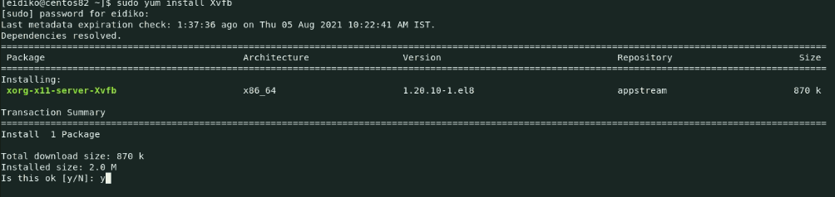

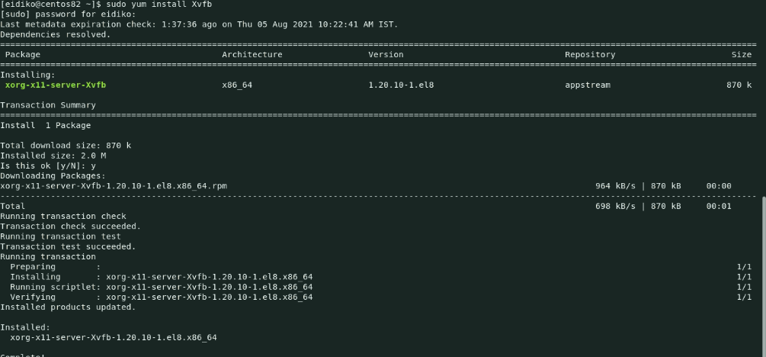

### JAVA Installation

#### Reason:

OpenJDK is an open-source project, implementing the Java Specifications for installing java type below command

#### Command:

$   sudo yum install openjdk*

Or

$ sudo yum install java-1.8.0-openjdk-devel

$ sudo yum install java-11-openjdk-devel



Then press y for further installation

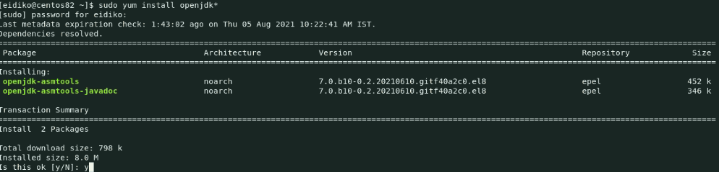

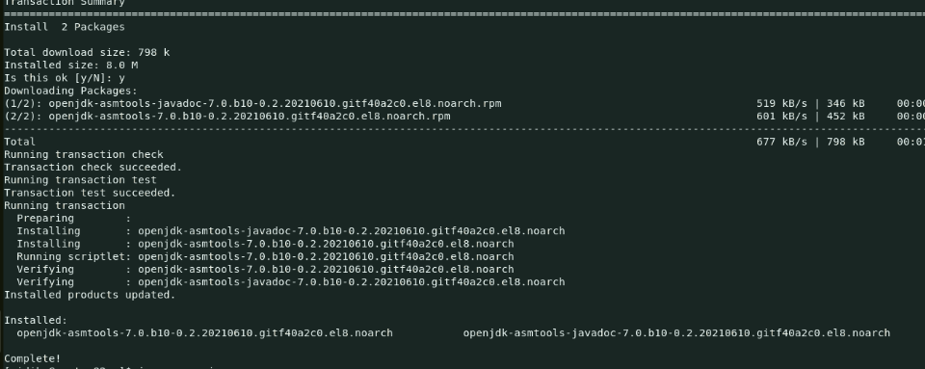

#### Reason:

Verify the version of the JDK using below command.

#### Command:

$   java -version

### 

### Jenkins Installation

Jenkins is a free and open source automation server. It helps automate the parts of software development related to building, testing, and deploying, facilitating continuous integration and continuous delivery.

#### Reason:

Add the Jenkins repository to the yum repos.

#### Command:

$    sudo wget -O /etc/yum.repos.d/jenkins.repo https://pkg.jenkins.io/redhat-stable/jenkins.repo

#### 

#### Command:

$   sudo rpm --import https://pkg.jenkins.io/redhat-stable/jenkins.io.key

#### 

#### Reason:

you can use yum install Jenkins command to install Jenkins I your system.

#### Command:

$   sudo yum install jenkins

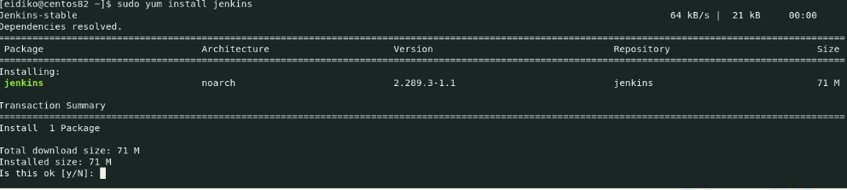

Press Y for further installation

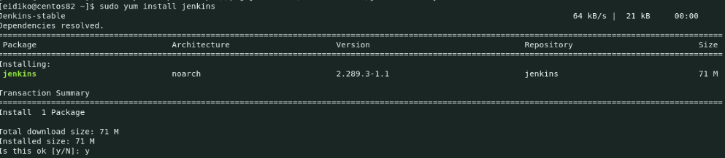

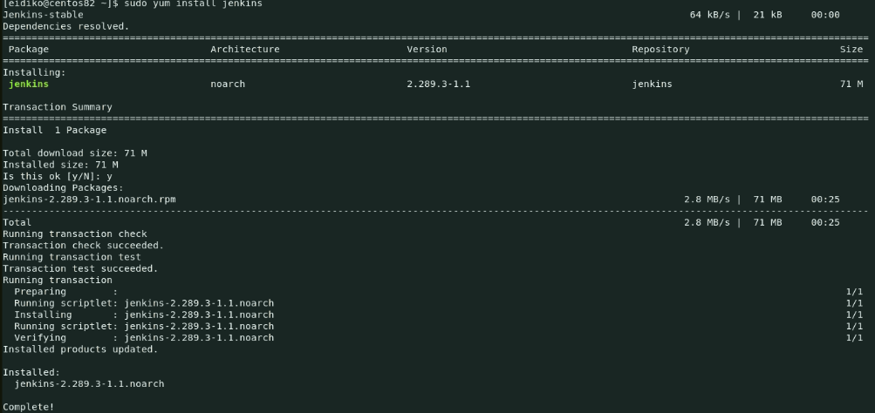

#### Reason:

It is used to check the status of Jenkins whether it is installed or not.

#### Command:

$   systemctl status jenkins

if Jenkins is not in active state then type below command.

$   systemctl start Jenkins

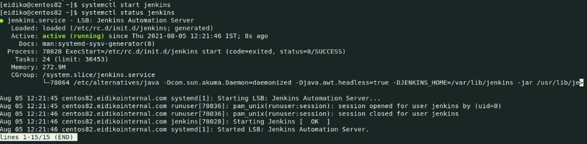

Then got to browser and click <http://localhost:8080> then it appears like this

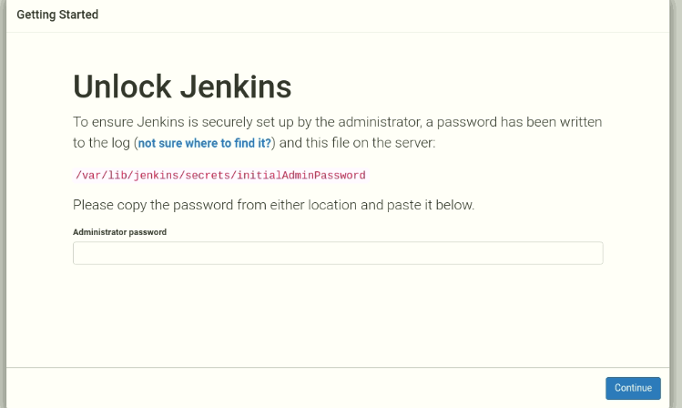

For administrator password goto /var/lib/Jenkins/secrets/initialAdminPassword copy the password pastein the administrator password block as shown in below.

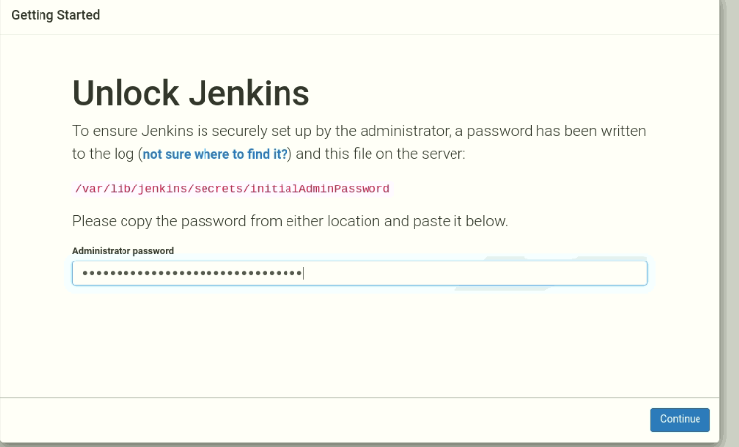

$ Click on Install suggested plugins

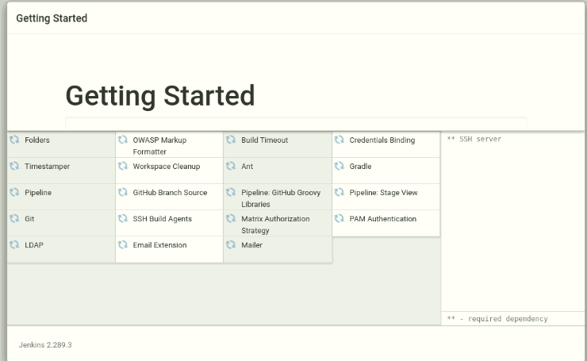

Creating user

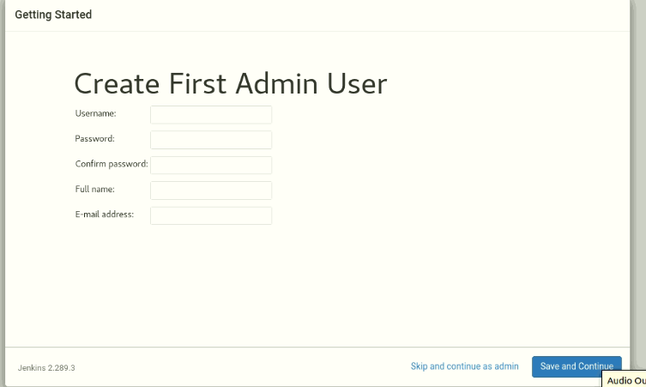

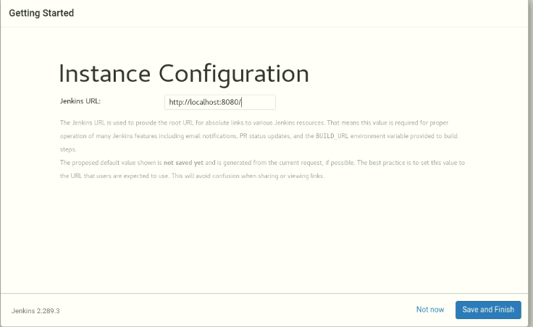

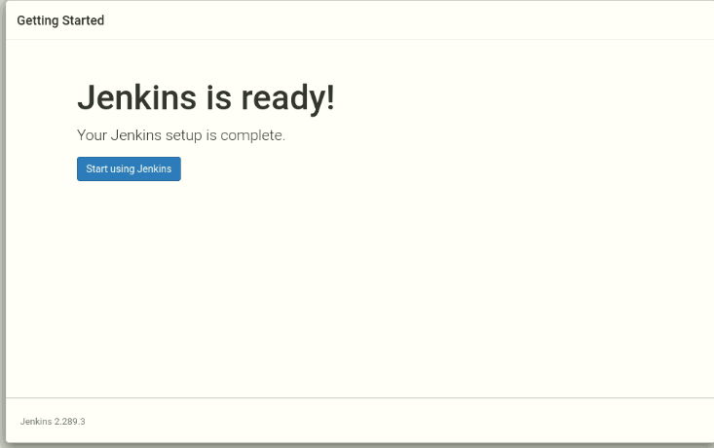

$ Click on new item and select freestyleproject and click on ok

$ In source code management select git and paste repository url.

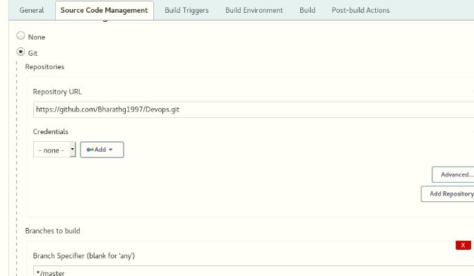

$ Under the general section select Project is parameterized block under name section give the groupname and in choice section give the group names which you are using.

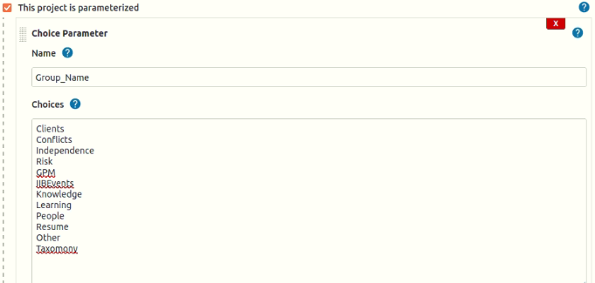

#### Binding Credentials

$ Next goto Build Environment and select user secret text(s) or files(s)

$ And then provide username and password.

$ In credentials tab select specific credentials and add credentials.

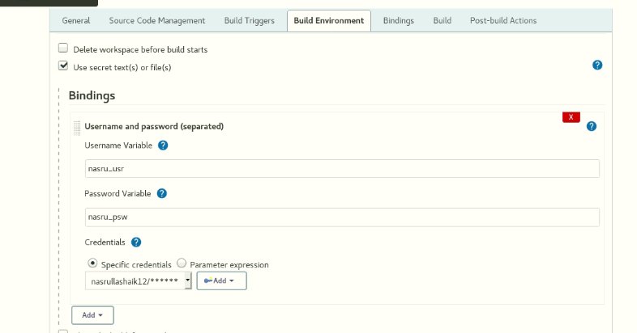

#### Setting build name

$ Go to Build Environment and select the set Build Name and give groupname along with build number.

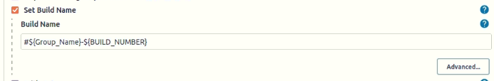

#### Execute shell command

$ Next, Go to build section and select the execute shell command and paste the script in execute shel command block which you have developed.

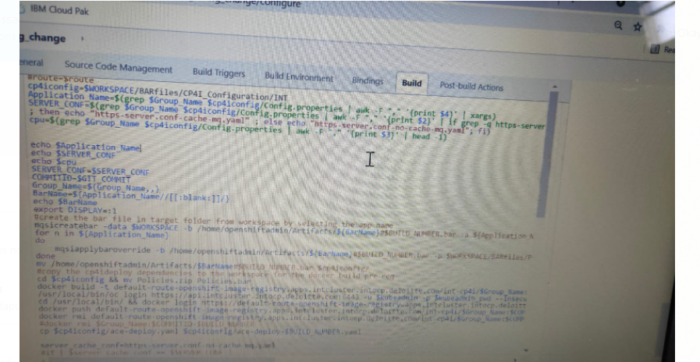

### Artifacts

#### Reason:

Adding Jenkins user into openshiftadmin group.

#### Command:

$   sudo usermod -aG openshiftadmin jenkins



**Reason:**

Creating Artifacts directory under /home/openshiftadmin

**Command:**

$   mkdir /home/openshiftadmin/Artifacts



#### Reason:

changing ownership permissions to /home/openshiftadmin/Artifacts/

#### Command:

$   sudo chown jenkins.jenkins/home/openshiftadmin/Artifacts/



#### Reason:

Changing permissions to /home/openshiftadmin/Artifacts/

#### Command:

$   sudo chmod -R 700 /home/openshiftadmin/Artifacts/



### Docker Installation

Docker is an open platform for developing, shipping, and running applications. Docker enables you to separate your applications from your infrastructure so you can deliver software quickly.

#### Reason:

Use DNF to add and enable the official Docker CE repository.

Next, run the following command which will add the Docker stable repository to your system.

#### Command:

$   sudo dnf config-manager --add-repo=https://download.docker.com/linux/centos/docker-ce.repo



#### Command:

$    sudo dnf repolist -v

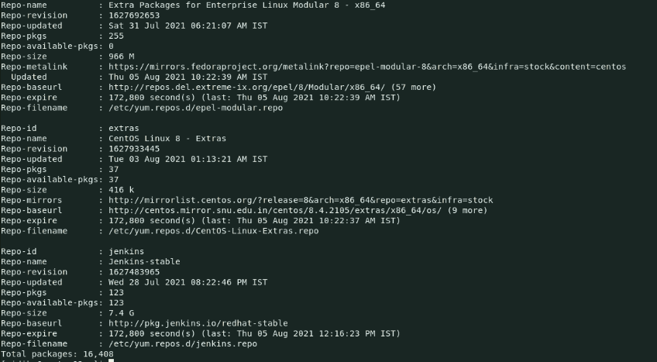

#### Reason:

To list all the available docker-ce packages

#### Command:

$     dnf list docker-ce --showduplicates | sort -r

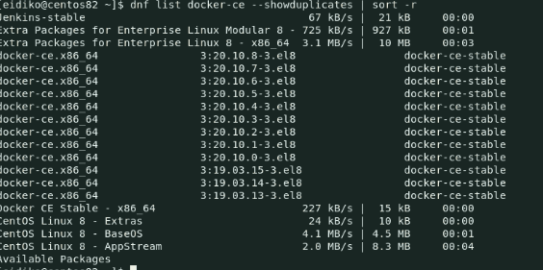

#### Command:

$    sudo dnf install docker-ce –allowerasing

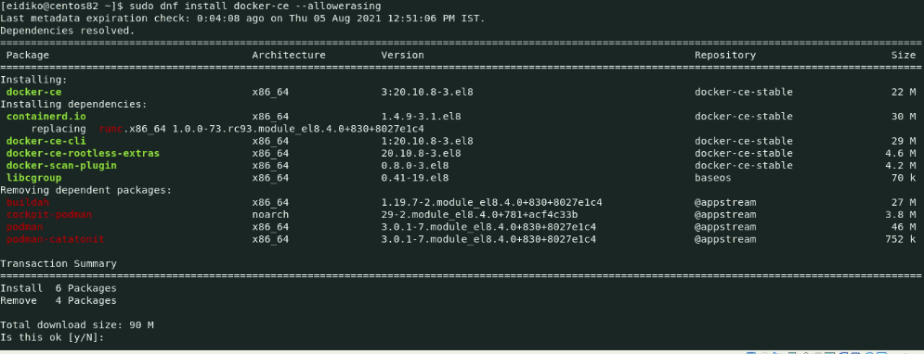

Then press y for further installation

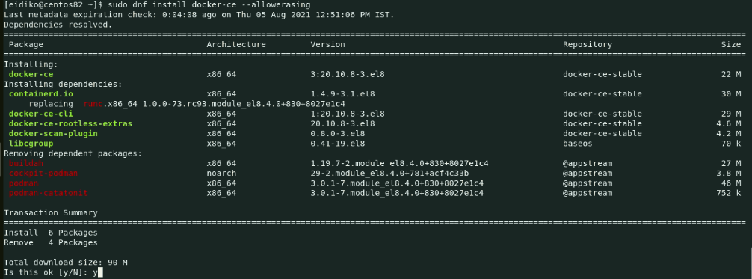

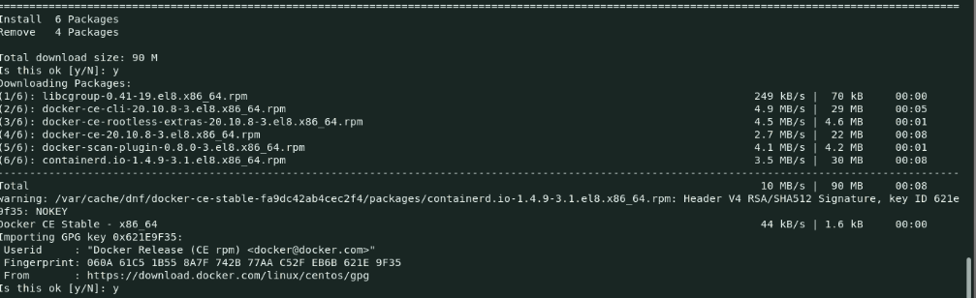

#### Reason:

Verify the version of the docker using below command.

#### Command:

$   sudo docker version

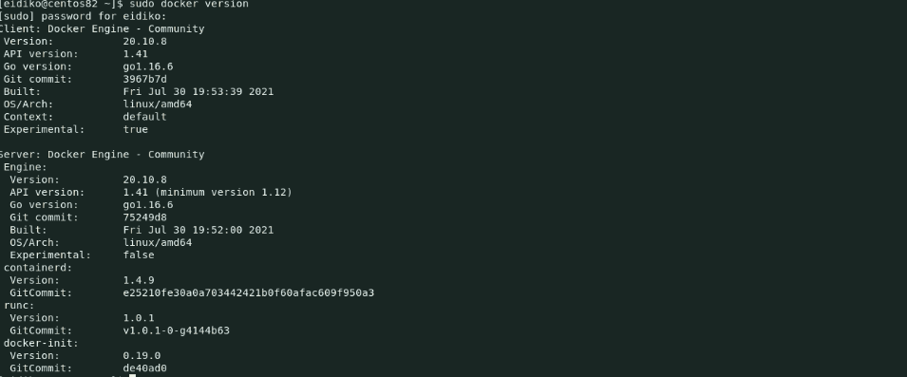

#### Reason:

Adding openshiftadmin user into docker.

#### Command:

$   sudo usermod -aG docker openshiftadmin



#### Reason:

Adding Jenkins user into docker.

#### Command:

$   sudo usermod -aG docker jenkins



### Openshift internal registry

1. If your OCP registry is using self-signed certificates, then you would not be able to access to do ‘docker login’ unless you add the certificate.
2. if you are planning to pull/push images to/from OCP registry that uses self signed certificate from outside OCP cluster, follow below steps to configure certificate on client mahcine.
3. Navigate to /etc/docker/certs.d and create a folder with name as external url of registry. If ‘certs.d’ folder doesn’t exist, then create it. The name of external url of registry can be found using below command.



1. Create the directory inside /etc/docker/certs.d

$  mkdir default-route-openshift-image-registry.apps.prod3.os.fyre.ibm.com



1. Navigate inside this direcory and run below command in single line to pull the certificate

$   ex +'/BEGIN CERTIFICATE/,/END CERTIFICATE/p' <(echo | openssl s_client -showcerts  -connect <external url for OCP registry>) -scq > ca.crt

$   sudo mv ca.crt ./default-route-openshift-image-registry.apps.stgcluster.stgocp.deloitte.com/

1. Restart the docker service.
2. Now validate that you are able to login to OCP registry using below command:

$   docker login <OCP registry url> -u $(oc whoami) -p $(oc whoami -t)

**For example:**

$   docker login default-route-openshift-image-registry.apps.prod3.os.fyre.ibm.com -u $(oc whoami) -p $(oc whoami -t)

$   docker pull [cp.icr.io/cp/appc/ace-server-prod@sha256:a51fa639c8235ca1f1af696d7f7616ce31c15f9a4a0991f526c80edff4b0772b](mailto:cp.icr.io/cp/appc/ace-server-prod@sha256:a51fa639c8235ca1f1af696d7f7616ce31c15f9a4a0991f526c80edff4b0772b)

$   docker tag cp.icr.io/cp/appc/ace-server-prod@sha256:a51fa639c8235ca1f1af696d7f7616ce31c15f9a4a0991f526c80edff4b0772b cp.icr.io/ace-prod:11.0.0.13-r1-eus

**Note** : Now we can build images with this taged base image

**Fix pack:**

The below command will be executed in installer machine

$   docker image save ace-fix:11.0.0.10-r2 -o ace-fix-110010-r2.tar

from the int installer machine, copy the image from the below path to the stage installer

$   /home/openshiftadmin/DOCKER/ace-fix:12.0.1.0-r3.tar

execute the below command from the path where the below image has been copied

$   docker image load -i ace-fix:12.0.1.0-r3.tar

### ACE Installation

Move 11.0.0.7-ACE-LINUX64-DEVELOP.tar.gz to opt/ibm folder

Next untar 11.0.0.7-ACE-LINUX64-DEVELOP.tar.gz file

#### Command:

$   sudo tar -xvf 11.0.0.7-ACE-LINUX64-DEVELOP.tar.gz



After untar the file goto /opt/ibm/ace-11.0.0.7 and then type ./ace



Then type ./ace make registry global accept license silently



#### Commands:

$   usermod -aG mqbrkrs openshiftadmin



$   usermod -aG mqbrkrs jenkins



Next, Copy /opt/ibm/ace-11.0.0.7/server/bin/mqsiprofile to bash_profile file

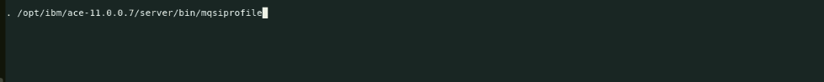

Then Run . .bash_profile



### OC Installation

untar openshift-client-linux.tar.gz



move kubectl and oc to /usr/local/bin



**Insecure-registries**

**Commands:**

$   cd /etc/docker/  
​  
$   touch daemon.json  
​  
$   sudo vi daemon.json

· Add default route image registry in daemon.json file

"insecure-registries": ["default-route-openshift-image-registry.apps.intcluster.intocp.deloitte.com"]

$   sudo systemctl restart docker  
​  
$   systemctl status docker