CICD Implementation on ACE to CP4i

Prerequisites:

- Bar file
- GitHub Workflow
- Yaml file For integration server

Create a repository in GitHub and push our code to Repository
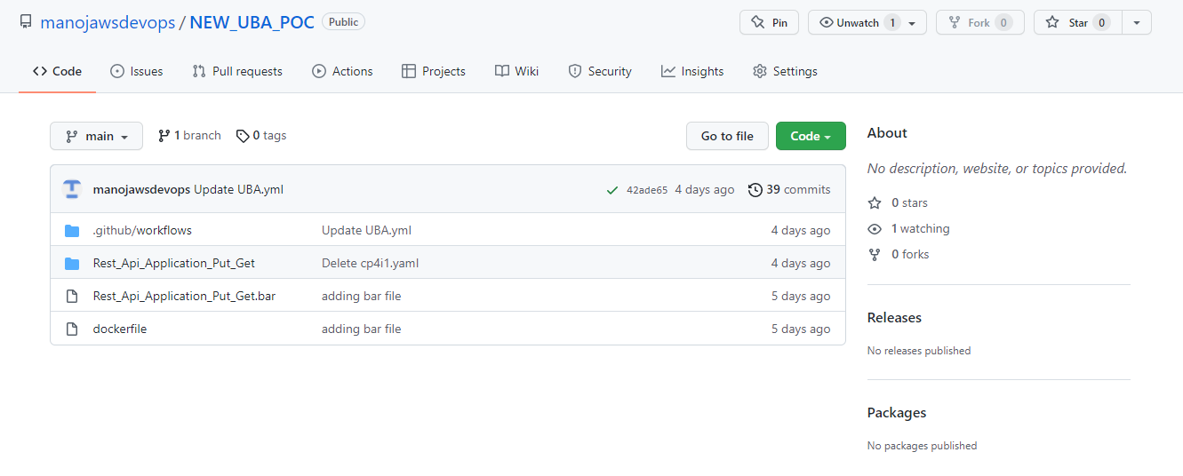

We are running on self-hosted runner so we need to create self-hosted runner & configure on repository

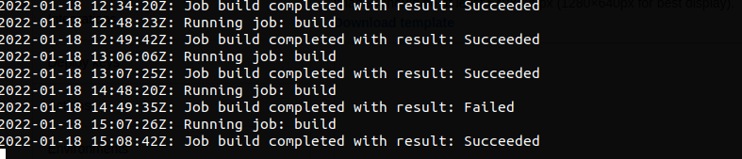

Create Github workflow actions yml file

Yml file:

name: UBA_CICD
on:
push:
branches: [ main ]
pull_request:
branches: [ main ]
env:
BAR_CREATION: /opt/ace-11.0.0.7/tools/mqsicreatebar
BAR_STORE: /home/bandaru/Templates
OCR_USERNAME: ${{secrets.OCR_USERNAME}}
DEFAULT_ROUTE: ${{secrets.DEFAULT_ROUTE}}
OC_TOKEN: ${{secrets.OC_TOKEN}}
OC_SERVER: ${{secrets.OC_SERVER}}
jobs:
build:
runs-on: self-hosted
steps:
- uses: actions/checkout@v2
- name: Set up JDK 11
uses: actions/setup-java@v2
with:
java-version: '11'
distribution: 'adopt'
- name: Building bar file
run: $BAR_CREATION -data /root -b $BAR_STORE/Rest_Api_Application_Put_Get.bar -a Rest_Api_Application_Put_Get
- name: Building Docker Image,Tag & Pushing to OCR Internal Registry
run: |
docker build -t cp4i:v11 -f dockerfile .
docker tag cp4i:v11 $DEFAULT_ROUTE/cp4i/cp4i:v1
docker login -u $OCR_USERNAME -p $(oc whoami -t) http://default-route-openshift-image-registry.cp4intpg-wdc04-7upm3s-8946bbc006b7c6eb0829d088919818bb-0000.us-east.containers.appdomain.cloud
docker push $DEFAULT_ROUTE/cp4i/cp4i:v1
- name: oc login
run: |
cd /usr/local/bin/
./oc login --token=$OC_TOKEN --server=$OC_SERVER
./oc project cp4i
./oc apply -f /root/Rest_Api_Application_Put_Get/cp4i.yaml
./oc apply -f /root/Rest_Api_Application_Put_Get/cp4i1.yaml

In the above Github workflow actions script we are working on
- Creating the barfile and storing the barfile in path
- Building the image using dockerfile.
- Tagging and pushing the builded image to openshift internal registry
- Creating two integration servers
- One is by using barurl creating integration server
- Second is by using image we are creating integration server

yaml file using barurl:

Yaml file:

apiVersion: appconnect.ibm.com/v1beta1
kind: IntegrationServer
metadata:
name: uba-integration-server-one
namespace: cp4i
spec:
adminServerSecure: true
createDashboardUsers: true
designerFlowsOperationMode: disabled
enableMetrics: true
license:
accept: true
license: L-KSBM-C5JEHP
use: CloudPakForIntegrationNonProduction
pod:
containers:
runtime:
resources:
limits:
cpu: 300m
memory: 350Mi
requests:
cpu: 300m
memory: 300Mi
replicas: 1
router:
timeout: 120s
service:
endpointType: http
version: '11.0.0.14-r1-eus'
barURL: >-
https://ace-dashboard-demo-dash:3443/v1/directories/Rest_Api_Application_Put_Get?6add4e18-7acd-464d-a314-e1b7ee8bddb6

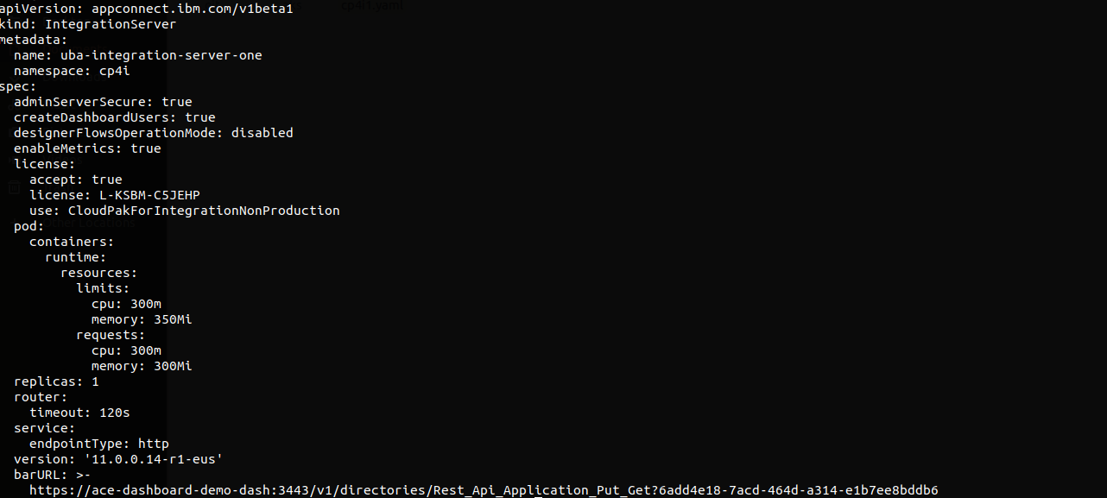

Note: For bar url we need to import the bar file in app connect and take that bar url and put it under the barurl field in yaml file

Yaml file using image:

Yaml File:

apiVersion: appconnect.ibm.com/v1beta1
kind: IntegrationServer
metadata:
name: uba-integration-server-second
namespace: cp4i
spec:
adminServiceSecure: true
license:
accept: true
license: L-KSBM-C5JEHP
use: CloudPakForIntegrationNonProduction
pod:
containers:
runtime:
image: image-registry.openshift-image-registry.svc:5000/cp4i/cp4i:v1
resources:
limits:
cpu: 900m
memory: 900Mi
requests:
cpu: 300m
memory: 300Mi
router:
timeout: 10s
designerFlowOperation: disabled
service:
endpointType: http
useCommonServices: true
version: 11.0.0.14-r1-eus
replicas: 1
logFormat: basic

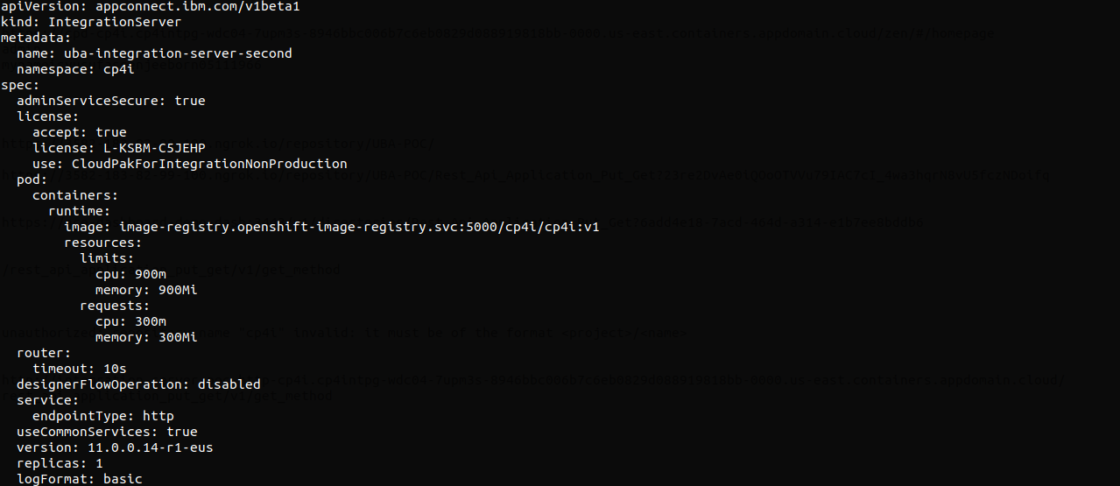

Next type the below commands for creating integration servers

oc apply -f /root/Rest_Api_Application_Put_Get/cp4i.yaml
oc apply -f /root/Rest_Api_Application_Put_Get/cp4i1.yaml

Go and check whether the integration servers created or not in App connect dash board

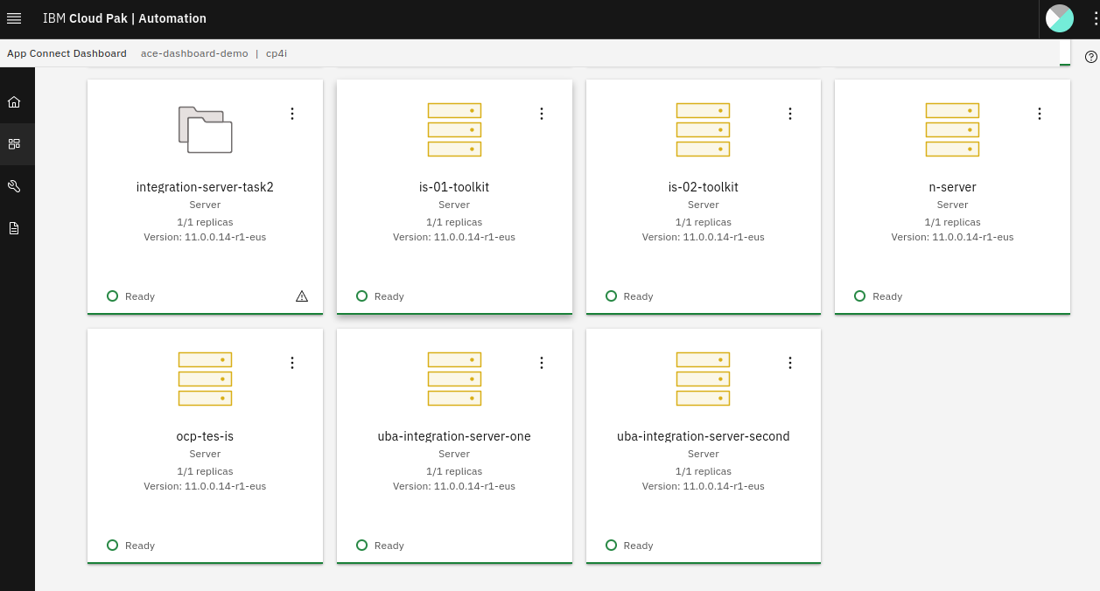
Integration servers was successfully with names uba-integration-server-one, uba-integration-server-second

Next goto routes and access the application

First integrationserver route

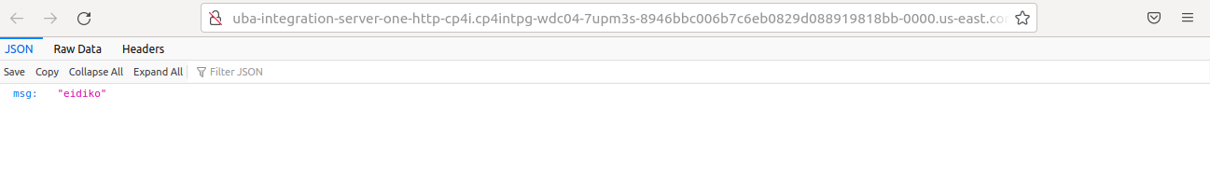
Second integrationserver route

