**Checking DB2 Connectivity From Openshift**

* The below are the configuration files we are created I,e.,
* setdbparms
* odbcini
* db2cli

**db2cli configuration file:**

[CRYSDSN]

Hostname=10.15.13.38

Port=5302

Database=MWPOCDB



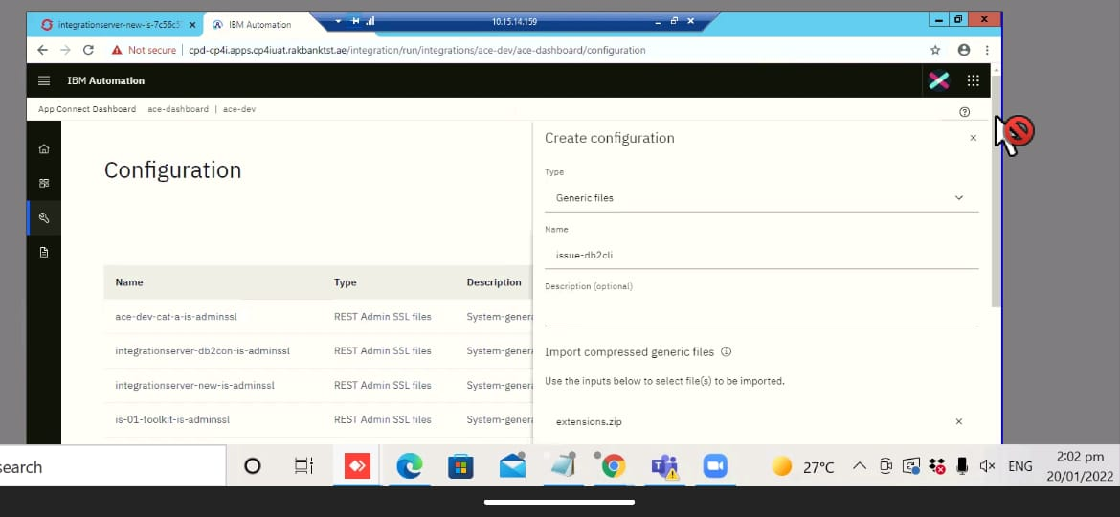

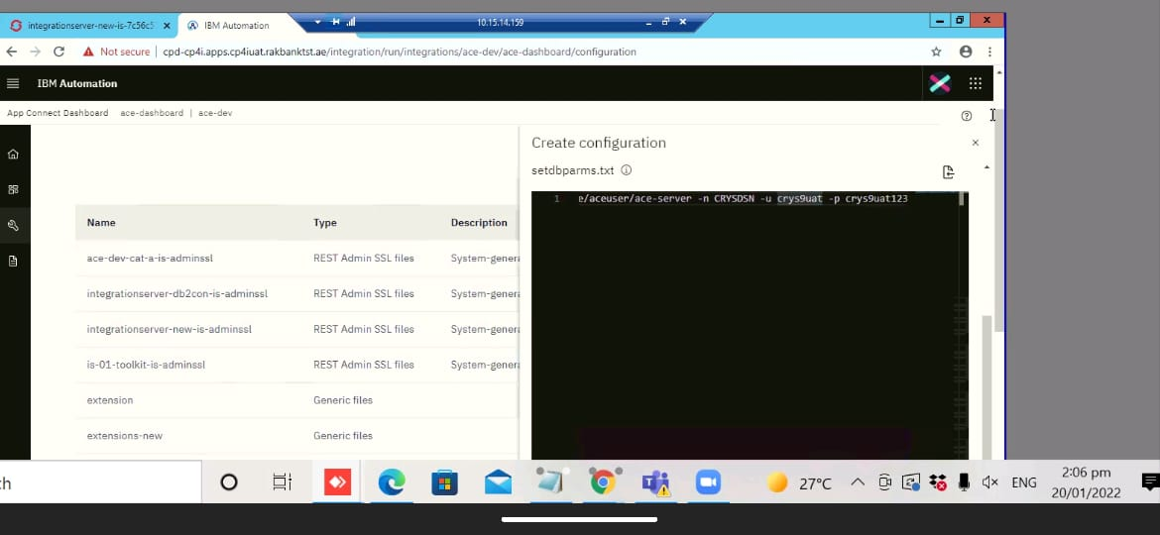

**Setdbparms Configuration file:**

mqsisetdbparms -w /home/aceuser/ace-server -n CRYSDSN -u crys9uat -p crys9uat123

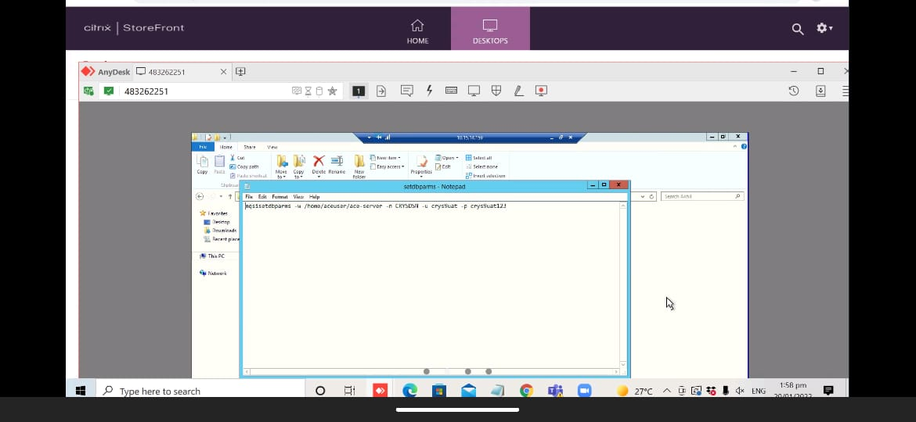

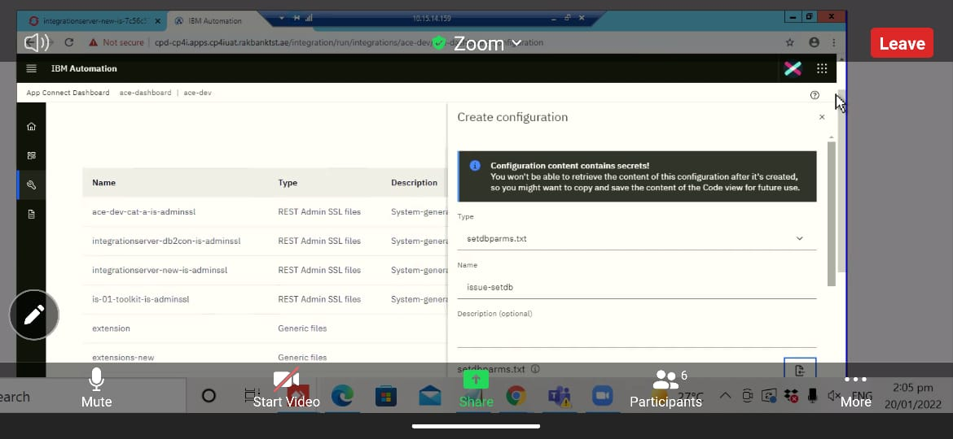

**Odbcini configuration File:**

;# DB2 stanza

[CRYSDSN]

DRIVER=/opt/ibm/ace-12/server/ODBC/dsdriver/odbc_cli/clidriver/lib/libdb2o.so

Description=IBM DB2 ODBC Database

Database=MWPOCDB

[ODBC]

InstallDir=/opt/ibm/ace-12/server/ODBC/drivers

UseCursorLib=0

IANAAppCodePage=4

UNICODE=UTF-8

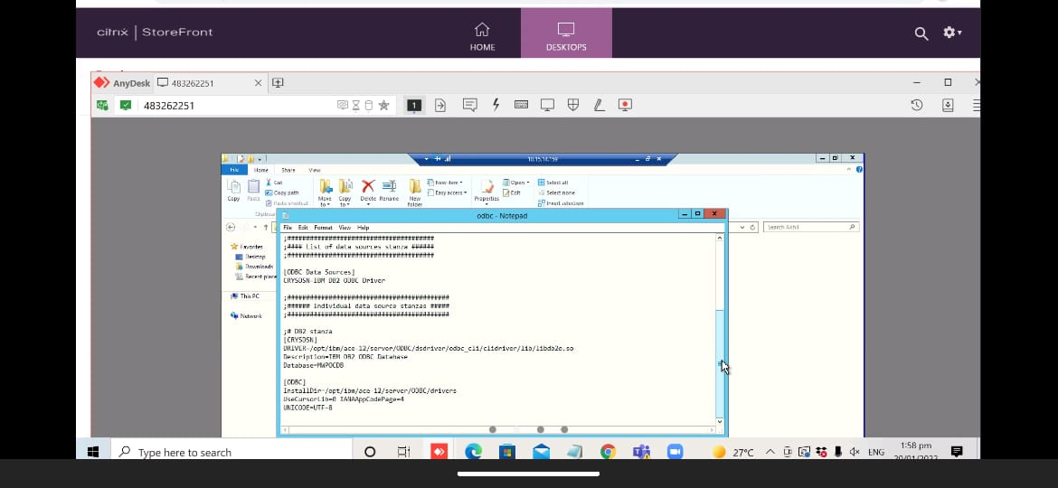

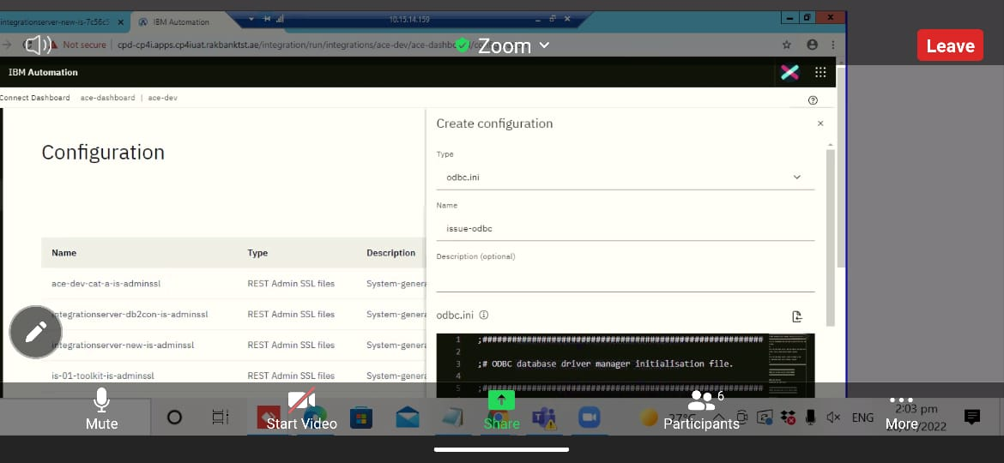

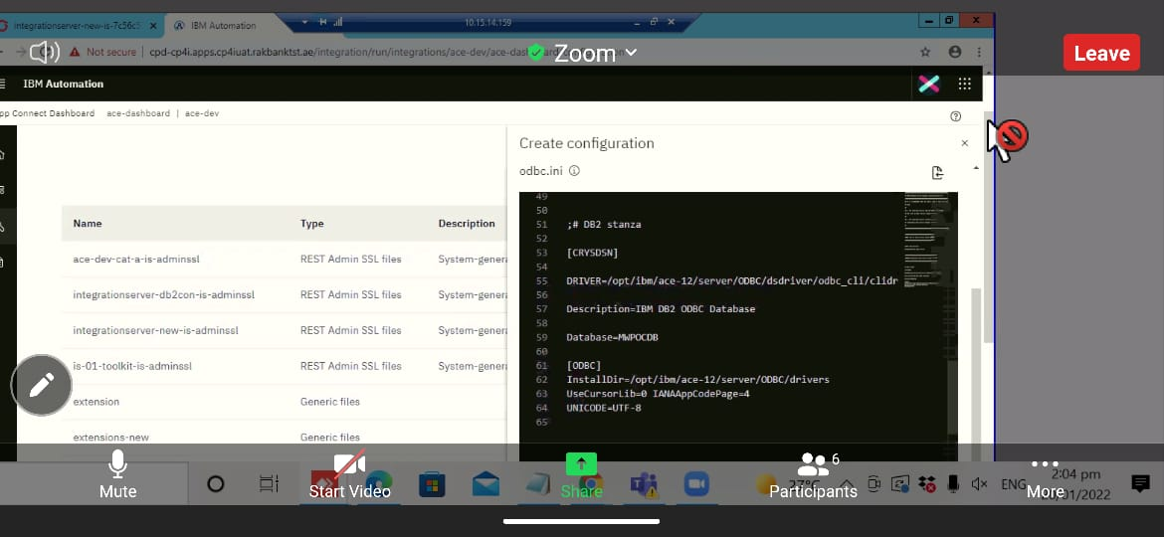

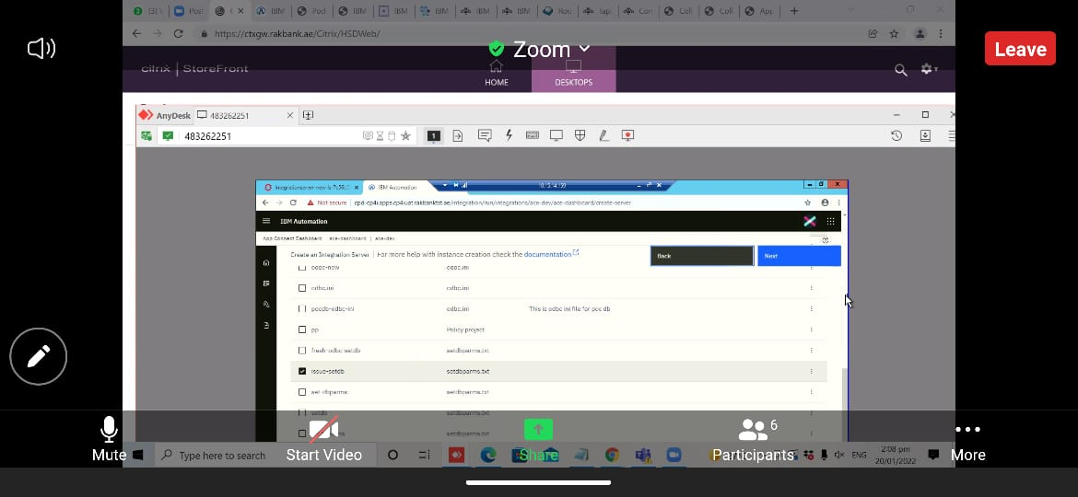

* ADD environment Variables to deployment of integration server

DB2CLIINIPATH = /home/aceuser/generic/db2cli.ini

ODBCINI = /home/aceuser/ace-server/odbc.ini

LD_LIBRARY_PATH = /opt/ibm/ace12/server/ODBC/dsdriver/odbc_cli/clidriver/lib/libdb2o.so

IE02_PATH= /opt/ibm/ace-12/ie02

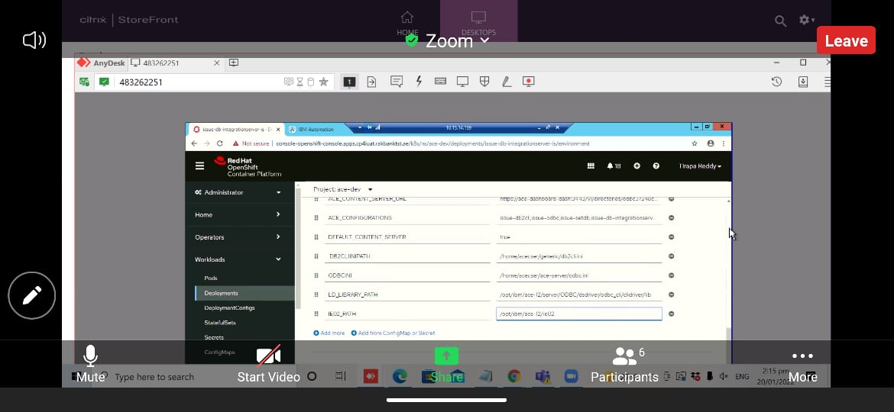

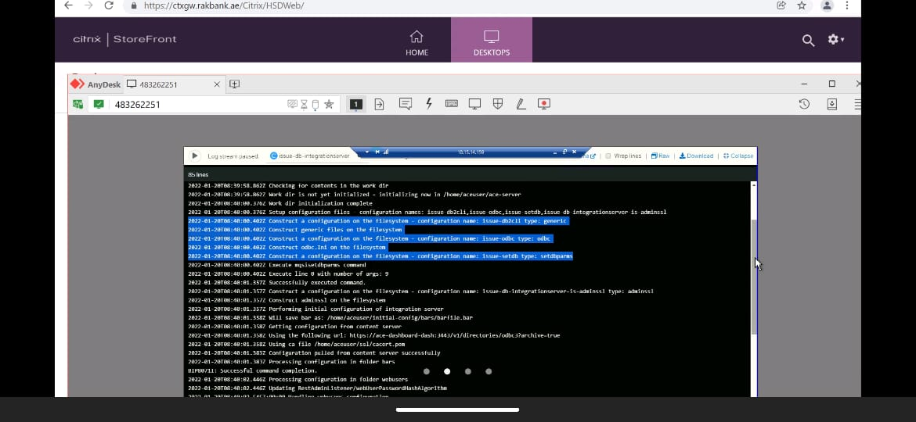

* Running mqsiprofile

. /opt/ibm/ace-12/server/bin/mqsiprofile

* Then Run the connection command

mqsicvp -n CRYSDSN -u crys9uat -p crys9uat123

