FuLLSTACK ASSIGNMENT 2

**Question no**.**1 : What is Conditional statement?**

**Answer** **:** A Conditional statement makes us choose which statement will be executed next and hence sometimes called as Selection statements. The JAVA conditional statements are:

If statement

If-else statement

Switch statement…etc.

**Question no.2: Write the syntax of Switch case Statement.**

**Answer** **:**

switch(expression)

{

case value1:

statements to be executed;

break;

case value2:

statements to be executed;

break;

default:

statement to be executed if no case value matches the given expression;

}

**Question no.3: Write the difference between break and continue statement?**

**Answer** **:**

Break Statement: Break statement mainly used to terminate the enclosing loop such as while, do-while, for or switch statement wherever break is declared.

Continue Statement: Continue statement mainly skip the rest of loop wherever continue is declared and execute the next iteration.

**Question no.4: What is Looping Statement?**

**Answer** **:** Looping statements are the statements execute one or more statement repeatedly several number of times. In java programming language there are three types of loops: while, for and do-while.

**Question no.5:What is difference between while and do-while statement?**

**Answer** **:**

While loop: The condition is tested at the beginning of the loop, and if the condition is True, then only statements in that loop will be executed. So, the While loop executes the code block only if the condition is True.

Do-while loop: The condition is tested at the end of the loop. So, the Do While executes the statements in the code block at least once even if the condition Fails.

**Question no.6 : What is Array? How it is created?**

**Answer** **:**  Java array is an object which contains elements of a similar data type. The elements of an array are stored in a contiguous memory location. It is a data structure where we store similar elements. We can store only a fixed set of elements in a Java array.

Creation of an integer array “a” with both declaration and instantiation:

**int** a[]=**new** **int**[5];

**Question no**.**7 : What is class?**

**Answer** **:** A class is a user defined blueprint or prototype from which objects are created.  It represents the set of properties or methods that are common to all objects of one type.

**Question no.8 : What is constructor?**

**Answer** **:** A constructor in Java is a special method that is used to initialize objects. The constructor is called when an object of a class is created. It can be used to set initial values for object attributes.

**Question no.9: What is the use of copy constructor?**

**Answer** **:** A copy constructor in a Java class is a constructor that creates an object using another object of the same Java class.

That's helpful when we want to copy a complex object that has several fields, or when we want to make a deep copy of an existing object.

**Question no.10 : What is the use of this keyword?**

**Answer** **:** The this keyword refers to the current object in a method or constructor. The most common use of the this keyword is to eliminate the confusion between class attributes and parameters with the same name.

**Question no.11: What is Method Overloading?**

**Answer** **:** If a class has multiple methods having same name but different in parameters, it is known as Method Overloading.

**Question no.12 : What is static variable?**

**Answer** **:**  When a variable is declared as static, then a single copy of the variable is created and shared among all objects at a class level. Static variables are, essentially, global variables. All instances of the class share the same static variable.

**Question no.13 : What is access modifier?**

**Answer** **:** A Java access modifier specifies which classes can access a given class and its fields, constructors and methods. Access modifiers can be specified separately for a class, its constructors, fields and methods.

**Question no.14: What is difference between instance and static methods?**

**Answer** **:**

**Instance method:** Instance method are methods which require an object of its class to be created before it can be called. To invoke a instance method, we have to create an Object of the class in within which it is defined.

**Static method**: Static methods are the methods in Java that can be called without creating an object of class. They are referenced by the class name itself or reference to the Object of that class.

**Question no.15: What is object? How it is created?**

**Answer** **:** An object is an instance of a class. Objects have states and behaviors. An object is created from a class. In Java, the new keyword is used to create new objects.

Puppy s = new Puppy("pinky");

Here “s” is an object of class “Puppy”.

Programs

1. **Write a java program for Matrix Addition.**

**Sol:**

import java.util.*;

public class Matrixadd

{

public static void main(String[] args)

{

int row,col;

Scanner s=new Scanner(System.in);

row=s.nextInt();

col=s.nextInt();

System.out.println("Number of rows in Matrix are:"+" "+row);

System.out.println("Number of columns in Matrix are:"+" "+col);

int a[][]= new int[row][col];

System.out.println("Matrix A:");

for(int i=0;i<row;i++)

{

for(int j=0;j<col;j++)

{

a[i][j]=s.nextInt();

System.out.print(a[i][j]+" ");

}

System.out.println();

}

int b[][]= new int[row][col];

System.out.println("Matrix B:");

for(int i=0;i<row;i++)

{

for(int j=0;j<col;j++)

{

b[i][j]=s.nextInt();

System.out.print(b[i][j]+" ");

}

System.out.println();

}

System.out.println("Resultant Addition Of Two Matrices A & B is C: ");

int c[][]=new int[row][col];

for(int i=0;i<row;i++)

{

for(int j=0;j<col;j++)

{

c[i][j]=a[i][j]+b[i][j];

System.out.print(c[i][j]+" ");

}

System.out.println();

}

}

}

**Expected Output:**

Number of rows in Matrix are: 2

Number of columns in Matrix are: 2

Matrix A:

1 1

1 1

Matrix B:

1 1

1 1

Resultant Addition Of Two Matrices A & B is C:

2 2

2 2

**Output**

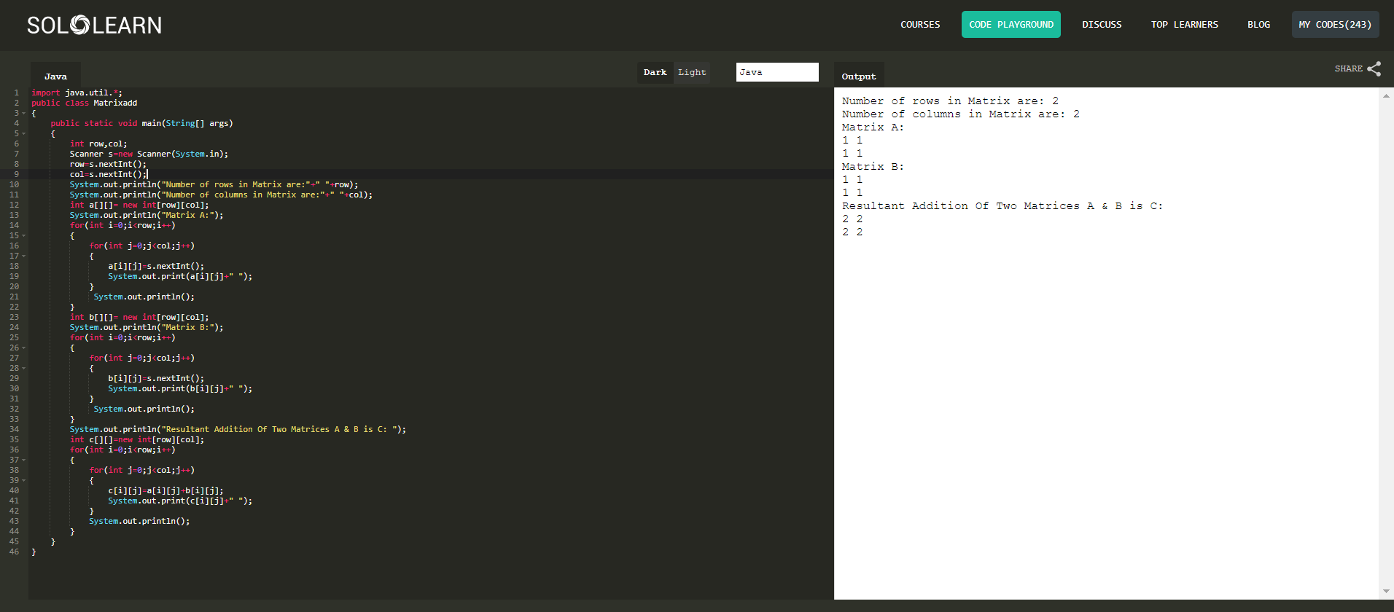

**2. Write a java program for Matrix Multiplication.**

**Sol:**

import java.util.*;

public class Matrixadd

{

public static void main(String[] args)

{

int row,col;

Scanner s=new Scanner(System.in);

row=s.nextInt();

col=s.nextInt();

System.out.println("Number of rows in Matrix are:"+" "+row);

System.out.println("Number of columns in Matrix are:"+" "+col);

int a[][]= new int[row][col];

System.out.println("Matrix A:");

for(int i=0;i<row;i++)

{

for(int j=0;j<col;j++)

{

a[i][j]=s.nextInt();

System.out.print(a[i][j]+" ");

}

System.out.println();

}

int b[][]= new int[row][col];

System.out.println("Matrix B:");

for(int i=0;i<row;i++)

{

for(int j=0;j<col;j++)

{

b[i][j]=s.nextInt();

System.out.print(b[i][j]+" ");

}

System.out.println();

}

System.out.println("Resultant Multiplication Of Two Matrices A & B is C: ");

int c[][]=new int[row][col];

for(int i=0;i<row;i++)

{

for(int j=0;j<col;j++)

{

c[i][j]=0;

for(int k=0;k<col;k++)

{

c[i][j]+=a[i][k]*b[k][j];

}

System.out.print(c[i][j]+" ");

}

System.out.println();

}

}

}

**Expected Output:**

Number of rows in Matrix are: 2

Number of columns in Matrix are: 2

Matrix A:

1 2

1 2

Matrix B:

1 2

1 2

Resultant Multiplication Of Two Matrices A & B is C:

3 6

3 6

**Output**

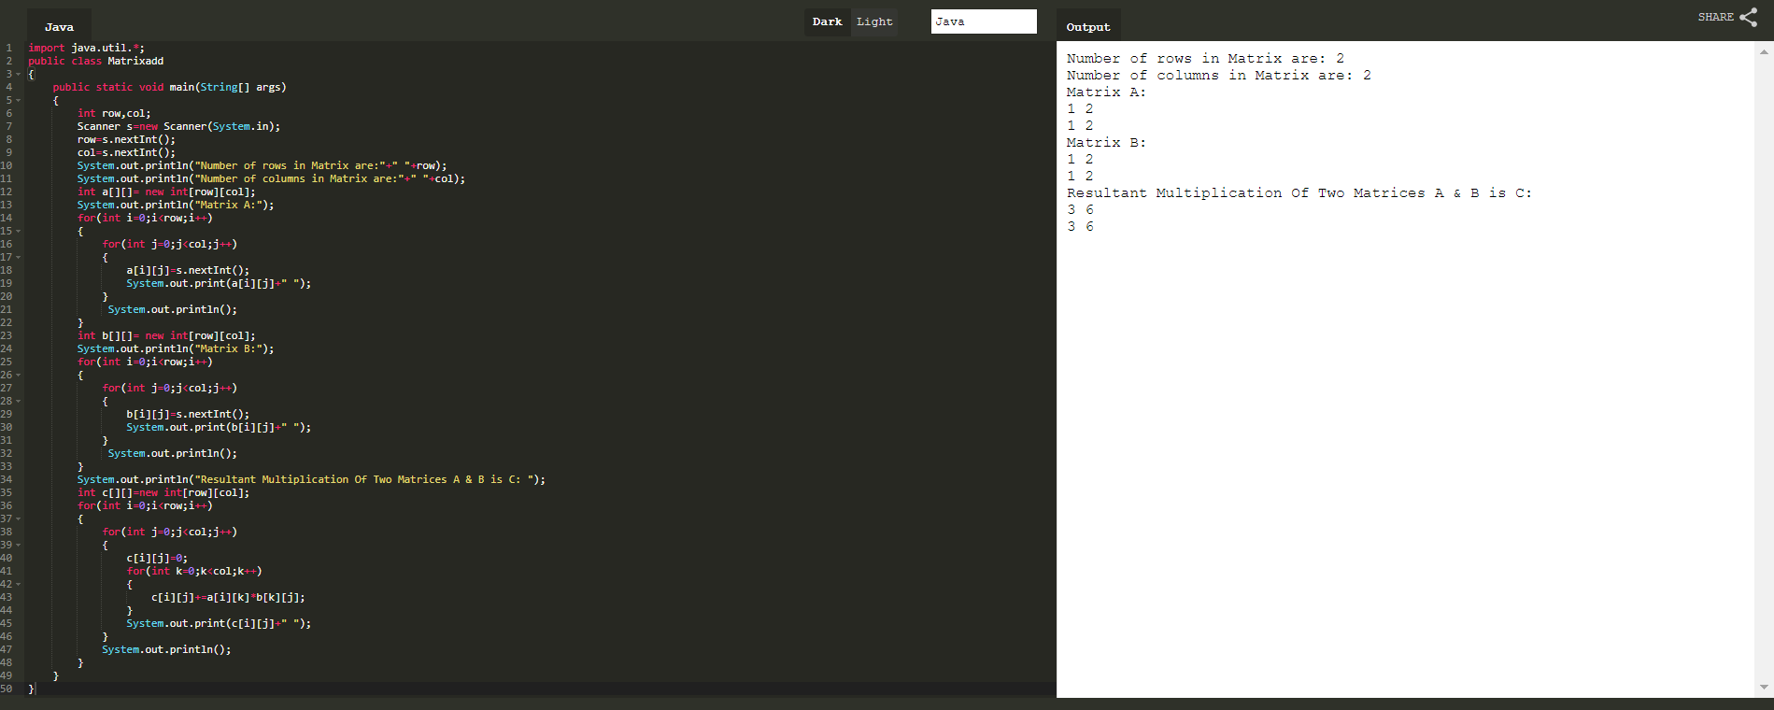

**3.Write a java program to demonstrate method overloading**

**Sol:**

public class Add

{

public int add(int a , int b)

{

return a+b;

}

public int add(int a , int b , int c)

{

return a+b+c;

}

public static void main(String args[])

{

Add ob = new Add();

System.out.println("Sum of two numbers: "+ob.add(74,22));

System.out.println("Sum of three numbers: "+ob.add(10, 2, 3));

}

}

**Expected Output:**

Sum of two numbers: 96

Sum of three numbers: 15

**Output**

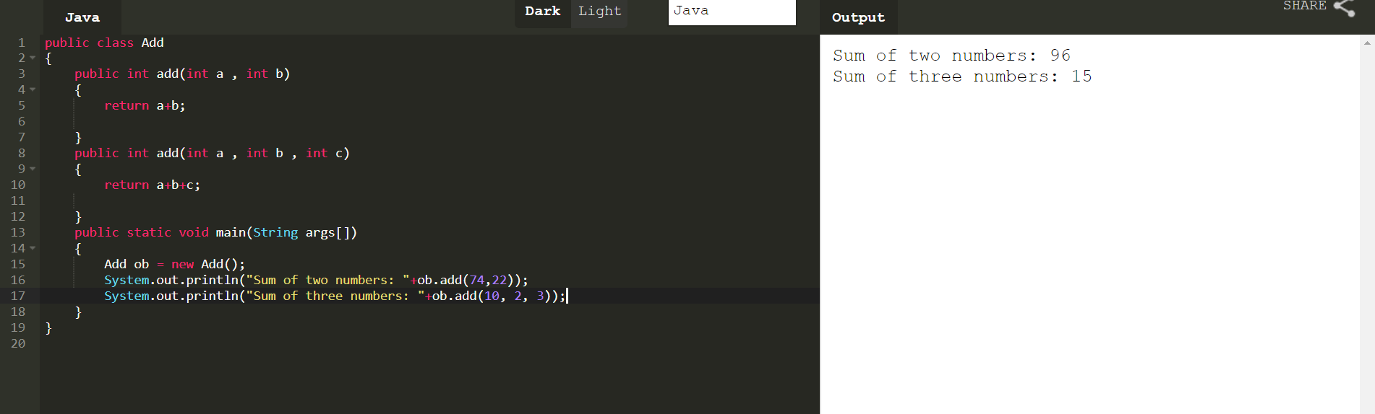

**4.Write a java program to create a class point with data two members x & y include all constructors and display().**

**Sol:**

class Point

{

int x;

String y;

Point()

{

x = 44;

y = "The value of x is";

}

public void display()

{

System.out.println(y+" "+x);

}

public static void main(String args[])

{

Point n = new Point();

n.display();

}

}

**Expected Output:**

The value of x is 44

**Output**

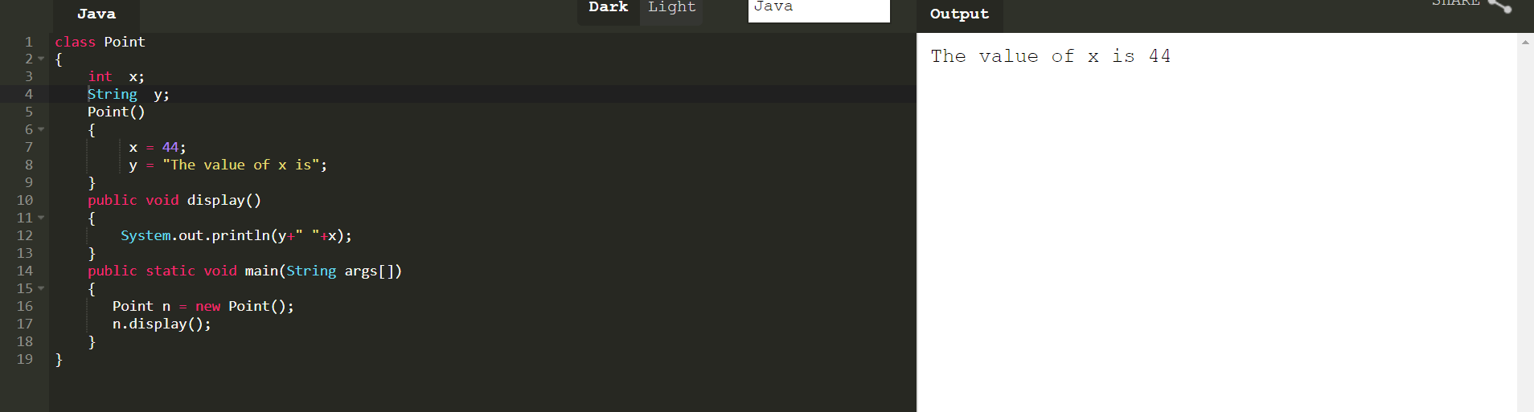

**5.Write a java program using static method.**

**Sol:**

class Square

{

static int square(int n)

{

return n*n;

}

public static void main(String args[])

{

int result=Square.square(6);

System.out.println("The square of 6 is "+result);

}

}

**Expected Output:**

The square of 6 is 36

**Output**

