INFOSYS SPRINGBOARD VIRTUAL INTERNSHIP 6.0 COMPLETION REPORT

Name: Bharathi
Batch Number: 10
Start Date: 22-NOV-2025
Internship Duration: 8 Weeks

1. Project Title
Smart Home Energy Management System (SHEMS)

2. Project Objective
The objective of the Smart Hostel Energy Management System (SHEMS) is to design and develop a secure and efficient web-based application that enables users to monitor, control, and optimize electricity usage within a smart hostel environment.
The system aims to:
- Provide secure authentication with role-based access
- Enable smart device monitoring and control
- Track real-time energy consumption
- Offer analytics dashboards for insights
- Support automation and scheduling
- Enforce admin-level energy policies to prevent excessive usage
The ultimate goal is to reduce energy wastage and promote smart, energy-efficient living.

3. Project Description in Detail
The Smart Hostel Energy Management System (SHEMS) is a full-stack web application developed using Spring Boot, MySQL, and Thymeleaf. It provides a digital platform that allows users to control electrical devices and monitor energy consumption in an efficient and structured manner.
Secure Authentication & Role Management
- Implemented using Spring Security
- Separate roles for User and Admin
- Secure login and registration system
- Role-based access to features and data
Smart Device Management
Users can manage their devices through:
- Adding new smart devices
- Turning devices ON or OFF
- Viewing current device status
- Each device is linked to its respective user account to maintain data privacy Real-Time Energy Tracking
- Energy usage is calculated using device power rating multiplied by usage duration
- Energy data is recorded and stored continuously in the database
- Enables monitoring of electricity consumption at the device level
Analytics & Dashboards
The system provides dashboards that display:
- Daily and weekly energy usage trends
- Device-wise energy consumption comparison
- Identification of peak usage periods
- Estimated cost based on energy consumption Administrators can also view:
- High energy-consuming users
- Top energy-consuming devices across the system Scheduling & Automation
- Users can set ON and OFF times for devices
- Background schedulers automatically control device states
- Helps reduce manual effort and unnecessary power usage Admin Energy Policy Enforcement
- Admins can define energy usage limits and active time windows
- If a device exceeds the defined threshold:
o The device is turned OFF automatically o The enforcement action is recorded in system logs
Overall, SHEMS functions as a complete smart energy management solution by integrating secure access, device control, real-time monitoring, analytics, automation, and policy enforcement.

4. Timeline Overview

Week | Activities Planned | Activities Completed
Week 1 | Understanding the project idea and choosing tools | Explored different smart energy solutions and decided to build the Smart Hostel Energy Management System. After identifying the  problem, chose Spring Boot for backend development and MySQL for database storage.
Week 2 | Planning user access and data storage | Designed how users and admins would log in and what each role could do. At the same time, created database tables for storing user and device details.
Week 3 | Designing system flow and module structure | As a team,we mapped how devices, users, and energy data would connect. This helped us clearly plan how energy tracking and device control would work together.
Week 4 | Developing device management  features | We built the part of the system where users can add devices and control whether they are ON or OFF. We tested if device status updates correctly.
Week 5 | Improving energy tracking logic | We studied how hostel appliances consume electricity and improved our logic so the system could estimate energy usage more realistically.
Week 6 | Implementing energy monitoring | We completed the feature that calculates energy usage using device power and time. The system started storing usage records for future analysis.
Week 7 | Connecting modules and creating dashboards | We combined authentication, devices, and energy tracking into one system. We also built dashboards to show energy trends in a simple and visual way.
Week 8 | Adding automation and finishing the project | We introduced scheduling so devices could run automatically. Admin energy control features were added, followed by full testing and final documentation.

5a. Key Milestones

Milestone | Description | Date Achieved
Project Kickoff | Requirement analysis and planning | 22-NOV-25
Prototype / First Draft | Authentication and device management completed | Week 4
Mid-Term Review | Review of energy tracking and dashboards | Week 6
Final Submission | Completion of all modules and documentation | Week 8
Presentation | Final system demonstration | Week 8

5b. Project Execution Details
The project followed a modular development approach across eight weeks. The initial phase focused on implementing secure authentication and role-based access. After ensuring secure login functionality, the team developed the smart device management module where users could add and control devices.
Next, the real-time energy tracking module was implemented to calculate energy usage based on device power and usage duration. This data was then visualized using dashboards. Following this, automation and scheduling features were added using background schedulers. Finally, admin-level energy policies were implemented to control excessive energy consumption automatically.
Continuous testing and integration ensured that all modules worked smoothly together.

6. Snapshots / Screenshots
This section includes screenshots of the Smart Hostel Energy Management System demonstrating:
- User Login Page
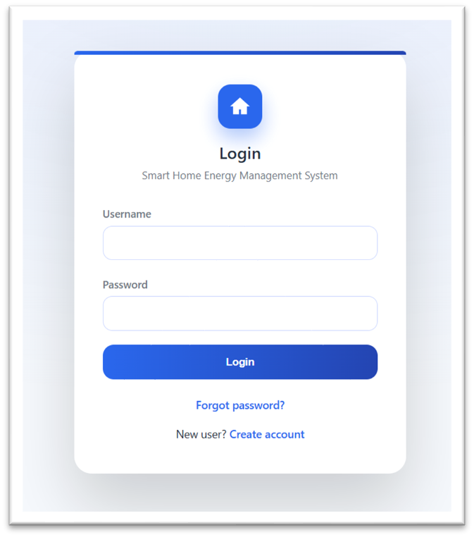
- User Registration Page
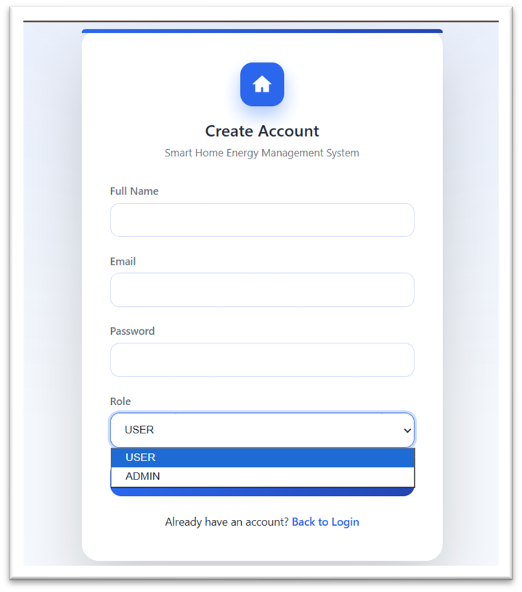

- User Dashboard

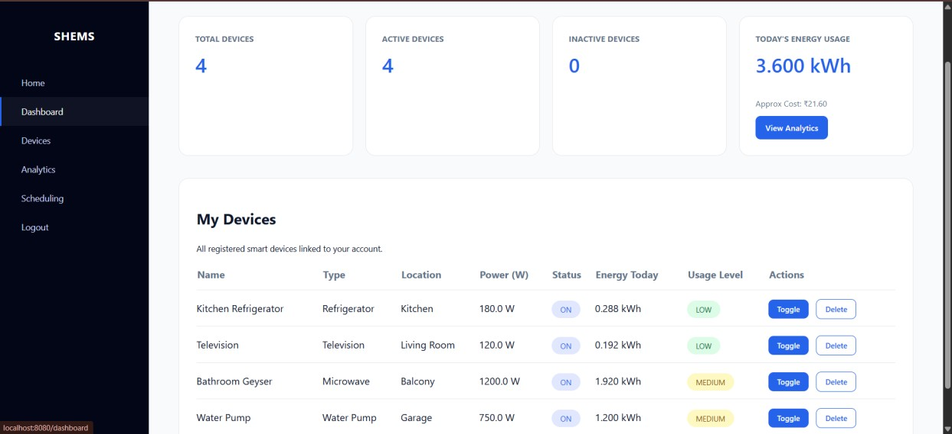

- Smart Device Management Screen

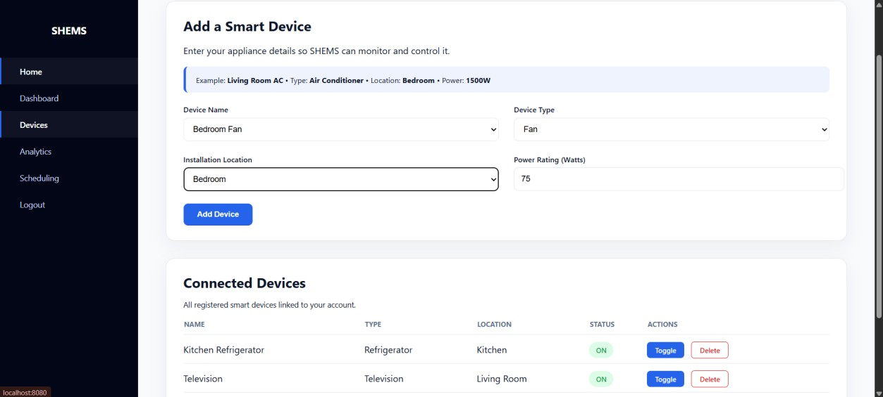

- Energy Analytics Dashboard

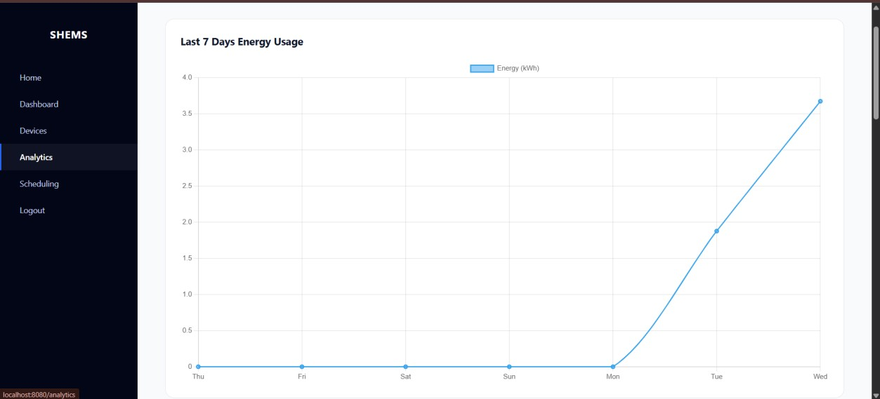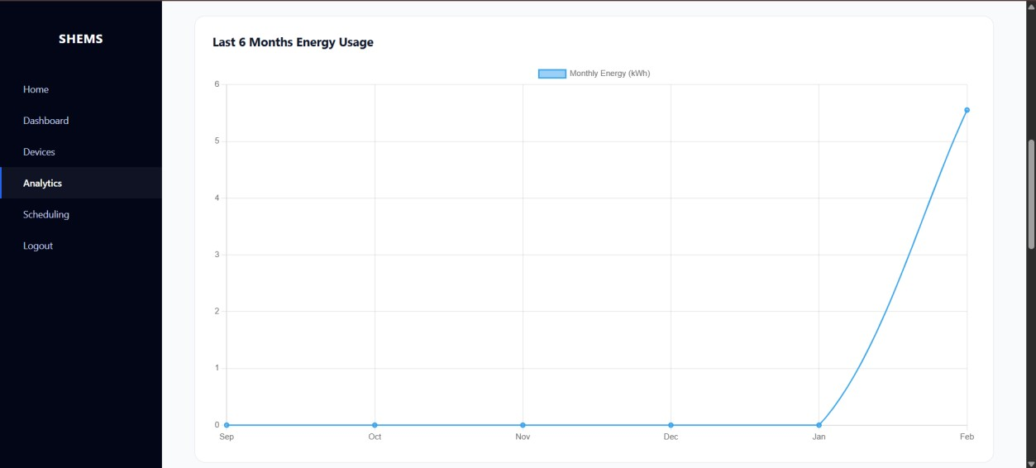

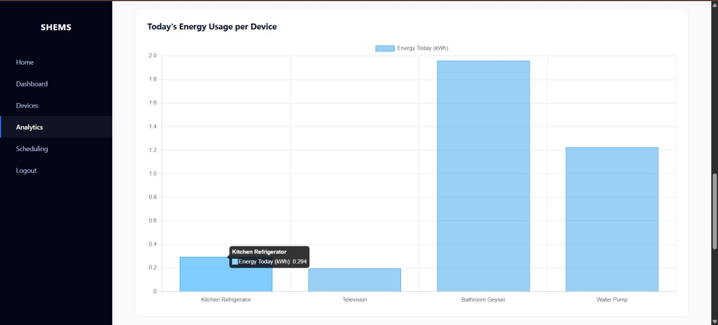
- Scheduling & Automation Screen

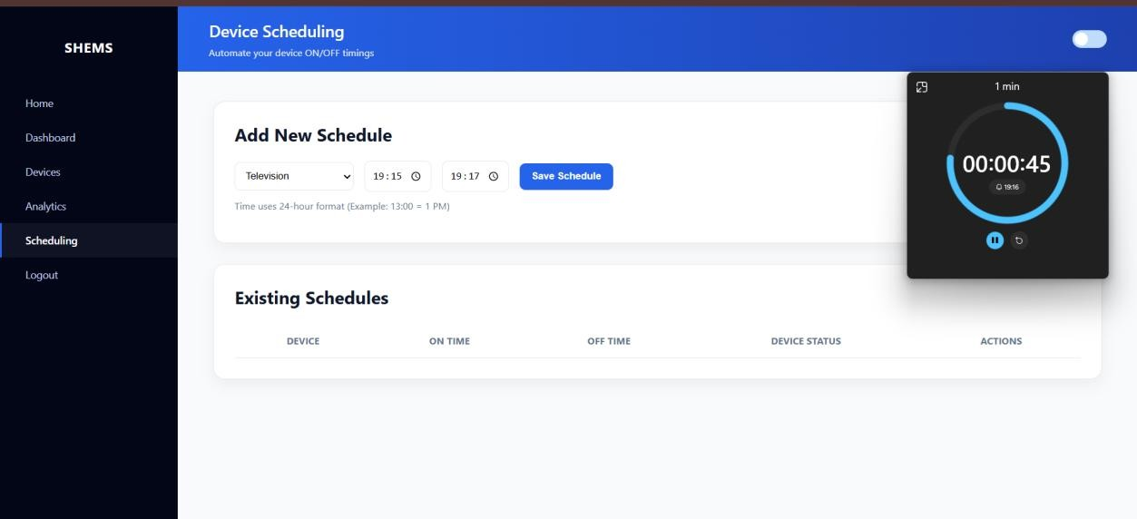
- Admin Dashboard

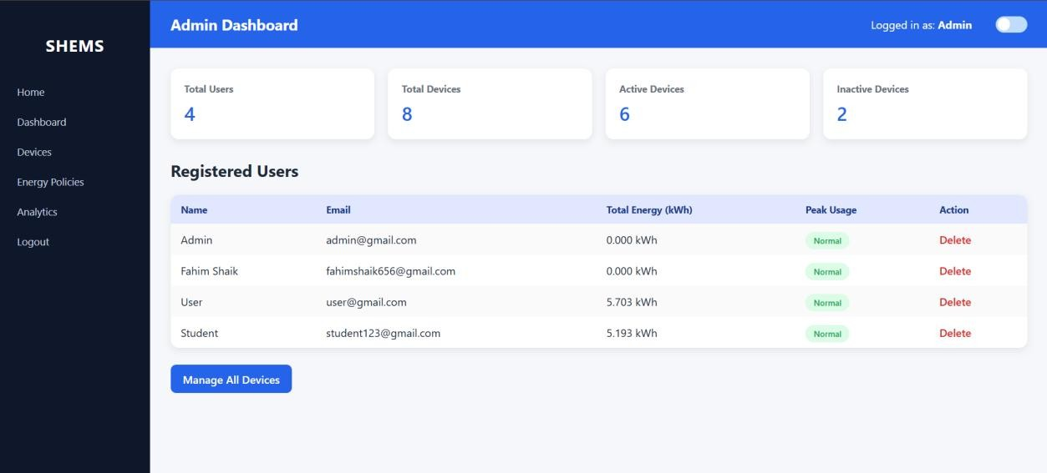

- Admin Energy Policy Management

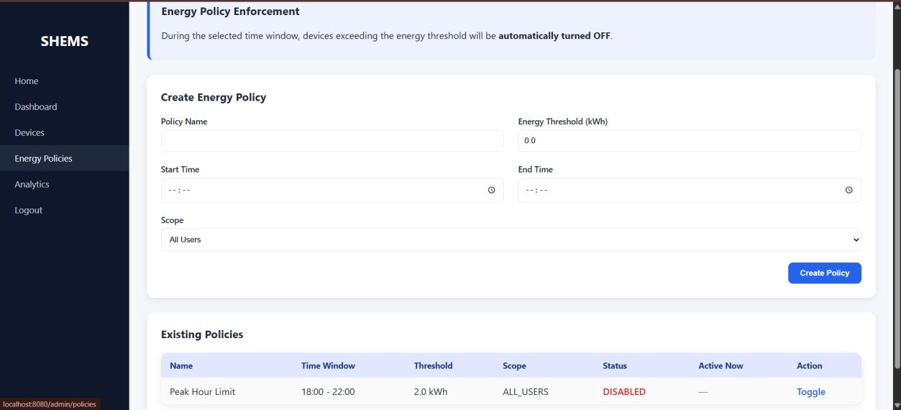
- Admin Analytics Overview

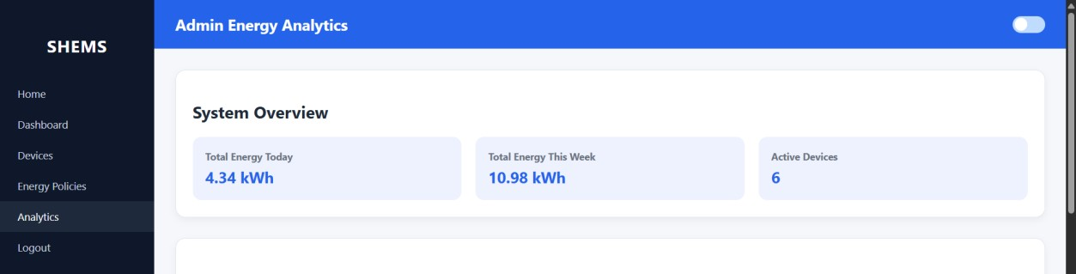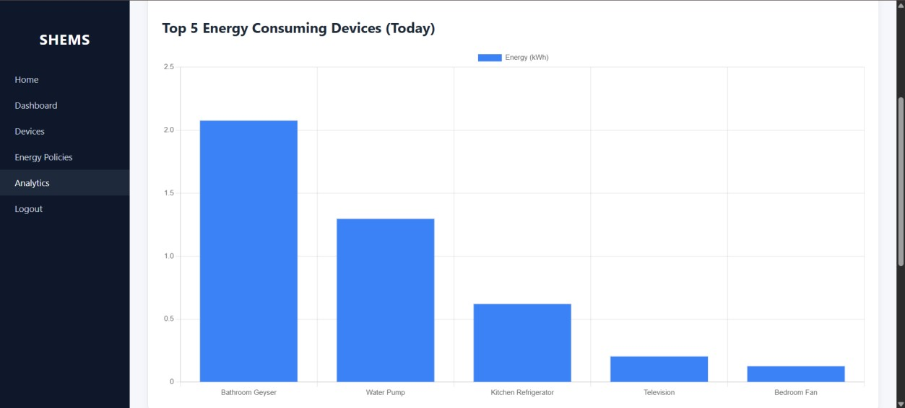

These screenshots collectively represent the complete system workflow

7. Learnings & Skills Acquired
- Hands-on experience with Spring Boot full-stack development
- Implementation of Spring Security and role-based authentication
- Understanding of real-time energy calculation logic
- Dashboard design and data visualization concepts
- Use of background schedulers for automation
- Database design using MySQL and Spring Data JPA
- Experience with admin-level monitoring and control features
- Improved debugging, integration testing, and modular design skills
- Strengthened teamwork and technical documentation skills

8. Challenges Faced
Challenge 1: Role-Based Access Control
Problem: Securing system features for different user roles
Solution: Implemented Spring Security with role-based authorization
Challenge 2: Accurate Energy Calculation
Problem: Maintaining reliable real-time energy tracking
Solution: Used power rating × usage duration formula
Challenge 3: Module Integration
Problem: Ensuring smooth interaction between modules
Solution: Followed modular design with continuous testing
Challenge 4: Automation Timing Accuracy
Problem: Ensuring scheduled actions execute correctly
Solution: Used background schedulers with validation logic
Challenge 5: Policy Enforcement Logic
Problem: Automatically controlling devices exceeding energy thresholds
Solution: Implemented admin-defined policies with enforcement and logging

9. Testimonials from Team
The team collaborated effectively throughout the internship by dividing responsibilities, conducting regular discussions, and supporting each other during development and testing.
Page |
This teamwork helped complete the project on time and strengthened both technical and communication skills.

10. Conclusion
The Smart Home Energy Management System (SHEMS) successfully demonstrates a real world smart energy solution integrating authentication, device control, real-time tracking, analytics, automation, and policy enforcement. This project significantly improved our understanding of full-stack development and real-time system design.

11. Acknowledgements
I sincerely thank our mentor and Infosys Springboard for their continuous guidance and support throughout the internship. Their feedback and encouragement played a vital role in the successful completion of this project.

Page |

