**Scientific Calculator in Java - Project Notes**

# Project Overview

This project is a GUI-based Scientific Calculator built using Java Swing. It allows users to perform basic arithmetic operations as well as scientific functions like sine, cosine, tangent, logarithm, square root, and exponentiation.

The calculator is implemented using a graphical interface with buttons for each function, and it displays results in a text field.

# Tools and Technologies Used

* IntelliJ IDEA Community Edition 2024.3.2
* Java (JDK 8 or above)
* Java Swing for GUI
* Java AWT Event Handling

# Features

* Basic Operations: Addition, Subtraction, Multiplication, Division
* Scientific Operations: sin, cos, tan, log, sqrt, power (x^y)
* Functional Buttons: Clear (C), Backspace (Backspace), Decimal Point (.), Equal (=)

# How to Run the Project

1. Open IntelliJ IDEA.
2. Create a new Java project.
3. Add a new Java Class file named 'Main.java'.
4. Paste the provided code into Main.java.

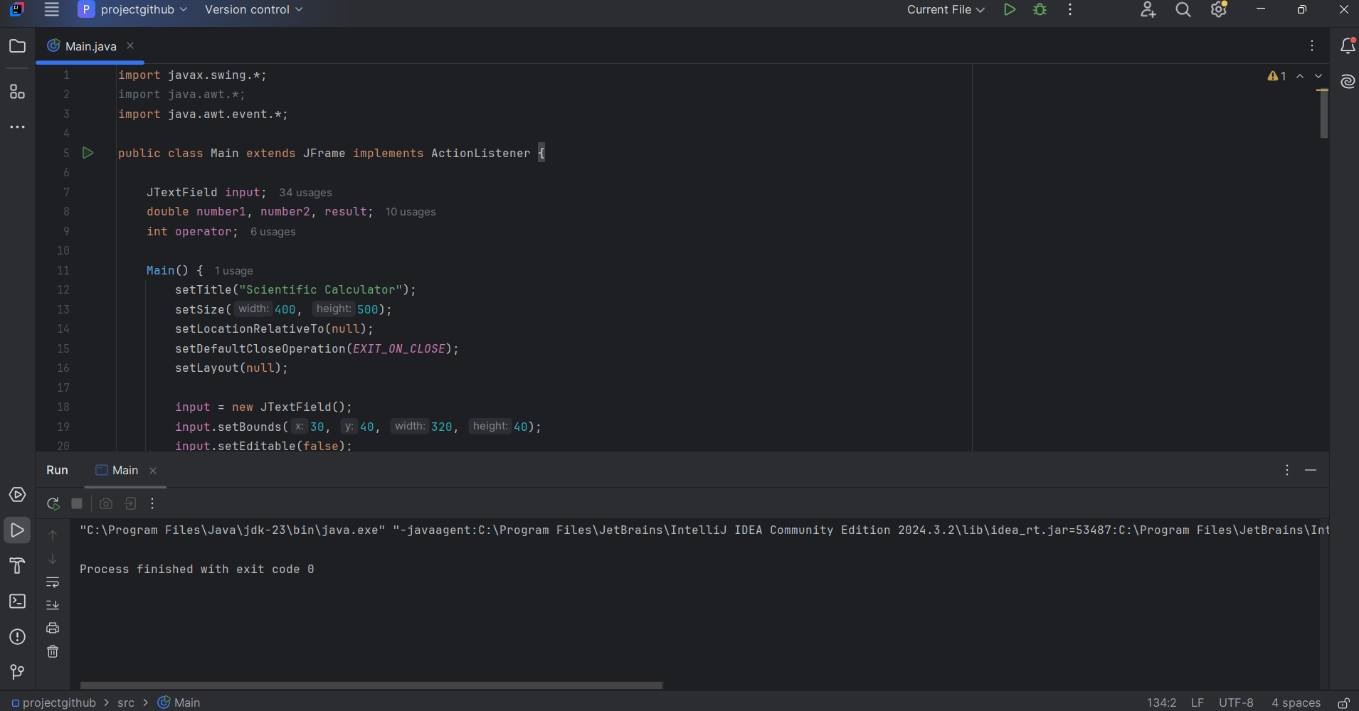

1. Run the file using the green Run button or right-click > Run 'Main.main()'.

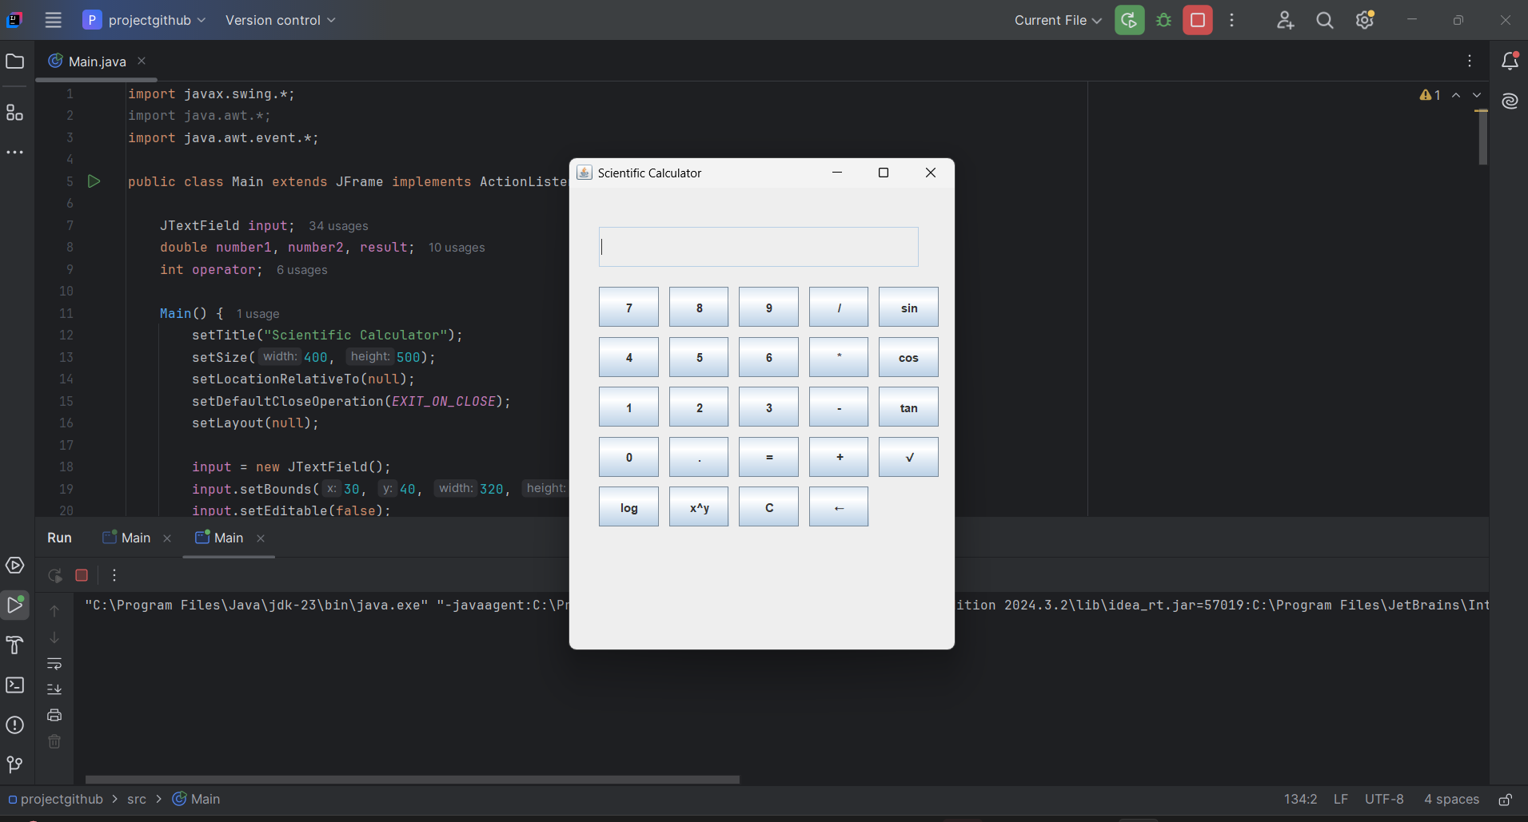

# Code Explanation

* The Main class extends JFrame and implements ActionListener.
* The GUI is built using JTextField and multiple JButtons for input.
* Mathematical functions are performed using java.lang.Math.
* The actionPerformed method handles all button click events.

# Future Enhancements (Optional)

* Add more scientific functions like factorial, exponential, or memory (M+, MR, MC).
* Use a layout manager for responsive design instead of absolute positioning.
* Export calculation history to a file.
* Create a mobile version using JavaFX or Android Studio.