 | GUNTHA BHARATHI |  | 192371079
 | 28/08/2026
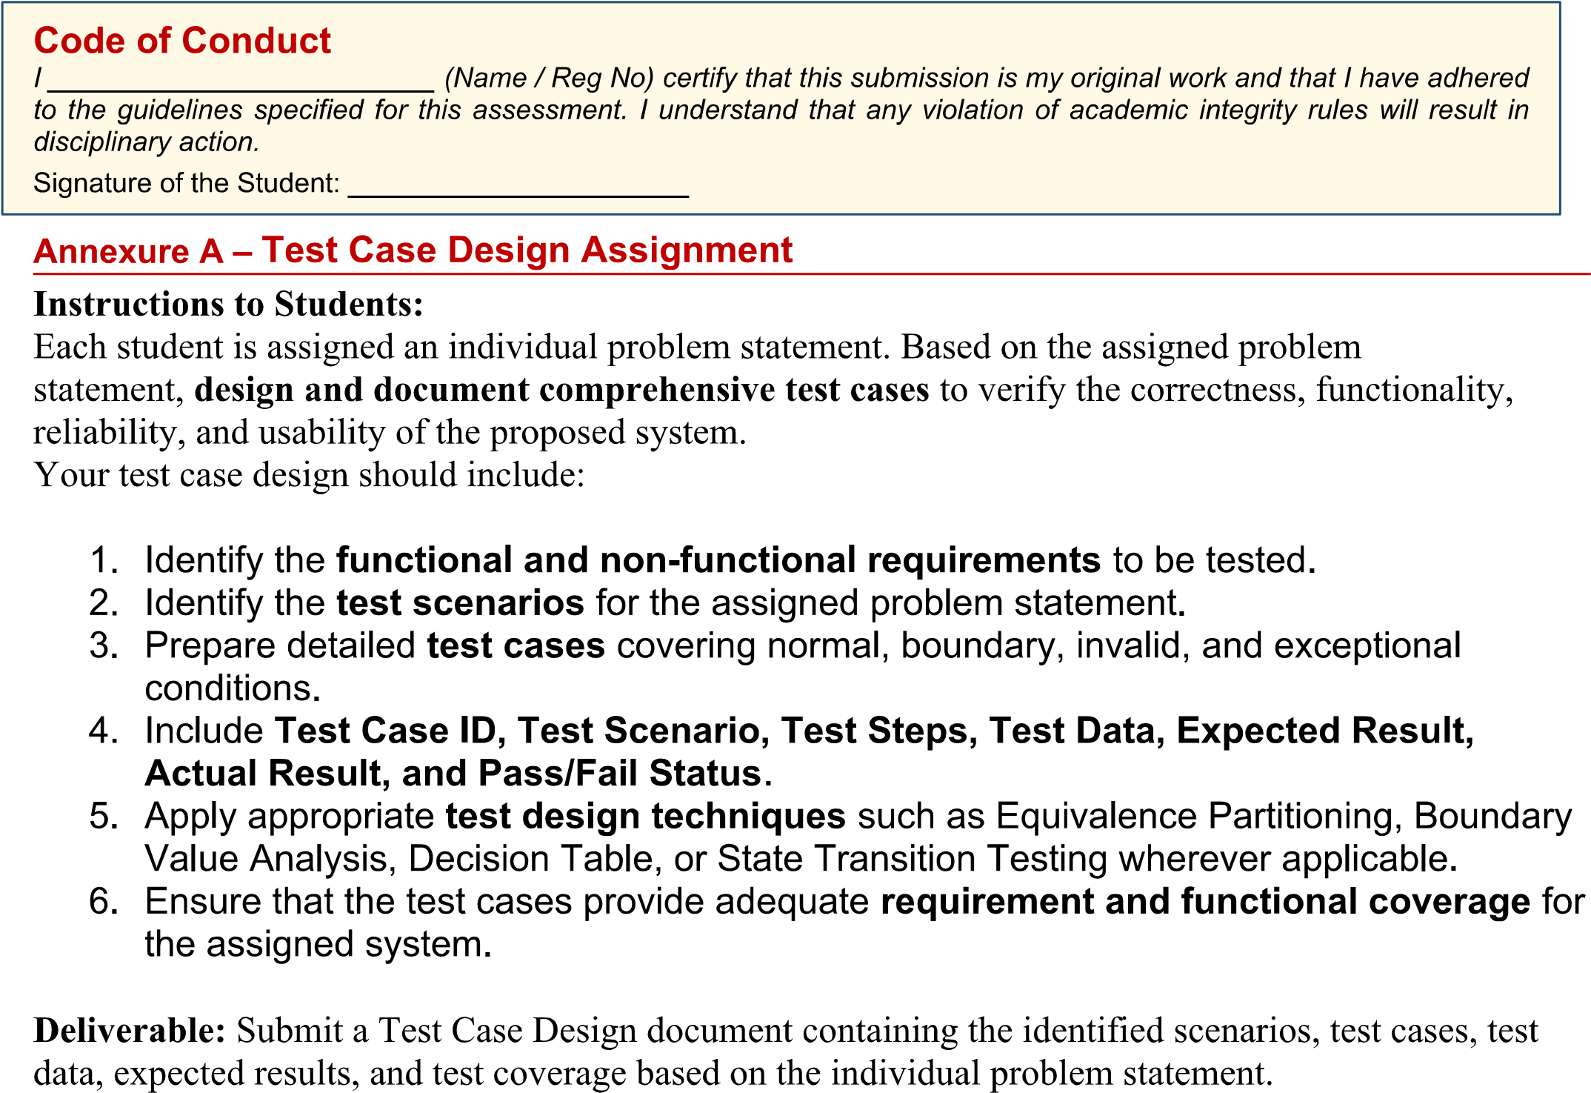
Guntha Bharathi / 192371079
Guntha Bharathi / 192371079
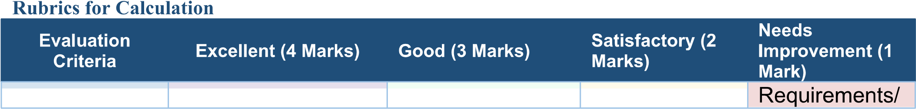
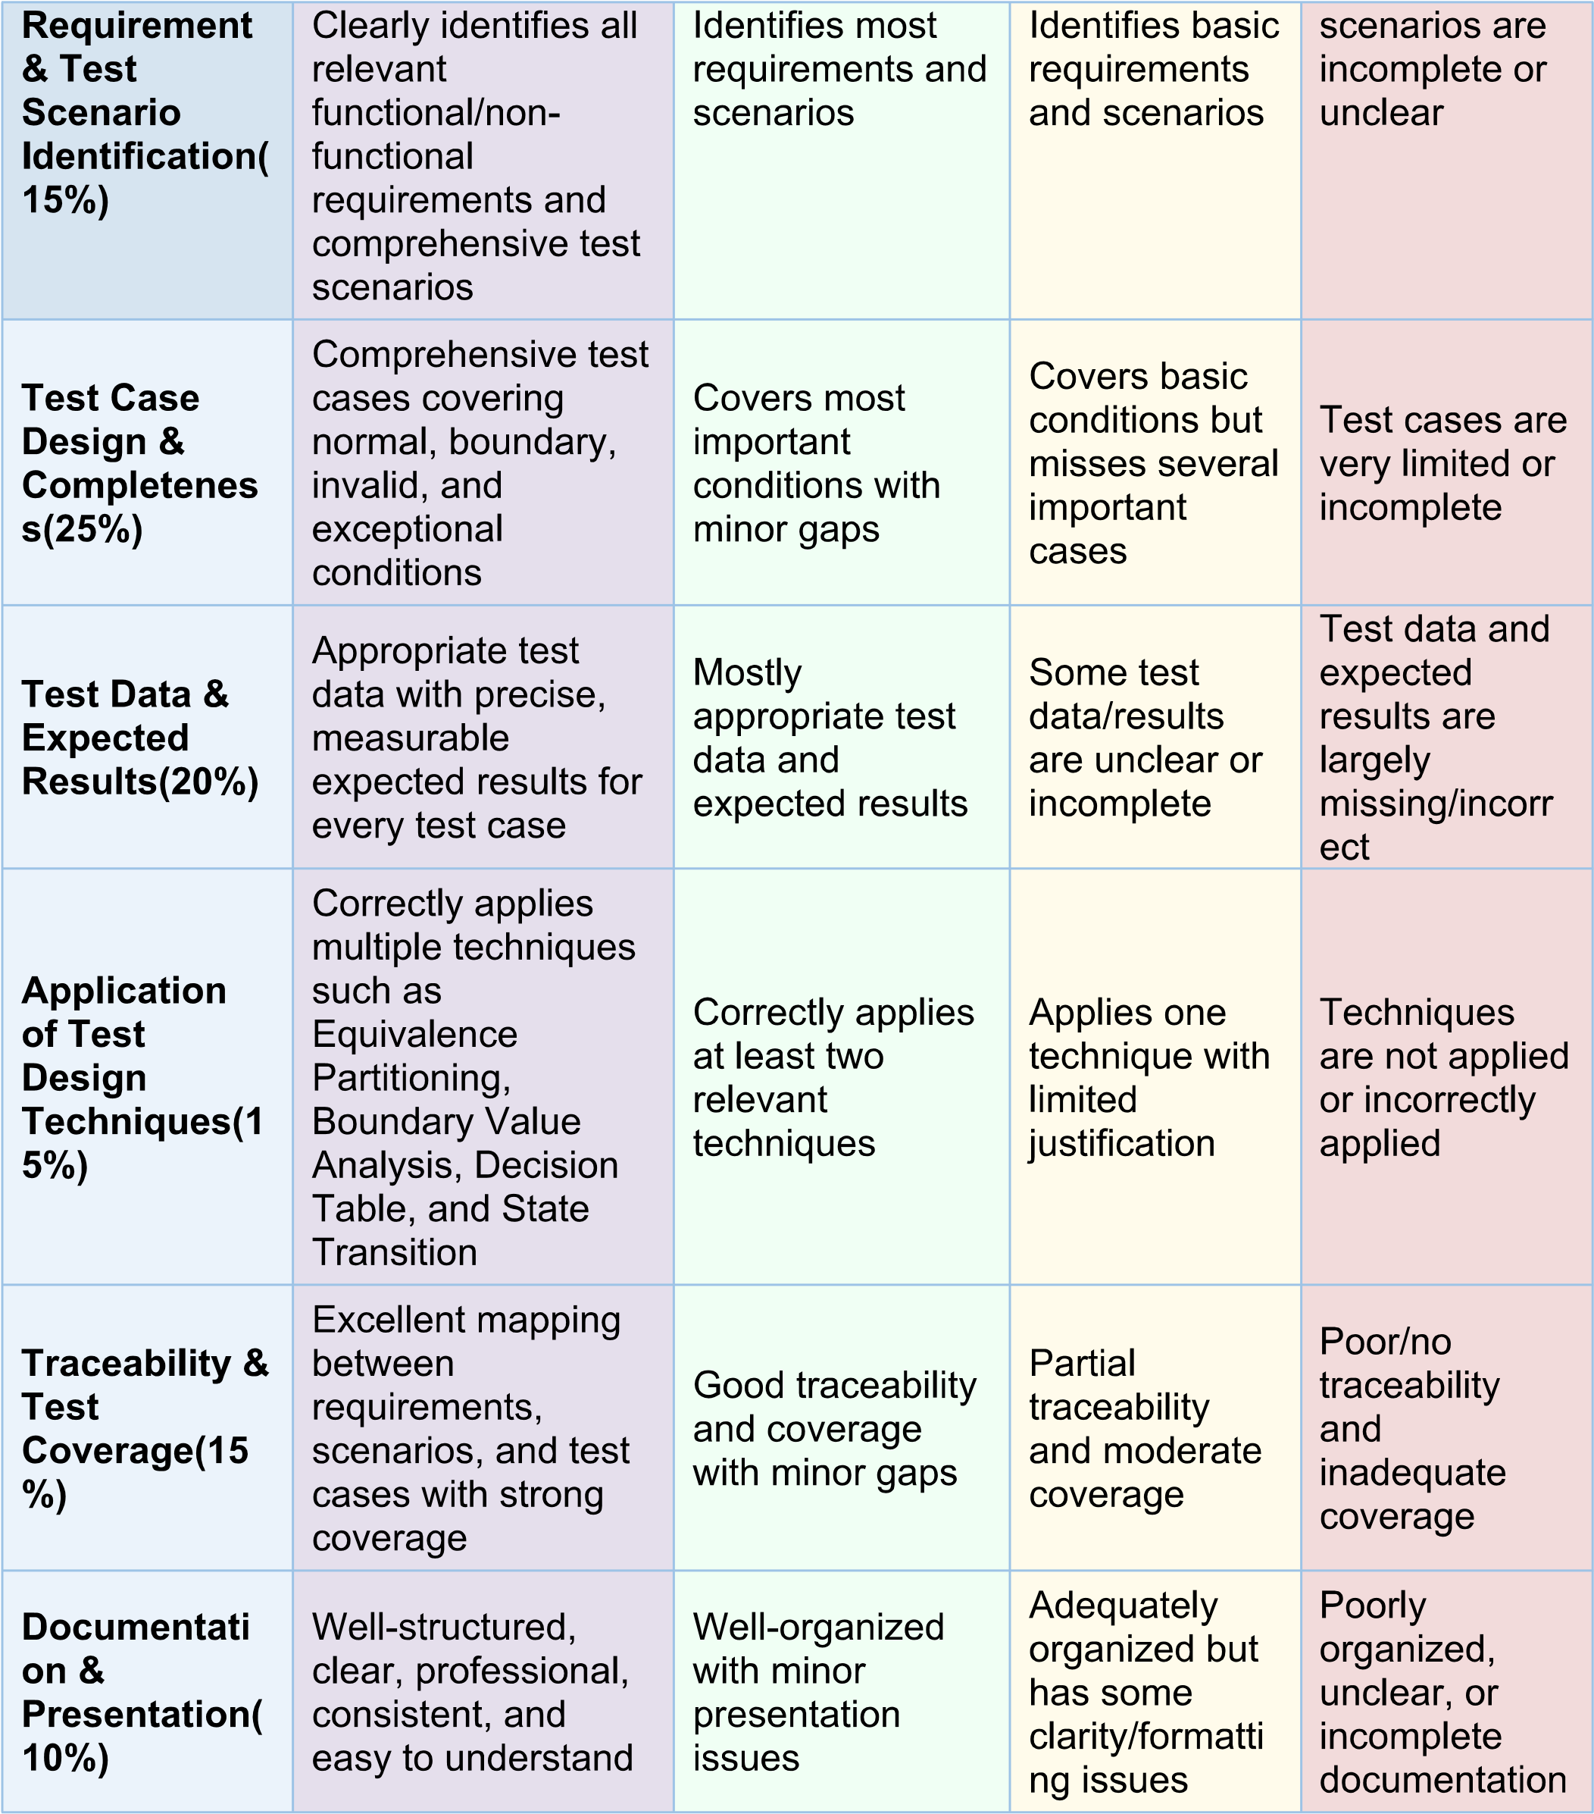
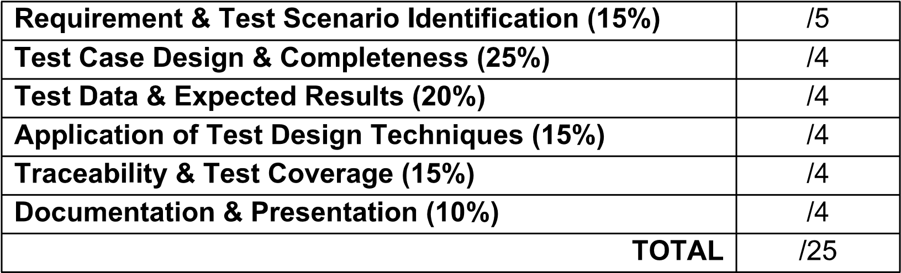

1. System Overview
The College Admission Counselling System (CACS) is a web-based application that automates the end-to-end admission process for a group of affiliated colleges. Prospective students register, submit academic marks and category details, select and rank college/course preferences, and are allotted seats automatically based on merit rank, category quota, and seat availability. Students then accept or decline the allotted seat and complete fee payment to confirm admission. This document identifies the requirements, test scenarios, applicable test-design techniques, detailed test cases, and requirement-traceability for the assigned problem statement.

2. Functional Requirements (FR)
ID | Functional Requirement
FR1 | The system shall allow a prospective student to register by providing personal, academic and category (quota) details.
FR2 | The system shall allow a registered student to log in securely using a unique ID and password.
FR3 | The system shall validate a student's eligibility against the minimum qualifying marks (35%) defined for the assigned course.
FR4 | The system shall allow a student to select and rank college/course preferences (maximum 10).
FR5 | The system shall compute a merit rank for every eligible student based on qualifying-exam marks/entrance score.
FR6 | The system shall allocate seats automatically based on merit rank, category quota and seat availability in the student's ranked preferences.
FR7 | The system shall allow a student to accept or decline an allotted seat within a stipulated deadline.
FR8 | The system shall process the admission fee payment and generate a fee receipt on successful payment.
FR9 | The system shall allow the admission counsellor/administrator to generate and publish the merit list and allotment list.
FR10 | The system shall send automated e-mail/SMS notifications to the student at every major status change (registration, eligibility, allotment, payment).

3. Non-Functional Requirements (NFR)
ID | Attribute | Non-Functional Requirement
NFR1 | Performance | The system shall support at least 10,000 concurrent users without response time exceeding 3 seconds during peak counselling hours.
NFR2 | Security | All student personal and payment data shall be encrypted in transit (TLS) and at rest; passwords shall be stored using a salted hash.
NFR3 | Availability | The counselling portal shall maintain 99.5% uptime during the active counselling window.
NFR4 | Usability | The interface shall be usable by students with basic computer literacy, with clear error messages and multilingual support.
NFR5 | Reliability | No seat-allocation or payment transaction shall be lost or duplicated even if the connection is interrupted mid-transaction.
NFR6 | Scalability | The architecture shall allow horizontal scaling of application servers during high-traffic admission cycles.

4. Test Scenarios
ID | Test Scenario | Related FR
TS01 | Verify student registration with valid and invalid data | FR1
TS02 | Verify secure login and account-lockout behaviour | FR2
TS03 | Verify eligibility check against the minimum qualifying marks | FR3
TS04 | Verify selection and ranking of college/course preferences | FR4
TS05 | Verify merit rank computation | FR5
TS06 | Verify seat-allocation logic (merit + quota + preference + availability) | FR6
TS07 | Verify seat acceptance / decline within deadline | FR7
TS08 | Verify fee payment and receipt generation | FR8
TS09 | Verify merit-list / allotment-list publishing by admin | FR9
TS10 | Verify e-mail/SMS notification delivery on status change | FR10
TS11 | Verify system behaviour under boundary and invalid marks input | FR3
TS12 | Verify system behaviour under payment-gateway failure (exceptional flow) | FR8

5. Test Design Techniques Applied

5.1 Equivalence Partitioning – "Marks" Input Field
Class | Range / Condition | Sample Value(s) | Validity | Expected System Behaviour
EP1 | Marks < 0 | -10, -1 | Invalid | Reject – "Marks cannot be negative"
EP2 | 0 ≤ Marks < 35 | 0, 20, 34 | Invalid (below cutoff) | Reject – "Not eligible, below minimum marks"
EP3 | 35 ≤ Marks ≤ 100 | 35, 60, 100 | Valid | Accept – proceed to merit ranking
EP4 | Marks > 100 | 101, 150 | Invalid | Reject – "Invalid marks, exceeds maximum"

5.2 Boundary Value Analysis – Eligibility Cutoff (Min = 35, Max = 100)
Boundary Value | Description | Expected Result
-1 | Below lower invalid range | Rejected – negative value
0 | Lower boundary of invalid range | Rejected – below cutoff
34 | Just below the eligibility cutoff (min-1) | Rejected – not eligible
35 | Exact eligibility cutoff (min) | Accepted – eligible
36 | Just above the eligibility cutoff (min+1) | Accepted – eligible
99 | Just below the maximum (max-1) | Accepted – eligible
100 | Exact maximum boundary (max) | Accepted – eligible
101 | Just above the maximum (max+1) | Rejected – invalid value

5.3 Decision Table – Seat Allocation Logic
Conditions considered: eligibility, category-quota match, and seat availability in the student's top preference.
Condition / Action | R1 | R2 | R3 | R4 | R5 | R6
C1: Eligible (marks ≥ cutoff) | Y | Y | Y | Y | Y | N
C2: Category quota matched | Y | Y | N | N | Y | -
C3: Seat available in top preference | Y | N | Y | N | N | -
A1: Allot seat in top preference | X
A2: Check next ranked preference |  | X |  | X | X
A3: Allot under general quota (if applicable) |  |  | X
A4: Mark as Waitlisted |  |  |  | X
A5: Reject application (not eligible) |  |  |  |  |  | X

5.4 State Transition Testing – Application Status Lifecycle
The diagram below models every valid status transition of a student's application, from initial registration through to admission confirmation or withdrawal. Each transition in the model is exercised by at least one test case (see Section 6).
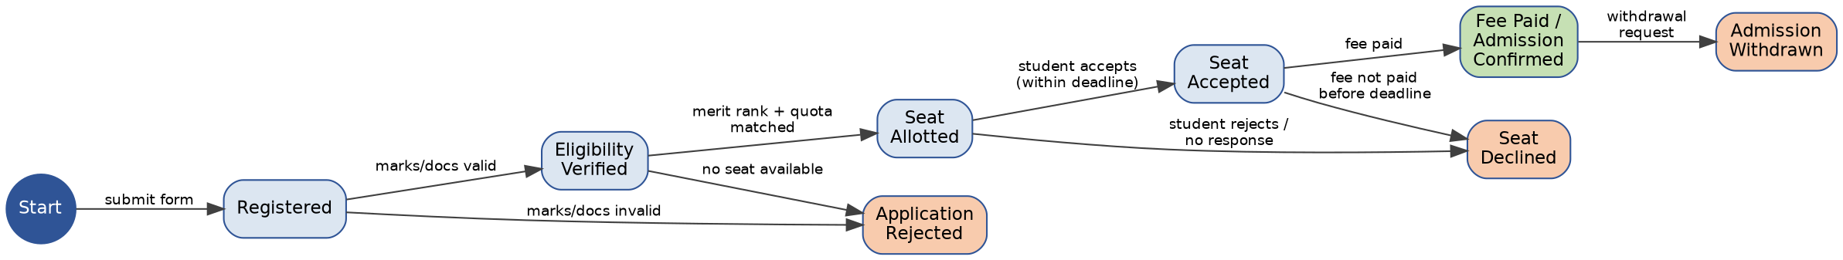

6. Detailed Test Cases
Test cases below cover normal, boundary, invalid, and exceptional conditions across all major functional areas, as required by the assignment.
TC ID | Category | Scenario | Test Steps | Test Data | Expected Result | Actual Result | Status
TC01 | Normal | TS01 | 1. Open registration page.  2. Enter valid name, DOB, marks and category.  3. Click Submit. | Name: Arun R; Marks: 78%; Category: General | Registration successful; confirmation message and Application No. displayed. | As expected | Pass
TC02 | Invalid | TS01 | 1. Open registration page.  2. Leave mandatory e-mail field blank.  3. Click Submit. | E-mail: <blank> | System rejects submission with message "E-mail is required". | As expected | Pass
TC03 | Invalid | TS01 | 1. Enter non-numeric value in marks field.  2. Click Submit. | Marks: "abc" | Validation error "Enter a valid numeric value for marks". | As expected | Pass
TC04 | Boundary (BVA) | TS03/TS11 | 1. Register with marks just below the cutoff.  2. Submit and check eligibility. | Marks = 34% | Student marked "Not Eligible" for counselling. | As expected | Pass
TC05 | Boundary (BVA) | TS03/TS11 | 1. Register with marks exactly at the cutoff.  2. Submit and check eligibility. | Marks = 35% | Student marked "Eligible" for counselling. | As expected | Pass
TC06 | Boundary (BVA) | TS03/TS11 | 1. Register with marks just above the cutoff.  2. Submit and check eligibility. | Marks = 36% | Student marked "Eligible" for counselling. | As expected | Pass
TC07 | Boundary (BVA) | TS03/TS11 | 1. Register with the maximum possible marks.  2. Submit and check eligibility. | Marks = 100% | Student marked "Eligible"; accepted as valid upper limit. | As expected | Pass
TC08 | Invalid (BVA) | TS11 | 1. Enter marks above the maximum possible value.  2. Click Submit. | Marks = 101% | Error "Invalid marks – value cannot exceed 100". | As expected | Pass
TC09 | Invalid | TS11 | 1. Enter a negative value for marks.  2. Click Submit. | Marks = -5% | Error "Marks cannot be negative". | As expected | Pass
TC10 | Normal | TS02 | 1. Enter registered ID and correct password.  2. Click Login. | ID: STU1023 / Pwd: Valid@123 | Student redirected to personal dashboard. | As expected | Pass
TC11 | Invalid | TS02 | 1. Enter registered ID with an incorrect password.  2. Click Login. | ID: STU1023 / Pwd: Wrong@1 | Error "Invalid credentials"; login refused. | As expected | Pass
TC12 | Exceptional | TS02 | 1. Attempt login with wrong password 5 times consecutively. | 5 consecutive wrong attempts | Account locked for 30 minutes; lockout message displayed. | As expected | Pass
TC13 | Normal | TS04 | 1. Log in.  2. Select and rank 3 college/course preferences.  3. Save. | 3 preferences in priority order | Preferences saved and displayed in the chosen order. | As expected | Pass
TC14 | Boundary | TS04 | 1. Add preferences up to the maximum allowed limit. | 10 preferences (maximum limit) | All 10 preferences accepted and saved. | As expected | Pass
TC15 | Invalid | TS04 | 1. Attempt to add one preference beyond the maximum limit. | 11th preference | Error "Maximum 10 preferences allowed"; 11th entry rejected. | As expected | Pass
TC16 | Normal | TS06 | 1. Run allocation for an eligible student whose merit rank and quota match preference 1, with a seat available. | Merit rank within cutoff; Preference 1 seat open | Seat allotted in preference 1 college/course. | As expected | Pass
TC17 | Normal | TS06 | 1. Run allocation where preference 1 is full but preference 2 has an open seat. | Preference 1: Full; Preference 2: Open | Seat allotted as per preference 2 automatically. | As expected | Pass
TC18 | Exceptional | TS06 | 1. Run allocation for a student whose merit rank/quota does not match any seat in any listed preference. | No seat matches any of the student's preferences | Status shown as "Not Allotted / Waitlisted"; student notified. | As expected | Pass
TC19 | Normal | TS07 | 1. Student logs in after allotment.  2. Clicks "Accept Seat" before the deadline. | Response within deadline | Status updated to "Seat Accepted"; proceeds to payment. | As expected | Pass
TC20 | Exceptional | TS07 | 1. Student does not respond to an allotted seat before the deadline. | No response till deadline expiry | Seat auto-declined; released to the next eligible candidate. | As expected | Pass
TC21 | Normal | TS08 | 1. Accept seat.  2. Enter valid payment details.  3. Submit payment. | Valid card/UPI details; Amount: Rs.5,000 | Payment successful; receipt generated; admission confirmed. | As expected | Pass
TC22 | Invalid | TS08 | 1. Enter invalid card details.  2. Submit payment. | Invalid card number / expired card | Payment declined with a clear error message; seat retained till deadline. | As expected | Pass
TC23 | Exceptional | TS12 | 1. Initiate payment.  2. Simulate gateway timeout/network failure mid-transaction. | Gateway timeout during processing | Transaction safely rolled back; no double debit; student prompted to retry. | As expected | Pass
TC24 | Normal | TS09 | 1. Admin generates the merit list after the registration window closes.  2. Publishes the list. | All eligible applicants' data | Merit list published, correctly sorted by rank and visible to students. | As expected | Pass
TC25 | Normal | TS10 | 1. Trigger a status change (e.g., seat allotted).  2. Observe notification delivery. | Registered mobile no. / e-mail | E-mail/SMS notification received within 2 minutes of the status change. | As expected | Pass

7. Requirement & Functional Coverage (Traceability Matrix)
FR ID | Functional Area | Covered By Test Case(s)
FR1 | Registration | TC01, TC02, TC03
FR2 | Login & security | TC10, TC11, TC12
FR3 | Eligibility check | TC04, TC05, TC06, TC07, TC08, TC09
FR4 | Preference selection | TC13, TC14, TC15
FR5 | Merit rank computation | TC16, TC17, TC24
FR6 | Seat allocation | TC16, TC17, TC18
FR7 | Seat accept/decline | TC19, TC20
FR8 | Fee payment & receipt | TC21, TC22, TC23
FR9 | Merit list publishing | TC24
FR10 | Notifications | TC25
All ten functional requirements (FR1–FR10) are covered by at least two independent test cases, and every transition in the application-status state model (Section 5.4) is exercised by the test cases in Section 6, giving complete requirement and functional coverage for the assigned system.

8. Conclusion
This Test Case Design document identifies the functional and non-functional requirements of the College Admission Counselling System, derives twelve test scenarios from them, and applies Equivalence Partitioning, Boundary Value Analysis, Decision Table, and State Transition testing to design twenty-five detailed test cases spanning normal, boundary, invalid, and exceptional conditions. The accompanying traceability matrix confirms complete coverage of all identified requirements.

