 | GUNTHA BHARATHI |  | 192371079
 | 28/08/2026
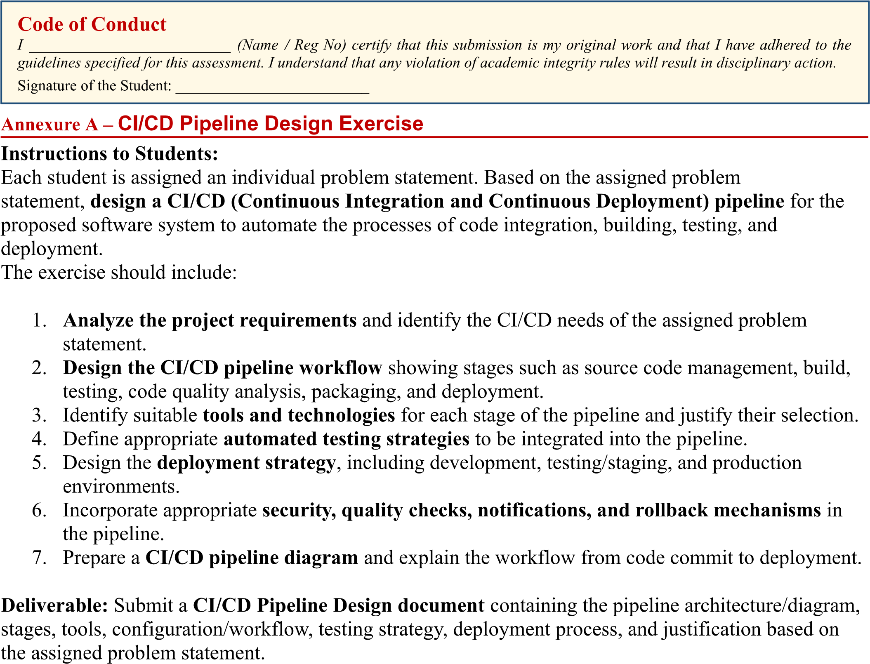
Guntha Bharathi / 192371079
Guntha Bharathi / 192371079

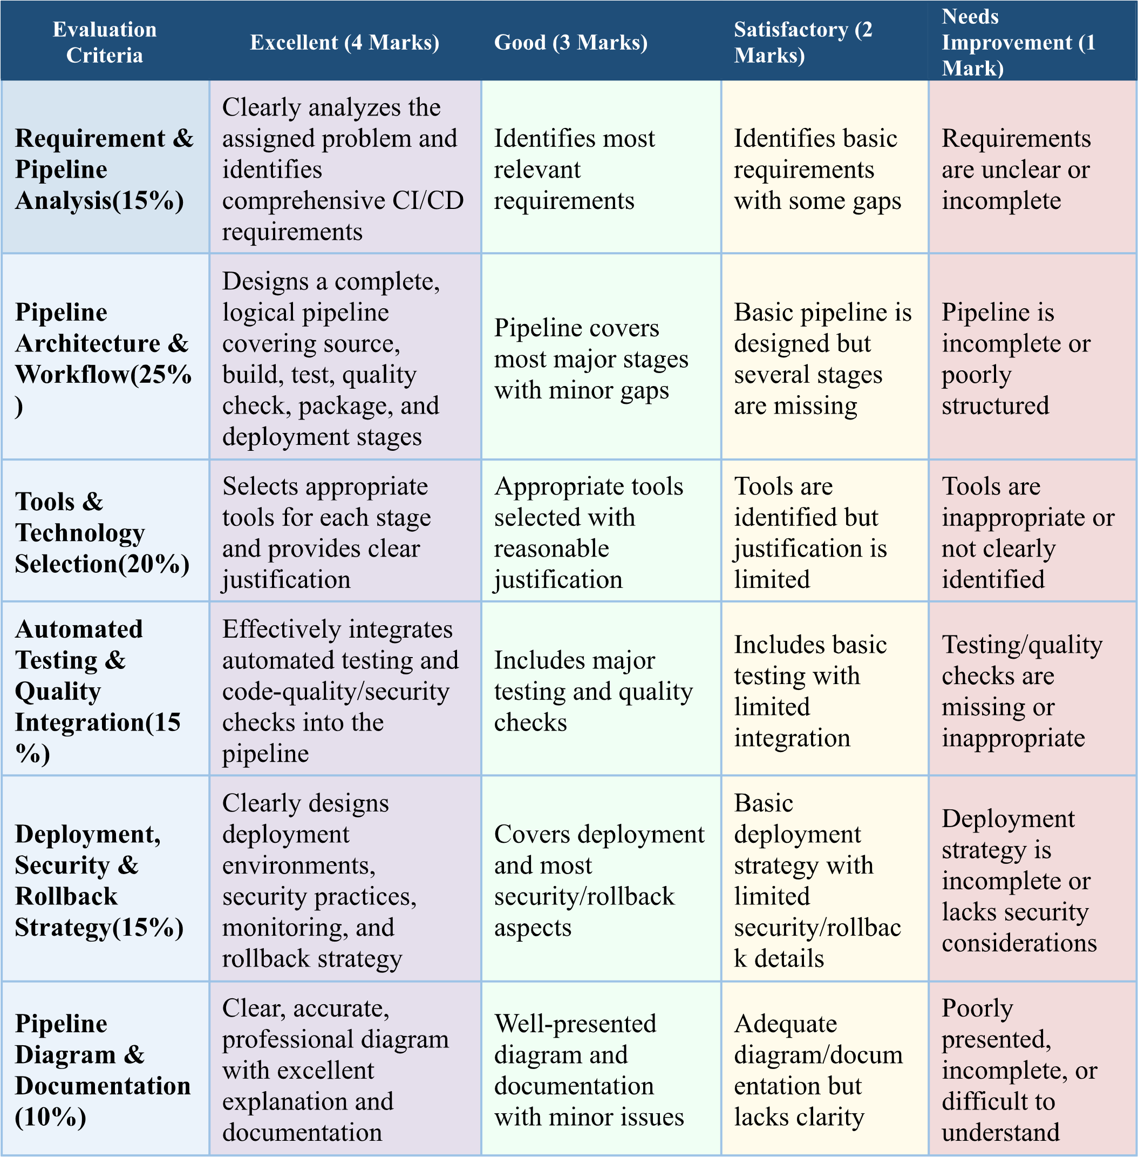

1. Requirement & Pipeline Analysis

1.1 Problem Statement Overview
The College Admission Counselling System is a web-based platform that automates student registration, application submission, document verification, merit-list generation, seat allotment (counselling), fee payment, and result/status notification for a college's admission process. It serves three user roles — applicants, counselling/admin staff, and super-admin (report/analytics) — and must remain accurate and available during high-traffic counselling rounds.

1.2 Key Functional Requirements
- Student registration, login, and profile management.
- Online application form with document upload (marksheets, category/income certificates).
- Automated eligibility check and merit-list/rank generation.
- Choice-filling and seat-allotment (counselling) engine, including reservation-category rules.
- Online fee payment gateway integration and receipt generation.
- Email/SMS notifications for status updates and allotment results.
- Admin dashboard for monitoring applications, seat matrix, and generating reports.

1.3 CI/CD Needs Identified
- Frequent, safe releases: the system evolves across admission phases (registration → verification → counselling → allotment), so each phase's code changes need to reach staging/production quickly without breaking earlier phases.
- Data-integrity safety net: merit-list and allotment logic is business-critical; every change must be automatically tested before deployment to avoid mis-allotment.
- Peak-load readiness: traffic spikes sharply on result-declaration and counselling days, so the pipeline must support load testing and rapid, zero-downtime scaling.
- Security and compliance: the system stores sensitive personal data (marks, income, category), so every build must pass automated security and dependency scans.
- Fast recovery: any faulty deployment during an active counselling round must be rolled back within minutes.

2. CI/CD Pipeline Architecture & Workflow
The pipeline is organized as a linear sequence of automated stages triggered on every commit, with a manual approval gate before production during active counselling windows:
- Source Stage: Developers commit code to feature branches and raise a pull request into develop; GitHub webhook triggers the pipeline.
- Build Stage: Backend (Spring Boot/Node.js) and frontend (React) are compiled/bundled; a Docker image is built for each service.
- Test Stage: Unit tests run first (fast feedback), followed by code-quality/security scanning.
- Integration & UI Testing Stage: API contract tests and Selenium regression tests validate the registration, application, and counselling flows end-to-end.
- Package Stage: A versioned Docker image is pushed to the registry (Docker Hub/Nexus) only if all prior stages pass.
- Deploy Stage: The image is deployed to Development, then Staging (UAT) for admission-office sign-off, then — after a manual approval gate — to Production using a blue-green or canary strategy.
- Monitor & Feedback Stage: Health checks, metrics, and logs are watched continuously; failures trigger automatic rollback and team notification.
This mirrors the assignment's required pipeline diagram (Section 6), which shows the full flow from code commit to deployment along with the rollback loop.

3. Tools & Technology Selection
Pipeline Stage | Tool / Technology | Justification
Source Control | Git + GitHub | Free, industry-standard version control; branch protection and pull-request reviews suit a student-team academic project; native webhook triggers CI on every push.
CI Orchestration | GitHub Actions | Tightly integrated with GitHub (no extra server to host), YAML-based pipelines are easy to version alongside code, and the free tier covers a college project's build volume.
Build | Maven (Java/Spring Boot backend) or npm (Node.js backend); npm/Vite for React frontend | Standard build tool for the chosen stack; produces reproducible, dependency-locked build artifacts.
Unit Testing | JUnit 5 + Mockito (backend), Jest + React Testing Library (frontend) | De-facto frameworks for their ecosystems; generate coverage reports the pipeline can gate on.
Code Quality & Security | SonarQube (static analysis), OWASP Dependency-Check | Flags bugs, code smells, and vulnerable dependencies (important since the system stores personal data such as marks, category, and income certificates) before merge.
Integration / API / UI Testing | Postman + Newman (API), Selenium (admission-form and counselling-flow UI regression) | Automates end-to-end checks of critical flows — registration, document upload, seat allotment — that unit tests alone cannot catch.
Containerization & Packaging | Docker, artifact stored in Docker Hub / Nexus | Guarantees the app runs identically across dev, staging, and production; versioned images make rollback trivial.
Deployment Orchestration | Kubernetes (or Docker Compose for a smaller academic deployment) | Handles scaling around peak load (admission and counselling season traffic spikes) and supports blue-green/canary rollouts.
Configuration & Secrets | GitHub Actions Encrypted Secrets / HashiCorp Vault | Keeps DB credentials, payment-gateway keys, and SMTP credentials out of source code.
Monitoring & Logging | Prometheus + Grafana, ELK Stack | Tracks response time, error rate, and server health in real time; central logs speed up root-cause analysis.
Notifications | Slack / Email via GitHub Actions integrations | Immediately informs the team of build, test, or deployment failures so issues are fixed before they affect applicants.

4. Automated Testing & Quality Integration
Testing is layered so that cheap, fast checks run first and expensive, slower checks run only once earlier gates pass — this keeps feedback quick for developers while still catching deep issues before release.
Testing Type | What It Validates in the Counselling System | Tool
Unit Testing | Merit-score calculation, seat-allotment ranking logic, reservation/category rule checks, eligibility validation functions. | JUnit / Jest
Integration Testing | Interaction between application-form service, document-upload service, database, and notification service. | Postman/Newman
API Testing | Correct request/response contracts for endpoints such as /register, /apply, /allot-seat, /payment. | Postman/Newman
UI / Regression Testing | Student registration wizard, choice-filling screen, and admin allotment dashboard behave correctly after each change. | Selenium
Security Testing | SQL injection, broken auth, and exposure of sensitive applicant data (marks, income, category certificates). | OWASP ZAP / Dependency-Check
Performance/Load Testing | System stays responsive when thousands of students check results or file choices simultaneously during counselling rounds. | JMeter
User Acceptance Testing (Staging) | End-to-end counselling workflow signed off by admission-office staff before production release. | Manual + Selenium
Quality gates: the pipeline is configured to fail the build automatically if unit-test coverage drops below an agreed threshold (e.g., 80%), if SonarQube reports new Blocker/Critical issues, or if OWASP Dependency-Check finds a high-severity vulnerable library — preventing risky code from ever reaching staging.

5. Deployment Strategy, Security & Rollback

5.1 Environments
- Development: auto-deployed on every successful merge to develop; used by the team for early integration checks.
- Staging / UAT: mirrors production configuration; admission-office staff perform user-acceptance testing here before sign-off.
- Production: deployed only after manual approval, using a blue-green (or canary) strategy so the new version is verified on a slice of traffic before it fully replaces the old one.

5.2 Security Practices
- Secrets (DB credentials, payment-gateway keys, SMTP keys) stored in encrypted CI secrets / a vault, never in source code.
- HTTPS enforced end-to-end; role-based access control for applicant vs counselling-staff vs admin.
- Automated dependency and static-analysis scanning on every build (Section 4).
- Database backups taken automatically before each production deployment.

5.3 Monitoring & Notifications
Prometheus/Grafana track response time, error rate, and CPU/memory; the ELK stack centralizes logs for fast diagnosis. Slack/email notifications fire automatically on build failure, quality-gate failure, and deployment success/failure so the team reacts immediately.

5.4 Rollback Mechanism
Each production deployment is tagged with the Docker image version and the previous Kubernetes ReplicaSet/manifest is retained. If the post-deploy health check fails or Prometheus alerts cross a threshold, the pipeline automatically executes kubectl rollout undo (or re-points the blue-green load balancer to the previous stable version), restoring service within minutes without manual intervention.

6. Pipeline Diagram & Documentation
Figure 1 shows the complete CI/CD pipeline for the College Admission Counselling System, from code commit to production deployment, including the monitoring/rollback feedback loop and notification touchpoints.
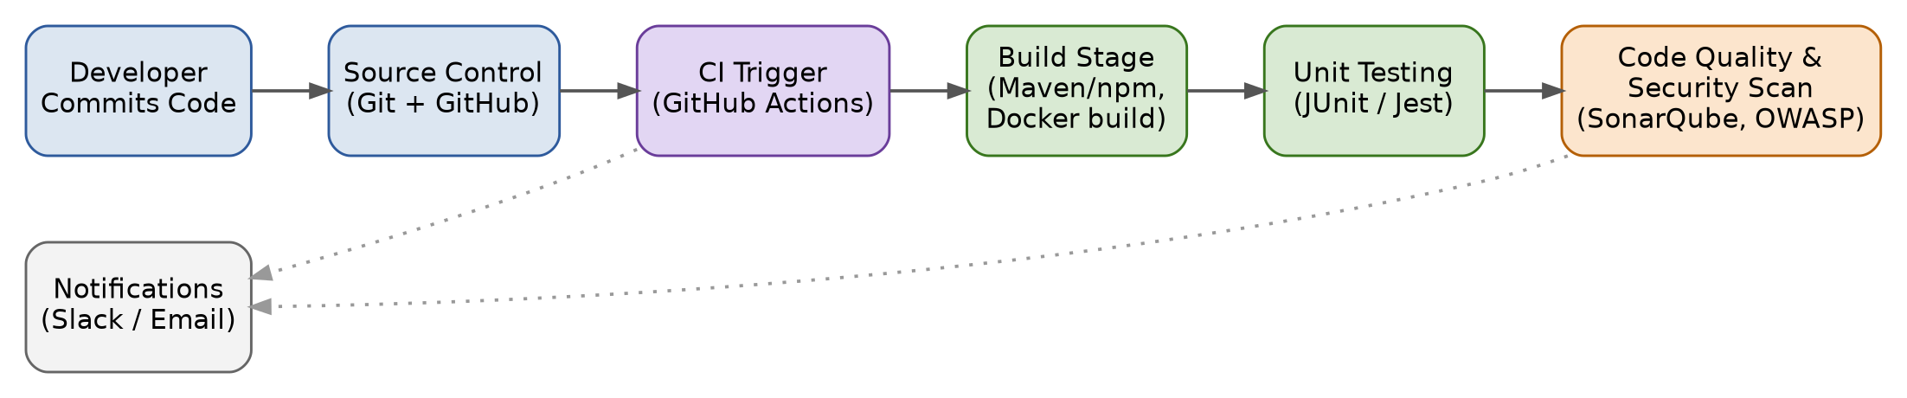
↓ continues to production deployment ↓
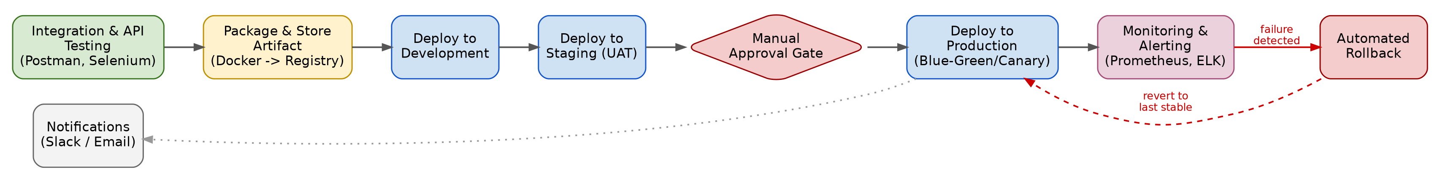
Figure 1: CI/CD Pipeline – College Admission Counselling System (top row continues into bottom row)

Workflow Walkthrough (Commit to Deployment)
- A developer pushes code to GitHub; the push/PR event triggers the GitHub Actions pipeline.
- The pipeline builds the backend and frontend and packages the Docker image.
- Unit tests run, followed by SonarQube and OWASP dependency scans; any failure stops the pipeline and notifies the team.
- Integration, API, and Selenium UI tests validate the registration/counselling flows.
- The verified Docker image is pushed to the registry, then auto-deployed to Development and Staging.
- Admission-office staff validate Staging; a manual approval gate then allows a blue-green/canary release to Production.
- Monitoring tools watch the live system; on failure, automated rollback restores the last stable version and the team is notified.

7. Sample CI/CD Configuration (GitHub Actions)
The excerpt below illustrates how the stages above translate into an executable pipeline definition (.github/workflows/ci-cd.yml):
name: CI-CD Admission Counselling System

on:
push:
branches: [ develop, main ]
pull_request:
branches: [ develop, main ]

jobs:
build-and-test:
runs-on: ubuntu-latest
steps:
- uses: actions/checkout@v4

- name: Set up JDK / Node
uses: actions/setup-java@v4
with: { java-version: '17', distribution: 'temurin' }

- name: Build backend
run: mvn -B clean package

- name: Run unit tests
run: mvn test

- name: SonarQube scan
run: mvn sonar:sonar -Dsonar.projectKey=admission-counselling

- name: OWASP dependency check
run: mvn org.owasp:dependency-check-maven:check

- name: Build Docker image
run: docker build -t admission-counselling:$(git rev-parse --short HEAD) .

- name: Push image to registry
run: docker push myregistry/admission-counselling:$(git rev-parse --short HEAD)

deploy-staging:
needs: build-and-test
runs-on: ubuntu-latest
steps:
- name: Deploy to staging (Kubernetes)
run: kubectl apply -f k8s/staging --record

- name: Run Postman/Newman integration tests
run: newman run tests/admission-flow.postman_collection.json

deploy-production:
needs: deploy-staging
runs-on: ubuntu-latest
environment:
name: production
url: https://admissions.example.edu
steps:
- name: Manual approval gate
uses: trstringer/manual-approval@v1

- name: Blue-Green deploy to production
run: kubectl apply -f k8s/production --record

- name: Health check
run: curl --fail https://admissions.example.edu/health || exit 1

- name: Rollback on failure
if: failure()
run: kubectl rollout undo deployment/admission-counselling -n production

- name: Notify team
if: always()
run: echo "Notify Slack/Email with pipeline status"

8. Conclusion
The proposed CI/CD pipeline automates the full journey of the College Admission Counselling System from source-code commit to production release. By layering fast unit tests, static/security analysis, and end-to-end functional tests before every deployment, and by pairing a staged (Dev → Staging → Production) rollout with monitoring and automatic rollback, the pipeline ensures that new features and fixes reach applicants quickly while keeping the admission and counselling process reliable, secure, and available during peak load.

Rubric Marking Grid
Criteria | Weightage
Requirement & Pipeline Analysis | 15%
Pipeline Architecture & Workflow | 25%
Tools & Technology Selection | 20%
Automated Testing & Quality Integration | 15%
Deployment, Security & Rollback Strategy | 15%
Pipeline Diagram & Documentation | 10%

