 | GUNTHA BHARATHI |  | 192371079
 | 14-08-2026
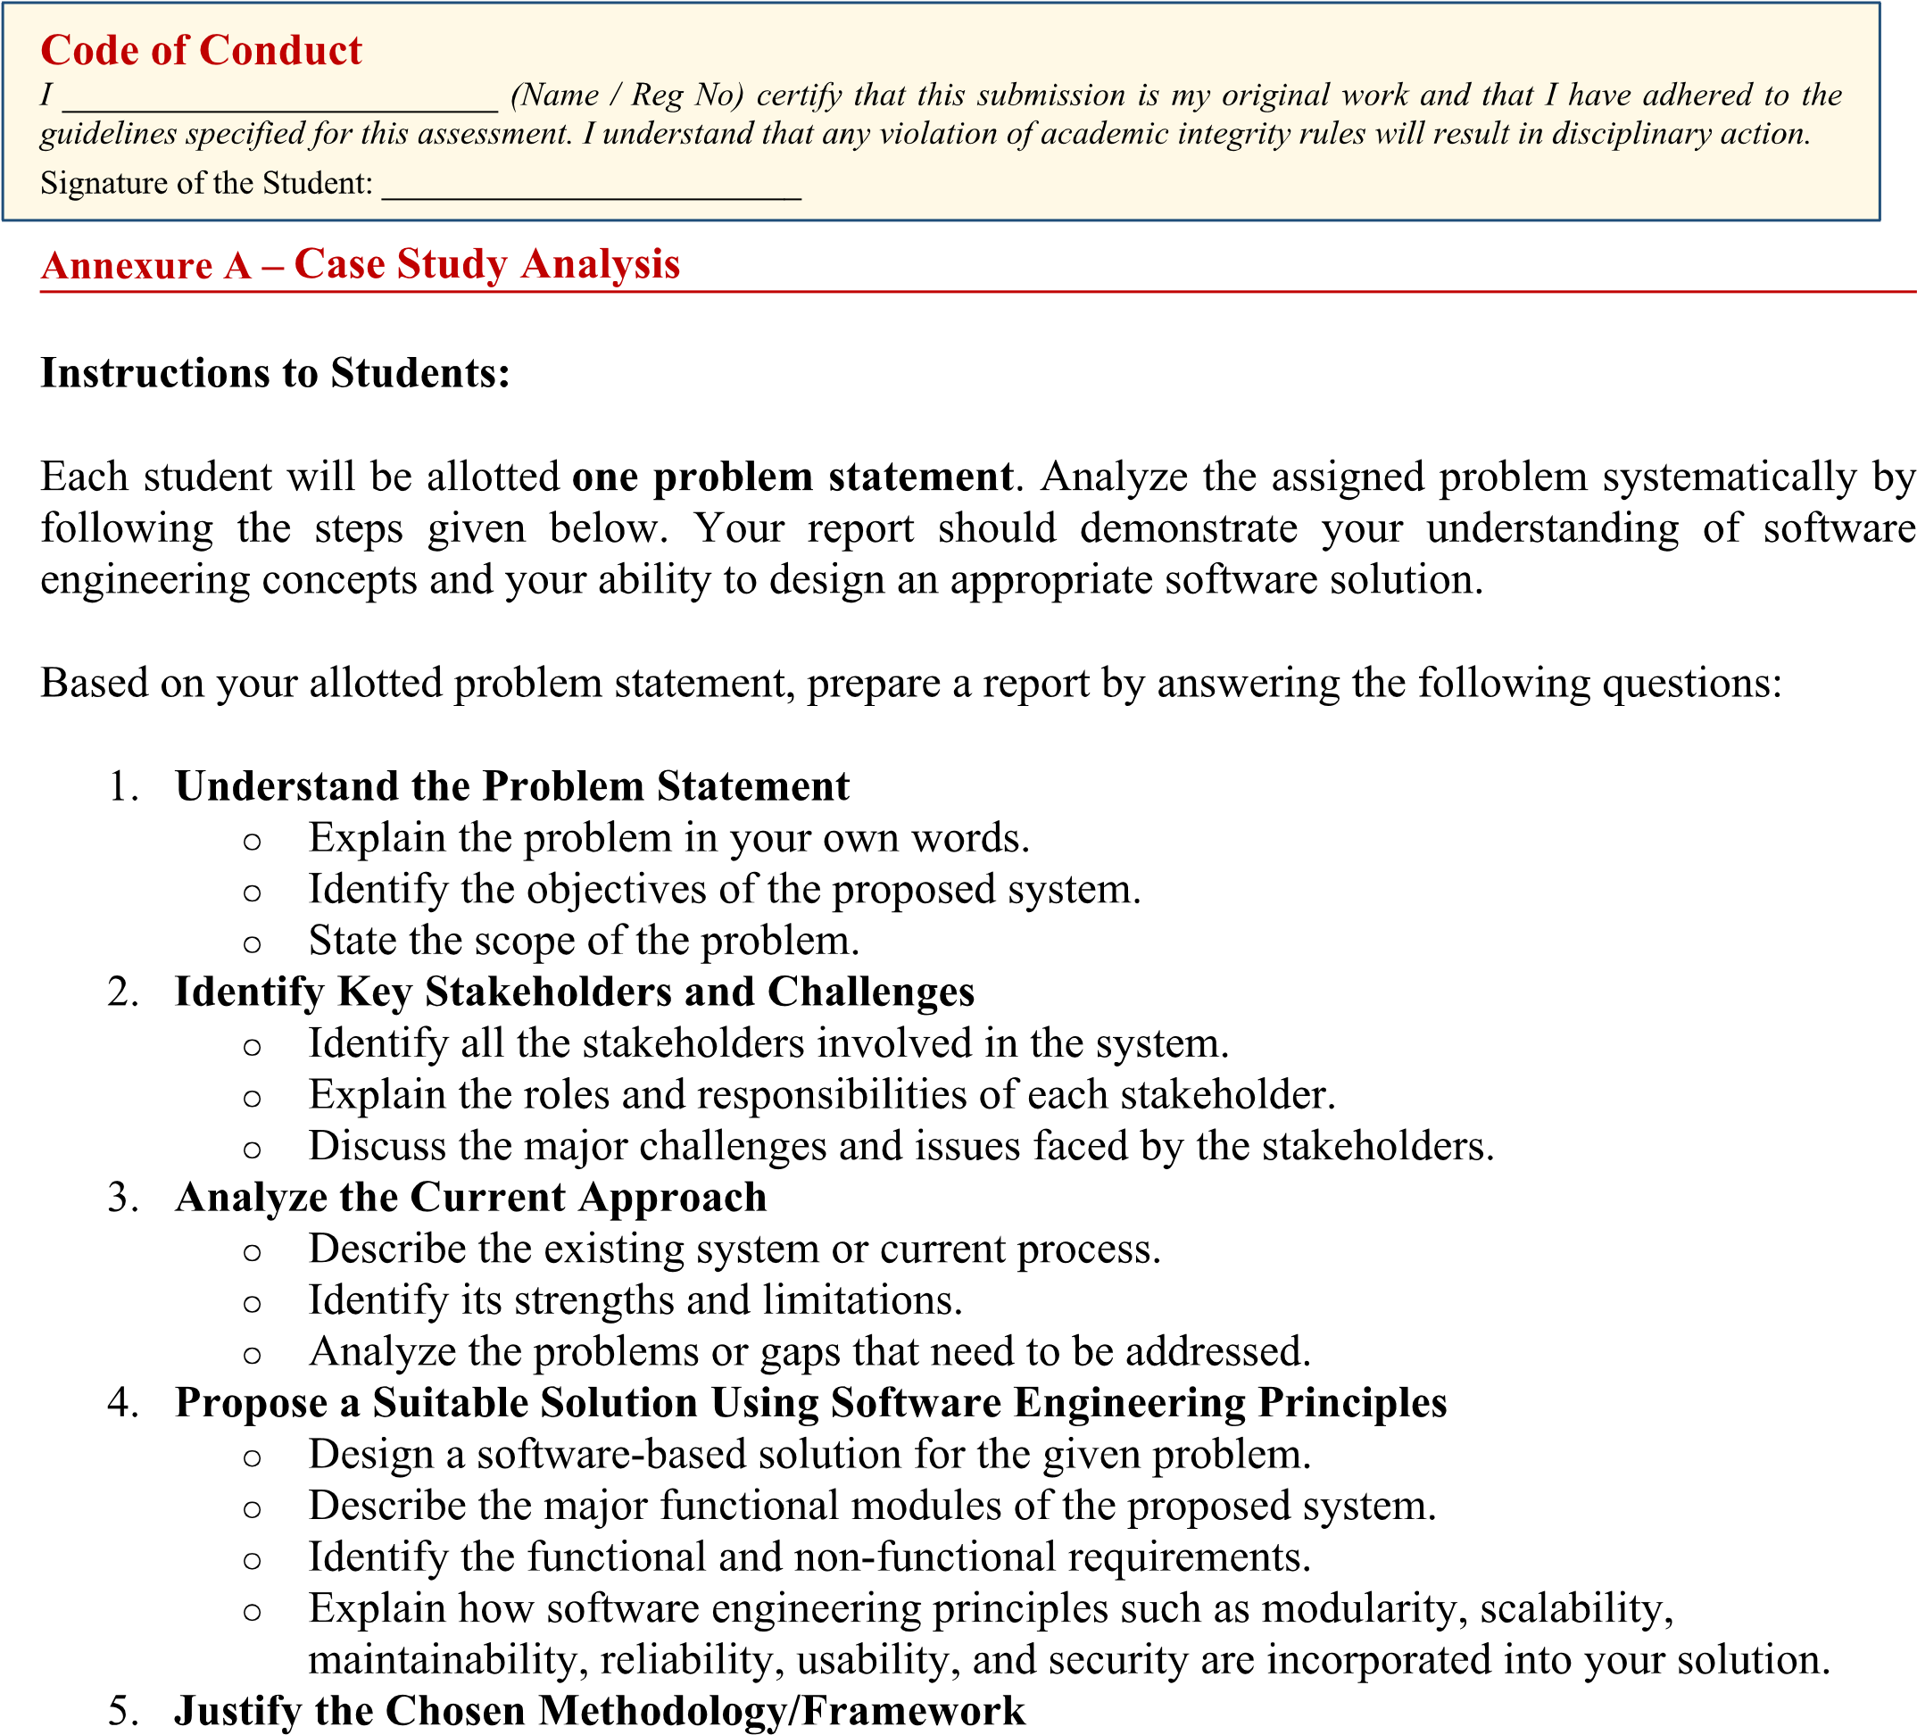
Guntha Bharathi / 192371079
Guntha Bharathi / 192371079
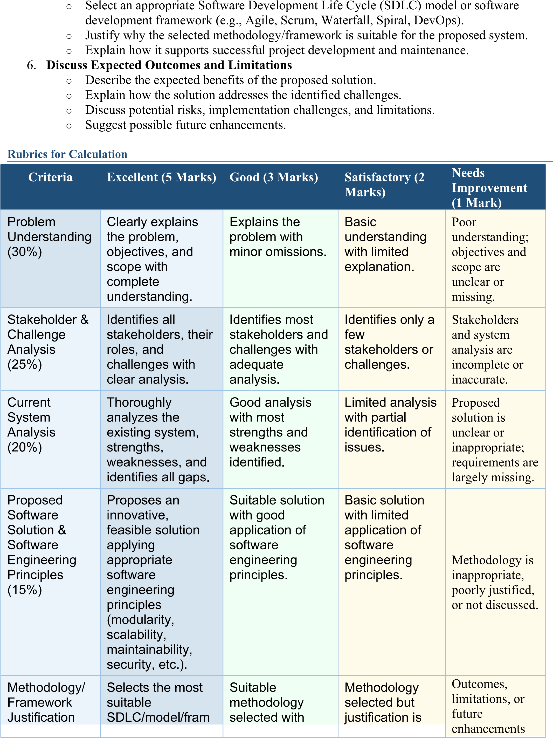
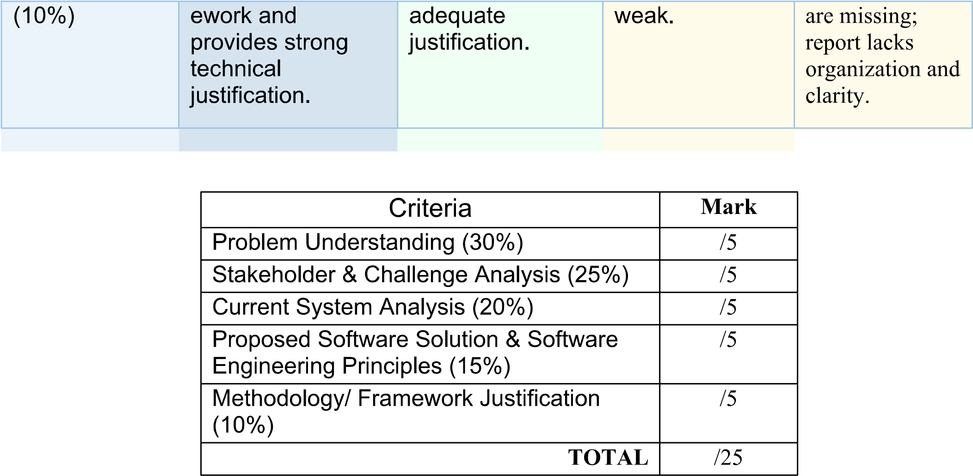

1. Understand the Problem Statement

1.1 Problem in Own Words
Every year, millions of Class XII students in India face the difficult task of choosing the “right” college and course out of thousands of institutions, hundreds of streams, and constantly changing cutoffs, fee structures, and eligibility norms. Today this decision is largely made through fragmented, manual means: word-of-mouth advice, scattered college websites, paid private consultants, and long queues at physical counseling centers. Students frequently lack a single, trustworthy platform that consolidates verified college/course data, offers personalized guidance based on their marks and interests, and lets them apply and track their admission status end-to-end. The College Admission Counseling System is proposed as a unified, web-based platform that digitizes and streamlines this entire journey — from self-assessment and college discovery, through expert counseling, to application submission and admission tracking — for students, counselors, and admission staff alike.

1.2 Objectives of the Proposed System
- Centralize information: provide a single verified repository of colleges, courses, eligibility criteria, fees, and cutoffs.
- Personalize guidance: recommend suitable colleges/courses based on a student's marks, interests, budget, and location preferences.
- Enable expert counseling: let students book and attend one-on-one sessions with qualified counselors online.
- Digitize applications: allow students to apply to multiple colleges, upload documents, and pay fees within one platform.
- Provide transparency: give students real-time visibility into their application status at every stage.
- Support institutions: give colleges and administrators tools to manage listings, verify applicants, and generate reports for data-driven decisions.

1.3 Scope of the Problem
The system scope covers the complete admission-counseling lifecycle for undergraduate/postgraduate admissions: student registration and profiling, college and course discovery, rule-based recommendation, counseling session scheduling (chat/video), online application submission with document upload, fee payment, application tracking and status notification, and administrative reporting/analytics. It is designed for use by students and parents, counselors/advisors, and college/university admission staff and system administrators across one or more affiliated institutions. The scope excludes the actual academic evaluation/entrance-exam conduction and post-admission academic activities (fee refunds beyond the admission stage, hostel allotment, curriculum delivery), which are treated as out-of-scope, downstream systems that the platform may integrate with in the future.

2. Identify Key Stakeholders and Challenges

2.1 Stakeholders, Roles and Responsibilities
Stakeholder | Role | Key Responsibilities / Interests
Student / Applicant | Primary end-user seeking admission guidance | Creates profile, searches colleges, books counseling sessions, submits applications, tracks status, pays fees
Parent / Guardian | Secondary user, decision influencer | Monitors student's application progress, co-decides on college/course choice, may handle payments
Counselor / Academic Advisor | Domain expert providing guidance | Conducts counseling sessions, recommends suitable colleges/courses, reviews student profile and aptitude
College / University Admission Staff | Institution-side reviewer | Verifies submitted applications and documents, updates seat availability, communicates decisions
System Administrator | Technical owner of the platform | Manages user accounts, college/course master data, system configuration, security, and uptime
College / University (Institution) | Service provider / data source | Supplies accurate course, eligibility, fee, and cutoff information; receives applications
Government / Regulatory Body (e.g., AICTE, State Admission Boards) | External compliance authority | Defines eligibility norms, reservation policy, and counseling schedules that the system must comply with

2.2 Major Challenges and Issues Faced by Stakeholders
- Information overload and inconsistency: students struggle to compare colleges because data (fees, cutoffs, seats) is scattered across many unofficial and often outdated sources.
- Limited access to expert guidance: quality counseling is often paid, urban-centric, and not scalable to the volume of students needing it, disadvantaging rural/remote applicants.
- Manual, error-prone application process: paper-based or semi-digital applications lead to lost documents, duplicate data entry, and delayed processing for admission staff.
- Lack of transparency: students and parents have little visibility into where an application stands, causing anxiety and repeated phone/email follow-ups.
- Administrative overload: college staff must manually verify large volumes of applications and documents within tight admission windows, increasing errors and turnaround time.
- Data privacy and security concerns: sensitive personal, academic, and payment information must be protected against breaches while still being accessible to authorized counselors and staff.
- Digital divide: some students may have limited internet access or digital literacy, requiring the system to remain simple, lightweight, and mobile-friendly.

3. Analyze the Current Approach

3.1 Existing System / Current Process
Currently, admission counseling largely follows a manual/semi-digital, disconnected process. Students gather information individually from college websites, brochures, education fairs, and private counselors. Guidance, where available, happens through in-person or phone consultations that must be scheduled during office hours. Applications are submitted separately to each college — sometimes on paper, sometimes through each institution's own basic web form — with physical or emailed document copies. Status updates are communicated inconsistently, often only when the student proactively calls or emails the admissions office. Colleges compile and cross-check applications largely in spreadsheets, with limited automation for verification, deduplication, or analytics.

3.2 Strengths of the Current Approach
- Personal, face-to-face counseling can build trust and address nuanced, individual concerns.
- Existing college websites and government portals do provide authoritative source information, even if scattered.
- Manual review by experienced admission staff can catch context that automated checks might miss.

3.3 Limitations of the Current Approach
- No single source of truth: information is duplicated and often inconsistent across sources.
- Counseling does not scale: a limited number of counselors cannot serve a large student population equitably.
- High turnaround time for application processing due to manual document verification.
- No real-time tracking, leading to poor communication and student anxiety.
- Prone to human error such as data entry mistakes, lost documents, and missed deadlines.
- Little to no analytics for colleges to understand applicant trends or optimize the counseling process.

3.4 Gaps to be Addressed
The core gap is the absence of an integrated digital platform that connects students, counselors, and institutions in real time. Specifically, the current approach lacks: (a) a centralized, verified college/course database; (b) an accessible and scalable mechanism for personalized guidance; (c) an end-to-end digital application and document workflow; (d) transparent, automated status tracking and notifications; and (e) structured data capture that would allow analytics-driven decision-making for institutions. The proposed system is designed specifically to close these gaps.

4. Propose a Suitable Solution Using Software Engineering Principles

4.1 Solution Overview and System Architecture
The proposed College Admission Counseling System is a layered web/mobile application comprising a presentation layer (responsive web portal and mobile app), an application/business-logic layer (a set of loosely-coupled modules), a data layer (a central relational database), and integrations with external services (payment gateway, SMS/email gateway, and video-call API for counseling). This layered, service-oriented architecture keeps concerns separated and allows each module to evolve independently.
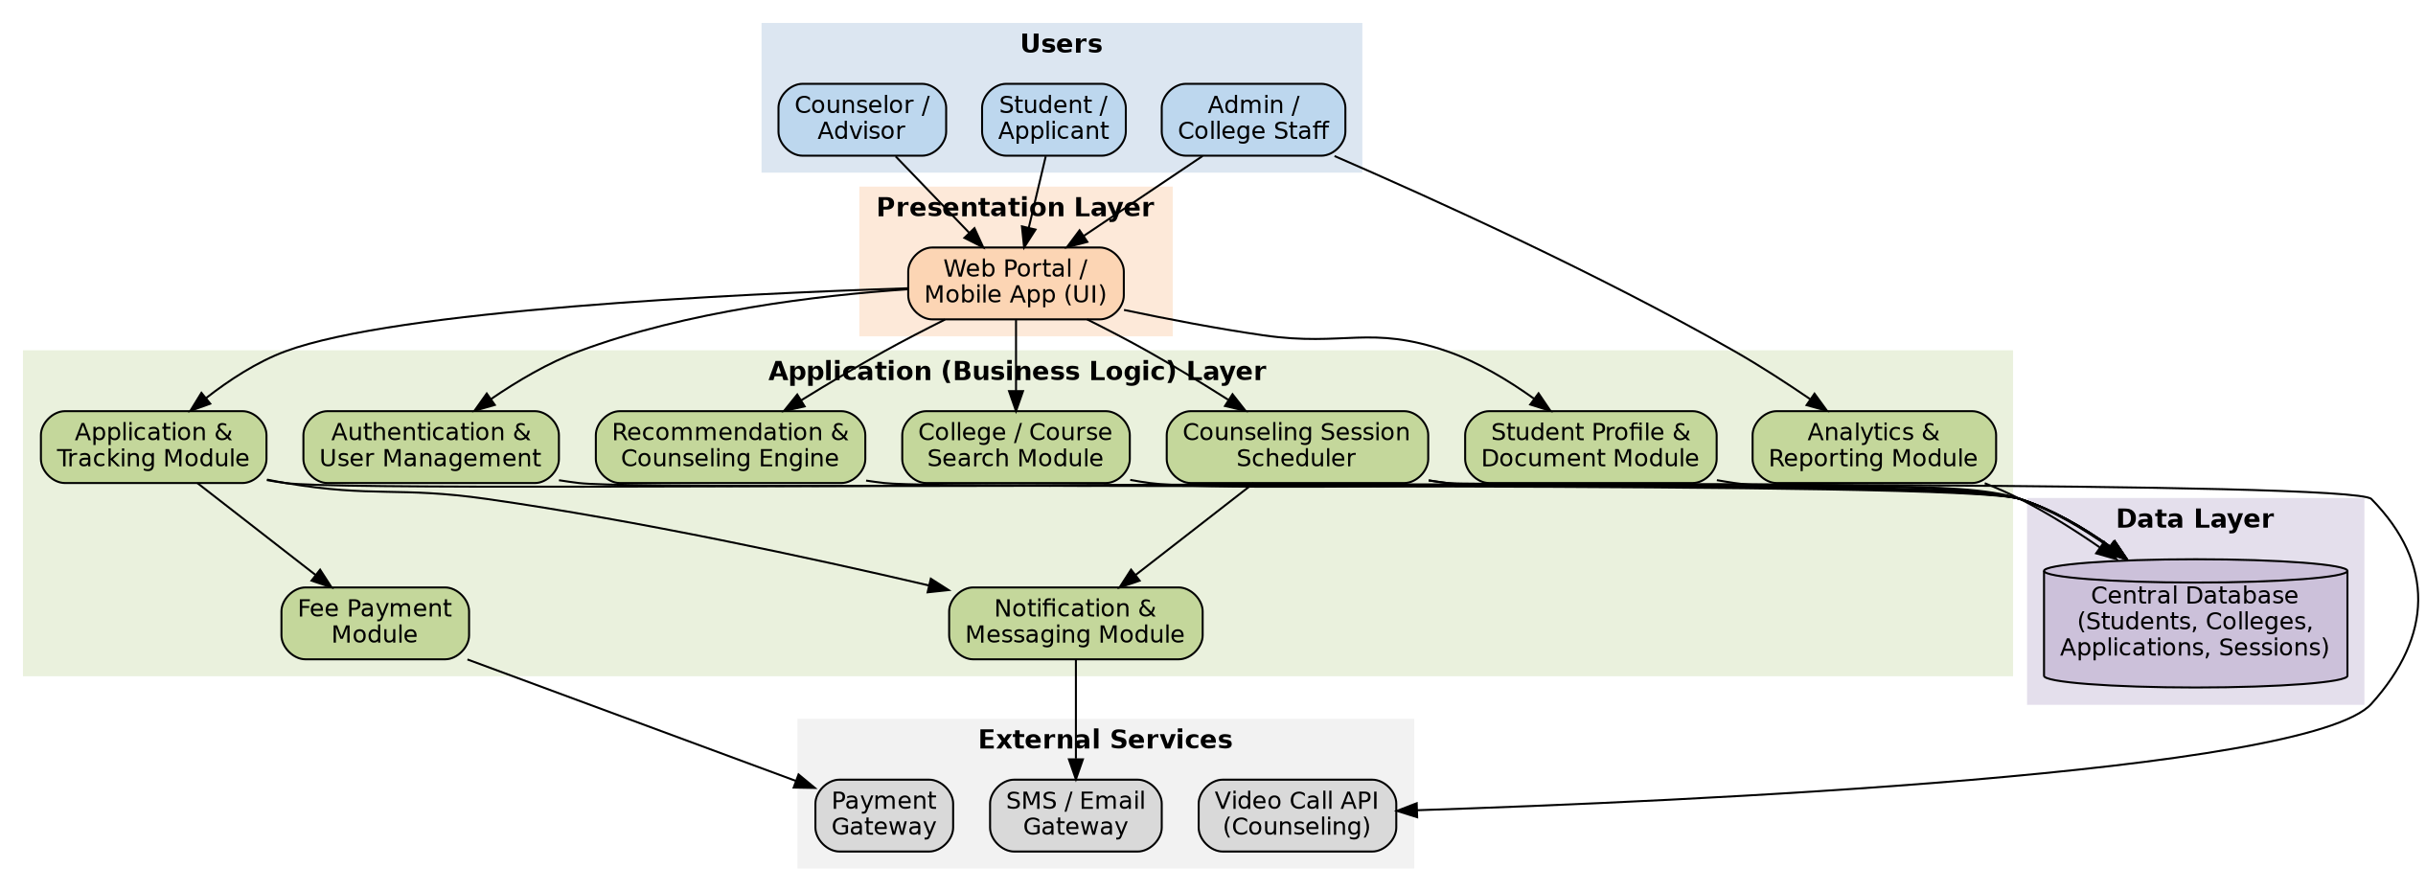
Figure 1: High-Level System Architecture of the College Admission Counseling System

4.2 Major Functional Modules
- Authentication & User Management: secure registration/login (student, counselor, admin roles) with OTP/email verification and role-based access control.
- Student Profile & Document Module: captures academic records, interests, budget, and location preferences; stores uploaded documents (marksheets, ID proof, certificates).
- College/Course Search Module: searchable, filterable catalog of colleges and courses with fees, cutoffs, eligibility, and location.
- Recommendation & Counseling Engine: rule-based (and optionally ML-assisted) matching of student profile to suitable colleges/courses.
- Counseling Session Scheduler: calendar-based booking of chat/video sessions between students and counselors.
- Application & Tracking Module: digital application submission to one or more colleges with real-time status (Submitted → Under Review → Accepted/Rejected).
- Fee Payment Module: secure online payment of application/counseling fees via an integrated payment gateway.
- Notification & Messaging Module: automated SMS/email/in-app alerts for deadlines, status changes, and session reminders.
- Analytics & Reporting Module: dashboards for administrators showing application volumes, conversion rates, and counselor performance.
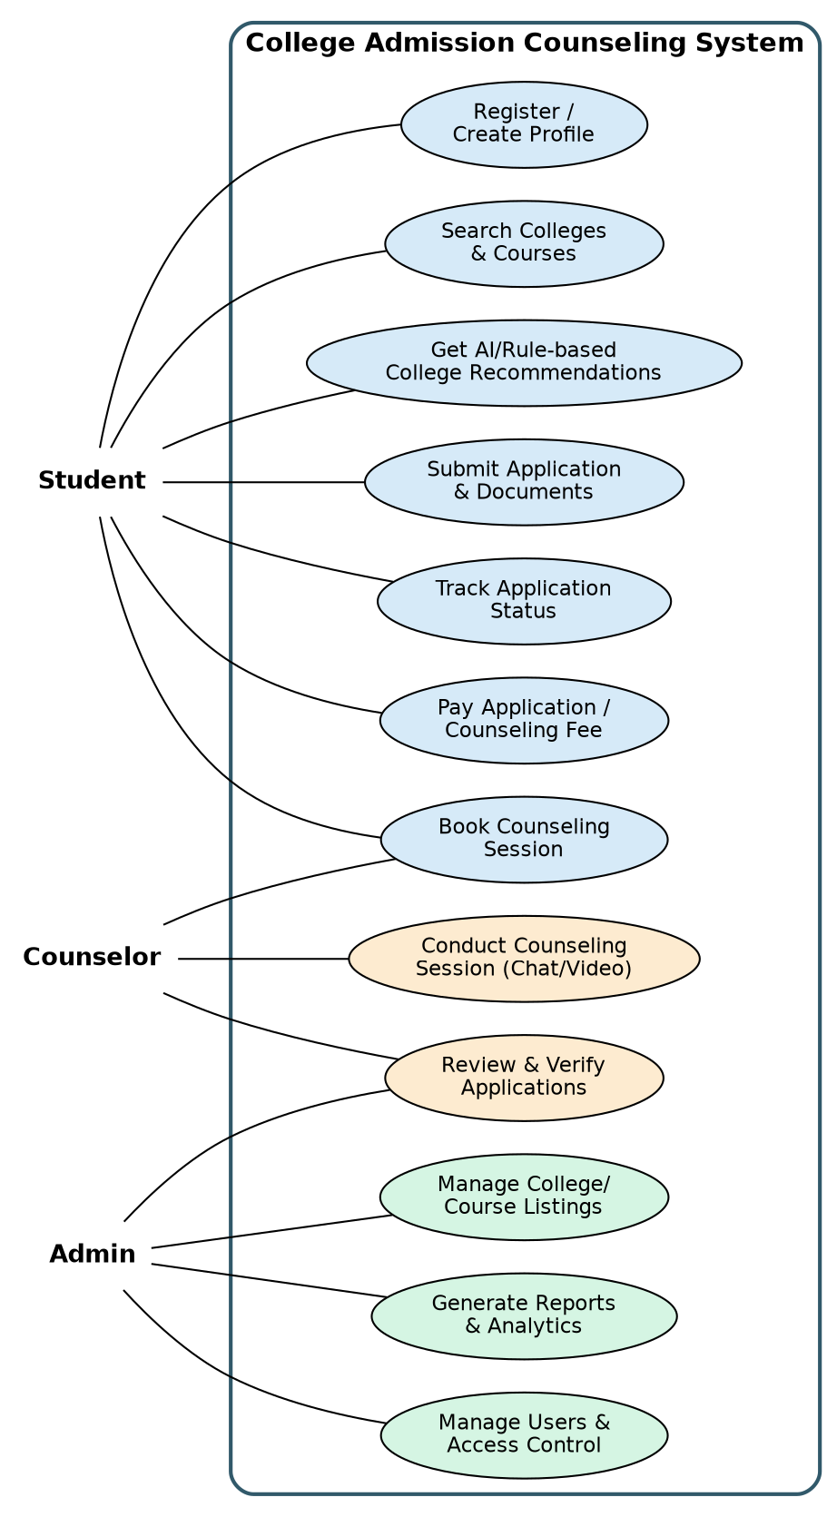
Figure 2: Use Case Diagram Showing Actors and Their Interactions with the System

4.3 Functional Requirements
# | Functional Requirement
1 | The system shall allow students to register and create/edit a profile with academic and preference details.
2 | The system shall allow students to search and filter colleges/courses by stream, fee range, location, and cutoff.
3 | The system shall generate a ranked list of recommended colleges/courses based on the student's profile.
4 | The system shall allow students to book, reschedule, or cancel counseling sessions with available counselors.
5 | The system shall support chat/video-based counseling sessions within the platform.
6 | The system shall allow students to submit applications with required documents to one or more colleges.
7 | The system shall process application fee payments through an integrated payment gateway and issue receipts.
8 | The system shall allow admission staff to review, verify, and update the status of submitted applications.
9 | The system shall send automated notifications for key events (deadlines, status changes, session reminders).
10 | The system shall provide administrators with dashboards/reports on applications, conversions, and counselor load.

4.4 Non-Functional Requirements
# | Non-Functional Requirement
1 | Performance: the system shall respond to search/recommendation queries within 2 seconds under normal load.
2 | Scalability: the system shall support concurrent access by at least 10,000 users during peak counseling periods without degradation.
3 | Availability: the system shall maintain 99.5% uptime, especially during critical admission windows.
4 | Security: all personal, academic, and payment data shall be encrypted in transit (TLS) and at rest.
5 | Usability: the interface shall be mobile-responsive, accessible, and usable by first-time users with minimal training.
6 | Maintainability: the codebase shall follow modular design and coding standards to allow independent updates to modules.
7 | Reliability: the system shall ensure data consistency for applications and payments even under partial failures (transactional integrity).
8 | Portability: the web application shall function consistently across major browsers and screen sizes.

4.5 Software Engineering Principles Incorporated
Principle | How it is Incorporated in the College Admission Counseling System
Modularity | System is decomposed into independent modules (Authentication, Profile, College Search, Recommendation, Application Tracking, Scheduling, Notification, Payment, Reporting) that communicate through well-defined APIs, so each can be built, tested, and modified in isolation.
Scalability | Deployed on a cloud platform with a load balancer and horizontally-scalable stateless application servers; the database is indexed and can be sharded/replicated, allowing the system to handle counseling-season traffic spikes (e.g., result-day surges) without redesign.
Maintainability | Layered (presentation–business logic–data) architecture, RESTful API contracts, coding standards, and version control (Git) keep modules loosely coupled, so bugs can be fixed or features added with minimal ripple effect.
Reliability | Automated data validation, transaction management for payments/applications, scheduled database backups, and centralized error logging/monitoring ensure the system behaves correctly and recovers gracefully from failures.
Usability | Responsive, mobile-friendly UI with guided step-by-step workflows (profile → search → recommend → apply), multilingual support, and accessible design (WCAG-compliant forms) make the system easy to use for students from diverse backgrounds.
Security | Role-based access control (Student/Counselor/Admin), encrypted storage of personal and payment data, HTTPS/TLS in transit, OTP-based authentication, and audit logs protect sensitive applicant data and ensure regulatory compliance (e.g., data-privacy norms).

5. Justify the Chosen Methodology/Framework

5.1 Selected SDLC Model: Agile (Scrum Framework)
The Agile Scrum framework is selected as the development methodology for the College Admission Counseling System. The project will be organized into fixed-length sprints (2–3 weeks each), with a prioritized product backlog maintained by a Product Owner, daily stand-ups, sprint reviews, and retrospectives.

5.2 Justification for Selecting Agile/Scrum
- Evolving and unclear requirements: admission workflows, counseling formats, and institutional rules vary and may change during development; Agile's iterative cycles accommodate refinement without derailing the whole project.
- Early and continuous stakeholder feedback: students, counselors, and admission staff can review working increments (e.g., the search module, then the application module) every sprint and redirect priorities quickly.
- Incremental, modular delivery: the system's modular architecture (Section 4.1) maps naturally onto sprint-sized deliverables, so each module can be developed, tested, and demonstrated independently.
- Risk reduction: high-risk integrations (payment gateway, video-call API) can be tackled in early sprints as spikes, surfacing integration problems before major investment is made.
- Time-to-market pressure: admission counseling is highly seasonal (around board-exam results); Agile allows a Minimum Viable Product (core search + counseling booking) to be released ahead of peak season, with later features added iteratively.

5.3 Indicative Sprint Plan
Sprint | Focus Area | Key Deliverables
Sprint 1 | Foundation | Requirement backlog, system architecture, database schema, authentication & profile module
Sprint 2 | Core Search & Recommendation | College/course search module, filter engine, rule-based recommendation logic
Sprint 3 | Counseling & Scheduling | Session booking calendar, video/chat integration, counselor dashboard
Sprint 4 | Application & Payment | Document upload, application tracking workflow, payment gateway integration
Sprint 5 | Admin, Reporting & Hardening | Admin panel, analytics dashboard, notifications, security testing, UAT and deployment

5.4 How Agile Supports Successful Development and Maintenance
Agile's short feedback loops mean that usability issues (e.g., a confusing recommendation flow) are caught and corrected within a sprint rather than after full deployment. Continuous integration and sprint-end testing keep the system in a consistently releasable state, which is critical for a platform that must remain available and correct during peak admission season. Post-launch, the same Scrum cadence is reused for maintenance: bug fixes, new college onboarding, and seasonal feature updates (e.g., a new counseling exam cycle) are simply treated as backlog items in ongoing sprints, giving the system a sustainable, long-term maintenance model rather than a one-time “build and abandon” delivery.
Figure 3: End-to-End Student Journey / Process Workflow Supported by the System

6. Discuss Expected Outcomes and Limitations

6.1 Expected Benefits
- A single, verified platform for college and course discovery, reducing student and parent confusion.
- Scalable access to personalized counseling, reaching students beyond urban/paid-consultant reach.
- Faster, error-reduced application processing for colleges through digital document verification.
- Real-time transparency for students via automated status tracking and notifications.
- Data-driven decision-making for institutions through analytics on applicant trends and counselor performance.

6.2 How the Solution Addresses the Identified Challenges
The centralized college/course database and recommendation engine directly resolve the information-overload and inconsistency problem (Section 2.2). The counseling-session scheduler and chat/video integration make expert guidance scalable and accessible regardless of location, addressing limited access to counseling. The application and tracking module digitizes and automates what was previously a manual, error-prone workflow, reducing administrative overload and lack of transparency. Role-based access control and encryption directly address data-privacy and security concerns, while a mobile-responsive, simple UI mitigates the digital-divide challenge.

6.3 Potential Risks, Implementation Challenges, and Limitations
- Data accuracy dependency: the system's recommendations are only as good as the college/course data supplied; incorrect or stale data (fees, cutoffs) from institutions can mislead students.
- Adoption and change management: colleges and counselors accustomed to manual processes may resist migrating to a new digital workflow, requiring training and phased rollout.
- Seasonal load spikes: traffic surges sharply around result dates and counseling deadlines, requiring careful load-testing and auto-scaling infrastructure.
- Integration risk: dependency on third-party payment and video-call APIs introduces external failure points outside the team's direct control.
- Digital divide: students with poor internet connectivity or low digital literacy may still need offline/assisted-access support (e.g., help desks).
- Data privacy and compliance: handling sensitive academic and personal data requires ongoing compliance with data-protection regulations, adding legal and security overhead.

6.4 Suggested Future Enhancements
- Integrate an AI/ML-based recommendation model trained on historical admission outcomes to improve match accuracy over time.
- Add a chatbot for instant, 24/7 answers to frequently asked admission queries.
- Support regional-language interfaces to further reduce the digital/language divide.
- Provide predictive analytics for students (e.g., estimated admission probability per college based on current-year trends).
- Extend integration to national counseling/exam boards for automatic cutoff and seat-matrix updates.

