 | GUNTHA BHARATHI |  | 192371079
 | 16-08-2026
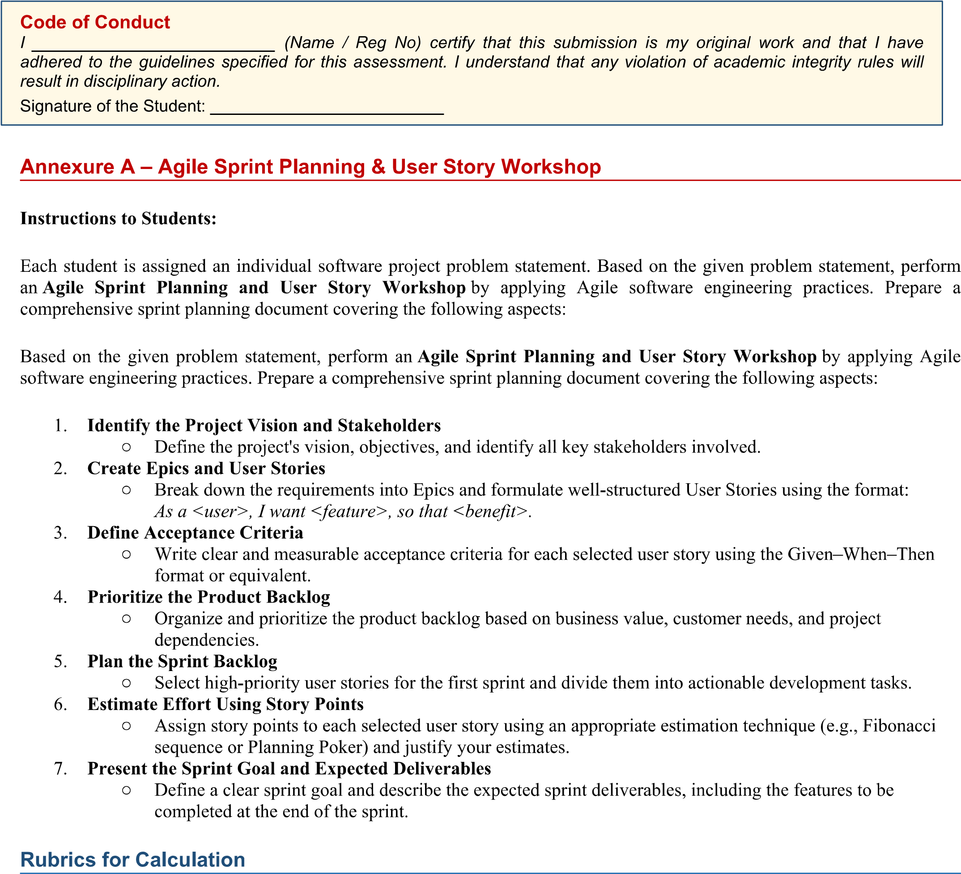
Guntha Bharathi
Guntha Bharathi / 192371079
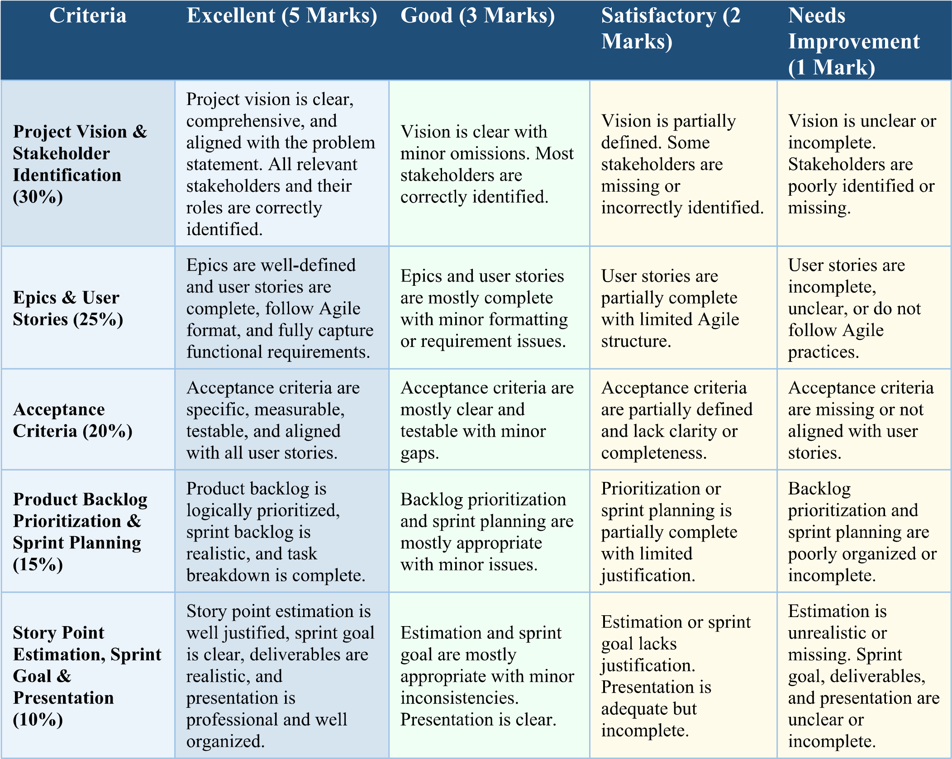

1. Project Vision and Stakeholders

1.1 Project Vision
To design and deliver a comprehensive, user-friendly digital platform — the College Admission Counseling System (CACS) — that empowers prospective students to explore colleges and courses, receive personalized academic counseling, and manage their entire admission journey online, while enabling counselors and admission staff to guide and process applicants efficiently, transparently, and at scale.

1.2 Project Objectives
- Provide a single online platform for students to search, compare, and shortlist colleges/courses based on eligibility, fees, location, and cutoff marks.
- Enable certified academic counselors to offer personalized, data-driven guidance to students on course and career selection.
- Allow students to submit and track applications to multiple colleges from one unified dashboard.
- Give college admission officers tools to review, shortlist, and manage applications efficiently.
- Automate deadline reminders and status notifications to reduce missed opportunities.
- Provide administrators with reporting/analytics on application trends to support institutional decision-making.

1.3 Key Stakeholders
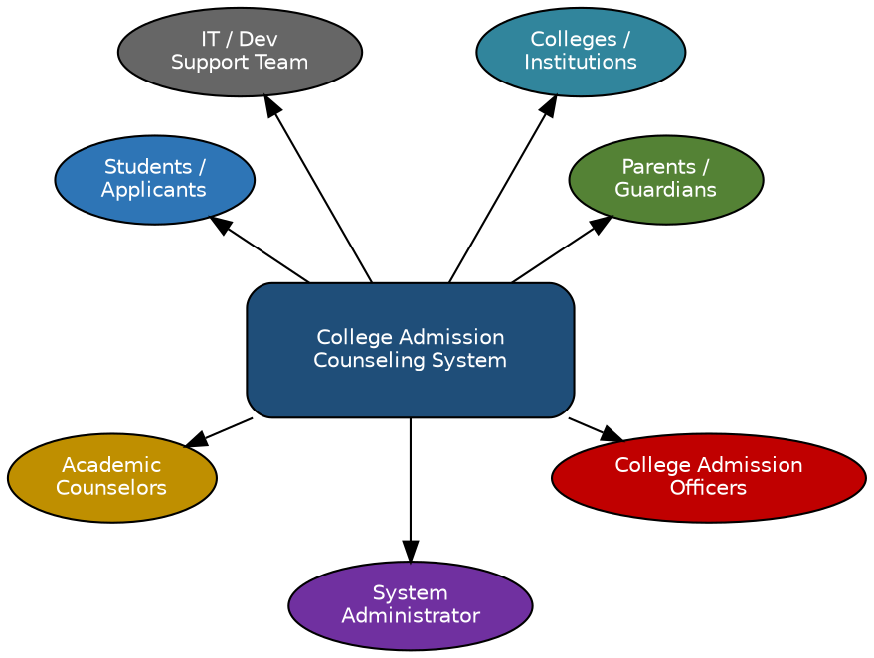
Stakeholder | Role / Interest in the System
Students / Applicants | Primary end-users; search colleges, receive counseling, apply, track application status.
Parents / Guardians | Secondary users; monitor progress, co-decide on college/course choice and fees.
Academic Counselors | Provide one-on-one and group guidance; review student profiles; recommend courses.
College Admission Officers | Manage seat availability/eligibility data; review and process incoming applications.
System Administrator | Manages users, master data, system configuration, and platform-wide reports.
Colleges / Institutions | Organizational stakeholders who list programs, seats, and eligibility criteria on the platform.
IT / Development Support Team | Builds, maintains, and supports the platform; ensures uptime, security, and performance.

2. Epics and User Stories
The product requirements are broken down into six Epics, each containing well-structured user stories following the format: “As a <user>, I want <feature>, so that <benefit>.”
Epic | User Story ID | User Story (As a / I want / So that)
Epic 1: Student Registration & Profile Management | US-01 | As a student, I want to register and create a profile with my academic details, so that I can receive personalized college and course recommendations.
 | US-02 | As a student, I want to upload my academic documents (mark sheets, certificates, ID proof), so that I can complete my application without visiting the college in person.
Epic 2: College & Course Search | US-03 | As a student, I want to search and filter colleges by location, course, fees, and cutoff marks, so that I can shortlist colleges matching my preferences.
 | US-04 | As a student, I want to compare multiple shortlisted colleges side-by-side, so that I can make an informed decision quickly.
Epic 3: Counseling & Guidance | US-05 | As a student, I want to book a one-on-one session with a counselor, so that I can get personalized advice on course and college selection.
 | US-06 | As a counselor, I want to view a student's academic profile before a session, so that I can give tailored, relevant guidance.
 | US-07 | As a student, I want to receive rule-based course recommendations based on my marks and interests, so that I can discover suitable options quickly.
Epic 4: Application Management | US-08 | As a student, I want to apply to multiple colleges through a single dashboard, so that I don't have to fill out separate forms repeatedly.
 | US-09 | As a student, I want to track the real-time status of my application, so that I know when to take the next required action.
 | US-10 | As an admission officer, I want to review and shortlist submitted applications, so that I can efficiently manage the admission pipeline.
Epic 5: Admin & College Management | US-11 | As an admin, I want to add and update college and course details (seats, eligibility, fees), so that students always see accurate, up-to-date information.
 | US-12 | As an admin, I want to generate reports on application trends, so that I can share insights with institutional management.
Epic 6: Notifications & Communication | US-13 | As a student, I want to receive email/SMS notifications about application deadlines and status changes, so that I never miss an important date.
 | US-14 | As a counselor, I want to send bulk reminders to students about upcoming sessions or deadlines, so that student engagement improves.
3. Acceptance Criteria (Given-When-Then)

Clear, measurable acceptance criteria are defined below for the highest-priority user stories selected for Sprint 1.
User Story | Given | When | Then
US-01 Student Registration | a new student is on the registration page and enters valid name, email, phone, and academic details | they submit the registration form | the system creates a verified student profile and redirects to the dashboard within 3 seconds.
US-03 College Search | a logged-in student is on the College Search page | they apply filters for location, course, fees, and cutoff | the system displays only matching colleges, sorted by relevance, within 2 seconds.
US-05 Book Counseling Session | a student has selected an available counselor time slot | they confirm the booking | the system reserves the slot, sends a confirmation notification to both student and counselor, and blocks the slot from further booking.
US-08 Apply to Multiple Colleges | a student has a complete profile and has selected 3 colleges | they click 'Submit Application' | the system creates 3 separate application records, each with status 'Submitted', and shows a confirmation summary.
US-09 Track Application Status | a student has one or more submitted applications | they open the 'My Applications' dashboard | the system displays the current status (Submitted / Under Review / Shortlisted / Rejected / Admitted) for each application, updated in real time.
US-13 Deadline Notifications | a student has an application deadline within 48 hours | the scheduled notification job runs | the system sends an email and SMS reminder to the student at least once before the deadline.

4. Prioritized Product Backlog
The backlog is prioritized using a Business Value vs. Priority (MoSCoW-style) approach, considering customer needs, dependencies, and value to the admission workflow. Registration and search must exist before counseling or application features can be used, so foundational stories are ranked highest.
Story ID | User Story (short) | Business Value | Priority | Story Pts
US-01 | Student registration & profile creation | High | High | 5
US-03 | College & course search with filters | High | High | 8
US-08 | Apply to multiple colleges (single dashboard) | High | High | 8
US-09 | Real-time application status tracking | High | High | 5
US-05 | Book one-on-one counseling session | High | High | 5
US-02 | Upload academic documents | Medium | Medium | 3
US-10 | Officer review & shortlist applications | High | Medium | 8
US-13 | Deadline / status notifications | Medium | Medium | 3
US-04 | Compare colleges side-by-side | Medium | Low | 5
US-06 | Counselor view of student profile | Medium | Low | 2
US-07 | Rule-based course recommendations | Medium | Low | 8
US-11 | Admin manages college/course master data | High | Medium | 5
US-12 | Admin analytics/report generation | Low | Low | 8
US-14 | Counselor bulk reminders | Low | Low | 3

Dependency note: US-01 (registration) is a prerequisite for all other stories. US-03 (search) is a prerequisite for US-04, US-05, and US-07. US-08 (apply) is a prerequisite for US-09 and US-10.

5. Sprint Backlog (Sprint 1)
Sprint 1 (2-week sprint) selects the five highest-priority, highest-value stories that together deliver an end-to-end “register → search → apply → track” flow. Selected stories: US-01, US-03, US-05, US-08, US-09 (Total = 31 story points).
User Story | Development Task | Owner | Est. (hrs)
US-01 | Design registration UI (form + validation) | Frontend Dev | 6
US-01 | Build registration API & profile database schema | Backend Dev | 8
US-01 | Implement email/OTP verification | Backend Dev | 4
US-03 | Design search & filter UI | Frontend Dev | 8
US-03 | Build college/course search API with filter logic | Backend Dev | 10
US-03 | Seed college & course master data | Backend Dev | 4
US-05 | Design counselor slot-booking calendar UI | Frontend Dev | 8
US-05 | Build booking API with slot-locking logic | Backend Dev | 8
US-05 | Trigger booking confirmation notifications | Backend Dev | 3
US-08 | Design multi-college application dashboard UI | Frontend Dev | 8
US-08 | Build application submission API (multi-record) | Backend Dev | 10
US-09 | Design 'My Applications' status tracker UI | Frontend Dev | 6
US-09 | Build status update API & real-time refresh | Backend Dev | 6
All | Sprint testing, bug fixes & QA sign-off | QA Engineer | 10

Agile Workflow — From Vision to Sprint Goal
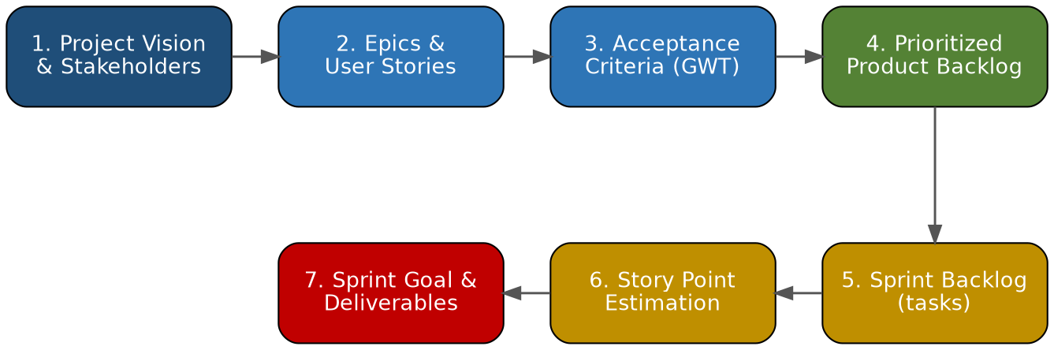

6. Effort Estimation Using Story Points
Effort is estimated in story points using the Fibonacci sequence (1, 2, 3, 5, 8, 13…) via Planning Poker, where the whole team votes independently and discusses outliers until consensus is reached. Points reflect complexity, effort, and uncertainty — not raw hours.
Story ID | Justification for Estimate | Technique | Points
US-01 | Simple CRUD form with validation and OTP/email verification; low complexity, well-understood. | Planning Poker | 5
US-03 | Requires multi-attribute filter logic, search performance tuning, and master-data seeding; moderate-high complexity. | Planning Poker | 8
US-05 | Slot-based booking with concurrency handling (slot locking) and dual-party notifications; moderate complexity. | Planning Poker | 5
US-08 | Must create multiple linked application records atomically and handle partial-failure cases; higher complexity. | Planning Poker | 8
US-09 | Mostly a read/display feature with real-time refresh; lower complexity, some dependency on US-08 data model. | Planning Poker | 5
Sprint 1 total committed effort: 31 story points, consistent with the team's estimated velocity of 30–35 points per 2-week sprint (based on team size and past performance).

7. Sprint Goal and Expected Deliverables

7.1 Sprint Goal
"Enable a prospective student to register, search and shortlist colleges, book a counseling session, apply to multiple colleges, and track application status — all within a single, working end-to-end flow."

7.2 Expected Sprint Deliverables
- A working student registration and profile module with email/OTP verification (US-01).
- A functional college & course search module with location, fee, and cutoff filters (US-03).
- A counselor session-booking feature with slot locking and confirmation notifications (US-05).
- A multi-college application submission dashboard (US-08).
- A real-time application status tracking screen for students (US-09).
- Updated and prioritized product backlog for Sprint 2 planning.
- A sprint demo of the integrated register → search → counsel → apply → track flow to stakeholders.

7.3 Definition of Done
- Code reviewed, merged, and deployed to the staging environment.
- Unit and integration tests written and passing for all five stories.
- All Given-When-Then acceptance criteria verified by QA.
- No critical or high-severity defects open.
- Feature demonstrated and accepted by the Product Owner in the Sprint Review.

