**Noise Pollution Monitoring**

**Abstract**

Analyzing noise pollution patterns through data analytics involves collecting, processing, and interpreting data related to sound levels in different locations over time. Here's a step-by-step guide on.

**NOISE POLLUTION PATTERNS**

**1. Data Collection**

* Acquire relevant data sources. This can include,
* **Sound Level Data:**Use sound level meters or sensors to collect continuous or periodic sound level measurements. These sensors can be placed in various locations.
* **Geospatial Data:** Incorporate geographic information system (GIS) data to understand the spatial distribution of noise.
* **Temporal Data:** Gather data over specific time periods to identify temporal patterns.

**2. Data Preprocessing**

* Clean and preprocess the collected data.
* Removing outliers and errors.
* Time synchronization if data is collected from different sources.

**3.Feature Engineering**

* Extract relevant features from the data. For example:
* Average sound levels over time.

**4. Spatial Analysis**

* Use GIS tools to visualize and analyze the spatial distribution of noise pollution.
* Identify areas with consistently high or low noise levels.

**5. Temporal Analysis**

* Analyze temporal patterns of noise pollution.
* Identify daily, weekly, or seasonal variations in noise levels.

**6. Correlation Analysis**

* Explore potential correlations between noise levels and external factors:
* Weather conditions.

**7. Machine Learning Models**

* Train machine learning models to predict or classify noise levels based on various features.
* Explore algorithms like regression, clustering, or classification depending on the nature of your analysis.

**8. Data Visualization**

* Use charts, graphs, and maps to visually represent your findings.
* Interactive maps can be especially useful for displaying spatial variations.

**HIGH NOISE AREA**

NSAs include schools, hospitals, residences, day-care facilities, long-term care facilities, churches, and libraries. NSAs may also include campgrounds, parks, and wilderness areas valued specifically for their solitude and tranquility. The 'A' in NSA is for "area;" individual residences, schools, etc.

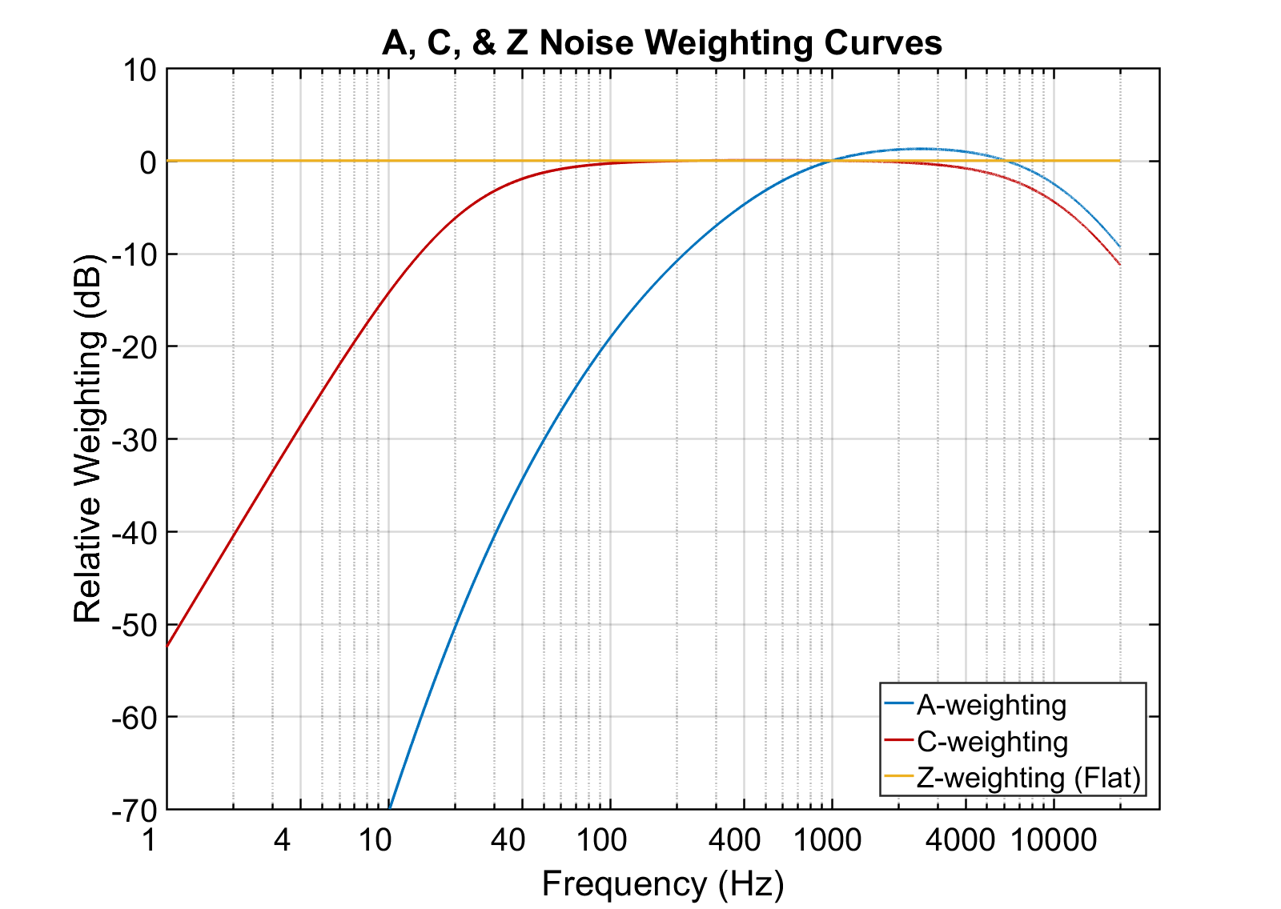

High-noise areas can vary based on factors such as location, time of day, and sources of noise. Here are some common types of high-noise areas:

**1. Urban Centers**

* City centers and downtown areas are often characterized by high noise levels due to traffic, construction, and various activities.

**2. Transportation Hubs**

* Areas around airports, train stations, and bus terminals can experience elevated noise levels from the constant movement of vehicles and aircraft.

**3. Major Roads and Highways**

* Proximity to busy roads and highways can result in high noise levels, particularly during peak traffic hours.

**4. Industrial Zones**

* Areas with industrial facilities and factories may have high noise levels due to machinery, equipment, and manufacturing processes.

**5. Entertainment Districts**

* Locations with a high concentration of bars, clubs, and entertainment venues can experience increased noise, especially during evenings and weekends.

**6. Construction Sites**

* Areas undergoing construction or redevelopment can have temporary high noise levels from machinery, construction activities, and equipment.

**7. Commercial Centers**

* Commercial areas with shopping malls, restaurants, and retail stores may experience elevated noise, especially during business hours.

**8. Recreational Areas**

* Parks, sports stadiums, and recreational areas may have increased noise during events, games, or public gatherings.

**9. Educational Institutions**

* Areas around schools, colleges, and universities may experience high noise levels during school hours and special events.

**10. Hospital Zones**

* Proximity to hospitals can result in high noise levels due to ambulance sirens, medical equipment, and the continuous operation of healthcare facilities.

**POTENTIAL SOURCES**

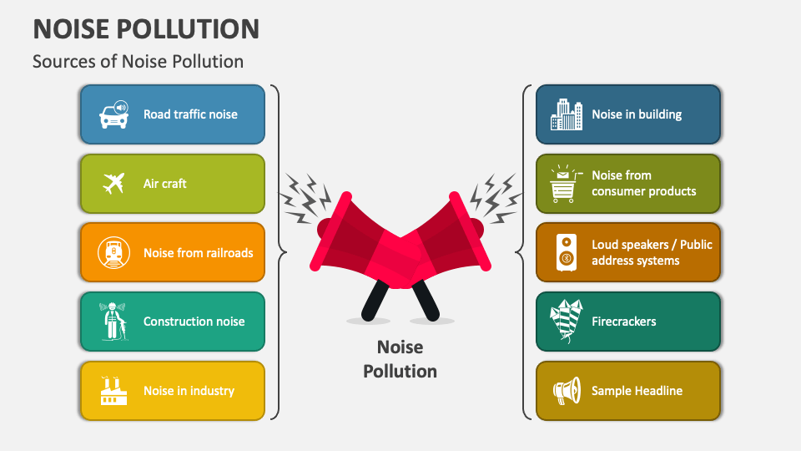

Monitoring noise pollution involves the use of various tools and technologies to measure and analyze sound levels. Here are some potential sources and methods for noise pollution monitoring:

**1. Sound Level Meters (SLMs)**

* Description: Handheld devices or stationary instruments that measure sound levels in decibels (dB).
* Application: Used for on-site measurements in different locations to assess ambient noise levels.

**2. Permanent Noise Monitoring Stations**

* Description: Fixed installations equipped with specialized sensors for continuous monitoring of noise levels.
* Application: Ideal for long-term monitoring in specific areas, providing a continuous dataset for analysis.

**3. Smartphone Apps**

* Description: Mobile applications that use the built-in microphones of smartphones to measure and record ambient noise levels.
* Application: Allows for widespread, crowd-sourced data collection in various locations.

**4. Noise Mapping Software:**

* Description: GIS-based tools that integrate noise data to create maps illustrating the spatial distribution of noise levels.
* Application: Useful for identifying high-noise areas and planning mitigation strategies.

**5. Community Noise Monitoring**

* Description: Involving local communities in noise monitoring using distributed sensors or citizen science initiatives.
* Application: Provides localized data and engages residents in the monitoring process.

**6. Traffic Noise Monitoring**

* Description: Specialized sensors placed near roads to monitor and analyze traffic-related noise.
* Application: Helps assess the impact of road traffic on noise pollution.

**7. Industrial Noise Monitoring**

* Description: Monitoring systems installed in and around industrial facilities to measure noise generated by machinery and processes.
* Application: Ensures compliance with noise regulations and helps in identifying sources for mitigation.

**8. Aircraft Noise Monitoring:**

* Description: Sensors near airports or flight paths that measure noise levels from aircraft.
* Application: Monitoring and managing the impact of aviation-related noise on surrounding areas.

**CONCLUSION**

In conclusion, effective noise monitoring is a crucial step in understanding, managing, and mitigating noise pollution. By employing a variety of monitoring methods and tools, we can gather comprehensive data to assess ambient noise levels, identify high-noise areas, and pinpoint the sources of noise pollution.