**Noise Pollution Monitoring**

**Objectives**

Monitoring noise pollution serves several important objectives.

Firstly, it helps assess the extent of noise pollution in different environments, such as urban areas, industrial zones, or residential neighborhoods. This data is crucial for understanding the impact of noise on public health and well-being.

Secondly, noise monitoring helps identify sources of excessive noise, allowing authorities to implement targeted measures for noise control and mitigation. This might include regulating specific industries, enforcing noise ordinances, or promoting the use of quieter technologies.

Additionally, monitoring noise pollution provides a basis for creating and evaluating noise management policies. By analyzing trends over time, policymakers can make informed decisions to improve overall environmental quality.

Ultimately, the goal of noise pollution monitoring is to create quieter, more comfortable living and working environments, promoting a better quality of life for communities.

**Deployment IOT sensor**

Deploying IoT (Internet of Things) sensors for noise pollution monitoring involves strategically placing sensors in various locations to collect real-time data. Here's a basic outline of the process

**1.Sensor Selection**

- Choose suitable noise sensors capable of measuring different frequencies and intensities.

- Ensure the sensors are durable, weather-resistant, and can transmit data wirelessly.

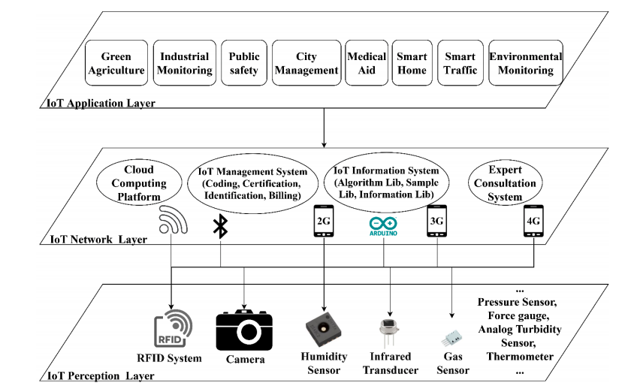

- Ensure the sensors are durable, weather-resistant, and can transmit data wirelessly.

**2.Sensor Placement**

- Identify key locations based on factors like population density, industrial areas, traffic hotspots, etc.

- Install sensors at optimal heights and positions to accurately capture noise levels.

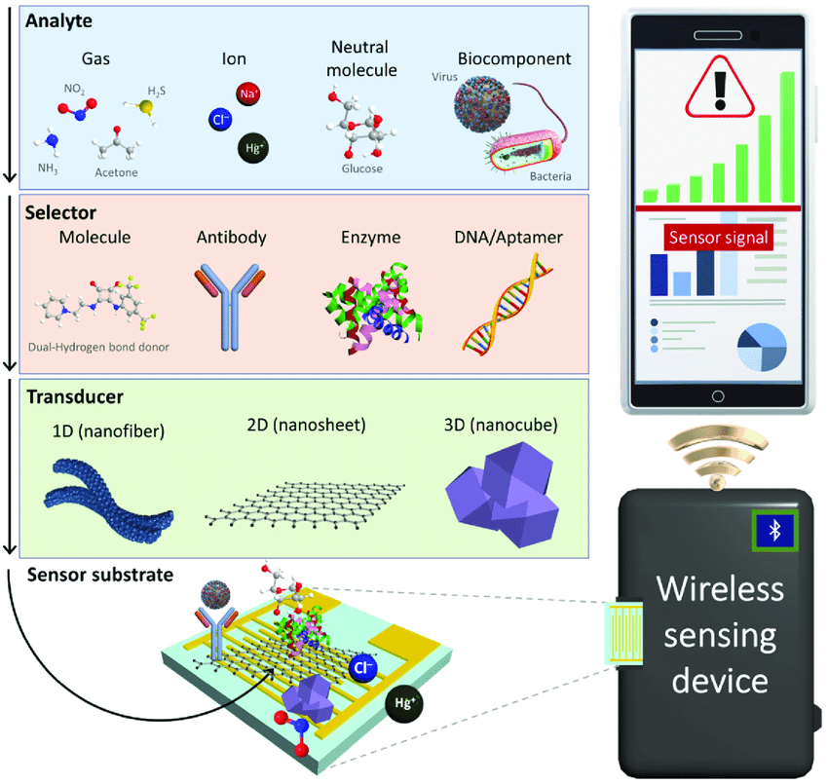

**3.Data Transmission**

- Establish a secure and reliable communication network (e.g., Wi-Fi, cellular, or LPWAN) for transmitting data from sensors to a central server.

**4. Centralized Data Hub**

- Set up a centralized hub or server to collect and process data from all deployed sensors.

- Implement a cloud-based solution for scalability and accessibility.

**5. Real-Time Monitoring**

- Develop a user interface or dashboard for real-time monitoring of noise levels.

- Include features for visualizing data trends, setting alerts for abnormal noise levels, and generating reports.

**6. Data Analytics**

- Use data analytics tools to analyze trends, identify patterns, and gain insights into noise pollution sources.

- Implement machine learning algorithms for predictive analysis.

**7. Integration with GIS**

- Integrate the noise pollution data with Geographic Information System (GIS) mapping for spatial analysis.

- This helps visualize the geographical distribution of noise and identify specific areas of concern.

**8. Alerts and Notifications**

- Implement an alert system to notify authorities or relevant stakeholders when noise levels exceed predefined thresholds.

- Ensure timely responses to mitigate noise issues.

**9. Power Management**

- Consider power-efficient sensor designs or implement renewable energy sources to ensure continuous sensor operation.

**10. Data Privacy and Security**

- Implement robust security measures to protect the collected data and ensure user privacy.

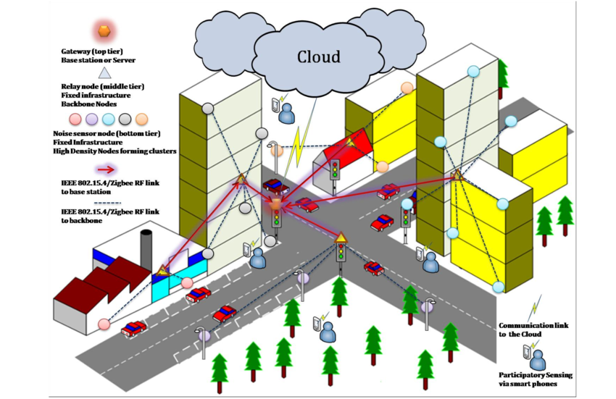

**11. Community Engagement**

- Involve the community by providing access to noise pollution data, promoting awareness, and encouraging active participation in noise reduction initiatives.

By deploying IoT sensors for noise pollution monitoring, communities can make informed decisions to address specific noise challenges and work towards creating quieter and healthier environments.

**Platform and Mobile App Developments**

Sure, I'll provide a simplified overview of the platform and mobile app development for noise pollution monitoring, along with some code snippets. Note that this is a high-level guide, and actual implementation details may vary based on specific requirements and technologies.

**Platform Development**

1. **Database Setup**

- Choose a database to store sensor data (e.g., MySQL, MongoDB).

- Create tables for storing sensor readings, location data, and other relevant information.

**2. Server-Side Development**

- Use a server-side language like Node.js, Python, or Java.

- Implement API endpoints for sensor data transmission, retrieval, and analysis.

**3. Sensors**

- Use sound sensors to capture noise levels. There are various types available, such as omnidirectional or directional microphones.

- Consider additional sensors for factors like air quality if you want a comprehensive environmental monitoring system.

**4. IoT Devices**

- Choose IoT devices to host your sensors and facilitate data transmission. Raspberry Pi or Arduino boards are popular choices.

- Ensure the devices have Wi-Fi or other connectivity options to send data to your platform.

**5. Connectivity**

- Implement a reliable communication protocol for your IoT devices to transmit data. MQTT or HTTP are common choices.

- Explore options for low-power, long-range communication protocols for remote monitoring.

**6. Data Storage**

- Set up a robust database to store the incoming noise data. Consider using cloud services like AWS, Azure, or Google Cloud for scalability.

**7. Web Platform**

- Develop a web-based dashboard for users to monitor noise levels. This could include real-time graphs, historical data, and customizable alert thresholds.

- Ensure the platform is user-friendly, accessible on various devices, and supports secure user authentication.

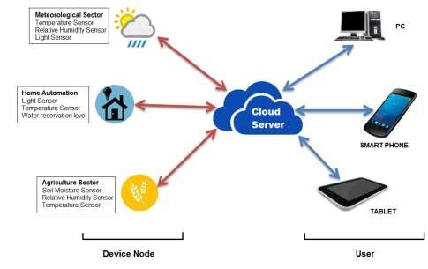

**Javascript**

// Sample endpoint for receiving noise data

app.post('/api/noise-data', (req, res) => {

const { sensorId, noiseLevel, location } = req.body;

// Store data in the database

// Perform analysis or trigger alerts based on noise levels

res.status(200).json({ message: 'Data received successfully' });

});

```

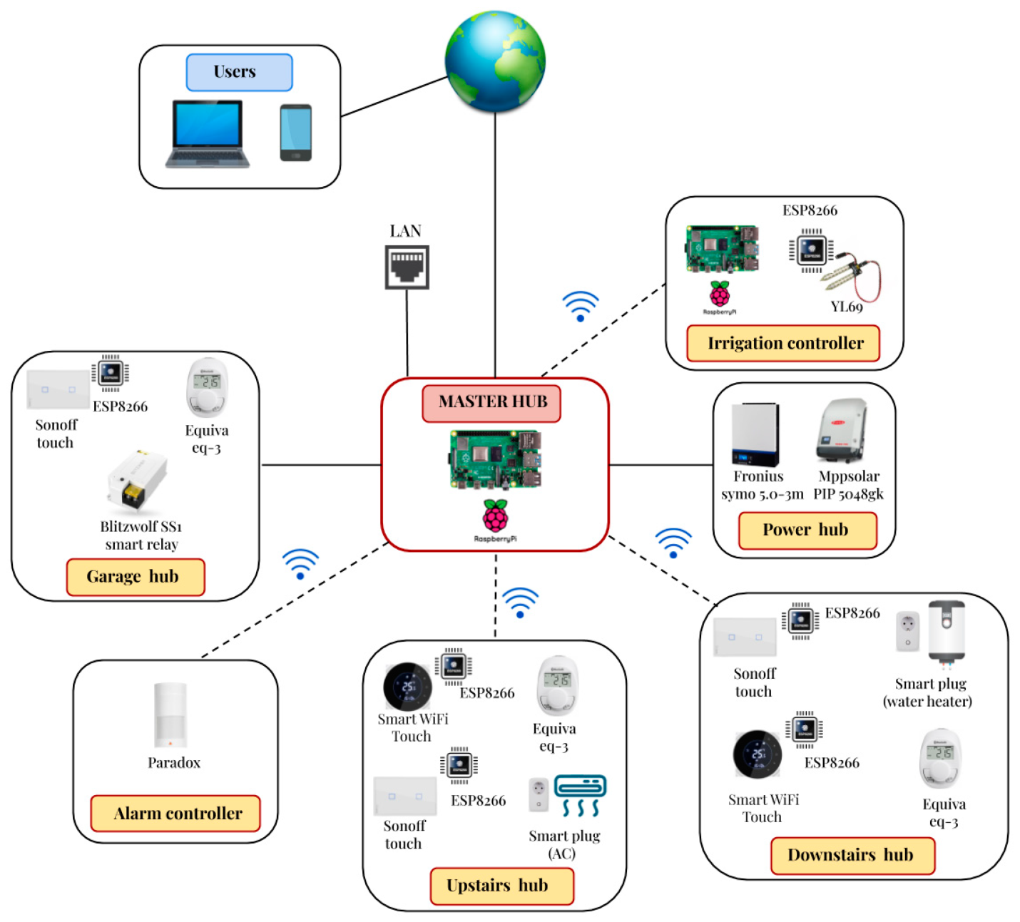

**3. Data Analysis**

- Use libraries or custom algorithms for analyzing noise data.

- Implement logic to identify trends, patterns, and potential sources of noise pollution.

**4.Real-Time Communication**

- Utilize technologies like WebSockets for real-time communication with sensors.

- Update the database and trigger alerts in real-time.

**Mobile App Development**

**1. App Architecture**

- Choose a mobile development framework (e.g., React Native, Flutter).

- Set up project structure and navigation.

**2. User Authentication**

- Implement user authentication for secure access to the app.

**3.Map Integration**

- Use mapping libraries (e.g., Google Maps, Mapbox) to display sensor locations.

- Fetch and display real-time noise data on the map.

**4.Real-Time Alerts**

- Implement push notifications for real-time alerts on excessive noise levels.

**4.Real-Time Alerts**

- Implement push notifications for real-time alerts on excessive noise levels.

**5.User Interface**

- Design an intuitive interface to display noise data, trends, and analysis.

- Provide filters and settings for users to customize their experience.

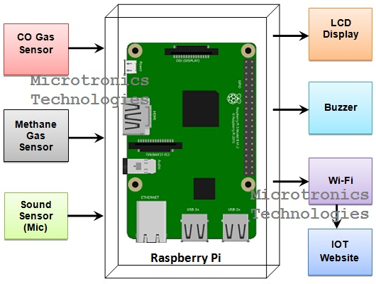

**6.Integration with Platform**

- Connect the mobile app to the server-side API for data retrieval and submission.

**Javascript**

// Sample function to fetch noise data

const fetchNoiseData = async () => {

try {

const response = await axios.get('https://your-api-url/api/noise-data');

// Process and display data in the app

} catch (error) {

console.error('Error fetching noise data:', error);

}

};

```