Commands for mongodb replication:

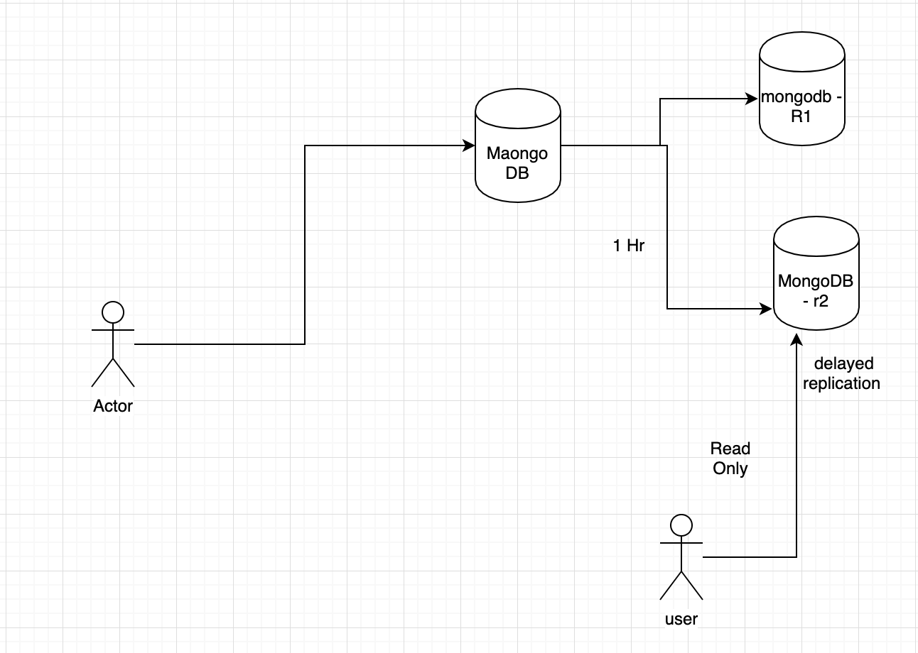

1. Start the standalone server with the following command-

mongod --dbpath "C:\Program Files\MongoDB\Server\4.2\data" --logpath "C:\Program Files\MongoDB\Server\4.2\log\mongod.log" --port 27017 --storageEngine=wiredTiger --journal --replSet MaongoDB

1. Connect to the server with port number 27017-

mongo --port 27017

1. Create variable rsconf -

rsconf={_id:"r2schools",members:[{_id:0,host:"localhost:27017"}]} rs.initiate(rsconf)

1. Start secondary server on the port 27020.

mongod --dbpath "C:\mongodbr1\db" --logpath "C:\mongodbr1\log\mongod.log" --port 27020 --storageEngine=wiredTiger --journal –replSet MaongoDB

1. Logon to secondary server.

mongo --port 27020

1. Start secondary server on the port 27021.

mongod --dbpath "C:\mongodbr2\db" --logpath "C:\mongodbr2\log\mongod.log" --port 27021 --storageEngine=wiredTiger --journal --replSet MaongoDB

1. Logon to secondary server

mongo --port 27021

1. Run the following commands on Primary server.

rs.add("localhost:27020")

rs.add("localhost:27021")

1. Now go to secondary servers and run below command on both the secondary servers.

rs.slaveOk()

1. To configure a delayed secondary member, set its [members[n].priority](https://docs.mongodb.com/manual/reference/replica-configuration/#rsconf.members[n].priority) value to 0, its [members[n].hidden](https://docs.mongodb.com/manual/reference/replica-configuration/#rsconf.members[n].hidden) value to true, and its [members[n].slaveDelay](https://docs.mongodb.com/manual/reference/replica-configuration/#rsconf.members[n].slaveDelay) value to the number of seconds of delay.

set a 1-hour delay on a secondary member currently at the index 0 in the [members](https://docs.mongodb.com/manual/reference/replica-configuration/#rsconf.members) array.To set the delay, issue the following sequence of operations in a [mongo](https://docs.mongodb.com/manual/reference/program/mongo/#bin.mongo) shell connected to the primary:

cfg = rs.conf()

cfg.members[0].priority = 0

cfg.members[0].hidden = true

cfg.members[0].slaveDelay = 3600

rs.reconfig(cfg)