**Spring Data JPA - Quick Example**

# Software Installation (Ensure the following are installed)

* **MySQL Server 8.0**
* **MySQL Workbench 8**
* **Eclipse IDE for Enterprise Java Developers 2019-03 R** • **Maven 3.6.2**

# Project Creation Using Spring Initializr

1. Go to: [https://start.spring.io](https://start.spring.io/) 2. Fill details:

o Group: com.cognizant o Artifact: orm-learn o Description: Demo project for Spring Data JPA and Hibernate

1. Select dependencies:

o **Spring Boot DevTools** o **Spring Data JPA** o **MySQL Driver**

1. Click **Generate** and download the ZIP.
2. Extract the ZIP to your Eclipse Workspace.
3. 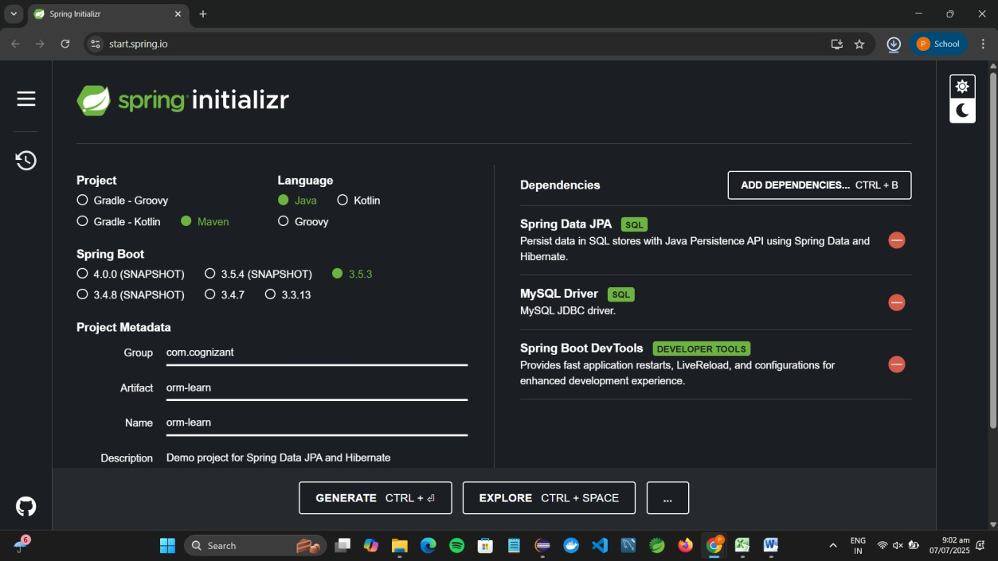

# Import Project into Eclipse

1. Open Eclipse → File > Import > Maven > Existing Maven Projects.
2. Browse and select extracted folder.
3. Click **Finish**.

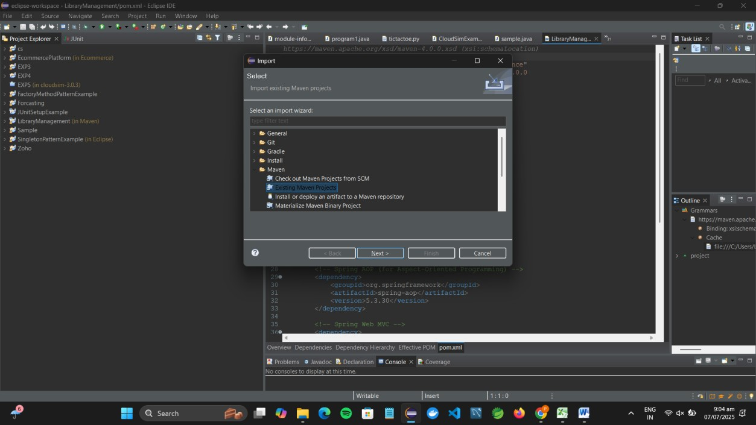

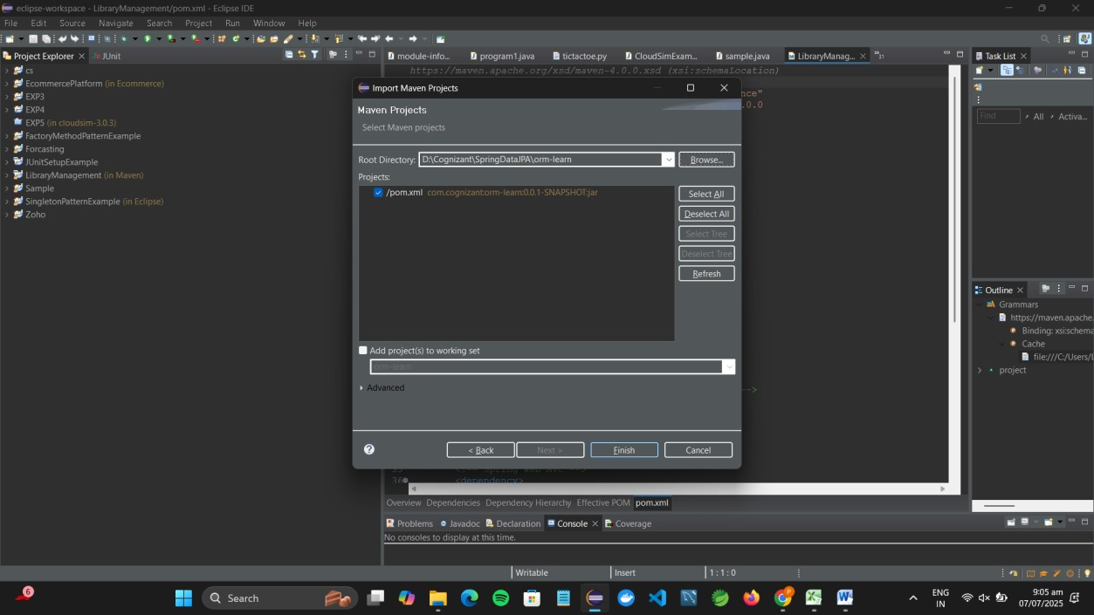

# MySQL Database Setup

1. Open MySQL Command Line:

mysql -u root -p

1. Create Schema: create schema ormlearn;

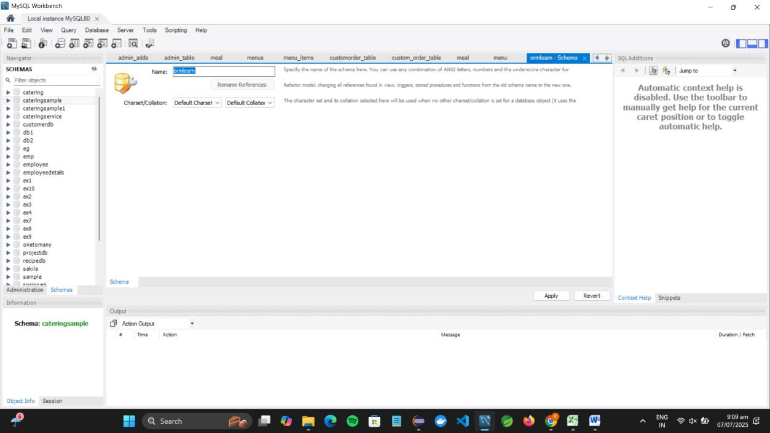

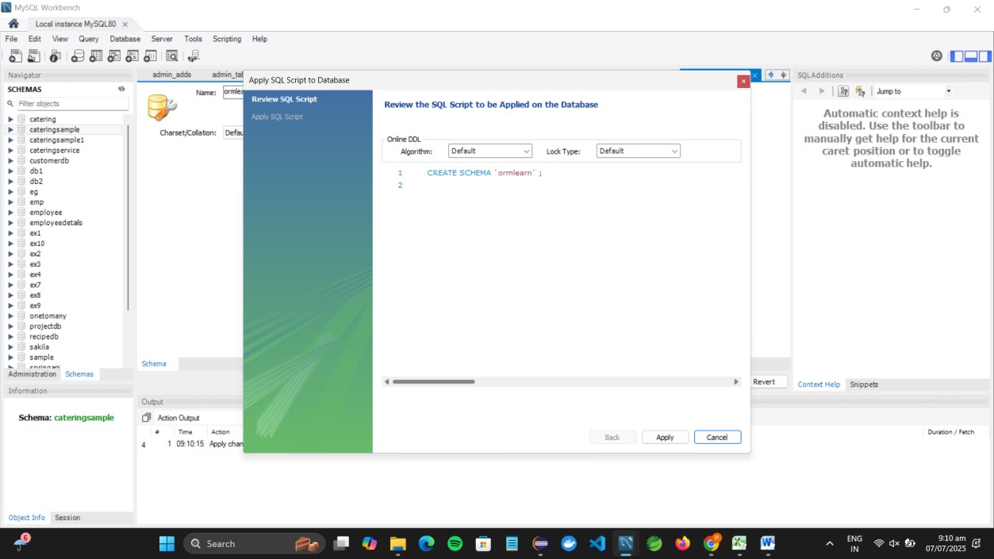

# 5: Build Project via Maven

**Open Command Prompt:**

• Press Win + R, type cmd, and hit Enter. • Go to your project directory:

cd D:\Cognizant\SpringDataJPA\orm-learn

**Run Maven Build:**

mvn clean package -Dhttp.proxyHost=proxy.cognizant.com -Dhttp.proxyPort=6050 -

Dhttps.proxyHost=proxy.cognizant.com -Dhttps.proxyPort=6050 -Dhttp.proxyUser=123456

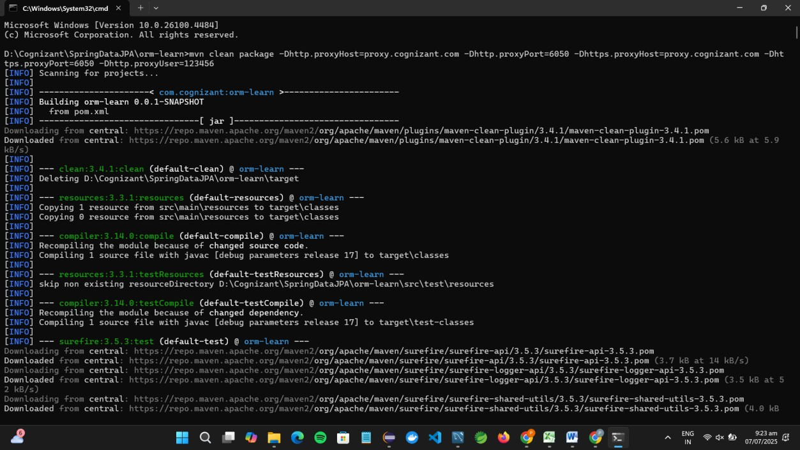

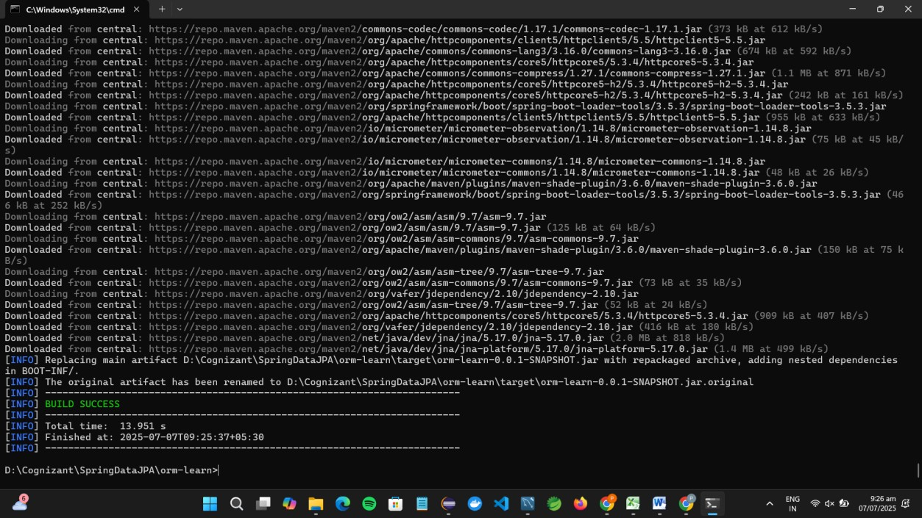

# 6.Create country Table and Insert Records in MySQL

**Open MySQL Workbench.**

1. Click your connection (e.g., Local instance MySQL80).
2. Choose your schema: ormlearn
3. Open a new SQL tab and run:

CREATE TABLE country ( code VARCHAR(2) PRIMARY KEY, name VARCHAR(50)

);

INSERT INTO country VALUES ('IN', 'India');

INSERT INTO country VALUES ('US', 'United States of America');

1. Click **Execute (lightning bolt)**.

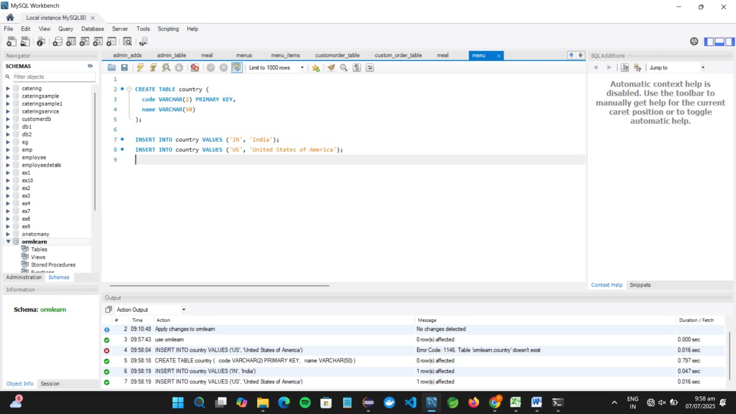

# 7.Create Entity Class Country.java

**Package location:**

com.cognizant.ormlearn.model  **Steps:**

1. Right-click src/main/java > com.cognizant.ormlearn → **New > Package** → Name it:

com.cognizant.ormlearn.model

1. Right-click this package → **New > Class** → Name: Country

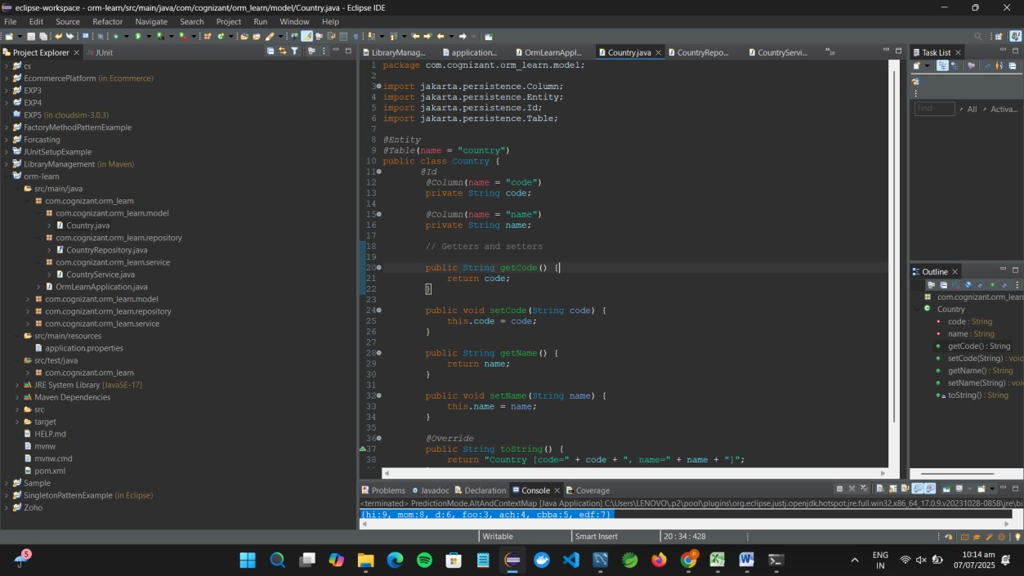

# 8.Create Repository Interface

**Package location:**

com.cognizant.ormlearn.repository  **Steps:**

1. Create new package:

com.cognizant.ormlearn.repository

**CountryRepository Interface:**

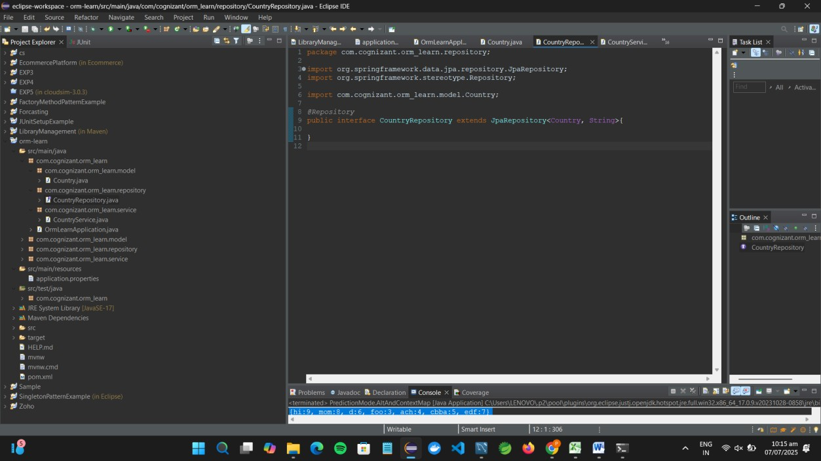

# 9.Create Service Class

**Package location:**

com.cognizant.ormlearn.service  **Steps:**

1. Create new package:

com.cognizant.ormlearn.service

**CountryService Class:**

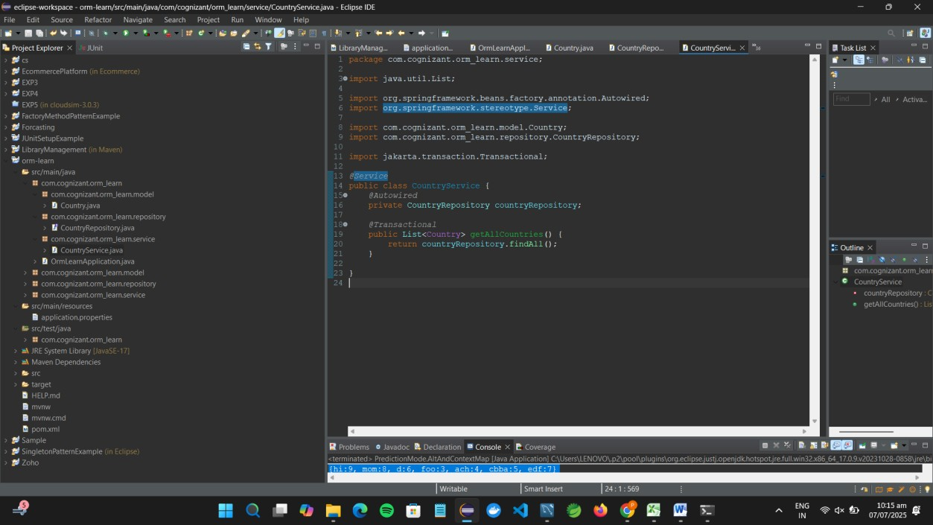

# 10.Modify Main Class to Call the Service

**Modify OrmLearnApplication.java to call the service:**

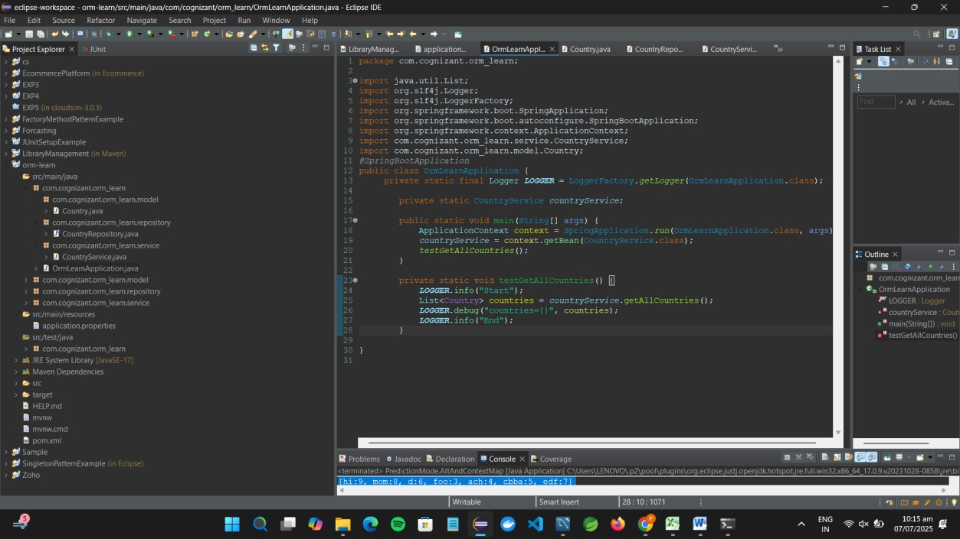

**Output Screenshot:**

