public class EvenOddChecker {

public static void main(String[] args) {

// Predefined list of numbers

int[] numbers = {5, 12, -3, 0, 99};

for (int number : numbers) {

if (number % 2 == 0) {

System.out.println(number + " is EVEN.");

} else {

System.out.println(number + " is ODD.");

}

}

System.out.println("Check completed!");

}

}

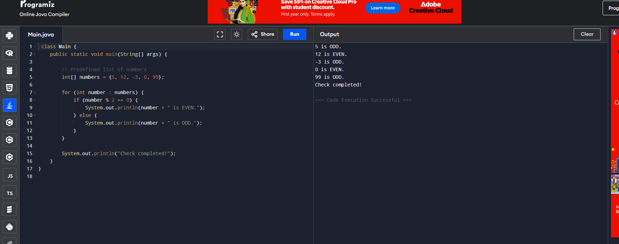

1 **What is the modulus operator in Java?**  
% returns the remainder after division.  
Example: 5 % 2 = 1, 10 % 3 = 1.

2 **How do you use the if-else statement in Java?**

java

CopyEdit

if (condition) {

// true block

} else {

// false block

}

3**What is the purpose of the Scanner class in Java?**  
It is used to take user input (keyboard, files, etc.).

4 **How do you take integer input from the user in Java?**

java

CopyEdit

Scanner sc = new Scanner(System.in);

int num = sc.nextInt();

5 **What are the basic numeric data types in Java?**  
byte, short, int, long, float, double

6 **Can an if condition contain multiple expressions?**  
Yes, using && (AND) or || (OR).  
Example:

java

CopyEdit

if (num > 0 && num % 2 == 0) { ... }

7 **What happens if a non-integer is entered when expecting an integer?**  
InputMismatchException unless input is validated.

8 **How does Java handle negative numbers with %?**  
The result has the same sign as the dividend. Example: -5 % 2 = -1.

9 **What is the default value of an int in Java?**  
Class/instance variable → 0, Local variable → Must be initialized before use.

10 **How would you make the program repeat until exit?**  
Use a do-while loop and prompt the user.