**COVID 19 VACCINE ANALYSIS**

**Phase 3:Development part 1**

**Introduction:**

The COVID 19 pandemic caused due to the virus named corona. This virus was originated in Wuhan, China in 2019 and was later spread throughout the world. The disease showed symptoms such as mild fever and cold but also caused life threatening symptoms like breathing problems caused by damage to the lungs. As this virus was new to the world and there was no vaccine or cure to it at the earlier period there were several deaths around the world. So the countries around the world announced lockdowns to prevent the spread of the disease. An effort was made by several health organizations to discover the cure or a vaccine to fight against the virus.

In later stages of 2020 several experimental vaccines were developed and was tested to humans. The efforts were successful as the vaccines were helpful in reducing the affects the virus and even if people were infected, they were not in any life threatening situation and escaped the illness having only minor symptoms. Many countries later developed their own vaccines and also helped other countries without the resources by providing them with vaccines developed.

**Data Collection:**

The dataset that I will be using here for the task of covid-19 vaccines analysis is taken from the online resource called kaggle and the collected file was imported to the desktop.

**Importing the Libraries:**

Now lets install the library

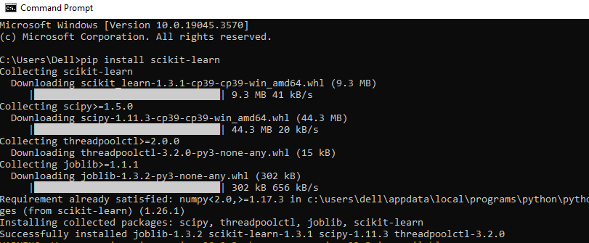 installing the library

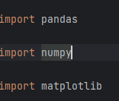

Importing the libraries

**Data processing:**

Reading the data

r.PNG

Output:

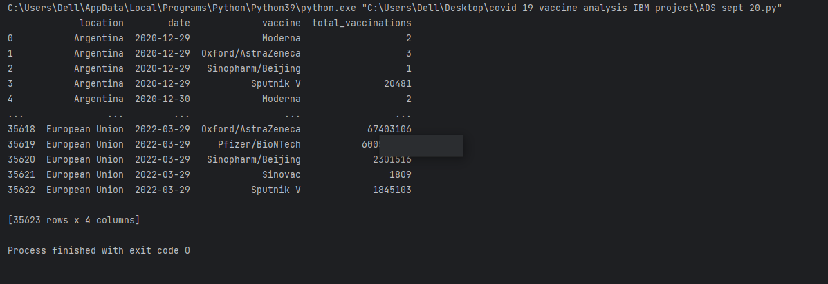

Processing the data:

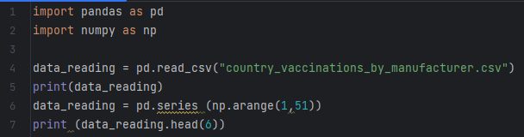

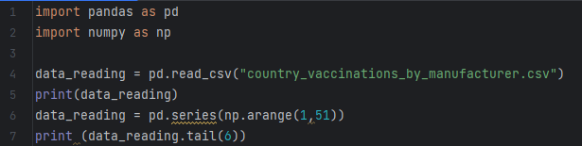

|  |  |
| --- | --- |
|  |  |
|  |  |
|  |  |
|  |  |

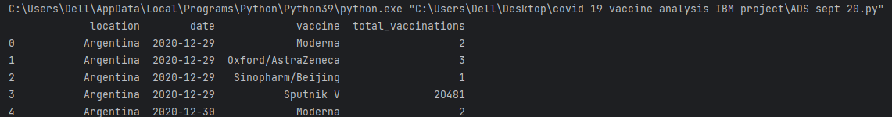

**Explanation:**

The data set named country vaccinations by manufacturer was downloaded from the online resource called kaggle.com and it was imported to the local desktop. A python file was created to get started with the analysis. Using the command pip install the required libraries are installed, now the installed libraries has to be imported to the python file where we are going to do the analysis, For importing those libraries into the python file the import command is used after importing the required libraries we have to read the data. By using

data_reading =pandas.read(country_vaccinations_by_manufacturer.csv)

this code we can read the data after reading the data we can get the clear vision of the data

Now we are going to process the data in our hands for the sake of better understanding of the data by using the head and tail functions in the pandas library we can process our data and gain valuable insights.