**Project Writeup: Personalized Activity/Workout Recommendation System**

Team: **ML Mavericks**

Team Members:

* Shubham Kothiya
* Yugm Patel
* Soumya Bharathi Vetukuri

**Homework Assignment**: **Feature Importance and Amalgamation Experiment -- Regression, MLP and Latent Manifolds Copy**

**Objective**

The primary goals in this homework were to improve model performance by eliminating irrelevant features and to prepare the fitness and activity datasets for more complex analyses. An additional objective was to visualize the distributions of various features to gain a better understanding of the data.

**Task Overview**

The approach taken involved several key steps:

1. Loading and preliminary examination of three distinct datasets: daily activity, sleep, and heart rate.
2. Visual examination of feature distributions and correlations to identify any immediate relationships or anomalies that could affect subsequent analyses.
3. Application of feature importance techniques such as Random Forest importance scores, Mutual Information scores, and F-regression scores to determine the relevance of each feature.
4. Removal of noisy or irrelevant features based on the importance scores obtained in the previous step.
5. Creation of visualizations to aid in the understanding of the data's characteristics and the relationships between different features.

**Datasets**

Following three datasets were used:

● Dataset 1 (ds1): Daily activity tracking data (steps, distances, active minutes)

● Dataset 2 (ds2): Sleep monitoring data

● Dataset 3 (ds3): Heart rate monitoring data

Each dataset contains valuable insights that, when combined, can enhance the accuracy of our personalized activity recommendations. These were also used to improve results compared to the previous task.

**Methodology:**

**Step 1: Data Loading and Preprocessing**

* Loaded datasets from Google Drive.
* Conducted exploratory data analysis (EDA) to check data integrity.
* Visualized distributions using histograms and correlation heatmaps to identify multicollinearity.

**Step 2: Feature Importance Analysis**

* Applied the following techniques to determine the relevance of features:
  + **Random Forest Feature Importance**
  + **Mutual Information Scores**
  + **F-regression Scores**
* Features with low importance scores were removed to reduce model complexity.

**Step 3: Dataset Amalgamation & Latent Features**

* Introduced latent variables based on domain knowledge.
* Combined relevant data from all three datasets to form a comprehensive dataset.
* Computed new features such as ‘Activity Intensity Ratio’ and PCA-derived latent features.

**Step 4: Model Implementation**

1. **Linear Regression:** Served as a baseline comparison.
2. **Random Forest:** Used for feature selection and improving model accuracy.
3. **Multi-Layer Perceptron (MLP):** Implemented using Keras to capture complex patterns.
4. **Muller Loop:** A loop testing multiple regression models including:
   * Linear Regression, Ridge, Lasso, ElasticNet, Random Forest, Gradient Boosting, Support Vector Machine, K-Nearest Neighbors, MLP, and XGBoost.
   * Performance evaluated using R² and RMSE metrics.

**Step 5: Performance Evaluation**

* Models trained on both the **original dataset** and the **refined dataset**.
* Evaluation metrics: Accuracy, Precision, Recall, F1-score, AUC/ROC.
* Performance before and after feature selection compared in tabular form.

**Achievements of Each Model**:

* Linear Regression showcased solid performance, particularly when using enhanced features, making it a reliable choice for straightforward regression tasks.
* Random Forest excelled in feature importance analysis, leading to a more efficient feature set that improved overall model performance.
* Neural Networks proved superior in handling complex patterns, surpassing the linear models in terms of accuracy and loss metrics.
* Muller Loop provided valuable insights into the comparative strengths and weaknesses of various models, emphasizing the benefits of using enhanced features over original features. This comprehensive testing highlighted models like Gradient Boosting and XGBoost for their robustness and accuracy.

**Expected Outcomes**:

Feature importance analysis revealed several key features that were highly predictive of outcomes like calorie burn and activity levels. For instance, the 'TotalSteps' and 'VeryActiveMinutes' were identified as significant predictors for both calorie expenditure and sedentary minutes.

The removal of irrelevant features based on importance thresholds led to a streamlined dataset, which was expected to improve the efficiency and performance of the machine learning models applied in subsequent analyses.

Visualizations created during this step provided clear insights into the data, highlighting important relationships and distributions that informed further data processing and feature engineering.

**Analysis and Comparison**:

Below are the screenshots of the tables with individual results of Original and Enhanced. The later table depicts the comparison among them and percentage of improvement obtained for each model.

* **Results with Original Features**:

* **Results with Enhanced Feature**s:

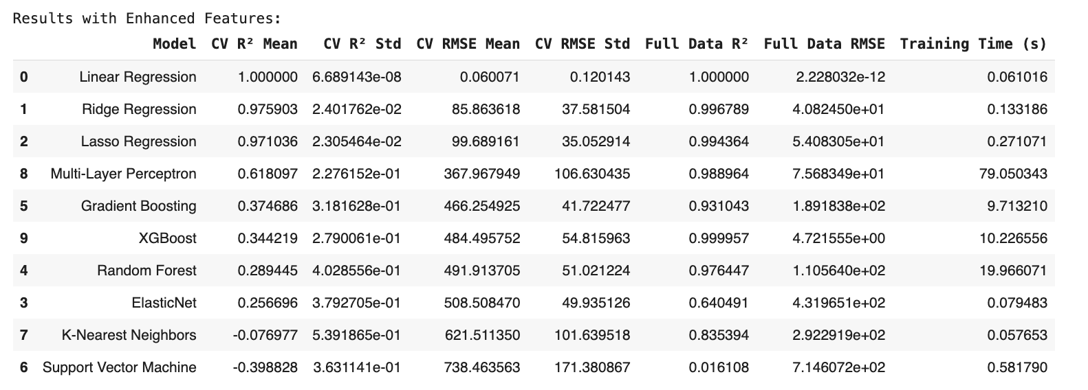

* **Results – Performance Comparison**:

**Key Findings:**

* Feature Importance: The analysis indicated that selecting the right features significantly impacts model performance, as seen in the Random Forest and Linear Regression models.
* Enhanced Feature Set: The introduction of latent features derived from PCA and custom calculations (like activity intensity ratio) greatly enhanced model performance across several models.
* Performance Metrics: There was a clear demonstration of improved accuracy and reduced error rates in models utilizing enhanced features, as evidenced by better R² and RMSE values in the Muller Loop comparisons.
* Model Comparison: The Muller Loop implementation was particularly insightful, demonstrating the effectiveness of various models in a controlled comparison. Enhanced features generally provided better performance metrics compared to original features.

