**Step1:**

Open the project with Visuval studio 2017 and Build the application .

Press F5.(run the solution)

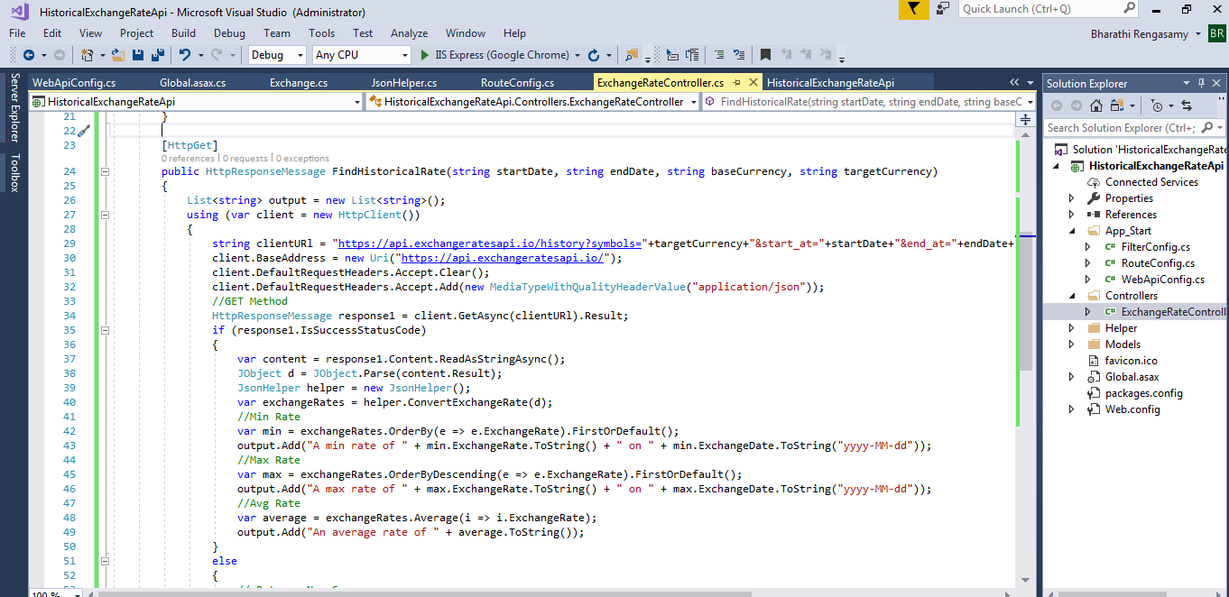

**Step2:**

Open postman (using postman chrome app ) -https://chrome.google.com/webstore/detail/postman/fhbjgbiflinjbdggehcddcbncdddomop?hl=en

Once launch the postman tool to test the application

1)select Get method and type the url :

http://localhost:64075/api/ExchangeRate/FindHistoricalRate

2)give the input value for each parameter

startDate=2018-01-01(yyyy-MM-dd)

EndDate=2018-09-01(yyyy-MM-dd)

baseCurrency=USD

targetCurrency=INR

Finally construct url like below:

<http://localhost:64075/api/ExchangeRate/FindHistoricalRate?startDate=2018-01-01&EndDate=2018-09-01&baseCurrency=USD&targetCurrency=INR>

(port number will different for other workstation)

3)press send

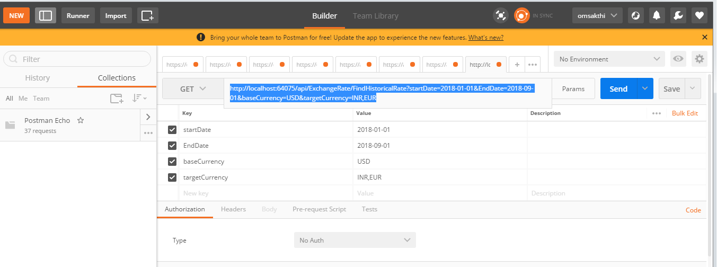

**Step4:**

Output with 200 Ok (Expected result) – find below screen shot.

