Open the project with Visuval studio 2017 and Build the application .

Press F5.

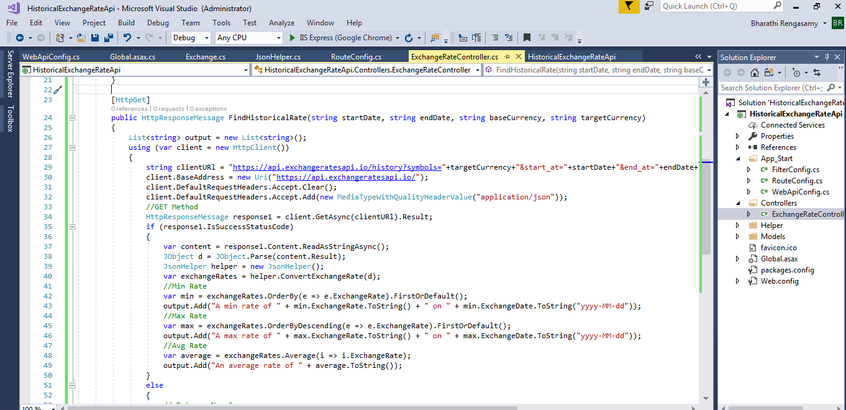

Open postman for testing this application and select Get method and type the url : <http://localhost:64075/api/ExchangeRate/FindHistoricalRate?startDate=2018-01-01&EndDate=2018-09-01&baseCurrency=USD&targetCurrency=INR,EUR> (port number will different for other workstation) and press send

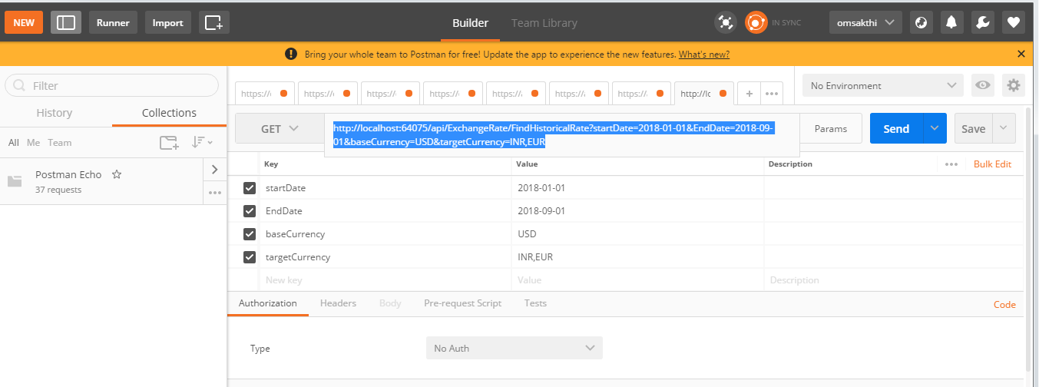

Output with 200 Ok (Expected result) – find below screen shot

