INTRO PAGE:
<html>
<head>
<title>Web page</title>
</head>
<body bgcolor="#abcabc">
<h4><center>WELCOME!!</CENTER></H4>
<h1><center><MARQUEE>TICKET RESERVATION SYSTEM</center></h1></MARQUEE>
<p>this webpage is used to book tickets in different fields includes Movie,event,bus,train.Clear & Simple Navigation
Keep the booking flow straightforward — from selecting the event/travel option to payment confirmation.<BR>
<CENETR>Step 1: Select <BR> Step 2: Details <BR> Step 3: Payment<BR></CENTER>
so users know where they are in the process
Provide filters for date, location, price range, and category.
Many users book tickets on their phones, so ensure the layout adapts perfectly to smaller screens.
Use large, tappable buttons and minimal typing requirements.
Show seat maps for events or transport.
Offer recommendations for related events or trips.
Send instant booking confirmations via email/SMS.
Tickets available,learn event details and make reservation also
We create this webpage only using HTML.</P>
<h4><center><hr>
<a href="movie.html">Movie</a><br>
<a href="event.html">Event</a><br>
<a href="bus.html">Bus</a><br>
<a href="train.html">Train</a>
<h3>Thank youu!!</h3>
<img src="https://www.shutterstock.com/image-vector/concept-illustration-travel-around-world-260nw-1547195744.jpg" width=250 height=250>
<h4></center>
</body>
</html>
OUTPUT:
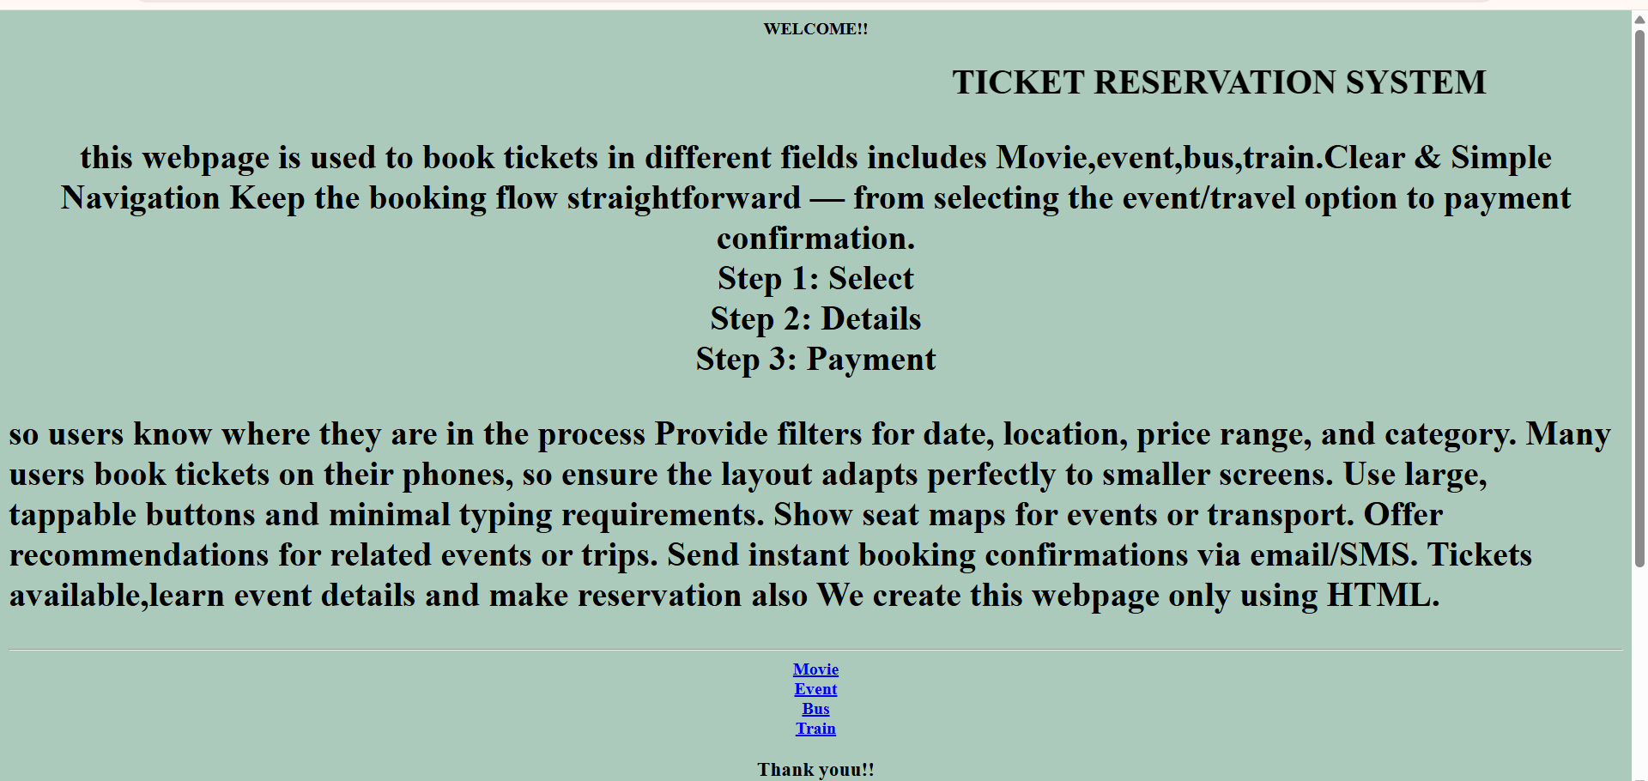

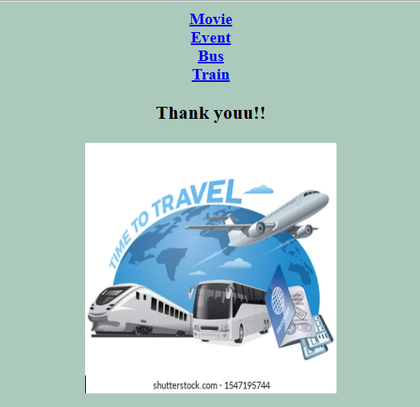

MOVIE PAGE:
<html>
<head>
<title>Movie page</title>
</head>
<body>
<body bgcolor="#abcabc">
<table border="2">
<tr>
<th>sno</th>
<th>movie name</th>
<th>time</th>
<th>seats availability</th>
<th>posture</th>
</tr>
<tr>
<td>1</td>
<td><b>Hi nana</b></td>
<td>6:00pm</td>
<td>120</td>
<td><img src="https://m.media-amazon.com/images/M/MV5BZWZjOWZhMDAtMWIxYi00NzUzLWFjNzctZTc5ZTYzMWNhY2I5XkEyXkFqcGc@._V1_.jpg" width="100" height="100"</td>
</tr>
<tr>
<td>2</td>
<td><b>love today</b></td>
<td>7.00pm</td>
<td>80</td>
<td>
<img src="https://tse1.mm.bing.net/th/id/OIP.hPNmq3oUG83EIlRUPF7RkwHaLH?rs=1&pid=ImgDetMain&o=7&rm=3" width="100" height="100"</td>
</tr>
<tr>
<td>3</td>
<td><b>Dragon</b></td>
<td>9.30am</td>
<td>140</td>
<td><img src="https://tse1.mm.bing.net/th/id/OIP.PDv8DvMhiFYy3Y3ShhQv3wHaLl?rs=1&pid=ImgDetMain&o=7&rm=3" width="100" height="100"</td>
</tr>
<tr>
<td>4</td>
<td><b>Wednesday</b></td>
<td>9.00am</td>
<td>130</td>
<td><img src="https://tse2.mm.bing.net/th/id/OIP.-ZtuuBt41LwRSoEPz-SntgHaKX?rs=1&pid=ImgDetMain&o=7&rm=3" width="100" height="100"</td>
</tr>
<tr>
<td>5</td>
<td><b>The Titanic</b></td>
<td>10.00am</td>
<td>90</td>
<td><img src="https://c8.alamy.com/comp/F762XE/film-movie-poster-of-titanic-F762XE.jpg" width="100" height="100"</td>
</tr>
</table>
<form>
<label>Movie Name:</label>
<input type ="text"></input><br>
<label>Show time:</label><br>
<input type ="Radio">7.00 PM</input><br>
<input type ="Radio">10.00 PM</input><br>
<label>Seats:</label>
<input type ="text"></input>
<button> click </button>
</body
</body>
</html>
OUTPUT:
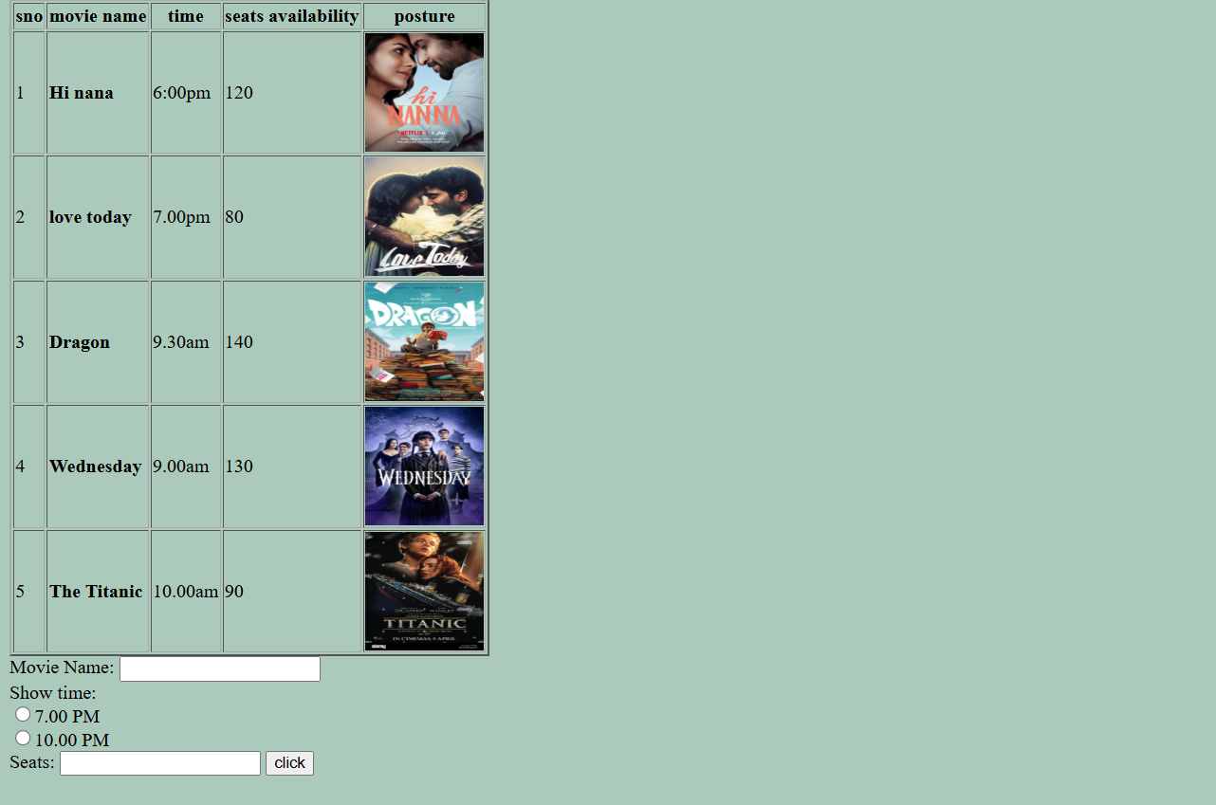

EVENT PAGE:
<html>
<head>
<title>Event page</title>
</head>
<body>
<body bgcolor="abcabc">
<h3><b><center>Event booking</b></center></h3>
<table border="2" style="width:100%">
<tr>
<th>sno</th>
<th>event name</th>
<th>time</th>
<th>date</th>
<th>posture</th>
</tr>
<tr>
<td>1</td>
<td><b>Euphoria 2026</b></td>
<td>10:00am</td>
<td>12-03-2025</td>
<td><img src="https://sxcjpr.edu.in/wp-content/uploads/2025/10/Poster-Freshers-Day-2025.jpg" width="300" height="300"</td>
</tr>
<tr>
<td>2</td>
<td><b>elective 2026</b></td>
<td>7.00pm</td>
<td>8-02-2026</td>
<td><img src="https://encrypted-tbn0.gstatic.com/images?q=tbn:ANd9GcR_RSSQ1AuRspypvhVrJbSgD4BMHmH97-pJ5LRGmYgktZczVLxso939jAA&s=10" width="300" height="300"</td>
</tr>
</table>
<form>
<label>event Name:</label>
<input type ="text"></input><br>
<label>time:</label><br>
<input type ="Radio">6.00 aM</input><br>
<input type ="Radio">10.00 aM</input><br>
<label>date</label>
<input type ="text"></input>
</body>
</html>
OUTPUT:
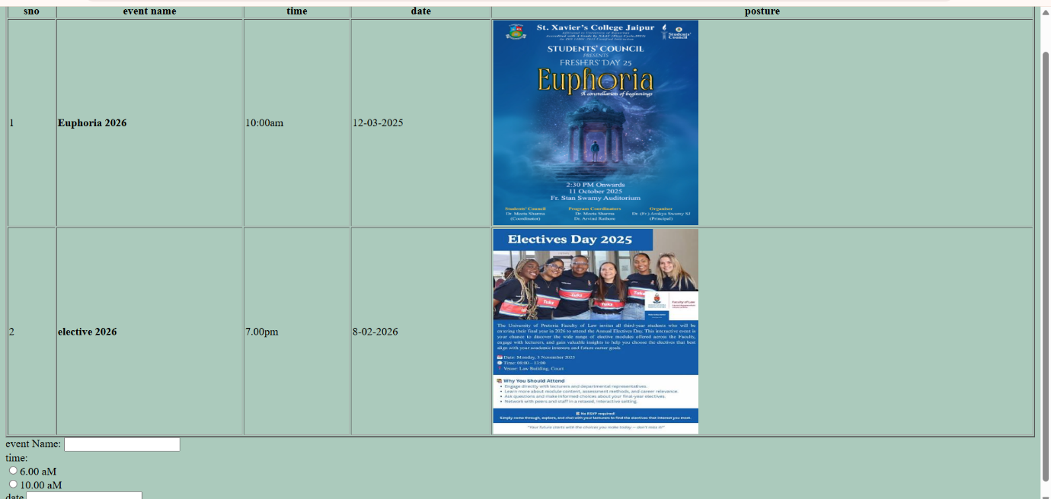

BUS PAGE:
<html>
<head>
<title> bus webpage</title>
</head>
<body>
<body bgcolor="#abcabc">
<h3><b> <center>Bus booking </center><b>
<table border="2" style="width:50%">
<tr>
<th>sno</th>
<th>bus from</th>
<th>bus destination</th>
<th>seats availability</th>
<th>amount/per person</th>
</tr>
<tr>
<td>1</td>
<td><b>Chennai</b></td>
<td>Madurai</td>
<td>12</td>
<td>120</td>
</tr>
<tr>
<td>1</td>
<td><b>thanjavur</b></td>
<td>Madurai</td>
<td>50</td>
<td>80</td>
</tr>
<tr>
<td>1</td>
<td><b>Chennai</b></td>
<td>trichy</td>
<td>18</td>
<td>65</td>
</tr>
</TABLE>
<form>
<label>bus from:</label>
<input type ="text"></input><br>
<label>bus to :</label>
<input type ="text"></input><br>
<label>bus time:</label>
<input type ="text"></input><br>
<label>Amount:</label>
<input type ="text"></input><br>
<label>Seats:</label>
<input type ="text"></input><br>
<button> click here</button>
<h4><center><marquee>Thankk you!!</center></h4></MARQUEE>
</body>
</html>

OUTPUT:
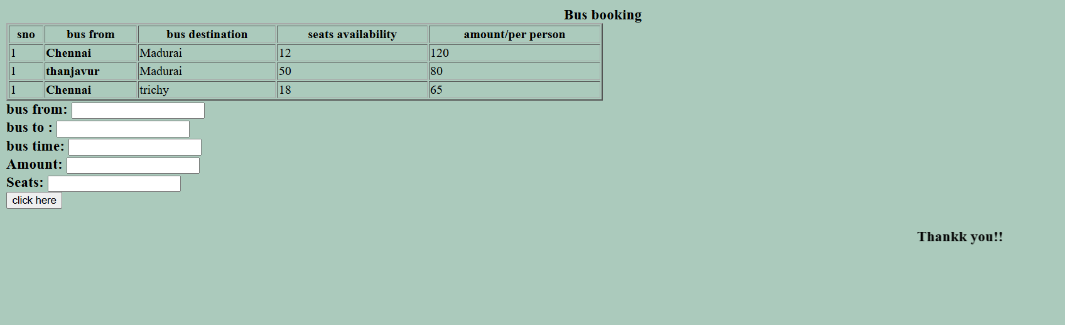
TRAIN PAGE:
<html>
<head>
<title>Train webpage</title>
</head>
<body>
<body bgcolor="#abcabc">
<h3><b> <center>Train booking </center><b><hr>
<table border="2" style="width:100%">
<tr>
<th>sno</th>
<th>bus from</th>
<th>bus destination</th>
<th>seats availability</th>
<th>amount/per person</th>
</tr>
<tr>
<td>1</td>
<td><b>Chennai</b></td>
<td>Madurai</td>
<td>12</td>
<td>120</td>
</tr>
<tr>
<td>1</td>
<td><b>thanjavur</b></td>
<td>Madurai</td>
<td>50</td>
<td>80</td>
</tr>
<tr>
<td>1</td>
<td><b>Chennai</b></td>
<td>trichy</td>
<td>18</td>
<td>65</td>
</tr>
</TABLE><hr>
<form>
<label>train from:</label>
<input type ="text"></input><br>
<label>train to :</label>
<input type ="text"></input><br>
<label>train time:</label>
<input type ="text"></input><br>
<label> total Amount:</label>
<input type ="text"></input><br>
<label>Seats:</label>
<input type ="text"></input><br>
<button> click here</button>
</body>
</html>

OUTPUT:
