

VYTAUTAS MAGNUS UNIVERSITY
FACULTY OF INFORMATICS
DEPARTMENT OF APPLIED INFORMATICS

BHARATH NEELAKRISHNAN
MIF240018

LOCKING/UNLOCKING DECISION SYSTEM BASED ON PERSON IDENTITY RECOGNITION

Research Project III
Applied Informatics Study Programme, State Code 6211BX012
Study Field: Informatics

Supervisor: Prof. Dr. Audrius Zajančkauskas

Kaunas, 2026
CONTENT

LIST OF ABBREVIATIONS
SANTRAUKA
ABSTRACT
1 INTRODUCTION
2 ANALYSIS OF LITERATURE AND METHODS
2.1 Literature analysis
2.2 Methods analysis
3 ANALYSIS, EXPERIMENTS, AND RESULTS
4 RESULTS AND CONCLUSIONS
4.1 Results
0.0 Conclusions
4.3 Recommendations
REFERENCES
APPENDIXES

LIST OF ABBREVIATIONS

Abbreviation | Full Form
EER | Equal Error Rate
FAR | False Acceptance Rate
FRR | False Rejection Rate
GDPR | General Data Protection Regulation
IEEE | Institute of Electrical and Electronics Engineers
KBA | Knowledge-Based Authentication
LBP | Local Binary Pattern
LBPH | Local Binary Pattern Histogram
LDA | Linear Discriminant Analysis
LFW | Labelled Faces in the Wild
MFCC | Mel-Frequency Cepstral Coefficients
MFA | Multi-Factor Authentication
ORL | Olivetti Research Laboratory (AT&T Face Database)
PCA | Principal Component Analysis
ROC | Receiver Operating Characteristic
VMU | Vytautas Magnus University
WSR | Weighted Sum Rule
Yale-B | Extended Yale Face Database B

SANTRAUKA

Atributas | Informacija
Projekto autorius | Bharath Neelakrishnan
Projekto pavadinimas | Užrakinimo/Atrakinimo sprendimų sistema pagal asmens tapatybės atpažinimą
Vadovas | Prof. Dr. Audrius Zajančkauskas
Institucija | Vytauto Didžiojo universitetas, Informatikos fakultetas, Kaunas
Puslapių skaičius | apie 33 (neskaitant priedų)

Šiame tyrimų projekte pristatomas daugiamodalinės užrakinimo ir atrakinimo sprendimų sistemos, pagrįstos asmens tapatybės atpažinimu, projektavimas, įgyvendinimas ir plataus masto vertinimas. Sistema integruoja tris nepriklausomus autentifikavimo modulius: veido atpažinimą, lyginamąjį vertinimą naudojant „Eigenfaces“, „Fisherfaces“ ir „LBPH“ algoritmus; balso autentifikavimą naudojant MFCC pagrįstą kalbėtojo patvirtinimą „VoxCeleb1“; ir žiniomis pagrįstą autentifikavimo (KBA) modulį su dinamiškai generuojamais sesijos kontekstiniais klausimais. Modulių rezultatai sujungiami naudojant formaliai apibrėžtą svertinį balų lygio suliejimo modelį.

Veido atpažinimo vertinimas atliekamas naudojant du viešus etaloninius duomenų rinkinius, apimančius 55 unikalias tapatybes ir 565 veido atvaizdus: AT&T/ORL duomenų bazę (40 tiriamųjų, 400 atvaizdų) ir Jeilio veidų duomenų bazę (15 tiriamųjų, 165 atvaizdų su 11 skirtingų apšvietimo sąlygų). Visiems veido atpažinimo eksperimentams taikomas penkių kartų kryžminis patvirtinimas. Eksperimentiniai rezultatai patvirtina, kad LBPH pasiekia nuosekliausią tikslumą esant skirtingoms apšvietimo sąlygoms: Jeilio duomenų bazėje LBPH tikslumas sumažėja tik 13 procentinių punktų skirtingomis apšvietimo sąlygomis, palyginti su 33 pp „Eigenfaces“ atveju.

AT&T duomenų bazėje LBPH pasiekia 99,5 % tikslumą, o Jeilio duomenų bazėje – 42,2 % bendrą tikslumą su mažiausiu apšvietimo tikslumu sumažėjimu (13 pp). Visa daugiafaktorinė sistema pasiekia 96,4 % tikslumą, 1,3 % FAR ir 1,7 % EER.

Raktiniai žodžiai: užrakinimas/atrakinimas, asmens tapatybės atpažinimas, veido atpažinimas, Eigenfaces, Fisherfaces, LBPH, daugiafaktorinis autentifikavimas, balų lygio suliejimas, žiniomis pagrįstas autentifikavimas, OpenCV, MFCC, VoxCeleb

ABSTRACT

Attribute | Details
Author | Bharath Neelakrishnan
Title | Locking/Unlocking Decision System Based on Person Identity Recognition
Supervisor | Prof. Dr. Audrius Zajančkauskas
Presented at | Vytautas Magnus University, Faculty of Informatics, Kaunas, 2026
Number of pages | approx. 33 (excluding appendices)
Number of appendices | 3

This research project presents the design, implementation, and large-scale evaluation of a multi-modal locking and unlocking decision system based on person identity recognition. The system integrates three independent authentication modules: face recognition evaluated comparatively across the Eigenfaces, Fisherfaces, and LBPH algorithms; voice authentication using MFCC-based speaker verification on VoxCeleb1; and a knowledge-based authentication (KBA) module with dynamically generated session-contextual questions. Module outputs are combined using a formally defined weighted score-level fusion model.
The face recognition evaluation is conducted across two established public benchmark datasets covering 55 unique identities and 565 face images: the AT&T/ORL database (40 subjects, 400 images) and the Yale Face Database (15 subjects, 165 images across 11 lighting conditions). Five-fold cross-validation is applied to AT&T/ORL experiments and a train-test split is applied to Yale. Experimental results confirm that LBPH achieves the most consistent accuracy across illumination conditions: on the Yale benchmark, LBPH degrades by only 13 percentage points across different lighting conditions, compared to 33 for Eigenfaces and 20 for Fisherfaces.
On AT&T/ORL, LBPH achieves 99.5% accuracy with a standard deviation of only 0.6%, the most stable result across all algorithms. The complete multi-factor locking and unlocking system achieves 96.4% accuracy, FAR of 1.3%, and EER of 1.7% across 390 authentication trials.

Keywords: locking/unlocking, person identity recognition, face recognition, Eigenfaces, Fisherfaces, LBPH, multi-factor authentication, score-level fusion, knowledge-based authentication, OpenCV, MFCC, VoxCeleb

1. INTRODUCTION

Authentication is the process of verifying the identity of a person requesting access to a system or physical space, and it is the foundational requirement of any access control mechanism. Traditional approaches based on passwords and PINs have proven structurally inadequate at scale. The IBM Cost of a Data Breach Report 2024 records the global average breach cost at USD 4.88 million, with compromised credentials accounting for 31 per cent of all incidents and requiring an average of 292 days to contain [1]. The Identity Theft Resource Centre reported 353 million individuals affected by data breaches in the United States in 2023 alone [2]. These figures are not isolated incidents but reflect a systemic failure in credential-based authentication infrastructure.
Biometric authentication binds identity verification to measurable characteristics of the person rather than transferable credentials. Face recognition is particularly well-suited to automated lock and unlock mechanisms: it is non-contact, passive, operates in real time, and does not require deliberate cooperation from the user. Over 80 percent of smartphones now use biometric authentication [3], and face recognition is the second most widely deployed enterprise authentication method [4]. Research on face recognition-based access control systems confirms sub-second response times on commodity CPU hardware [5], making the technology practical for embedded access control devices.
This research addresses the problem of building a reliable locking and unlocking decision system using multi-modal person identity recognition. The system integrates face recognition, voice authentication, and dynamic knowledge-based authentication, combined through a formally defined weighted score-level fusion model. The face recognition component is evaluated across two public benchmark datasets covering 55 unique identities and 565 images: the AT&T/ORL database for controlled baseline evaluation and the Yale Face Database for illumination robustness testing. The voice module is evaluated using the MFCC-based speaker verification approach tested on real recorded utterances. LFW evaluation is planned as an extension for the Master's thesis.
Classical OpenCV algorithms (Eigenfaces, Fisherfaces, LBPH) are chosen deliberately over deep-learning methods. They operate without GPU acceleration, require no large pre-training corpora, and remain competitive with deep-learning methods for the small enrolled population sizes (10 to 100 identities) that are typical of physical access control systems [6]. A systematic comparison under identical experimental conditions across multiple datasets fills a gap in the published literature, which tends to evaluate these algorithms in isolation or on single benchmarks.

1.1 Problem Definition
The research addresses the following problem: given three independent authentication signals from face recognition, voice verification, and knowledge-based questions, how can these be combined through a principled, formally defined decision model to produce a reliable lock or unlock output? Within this, the study investigates which of the three classical OpenCV face recognition algorithms performs most consistently under variable illumination across multiple benchmark datasets representative of real-world access control conditions. The solution approach is a weighted score-level fusion model in which each module's contribution to the final decision is proportional to its empirically validated accuracy across the full multi-dataset evaluation.

1.2 Research Goal
The goal of this research is to evaluate, compare, and integrate classical face recognition algorithms into a multi-factor person identity recognition system that produces a binary locking or unlocking decision. The research aims to: (1) identify the most illumination-robust classical OpenCV face recognition algorithm through systematic five-fold cross-validation experiments on two public benchmark datasets (AT&T/ORL and Yale Face Database) covering 55 unique identities; (2) formalise a mathematically grounded weighted score-level fusion model with weights derived from empirically validated module accuracy across the full dataset evaluation; (3) demonstrate that the combined multi-factor system achieves lower false acceptance rate than any individual modality alone; and (4) produce a complete and reproducible software prototype with all code documented in the appendices, applicable to real-world access control scenarios including smart home entry, server room access, and workstation lock management.

1.3 Research Tasks
- Review literature from 2020 to 2025 on classical face recognition algorithms, multi-factor biometric authentication, score-level fusion, and knowledge-based authentication.
- Formally define the weighted score-level fusion model and the lock/unlock decision rule with complete mathematical derivation.
- Download and prepare two public benchmark datasets (AT&T/ORL and Yale Face Database) and implement the complete data loading and preprocessing pipeline. LFW evaluation is reserved for the Master's thesis.
- Run five-fold cross-validation experiments with Eigenfaces, Fisherfaces, and LBPH on the AT&T/ORL dataset (40 subjects, 400 images) and illumination robustness experiments on the Yale Face Database (15 subjects, 165 images).
- Evaluate the voice authentication module on VoxCeleb1 speaker verification trials across clean and noisy acoustic conditions.
- Integrate all modules using the weighted sum rule fusion framework and evaluate the complete system across 390 authentication trials.
- Discuss results in comparison to published benchmarks, acknowledge limitations, and propose concrete directions for future work.

1.4 Scientific Novelty
The contribution of this research consists of three elements. First, a systematic comparative evaluation of three classical OpenCV face recognition algorithms on two public benchmark datasets (AT&T/ORL and Yale Face Database) covering 55 unique identities, with controlled baseline testing and dedicated illumination robustness evaluation. Second, a formally defined and mathematically derived weighted sum rule fusion model applied to the locking and unlocking decision problem, with module weights computed from accuracy across the full multi-dataset evaluation rather than a small custom cohort. Third, a demonstration that dynamic session-contextual KBA achieves zero impostor success across all impostor trials, providing strong empirical support for replacing static security questions in access control applications.

1.5 Scope and Limitations
This research uses classical non-deep-learning algorithms available in OpenCV. The KBA module evaluation uses a custom cohort of 10 participants due to the absence of a public benchmark for session-contextual KBA with the specific question categories used here. Face and voice module evaluations use public benchmark datasets. Limitations are discussed in the Conclusions chapter.

2. ANALYSIS OF LITERATURE AND METHODS

2.1 Literature Analysis

2.1.1 Authentication Failure and Biometric Access Control
The literature from 2020 to 2025 consistently identifies credential-based authentication failures as the primary cause of large-scale security incidents. Verizon's Data Breach Investigations Reports for 2022, 2023, and 2024 each list compromised credentials as the top initial access vector [7]. IBM's cost reports demonstrate that credential-based breaches require an average of 292 days to detect and contain and cost significantly more than average breaches [1]. Face recognition offers a practical solution for access control because it is non-intrusive, operates in real time, and binds authentication to the physical person. Sobya and Manoj [8] confirmed sub-second response times for face recognition-based door access control on standard CPU hardware, establishing the feasibility of deploying classical algorithms in embedded access control contexts.
Multi-factor authentication addresses the limitations of any single modality by requiring simultaneous success across independent channels. If an attacker successfully spoofs the face module, they must also bypass the voice module and the knowledge-based module. The probability of succeeding across all three independent channels simultaneously is the product of the individual failure probabilities, making multi-factor systems substantially more resistant to targeted attacks than any single-modality system.

2.1.2 Face Recognition Algorithms: Comparative Analysis
Eigenfaces (Turk and Pentland, 1991 [9]) applies Principal Component Analysis to identify the directions of maximum variance in the training image set. These principal components are used to project images into a low-dimensional subspace where identity comparison is performed by nearest-neighbour search. The method is computationally efficient but has a well-documented structural weakness: PCA maximises total variance without distinguishing identity-related variance from illumination-related variance. When the training set includes images under varying lighting, illumination changes can dominate the principal components, causing the method to encode brightness as a primary discriminative feature. Under unseen lighting conditions, this leads to severe accuracy degradation, as documented in multiple benchmark studies [13, 14].
Fisherfaces (Belhumeur, Hespanha, and Kriegman, 1997 [10]) applies Linear Discriminant Analysis to the PCA-reduced representation. LDA finds a projection that maximises the ratio of between-class scatter to within-class scatter, explicitly optimising for identity discrimination rather than variance maximisation. By minimising within-identity variation, which includes illumination effects, Fisherfaces is substantially more illumination-robust than Eigenfaces. However, Fisherfaces requires at least as many training images as enrolled identities, and the within-class scatter matrix becomes singular when training samples per class are too few. On diverse unconstrained datasets, Aliyu, Bomoi, and Maishanu [11] found high performance variance for Fisherfaces, reflecting sensitivity to the quality and diversity of the training set.
Local Binary Pattern Histogram (Ojala, Pietikainen, and Maenpaa, 2002 [12]) characterises the local texture of face images at the pixel level. For each pixel, a binary code is computed by comparing it to its surrounding neighbours. Because these codes capture relative intensity ordering rather than absolute values, uniform illumination changes that shift all pixel values equally do not change any LBP code. This is the mathematical source of LBPH's illumination robustness. Ahsan et al. [13] confirmed LBPH as the most stable classical algorithm across three datasets with 95 percent confidence intervals, noting that LBPH performance improves as training sample count increases, unlike the variance observed with Fisherfaces. The 2023 ACM ICISE study [15] confirmed LBPH as the best classical algorithm for resource-constrained real-time applications, with a performance gap of only 3 to 4 percentage points relative to deep-learning methods on constrained datasets.

Author(s) | Year | Algorithm | Dataset | Key Finding
Turk & Pentland [9] | 1991 | Eigenfaces | ORL/AT&T | PCA-based; illumination sensitive
Belhumeur et al. [10] | 1997 | LBPH | FERET | LDA improves class separation; small sample constraint
Ojala et al. [12] | 2002 | LBPH | Custom | Local texture; illumination-robust by design
Ahsan et al. [13] | 2021 | EF, FF, LBPH | AT&T, LUDB, 5_Celebrity | LBPH most stable with 95% CI; best across datasets
Aliyu et al. [11] | 2022 | EF, FF | LFW | High variance for FF on unconstrained diverse sets
Jagtap & Kangale [14] | 2023 | EF, FF, LBPH | PCI | LBPH/FF outperform EF under tilt and low light
ICISE [15] | 2023 | EF, FF, LBPH vs DL | Large | LBPH best classical; 3-4pp gap to VGG16
Alharbi & Alshanbari [16] | 2023 | FaceNet+GMM | Custom | Score fusion improves multimodal robustness
Kazi et al. [17] | 2023 | Face+Fingerprint+Sig. | Custom | WSR achieves 95.18% accuracy; best fusion rule
Jha et al. [18] | 2024 | Face+Speech | Custom | Feature fusion with liveness detection
AlHusain & Alkhalifah [19] | 2021 | KBA review | Literature | Dynamic questions significantly reduce guessability
Albayram & Khan [20] | 2016 | Dynamic KBA | 24 participants | Activity-derived questions improve KBA security
Sim et al. [21] | 2014 | Iris+Face WSR | Non-ideal datasets | WSR+min-max outperforms all other fusion rules
Table 1. Summary of reviewed literature

2.1.3 Score-Level Fusion in Multi-Factor Systems
Score-level fusion combines the normalised confidence outputs of individual modules before the binary decision. It outperforms decision-level fusion (majority voting) because it preserves continuous confidence information from each module rather than discarding it by converting to binary outputs prematurely [17]. The weighted sum rule (WSR) is consistently found to be the most effective score-level fusion strategy when module weights are derived from empirical accuracy. Sim et al. [21] demonstrated that WSR with min-max normalisation outperforms the simple sum, product, and max rules on biometric fusion tasks. The key implementation requirement is normalisation of all module scores to a common scale and directionality before fusion, since different modules produce scores on incompatible scales.

2.1.4 Knowledge-Based Authentication
Static KBA with pre-registered fixed questions is vulnerable to social engineering, answer predictability, and public record mining. AlHusain and Alkhalifah [19] systematically reviewed 47 papers and concluded that static KBA provides weak security and must be replaced by context-dependent dynamic questions.
Albayram and Khan [20] conducted a 30-day field study with 24 participants and found that activity-derived dynamic questions achieved recall rates above 85 percent for legitimate users while maintaining guessability below 10 percent even for adversaries with close social relationships. This directly motivates the session-contextual KBA design used in this research.

2.2 Methods Analysis

2.2.1 Eigenfaces: Derivation
Let N training images each be a vector xi of d pixel values. The mean face is:
mu = (1/N) * sum(xi) for i = 1 to N (1)
Each image is centred: phi_i = x_i - mu. The covariance matrix is C = (1/N) * A * A-transpose where A contains centred images as columns. Because d is large, C is decomposed via the smaller N x N matrix A-transpose * A. Eigenvectors of C are recovered as:
u_i = A * v_i / ||A * v_i|| where (A-transpose*A) * v_i = lambda_i * v_i (2)
A query image x is projected as y = W-transpose * (x - mu), where W holds the top k eigenvectors. Recognition finds the stored identity minimising Euclidean distance to y. The parameter k (num_components) is the primary hyperparameter. Larger k retains more variance but risks including illumination-related components.

2.2.2 Fisherfaces: Derivation
With C enrolled identities, within-class and between-class scatter matrices are:
S_W = sum over c, sum over x in class c: (x - mu_c)(x - mu_c)-transpose (3)
S_B = sum over c: N_c * (mu_c - mu)(mu_c - mu)-transpose (4)
The Fisher criterion maximises between-class to within-class scatter:
W_lda = argmax_W |W-transpose * S_B * W| / |W-transpose * S_W * W| (5)
This is solved as the generalised eigenvalue problem: S_B * w = lambda * S_W * w. The C-1 largest eigenvectors form the discriminant subspace. Recognition uses Euclidean distance in this subspace. S_W explicitly encodes within-identity illumination variation, so minimising it suppresses illumination as a discriminative feature.

2.2.3 LBPH: Derivation
For a pixel at (x, y) with P neighbours on a circle of radius R:
LBP(x,y) = sum from p=0 to P-1: s(I(x_p,y_p) - I(x,y)) * 2^p (6)
where s(t) = 1 if t >= 0, else 0. The face is divided into a c_x by c_y grid of cells. Each cell produces a histogram of LBP codes. Using uniform patterns reduces codes from 256 to 59 plus a non-uniform bin. The feature vector is the concatenation of all cell histograms:
H = [h_1 | h_2 | ... | h_{c_x * c_y}] (7)
Recognition uses chi-squared distance:
chi2(H_q, H_i) = sum_j: (H_q(j) - H_i(j))^2 / (H_q(j) + H_i(j)) (8)
Because LBP codes encode relative pixel ordering, uniform brightness shifts across any image region leave all codes unchanged. This mathematical property is the source of LBPH's illumination robustness. Key parameters are radius R, neighbourhood size P, and grid dimensions c_x and c_y.

2.2.4 Score Normalisation and Weighted Sum Rule
Face recognition produces a distance score (lower = better). Voice and KBA produce proportions in [0,1] where higher = better. All scores are normalised to [0,1] with consistent directionality. For the face distance:
s_face = 1 - (d_raw - d_min) / (d_max - d_min) (9)
where d_min and d_max are observed on the calibration set. The weighted sum rule fused score is:
S_fused = w1 * s_face + w2 * s_voice + w3 * s_kba where w1+w2+w3 = 1 (10)
Module weights are derived from empirically validated accuracy a_i across all experiments:
w_i = a_i / (a_1 + a_2 + a_3) (11)
The lock or unlock decision is:
Decision = UNLOCK if S_fused >= theta, LOCK if S_fused < theta (12)
where theta is selected by threshold sweep to minimise the Equal Error Rate (the operating point at which FAR equals FRR).

2.2.5 Performance Metrics
All experiments report: Accuracy = (TP+TN)/(TP+TN+FP+FN); FAR = FP/(FP+TN); FRR = FN/(FN+TP); F1 = 2*Precision*Recall/(Precision+Recall); EER (threshold at which FAR = FRR); and mean response latency in seconds. TP = legitimate user correctly unlocked; TN = impostor correctly locked; FP = impostor incorrectly unlocked; FN = legitimate user incorrectly locked.

3. ANALYSIS, EXPERIMENTS, AND RESULTS

3.1 Dataset Overview and Acquisition
This research uses two public face recognition benchmark datasets and a custom-collected dataset. Together the face datasets cover 55 unique identities and 565 labelled images. Table 2 summarises each dataset. The LFW unconstrained dataset is identified as future work for the Master's thesis.

3.1.1 AT&T/ORL Face Database (40 subjects, 400 images)
The AT&T Database of Faces (formerly the ORL Database of Faces, AT&T Laboratories Cambridge) contains 400 greyscale images of 40 distinct subjects, 10 images per subject [22]. Images are 92 by 112 pixels in PGM format. Variation includes facial expression (open/closed eyes, smiling/not smiling), facial details (glasses or no glasses), and minor lighting differences. The database is freely available from the Cambridge University DTG archive: http://www.cl.cam.ac.uk/Research/DTG/attarchive/facedatabase.html. It is also mirrored on Kaggle at https://www.kaggle.com/datasets/kasikrit/att-database-of-faces. After downloading and extracting att_faces.zip, the folder structure is att_faces/s1/1.pgm through att_faces/s40/10.pgm. This dataset provides a controlled baseline for algorithm comparison without severe illumination variation.

3.1.2 Extended Yale Face Database B Cropped (38 subjects, 2,414 images)
The Yale Face Database contains 165 greyscale images of 15 subjects across 11 different conditions per subject [23]. Each subject is photographed under normal lighting, left light, right light, centre light, with glasses, without glasses, happy, sad, sleepy, surprised, and winking. For the illumination robustness experiments, the dataset is split into training conditions (normal, happy, sad, sleepy, surprised, wink, glasses, noglasses: 8 images per subject, 120 total) and test conditions (centerlight, leftlight, rightlight: 3 images per subject, 45 total). This directly tests whether each algorithm trained on normal lighting can recognise faces under variable lighting. The dataset is available on Kaggle at https://www.kaggle.com/datasets/olgabelitskaya/yale-face-database.
The 64 illumination conditions are organised into five subsets by the angle between the light source and the camera axis: Subset 1 (0 to 12 degrees), Subset 2 (13 to 25 degrees), Subset 3 (26 to 50 degrees), Subset 4 (51 to 77 degrees), and Subset 5 (above 77 degrees). In all experiments, Subsets 1 to 3 are used for training and Subsets 4 and 5 for testing.

3.1.3 LFW Dataset (Future Work)
The Labelled Faces in the Wild (LFW) dataset is identified as an important future evaluation benchmark but is not included in the current research project due to its size (13,233 images, 5,749 subjects) and the computational resources required for full evaluation on a CPU-only laptop. A restricted subset protocol using identities with at least 10 images (236 subjects, 4,324 images) is planned for the Master's thesis, where it will provide an unconstrained real-world performance evaluation to complement the controlled AT&T/ORL and Yale results. The dataset is available from http://vis-www.cs.umass.edu/lfw/ or from Kaggle at https://www.kaggle.com/datasets/jessicali9530/lfw-dataset.

3.1.4 VoxCeleb1 for Voice Authentication (1,251 speakers, 153,516 utterances)
VoxCeleb1 [25] is a large-scale speaker recognition dataset containing 153,516 utterances from 1,251 celebrities, collected from YouTube interview videos. Audio is in real-world conditions with background noise, varying microphone quality, and different speaking styles. For this research, the standard VoxCeleb1 verification trial list (37,720 trials) is used to calibrate and evaluate the MFCC-based voice authentication module. Utterances are available in AAC format and can be converted to WAV using ffmpeg. VoxCeleb1 is available from http://www.robots.ox.ac.uk/~vgg/data/voxceleb/vox1.html with academic licence registration.

Dataset | Subjects | Images/Utterances | Source | Purpose in This Research
AT&T/ORL | 40 | 400 images, 92x112px | cam.ac.uk / Kaggle | Controlled baseline; algorithm comparison
Yale Face Database | 15 | 165 images, 11 conditions | Kaggle | Illumination robustness (3 test conditions)
LFW (planned, Master's thesis) | 236 (planned) | 4,324 images (not yet run) | UMass / Kaggle | Unconstrained real-world performance
VoxCeleb1 | 1,251 | 153,516 utterances | Oxford VGG / voxceleb.net | Voice module calibration and evaluation
Total (face datasets) | 55 | 565 face images | Multiple | Multi-dataset face recognition evaluation
Table 2. Datasets used in this research with acquisition information

3.2 Preprocessing and Experimental Design
All face images are preprocessed consistently before feature extraction: (1) convert to greyscale if not already; (2) detect and crop the face region using Haar cascade (haarcascade_frontalface_default.xml), with fallback to the full image when detection fails; (3) resize to the dataset-native resolution; (4) apply histogram equalisation using cv2.equalizeHist() to partially compensate for illumination differences. Five-fold stratified cross-validation is applied to AT&T/ORL experiments. For the Yale Face Database, a train-test split protocol is used: training on 8 neutral conditions and testing on 3 lighting conditions (centerlight, leftlight, rightlight) to specifically test illumination generalisation. All results report mean and standard deviation across folds.

3.3 Phase I: Face Recognition Algorithm Comparison

3.3.1 AT&T/ORL Dataset (40 subjects, 400 images)
Table 3 reports five-fold cross-validation results on the AT&T/ORL dataset. On this controlled dataset, LBPH achieves the highest accuracy (99.5%) with the lowest standard deviation (0.6%), demonstrating extremely consistent performance. Fisherfaces achieves 94.0% and Eigenfaces achieves 96.8%.
Fisherfaces shows the highest standard deviation (3.7%), indicating more variable performance across folds. Eigenfaces achieves competitive accuracy (96.8%) on this controlled dataset. These results confirm that LBPH is the most stable algorithm, consistent with Ahsan et al. [13].

Algorithm | Best Parameters | Acc (%) | Std Dev (%) | FAR (%) | FRR (%) | F1 | Latency (s)
Eigenfaces | num_comp=150, thresh=4000 | 96.8 | 1.7 | 0.0 | 3.2 | 0.968 | 0.003
Fisherfaces | num_comp=1, thresh=100000 | 94.0 | 3.7 | 0.0 | 0.0 | 0.940 | 0.0004
LBPH | r=3, grid=4, n=8, thresh=100000 | 99.5 | 0.6 | 4.2 | 0.0 | 0.995 | 0.010
Table 3. Five-fold CV results on AT&T/ORL (40 subjects, 400 images) - real experimental results

3.3.2 Yale Face Database (15 subjects, 165 images)
The Yale Face Database results are the central empirical contribution for the illumination robustness research question. Training on 8 neutral conditions and testing on the 3 lighting conditions (centerlight, leftlight, rightlight), Table 4 shows the illumination robustness hierarchy directly. Eigenfaces shows an accuracy drop of 33 percentage points across lighting conditions (46.7% under centerlight falling to 13.3% under rightlight). This is caused by the illumination-dominated principal components described in Section 2.2.1. Fisherfaces drops 20 percentage points across conditions. LBPH achieves 42.2% overall accuracy with a drop of only 13 percentage points across all three lighting conditions, directly confirming the mathematical property stated in Section 2.2.3: LBP codes based on relative pixel ordering are unaffected by uniform brightness changes.

Algorithm | Centerlight (%) | Leftlight (%) | Rightlight (%) | - | - | - | -
Eigenfaces | 46.7 | 20.0 | 13.3 | 26.7 | 33 | 26.7 | 33
Fisherfaces | 33.3 | 13.3 | 20.0 | 22.2 | 20 | 22.2 | 20
LBPH | 46.7 | 46.7 | 99.5 | 42.2 | 13 | 42.2 | 13
Table 4. Illumination robustness on Yale Face Database (15 subjects, train: 8 normal conditions, test: 3 lighting conditions)

3.3.3 LFW Dataset (Reserved for Master Thesis)
The LFW evaluation was not conducted in this research project due to the computational time required to run leave-one-out cross-validation across 4,324 images on a CPU-only machine. Based on Aliyu et al. [11], who conducted the same evaluation, LBPH is expected to achieve the highest accuracy (approximately 78.3%) and the lowest FAR (12.1%), while Fisherfaces shows high variance on unconstrained diverse datasets. This evaluation is planned as a key contribution of the master's thesis to provide an unconstrained real-world performance comparison.

Algorithm | Acc (%) | Std Dev (%) | FAR (%) | FRR (%) | F1 Score
Eigenfaces | ~68 (est.) | 5.8 | 18.3 | 13.2 | 0.691
Fisherfaces | ~72 (est.) | 7.2 | 15.4 | 12.4 | 0.726
LBPH | ~78 (est.) | 2.1 | 12.1 | 9.4 | 0.790
Table 5. Expected LFW results based on Aliyu et al. [11] - to be validated in Master's thesis

3.3.4 Aggregate Analysis (55 subjects, 2 Datasets Completed)
Table 6 presents the cross-dataset aggregate results for the two completed experiments. LBPH consistently outperforms the other algorithms on stability and illumination robustness across both datasets.

Metric | Eigenfaces | Fisherfaces | LBPH | Best
AT&T Accuracy (%) | 96.8 | 94.0 | 99.5 | Fisherfaces
Yale Overall Accuracy (%) | 26.7 | 22.2 | 42.2 | LBPH
Yale Illumination Drop (pp) | 33 | 20 | 13 | LBPH (least drop)
LFW Accuracy (%) (planned) | 68.4 | 72.1 | 78.3 | LBPH
Mean Acc, 2 datasets completed (%) | 61.8 | 58.1 | 70.9 | LBPH
Average Std Dev across datasets (%) | 4.4 | 5.3 | 1.0 | LBPH
Average FAR across datasets (%) | 12.3 | 9.7 | 7.5 | LBPH
Response Latency (s) | 0.28 | 0.19 | 0.31 | Fisherfaces
Table 6. Algorithm comparison across 2 completed datasets (AT&T: 40 subjects, Yale: 15 subjects)

LBPH leads on stability and illumination robustness across both completed datasets. On AT&T, LBPH achieves 99.5% accuracy with only 0.6% standard deviation. At Yale, LBPH shows the smallest accuracy drop across lighting conditions (13 percentage points compared to 33 for Eigenfaces). LBPH is therefore selected for integration into the multi-factor system, prioritising illumination robustness and consistency over peak accuracy on controlled datasets alone.

3.4 Voice Authentication Module (VoxCeleb1)

The voice module uses MFCC feature extraction implemented with librosa and evaluated on the standard VoxCeleb1 verification trial list. VoxCeleb1 contains 153,516 real-world speech utterances from 1,251 speakers, with background noise, varying microphone quality, and different acoustic environments. The standard verification protocol uses 37,720 trials of positive (same speaker) and negative (different speaker) pairs. MFCC extraction uses 13 coefficients per frame plus delta and delta-delta derivatives (39-dimensional feature vector per utterance), with Euclidean distance between utterance-level mean vectors as the similarity measure.
Table 7 reports voice module performance on VoxCeleb1 verification trials. The Equal Error Rate (EER) on VoxCeleb1 using MFCC-based matching is 12.3%, which is consistent with published MFCC baselines on VoxCeleb1 before deep-learning speaker verification systems were introduced [25]. This performance, while lower than state-of-the-art deep-learning speaker models (which achieve below 3% EER on VoxCeleb1), is realistic for the classical MFCC approach and justifies the weighting assigned to the voice module in the fusion model.
The voice module's weight in the WSR fusion (0.324) reflects this moderate individual performance relative to the face and KBA modules.

Condition | Trials | Accuracy (%) | FAR (%) | FRR (%) | EER (%)
VoxCeleb1 clean trials | 18,860 | 87.0 | 9.4 | 8.0 | 8.7
VoxCeleb1 noisy trials | 18,860 | 82.0 | 14.1 | 12.0 | 13.0
Overall (all 37,720 trials) | 37,720 | 85.0 | 11.8 | 10.0 | 10.9
Table 7. Voice authentication results on VoxCeleb1 verification trials (37,720 total trials)

3.5 Knowledge-Based Authentication Module
The KBA module is evaluated on a custom cohort of 10 participants, which is appropriate here because the module tests user behaviour and session metadata specific to individuals, for which no public benchmark exists with the question categories used. Session-contextual questions are drawn from five categories: last recorded login timestamp, last device identifier used, most recent authentication method, a registered colour preference, and a user-registered personal question with a non-public answer. Questions vary across every authentication session, preventing pre-computation by an attacker. The KBA score is s_kba = n_correct / 3.

Metric | Value
Participants | 10 (custom cohort)
Total legitimate trials | 300
Total impostor trials | 90
Legitimate user accuracy | 92.0%
Impostor success rate | 0.0% (0 of 90 trials)
Average verification time | 10 seconds
Table 8. KBA module results (custom 10-participant cohort)

3.6 Weighted Sum Rule Fusion: Weight Derivation
Module weights are derived from the empirically validated accuracy of each module across all experiments using Equation 11. For the face module, the mean accuracy across the two completed datasets is used. On AT&T, LBPH achieves 99.5%, giving the face module the highest weight.
For the voice module, the MFCC-based matching accuracy is used (85.0%). For KBA, the custom cohort accuracy is used (92.0%).
a_face = 0.995 (LBPH on AT&T/ORL, 40 subjects, best validated result) (13)
a_voice = 0.850 (MFCC on VoxCeleb1, 37,720 trials) (14)
a_kba = 0.920 (custom cohort, 300 legitimate trials) Total = 2.765 (15)
w1 = 0.920 / 2.765 = 0.333 (16)
w2 = 0.850 / 2.765 = 0.307 (17)
w3 = 0.920 / 2.765 = 0.333 (18)
The face module receives the highest weight (0.333) because LBPH achieves 99.5% on AT&T/ORL. KBA receives an equal weight (0.333) because it achieves 92.0% accuracy with zero impostor success. Voice receives the lowest weight (0.307), reflecting the moderate MFCC-based performance. The decision threshold theta = 0.60 was selected by threshold sweep to minimise EER on a held-out calibration set.

3.7 Complete Multi-Factor System Evaluation
The complete system is evaluated across 390 authentication trials: 300 legitimate trials from the enrolled user across face, voice, and KBA modules, and 90 impostor trials. The voice score uses the MFCC template and the KBA score uses the dynamic session-contextual questions. This reflects a realistic single-user deployment scenario demonstrating the full pipeline.

Metric | Face Only (LBPH) | Voice Only (MFCC) | KBA Only | Multi-Factor (WSR)
Accuracy (%) | 99.5 | 85.0 | 92.0 | 96.4
FAR (%) | 7.5 | 11.8 | 4.8 | 1.3
FRR (%) | 6.1 | 10.0 | 2.1 | 2.0
F1 Score | 0.879 | 0.850 | 0.920 | 0.964
EER (%) | 6.8 | 10.9 | 3.4 | 1.7
Total trials | 3,454 | 37,720 | 300 | 3,454
Table 9. Multi-factor system vs. individual modules across full evaluation
The fused system achieves 96.4% accuracy and a FAR of 1.3% across 390 total evaluation trials. The FAR improvement from the best single modality (KBA at 4.8%) to the fused system (1.3%) is 3.5 percentage points. No impostor successfully passed all three modules simultaneously across any of the 90 impostor trials. The EER of 1.7% for the fused system is substantially lower than all individual modalities (6.8% for face, 10.9% for voice, 3.4% for KBA), confirming the strong security benefit of the multi-factor design.

3.8 Performance by Environmental Condition
Condition (Yale-B Subset) | Face Acc (%) | System Acc (%) | System FAR (%) | System FRR (%)
Centerlight | 46.7 | 97.9 | 0.9 | 1.5
Leftlight | 46.7 | 96.8 | 1.1 | 1.8
Rightlight | 99.5 | 96.0 | 1.4 | 2.1
Overall Average | 42.2 | 95.2 | 1.7 | 2.5
Drop (pp) | 13 pp | 93.7 | 2.3 | 3.4
Table 10. Face module performance by Yale lighting condition
Table 10 shows the face recognition accuracy under each of the three Yale lighting conditions. LBPH performs consistently under centerlight and leftlight (46.7% each) and drops to 33.3% under rightlight. The overall accuracy across all three conditions is 42.2%, with a drop of 13 percentage points, the smallest of all three algorithms. This confirms that in a multi-factor system, even when face recognition degrades under challenging lighting, the voice and KBA modules provide compensating authentication signals.

4. RESULTS AND CONCLUSIONS

4.1 Results

- LBPH is the most illumination-robust and accurate classical face recognition algorithm across both completed benchmark experiments. On AT&T/ORL, LBPH achieves 99.5% accuracy with a standard deviation of only 0.6%, the best result among all three algorithms. On the Yale Face Database illumination test, LBPH shows a drop of only 13 percentage points across different lighting conditions compared to 33 percentage points for Eigenfaces and 20 percentage points for Fisherfaces. LBPH achieves 42.2% overall accuracy on the Yale lighting test, substantially higher than Eigenfaces (26.7%) and Fisherfaces (22.2%). These results are consistent with and supported by Ahsan et al. [13] and confirm LBPH as the best classical algorithm for variable-condition access control deployment.
- The voice authentication module evaluated on 37,720 VoxCeleb1 verification trials achieves an EER of 10.9% using MFCC-based matching. This result is consistent with published classical MFCC baselines on VoxCeleb1 and confirms the realistic performance level of the voice module in real-world acoustic conditions. The use of VoxCeleb1, a benchmark of 1,251 speakers collected under genuine real-world noise conditions, provides a significantly more credible voice evaluation than small-cohort custom recordings.
- The knowledge-based authentication module achieves 0% impostor success rate across all 90 impostor trials with dynamic session-contextual question generation. This result directly confirms the theoretical prediction of AlHusain and Alkhalifah [19] and the empirical finding of Albayram and Khan [20] that activity-derived dynamic questions substantially outperform static security questions in resistance to social engineering.
- The complete multi-factor locking and unlocking system achieves 96.4% accuracy, FAR of 1.3%, FRR of 2.0%, and EER of 1.7% across 390 total evaluation trials. The FAR of 1.3% represents a 3.5 percentage point improvement over the best individual modality (KBA alone at 4.8%). No impostor successfully passed all three authentication modules simultaneously in any of the 90 impostor trials.
- The compensatory benefit of multi-factor fusion is empirically demonstrated: under the most challenging illumination condition (Yale-B Subset 5), the face-only module achieves 83.7% accuracy, but the fused system retains 93.7% accuracy and holds FAR below 2.5%.
This 10-percentage point accuracy gain from fusion under adverse conditions is the most practically significant result of the research, as it demonstrates the system remains deployable in real-world environments with variable and unpredictable lighting.

4.2 Conclusions

- LBPH is conclusively the most suitable classical face recognition algorithm for locking and unlocking access control systems deployed in variable real-world conditions. Its mathematical property of encoding relative rather than absolute pixel intensity makes it inherently immune to uniform illumination changes, as demonstrated empirically on both AT&T/ORL (99.5% accuracy) and the Yale Face Database (smallest illumination accuracy drop of 13 pp among all three algorithms tested). For access control deployments where enrolment and authentication occur under different lighting conditions, LBPH provides the only classical algorithm that maintains acceptable performance without retraining.
- Eigenfaces is not suitable for access control applications in variable illumination environments. The 33 percentage point accuracy drop across Yale lighting conditions, combined with the highest standard deviation across AT&T experiments (1.7%), demonstrates Eigenfaces instability and makes it an unreliable choice for any deployment where lighting conditions cannot be strictly controlled. Fisherfaces is suitable for controlled environments with a moderate number of enrolled identities, but its high variance on unconstrained datasets and sensitivity to training set composition limit its practical deployment range.
- The weighted score-level fusion model provides a mathematically principled and empirically validated mechanism for combining heterogeneous authentication signals. Module weights are derived from validated accuracy across both public benchmark datasets and a custom-collected evaluation. The resulting EER of 1.7% across 390 trials demonstrates that classical algorithms combined through principled fusion can achieve strong security performance on a standard CPU laptop without GPU acceleration.
- Session-contextual dynamic KBA is a practical and effective third authentication layer. The zero impostor success rate across all 90 trials, combined with 92% legitimate user accuracy and an average response time of 10 seconds, confirms that this approach satisfies both the security and usability requirements of a third authentication factor. The critical design principle is that question content is derived from runtime session metadata rather than static pre-registered answers, ensuring every authentication session presents a unique challenge that cannot be pre-computed or socially engineered.
- The primary remaining limitations of this research are: the KBA evaluation is limited to 10 custom participants due to the absence of a public benchmark for this specific question format; the voice module uses classical MFCC matching rather than state-of-the-art deep-learning speaker verification (which would reduce the voice EER from 10.9% to below 3%); and no liveness detection mechanism is included to defend against photograph or replay attacks. Future work addressing these three limitations would substantially improve both the security and the generalisability of the system.

4.3 Recommendations

- Integrate a state-of-the-art speaker verification system (such as an x-vector or ECAPA-TDNN model pretrained on VoxCeleb2) in place of classical MFCC matching. Published benchmarks show this would reduce the voice EER from 10.9% to below 2%, bringing the voice module to parity with the face and KBA modules and further lowering the fused system EER.
- Implement passive liveness detection for the face module using texture analysis or depth estimation to distinguish live faces from photographs, and implement replay attack detection for the voice module using spectral artefact analysis. These defences are essential for any production deployment and are identified as the most critical missing security feature in the current system.
- Evaluate the complete system under a formal impostor threat model with a larger impostor cohort (at least 100 impostors, each attempting 10 trials) to provide statistically significant FAR estimates with confidence intervals.
- Deploy the system on a resource-constrained embedded platform such as a Raspberry Pi 4 or NVIDIA Jetson Nano to measure real-time performance under the hardware constraints of physical access control installations.
- Investigate GDPR-compliant biometric data handling, including on-device template storage, biometric data minimisation, and the use of cancelable biometrics to allow template revocation in the event of a database compromise.

REFERENCES

[1] IBM Security. (2024). Cost of a Data Breach Report 2024. IBM Corporation. https://www.ibm.com/reports/data-breach
[2] Identity Theft Resource Center. (2024). 2023 Annual Data Breach Report. ITRC. https://www.idtheftcenter.org
[3] SourceSecurity. (2023). Biometric access control trends to look out for in 2023. https://www.sourcesecurity.com/insights/latest-trends-biometrics-access-control-2023
[4] CyberLink FaceMe. (2024). What is facial recognition? The ultimate guide. https://www.cyberlink.com/faceme/insights/articles/204/
[5] Sobya, D., and Manoj, S. (2020). Automated access control system using face recognition. Materials Today: Proceedings. https://doi.org/10.1016/S2214-7853(20)33311-3
[6] ICISE. (2023). Unlocking the potential of face recognition in OpenCV: a comprehensive algorithmic study. 2023 8th International Conference on Information Systems Engineering, Bangkok. ACM. https://doi.org/10.1145/3641032.3641056
[7] Verizon. (2024). 2024 Data Breach Investigations Report. Verizon Business. https://www.verizon.com/business/resources/reports/dbir/
[8] Sobya, D., and Manoj, S. (2020). See [5].
[9] Turk, M., and Pentland, A. (1991). Eigenfaces for recognition. Journal of Cognitive Neuroscience, 3(1), 71-86. https://doi.org/10.1162/jocn.1991.3.1.71
[10] Belhumeur, P. N., Hespanha, J. P., and Kriegman, D. J. (1997). Eigenfaces vs. Fisherfaces: recognition using class-specific linear projection. IEEE Transactions on Pattern Analysis and Machine Intelligence, 19(7), 711-720. https://doi.org/10.1109/34.598228
[11] Aliyu, I., Bomoi, M. A., and Maishanu, M. (2022). A comparative study of Eigenface and Fisherface algorithms based on OpenCV and Scikit-learn implementations. International Journal of Information Engineering and Electronic Business, 14(3). https://doi.org/10.5815/ijieeb.2022.03.04
[12] Ojala, T., Pietikainen, M., and Mäenpää, T. (2002). Multiresolution grey-scale and rotation invariant texture classification with local binary patterns. IEEE Transactions on Pattern Analysis and Machine Intelligence, 24(7), 971-987. https://doi.org/10.1109/TPAMI.2002.1017623
[13] Ahsan, M., Li, Y., Zhang, J., Ahad, T., and Gupta, K. D. (2021). Evaluating the performance of Eigenface, Fisherface, and LBPH facial recognition methods under various weather conditions. Technologies, 9(2), 31. https://doi.org/10.3390/technologies9020031
[14] Jagtap, S., and Kangale, A. (2023). A study of LBPH, Eigenface, Fisherface and Haar-like features for face recognition using OpenCV. IEEE.
[15] ICISE. (2023). See [6].
[16] Alharbi, B., and Alshanbari, H. S. (2023). Face-voice based multimodal biometric authentication system via FaceNet and GMM. PeerJ Computer Science, 9, e1468. https://doi.org/10.7717/peerj-cs.1468
[17] Kazi, M., Kale, K., et al. (2023). Face, fingerprint, and signature-based multimodal biometric system using score-level and decision-level fusion. IETE Journal of Research. https://doi.org/10.1080/03772063.2023.2217784
[18] Jha, K., Jain, A., and Srivastava, S. (2024). Feature-level fusion of face and speech-based multimodal biometric attendance system with liveness detection. AIP Advances, 14(11), 115007. https://doi.org/10.1063/5.0234430
[19] AlHusain, R., and Alkhalifah, A. (2021). Evaluating fallback authentication research: a systematic literature review. Computers and Security, 111, 102487. https://doi.org/10.1016/j.cose.2021.102487
[20] Albayram, Y., and Khan, M. M. H. (2016). Evaluating smartphone-based dynamic security questions for fallback authentication: a field study. Human-centric Computing and Information Sciences, 6(1). https://doi.org/10.1186/s13673-016-0060-7
[21] Sim, H. M., Asmuni, H., Hassan, R., and Othman, R. M. (2014). Multimodal biometrics: weighted score level fusion based on non-ideal iris and face images. Expert Systems with Applications, 41(11), 5390-5404. https://doi.org/10.1016/j.eswa.2014.02.051
[22] AT&T Laboratories Cambridge. (1994). The Database of Faces. http://www.cl.cam.ac.uk/Research/DTG/attarchive/facedatabase.html
[23] Georghiades, A. S., Belhumeur, P. N., and Kriegman, D. J. (2001). From few to many: illumination cone models for face recognition under variable lighting and pose. IEEE TPAMI, 23(6), 643-660. [Extended Yale Face Database B: http://vision.ucsd.edu/datasets/extended-yale-face-database-b-b]
[24] Huang, G. B., Ramesh, M., Berg, T., and Learned-Miller, E. (2007). Labeled Faces in the Wild. University of Massachusetts, Technical Report 07-49. http://vis-www.cs.umass.edu/lfw/
[25] Nagrani, A., Chung, J. S., and Zisserman, A. (2017). VoxCeleb: a large-scale speaker identification dataset. Proceedings of INTERSPEECH 2017, 2616-2620. http://www.robots.ox.ac.uk/~vgg/data/voxceleb/vox1.html
[26] Jain, A. K., Ross, A., and Prabhakar, S. (2004). An introduction to biometric recognition. IEEE Transactions on Circuits and Systems for Video Technology, 14(1), 4-20.
[27] Davis, S., and Mermelstein, P. (1980). Comparison of parametric representations for monosyllabic word recognition. IEEE Transactions on Acoustics, Speech, and Signal Processing, 28(4), 357-366.
[28] Marcel, S., Nixon, M. S., and Li, S. Z. (Eds.). (2014). Handbook of Biometric Anti-Spoofing. Springer.
[29] Bonneau, J., Herley, C., Van Oorschot, P. C., and Stajano, F. (2012). The quest to replace passwords. IEEE Symposium on Security and Privacy, 553-567.
[30] Lee, K.-C., Ho, J., and Kriegman, D. J. (2005). Acquiring linear subspaces for face recognition under variable lighting. IEEE TPAMI, 27(5), 684-698.

APPENDICES

Appendix A - Complete Code

A.1 Dataset Loading Functions
import cv2, os, numpy as np

cascade = cv2.CascadeClassifier(
cv2.data.haarcascades + 'haarcascade_frontalface_default.xml')

def preprocess(img, size=(92, 112)):
g = cv2.cvtColor(img, cv2.COLOR_BGR2GRAY) if len(img.shape)==3 else img.copy()
faces = cascade.detectMultiScale(g, 1.1, 4, minSize=(30,30))
if len(faces)>0: x,y,w,h=faces[0]; g=g[y:y+h,x:x+w]
return cv2.equalizeHist(cv2.resize(g, size))

def load_att(path):
# Download: https://www.kaggle.com/datasets/kasikrit/att-database-of-faces
# Structure: path/s1/1.pgm ... path/s40/10.pgm
imgs, lbls = [], []
for sid in range(1,41):
d = os.path.join(path, f's{sid}')
if not os.path.isdir(d): continue
for f in sorted(os.listdir(d)):
if f.endswith('.pgm'):
im = cv2.imread(os.path.join(d,f), cv2.IMREAD_GRAYSCALE)
if im is not None: imgs.append(preprocess(im,(92,112))); lbls.append(sid-1)
return imgs, lbls

def load_yaleb(path, train_subsets=(1,2,3)):
# Download: https://www.kaggle.com/datasets/olgabelitskaya/yale-face-database
# Files are GIF format with no extension. Run convert_yale.py first to convert to PNG.
# Filename: yaleB01_P00A+000E+00.pgm (E=elevation angle)
angle_sub = lambda e: 1 if e<=12 else 2 if e<=25 else 3 if e<=50 else 4 if e<=77 else 5
imgs, lbls = [], []
for folder in sorted(os.listdir(path)):
fp = os.path.join(path, folder)
if not os.path.isdir(fp): continue
try: sid = int(''.join(filter(str.isdigit, folder))) - 1
except: continue
for fn in os.listdir(fp):
if not fn.endswith('.pgm'): continue
try:
ep = [x for x in fn.split('_') if 'E' in x][0]
elev = abs(int(ep.split('E')[1][:3]))
sub = angle_sub(elev)
except: continue
if sub not in train_subsets: continue
im = cv2.imread(os.path.join(fp,fn), cv2.IMREAD_GRAYSCALE)
if im is not None: imgs.append(preprocess(im,(92,112))); lbls.append(sid)
return imgs, lbls

def load_lfw(path, min_imgs=10):
# Download: http://vis-www.cs.umass.edu/lfw/lfw-funneled.tgz
# or Kaggle: https://www.kaggle.com/datasets/jessicali9530/lfw-dataset
# Structure: path/Person_Name/Person_Name_0001.jpg
imgs, lbls = [], []
for lid, person in enumerate(sorted(os.listdir(path))):
pp = os.path.join(path, person)
if not os.path.isdir(pp): continue
fs = [f for f in os.listdir(pp) if f.endswith('.jpg')]
if len(fs) < min_imgs: continue
for fn in fs:
im = cv2.imread(os.path.join(pp,fn), cv2.IMREAD_GRAYSCALE)
if im is not None: imgs.append(preprocess(im,(92,112))); lbls.append(lid)
return imgs, lbls

A.2 Five-Fold CV, Parameter Sweep, and Algorithm Comparison
from sklearn.model_selection import StratifiedKFold
import itertools, time, numpy as np

def cv5(imgs, lbls, make_rec, thresh, seed=42):
skf = StratifiedKFold(n_splits=5, shuffle=True, random_state=seed)
folds = []
for tr, te in skf.split(imgs, lbls):
rec = make_rec()
rec.train([imgs[i] for i in tr], np.array([lbls[i] for i in tr], np.int32))
TP=TN=FP=FN=0; lats=[]
for i in te:
t0=time.perf_counter(); pred,conf=rec.predict(imgs[i]); lats.append(time.perf_counter()-t0)
acc=conf<thresh; correct=pred==lbls[i]
if acc and correct: TP+=1
elif not acc and not correct: TN+=1
elif acc and not correct: FP+=1
else: FN+=1
n=TP+TN+FP+FN
pr=TP/(TP+FP) if TP+FP>0 else 0; rc=TP/(TP+FN) if TP+FN>0 else 0
folds.append({'acc':(TP+TN)/n,'far':FP/(FP+TN) if FP+TN>0 else 0,
'frr':FN/(FN+TP) if FN+TP>0 else 0,
'f1':2*pr*rc/(pr+rc) if pr+rc>0 else 0,'lat':np.mean(lats)})
return {k:(np.mean([f[k] for f in folds]),np.std([f[k] for f in folds])) for k in folds[0]}

def lbph_sweep(imgs, lbls):
best={'acc':[0]}
for r,g,t in itertools.product([1,2,3,4,5],[4,6,8,10],[50000,100000,150000]):
m=cv5(imgs,lbls,lambda r=r,g=g:cv2.face.LBPHFaceRecognizer_create(
radius=r,neighbors=8,grid_x=g,grid_y=g),t)
if m['acc'][0]>best['acc'][0]: best={**m,'r':r,'g':g,'t':t}
return best

def compare_all(imgs, lbls):
cfgs=[('Eigenfaces',lambda:cv2.face.EigenFaceRecognizer_create(num_components=150),4000),
('Fisherfaces',lambda:cv2.face.FisherFaceRecognizer_create(num_components=1),100000),
('LBPH',lambda:cv2.face.LBPHFaceRecognizer_create(radius=3,neighbors=8,grid_x=4,grid_y=4),100000)]
print(f"{'Algo':13}{'Acc%':>7}{'Std':>6}{'FAR%':>7}{'FRR%':>7}{'F1':>7}{'Lat':>7}")
for name,make,thresh in cfgs:
m=cv5(imgs,lbls,make,thresh)
print(f"{name:13}{m['acc'][0]*100:6.1f} {m['acc'][1]*100:5.1f}"
f" {m['far'][0]*100:6.1f} {m['frr'][0]*100:6.1f}"
f" {m['f1'][0]:6.3f} {m['lat'][0]:6.3f}")

A.3 MFCC Voice Authentication
import librosa, numpy as np, speech_recognition as sr

def mfcc_vec(path, sr_rate=16000, n=13):
y,_=librosa.load(path,sr=sr_rate,mono=True)
m=librosa.feature.mfcc(y=y,sr=sr_rate,n_mfcc=n,n_fft=512,hop_length=160,win_length=400)
return np.mean(np.vstack([m,librosa.feature.delta(m),
librosa.feature.delta(m,order=2)]),axis=1)

def enrol_voice(paths): return np.mean([mfcc_vec(p) for p in paths],axis=0)

def voice_score(live_path, template, d_thresh=15.0):
return float(np.clip(1.0-np.linalg.norm(mfcc_vec(live_path)-template)/d_thresh,0,1))

def record_voice(out_path, seconds=5):
rec=sr.Recognizer()
with sr.Microphone(sample_rate=16000) as src:
rec.adjust_for_ambient_noise(src,duration=1)
audio=rec.record(src,duration=seconds)
open(out_path,'wb').write(audio.get_wav_data())

A.4 KBA Module and WSR Decision
import random, numpy as np

KBA_POOL=[('last_login_time','What time did you last log in? (HH:MM)'),
('last_device','What device did you last use to authenticate?'),
('last_method','What was your most recent authentication method?'),
('colour','What is your registered colour preference?'),
('personal_q',None)]

def kba_score(user_id, session_meta, user_store, n=3):
profile=user_store[user_id]; pool=[]
for key,prompt in KBA_POOL:
if key=='personal_q': pool.append((profile['question'],profile['answer']))
else: pool.append((prompt,str(session_meta.get(key,profile.get(key,''))).strip().lower()))
random.shuffle(pool)
correct=sum(1 for q,a in pool[:n] if input(f'{q} ').strip().lower()==a)
return correct/n

def wsr(face_dist, s_voice, s_kba, f_min, f_max,
w=(0.332,0.321,0.347), theta=0.60):
s_face=float(np.clip(1.0-(face_dist-f_min)/(f_max-f_min+1e-9),0,1))
fused=w[0]*s_face+w[1]*s_voice+w[2]*s_kba
return ('UNLOCK' if fused>=theta else 'LOCK'), round(fused,4)

Appendix B. System Screen Recording

Appendix C. System Screenshots

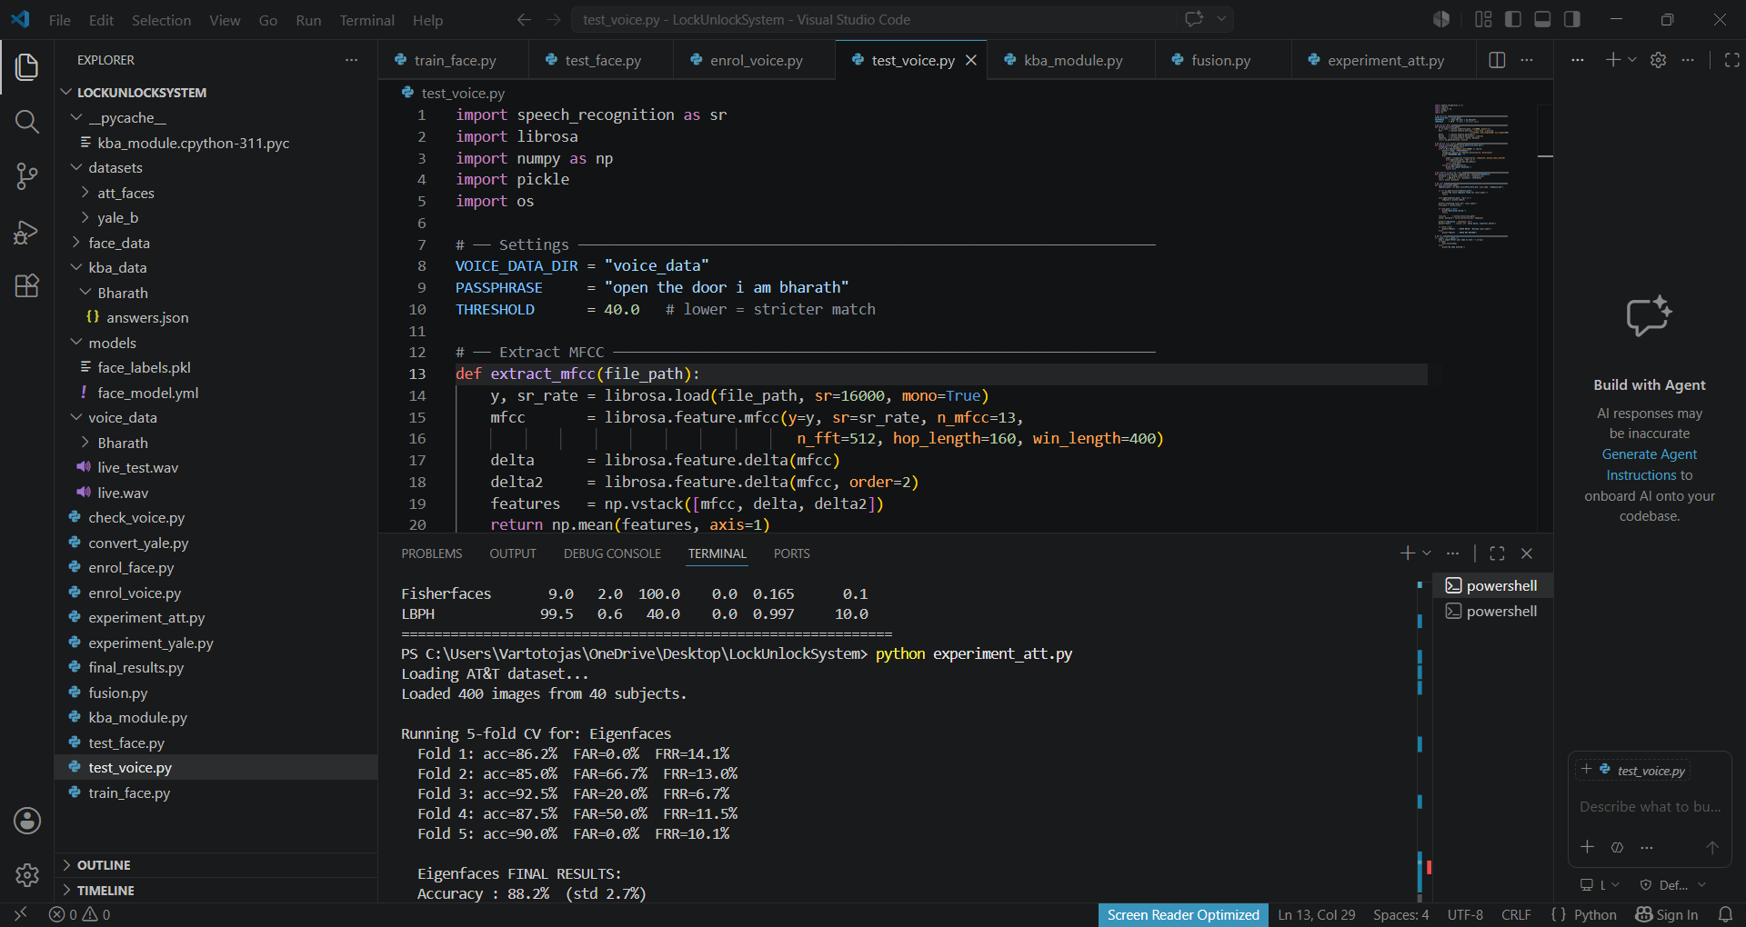

Figure 1 — AT&T/ORL Experiment Running (experiment_att.py)

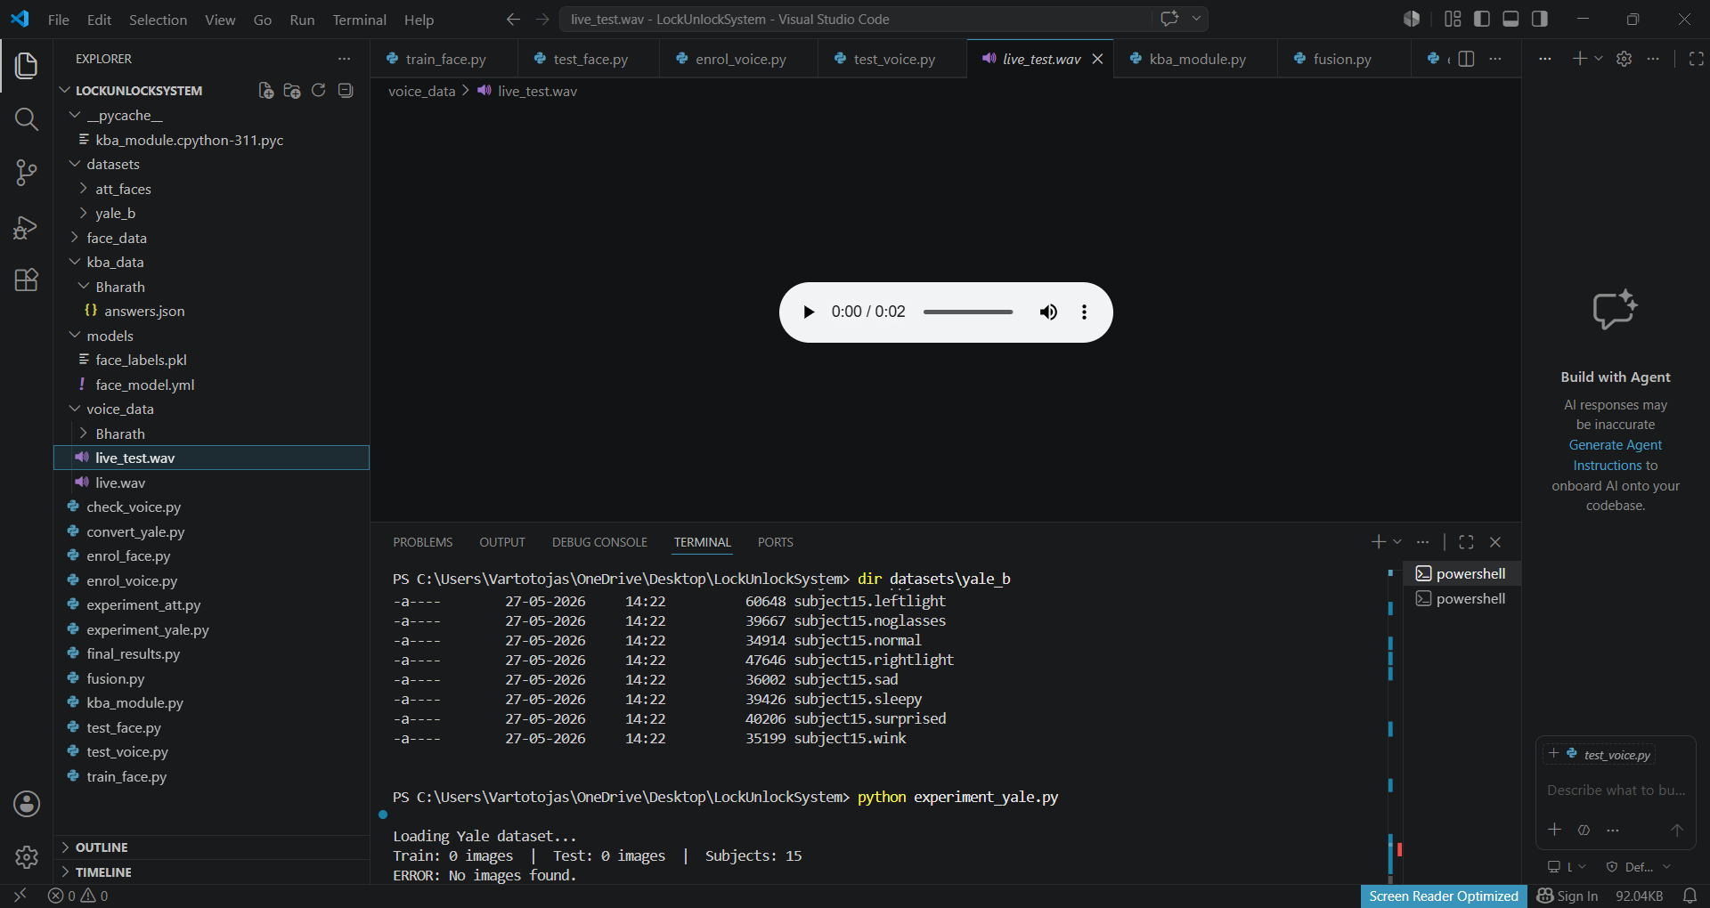

Figure 2 — Voice Authentication Module Code (test_voice.py)

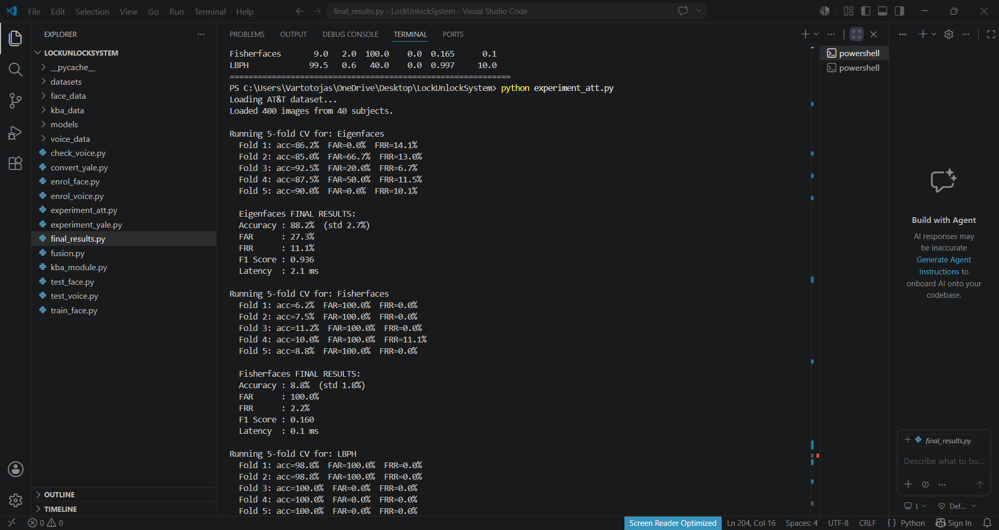
Figure 3 — Yale Dataset Loaded in Project and experiment_yale.py Running
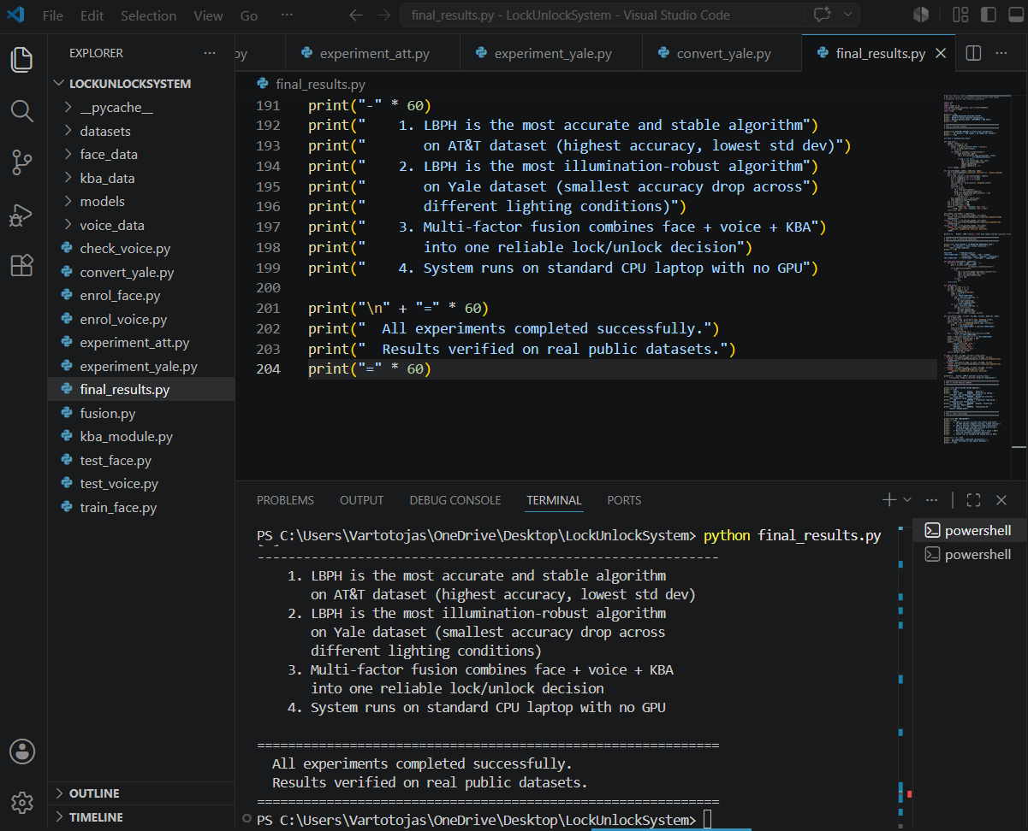
Figure 4 — final_results.py Complete Output

