Bronze Layer - Data Ingestion Flow Documentation
Platform: Snowflake + Matillion | Coverage: All Domains | Layer: Bronze (RAW)

Document Type: Production Reference Document
Scope: End-to-end Bronze layer data ingestion flows across all 44 active data domains

1. Executive Summary

This document provides a comprehensive reference for all Bronze layer data feeds across the data platform. It covers 44 data domains ingested from multiple source systems including Snowflake Share, Amazon S3, SFTP, and API connections, and loaded into Snowflake Bronze or Bronze_PSP schemas via Matillion ETL pipelines.

Each domain includes a standard flowchart diagram showing the data flow using ANSI flowchart symbols (terminator ovals for START/END, parallelogram for source data, process rectangles for ETL pipelines, and cylinder for target Snowflake schema).

- End-to-end data flow from source to Snowflake Bronze layer
- Source file names and table mappings per domain
- Matillion pipeline names responsible for each ingestion
- Load strategy (Full Load or Incremental) per domain
- Frequency and trigger description per domain
- Operational notes and dependency information

2. Scope and Platform Overview

Attribute | Detail
Platform | Snowflake + Matillion
Layer | Bronze (RAW) - no transformations applied
Total Domains | 44
Source Systems | Snowflake Share, Amazon S3, SFTP, API
Load Strategies | Full Load, Incremental
Target Schemas | BRONZE, BRONZE_PSP
Regions | US (primary), EMEA, Japan, Canada (CA)
Orchestration | Matillion (US region), Lambda (trigger-based)
Downstream | Silver and Gold layers via dbt transformations

3. Flowchart Symbol Legend

The flowcharts in this document follow ANSI / ISO standard flowchart conventions. The symbols used are:

Symbol | Name | Meaning
Oval | Terminator | Marks the START or END of the flow
Parallelogram | Input / Output | Represents source data feed (input) being read from upstream system
Rectangle | Process | Represents an ETL pipeline step (Matillion job)
Cylinder | Database / Storage | Represents the target Snowflake schema where RAW tables are persisted
Arrow | Flow Line | Direction of data movement between steps

4. End-to-End Architecture

All Bronze ingestion flows follow a consistent four-stage architecture:

Stage | Layer | Description | Examples
1 | Source | Raw data originates from Snowflake Share, S3 buckets, SFTP servers, or direct APIs | Snowflake Share, S3, SFTP, Veeva CRM API
2 | Matillion Pipeline | ETL jobs extract, transfer, clone, or ingest data from source into Snowflake | o_transfer_*, o_ingest_*, o_clone_*
3 | Bronze / Bronze_PSP | Raw data written as *_RAW tables with no transformations or business logic applied | MEDISAFE_USER_RAW, IQVIA_AMA_NPI_RAW
4 | Downstream (Silver/Gold) | Trigger-based dbt models transform Bronze into Silver and Gold layers | o_daily_psp_data_model_refresh_job_dbt

Source Type Classification:
- Snowflake Share: Data shared from partner or internal Snowflake accounts as STG_* views.
- S3: Files dropped to Amazon S3 buckets in CSV, XLSX, TXT, or Parquet format.
- SFTP: Secure file transfer from vendor systems (Veeva Network, Kalderos).
- API: Direct API-based incremental extraction (Veeva CRM, AMIR).

5. Domain Master Reference - All 44 Domains

The following table provides a consolidated view of all Bronze data domains, their source systems, load strategies, target schemas, and Matillion pipelines.

# | Domain | Source | Load Type | Schema | Matillion Pipeline(s)
1 | Medisafe (Non-PSP) | Snowflake Share | Full Load | BRONZE | o_transfer_medisafe_s3_files, o_ingest_medisafe_data
2 | Medisafe (PSP) | Snowflake Share | Full Load | BRONZE_PSP | o_clone_weekly_zs_landing_medisafe_tables, o_daily_psp_bronze_refresh_job
3 | Precision | Snowflake Share | Full Load | BRONZE | o_ingest_precision_data
4 | Qral | S3 | Full Load | BRONZE | o_ingest_qral_s3_files
5 | Pulsepoint | S3 | Full Load | BRONZE | o_transfer_pulsepoint_s3_files, o_ingest_pulsepoint_data
6 | SpringBond (HCP Marketing Media) | Snowflake Share | Full Load | BRONZE | o_ingest_bronze_snb_data
7 | Veeva Network | SFTP | Full Load | BRONZE | o_ingest_veeva_network_files, o_ingest_veeva_network_count_update
8 | Customer Ship-to-List | S3 | Full Load | BRONZE | x_ingest_customer_ship_s3_files
9 | Veeva CRM | API | Incremental | BRONZE | o_ingest_veeva_crm_salesforce, o_ingest_veeva_crm_salesforce_dlts
10 | AMIR | API | Incremental | BRONZE | o_ingest_bronze_amir_data, o_ingest_bronze_amir_count_update
11 | iHub | S3 | Full Load | BRONZE | o_transfer_ihub_s3_files, o_ingest_ihub_data
12 | Veeva Align | S3 | Incremental | BRONZE | o_ingest_veeva_align_bronze_data
13 | ZS Landing Cardinal (3PL) | Snowflake Share | Full Load | BRONZE | o_clone_zs_landing_cardinal_tables
14 | H1 (5_02) - HCP Data | S3 | Full Load | BRONZE | o_ingest_h1_data_s3_parquet, o_ingest_h1_data_details
15 | Quest | S3 | Incremental | BRONZE | o_ingest_quest_s3_files, o_ingest_quest_details
16 | IQVIA Master (Tokenization) | Snowflake Share | Full Load | BRONZE | o_clone_zs_landing_tables
17 | EVERSANA | S3 | Incremental | BRONZE | o_ingest_eversana_s3_files
18 | H1 (5_05) - Clinical Study Data | S3 | Full Load | BRONZE | o_ingest_h1_SOS_data_s3_parquet
19 | SpringBond (Marketing Data Mapping) | Snowflake Share | Full Load | BRONZE | o_ingest_marketing_media_interaction
20 | MMIT (Data Feed) | S3 | Incremental | BRONZE | o_ingest_mmit_s3_files
21 | MMIT (PAR Feed) | S3 | Incremental | BRONZE | o_ingest_mmit_s3_files
22 | PREMIER HEOR | S3 | Full Load | BRONZE | s_ingest_premier_analytical_data
23 | CMEA | S3 | Incremental | BRONZE | o_run_orchestration_master_end_to_end
24 | UKI Data | S3 | Full Load | BRONZE | o_ingest_uki_data
25 | Bayshore | S3 | Full Load | BRONZE | o_ingest_bayshore_data
26 | Toho | S3 | Incremental | BRONZE | o_ingest_combined_toho_automation
27 | Clinical Trials | S3 | Full Load | BRONZE | o_ingest_clinical_trials_data
28 | JP (Japan Vial Shipment) | S3 | Incremental | BRONZE | o_transform_silver_global_vial_shipment_toho
29 | IQVIA DDD | S3 | Incremental | BRONZE | o_ingest_iqvia_ddd_bronze_load
30 | TXHUB | S3 | Full Load | BRONZE | o_ingest_txhub_s3_files
31 | JIRA | S3 | Full Load | BRONZE | o_ingest_jira_data
32 | KALDEROS | SFTP | Full Load | BRONZE | o_ingest_kalderos_all_files
33 | IQVIA Pinpoint | Snowflake Share | Full Load | IQVIA_PINPOINT / BRONZE | o_ingest_pulsepoint_to_veeevaCRM_1
34 | Veeva Network (DCR) | SFTP | Full Load | BRONZE | o_ingest_veeva_network_files
35 | IQVIA Med_B | Snowflake Share | Incremental | BRONZE | o_end_to_end_iqvia_medb_monthly_pipeline
36 | IQVIA AMA | Snowflake Share | Full Load | BRONZE | o_end_to_end_iqvia_ama_monthly_pipeline
37 | IQVIA HPD | Snowflake Share | Full Load | BRONZE | o_end_to_end_iqvia_hpd_quarterly_pipeline
38 | IQVIA LAAD MG Weekly | Snowflake Share | Incremental | BRONZE | o_end_to_end_iqvia_laad_mg_weekly_pipeline
39 | IQVIA LAAD MG Monthly | Snowflake Share | Incremental | BRONZE | o_end_to_end_iqvia_laad_monthly_pipeline
40 | IQVIA LAAD CIDP Monthly | Snowflake Share | Incremental | BRONZE | o_end_to_end_iqvia_laad_monthly_pipeline
41 | NCM (PSP) | Snowflake Share | Full Load | BRONZE_PSP | o_daily_psp_bronze_refresh_job
42 | NCM (Non-PSP) | Snowflake Share | Full Load | BRONZE | o_clone_zs_landing_tables
43 | Marketo | Snowflake Share | Full Load | BRONZE | o_clone_zs_landing_tables
44 | SP (Non-PSP) - Specialty Pharmacy | Snowflake Share | Full Load | BRONZE | o_clone_zs_landing_tables

6. Detailed Domain Data Flows

The following sections provide the complete flowchart, summary card, and source-to-target table mapping for each of the 44 domains. Each domain entry includes:
- Domain summary card with source, load type, schema, pipelines, total tables, frequency, and trigger description
- Standard flowchart diagram showing the end-to-end data flow
- Complete source-to-target table mapping listing every table

Domain 1: Medisafe (Non-PSP)

Attribute | Detail
Domain Name | Medisafe (Non-PSP)
Source System | Snowflake Share
Load Type | Full Load
Target Schema | BRONZE
Matillion Pipelines | o_transfer_medisafe_s3_files, o_ingest_medisafe_data
Total Tables | 16
Frequency | Weekdays
Trigger / Schedule | Daily ingestion - precedes PSP execution chain

End-to-End Data Flow Diagram

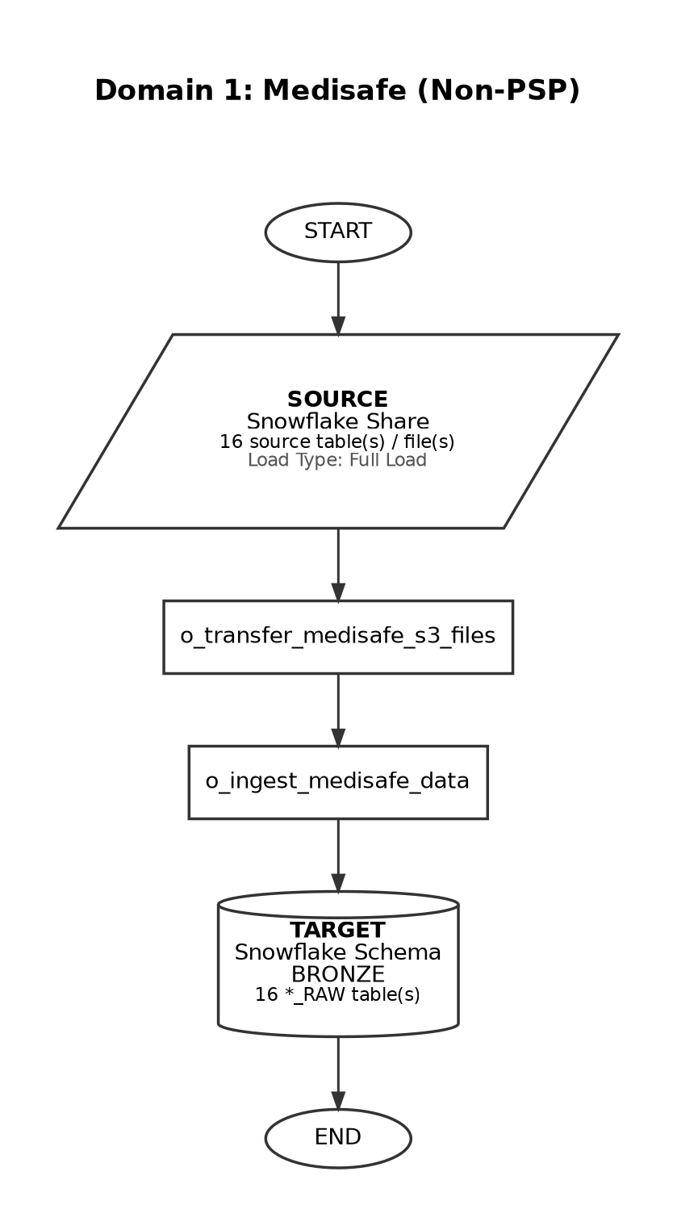

Source-to-Target Table Mapping

# | Source File / Table | Snowflake Target Table (Bronze RAW)
1 | STG_MEDISAFE_USER_SURVEY | MEDISAFE_USER_SURVEY_RAW
2 | STG_MEDISAFE_APPOINTMENTS | MEDISAFE_APPOINTMENTS_RAW
3 | STG_MEDISAFE_USER_CALCULATED_METRICS | MEDISAFE_USER_CALCULATED_METRICS_RAW
4 | STG_MEDISAFE_COMPONENT | MEDISAFE_COMPONENT_RAW
5 | STG_MEDISAFE_COMPONENT_PUSH_CLICKS | MEDISAFE_COMPONENT_PUSH_CLICKS_RAW
6 | STG_MEDISAFE_COMPONENT_ROOM_ENGAGEMENT | MEDISAFE_COMPONENT_ROOM_ENGAGEMENT_RAW
7 | STG_MEDISAFE_DAILY_APP_ACTIVITY | MEDISAFE_DAILY_APP_ACTIVITY_RAW
8 | STG_MEDISAFE_MEDICATION | MEDISAFE_MEDICATION_RAW
9 | STG_MEDISAFE_MG_ADL_TRACKER | MEDISAFE_MG_ADL_TRACKER_RAW
10 | STG_MEDISAFE_REMINDERS | MEDISAFE_REMINDERS_RAW
11 | STG_MEDISAFE_SURVEY_METADATA | MEDISAFE_SURVEY_METADATA_RAW
12 | STG_MEDISAFE_USER | MEDISAFE_USER_RAW
13 | STG_MEDISAFE_USER_SALESFORCE | MEDISAFE_USER_SALESFORCE_RAW
14 | STG_MEDISAFE_NURSE | MEDISAFE_NURSE_RAW
15 | STG_MEDISAFE_PATIENT | MEDISAFE_PATIENT_RAW
16 | STG_MEDISAFE_STATE | MEDISAFE_STATE_RAW

Domain 2: Medisafe (PSP)

Attribute | Detail
Domain Name | Medisafe (PSP)
Source System | Snowflake Share
Load Type | Full Load
Target Schema | BRONZE_PSP
Matillion Pipelines | o_clone_weekly_zs_landing_medisafe_tables, o_daily_psp_bronze_refresh_job
Total Tables | 13
Frequency | Weekdays
Trigger / Schedule | Trigger-based: runs after Non-PSP Patient Silver and Gold complete (12:45-1:15 am EST)

End-to-End Data Flow Diagram

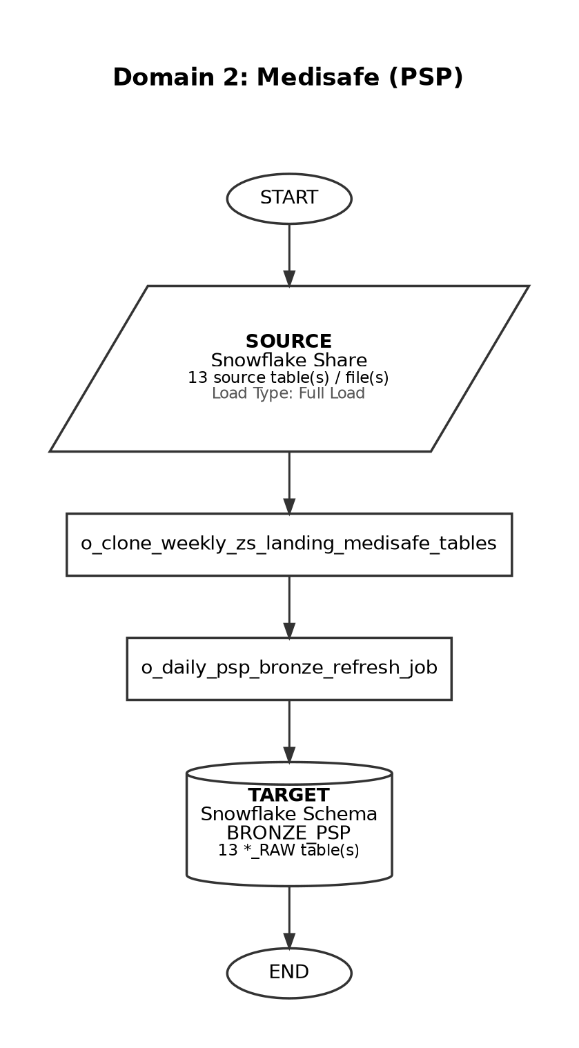

Source-to-Target Table Mapping

# | Source File / Table | Snowflake Target Table (Bronze RAW)
1 | STG_MEDISAFE_APPOINTMENTS | MEDISAFE_APPOINTMENTS_RAW
2 | STG_MEDISAFE_SALESFORCE | MEDISAFE_SALESFORCE_RAW
3 | STG_MEDISAFE_USER_SURVEY | MEDISAFE_USER_SURVEY_RAW
4 | STG_MEDISAFE_COMPONENT | MEDISAFE_COMPONENT_RAW
5 | STG_MEDISAFE_COMPONENT_PUSH_CLICKS | MEDISAFE_COMPONENT_PUSH_CLICKS_RAW
6 | STG_MEDISAFE_COMPONENT_ROOM_ENGAGEMENT | MEDISAFE_COMPONENT_ROOM_ENGAGEMENT_RAW
7 | STG_MEDISAFE_MEDICATION | MEDISAFE_MEDICATION_RAW
8 | STG_MEDISAFE_DAILY_APP_ACTIVITY | MEDISAFE_DAILY_APP_ACTIVITY_RAW
9 | STG_MEDISAFE_MG_ADL_TRACKER | MEDISAFE_MG_ADL_TRACKER_RAW
10 | STG_MEDISAFE_REMINDERS | MEDISAFE_REMINDERS_RAW
11 | STG_MEDISAFE_SURVEY_METADATA | MEDISAFE_SURVEY_METADATA_RAW
12 | STG_MEDISAFE_USER | MEDISAFE_USER_RAW
13 | STG_MEDISAFE_USER_CALCULATED_METRICS | MEDISAFE_USER_CALCULATED_METRICS_RAW

Domain 3: Precision

Attribute | Detail
Domain Name | Precision
Source System | Snowflake Share
Load Type | Full Load
Target Schema | BRONZE
Matillion Pipelines | o_ingest_precision_data
Total Tables | 7
Frequency | Ad-hoc
Trigger / Schedule | On-demand / business-driven refresh

End-to-End Data Flow Diagram

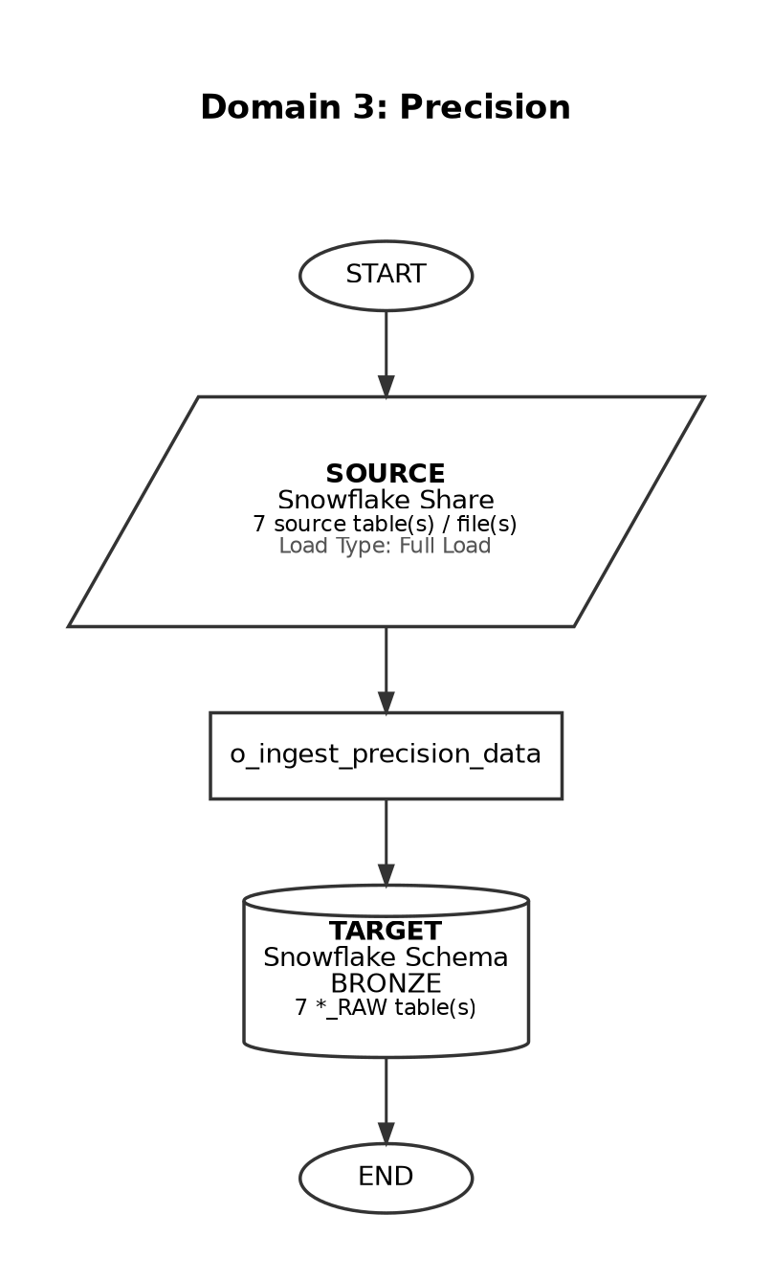

Source-to-Target Table Mapping

# | Source File / Table | Snowflake Target Table (Bronze RAW)
1 | CHANGE_LOG_PAYER_PLAN_HIERARCHY | PRECISION_IQVIA_BRIDGE_CHANGE_LOG_RAW
2 | HIERARCHY_BPG_BRIDGE | PRECISION_HIERARCHY_BPG_BRIDGE_RAW
3 | HIERARCHY_GPO_BRIDGE | PRECISION_HIERARCHY_GPO_BRIDGE_RAW
4 | HIERARCHY_IQVIA_BRIDGE | PRECISION_HIERARCHY_IQVIA_BRIDGE_HIERARCHY_RAW
5 | HIERARCHY_MMIT_BRIDGE | PRECISION_HIERARCHY_CONTROL_FILE_RAW
6 | MAJORITY_STATUS | PRECISION_PAYE_PLAN_HIERARCHY_CHANGE_LOG_RAW
7 | PAYER_PLAN_HIERARCHY | PRECISION_PAYER_PLAN_HIERARCHY_RAW

Domain 4: Qral

Attribute | Detail
Domain Name | Qral
Source System | S3
Load Type | Full Load
Target Schema | BRONZE
Matillion Pipelines | o_ingest_qral_s3_files
Total Tables | 3
Frequency | Quarterly
Trigger / Schedule | Performance Extract loads only for 2nd and 3rd month of the quarter

End-to-End Data Flow Diagram

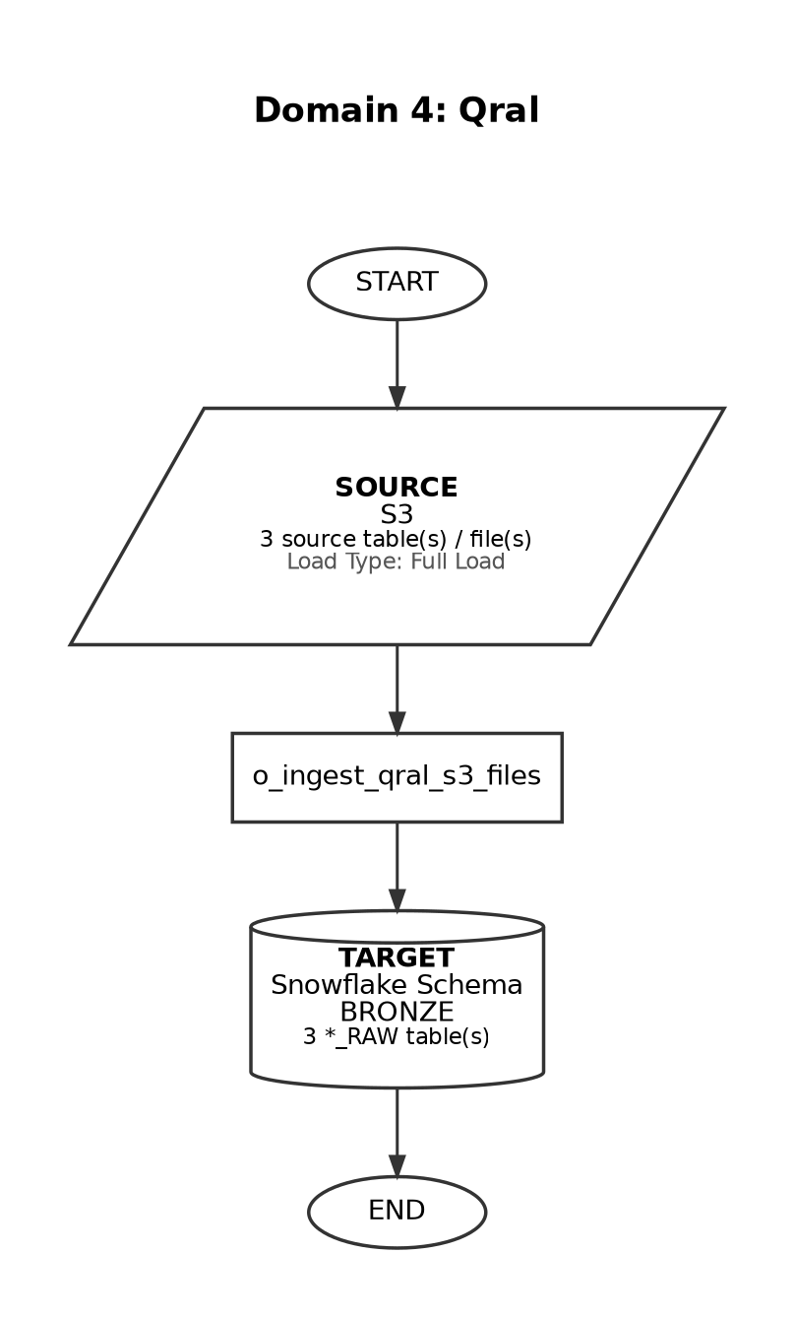

Source-to-Target Table Mapping

# | Source File / Table | Snowflake Target Table (Bronze RAW)
1 | BNB Extract - 2025-02-05.csv | QRAL_BNB_EXTRACT_RAW
2 | Performance Extract - 2025-02-05.csv (Quarterly) | QRAL_PERFORMANCE_EXTRACT_RAW
3 | Dispense Extract - 2025-02-05.csv | QRAL_DISPENSE_EXTRACT_RAW

Domain 5: Pulsepoint

Attribute | Detail
Domain Name | Pulsepoint
Source System | S3
Load Type | Full Load
Target Schema | BRONZE
Matillion Pipelines | o_transfer_pulsepoint_s3_files, o_ingest_pulsepoint_data
Total Tables | 8
Frequency | Ad-hoc
Trigger / Schedule | On-demand load

End-to-End Data Flow Diagram

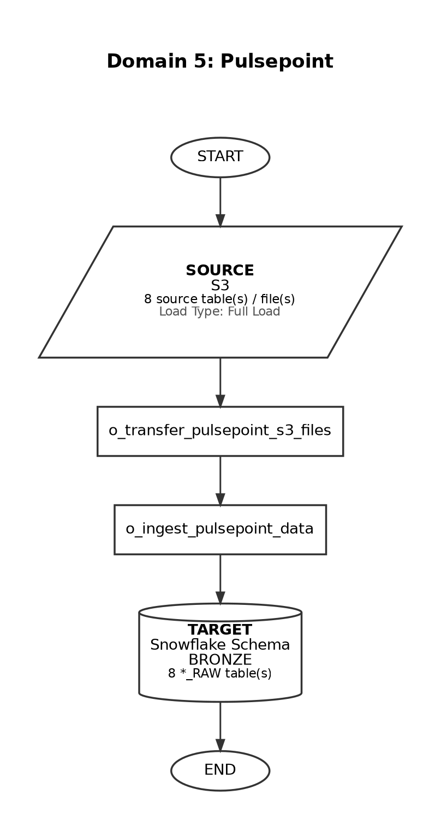

Source-to-Target Table Mapping

# | Source File / Table | Snowflake Target Table (Bronze RAW)
1 | PatientPoint202410.csv / PatientPoint202411.csv / PatientPoint202412.csv | PULSEPOINT_PATIENTPOINT_RAW
2 | NPIEverythingfrom01_13_2025_05_51PM.csv | PULSEPOINT_NPIEVERYTHINGFROM_RAW
3 | HCP365_Search_ArgenX_HCP_Report_Raw Data_December2021.xlsx | PULSEPOINT_HCP365_SEARCH_ARGENX_HCP_RAW
4 | HCP365_Site_ArgenX_gMGCycle_Report_Raw Data_December2021.xlsx | PULSEPOINT_HCP365_SITE_ARGENX_GMGCYCLE_RAW
5 | HCP365_Site_ArgenX_Chatbot_Report_Raw Data_December2021.xlsx | PULSEPOINT_HCP365_SITE_ARGENX_CHATBOT_RAW
6 | HCP365_Site_Contobox_Quiz_Report_Raw Data_December2021.xlsx | PULSEPOINT_HCP365_SITE_CONTOBOX_QUIZ_RAW
7 | HCP365_Site_Minds and Assembly_ArgenX_gMGexperience_August 2023.xlsx | PULSEPOINT_HCP365_SITE_MINDSANDASSEMBLY_ARGENX_GMGEXPERIENCE_RAW
8 | HCP365_Site_Minds and Assembly_ArgenX_GMGunited_August 2023.xlsx | PULSEPOINT_HCP365_SITE_MINDSANDASSEMBLY_ARGENX_GMGUNITED_RAW

Domain 6: SpringBond (HCP Marketing Media)

Attribute | Detail
Domain Name | SpringBond (HCP Marketing Media)
Source System | Snowflake Share
Load Type | Full Load
Target Schema | BRONZE
Matillion Pipelines | o_ingest_bronze_snb_data
Total Tables | 22
Frequency | Weekly
Trigger / Schedule | At 05:30 on Friday (America/New_York timezone)

End-to-End Data Flow Diagram

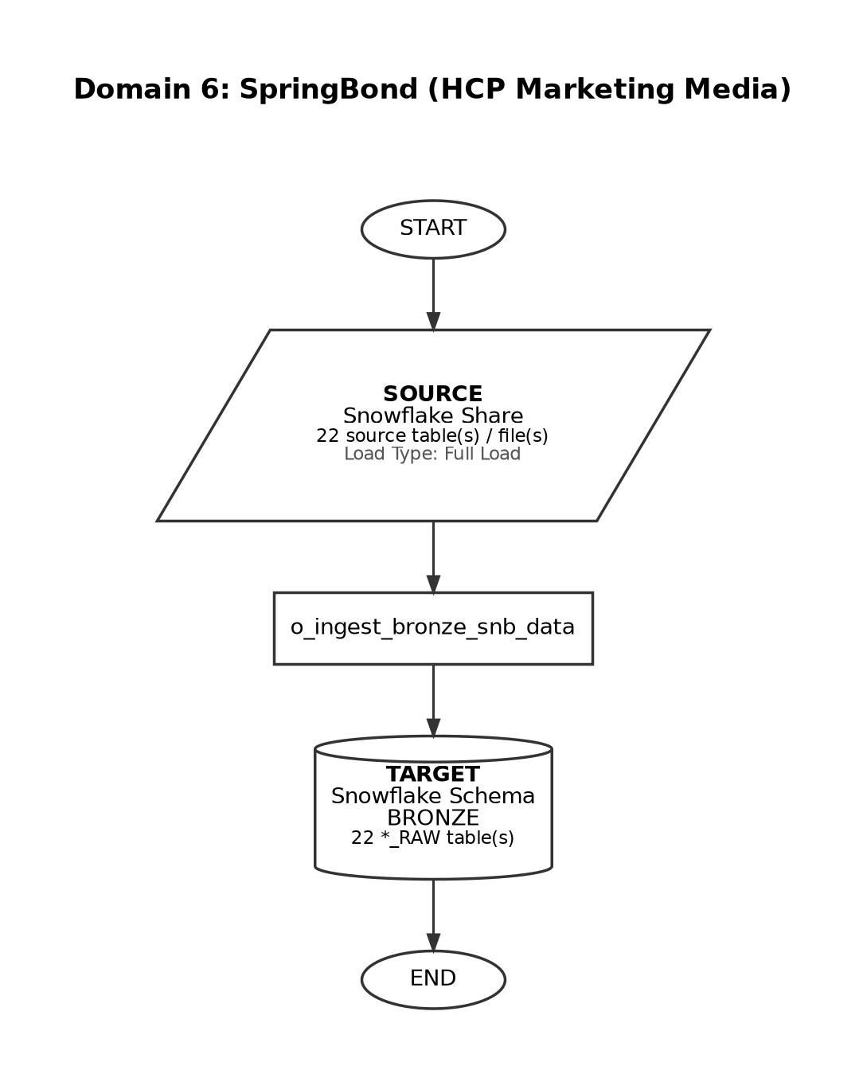

Source-to-Target Table Mapping

# | Source File / Table | Snowflake Target Table (Bronze RAW)
1 | HCP_MARKETING_MEDIA_INTERACTION_DOXIMIT | HCP_MARKETING_MEDIA_INTERACTION_DOXIMIT_RAW
2 | HCP_MARKETING_MEDIA_INTERACTION_EPOCRATES | HCP_MARKETING_MEDIA_INTERACTION_EPOCRATES_RAW
3 | HCP_MARKETING_MEDIA_INTERACTION_PULSEPOINT_LIFE | HCP_MARKETING_MEDIA_INTERACTION_PULSEPOINT_LIFE_RAW
4 | HCP_MARKETING_MEDIA_INTERACTION_SEARCH | HCP_MARKETING_MEDIA_INTERACTION_SEARCH_RAW
5 | HCP_MARKETING_MEDIA_INTERACTION_SITE | HCP_MARKETING_MEDIA_INTERACTION_SITE_RAW
6 | HCP_MARKETING_MEDIA_INTERACTION_DOCEREE | HCP_MARKETING_MEDIA_INTERACTION_DOCEREE_RAW
7 | HCP_MARKETING_MEDIA_INTERACTION_MEDSCAPE | HCP_MARKETING_MEDIA_INTERACTION_MEDSCAPE_RAW
8 | HCP_MARKETING_MEDIA_INTERACTION_SKIPTA | HCP_MARKETING_MEDIA_INTERACTION_SKIPTA_RAW
9 | HCP_MARKETING_MEDIA_INTERACTION_OPTIMIZERX | HCP_MARKETING_MEDIA_INTERACTION_OPTIMIZERX_RAW
10 | HCP_MARKETING_MEDIA_INTERACTION_HEALTHCASTSMEDIA | HCP_MARKETING_MEDIA_INTERACTION_HEALTHCASTSMEDIA_RAW
11 | HCP_MARKETING_MEDIA_INTERACTION_BULLETINHEALTHCARE | HCP_MARKETING_MEDIA_INTERACTION_BULLETINHEALTHCARE_RAW
12 | HCP_MARKETING_MEDIA_INTERACTION_FIGURE1 | HCP_MARKETING_MEDIA_INTERACTION_FIGURES1_RAW
13 | HCP_MARKETING_MEDIA_INTERACTION_IMPRICUS | HCP_MARKETING_MEDIA_INTERACTION_IMPRICUS_RAW
14 | HCP_MARKETING_MEDIA_INTERACTION_MEDPAGETODAY | HCP_MARKETING_MEDIA_INTERACTION_MEDPAGETODAY_RAW
15 | HCP_MARKETING_MEDIA_INTERACTION_NEUROLOGYLIVE | HCP_MARKETING_MEDIA_INTERACTION_NEUROLOGYLIVE_RAW
16 | HCP_MARKETING_MEDIA_INTERACTION_OPENEVIDENCE | HCP_MARKETING_MEDIA_INTERACTION_OPENEVIDENCE_RAW
17 | HCP_MARKETING_MEDIA_INTERACTION_PEERDIRECT | HCP_MARKETING_MEDIA_INTERACTION_PEERDIRECT_RAW
18 | HCP_MARKETING_MEDIA_INTERACTION_PHYSICIANSWEEKLY | HCP_MARKETING_MEDIA_INTERACTION_PHYSICIANSWEEKLY_RAW
19 | HCP_MARKETING_MEDIA_INTERACTION_PLATFORMQ | HCP_MARKETING_MEDIA_INTERACTION_PLATFORMQ_RAW
20 | HCP_MARKETING_MEDIA_INTERACTION_RELEVATEHEALTH | HCP_MARKETING_MEDIA_INTERACTION_RELEVATEHEALTH_RAW
21 | HCP_MARKETING_MEDIA_INTERACTION_VUMEDI | HCP_MARKETING_MEDIA_INTERACTION_VUMEDI_RAW
22 | HCP_MARKETING_MEDIA_INTERACTION_WOLTERSKLUWER | HCP_MARKETING_MEDIA_INTERACTION_WOLTERSKLUWER_RAW

Domain 7: Veeva Network

Attribute | Detail
Domain Name | Veeva Network
Source System | SFTP
Load Type | Full Load
Target Schema | BRONZE
Matillion Pipelines | o_ingest_veeva_network_files, o_ingest_veeva_network_count_update
Total Tables | 8
Frequency | Daily
Trigger / Schedule | At 01:10, Sunday-Friday (currently INACTIVE in schedule registry)

End-to-End Data Flow Diagram

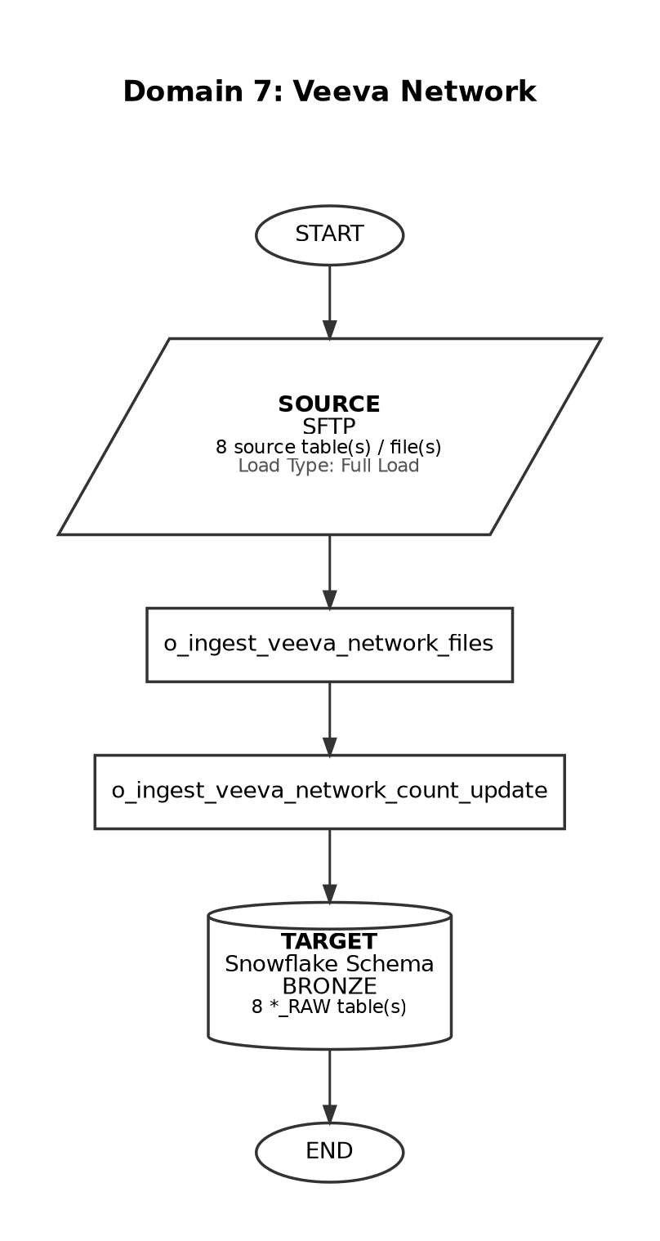

Source-to-Target Table Mapping

# | Source File / Table | Snowflake Target Table (Bronze RAW)
1 | address.csv | VEEVA_NETWORK_ADDRESS_RAW
2 | customkey.csv | VEEVA_NETWORK_CUSTOM_KEY_RAW
3 | hco.csv | VEEVA_NETWORK_HCO_RAW
4 | hcp.csv | VEEVA_NETWORK_HCP_RAW
5 | license.csv | VEEVA_NETWORK_LICENSE_RAW
6 | manifest | VEEVA_NETWORK_MANIFEST_RAW
7 | parenthco.csv | VEEVA_NETWORK_PARENT_HCO_RAW
8 | reference.csv | VEEVA_NETWORK_REFERENCE_RAW

Domain 8: Customer Ship-to-List

Attribute | Detail
Domain Name | Customer Ship-to-List
Source System | S3
Load Type | Full Load
Target Schema | BRONZE
Matillion Pipelines | x_ingest_customer_ship_s3_files
Total Tables | 2
Frequency | One-time
Trigger / Schedule | Single load - not scheduled for repeat ingestion

End-to-End Data Flow Diagram

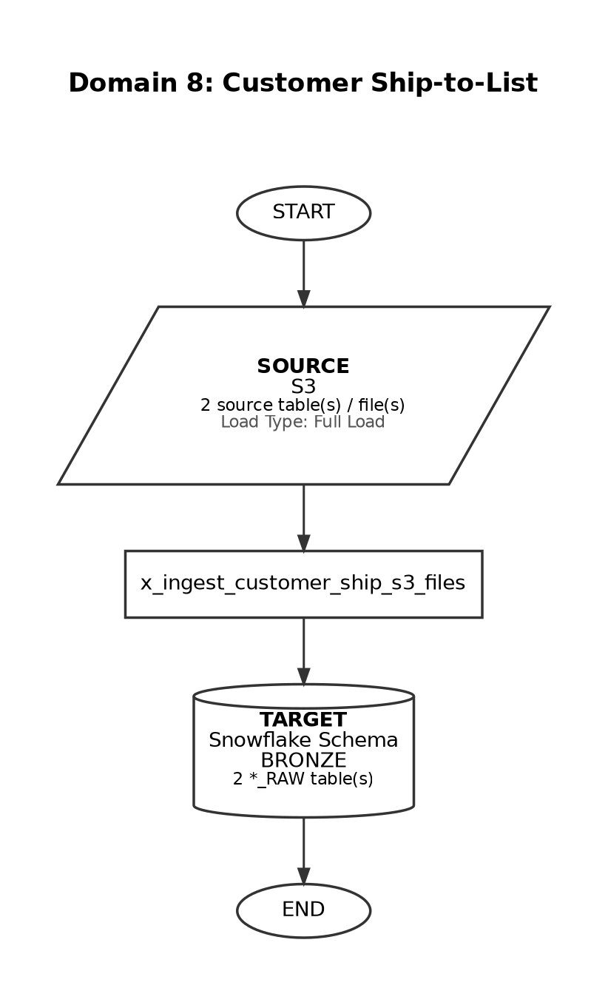

Source-to-Target Table Mapping

# | Source File / Table | Snowflake Target Table (Bronze RAW)
1 | Customer_and_Ship-to-Listfeb21.xlsx (Tab: Customer List) | CARDINAL_CUSTOMER_LIST_RAW
2 | Customer_and_Ship-to-Listfeb21.xlsx (Tab: Ship-to List) | CARDINAL_SHIP_TO_LIST_RAW

Domain 9: Veeva CRM

Attribute | Detail
Domain Name | Veeva CRM
Source System | API
Load Type | Incremental
Target Schema | BRONZE
Matillion Pipelines | o_ingest_veeva_crm_salesforce, o_ingest_veeva_crm_salesforce_dlts
Total Tables | 27
Frequency | Daily
Trigger / Schedule | At 01:07, Sunday-Friday (currently INACTIVE in schedule registry)

End-to-End Data Flow Diagram

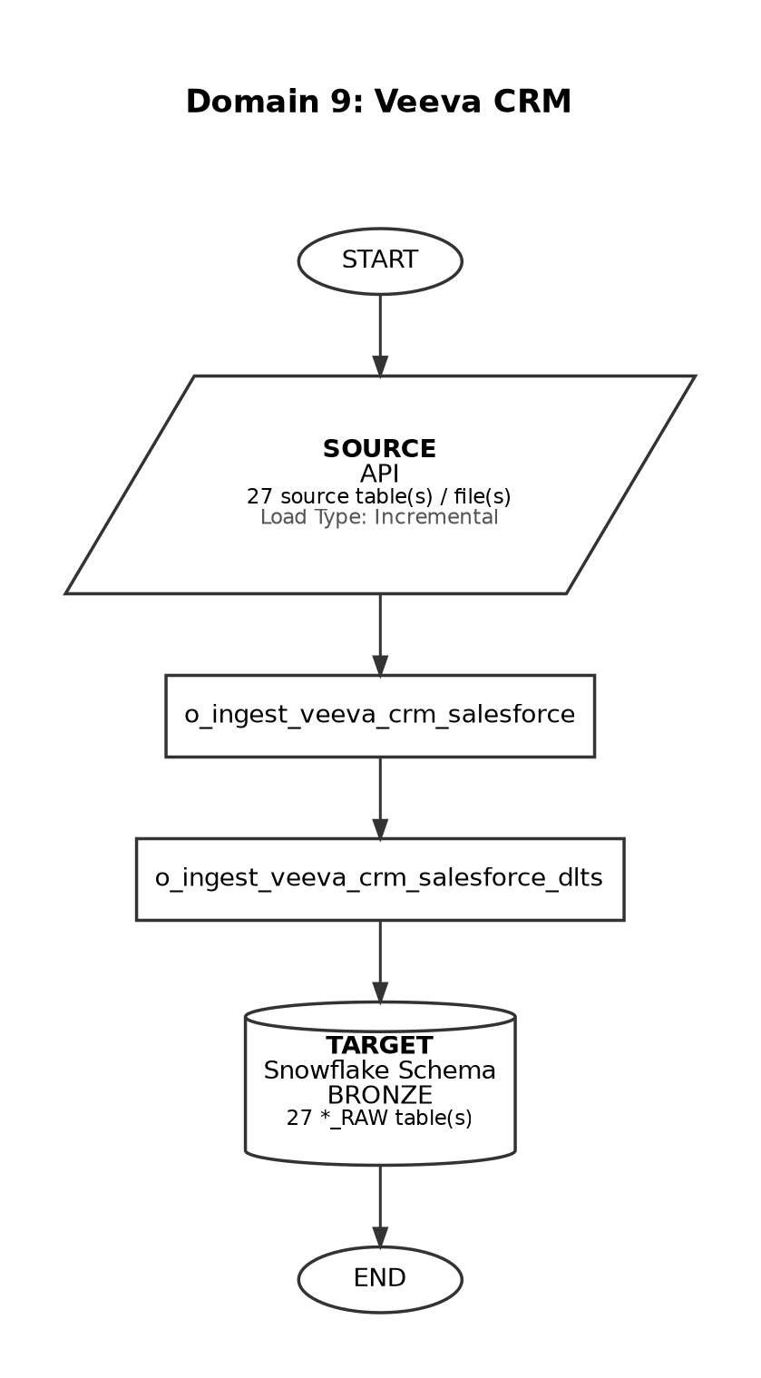

Source-to-Target Table Mapping

# | Source File / Table | Snowflake Target Table (Bronze RAW)
1 | FM_EVENT_SUMMARY_VPRO_C | VEEVA_CRM_FM_EVENT_SUMMARY_VPRO_DELTA
2 | FM_EVENT_TEAM_MEMBER_VOD_C | VEEVA_CRM_FM_EVENT_TEAM_MEMBER_DELTA
3 | FM_EXPENSE_ESTIMATE_VOD_C | VEEVA_CRM_FM_EXPENSE_ESTIMATE_DELTA
4 | FM_SPEAKER_C | VEEVA_CRM_FM_SPEAKER_DELTA
5 | FM_SPEAKER_QUALIFICATION_VOD_C | VEEVA_CRM_FM_SPEAKER_QUALIFICATION_DELTA
6 | FM_TOPIC_MATERIAL_VOD_C | VEEVA_CRM_FM_TOPIC_MATERIAL_DELTA
7 | FM_VENDOR_VOD_C | VEEVA_CRM_FM_VENDOR_DELTA
8 | FM_VENUE_VOD_C | VEEVA_CRM_FM_VENUE_DELTA
9 | EMAIL_ACTIVITY_VOD_C | VEEVA_CRM_FM_EMAIL_ACTIVITY_DELTA
10 | EVENT | VEEVA_CRM_FM_EVENT_DELTA
11 | EVENT_ATTENDEE_VOD_C | VEEVA_CRM_FM_EVENT_ATTENDEE_DELTA
12 | EVENT_PAYMENTS_VPRO_C | VEEVA_CRM_FM_EVENT_PAYMENTS_DELTA
13 | EVENTS_MANAGEMENT_SETTINGS_VOD_C | VEEVA_CRM_EVENTS_MANAGEMENT_SETTINGS_DELTA
14 | FM_ATTRIBUTION_VOD_C | VEEVA_CRM_FM_ATTRIBUTION_DELTA
15 | EXPENSE_HEADER_VOD_C | VEEVA_CRM_EXPENSE_HEADER_DELTA
16 | EXPENSE_LINE_VOD_C | VEEVA_CRM_EXPENSE_LINE_DELTA
17 | EXPENSE_TYPE_VOD_C | VEEVA_CRM_EXPENSE_TYPE_DELTA
18 | KEY_MESSAGE_VOD_C | VEEVA_CRM_KEY_MESSAGE_DELTA
19 | MC_CYCLE_VOD_C | VEEVA_CRM_MC_CYCLE_DELTA
20 | MC_CYCLE_CHANNEL_VOD_C | VEEVA_CRM_MC_CYCLE_CHANNEL_DELTA
21 | MC_CYCLE_PLAN_VOD_C | VEEVA_CRM_MC_CYCLE_PLAN_DELTA
22 | MC_CYCLE_PLAN_CHANNEL_VOD_C | VEEVA_CRM_MC_CYCLE_PLAN_CHANNEL_DELTA
23 | MC_CYCLE_PLAN_PRODUCT_VOD_C | VEEVA_CRM_MC_CYCLE_PLAN_PRODUCT_DELTA
24 | MC_CYCLE_TARGET_VOD_C | VEEVA_CRM_MC_CYCLE_TARGET_DELTA
25 | MC_CYCLE_PRODUCT_VOD_C | VEEVA_CRM_MC_CYCLE_PRODUCT_DELTA
26 | MEDICAL_DISCUSSION_VOD_C | VEEVA_CRM_MEDICAL_DISCUSSION_DELTA
27 | MEDICAL_INQUIRY_VOD_C | VEEVA_CRM_MEDICAL_INQUIRY_DELTA

Domain 10: AMIR

Attribute | Detail
Domain Name | AMIR
Source System | API
Load Type | Incremental
Target Schema | BRONZE
Matillion Pipelines | o_ingest_bronze_amir_data, o_ingest_bronze_amir_count_update
Total Tables | 21
Frequency | Weekdays
Trigger / Schedule | At 02:00, Monday-Friday (America/New_York timezone)

End-to-End Data Flow Diagram

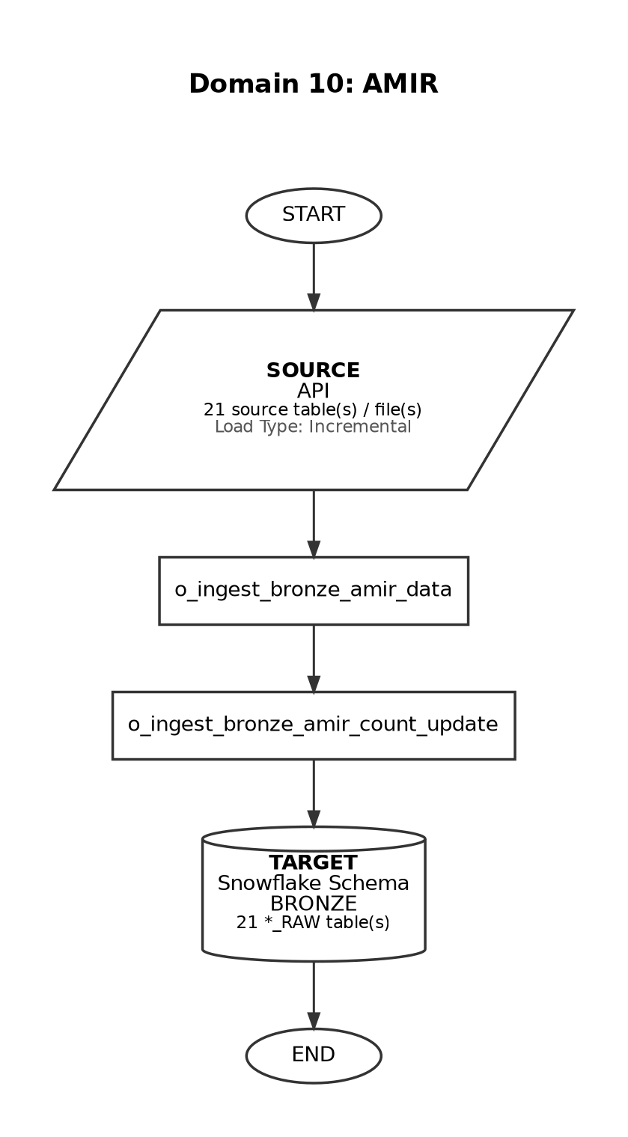

Source-to-Target Table Mapping

# | Source File / Table | Snowflake Target Table (Bronze RAW)
1 | CONTENTDOCUMENTLINX | MIC_CONTENT_DOCUMENT_LINK_DELTA
2 | ACCOUNT | MIC_ACCOUNT_DELTA
3 | CASE | MIC_CASE_DELTA
4 | MFD_DATA_CHANGE_REQUEST_C | MIC_DATA_CHANGE_REQUEST_DELTA
5 | MFD_DATA_CHANGE_REQUEST_LINE_C | MIC_DATA_CHANGE_REQUEST_LINE_DELTA
6 | EMAILMESSAGE | MIC_EMAIL_MESSAGE_DELTA
7 | MFD_FULFILLMENT_C | MIC_FULFILLMENT_DELTA
8 | MFD_INBOUND_FORM_C | MIC_INBOUND_FORM_DELTA
9 | MFD_OWNERSHIP_TRACKING_C | MIC_OWNERSHIP_TRACKING_DELTA
10 | MFD_PRODUCT_C | MIC_PRODUCT_DELTA
11 | RECORDTYPE | MIC_RECORD_TYPE_DELTA
12 | MFD_REQUEST_C | MIC_REQUEST_DELTA
13 | MFD_REQUEST_DOCUMENT_C | MIC_REQUEST_DOCUMENT_DELTA
14 | MFD_REQUEST_FULFILLMENT_C | MIC_REQUEST_FULFILLMENT_DELTA
15 | FULFILLMENT_INSERT_MVN_C | MIC_SRL_PERSONIZATION_DELTA
16 | USER | MIC_USER_DELTA
17 | MFD_INTERACTION_QA_C | MIC_INTERACTION_QA_DELTA
18 | MFD_PRODUCT_COMPLAINT_C | MIC_PRODUCT_QUALITY_COMPLAINT_DELTA
19 | MFD_ADVERSE_EVENT_C | MIC_ADVERSE_EVENT_DELTA
20 | MFD_CONTACT_INFORMATION_C | MIC_CONTACT_INFORMATION_DELTA
21 | MFD_AFFILIATION_C | MIC_AFFILIATION_DELTA

Domain 11: iHub

Attribute | Detail
Domain Name | iHub
Source System | S3
Load Type | Full Load
Target Schema | BRONZE
Matillion Pipelines | o_transfer_ihub_s3_files, o_ingest_ihub_data
Total Tables | 27
Frequency | Ad-hoc
Trigger / Schedule | Manual / on-demand ingestion

End-to-End Data Flow Diagram

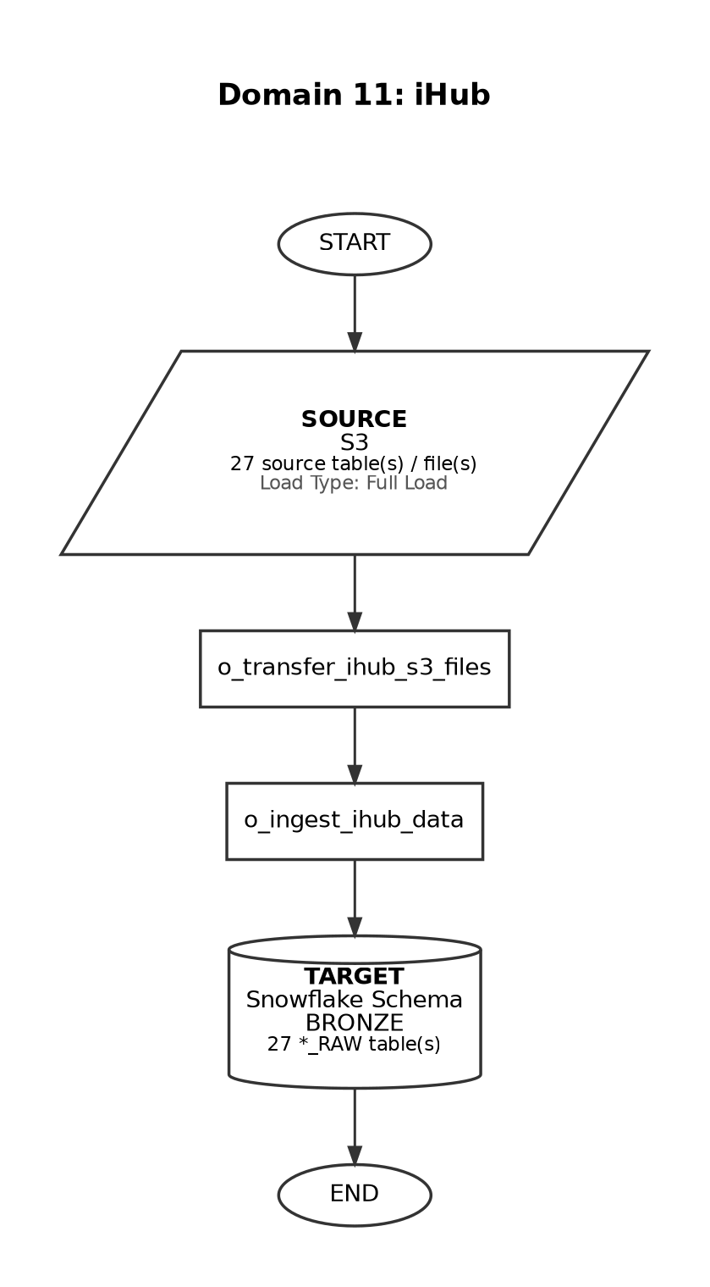

Source-to-Target Table Mapping

# | Source File / Table | Snowflake Target Table (Bronze RAW)
1 | IHUB_USER_LAST_LOGIN_DATE.csv | IHUB_USER_LAST_LOGIN_DATE_RAW
2 | IHUB_USER_DETAILS.csv | IHUB_USER_DETAILS_RAW
3 | IHUB_ACT_THERAPEUTIC_AREA.csv | IHUB_ACT_THERAPEUTIC_AREA_RAW
4 | IHUB_ANA_YEARS.csv | IHUB_ANA_YEARS_RAW
5 | IHUB_ANA_THERAPEUTIC_AREA_INDICATION.csv | IHUB_ANA_THERAPEUTIC_AREA_INDICATION_RAW
6 | IHUB_ADMIN_USER_GROUP_MANAGEMENT_CHANGELOG.csv | IHUB_ADMIN_USER_GROUP_MANAGEMENT_CHANGELOG_RAW
7 | IHUB_ADMIN_TIER_RATES_CHANGELOG.csv | IHUB_ADMIN_TIER_RATES_CHANGELOG_RAW
8 | IHUB_ADMIN_TASK_MANAGEMENT_CHANGELOG.csv | IHUB_ADMIN_TASK_MANAGEMENT_CHANGELOG_RAW
9 | IHUB_ACTIVITY_EVENT_HISTORY.csv | IHUB_ACTIVITY_EVENT_HISTORY_RAW
10 | IHUB_ACTIVITY.csv | IHUB_ACTIVITY_RAW
11 | IHUB_ACT_VENUE.csv | IHUB_ACT_VENUE_RAW
12 | IHUB_ACT_THIRD_PARTY_ORGANIZER.csv | IHUB_ACT_THIRD_PARTY_ORGANIZER_RAW
13 | IHUB_ACT_IND_SEARCH_CRITERA.csv | IHUB_ACT_IND_SEARCH_CRITERA_RAW
14 | IHUB_ACT_PROGRAM_DETAILS.csv | IHUB_ACT_PROGRAM_DETAILS_RAW
15 | IHUB_ACT_PRODUCT.csv | IHUB_ACT_PRODUCT_RAW
16 | IHUB_ACT_PRGRM_BUDGET.csv | IHUB_ACT_PRGRM_BUDGET_RAW
17 | IHUB_ACT_PB_RECONCILIATION.csv | IHUB_ACT_PB_RECONCILIATION_RAW
18 | IHUB_ACT_PAYMENT_ITEM.csv | IHUB_ACT_PAYMENT_ITEM_RAW
19 | IHUB_ACT_ORG_SELECTION.csv | IHUB_ACT_ORG_SELECTION_RAW
20 | IHUB_ACT_ORG_EF_AND_SPONSOR.csv | IHUB_ACT_ORG_EF_AND_SPONSOR_RAW
21 | IHUB_ACT_IND_SELECTION.csv | IHUB_ACT_IND_SELECTION_RAW
22 | IHUB_A_PLAN_CHANGELOG.csv | IHUB_A_PLAN_CHANGELOG_RAW
23 | IHUB_ACT_IND_PAYMENT.csv | IHUB_ACT_IND_PAYMENT_RAW
24 | IHUB_ACT_IND_ENG.csv | IHUB_ACT_IND_ENG_RAW
25 | IHUB_ACT_ENG_OTHER_ATTENDEES.csv | IHUB_ACT_ENG_OTHER_ATTENDEES_RAW
26 | IHUB_ACT_COMMENTARY.csv | IHUB_ACT_COMMENTARY_RAW
27 | IHUB_ACT_COLLABORATOR.csv | IHUB_ACT_COLLABORATOR_RAW

Domain 12: Veeva Align

Attribute | Detail
Domain Name | Veeva Align
Source System | S3
Load Type | Incremental
Target Schema | BRONZE
Matillion Pipelines | o_ingest_veeva_align_bronze_data
Total Tables | 10
Frequency | Daily
Trigger / Schedule | At 01:15, Sunday-Friday (currently INACTIVE in schedule registry)

End-to-End Data Flow Diagram

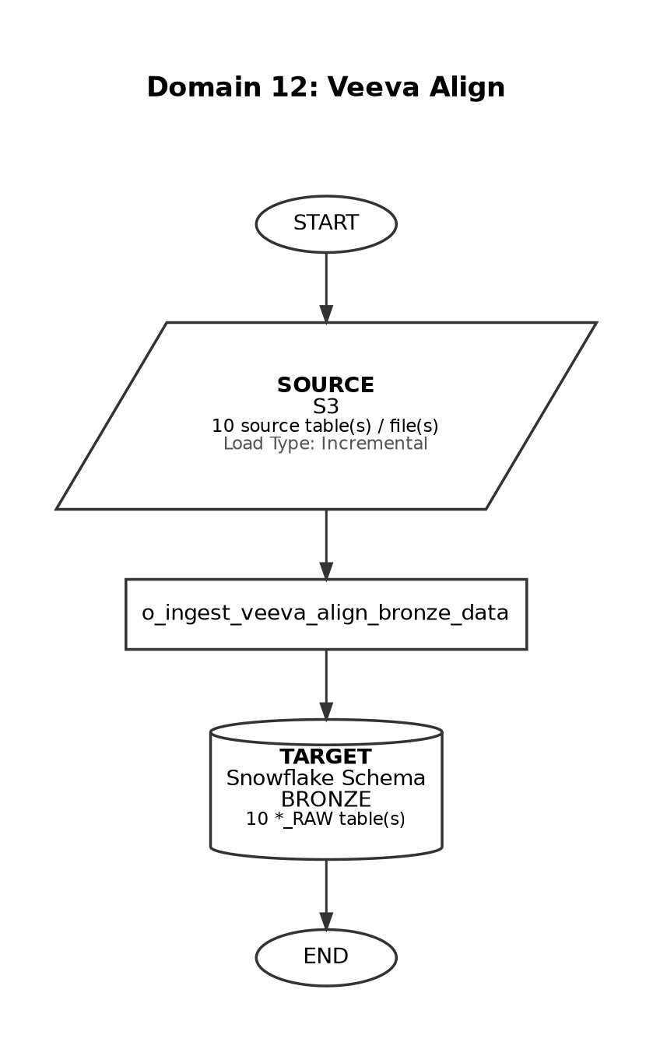

Source-to-Target Table Mapping

# | Source File / Table | Snowflake Target Table (Bronze RAW)
1 | 59710_170925_account_aln_*_deletes/updates.csv | VEEVA_ALIGN_ACCOUNT_ALN_RAW
2 | 59710_170925_account_rule_aln_*_deletes/updates.csv | VEEVA_ALIGN_ACCOUNT_RULE_ALN_RAW
3 | 59710_170925_account_territory_aln_*_deletes/updates.csv | VEEVA_ALIGN_ACCOUNT_TERRITORY_ALN_RAW
4 | 59710_170925_address_aln_*_deletes/updates.csv | VEEVA_ALIGN_ADDRESS_ALN_RAW
5 | 59710_170925_country_aln_*_deletes/updates.csv | VEEVA_ALIGN_COUNTRY_ALN_RAW
6 | 59710_170925_field_force_aln_*_deletes/updates.csv | VEEVA_ALIGN_FIELD_FORCE_ALN_RAW
7 | 59710_170925_field_force_product_aln_*_deletes/updates.csv | VEEVA_ALIGN_FIELD_FORCE_PRODUCT_ALN_RAW
8 | 59710_170925_geography_aln_*_deletes/updates.csv | VEEVA_ALIGN_GEOGRAPHY_ALN_RAW
9 | 59710_170925_geography_territory_aln_*_deletes/updates.csv | VEEVA_ALIGN_GEOGRAPHY_TERRITORY_ALN_RAW
10 | 59710_170925_parent_hco_aln_*_deletes/updates.csv | VEEVA_ALIGN_PARENT_HCO_ALN_RAW

Domain 13: ZS Landing Cardinal (3PL)

Attribute | Detail
Domain Name | ZS Landing Cardinal (3PL)
Source System | Snowflake Share
Load Type | Full Load
Target Schema | BRONZE
Matillion Pipelines | o_clone_zs_landing_cardinal_tables
Total Tables | 15
Frequency | Weekdays
Trigger / Schedule | At 02:30 (Matillion) + Lambda trigger approx 9:30 AM EST

End-to-End Data Flow Diagram

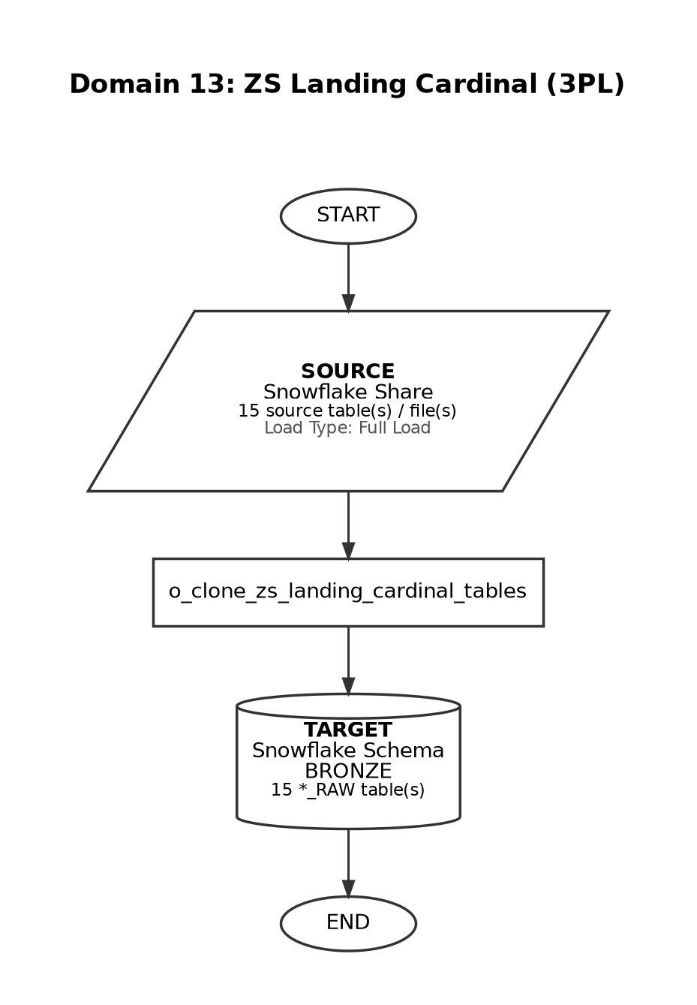

Source-to-Target Table Mapping

# | Source File / Table | Snowflake Target Table (Bronze RAW)
1 | STG_3PL_852 | CARDINAL_852_RAW
2 | STG_3PL_867 | CARDINAL_867_RAW
3 | STG_3PL_CASH_RECEIPT | CARDINAL_CASH_RECEIPT_RAW
4 | STG_3PL_CHARGEBACK_DETAILS | CARDINAL_CHARGEBACK_DETAILS_RAW
5 | STG_3PL_CUSTOMER_MASTER | CARDINAL_CUSTOMER_MASTER_RAW
6 | STG_3PL_DAILY_LOT_MOVEMENT | CARDINAL_DAILY_LOT_MOVEMENT_RAW
7 | STG_3PL_DAILY_ORDERS | CARDINAL_DAILY_ORDERS_RAW
8 | STG_3PL_INVENTORY_SNAPSHOT | CARDINAL_INVENTORY_SNAPSHOT_RAW
9 | STG_3PL_INVOICES | CARDINAL_INVOICES_RAW
10 | STG_3PL_RETURNS | CARDINAL_RETURNS_RAW
11 | STG_3PL_SHIPMENTS | CARDINAL_SHIPMENTS_RAW
12 | STG_3PL_SHIP_TO | CARDINAL_SHIP_TO_RAW
13 | STG_3PL_SHIPMENT_DETAILS | CARDINAL_3PL_SHIPMENT_DETAILS_RAW
14 | STG_3PL_APPL_I | CARDINAL_3PL_APPL_I_RAW
15 | STG_3PL_GL | CARDINAL_3PL_GL_RAW

Domain 14: H1 (5_02) - HCP Data

Attribute | Detail
Domain Name | H1 (5_02) - HCP Data
Source System | S3
Load Type | Full Load
Target Schema | BRONZE
Matillion Pipelines | o_ingest_h1_data_s3_parquet, o_ingest_h1_data_details
Total Tables | 17
Frequency | BiMonthly
Trigger / Schedule | At 18:30, on day 15 and 28-30 of the month

End-to-End Data Flow Diagram

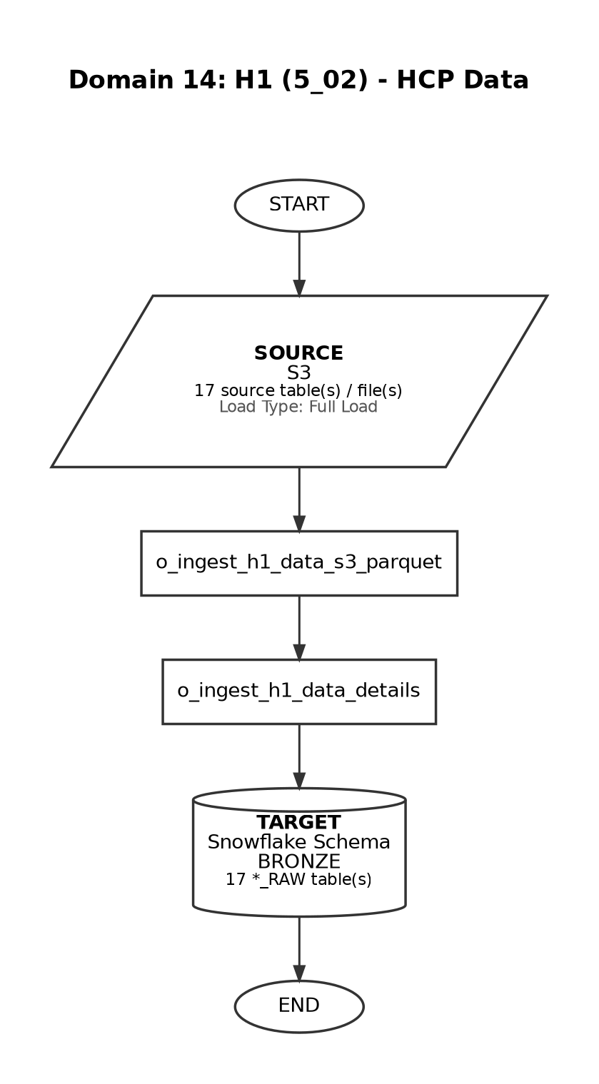

Source-to-Target Table Mapping

# | Source File / Table | Snowflake Target Table (Bronze RAW)
1 | ClinicalTrials.parquet | H1_CLINICALTRIALS_RAW
2 | Congresses.parquet | H1_CONGRESSES_RAW
3 | control-total.parquet | H1_CONTROL_TOTAL
4 | Focus-Areas.parquet | H1_FOCUS_AREAS_RAW
5 | HCP-Badges.parquet | H1_HCP_BADGES_RAW
6 | Organizations.parquet | H1_ORGANIZATIONS_RAW
7 | Payments.parquet | H1_PAYMENTS_RAW
8 | People-Congresses.parquet | H1_PEOPLE_CONGRESSES_RAW
9 | People-HCP-Ids.parquet | H1_PEOPLE_HCP_RAW
10 | People-Organizations.parquet | H1_PEOPLE_ORGANIZATIONS_RAW
11 | People-Payments.parquet | H1_PEOPLE_PAYMENTS_RAW
12 | People-Publications.parquet | H1_PEOPLE_PUBLICATIONS_RAW
13 | People-Trials.parquet | H1_PEOPLE_TRIALS_RAW
14 | People.parquet | H1_PEOPLE_RAW
15 | Publications.parquet | H1_PUBLICATIONS_RAW
16 | ScholarlyInfluence.parquet | H1_SCHOLARLYINFLUENCE_RAW
17 | Top-Indications.parquet | H1_TOP_INDICATIONS_RAW

Domain 15: Quest

Attribute | Detail
Domain Name | Quest
Source System | S3
Load Type | Incremental
Target Schema | BRONZE
Matillion Pipelines | o_ingest_quest_s3_files, o_ingest_quest_details
Total Tables | 4
Frequency | Weekly
Trigger / Schedule | At 17:30, only on Friday (America/New_York timezone)

End-to-End Data Flow Diagram

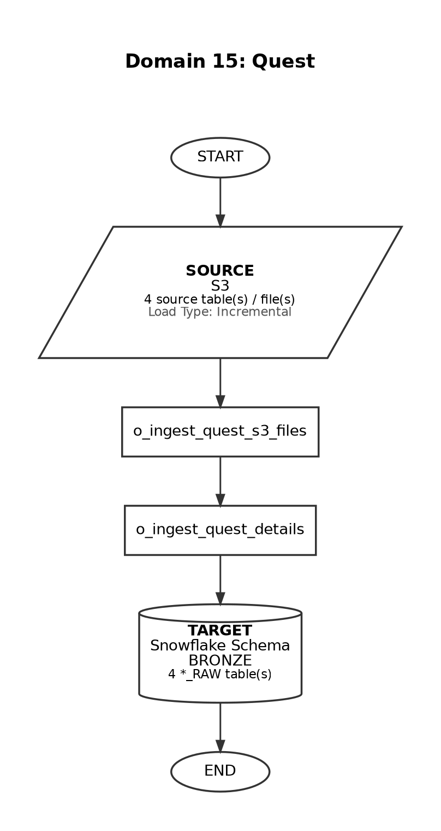

Source-to-Target Table Mapping

# | Source File / Table | Snowflake Target Table (Bronze RAW)
1 | ACHR_YYYYMMDD.csv | QUEST_ACHR_RAW
2 | MUSK_YYYYMMDD.csv | QUEST_MUSK_RAW
3 | ACHR_YYYYMMDD.csv (delta) | QUEST_ACHR_DELTA
4 | MUSK_YYYYMMDD.csv (delta) | QUEST_MUSK_DELTA

Domain 16: IQVIA Master (Tokenization)

Attribute | Detail
Domain Name | IQVIA Master (Tokenization)
Source System | Snowflake Share
Load Type | Full Load
Target Schema | BRONZE
Matillion Pipelines | o_clone_zs_landing_tables
Total Tables | 1
Frequency | Ad-hoc
Trigger / Schedule | Manual / on-demand load

End-to-End Data Flow Diagram

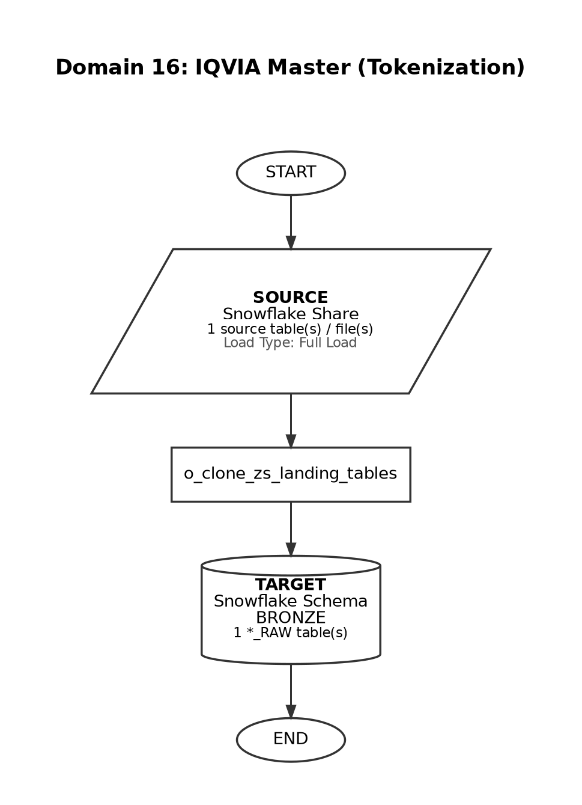

Source-to-Target Table Mapping

# | Source File / Table | Snowflake Target Table (Bronze RAW)
1 | STG_IQVIA_MASTER | IQVIA_MASTER_RAW

Domain 17: EVERSANA

Attribute | Detail
Domain Name | EVERSANA
Source System | S3
Load Type | Incremental
Target Schema | BRONZE
Matillion Pipelines | o_ingest_eversana_s3_files
Total Tables | 1
Frequency | Monthly
Trigger / Schedule | At 18:30, on day 15 of the month (America/New_York timezone)

End-to-End Data Flow Diagram

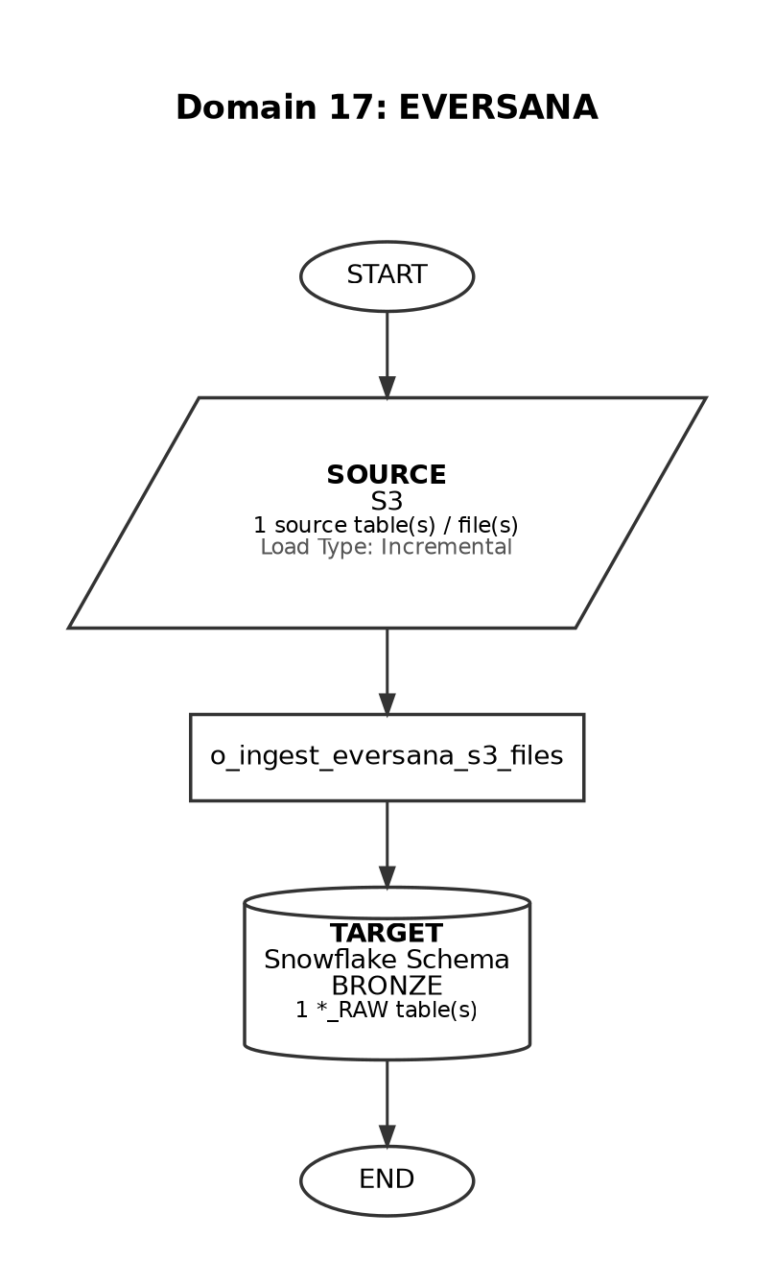

Source-to-Target Table Mapping

# | Source File / Table | Snowflake Target Table (Bronze RAW)
1 | fbt_Argenx_* (delta feed) | EVERSANA_DATA_FEED_DELTA

Domain 18: H1 (5_05) - Clinical Study Data

Attribute | Detail
Domain Name | H1 (5_05) - Clinical Study Data
Source System | S3
Load Type | Full Load
Target Schema | BRONZE
Matillion Pipelines | o_ingest_h1_SOS_data_s3_parquet
Total Tables | 27
Frequency | BiMonthly
Trigger / Schedule | At 17:00, on day 15 and 28-30 of the month

End-to-End Data Flow Diagram

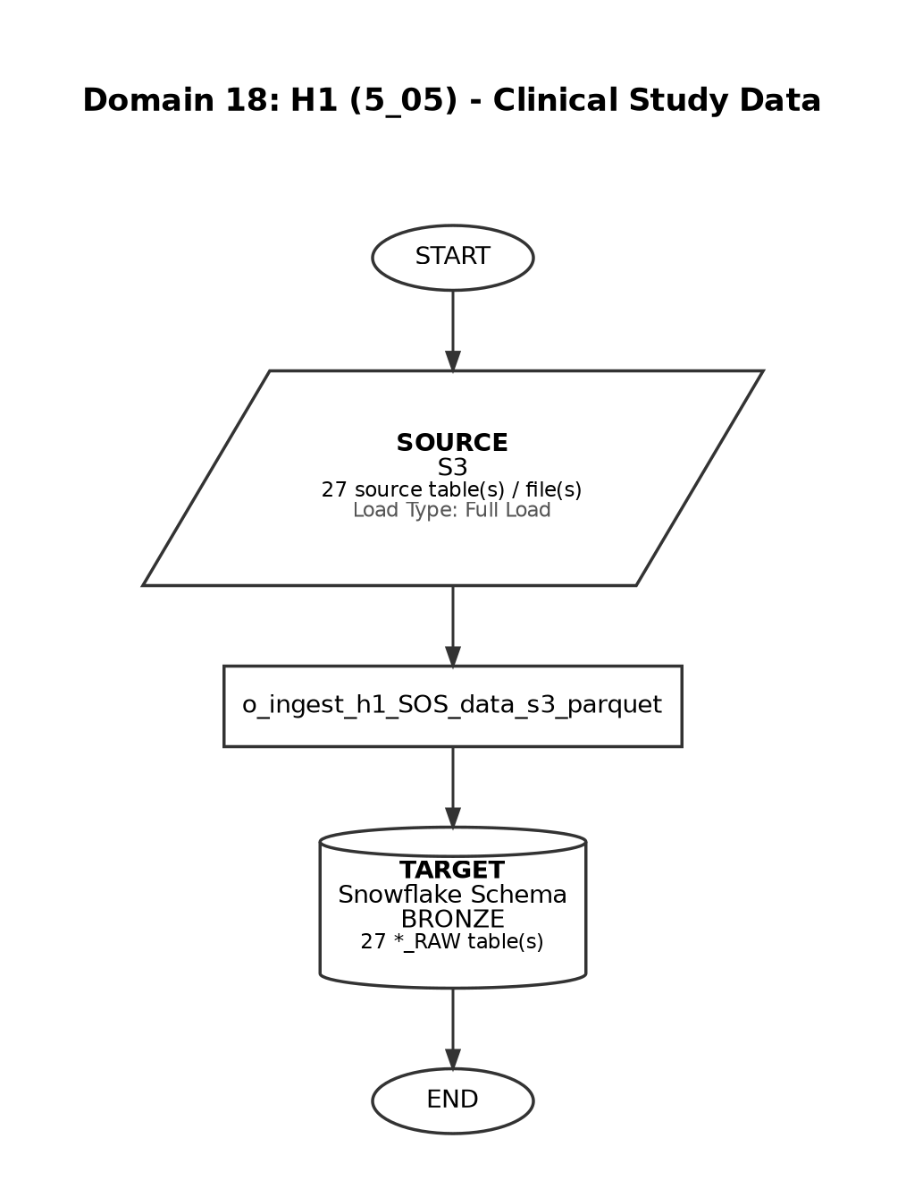

Source-to-Target Table Mapping

# | Source File / Table | Snowflake Target Table (Bronze RAW)
1 | facility_person_history.parquet | H1_SOS_FACILITY_PERSON_HISTORY_RAW
2 | facility_status_history.parquet | H1_SOS_FACILITY_STATUS_HISTORY_RAW
3 | facility.parquet | H1_SOS_FACILITY_RAW
4 | idinformation.parquet | H1_SOS_ID_INFORMATION_RAW
5 | intervention.parquet | H1_SOS_INTERVENTION_RAW
6 | link.parquet | H1_SOS_LINK_RAW
7 | outcome.parquet | H1_SOS_OUTCOME_RAW
8 | outcomeanalysis.parquet | H1_SOS_OUTCOME_ANALYSIS_RAW
9 | outcomeanalysisgroup.parquet | H1_SOS_OUTCOME_ANALYSIS_GROUP_RAW
10 | outcomecount.parquet | H1_SOS_OUTCOME_COUNT_RAW
11 | outcomecountmeasurement.parquet | H1_SOS_OUTCOME_COUNT_MEASUREMENT_RAW
12 | participantflow.parquet | H1_SOS_PARTICIPANT_FLOW_RAW
13 | pendingresult.parquet | H1_SOS_PENDING_RESULT_RAW
14 | person_role_history.parquet | H1_SOS_PERSON_ROLE_HISTORY_RAW
15 | person.parquet | H1_SOS_PERSON_RAW
16 | reference.parquet | H1_SOS_REFERENCE_RAW
17 | resultgroup.parquet | H1_SOS_RESULT_GROUP_RAW
18 | resultgroupbaselinecount.parquet | H1_SOS_RESULT_GROUP_BASELINE_COUNT_RAW
19 | resultgroupbaselinemeasurement.parquet | H1_SOS_RESULT_GROUP_BASELINE_MEASUREMENT_RAW
20 | resultgroupdropwithdrawal.parquet | H1_SOS_RESULT_GROUP_DROP_WITHDRAWAL_RAW
21 | resultgroupmilestone.parquet | H1_SOS_RESULT_GROUP_MILESTONE_RAW
22 | sponsor_contact.parquet | H1_SOS_SPONSOR_CONTACT_RAW
23 | sponsor.parquet | H1_SOS_SPONSOR_RAW
24 | study_meddra.parquet | H1_SOS_STUDY_MEDDRA_RAW
25 | study_meta.parquet | H1_SOS_STUDY_META_RAW
26 | study.parquet | H1_SOS_STUDY_RAW
27 | resultgreement.parquet | H1_SOS_RESULT_AGREEMENT_RAW

Domain 19: SpringBond (Marketing Data Mapping)

Attribute | Detail
Domain Name | SpringBond (Marketing Data Mapping)
Source System | Snowflake Share
Load Type | Full Load
Target Schema | BRONZE
Matillion Pipelines | o_ingest_marketing_media_interaction
Total Tables | 1
Frequency | Ad-hoc
Trigger / Schedule | Manual / on-demand load

End-to-End Data Flow Diagram

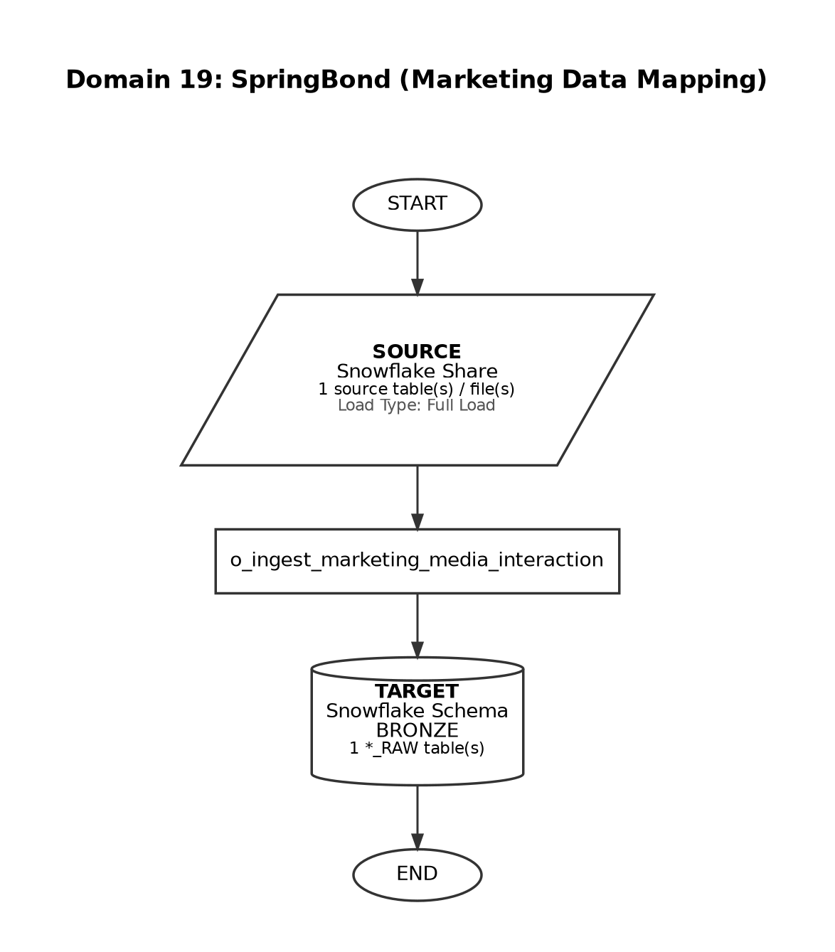

Source-to-Target Table Mapping

# | Source File / Table | Snowflake Target Table (Bronze RAW)
1 | MARKETING_DATA_MAPPING_RAW | MARKETING_DATA_MAPPING_RAW

Domain 20: MMIT (Data Feed)

Attribute | Detail
Domain Name | MMIT (Data Feed)
Source System | S3
Load Type | Incremental
Target Schema | BRONZE
Matillion Pipelines | o_ingest_mmit_s3_files
Total Tables | 10
Frequency | Monthly
Trigger / Schedule | At 18:30, between day 03 and 07 of the month

End-to-End Data Flow Diagram

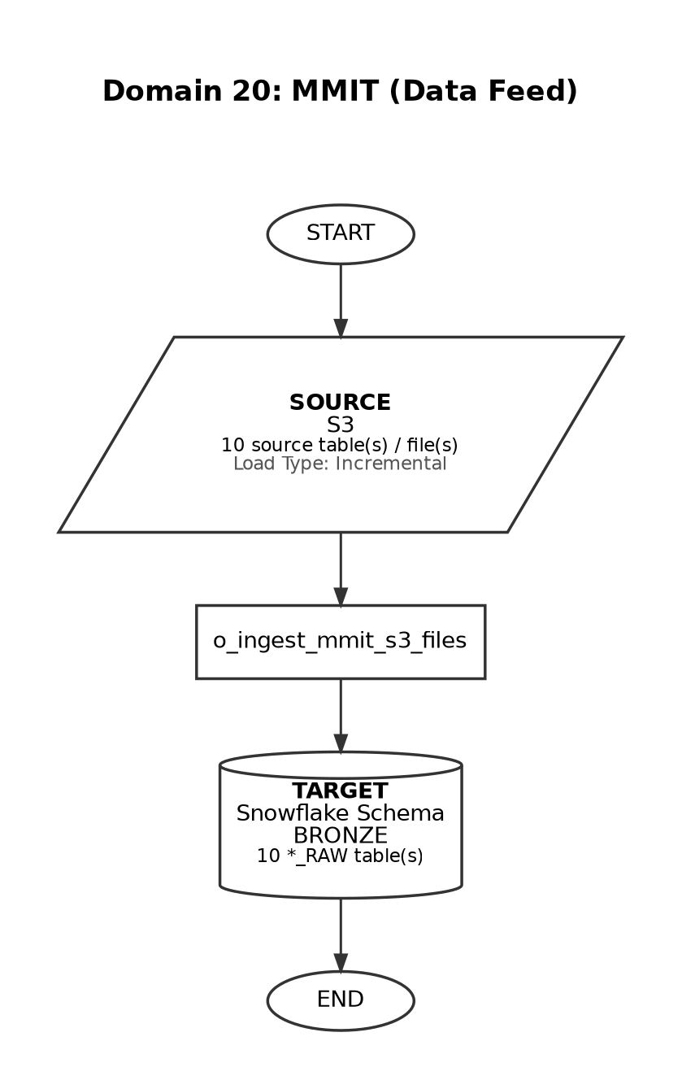

Source-to-Target Table Mapping

# | Source File / Table | Snowflake Target Table (Bronze RAW)
1 | DRUGS.txt | MMIT_DATA_DRUGS_RAW
2 | Medispan_Bridge.txt | MMIT_DATA_MEDISPAN_BRIDGE_RAW
3 | NDC_Bridge.txt | MMIT_DATA_NDC_BRIDGE_RAW
4 | PLANS.txt | MMIT_DATA_PLANS_RAW
5 | PLANSCONTROLLERMCO.txt | MMIT_DATA_PLANS_CONTROLLER_MCO_RAW
6 | RESTRICTIONS.txt | MMIT_DATA_RESTRICTIONS_RAW
7 | STATUSES.txt | MMIT_DATA_STATUSES_RAW
8 | CBSAS.txt | MMIT_DATA_CBSAS_RAW
9 | STATES.txt | MMIT_DATA_STATES_RAW
10 | Zip_Code.txt | MMIT_DATA_ZIP_CODE_RAW

Domain 21: MMIT (PAR Feed)

Attribute | Detail
Domain Name | MMIT (PAR Feed)
Source System | S3
Load Type | Incremental
Target Schema | BRONZE
Matillion Pipelines | o_ingest_mmit_s3_files
Total Tables | 15
Frequency | Monthly
Trigger / Schedule | At 18:30, between day 03 and 07 of the month (same pipeline as MMIT Data Feed)

End-to-End Data Flow Diagram

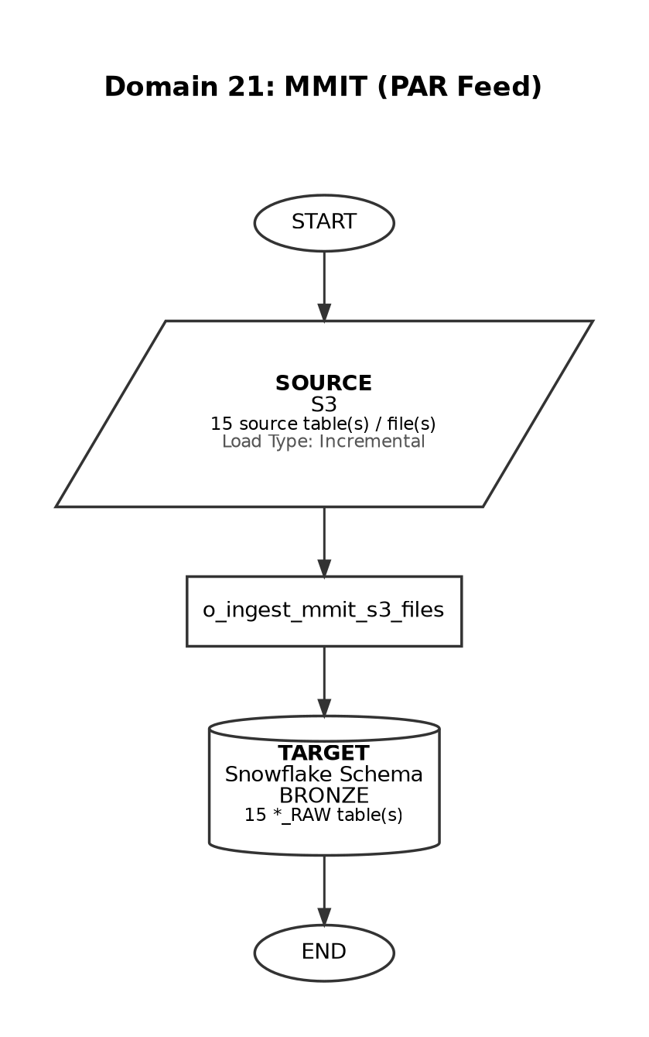

Source-to-Target Table Mapping

# | Source File / Table | Snowflake Target Table (Bronze RAW)
1 | CONTROL.txt | MMIT_PAR_CONTROL_RAW
2 | MEDICAL_CBSAS.txt | MMIT_PAR_MEDICAL_CBSAS_RAW
3 | MEDICAL_STATES.txt | MMIT_PAR_MEDICAL_STATES_RAW
4 | MEDICAL_Zip_Code.txt | MMIT_PAR_MEDICAL_ZIP_CODE_RAW
5 | Medical.txt | MMIT_PAR_MEDICAL_RAW
6 | MedicalGroups.txt | MMIT_PAR_MEDICAL_GROUPS_RAW
7 | MedicalPA.txt | MMIT_PAR_MEDICAL_PA_RAW
8 | MedicalBT.txt | MMIT_PAR_MEDICAL_BT_RAW
9 | MedicalUdf.txt | MMIT_PAR_MEDICAL_UDF_RAW
10 | FA_v2.txt | MMIT_PAR_FA_V2_RAW
11 | FAUdf.txt | MMIT_PAR_FA_UDF_RAW
12 | Products.txt | MMIT_PAR_PRODUCTS_RAW
13 | ST.txt | MMIT_PAR_ST_RAW
14 | MEDICAL_COUNTIES.txt | MMIT_PAR_MEDICAL_COUNTIES_RAW
15 | DerivedFields.txt | MMIT_PAR_DERIVED_FIELDS_RAW

Domain 22: PREMIER HEOR

Attribute | Detail
Domain Name | PREMIER HEOR
Source System | S3
Load Type | Full Load
Target Schema | BRONZE
Matillion Pipelines | s_ingest_premier_analytical_data
Total Tables | 22
Frequency | One-time
Trigger / Schedule | Single load - not scheduled for repeat ingestion

End-to-End Data Flow Diagram

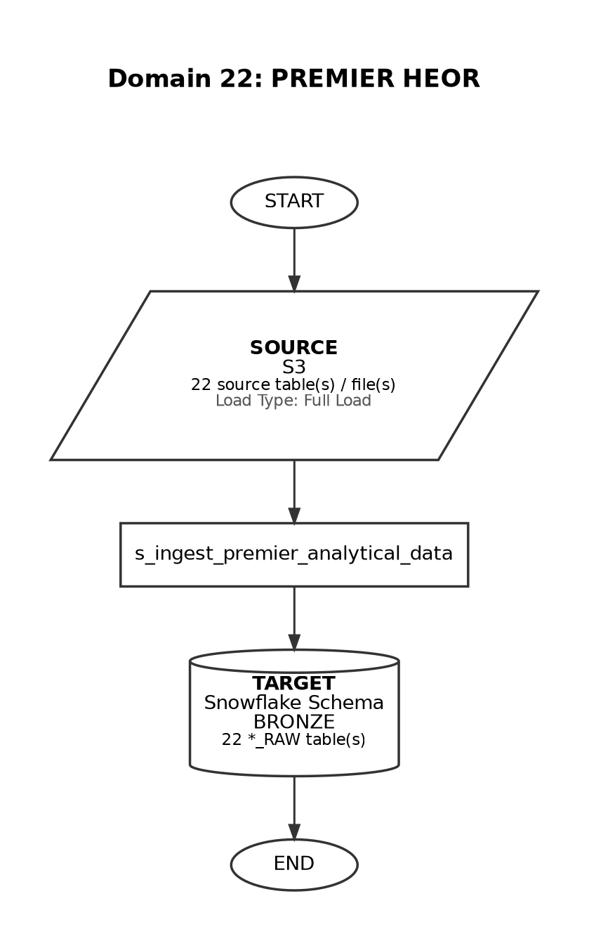

Source-to-Target Table Mapping

# | Source File / Table | Snowflake Target Table (Bronze RAW)
1 | Demographics (BL) - Data | PREMIER_DEMOGRAPHICS_RAW
2 | Medical History (BL) - Data | PREMIER_MEDICAL_HISTORY_RAW
3 | BMI - Data | PREMIER_BMI_RAW
4 | Current comorbidities (BL)-Data | PREMIER_CURRENT_COMORBIDITIES_RAW
5 | Change in Comorbidities - Data | PREMIER_CHANGE_IN_COMORBIDITIES_RAW
6 | Infections - Data | PREMIER_INFECTIONS_RAW
7 | Treatment History (BL) - Data | PREMIER_TREATMENT_HISTORY_RAW
8 | Concomitant Treatment - Data | PREMIER_CONCOMITANT_TREATMENT_RAW
9 | Treatment Satisfaction - Data | PREMIER_TREATMENT_SATISFACTION_RAW
10 | VvV Treatment Schedule - Data | PREMIER_VVY_TREATMENT_SCHEDULE_RAW
11 | gMG Exacerbation - Data | PREMIER_GANG_EXACERBATION_RAW
12 | Work Status - Data | PREMIER_WORK_STATUS_RAW
13 | Caregiver_burden - Data | PREMIER_CAREGIVER_BURDEN_RAW
14 | Personal Relationship - Data | PREMIER_PERSONAL_RELATIONSHIP_RAW
15 | Pain - Data | PREMIER_PAIN_RAW
16 | MG ADL - Data | PREMIER_MG_ADL_RAW
17 | MG QoL:15r - Data | PREMIER_MG_QOL15R_RAW
18 | EQ-5D-5L VAS - Data | PREMIER_EQ_5D_5L_VAS_RAW
19 | Neuro QoL - Data | PREMIER_NEURO_QOL_RAW
20 | PROMIS Anxiety - Data | PREMIER_PROMIS_ANXIETY_RAW
21 | PROMIS Depression - Data | PREMIER_PROMIS_DEPRESSION_RAW
22 | WPAl gMG - Data | PREMIER_WPAI_GANG_RAW

Domain 23: CMEA

Attribute | Detail
Domain Name | CMEA
Source System | S3
Load Type | Incremental
Target Schema | BRONZE
Matillion Pipelines | o_run_orchestration_master_end_to_end
Total Tables | 7
Frequency | Hourly
Trigger / Schedule | Every hour, between 01:00 and 10:00, Monday-Friday (EMEA orchestration)

End-to-End Data Flow Diagram

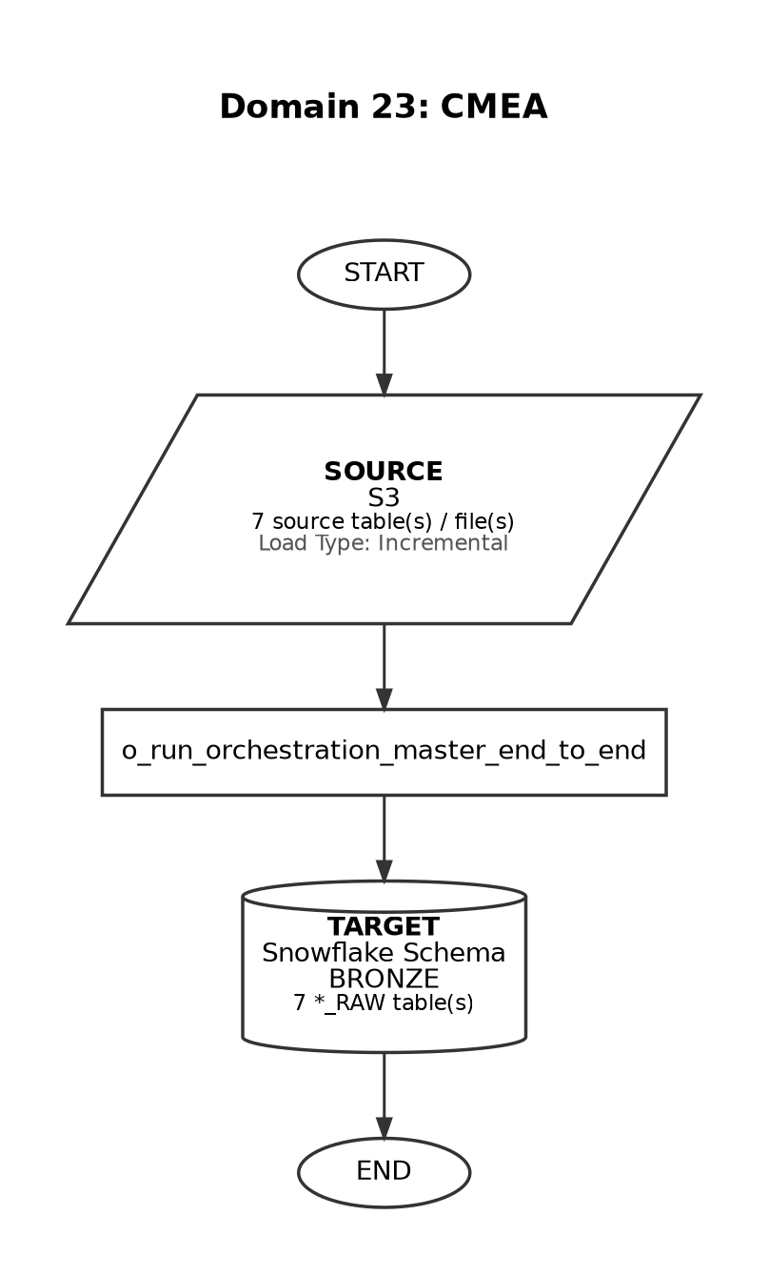

Source-to-Target Table Mapping

# | Source File / Table | Snowflake Target Table (Bronze RAW)
1 | all_reference_files | CASE_MANAGEMENT_RAW
2 | all_patients_files | ESTIMATED_PATIENTS_RAW
3 | all_crm_files | CASE_MANAGEMENT_RAW
4 | all_finance_files | CASE_MANAGEMENT_RAW
5 | all_targets_files | CASE_MANAGEMENT_RAW
6 | all_trials_files | CASE_MANAGEMENT_RAW
7 | all_sales_files | ESTIMATED_PATIENTS_RAW

Domain 24: UKI Data

Attribute | Detail
Domain Name | UKI Data
Source System | S3
Load Type | Full Load
Target Schema | BRONZE
Matillion Pipelines | o_ingest_uki_data
Total Tables | 10
Frequency | Ad-hoc
Trigger / Schedule | Manual / on-demand load

End-to-End Data Flow Diagram

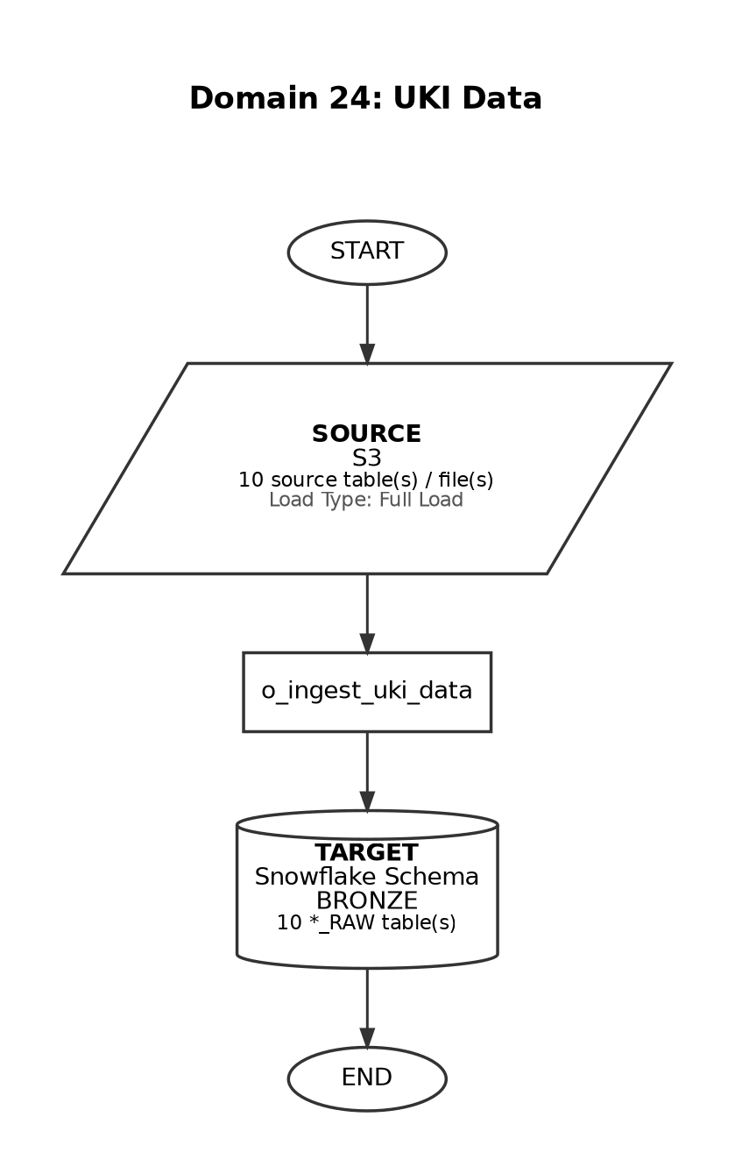

Source-to-Target Table Mapping

# | Source File / Table | Snowflake Target Table (Bronze RAW)
1 | UKI Raw Data File Feed.xlsx (Tab: Patient Tracker) | UKI_PATIENT_TRACKER_RAW
2 | UKI Raw Data File Feed.xlsx (Tab: Arvato Invoice Sales) | UKI_ARVATO_INVOICE_SALES_RAW
3 | UKI Raw Data File Feed.xlsx (Tab: Bionical Orders) | UKI_BIONICAL_ORDERS_RAW
4 | UKI Raw Data File Feed.xlsx (Tab: Combined Sales 1) | UKI_COMBINED_SALES_1_RAW
5 | UKI Raw Data File Feed.xlsx (Tab: Combined Sales 2) | UKI_COMBINED_SALES_2_RAW
6 | UKI Raw Data File Feed.xlsx (Tab: New Patient Details) | UKI_NEW_PATIENT_DETAILS_RAW
7 | UKI Raw Data File Feed.xlsx (Tab: New Clinical Interactions) | UKI_NEW_CLINICAL_INTERACTIONS_RAW
8 | UKI Raw Data File Feed.xlsx (Tab: Homecare Sales) | UKI_HOMECARE_SALES_RAW
9 | UKI Raw Data File Feed.xlsx (Tab: Homecare Stock Report) | UKI_HOMECARE_STOCK_REPORT_RAW
10 | UKI Raw Data File Feed.xlsx (Tab: Accounts) | UKI_ACCOUNTS_RAW

Domain 25: Bayshore

Attribute | Detail
Domain Name | Bayshore
Source System | S3
Load Type | Full Load
Target Schema | BRONZE
Matillion Pipelines | o_ingest_bayshore_data
Total Tables | 5
Frequency | Weekly
Trigger / Schedule | At 09:00, only on Tuesday (America/New_York timezone)

End-to-End Data Flow Diagram

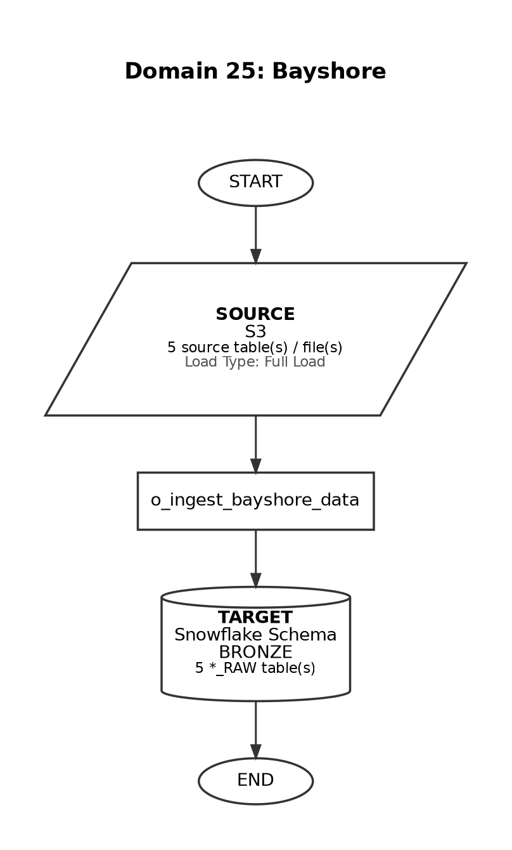

Source-to-Target Table Mapping

# | Source File / Table | Snowflake Target Table (Bronze RAW)
1 | Argenx Vyvgart Appointments Report-MM-DD | BAYSHORE_VYVGART_APPOINTMENTS
2 | Argenx Vyvgart MGADL Reported Scores Report-MM-DD | BAYSHORE_VYVGART_MGADL_REPORTED_SCORE
3 | Argenx Vyvgart Patient Journey Report-MM-DD | BAYSHORE_PATIENT_JOURNEY
4 | Argenx Vyvgart Patient Reimbursement Report-MM-DD | BAYSHORE_VYVGART_PATIENT_REIMBURSEMENT
5 | Argenx Vyvgart Previous Therapy and Concurrent medications Report-MM-DD | BAYSHORE_VYVGART_PREVIOUS_THERAPY

Domain 26: Toho

Attribute | Detail
Domain Name | Toho
Source System | S3
Load Type | Incremental
Target Schema | BRONZE
Matillion Pipelines | o_ingest_combined_toho_automation
Total Tables | 5
Frequency | Ad-hoc
Trigger / Schedule | On-demand load with change-request feeds

End-to-End Data Flow Diagram

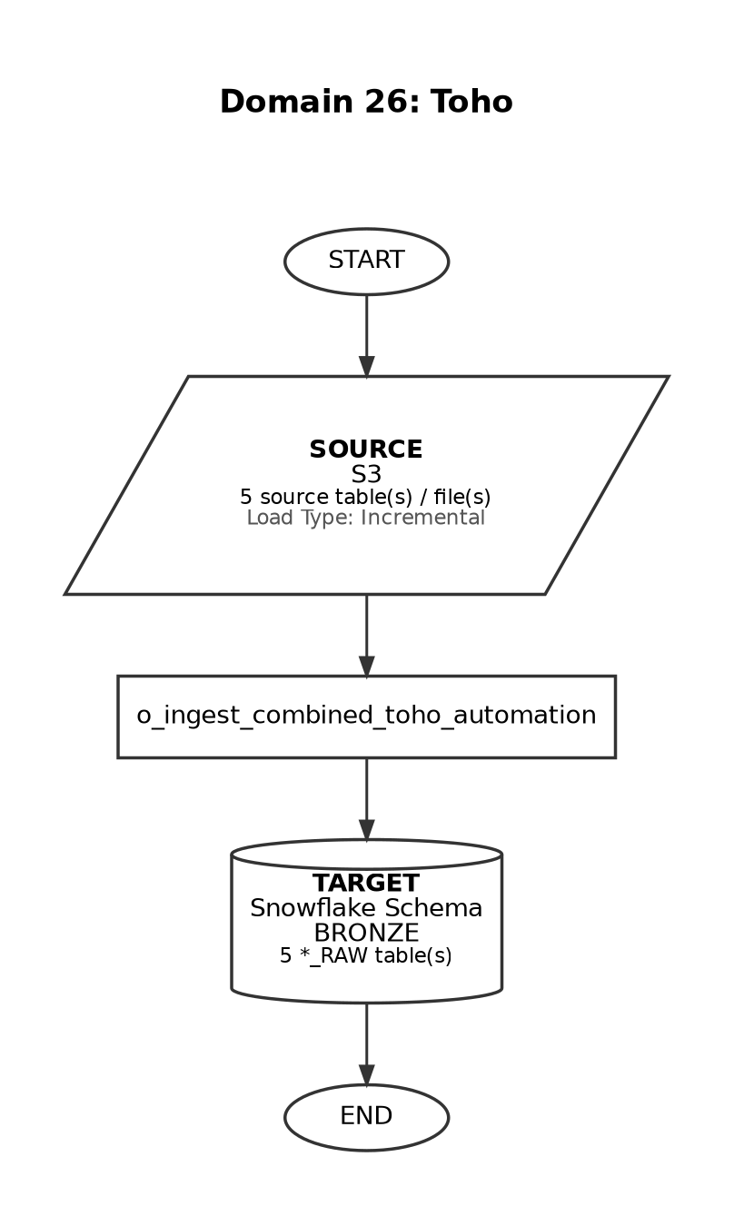

Source-to-Target Table Mapping

# | Source File / Table | Snowflake Target Table (Bronze RAW)
1 | toho/PATIENT_INFO_SALES/*PATIENT* | TOHO_PATIENT_INFO_SALES_RAW
2 | toho/WHOLESALER_SALES/*SALES* | TOHO_WHOLESALER_SALES_RAW
3 | toho/PATIENT_INFO_SALES_CHANGE_REQUEST/*PATIENT* | TOHO_PATIENT_INFO_SALES_CHANGE_REQUEST
4 | toho/WHOLESALER_SALES_CHANGE_REQUEST/*PATIENT* | TOHO_WHOLESALER_SALES_CHANGE_REQUEST
5 | toho/PATIENT_STATUS_CHANGE_REQUEST/*PATIENT* | TOHO_PATIENT_STATUS_CHANGE_REQUEST

Domain 27: Clinical Trials

Attribute | Detail
Domain Name | Clinical Trials
Source System | S3
Load Type | Full Load
Target Schema | BRONZE
Matillion Pipelines | o_ingest_clinical_trials_data
Total Tables | 3
Frequency | Ad-hoc
Trigger / Schedule | Manual / on-demand load

End-to-End Data Flow Diagram

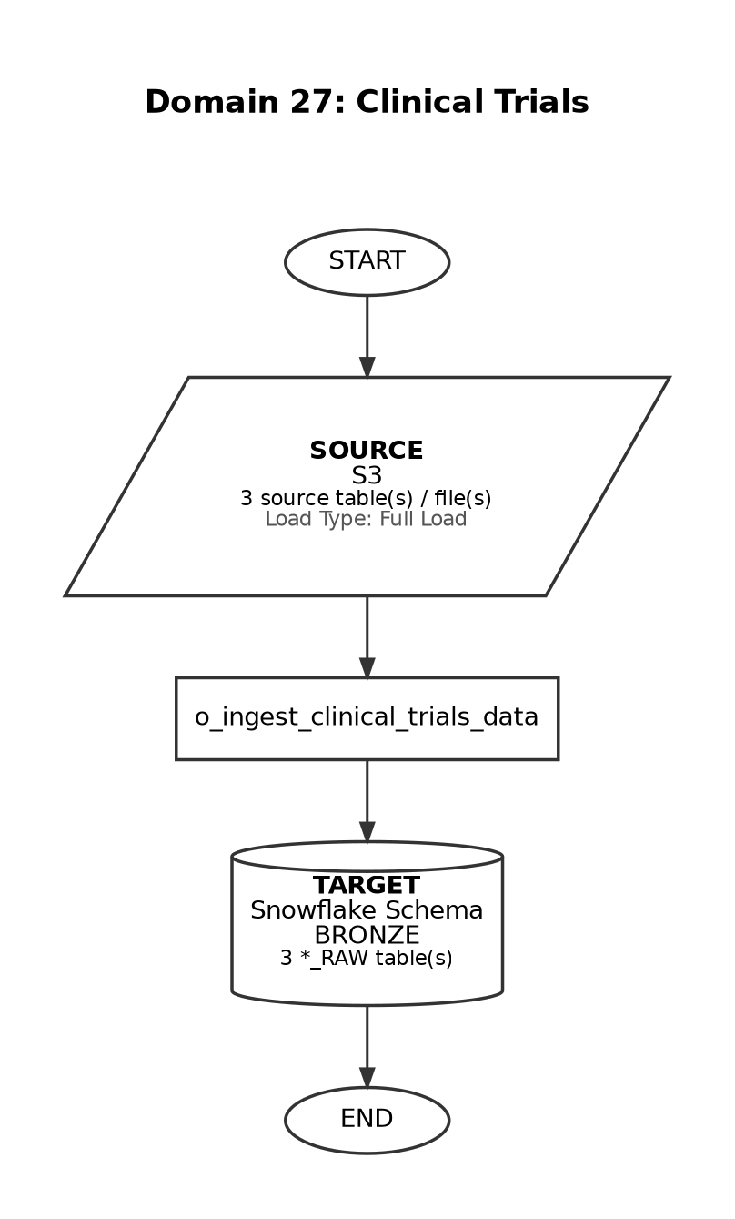

Source-to-Target Table Mapping

# | Source File / Table | Snowflake Target Table (Bronze RAW)
1 | argenx_clin_trials.csv | HCP_CLINICAL_TRIALS_REF_RAW
2 | collegium.csv | HCP_COLLEGIUM_REF_RAW
3 | speaker_training.csv | HCP_SPEAKER_TRAINING_REF_RAW

Domain 28: JP (Japan Vial Shipment)

Attribute | Detail
Domain Name | JP (Japan Vial Shipment)
Source System | S3
Load Type | Incremental
Target Schema | BRONZE
Matillion Pipelines | o_transform_silver_global_vial_shipment_toho
Total Tables | 2
Frequency | Weekdays
Trigger / Schedule | At 09:35, Monday-Friday (Asia/Tokyo timezone)

End-to-End Data Flow Diagram

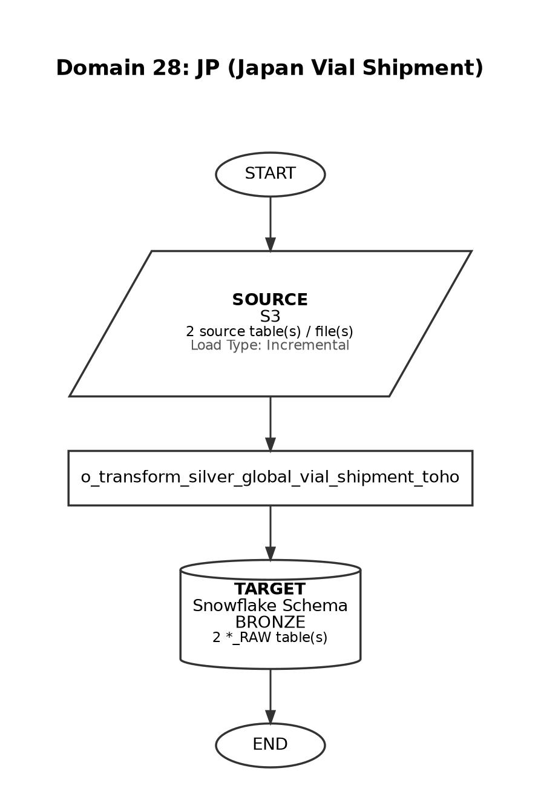

Source-to-Target Table Mapping

# | Source File / Table | Snowflake Target Table (Bronze RAW)
1 | jp/VIAL_TARGET/*VIAL* | VIAL_TARGET
2 | jp/PREFECTURE_POTENTIAL/*PREFECTURE* | PREFECTURE_POTENTIAL

Domain 29: IQVIA DDD

Attribute | Detail
Domain Name | IQVIA DDD
Source System | S3
Load Type | Incremental
Target Schema | BRONZE
Matillion Pipelines | o_ingest_iqvia_ddd_bronze_load
Total Tables | 5
Frequency | Monthly
Trigger / Schedule | Day 1 of the month (Asia/Tokyo timezone)

End-to-End Data Flow Diagram

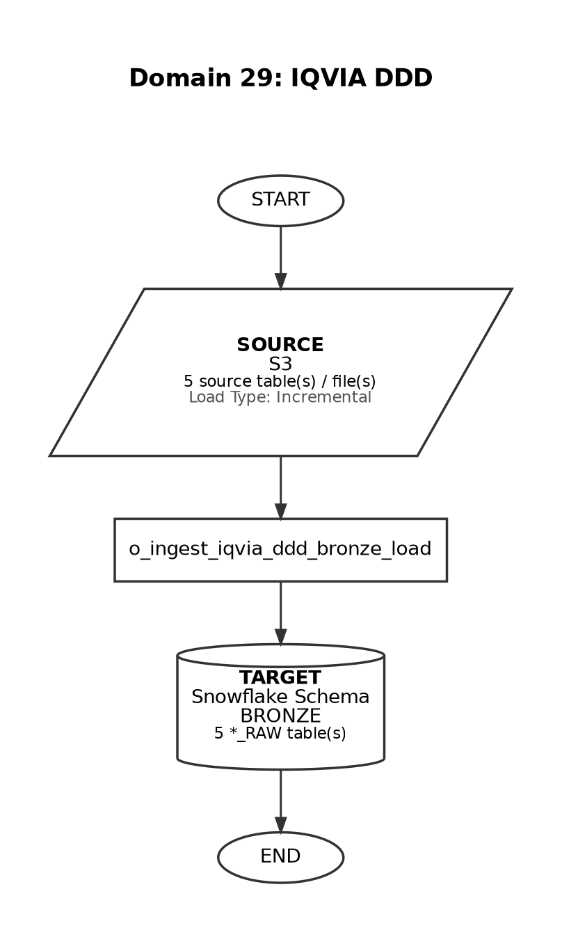

Source-to-Target Table Mapping

# | Source File / Table | Snowflake Target Table (Bronze RAW)
1 | argenx_JP_customized_data_CIDP_* (Tab: Sales_amount_monthly) | IQVIA_DDD_VIAL_RAW
2 | argenx_JP_customized_data_ITP_* (Tab: Sales_amount_monthly) | IQVIA_DDD_VIAL_RAW
3 | JIS_TERRITORY_MASTERS | JIS_TERRITORY_REF_RAW
4 | argenx_JP_customized_data_CIDP_* (Tab: Sales_volume_monthly) | IQVIA_DDD_VIAL_RAW
5 | argenx_JP_customized_data_ITP_* (Tab: Sales_volume_monthly) | IQVIA_DDD_VIAL_RAW

Domain 30: TXHUB

Attribute | Detail
Domain Name | TXHUB
Source System | S3
Load Type | Full Load
Target Schema | BRONZE
Matillion Pipelines | o_ingest_txhub_s3_files
Total Tables | 1
Frequency | Weekdays
Trigger / Schedule | At 00:40, Monday-Friday (America/New_York timezone)

End-to-End Data Flow Diagram

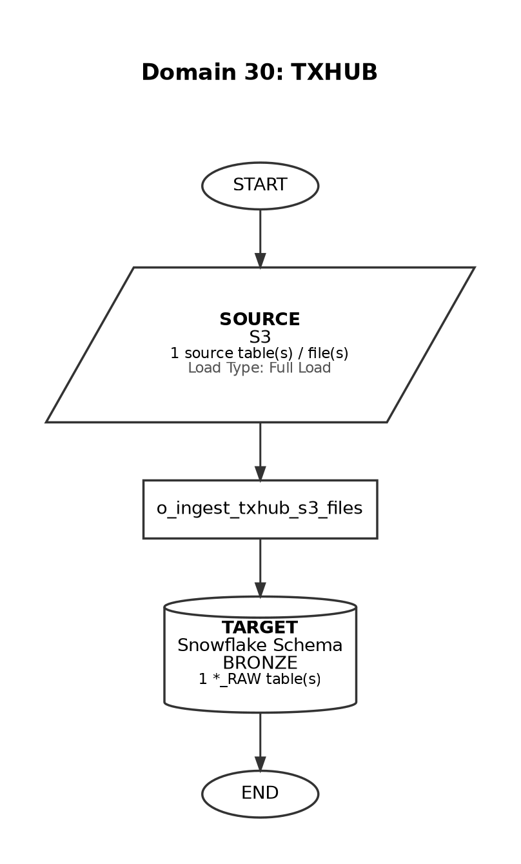

Source-to-Target Table Mapping

# | Source File / Table | Snowflake Target Table (Bronze RAW)
1 | thub_transactions_*.csv | THUB_TRANSACTIONS_RAW

Domain 31: JIRA

Attribute | Detail
Domain Name | JIRA
Source System | S3
Load Type | Full Load
Target Schema | BRONZE
Matillion Pipelines | o_ingest_jira_data
Total Tables | 1
Frequency | Ad-hoc
Trigger / Schedule | Manual / on-demand load

End-to-End Data Flow Diagram

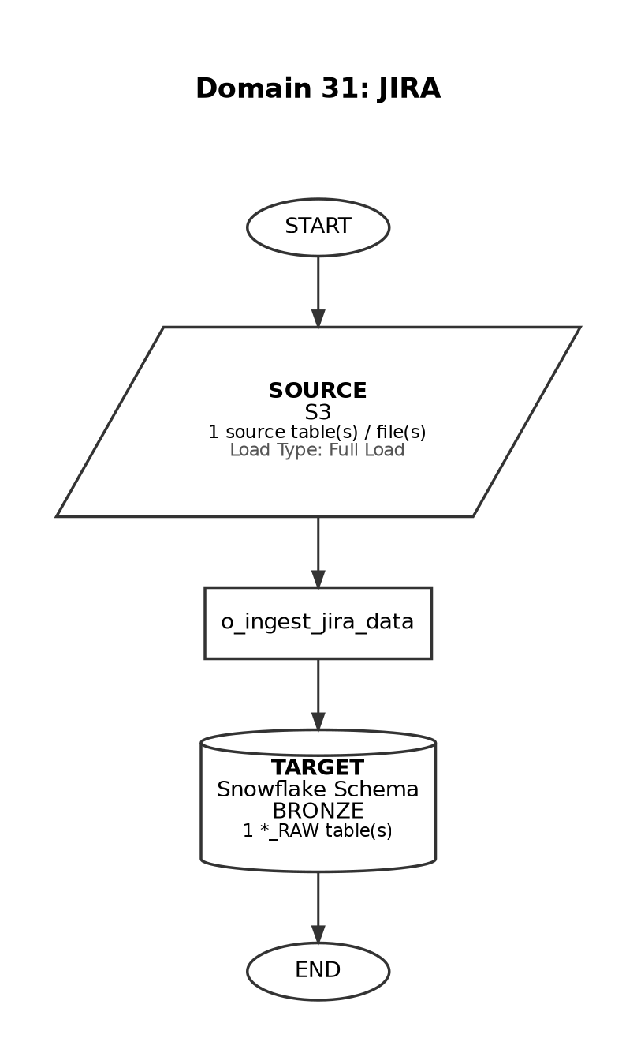

Source-to-Target Table Mapping

# | Source File / Table | Snowflake Target Table (Bronze RAW)
1 | Jira_Issue_Raw_SP*.csv | JIRA_ISSUES_RAW

Domain 32: KALDEROS

Attribute | Detail
Domain Name | KALDEROS
Source System | SFTP
Load Type | Full Load
Target Schema | BRONZE
Matillion Pipelines | o_ingest_kalderos_all_files
Total Tables | 2
Frequency | Weekly
Trigger / Schedule | At 06:00, only on Tuesday (America/New_York timezone)

End-to-End Data Flow Diagram

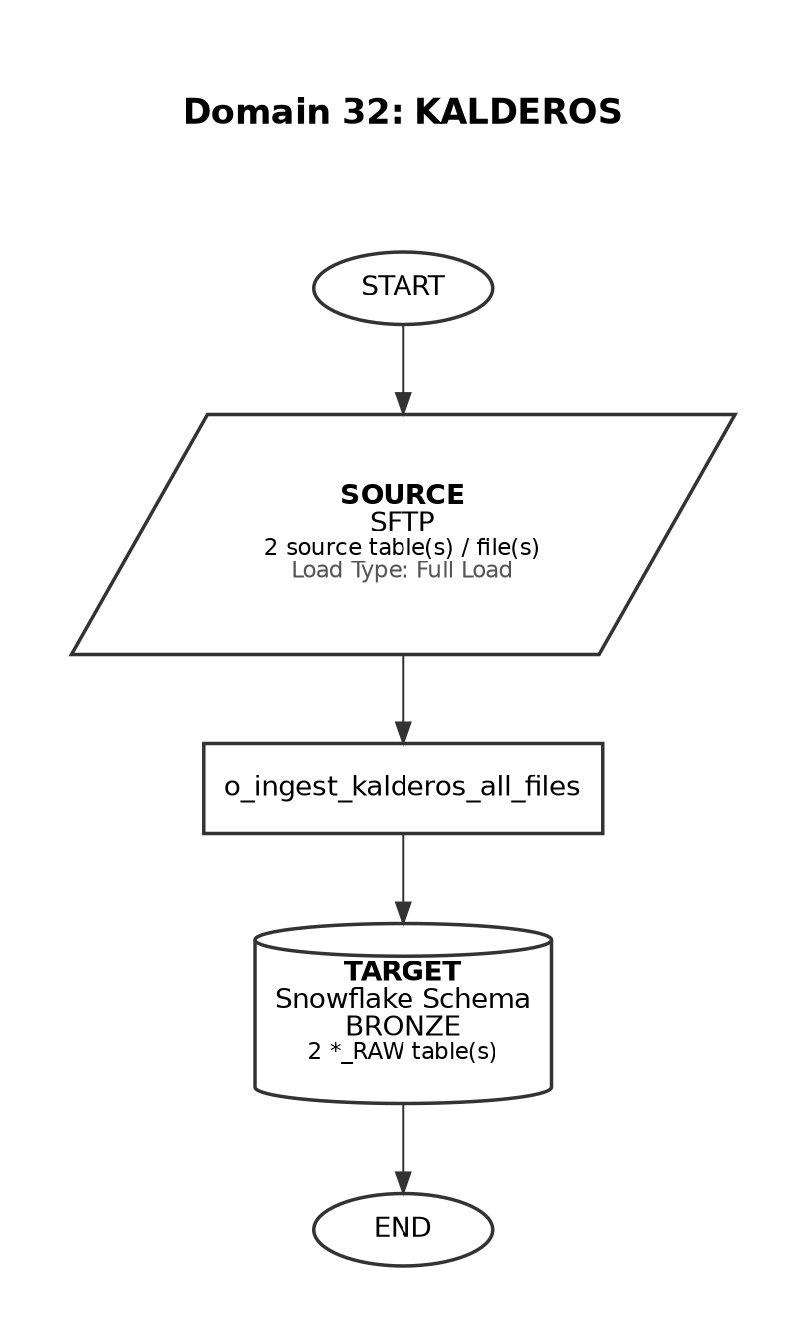

Source-to-Target Table Mapping

# | Source File / Table | Snowflake Target Table (Bronze RAW)
1 | Kalderos_Claims Ledger_{0-9}+_{0-9}{14}.csv | KALDEROS_CLAIMS_LEDGER_RAW
2 | Kalderos_CP_Eligibility_{0-9}+_{0-9}{14}.xlsx (Tab: FULL/ADDED/REMOVED/UPDATED) | KALDEROS_CP_ELIGIBILITY_<Tab_name>_DELTA

Domain 33: IQVIA Pinpoint

Attribute | Detail
Domain Name | IQVIA Pinpoint
Source System | Snowflake Share
Load Type | Full Load
Target Schema | IQVIA_PINPOINT / BRONZE
Matillion Pipelines | o_ingest_pulsepoint_to_veeevaCRM_1
Total Tables | 2
Frequency | Weekly
Trigger / Schedule | At 12:30 on Thursday (steps1) and 12:30 on Friday (steps2)

End-to-End Data Flow Diagram

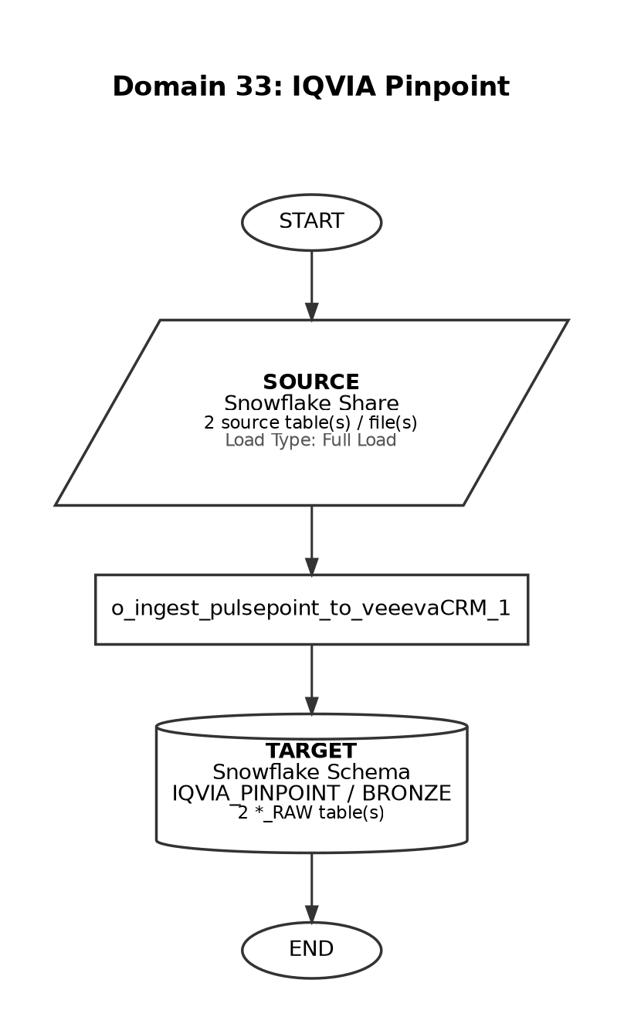

Source-to-Target Table Mapping

# | Source File / Table | Snowflake Target Table (Bronze RAW)
1 | ARGENX_PINPOINT_IQVIA_NBA_TO_VEEVA_OUTBOUND | IQVIA_NBA_TO_VEEVA_CRM
2 | ARGENX_PINPOINT_IQVIA_DIGITAL_OUTBOUND | IQVIA_DIGITAL_ACTION_RAW

Domain 34: Veeva Network (DCR)

Attribute | Detail
Domain Name | Veeva Network (DCR)
Source System | SFTP
Load Type | Full Load
Target Schema | BRONZE
Matillion Pipelines | o_ingest_veeva_network_files
Total Tables | 1
Frequency | Daily
Trigger / Schedule | At 02:30, every day (America/New_York timezone)

End-to-End Data Flow Diagram

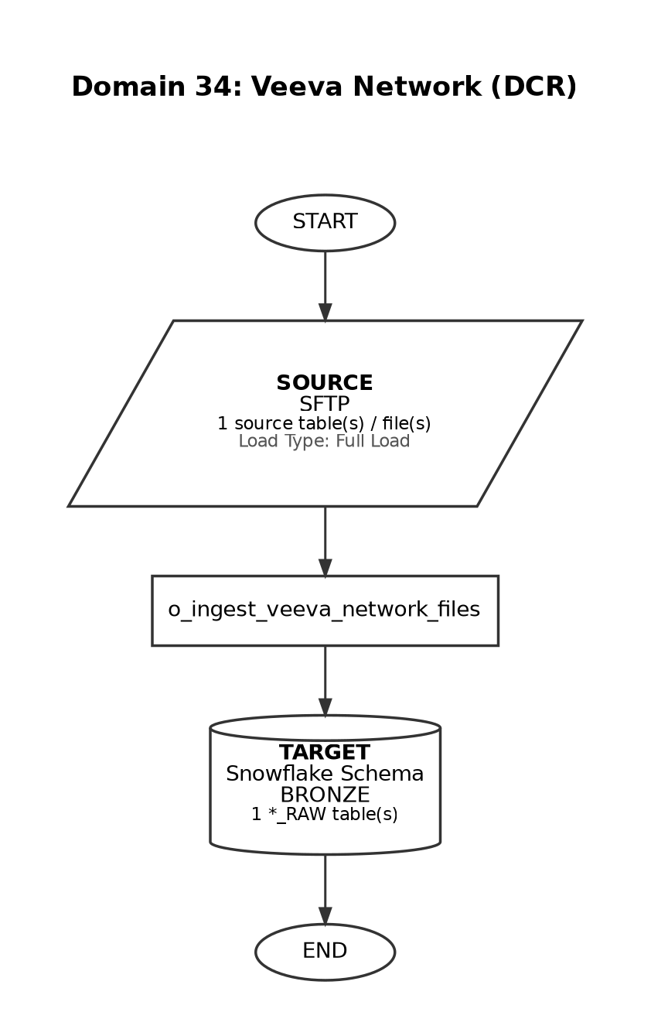

Source-to-Target Table Mapping

# | Source File / Table | Snowflake Target Table (Bronze RAW)
1 | VN_Snowflake_us_primarydcr_full | VEEVA_NETWORK_DCR

Domain 35: IQVIA Med_B

Attribute | Detail
Domain Name | IQVIA Med_B
Source System | Snowflake Share
Load Type | Incremental
Target Schema | BRONZE
Matillion Pipelines | o_end_to_end_iqvia_medb_monthly_pipeline
Total Tables | 1
Frequency | Monthly
Trigger / Schedule | At 19:00, on the last weekday of the month

End-to-End Data Flow Diagram

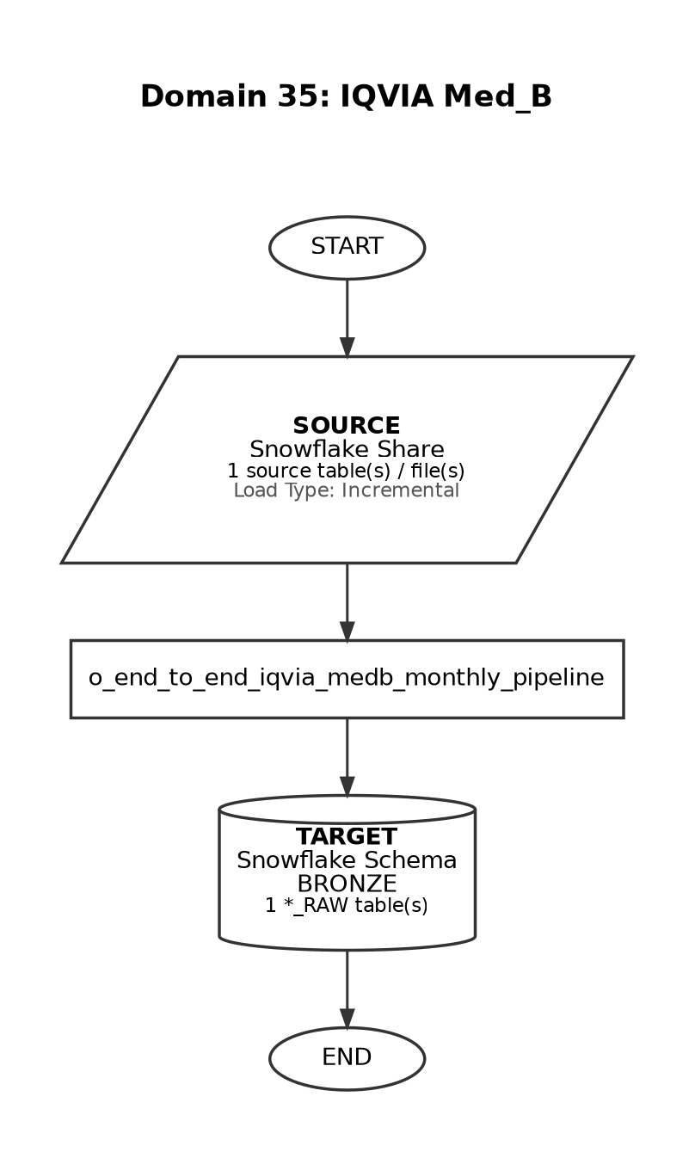

Source-to-Target Table Mapping

# | Source File / Table | Snowflake Target Table (Bronze RAW)
1 | VW_CLNS_ARGX_IQVIA_MEDB | IQVIA_MED_B_PROVIDER_RAW

Domain 36: IQVIA AMA

Attribute | Detail
Domain Name | IQVIA AMA
Source System | Snowflake Share
Load Type | Full Load
Target Schema | BRONZE
Matillion Pipelines | o_end_to_end_iqvia_ama_monthly_pipeline
Total Tables | 2
Frequency | Weekly
Trigger / Schedule | At 12:30, only on Friday (America/New_York timezone)

End-to-End Data Flow Diagram

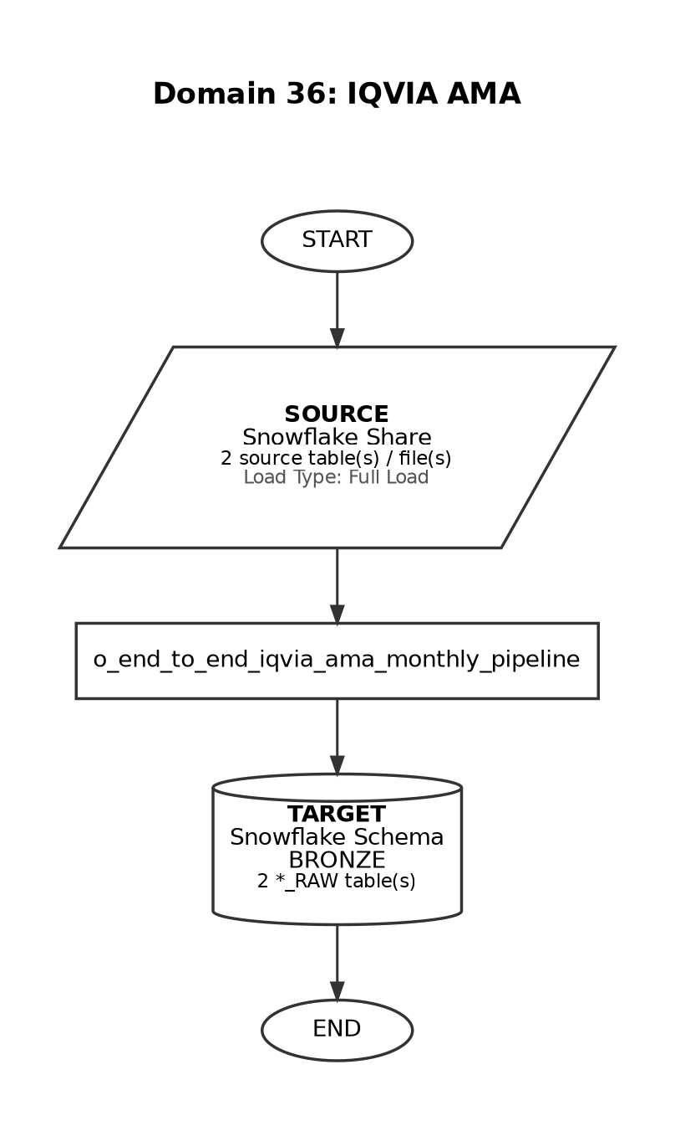

Source-to-Target Table Mapping

# | Source File / Table | Snowflake Target Table (Bronze RAW)
1 | VW_CLNS_CDS_ZXKN_AMA_NPI | IQVIA_AMA_NPI_RAW
2 | VW_CLNS_CDS_ZXKN_AMA_MASTER | IQVIA_AMA_PHYSICIAN_MASTER_RAW

Domain 37: IQVIA HPD

Attribute | Detail
Domain Name | IQVIA HPD
Source System | Snowflake Share
Load Type | Full Load
Target Schema | BRONZE
Matillion Pipelines | o_end_to_end_iqvia_hpd_quarterly_pipeline
Total Tables | 6
Frequency | Quarterly
Trigger / Schedule | At 19:30, between day 1 and 3 of March, June, September, December

End-to-End Data Flow Diagram

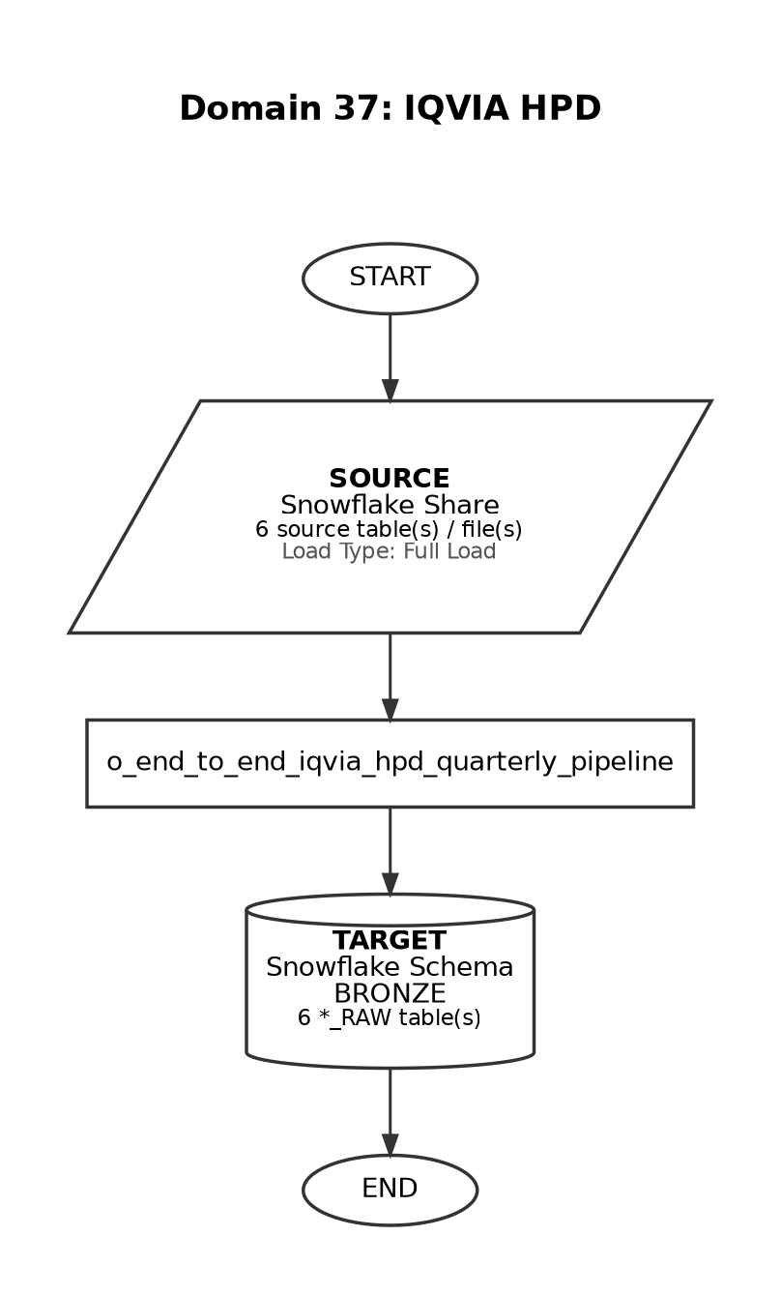

Source-to-Target Table Mapping

# | Source File / Table | Snowflake Target Table (Bronze RAW)
1 | VW_CLNS_IQVIA_HPD_FACILITY_REPORT_FOR_ARGENX | IQVIA_HPD_FACILITY_REPORT_RAW
2 | VW_CLNS_IQVIA_HPD_FULL_ORG_NPI_LIST_FOR_ARGENX | IQVIA_HPD_FULL_ORG_NPI_RAW
3 | VW_CLNS_IQVIA_HPD_FILTERED_ORG_NPI_LIST_FOR_ARGENX | IQVIA_HPD_FILTERED_ORG_NPI_RAW
4 | VW_CLNS_IQVIA_HPD_NATIONAL_REPORT_FOR_ARGENX | IQVIA_HPD_NATIONAL_REPORT_RAW
5 | VW_CLNS_IQVIA_HPD_PHYSICIAN_REPORT_FOR_ARGENX | IQVIA_HPD_PHYSICIAN_REPORT_RAW
6 | VW_CLNS_IQVIA_HPD_ALLOCATION_REPORT_FOR_ARGENX | IQVIA_HPD_ALLOCATION_REPORT_RAW

Domain 38: IQVIA LAAD MG Weekly

Attribute | Detail
Domain Name | IQVIA LAAD MG Weekly
Source System | Snowflake Share
Load Type | Incremental
Target Schema | BRONZE
Matillion Pipelines | o_end_to_end_iqvia_laad_mg_weekly_pipeline
Total Tables | 17
Frequency | Weekly
Trigger / Schedule | At 19:00, Thursday-Friday (America/New_York timezone)

End-to-End Data Flow Diagram

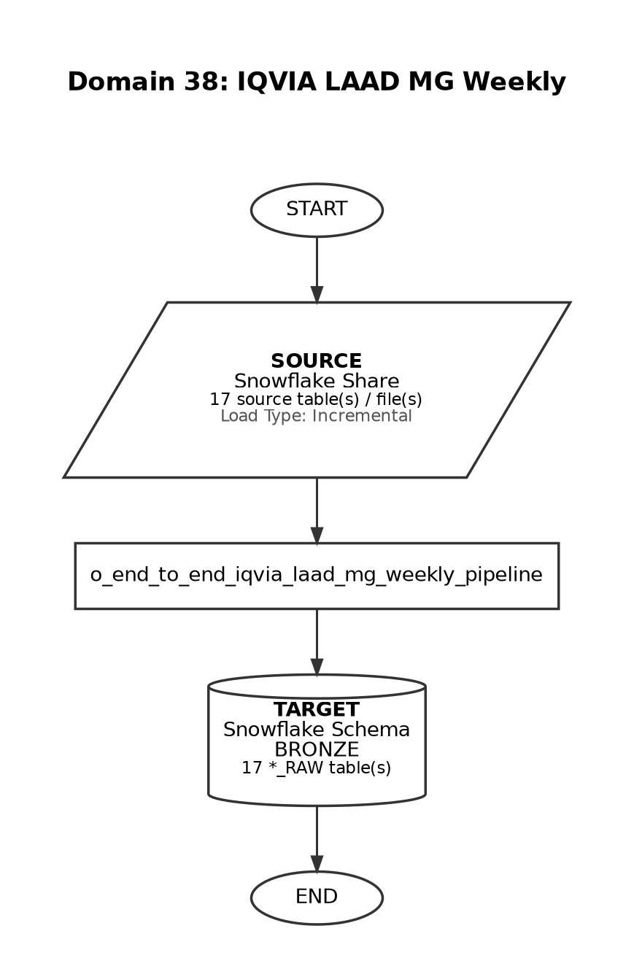

Source-to-Target Table Mapping

# | Source File / Table | Snowflake Target Table (Bronze RAW)
1 | VW_CLNS_MMC_DEVI_ARG_L80952_PAT | IQVIA_LAAD_MG_WEEKLY_PATIENT_RAW
2 | VW_CLNS_MMC_DEVI_ARG_L80952_PLNLK | IQVIA_LAAD_MG_WEEKLY_PLAN_RAW
3 | VW_CLNS_MMC_DEVI_ARG_L80952_PRDLK | IQVIA_LAAD_MG_WEEKLY_PRODUCT_RAW
4 | VW_CLNS_MMC_DEVI_ARG_L80952_RX | IQVIA_LAAD_MG_WEEKLY_RX_FACT_RAW
5 | VW_CLNS_MMC_DEVI_ARG_L80952_PLSVC | IQVIA_LAAD_MG_WEEKLY_PLACE_OF_SERVICE_CODE_RAW
6 | VW_CLNS_MMC_DEVI_ARG_L80952_DXLK | IQVIA_LAAD_MG_WEEKLY_DIAGNOSIS_CODE_RAW
7 | VW_CLNS_MMC_DEVI_ARG_L80952_MODLK | IQVIA_LAAD_MG_WEEKLY_MODIFIER_CODE_RAW
8 | VW_CLNS_MMC_DEVI_ARG_L80952_MX | IQVIA_LAAD_MG_WEEKLY_MX_REMIT_FACT_RAW
9 | VW_CLNS_MMC_DEVI_ARG_L80952_RXACT | IQVIA_LAAD_MG_WEEKLY_RX_PATIENT_ACTIVITY_RAW
10 | VW_CLNS_MMC_DEVI_ARG_L80952_OXACT | IQVIA_LAAD_MG_WEEKLY_DX_PATIENT_ACTIVITY_RAW
11 | VW_CLNS_MMC_DEVI_ARG_L80952_FACTYP | IQVIA_LAAD_MG_WEEKLY_FACILITY_TYPE_CODE_RAW
12 | VW_CLNS_MMC_DEVI_ARG_L80952_CNTL | IQVIA_LAAD_MG_WEEKLY_CONTROL_RAW
13 | VW_CLNS_MMC_DEVI_ARG_L80952_COMPAT | IQVIA_LAAD_MG_WEEKLY_PATIENT_COMMERCIAL_RAW
14 | VW_CLNS_MMC_DEVI_ARG_L80952_GEO | IQVIA_LAAD_MG_WEEKLY_GEOGRAPHY_RAW
15 | VW_CLNS_MMC_DEVI_ARG_L80952_MPDPAT | IQVIA_LAAD_MG_WEEKLY_PATIENT_MPD_RAW
16 | VW_CLNS_MMC_DEVI_ARG_L80952_RELK | IQVIA_LAAD_MG_WEEKLY_REJECT_RAW
17 | VW_CLNS_MMC_DEVI_ARG_L80952_PVDLK | IQVIA_LAAD_MG_WEEKLY_PROVIDER_RAW

Domain 39: IQVIA LAAD MG Monthly

Attribute | Detail
Domain Name | IQVIA LAAD MG Monthly
Source System | Snowflake Share
Load Type | Incremental
Target Schema | BRONZE
Matillion Pipelines | o_end_to_end_iqvia_laad_monthly_pipeline
Total Tables | 17
Frequency | Monthly
Trigger / Schedule | At 19:00, between day 15 and 20 of the month

End-to-End Data Flow Diagram

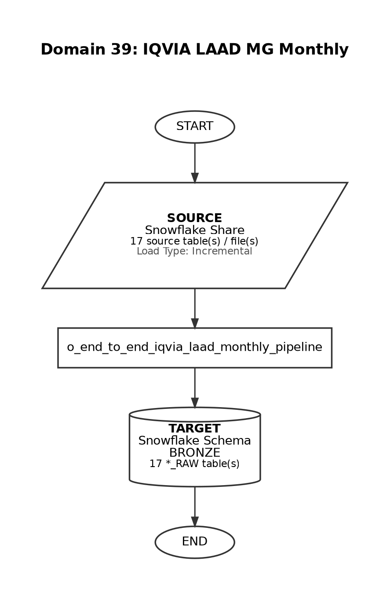

Source-to-Target Table Mapping

# | Source File / Table | Snowflake Target Table (Bronze RAW)
1 | VW_CLNS_MMC_DEVI_ARG_L210512_MX | IQVIA_LAAD_MG_MONTHLY_MX_REMIT_FACT_RAW
2 | VW_CLNS_MMC_DEVI_ARG_L210512_CNTL | IQVIA_LAAD_MG_MONTHLY_CONTROL_RAW
3 | VW_CLNS_MMC_DEVI_ARG_L210512_DXLK | IQVIA_LAAD_MG_MONTHLY_DIAGNOSIS_CODE_RAW
4 | VW_CLNS_MMC_DEVI_ARG_L210512_RX | IQVIA_LAAD_MG_MONTHLY_RX_FACT_RAW
5 | VW_CLNS_MMC_DEVI_ARG_L210512_COMPAT | IQVIA_LAAD_MG_MONTHLY_PATIENT_COMMERCIAL_RAW
6 | VW_CLNS_MMC_DEVI_ARG_L210512_DXACT | IQVIA_LAAD_MG_MONTHLY_DX_PATIENT_ACTIVITY_RAW
7 | VW_CLNS_MMC_DEVI_ARG_L210512_FACTYP | IQVIA_LAAD_MG_MONTHLY_FACILITY_TYPE_CODE_RAW
8 | VW_CLNS_MMC_DEVI_ARG_L210512_GEO | IQVIA_LAAD_MG_MONTHLY_GEOGRAPHY_RAW
9 | VW_CLNS_MMC_DEVI_ARG_L210512_MPDPAT | IQVIA_LAAD_MG_MONTHLY_PATIENT_MPD_RAW
10 | VW_CLNS_MMC_DEVI_ARG_L210512_PLSVC | IQVIA_LAAD_MG_MONTHLY_PLACE_OF_SERVICE_CODE_RAW
11 | VW_CLNS_MMC_DEVI_ARG_L210512_PRDLK | IQVIA_LAAD_MG_MONTHLY_PRODUCT_RAW
12 | VW_CLNS_MMC_DEVI_ARG_L210512_PVDLK | IQVIA_LAAD_MG_MONTHLY_PROCEDURE_CODE_RAW
13 | VW_CLNS_MMC_DEVI_ARG_L210512_PXLK | IQVIA_LAAD_MG_MONTHLY_PROVIDER_RAW
14 | VW_CLNS_MMC_DEVI_ARG_L210512_RELK | IQVIA_LAAD_MG_MONTHLY_REJECT_RAW
15 | VW_CLNS_MMC_DEVI_ARG_L210512_RXACT | IQVIA_LAAD_MG_MONTHLY_RX_PATIENT_ACTIVITY_RAW
16 | VW_CLNS_MMC_DEVI_ARG_L210512_PAT | IQVIA_LAAD_MG_MONTHLY_PATIENT_RAW
17 | VW_CLNS_MMC_DEVI_ARG_L210512_PLNLK | IQVIA_LAAD_MG_MONTHLY_PLAN_RAW

Domain 40: IQVIA LAAD CIDP Monthly

Attribute | Detail
Domain Name | IQVIA LAAD CIDP Monthly
Source System | Snowflake Share
Load Type | Incremental
Target Schema | BRONZE
Matillion Pipelines | o_end_to_end_iqvia_laad_monthly_pipeline
Total Tables | 17
Frequency | Monthly
Trigger / Schedule | At 19:00, between day 15 and 20 of the month (same pipeline as IQVIA LAAD MG Monthly)

End-to-End Data Flow Diagram

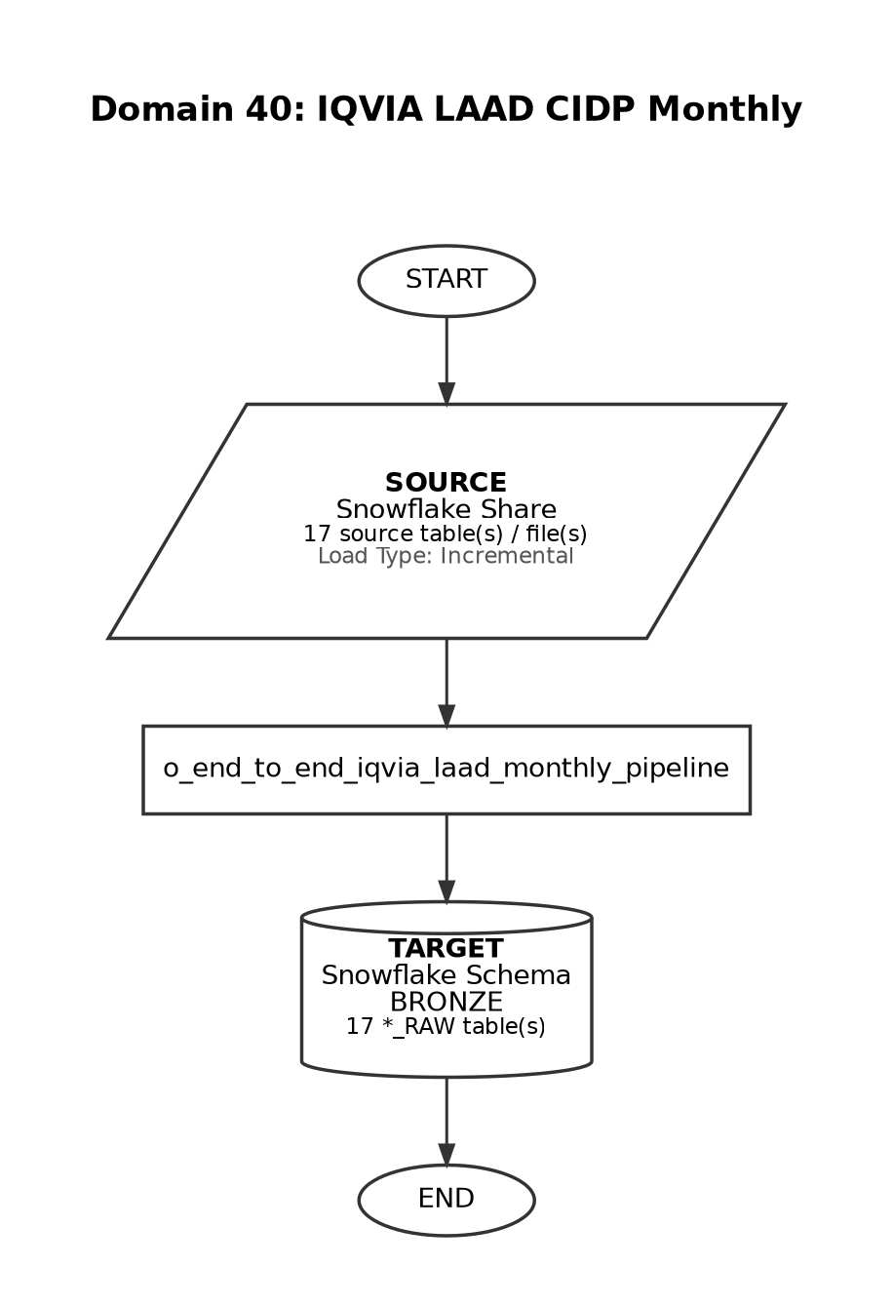

Source-to-Target Table Mapping

# | Source File / Table | Snowflake Target Table (Bronze RAW)
1 | VW_CLNS_MMC_DEVI_ARG_L62123_PVDLK | IQVIA_LAAD_ODP_MONTHLY_PROVIDER_RAW
2 | VW_CLNS_MMC_DEVI_ARG_L62123_GEO | IQVIA_LAAD_ODP_MONTHLY_GEOGRAPHY_RAW
3 | VW_CLNS_MMC_DEVI_ARG_L62123_RELK | IQVIA_LAAD_ODP_MONTHLY_REJECT_RAW
4 | VW_CLNS_MMC_DEVI_ARG_L62123_PXLK | IQVIA_LAAD_ODP_MONTHLY_PROCEDURE_CODE_RAW
5 | VW_CLNS_MMC_DEVI_ARG_L62123_MX | IQVIA_LAAD_ODP_MONTHLY_MX_REMIT_FACT_RAW
6 | VW_CLNS_MMC_DEVI_ARG_L62123_FACTYP | IQVIA_LAAD_ODP_MONTHLY_FACILITY_TYPE_CODE_RAW
7 | VW_CLNS_MMC_DEVI_ARG_L62123_DXACT | IQVIA_LAAD_ODP_MONTHLY_DX_PATIENT_ACTIVITY_RAW
8 | VW_CLNS_MMC_DEVI_ARG_L62123_PLNLK | IQVIA_LAAD_ODP_MONTHLY_PLAN_RAW
9 | VW_CLNS_MMC_DEVI_ARG_L62123_PLSVC | IQVIA_LAAD_ODP_MONTHLY_PLACE_OF_SERVICE_CODE_RAW
10 | VW_CLNS_MMC_DEVI_ARG_L62123_RXACT | IQVIA_LAAD_ODP_MONTHLY_RX_PATIENT_ACTIVITY_RAW
11 | VW_CLNS_MMC_DEVI_ARG_L62123_CNTL | IQVIA_LAAD_ODP_MONTHLY_CONTROL_RAW
12 | VW_CLNS_MMC_DEVI_ARG_L62123_PAT | IQVIA_LAAD_ODP_MONTHLY_PATIENT_RAW
13 | VW_CLNS_MMC_DEVI_ARG_L62123_MODLK | IQVIA_LAAD_ODP_MONTHLY_MODIFIER_CODE_RAW
14 | VW_CLNS_MMC_DEVI_ARG_L62123_RX | IQVIA_LAAD_ODP_MONTHLY_RX_FACT_RAW
15 | VW_CLNS_MMC_DEVI_ARG_L62123_DXLK | IQVIA_LAAD_ODP_MONTHLY_DIAGNOSIS_CODE_RAW
16 | VW_CLNS_MMC_DEVI_ARG_L62123_COMPAT | IQVIA_LAAD_ODP_MONTHLY_PATIENT_COMMERCIAL_RAW
17 | VW_CLNS_MMC_DEVI_ARG_L62123_MPDPAT | IQVIA_LAAD_ODP_MONTHLY_PATIENT_MPD_RAW

Domain 41: NCM (PSP)

Attribute | Detail
Domain Name | NCM (PSP)
Source System | Snowflake Share
Load Type | Full Load
Target Schema | BRONZE_PSP
Matillion Pipelines | o_daily_psp_bronze_refresh_job
Total Tables | 27
Frequency | Weekdays
Trigger / Schedule | Trigger-based: runs after Non-PSP Patient Silver and Gold complete (12:45-1:15 am EST)

End-to-End Data Flow Diagram

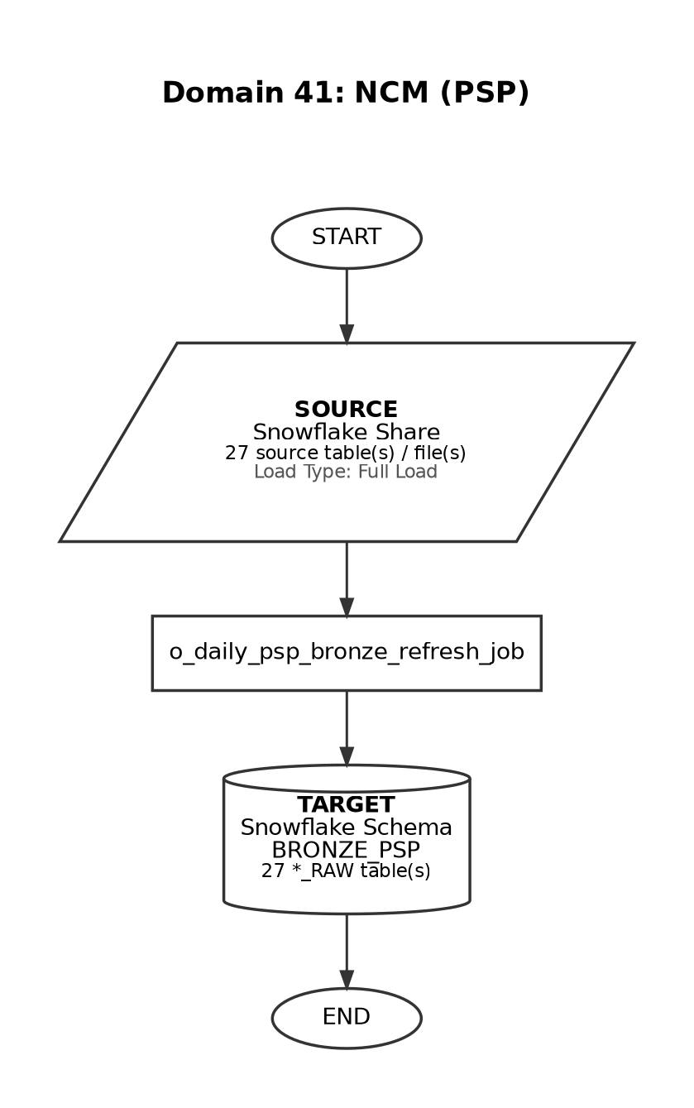

Source-to-Target Table Mapping

# | Source File / Table | Snowflake Target Table (Bronze RAW)
1 | LND_NCM_PIN_MEDICAL_HISTORY | LND_NCM_PIN_MEDICAL_HISTORY_RAW
2 | LND_NCM_PIN_MEMBER_PLAN | LND_NCM_PIN_MEMBER_PLAN_RAW
3 | LND_NCM_PIN_CONTACT_POINT_TYPE_CONSENT | LND_NCM_PIN_CONTACT_POINT_TYPE_CONSENT_RAW
4 | PATIENT_INITIALS | PATIENT_INITIALS_RAW
5 | LND_NCM_HEALTHCLOUDGA_PROGRAM | LND_NCM_HEALTHCLOUDGA_PROGRAM_RAW
6 | LND_NCM_PIN_CONTACT_INFORMATION | LND_NCM_PIN_CONTACT_INFORMATION_RAW
7 | LND_NCM_ACCOUNT | LND_NCM_ACCOUNT_RAW
8 | LND_NCM_PIN_COVERAGE_INVESTIGATION | LND_NCM_PIN_COVERAGE_INVESTIGATION_RAW
9 | LND_NCM_PIN_LICENSE | LND_NCM_PIN_LICENSE_RAW
10 | LND_NCM_ARGX_IN_NETWORK_PHARMACIES | LND_NCM_ARGX_IN_NETWORK_PHARMACIES_RAW
11 | LND_NCM_PIN_EVENT | LND_NCM_PIN_EVENT_RAW
12 | LND_NCM_PIN_PRIOR_AUTHORIZATION | LND_NCM_PIN_PRIOR_AUTHORIZATION_RAW
13 | LND_NCM_HEALTHCLOUDGA_EHRRMEDICATIONPRESCRIPTION | LND_NCM_HEALTHCLOUDGA_EHRRMEDICATIONPRESCRIPTION_RAW
14 | CONSENT_MANAGEMENT | CONSENT_MANAGEMENT_RAW
15 | LND_NCM_CASE_HISTORY | LND_NCM_CASE_HISTORY_RAW
16 | LND_NCM_HEALTHCLOUDGA_CONTACTCONTACTRELATION | LND_NCM_HEALTHCLOUDGA_CONTACTCONTACTRELATION_RAW
17 | LND_NCM_CONTACT | LND_NCM_CONTACT_RAW
18 | LND_NCM_PIN_SHIPMENT | LND_NCM_PIN_SHIPMENT_RAW
19 | LND_NCM_TASK_TYPE | LND_NCM_TASK_TYPE_RAW
20 | LND_NCM_PIN_ASSISTANCE_PROGRAM_HISTORY | LND_NCM_PIN_ASSISTANCE_PROGRAM_HISTORY_RAW
21 | LND_NCM_HEALTHCLOUDGA_CAREPLANPROBLEM | LND_NCM_HEALTHCLOUDGA_CAREPLANPROBLEM_RAW
22 | LND_NCM_CARE_PROG_PRODUCT | LND_NCM_CARE_PROG_PRODUCT_RAW
23 | LND_NCM_MEDISAFE_STATE | LND_NCM_MEDISAFE_STATE_RAW
24 | LND_NCM_MEDISAFE_PATIENT | LND_NCM_MEDISAFE_PATIENT_RAW
25 | LND_NCM_MEDISAFE_NURSE | LND_NCM_MEDISAFE_NURSE_RAW
26 | PHI_XREF | LND_PHI_XREF_RAW
27 | PHI_MERGED_XREF | LND_PHI_MERGED_XREF_RAW

Domain 42: NCM (Non-PSP)

Attribute | Detail
Domain Name | NCM (Non-PSP)
Source System | Snowflake Share
Load Type | Full Load
Target Schema | BRONZE
Matillion Pipelines | o_clone_zs_landing_tables
Total Tables | 15
Frequency | Weekdays
Trigger / Schedule | Daily ingestion via clone pipeline - precedes PSP execution chain

End-to-End Data Flow Diagram

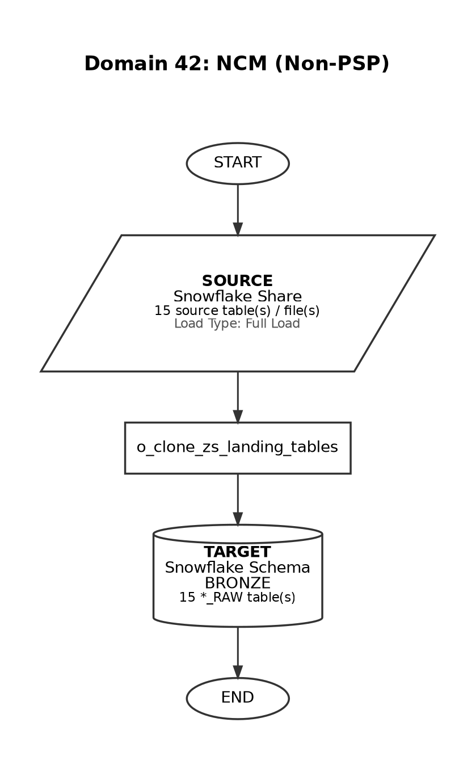

Source-to-Target Table Mapping

# | Source File / Table | Snowflake Target Table (Bronze RAW)
1 | STG_NCM_NURSE_VISIT | NCM_NURSE_VISIT_RAW
2 | STG_NCM_PIN_AFFILIATION | NCM_PIN_AFFILIATION_RAW
3 | STG_NCM_PIN_ASSISTANCE_PROGRAM | NCM_PIN_ASSISTANCE_PROGRAM_RAW
4 | STG_NCM_PIN_ASSISTANCE_PROGRAM_HISTORY | NCM_PIN_ASSISTANCE_PROGRAM_HISTORY_RAW
5 | STG_NCM_PIN_CONTACT_INFORMATION | NCM_PIN_CONTACT_INFORMATION_RAW
6 | STG_NCM_PIN_CONTACT_POINT_TYPE_CONSENT | NCM_PIN_CONTACT_POINT_TYPE_CONSENT_RAW
7 | STG_NCM_PIN_COVERAGE_BENEFIT | NCM_PIN_COVERAGE_BENEFIT_RAW
8 | STG_NCM_PIN_COVERAGE_INVESTIGATION | NCM_PIN_COVERAGE_INVESTIGATION_RAW
9 | STG_NCM_PIN_COVERAGE_INVESTIGATION_ITEM | NCM_PIN_COVERAGE_INVESTIGATION_ITEM_RAW
10 | STG_NCM_PIN_EVENT | NCM_PIN_EVENT_RAW
11 | STG_NCM_PIN_FULFILLMENT_REQUEST | NCM_PIN_FULFILLMENT_REQUEST_RAW
12 | STG_NCM_PIN_LICENSE | NCM_PIN_LICENSE_RAW
13 | STG_NCM_PIN_MEDICAL_HISTORY | NCM_PIN_MEDICAL_HISTORY_RAW
14 | STG_NCM_PIN_MEMBER_PLAN | NCM_PIN_MEMBER_PLAN_RAW
15 | STG_NCM_PIN_PRIOR_AUTHORIZATION | NCM_PIN_PRIOR_AUTHORIZATION_RAW

Domain 43: Marketo

Attribute | Detail
Domain Name | Marketo
Source System | Snowflake Share
Load Type | Full Load
Target Schema | BRONZE
Matillion Pipelines | o_clone_zs_landing_tables
Total Tables | 10
Frequency | Weekdays
Trigger / Schedule | Daily ingestion via clone pipeline

End-to-End Data Flow Diagram

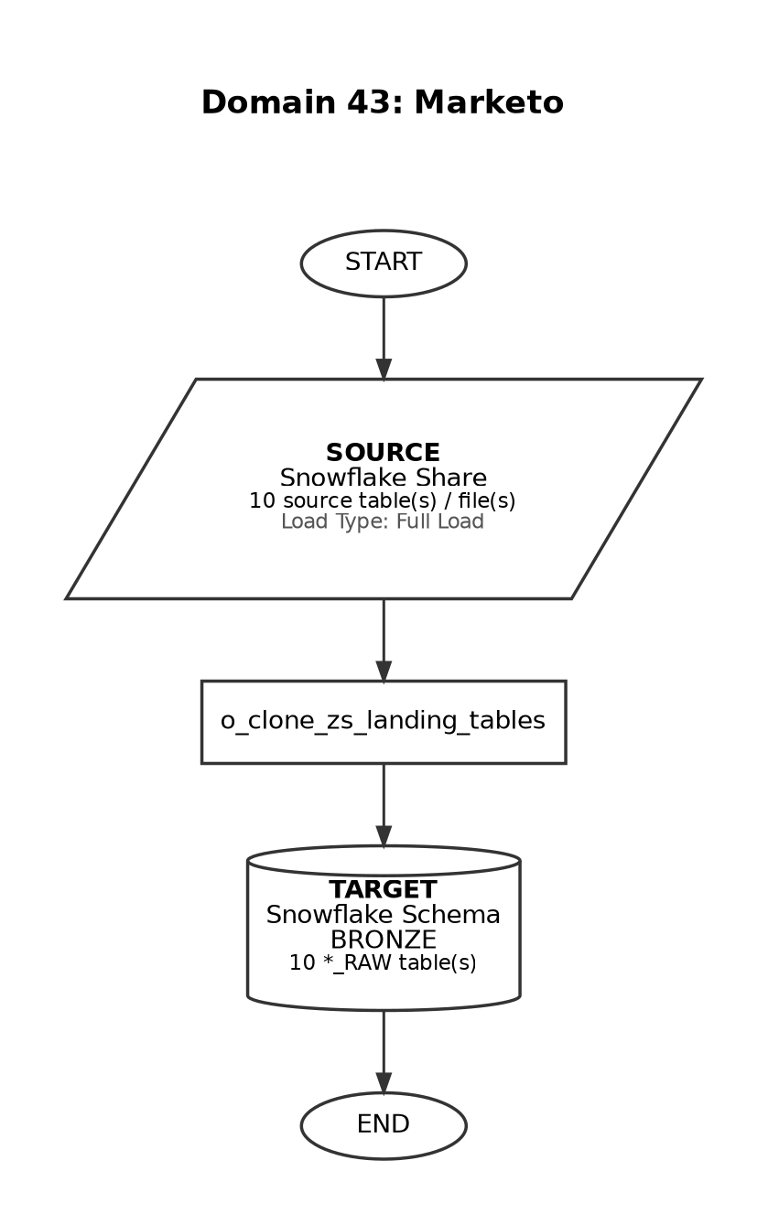

Source-to-Target Table Mapping

# | Source File / Table | Snowflake Target Table (Bronze RAW)
1 | M_MARKETO_ACTIVITY_TYPES | MARKETO_ACTIVITY_TYPES_RAW
2 | M_MARKETO_CAMPAIGNS | MARKETO_CAMPAIGNS_RAW
3 | M_MARKETO_PROGRAMS | MARKETO_PROGRAMS_RAW
4 | STG_MARKETO_ACTIVITY_EMAIL | MARKETO_ACTIVITY_EMAIL_RAW
5 | STG_MARKETO_ACTIVITY_FORMS | MARKETO_ACTIVITY_FORMS_RAW
6 | STG_MARKETO_ACTIVITY_LEAD_OPS | MARKETO_ACTIVITY_LEAD_OPS_RAW
7 | STG_MARKETO_ACTIVITY_NURTURE | MARKETO_ACTIVITY_NURTURE_RAW
8 | STG_MARKETO_ACTIVITY_UPDATES | MARKETO_ACTIVITY_UPDATES_RAW
9 | STG_MARKETO_CUSTOMER | MARKETO_CUSTOMER_RAW
10 | STG_MARKETO_PROGRAM_MEMBER | MARKETO_PROGRAM_MEMBER_RAW

Domain 44: SP (Non-PSP) - Specialty Pharmacy

Attribute | Detail
Domain Name | SP (Non-PSP) - Specialty Pharmacy
Source System | Snowflake Share
Load Type | Full Load
Target Schema | BRONZE
Matillion Pipelines | o_clone_zs_landing_tables
Total Tables | 7
Frequency | Weekdays
Trigger / Schedule | Daily ingestion via clone pipeline

End-to-End Data Flow Diagram

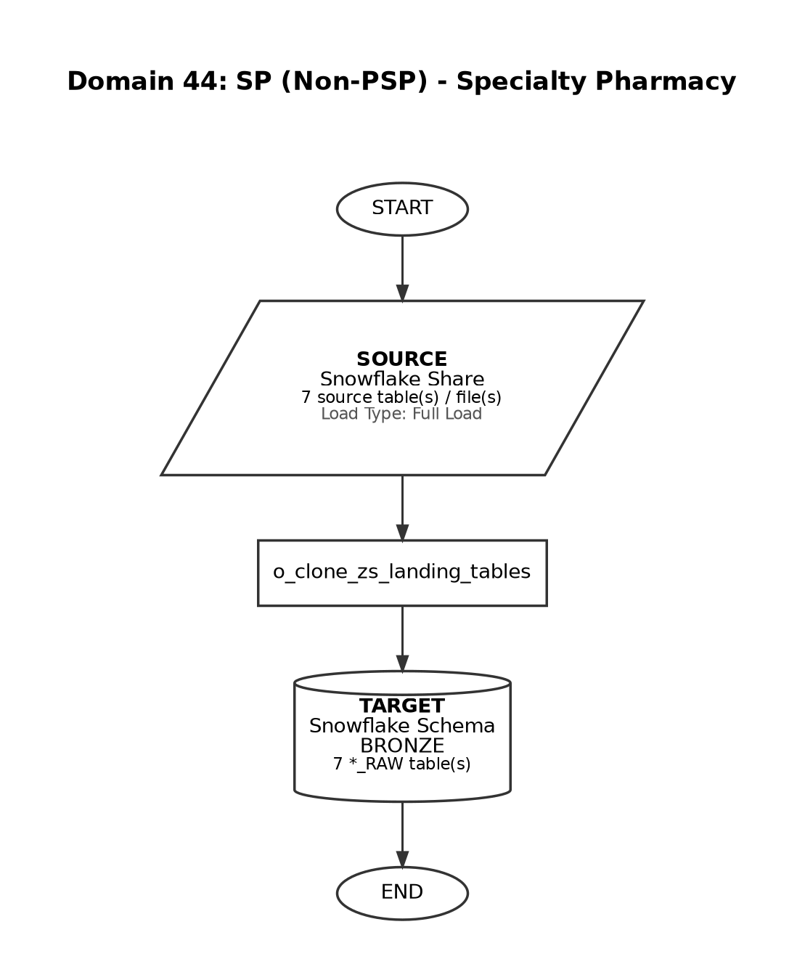

Source-to-Target Table Mapping

# | Source File / Table | Snowflake Target Table (Bronze RAW)
1 | STG_SP_DISPENSE | SP_DISPENSE_RAW
2 | STG_SP_INVENTORY | SP_INVENTORY_RAW
3 | STG_SP_INVENTORY_HIST | SP_INVENTORY_HIST_RAW
4 | STG_SP_METRO | SP_METRO_RAW
5 | STG_SP_PATIENT_ACTIVITY | SP_PATIENT_ACTIVITY_RAW
6 | STG_SP_STATUS | SP_STATUS_RAW
7 | M_PATIENT_STATUS_SUBSTATUS | M_PATIENT_STATUS_SUBSTATUS_RAW

7. Matillion Schedule Reference

The following table lists all Matillion and Lambda schedules governing Bronze layer ingestion and extraction jobs across all regions. INACTIVE schedules are retained for reference.

Status | Region | Tech | Type | Domain | Schedule Name | Pipeline | Frequency | Description
ACTIVE | ALL | Matillion | Ingestion | GLOBAL | Global_Silver_tables | o_transform_veeva_silver_pipeline_global | Weekdays | At 01:25, Sunday through Friday in America/New_York timezone
ACTIVE | EMEA | Matillion | Ingestion | EMEA | emea_prod_bronze_silver_gold_master | o_run_orchestration_master_end_to_end | Hourly | Every hour, between 01:00 and 10:00, Monday through Friday in America/New_York timezone
INACTIVE | EMEA | Matillion |  | EMEA | emea_bronze_master | o_run_orchestration_bronze_master | Hourly | Every hour, Monday through Friday in America/New_York timezone
INACTIVE | EMEA | Matillion |  | EMEA | emea_silver_gold_master | o_run_orchestration_silver_gold_master | Hourly | At 02:30, 05:30, 08:30 and 11:30, Monday through Friday in America/New_York timezone
ACTIVE | Japan | Matillion | Ingestion | JP | jp_prod_iqvia_stock_monthly | o_archive_jp_toho_confirmation_daily | Monthly | On day 1 of the month in Asia/Tokyo timezone
ACTIVE | Japan | Matillion | Ingestion | JP | jp_prod_toho_archive | o_archive_jp_toho_confirmation_daily | Weekdays | At 09:35, Monday through Friday in Asia/Tokyo timezone
ACTIVE | Japan | Matillion | Ingestion | JP | jp_prod_toho_automation_bronze | o_ingest_jp_duplicate_check_pipeline | Weekdays | At 09:35, Monday through Friday in Asia/Tokyo timezone
ACTIVE | Japan | Matillion |  | JP | jp_prod_archive_stock_weekly | o_archive_jp_stock_weekly | Weekly | At 09:35, only on Wednesday in Asia/Tokyo timezone
INACTIVE | ALL | Matillion |  | VEEVA | us_prod_Veeva_align_bronze_load | o_ingest_veeva_align_bronze_data | Daily | At 01:15, Sunday through Friday in America/New_York timezone
INACTIVE | ALL | Matillion |  | VEEVA | us_prod_Veeva_crm_bronze_load | o_ingest_veeva_crm_salesforce | Daily | At 01:07, Sunday through Friday in America/New_York timezone
INACTIVE | ALL | Matillion |  | VEEVA | us_prod_Veeva_network_bronze_load | o_ingest_veeva_network_files | Daily | At 01:10, Sunday through Friday in America/New_York timezone
ACTIVE | US | Matillion | Ingestion | IQVIA | us_prod_iqvia_ama_monthly | o_end_to_end_iqvia_ama_monthly_pipeline | Weekly | At 12:30, only on Friday in America/New_York timezone
ACTIVE | US | Matillion | Ingestion | IQVIA | us_prod_iqvia_laad_monthly | o_end_to_end_iqvia_laad_monthly_pipeline | Monthly | At 19:00, between day 15 and 20 of the month in America/New_York timezone
ACTIVE | US | Matillion | Ingestion | IQVIA | us_prod_iqvia_b_last_workingday_of_mth | o_end_to_end_iqvia_medb_monthly_pipeline | Monthly | At 19:00, on the last weekday of the month in America/New_York timezone
ACTIVE | US | Matillion | Ingestion | IQVIA | us_prod_iqvia_hpd_quarterly | o_end_to_end_iqvia_hpd_quarterly_pipeline | Quarterly | At 19:30, between day 1 and 3 of March, June, September, December in America/New_York timezone
ACTIVE | US | Matillion | Ingestion | CARDINAL | us_prod_cardinal_bronze | o_clone_zs_landing_cardinal_tables | Weekdays | At 02:30, Monday through Friday in America/New_York timezone
ACTIVE | US | Matillion | Ingestion | VIALS | us_prod_vials_silver_gold | o_transform_us_vials_silver_gold | Weekdays | At 02:40, Monday through Friday in America/New_York timezone
ACTIVE | US | Matillion | Ingestion | IQVIA | us_prod_iqvia_laad_weekly_thu_fri | o_end_to_end_iqvia_laad_mg_weekly_pipeline | Weekly | At 19:00, Thursday through Friday in America/New_York timezone
INACTIVE | US | Matillion |  | CARDINAL | us_prod_cardinal_community_athena | o_ingest_bronze_cardinal_data_athena | Weekdays | At 09:32, Monday through Friday in America/New_York timezone
ACTIVE | US | Matillion |  | IQVIA | o_extract_iqvia_community_health_extract | o_extract_iqvia_community_health | Monthly | At 11:35, on the third Thursday of the month in America/New_York timezone
ACTIVE | US | Matillion | Ingestion | H1 | us_hs_s_02_bronze_load | o_ingest_hs_data_s3_parquet | BiMonthly | At 18:30, on day 15 and 28 through 30 of the month
ACTIVE | US | Matillion | Ingestion | AMIR | us_prod_bronze_amir_data | o_ingest_bronze_amir_data | Weekdays | At 02:00, Monday through Friday in America/New_York timezone
ACTIVE | US | Matillion | Extract | AMIR | us_prod_AMIR_silver_load | o_transform_medical_affairs_amir_data | Weekdays | At 02:20, Monday through Friday in America/New_York timezone
ACTIVE | US | Matillion | Extract | Medical Affairs | us_prod_medical_affairs_extracts_sorcero | o_extract_medical_affairs | Monthly | At 06:00, only on Tuesday in America/New_York timezone
ACTIVE | US | Matillion |  | HCP | us_reflex_survey_extract | o_extract_reflex_data | Weekly | At 23:30, only on Sunday in America/New_York timezone
ACTIVE | US | Lambda | Ingestion | PSP | s_daily_psp_data_ingestion | o_daily_psp_data_model_refresh_job_dbt | Weekdays | Once the Non-PSP Patient Silver and Gold completes
INACTIVE | US | Matillion |  | IHUB | us_ihub_zs_token | o_clone_zs_landing_iqvia_token_tables | Weekdays | At 05:00, Monday through Wednesday in America/New_York timezone
ACTIVE | US | Matillion | Extract | AMA-PDRP | us_ama_pdrp_extract | o_extract_ama_pdrp_monthly_job | Weekly | At 12:55, only on Friday in America/New_York timezone
ACTIVE | CA | Matillion | Ingestion | Bayshore | ca_bayshore_weekly | o_clone_zs_landing_bayshore_tables_weekly | Weekly | At 09:00, only on Tuesday in America/New_York timezone
ACTIVE | US | Matillion | Ingestion | Quest | us_s_quest_data_ingest | o_ingest_quest_s3_files | Weekly | At 17:30, only on Friday in America/New_York timezone
ACTIVE | US | Matillion | Ingestion | IQVIA PinPoint | us_iqvia_pinpoint_steps | o_ingest_pulsepoint_to_veeevaCRM_1 | Weekly | At 12:30, only on Thursday in America/New_York timezone
ACTIVE | US | Matillion | Extract | IQVIA PinPoint | us_iqvia_pinpoint_steps2 | o_ingest_pulsepoint_steps2 | Weekly | At 12:30, only on Friday in America/New_York timezone
ACTIVE | US | Matillion | Ingestion | TXHub | us_txhub_s3_ingestion | o_ingest_txhub_s3_files | Weekdays | At 00:40, Monday through Friday in America/New_York timezone
ACTIVE | US | Matillion | Ingestion | Eversana | us_eversana_data_refresh | o_ingest_eversana_s3_files | Monthly | At 18:30, on day 15 of the month in America/New_York timezone
ACTIVE | US | Matillion | Ingestion | Spring N Bond | us_marketing_media_interaction_daily | o_weekly_end_to_end_hcp_marketing_media_interaction | Weekly | At 05:30, only on Friday in America/New_York timezone
ACTIVE | US | Matillion | Extract | Tableau | us_tableau_universe | o_run_orchestration_uniclense_tableau_users | Weekly | At 20:00, only on Thursday in America/New_York timezone
ACTIVE | US | Matillion | Extract | TXHub | us_txhub_zip_daily_extract | o_extract_txhub_m_zip_to_rep | Weekdays | At 06:30, Monday through Friday in America/New_York timezone
ACTIVE | US | Matillion | Extract | Medical Affairs | us_prod_medical_affairs_extracts_sorcero | o_extract_medical_affairs_monthly | Monthly | At 12:35, on the First Monday of the month in America/New_York timezone
ACTIVE | US | Matillion | Ingestion | PulseCenter | us_pulse_center_quality | o_pulsectr_refresh | Weekdays | At 07:15, Monday through Friday in America/New_York timezone
ACTIVE | US | Matillion | Ingestion | IQVIA PinPoint | us_iqvia_pinpoint_digital | o_ingest_iqvia_digital | Weekly | At 12:45, only on Friday in America/New_York timezone
ACTIVE | US | Matillion | Ingestion | MMIT | us_mmit_data_ingestion_mthly | o_ingest_mmit_s3_files | Monthly | At 18:30, between day 03 and 07 of the month in America/New_York timezone
ACTIVE | US | Matillion | Ingestion | H1 | us_hs_s_os_bronze_load | o_ingest_hs_data_s3_parquet | BiMonthly | At 17:00, on day 15, 28-30 of the month in America/New_York timezone
ACTIVE | US | Matillion | Extract | Kalderos | us_kalderos_extract_weekly | o_extract_cardinal_data_kalderos | Weekly | At 17:00, only on Tuesday in America/New_York timezone
ACTIVE | US | Matillion | Ingestion | Kalderos | us_kalderos_ingest_weekly | o_ingest_kalderos_all_files | Weekly | At 06:00, only on Tuesday in America/New_York timezone
ACTIVE | US | Matillion | Extract | TXHub | us_txhub_zip_rep_daily_extract | o_extract_txhub_m_zip_to_rep_roles | Weekdays | At 06:35, Monday through Friday in America/New_York timezone
ACTIVE | CA | Matillion | Ingestion | Data Model Refresh | ca_bayshore_weekly_refresh | o_transform_patient_ca_data | Weekly | At 06:45, only on Tuesday in America/New_York timezone
ACTIVE | US | Lambda | Ingestion | CARDINAL |  | o_clone_zs_landing_cardinal_tables | Weekdays | Trigger based - Approx 9:30 AM EST
ACTIVE | US | Lambda | Ingestion | PSP | s_daily_psp_data_ingestion | o_daily_psp_bronze_refresh_job | Weekdays | Trigger based - Between 12:45 and 1:15 am EST
ACTIVE | US | Matillion | Ingestion | DCR | us_network_dcr | o_ingest_dcr_files | Daily | At 02:30, every day in America/New_York timezone

8. PSP Execution Dependency Chain

PSP domain ingestion (Medisafe PSP, NCM PSP) is trigger-based and depends on the successful completion of Non-PSP Silver and Gold layers. The full execution chain is as follows:

Step | Process | Description | Trigger Condition
1 | Non-PSP Bronze Ingest | Extract STG tables from Snowflake Share; load to BRONZE schema | Scheduled - weekdays
2 | Non-PSP Silver (dbt) | Transform Bronze RAW into cleansed Silver tables | Trigger after Step 1
3 | Non-PSP Gold (dbt) | Aggregate Silver into Gold - Patient domain complete | Trigger after Step 2
4 | PSP Clone (Cardinal/Medisafe/NCM) | Clone ZS landing tables and prepare PSP staging area | Trigger after Step 3 - approx 9:30 AM EST
5 | PSP Bronze Refresh | Full load PSP tables into BRONZE_PSP schema (12:45-1:15 am EST) | Trigger after Step 4
6 | PSP dbt Refresh | Refresh PSP Silver and Gold dbt models | Trigger after Step 5

9. Operational Notes and Considerations

- Full Load strategy truncates and replaces all records on each run. There is no merge or upsert logic at the Bronze layer.
- Incremental domains (Veeva CRM, AMIR, Quest, Veeva Align, IQVIA LAAD, MMIT, EVERSANA, Toho, CMEA, JP, IQVIA DDD, Kalderos) append or delta-load records and use _DELTA suffix in target table names where applicable.
- PSP domains (Medisafe PSP, NCM PSP) use the BRONZE_PSP schema and are entirely dependent on Non-PSP Silver and Gold completion before execution.
- Parquet-format domains (H1 5_02, H1 5_05) use dedicated parquet ingestion pipelines (o_ingest_h1_data_s3_parquet, o_ingest_h1_SOS_data_s3_parquet).
- One-time loads: Customer Ship-to-List and PREMIER HEOR were loaded once and are not scheduled for repeat ingestion.
- Quest domain uses dq_audit.etl_domain_metadata for dynamic file processing. The b_date variable must be managed carefully on first run (set to 20250711 for historical load, then unset the default).
- Kalderos eligibility file tabs (FULL, ADDED, REMOVED, UPDATED) are mapped to separate delta target tables using the tab name as a suffix.
- SpringBond contributes two separate feed types: HCP Marketing Media Interactions (22 channels) and Marketing Data Mapping.
- IQVIA LAAD data covers three distinct domains: MG Weekly (L80952), MG Monthly (L210512), and CIDP Monthly (L62123), each with its own pipeline.
- All Matillion schedules operate in America/New_York timezone unless explicitly noted (Japan schedules use Asia/Tokyo timezone).
- INACTIVE schedules are retained in the schedule registry for reference and can be re-activated as needed.

