Bronze Layer
Domain Flowcharts
End-to-End Data Ingestion Flow Diagrams
All 44 Domains
Platform: Snowflake + Matillion
Layer: Bronze (RAW)

Domain 1

Medisafe (Non-PSP)
Frequency: Weekdays
Daily ingestion - precedes PSP execution chain
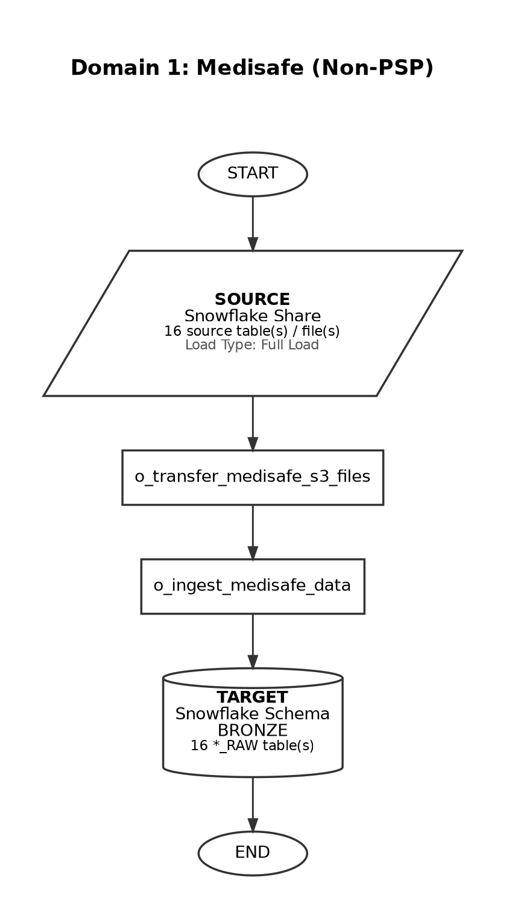

Domain 2

Medisafe (PSP)
Frequency: Weekdays
Trigger-based: runs after Non-PSP Patient Silver and Gold complete (12:45-1:15 am EST)
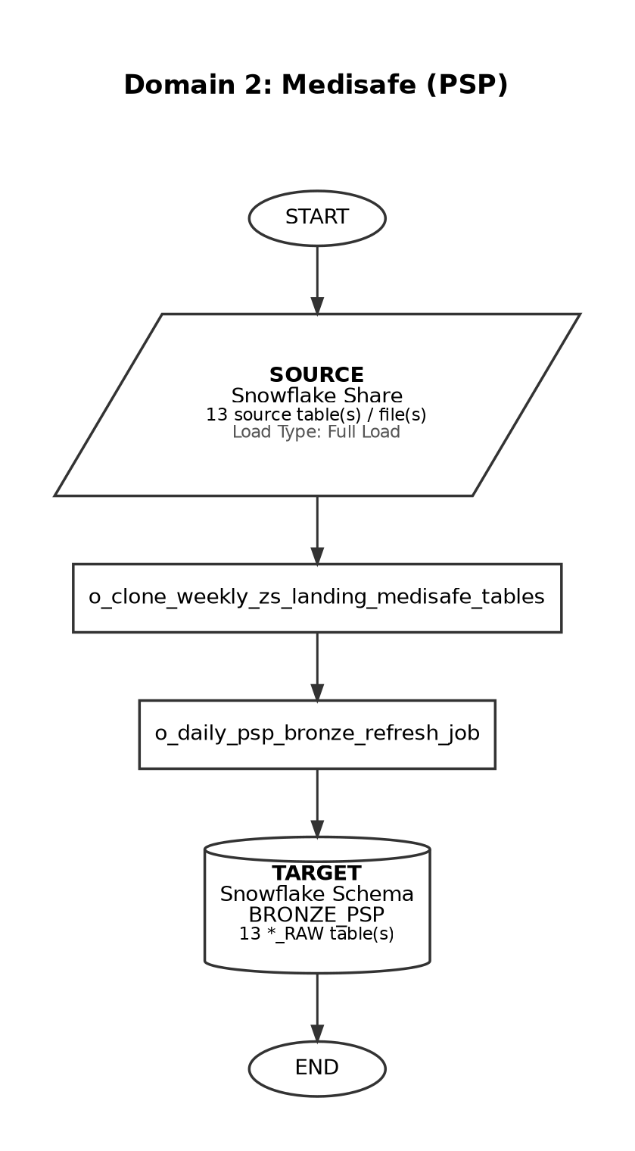

Domain 3

Precision
Frequency: Ad-hoc
On-demand / business-driven refresh
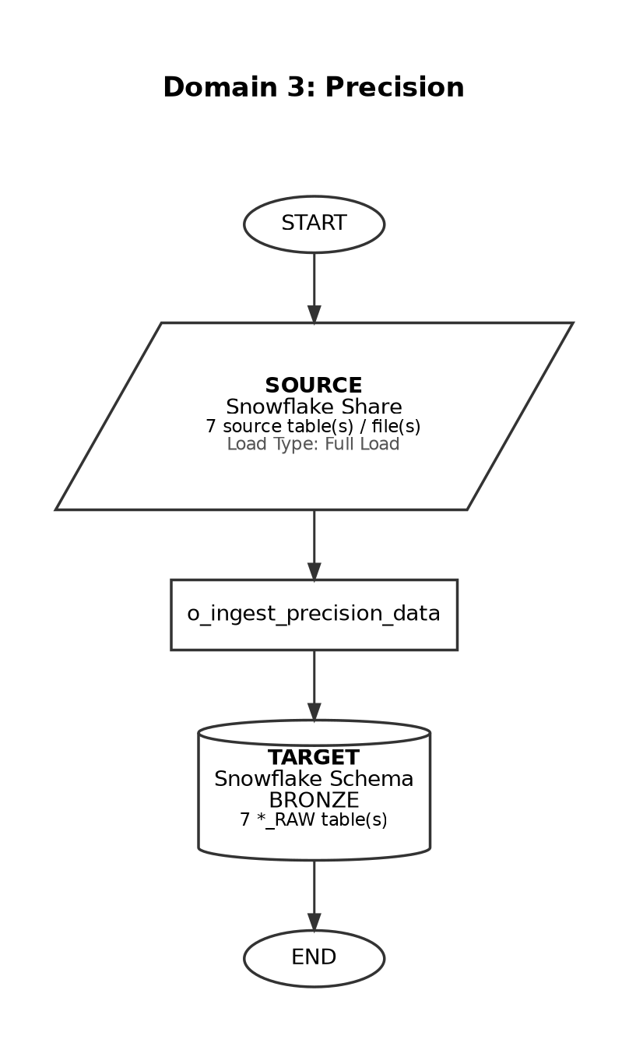

Domain 4

Qral
Frequency: Quarterly
Performance Extract loads only for 2nd and 3rd month of the quarter
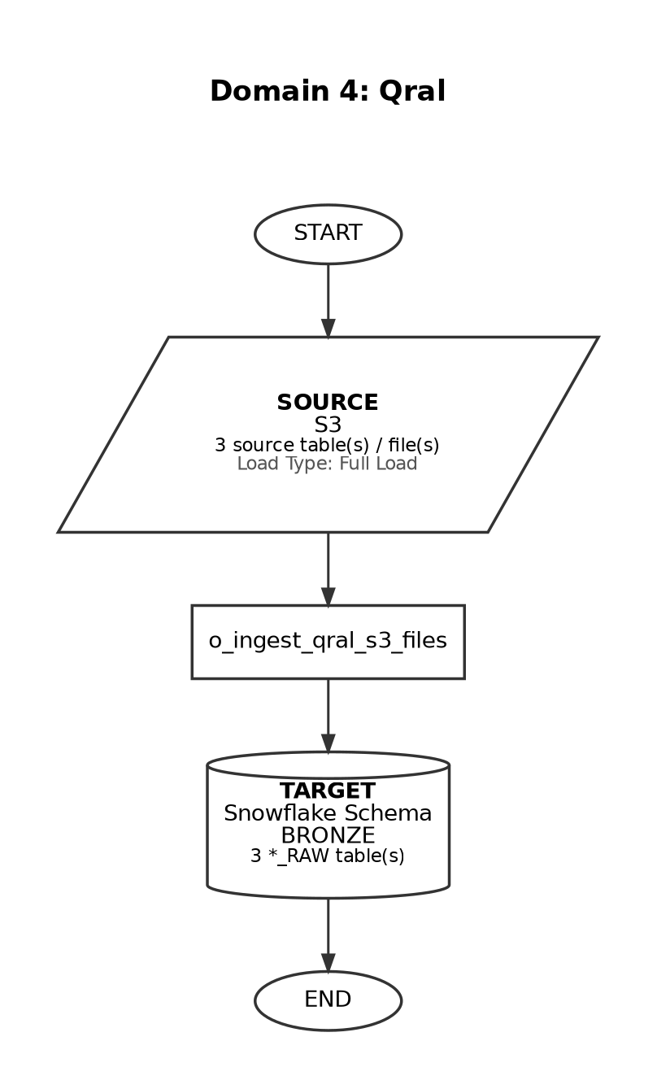

Domain 5

Pulsepoint
Frequency: Ad-hoc
On-demand load
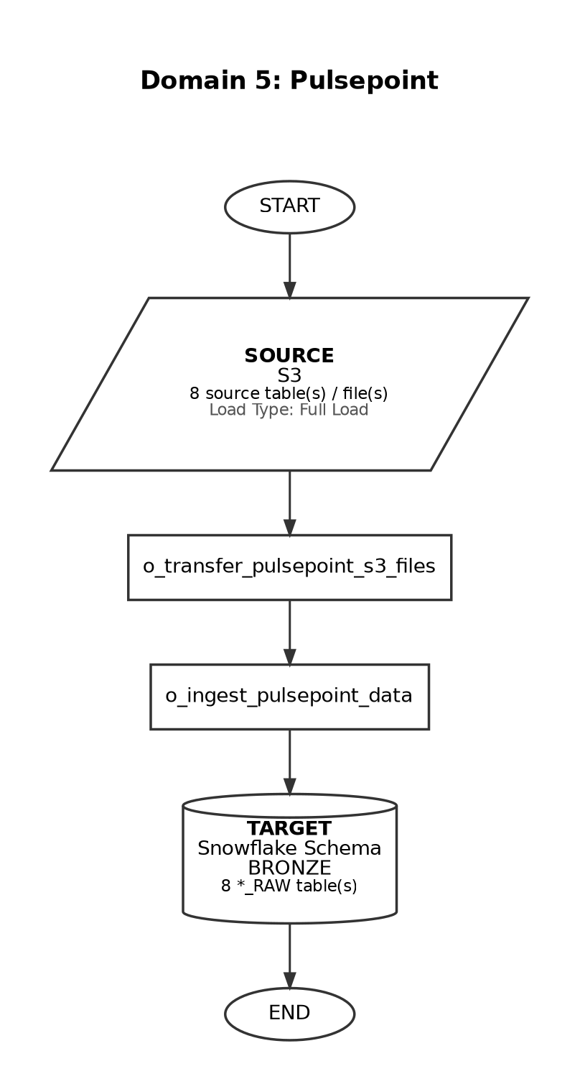

Domain 6

SpringBond (HCP Marketing Media)
Frequency: Weekly
At 05:30 on Friday (America/New_York timezone)
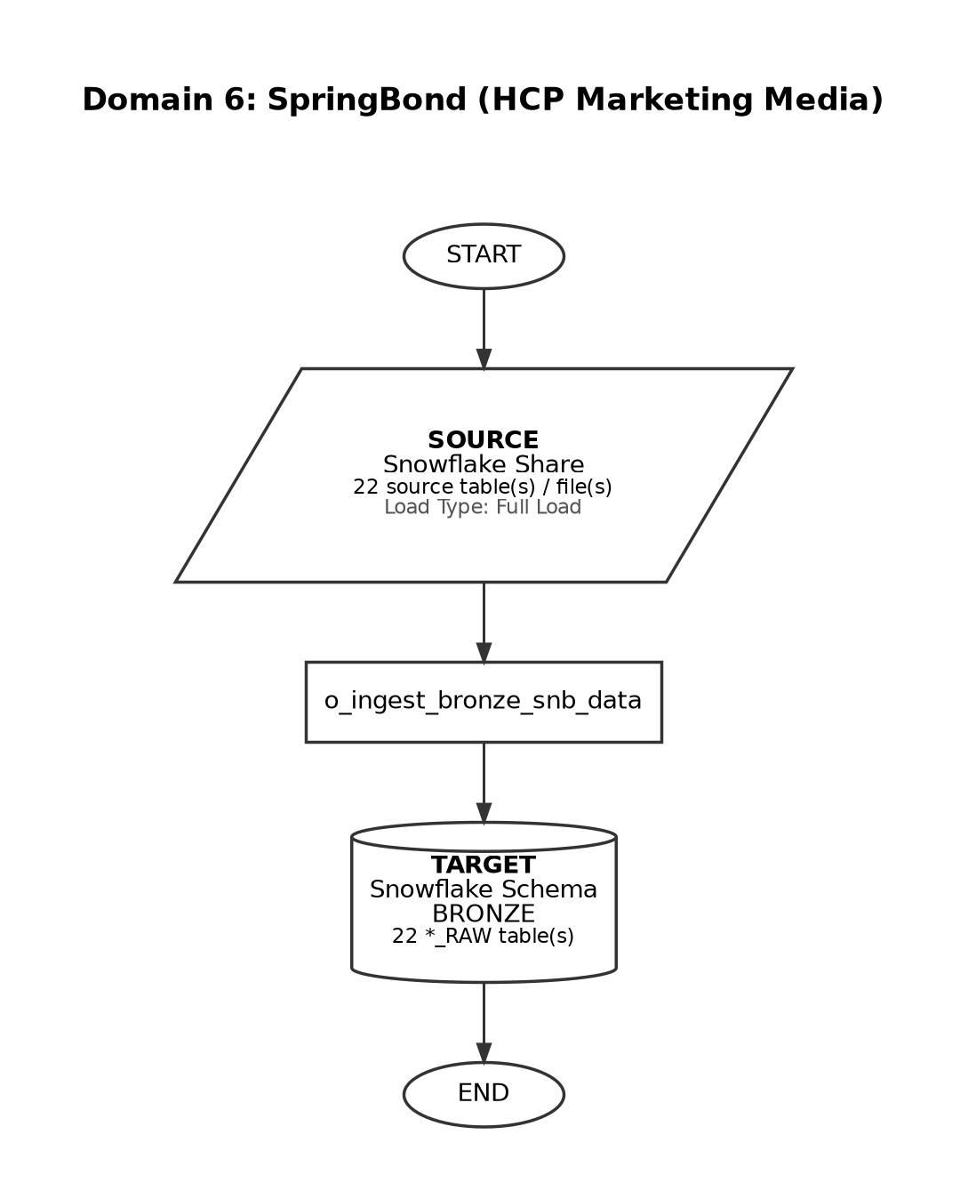

Domain 7

Veeva Network
Frequency: Daily
At 01:10, Sunday-Friday (currently INACTIVE in schedule registry)
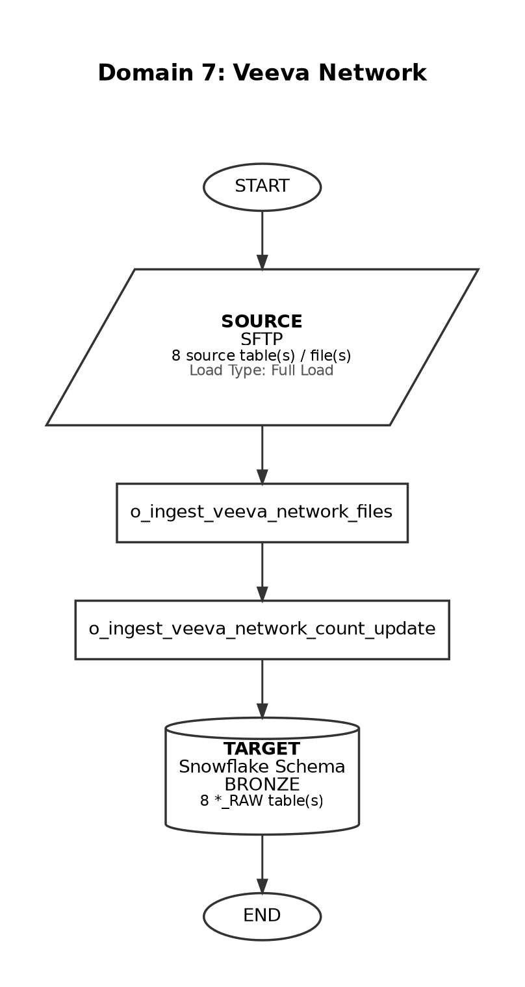

Domain 8

Customer Ship-to-List
Frequency: One-time
Single load - not scheduled for repeat ingestion
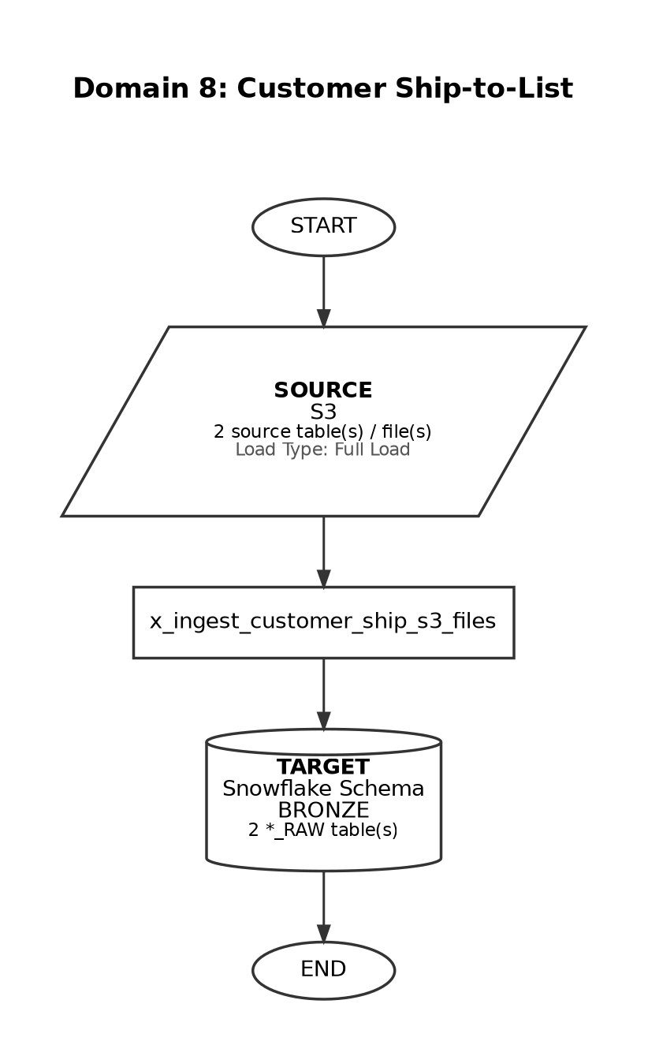

Domain 9

Veeva CRM
Frequency: Daily
At 01:07, Sunday-Friday (currently INACTIVE in schedule registry)
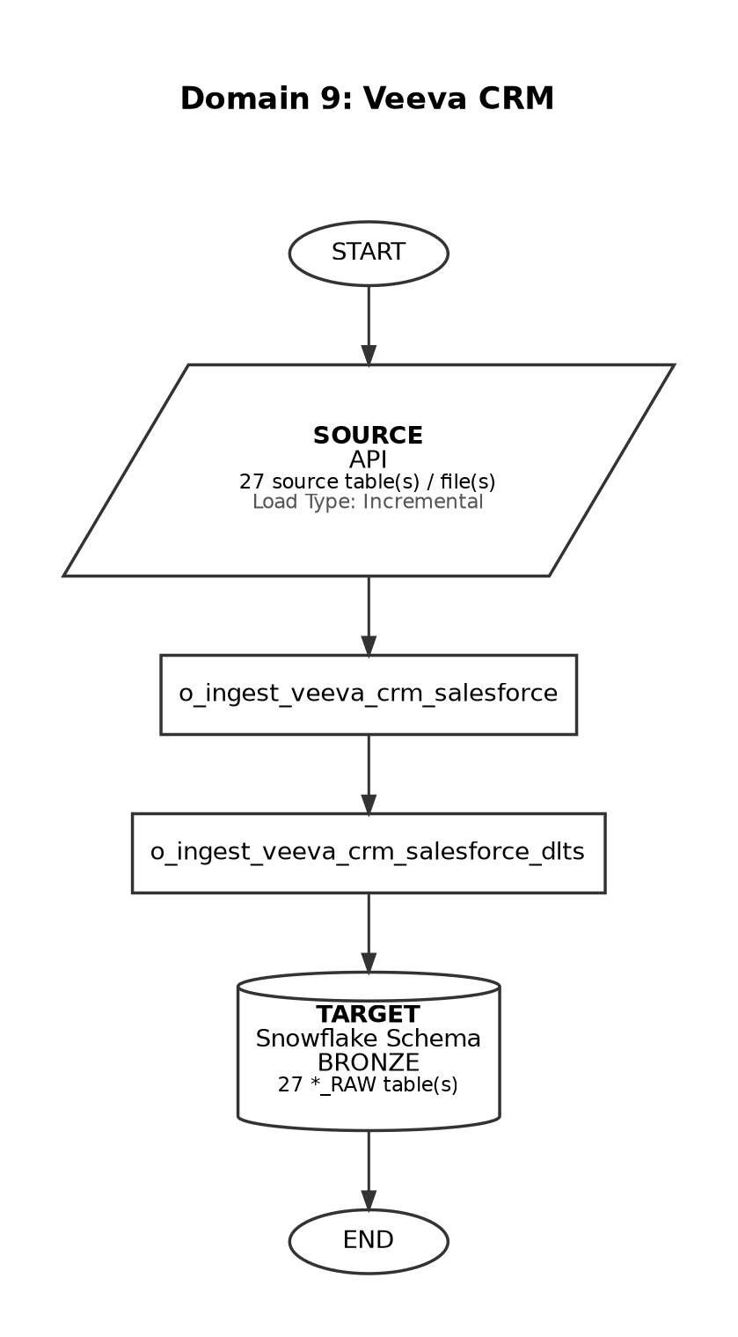

Domain 10

AMIR
Frequency: Weekdays
At 02:00, Monday-Friday (America/New_York timezone)
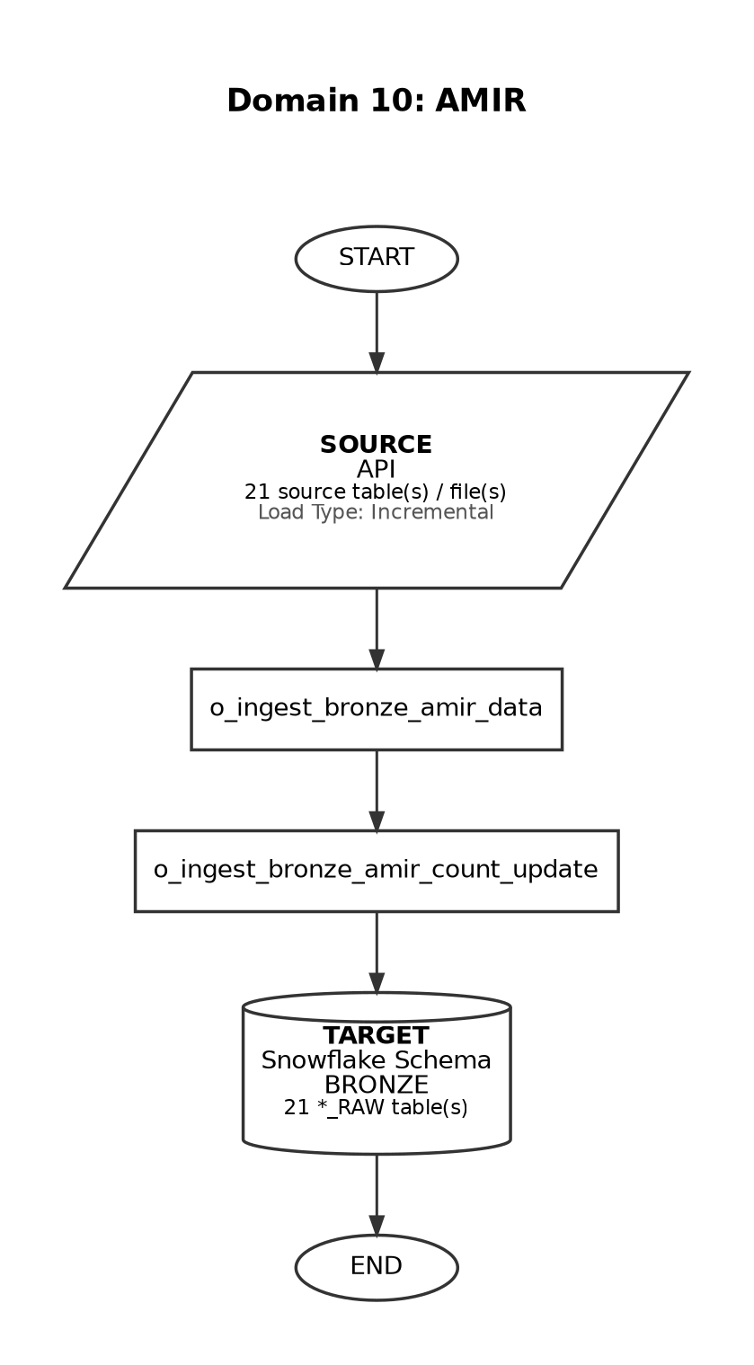

Domain 11

iHub
Frequency: Ad-hoc
Manual / on-demand ingestion
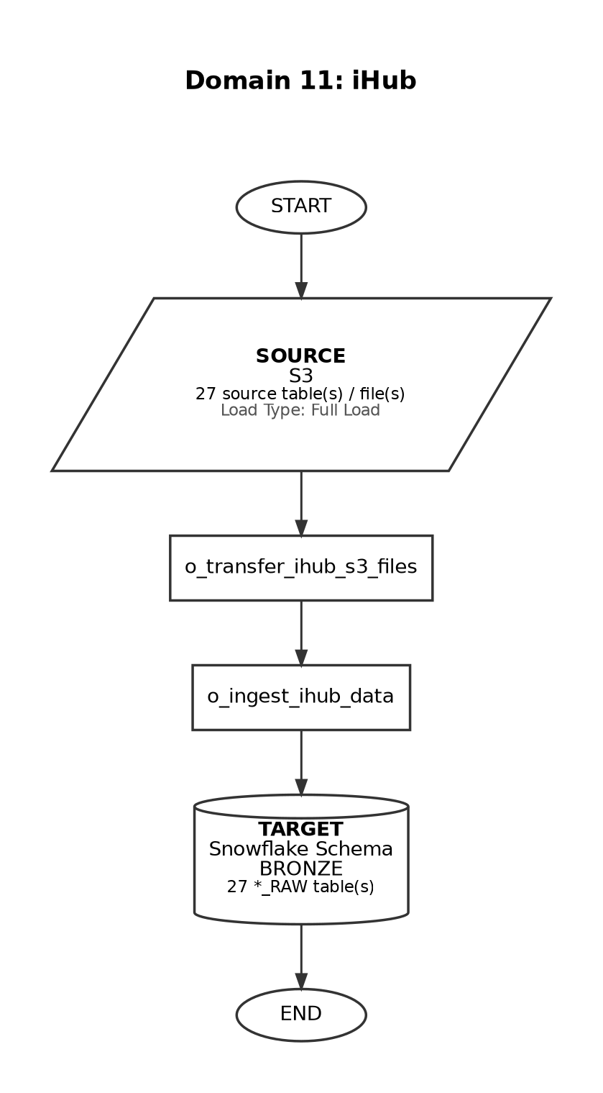

Domain 12

Veeva Align
Frequency: Daily
At 01:15, Sunday-Friday (currently INACTIVE in schedule registry)
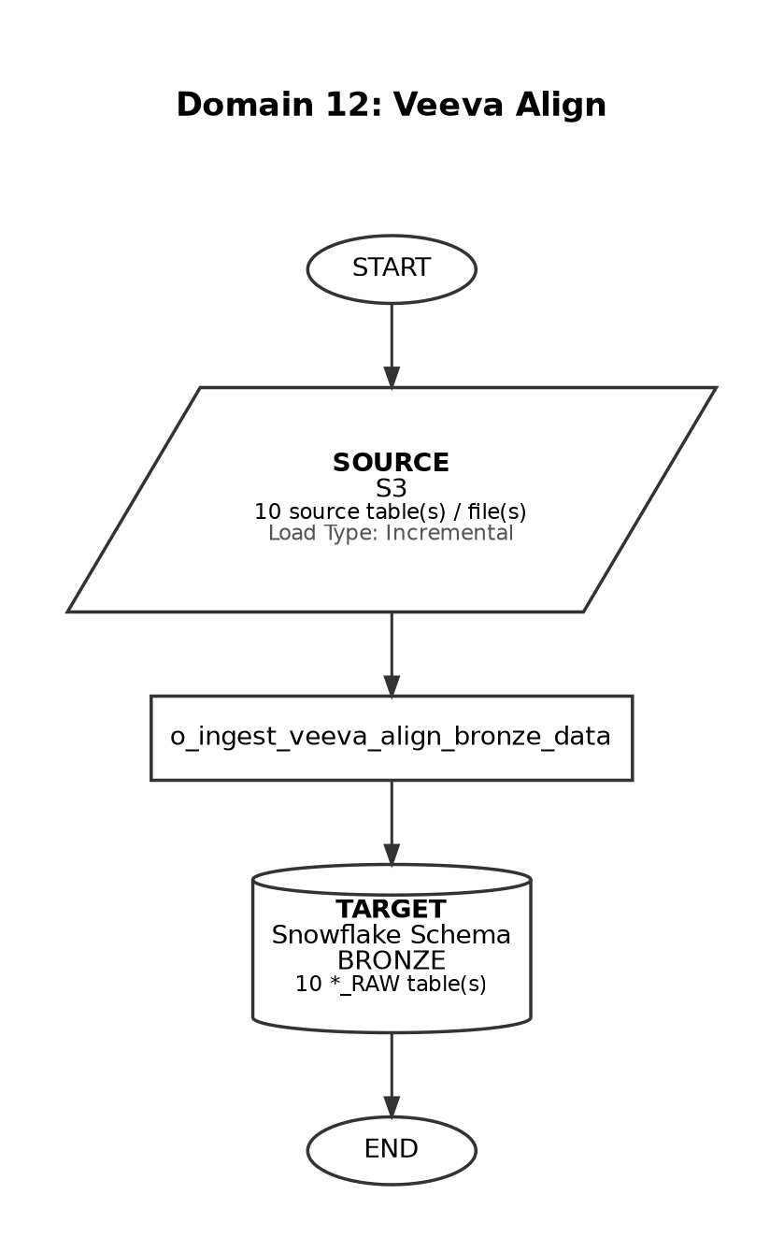

Domain 13

ZS Landing Cardinal (3PL)
Frequency: Weekdays
At 02:30 (Matillion) + Lambda trigger approx 9:30 AM EST
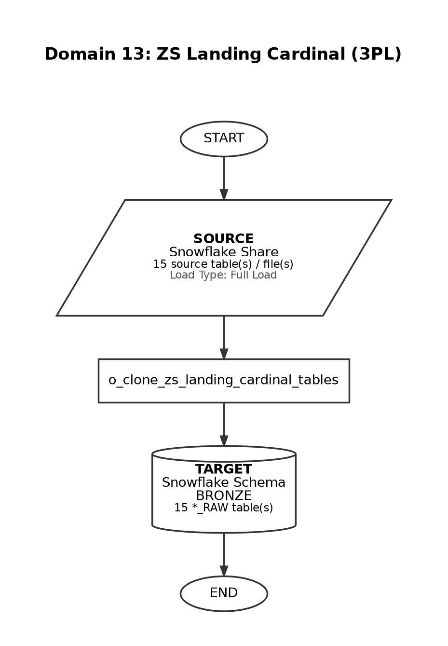

Domain 14

H1 (5_02) - HCP Data
Frequency: BiMonthly
At 18:30, on day 15 and 28-30 of the month
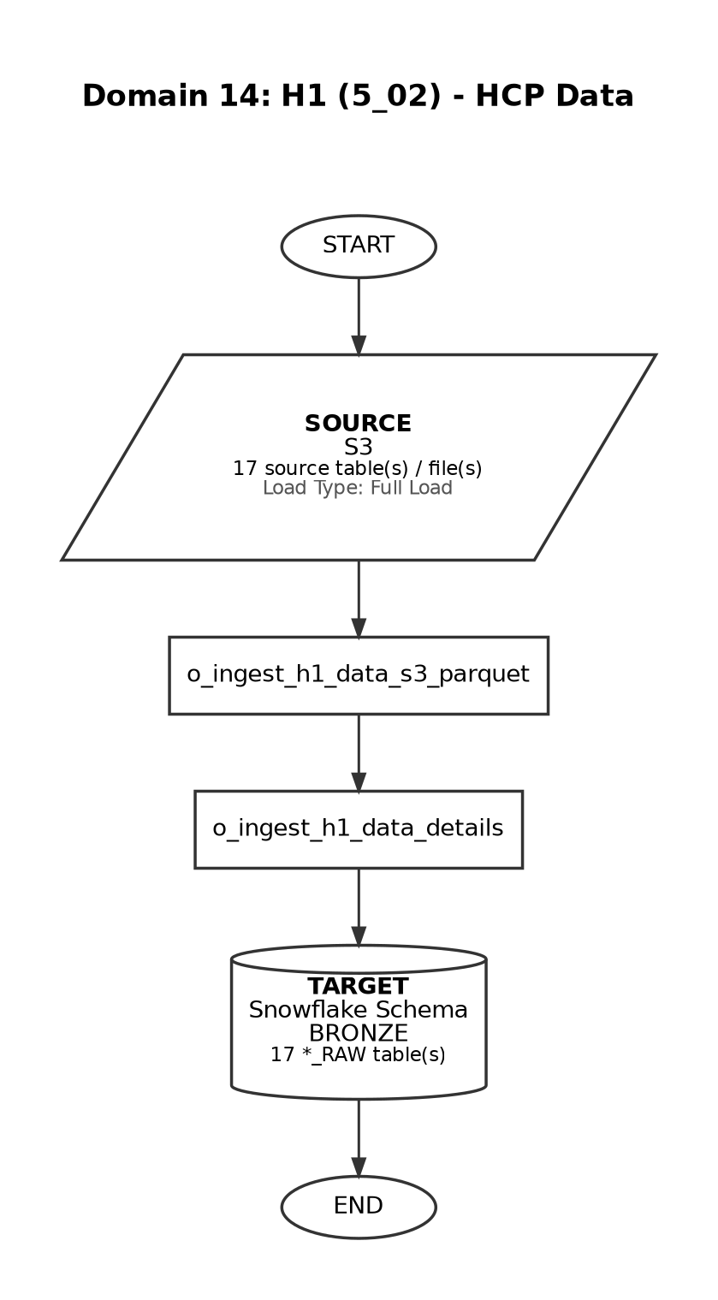

Domain 15

Quest
Frequency: Weekly
At 17:30, only on Friday (America/New_York timezone)
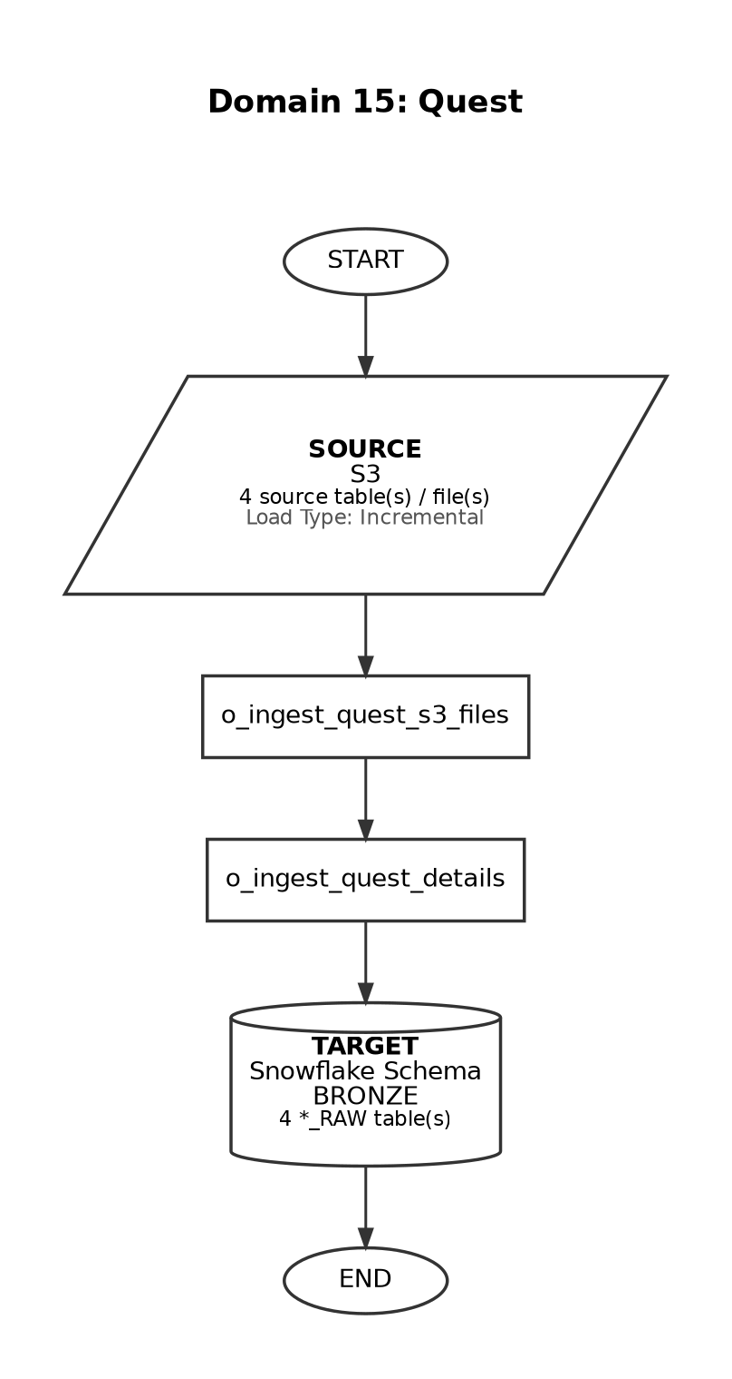

Domain 16

IQVIA Master (Tokenization)
Frequency: Ad-hoc
Manual / on-demand load
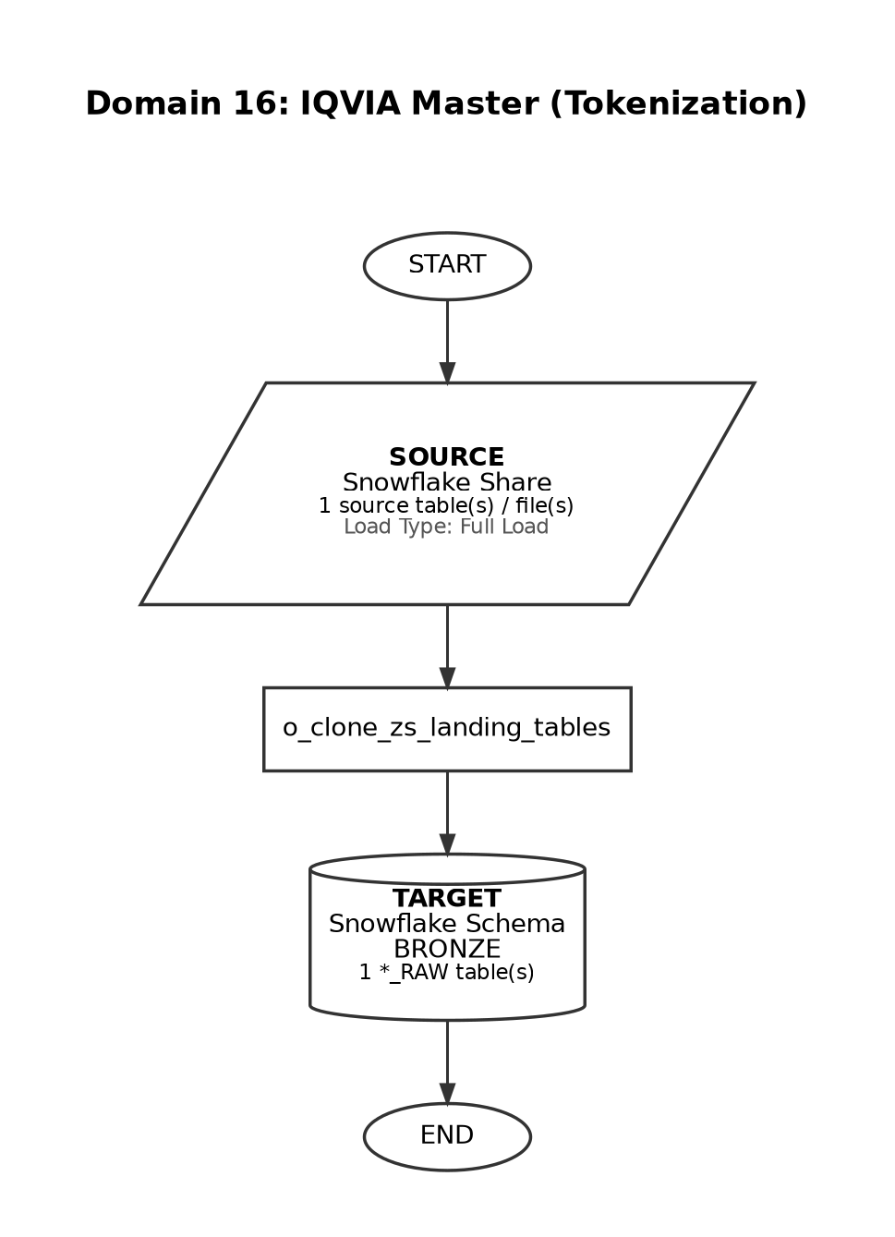

Domain 17

EVERSANA
Frequency: Monthly
At 18:30, on day 15 of the month (America/New_York timezone)
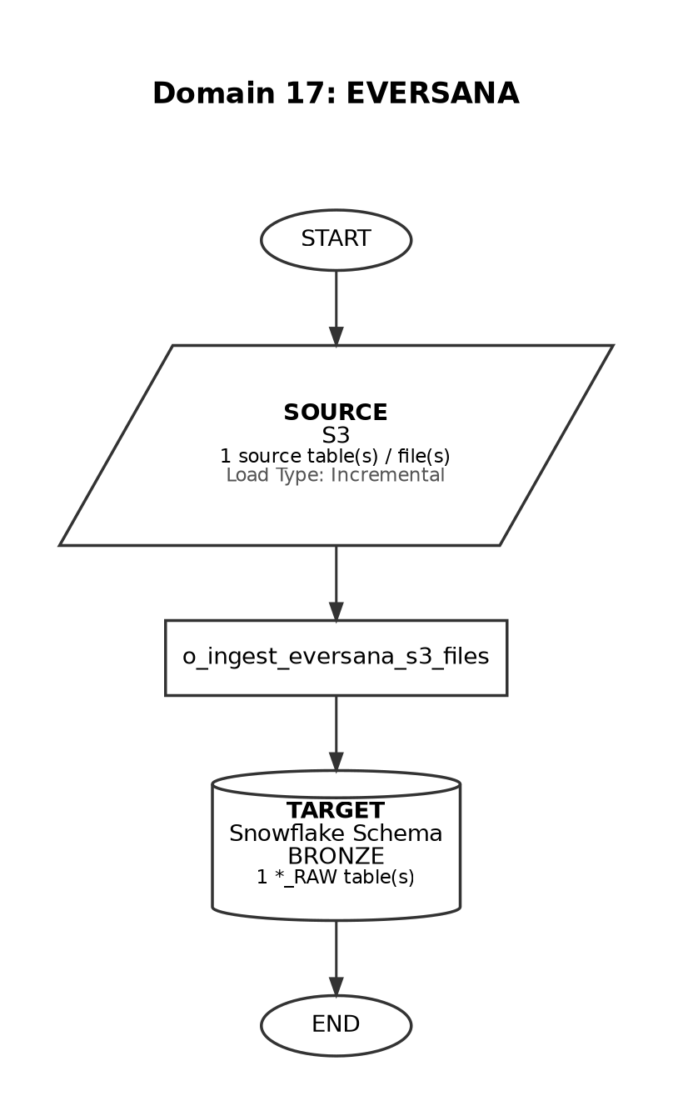

Domain 18

H1 (5_05) - Clinical Study Data
Frequency: BiMonthly
At 17:00, on day 15 and 28-30 of the month
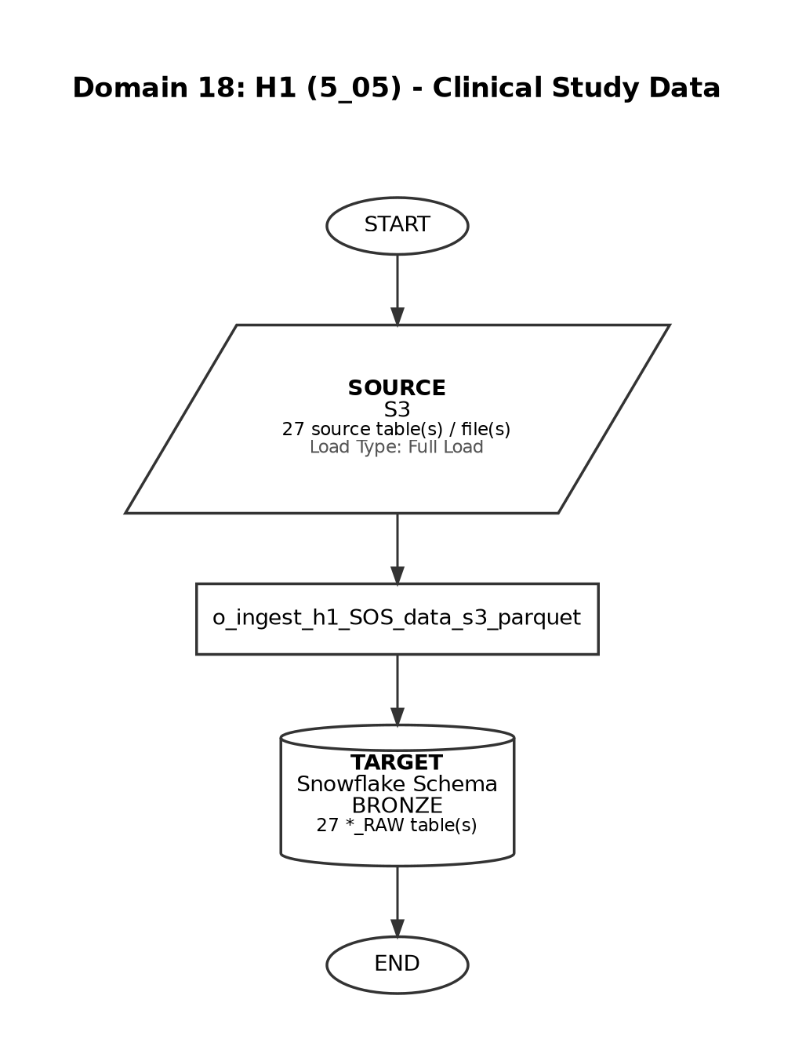

Domain 19

SpringBond (Marketing Data Mapping)
Frequency: Ad-hoc
Manual / on-demand load
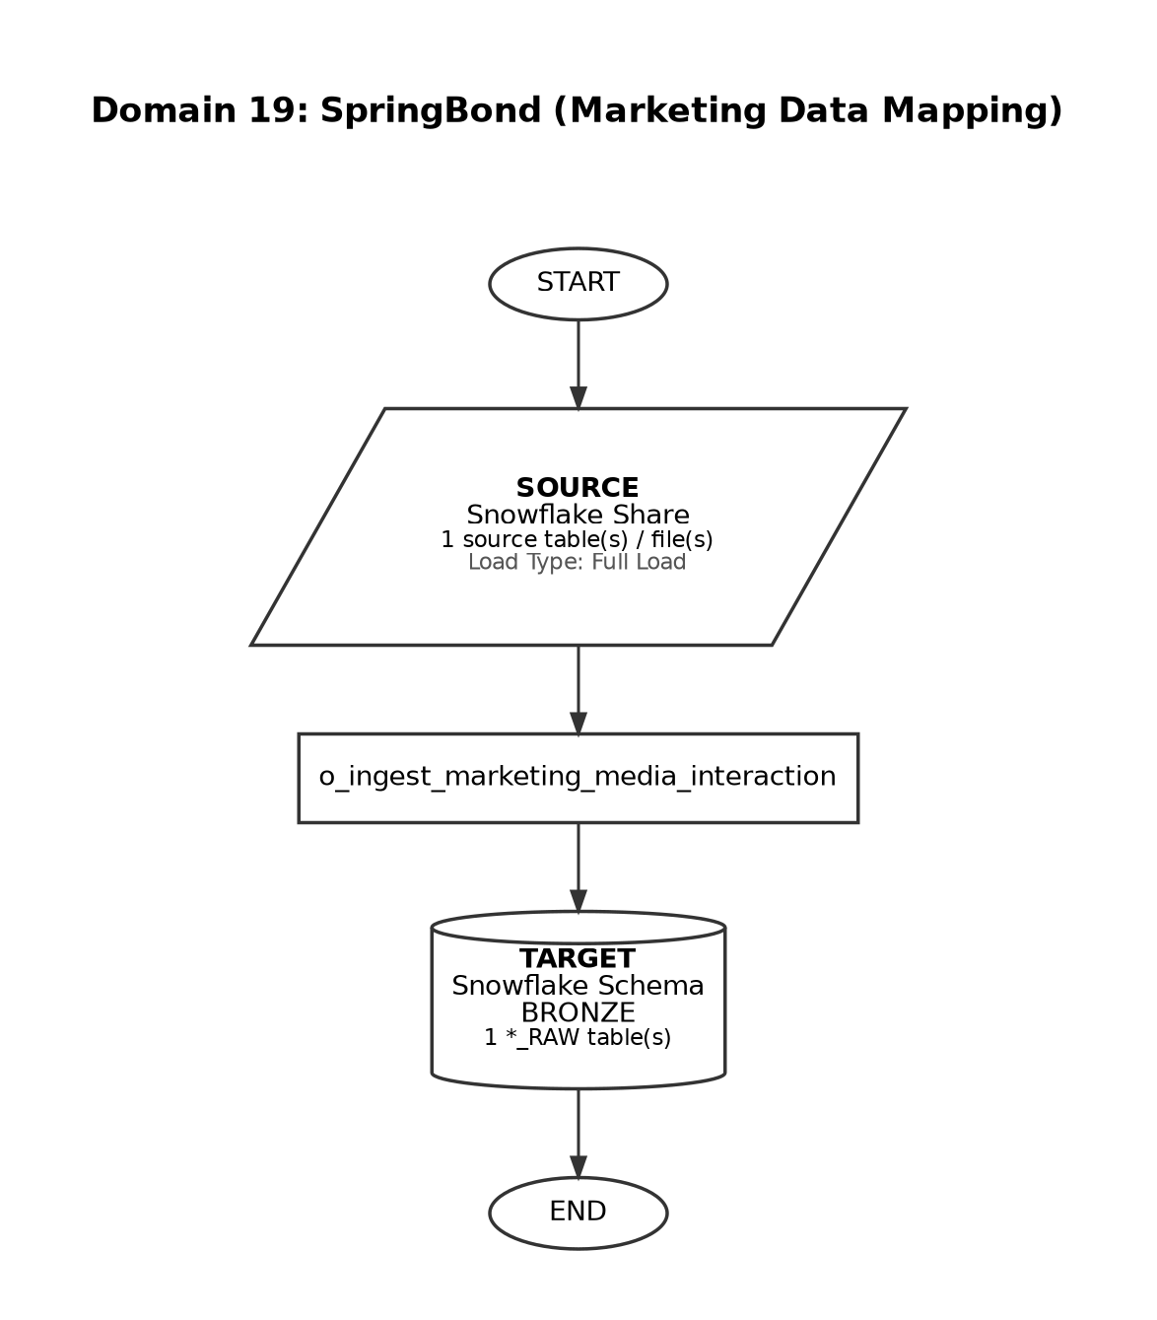

Domain 20

MMIT (Data Feed)
Frequency: Monthly
At 18:30, between day 03 and 07 of the month
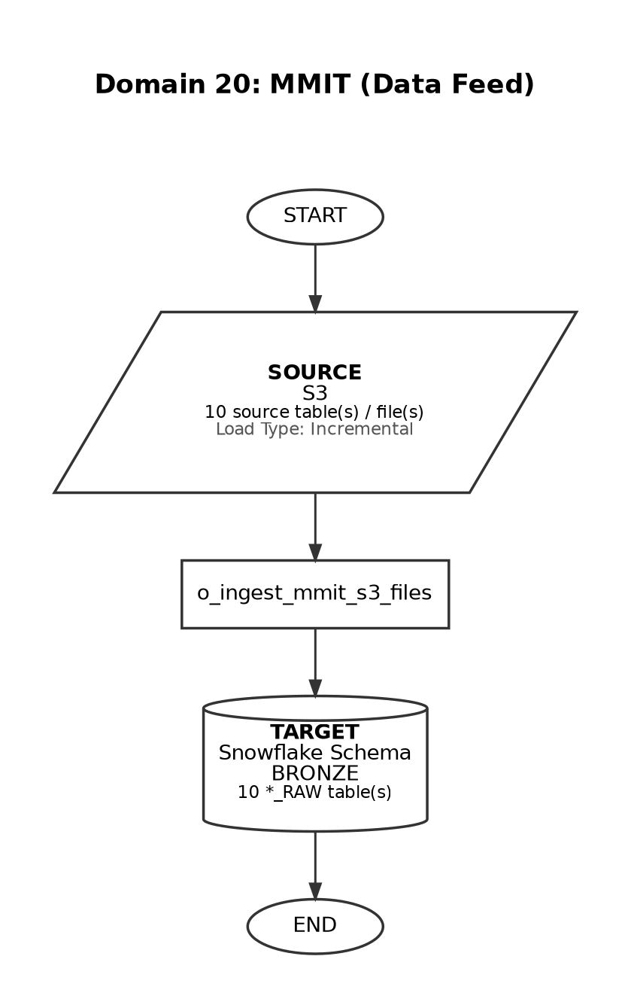

Domain 21

MMIT (PAR Feed)
Frequency: Monthly
At 18:30, between day 03 and 07 of the month (same pipeline as MMIT Data Feed)
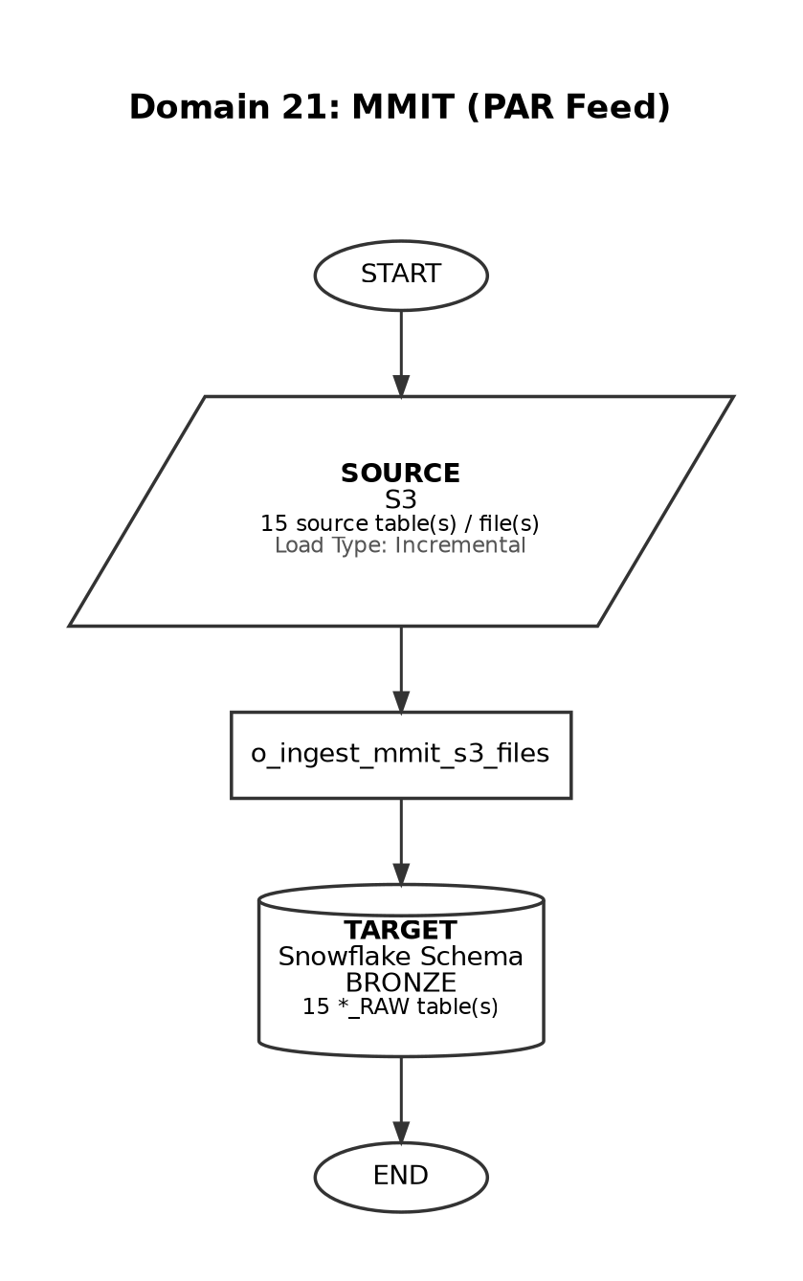

Domain 22

PREMIER HEOR
Frequency: One-time
Single load - not scheduled for repeat ingestion
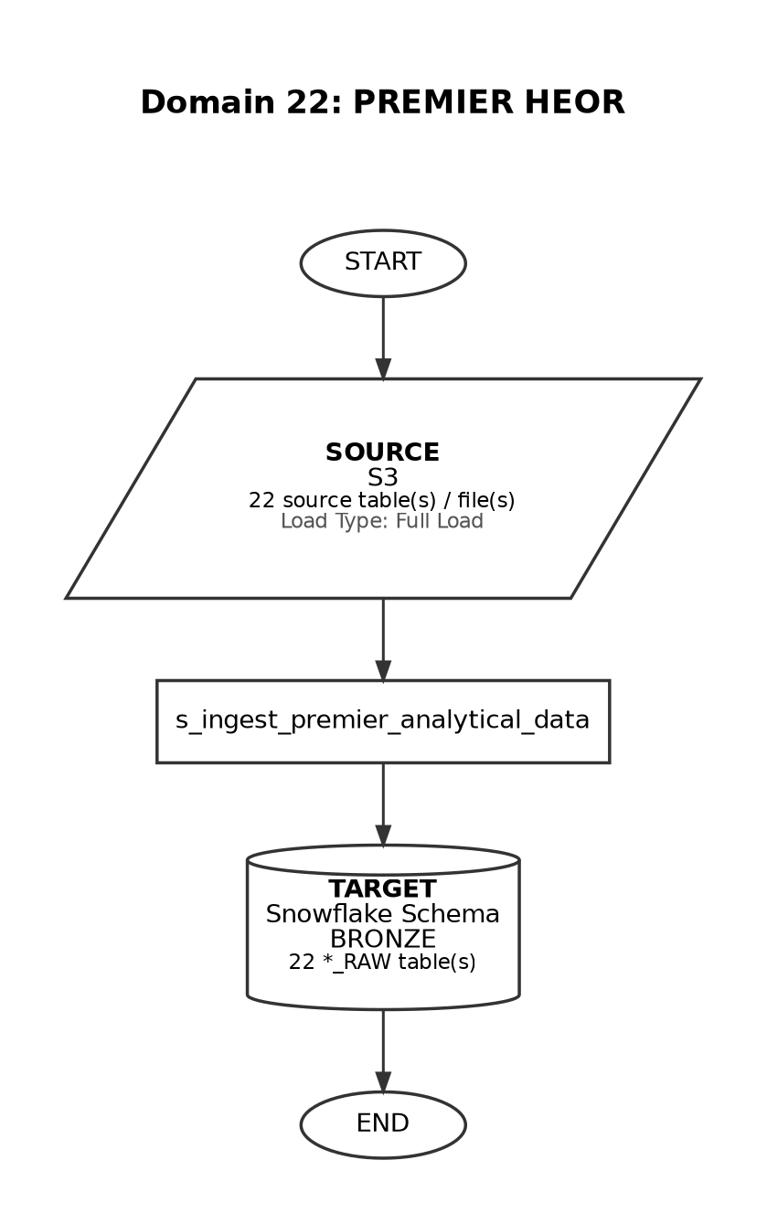

Domain 23

CMEA
Frequency: Hourly
Every hour, between 01:00 and 10:00, Monday-Friday (EMEA orchestration)
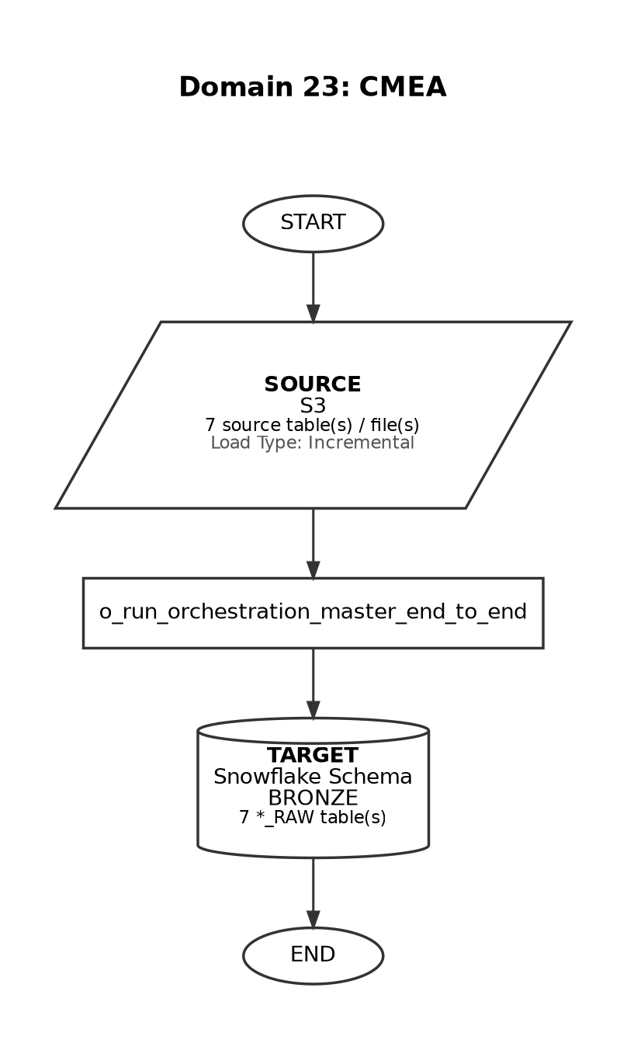

Domain 24

UKI Data
Frequency: Ad-hoc
Manual / on-demand load
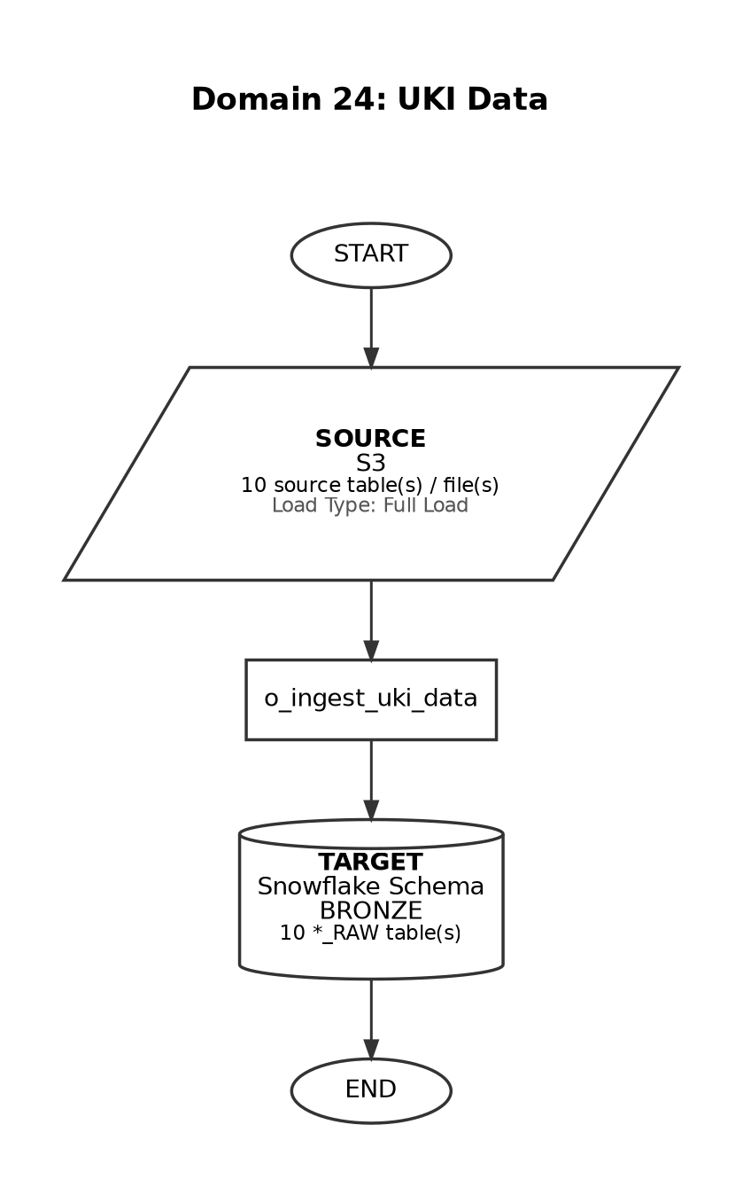

Domain 25

Bayshore
Frequency: Weekly
At 09:00, only on Tuesday (America/New_York timezone)
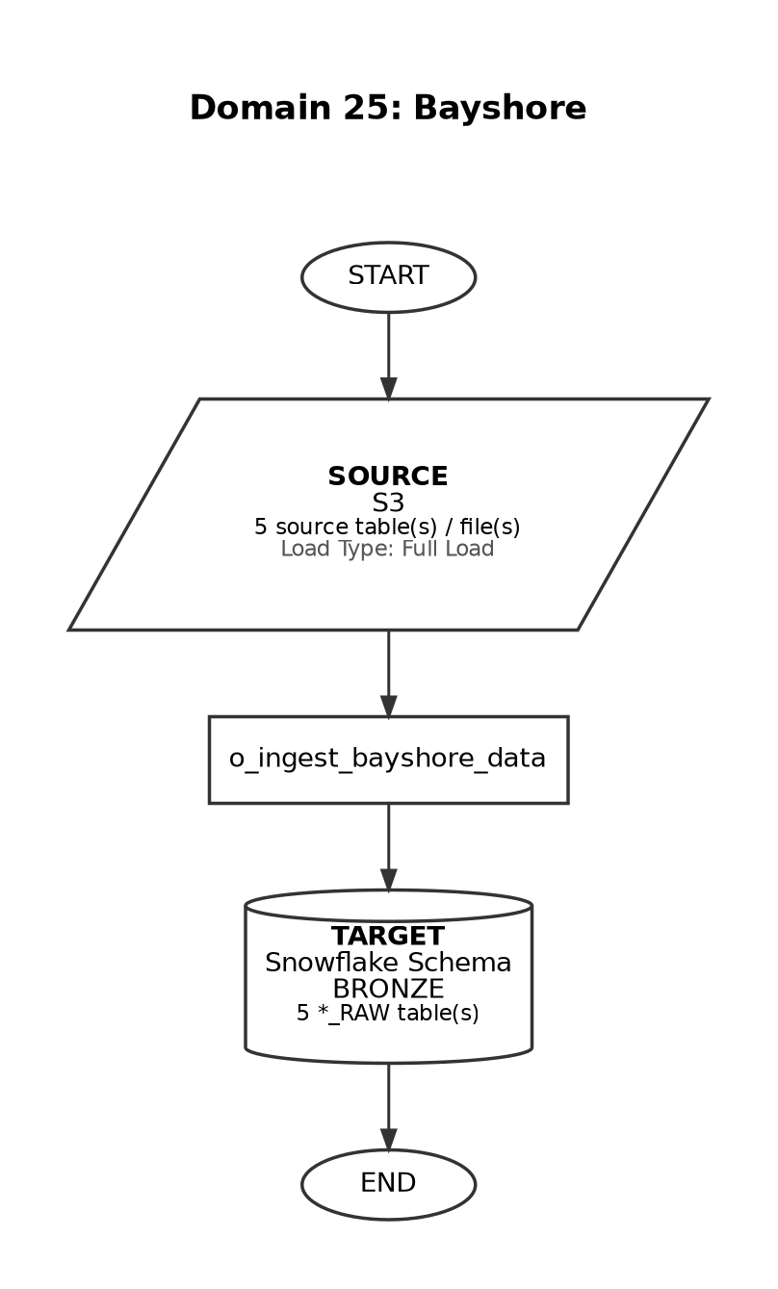

Domain 26

Toho
Frequency: Ad-hoc
On-demand load with change-request feeds
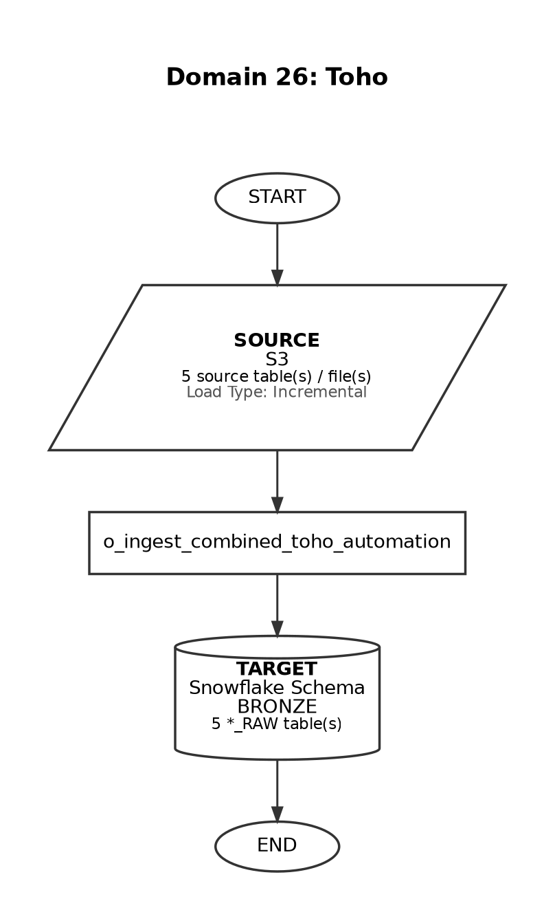

Domain 27

Clinical Trials
Frequency: Ad-hoc
Manual / on-demand load
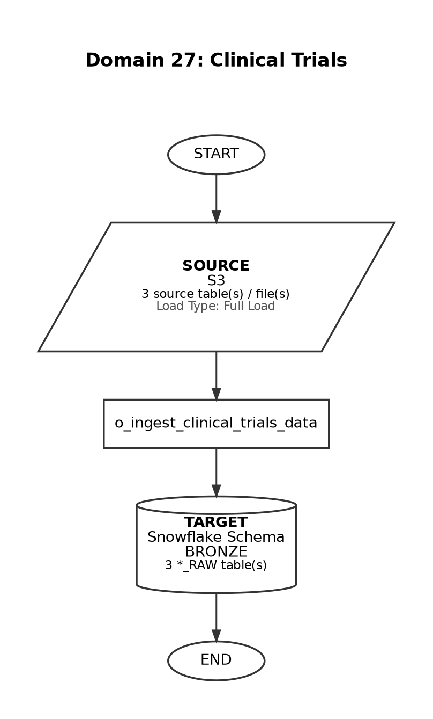

Domain 28

JP (Japan Vial Shipment)
Frequency: Weekdays
At 09:35, Monday-Friday (Asia/Tokyo timezone)
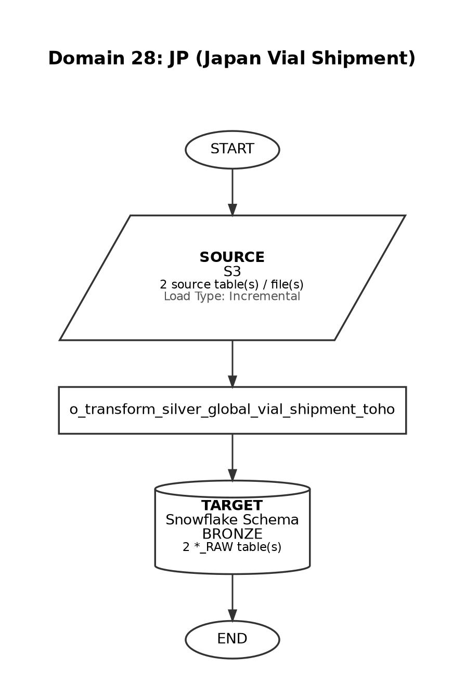

Domain 29

IQVIA DDD
Frequency: Monthly
Day 1 of the month (Asia/Tokyo timezone)
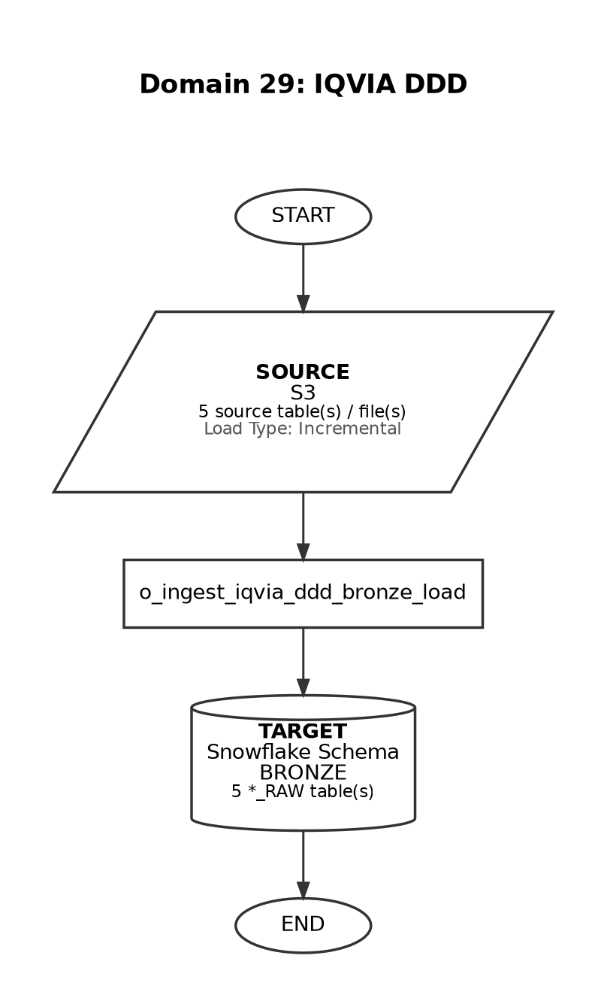

Domain 30

TXHUB
Frequency: Weekdays
At 00:40, Monday-Friday (America/New_York timezone)
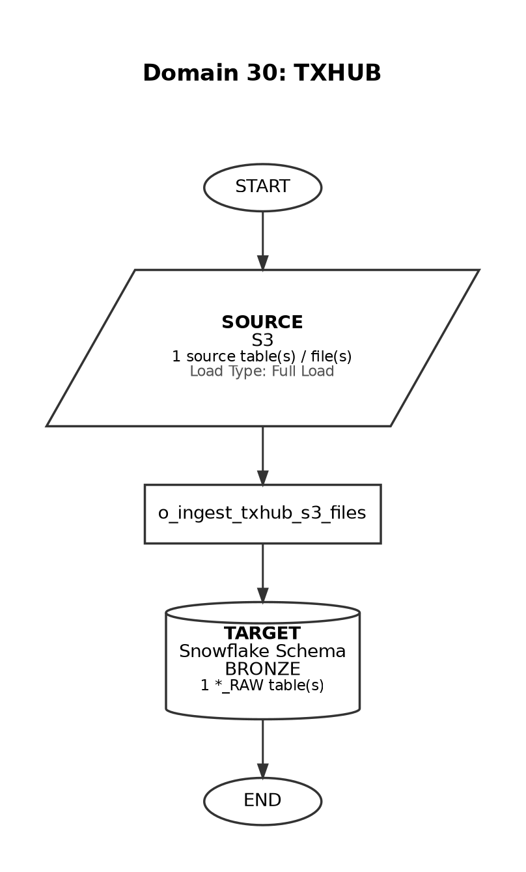

Domain 31

JIRA
Frequency: Ad-hoc
Manual / on-demand load
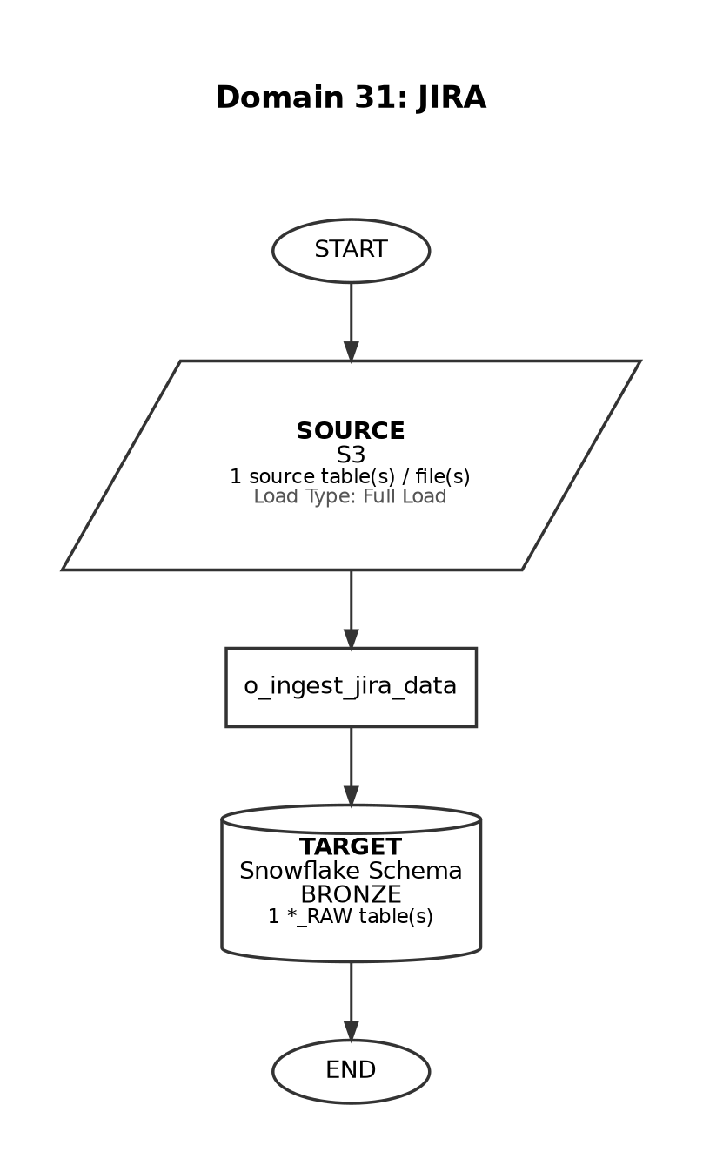

Domain 32

KALDEROS
Frequency: Weekly
At 06:00, only on Tuesday (America/New_York timezone)
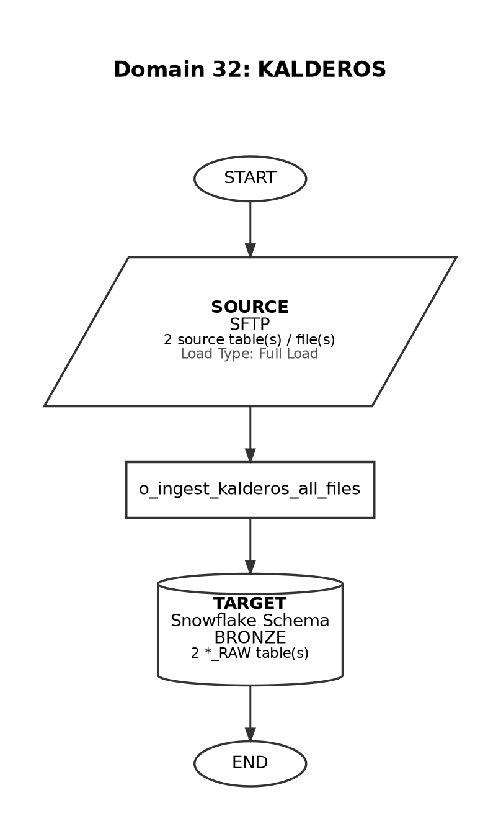

Domain 33

IQVIA Pinpoint
Frequency: Weekly
At 12:30 on Thursday (steps1) and 12:30 on Friday (steps2)
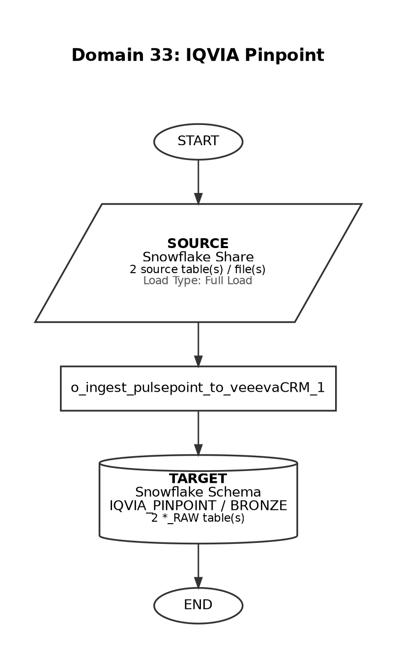

Domain 34

Veeva Network (DCR)
Frequency: Daily
At 02:30, every day (America/New_York timezone)
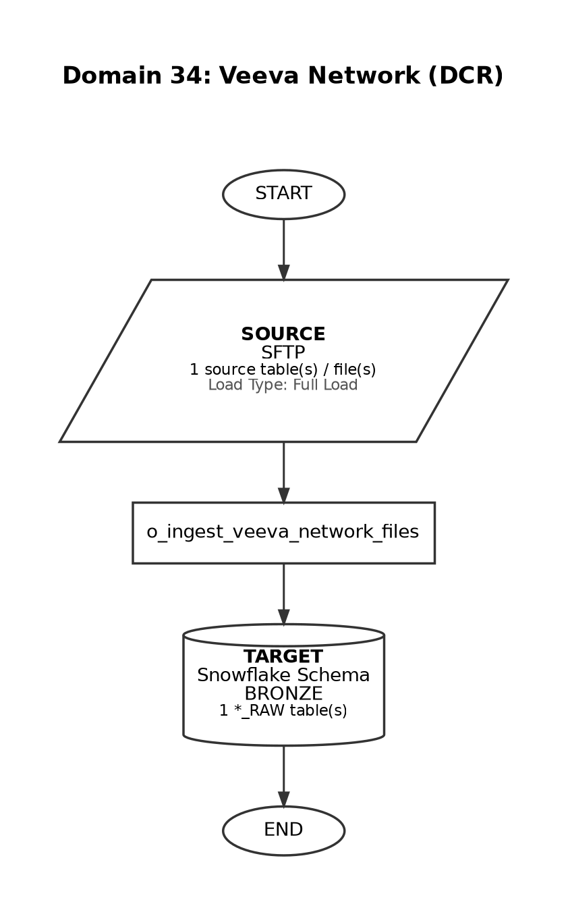

Domain 35

IQVIA Med_B
Frequency: Monthly
At 19:00, on the last weekday of the month
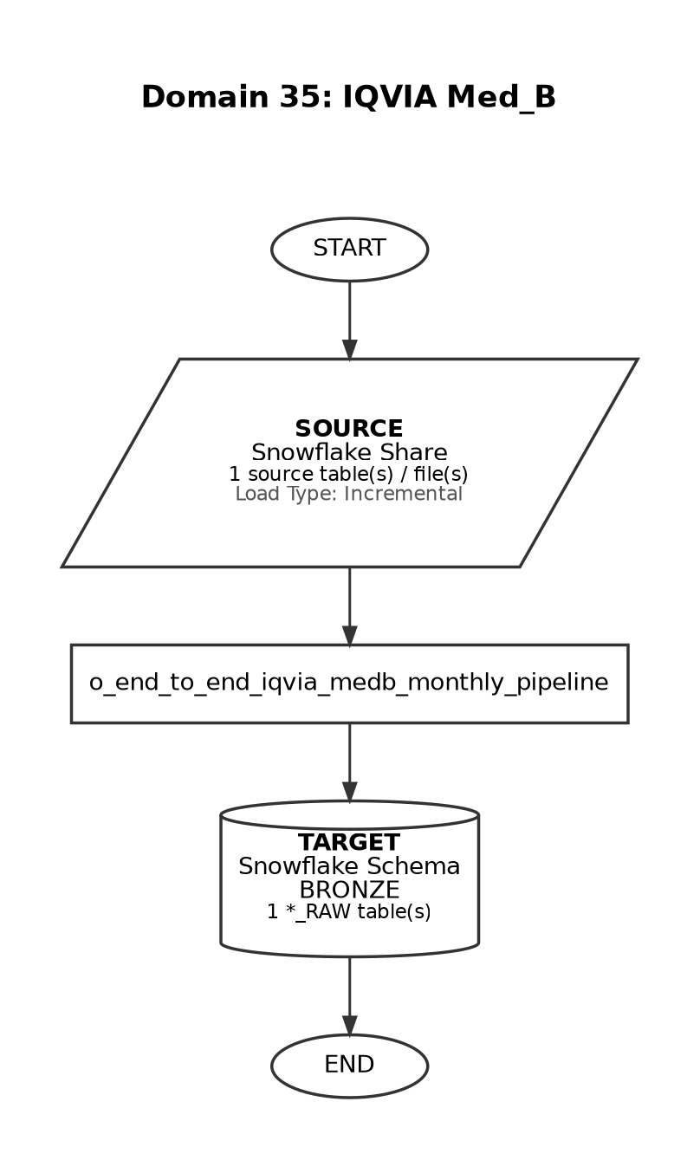

Domain 36

IQVIA AMA
Frequency: Weekly
At 12:30, only on Friday (America/New_York timezone)
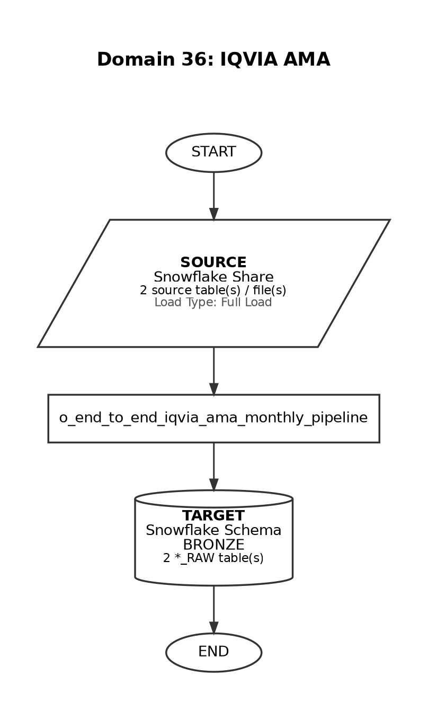

Domain 37

IQVIA HPD
Frequency: Quarterly
At 19:30, between day 1 and 3 of March, June, September, December
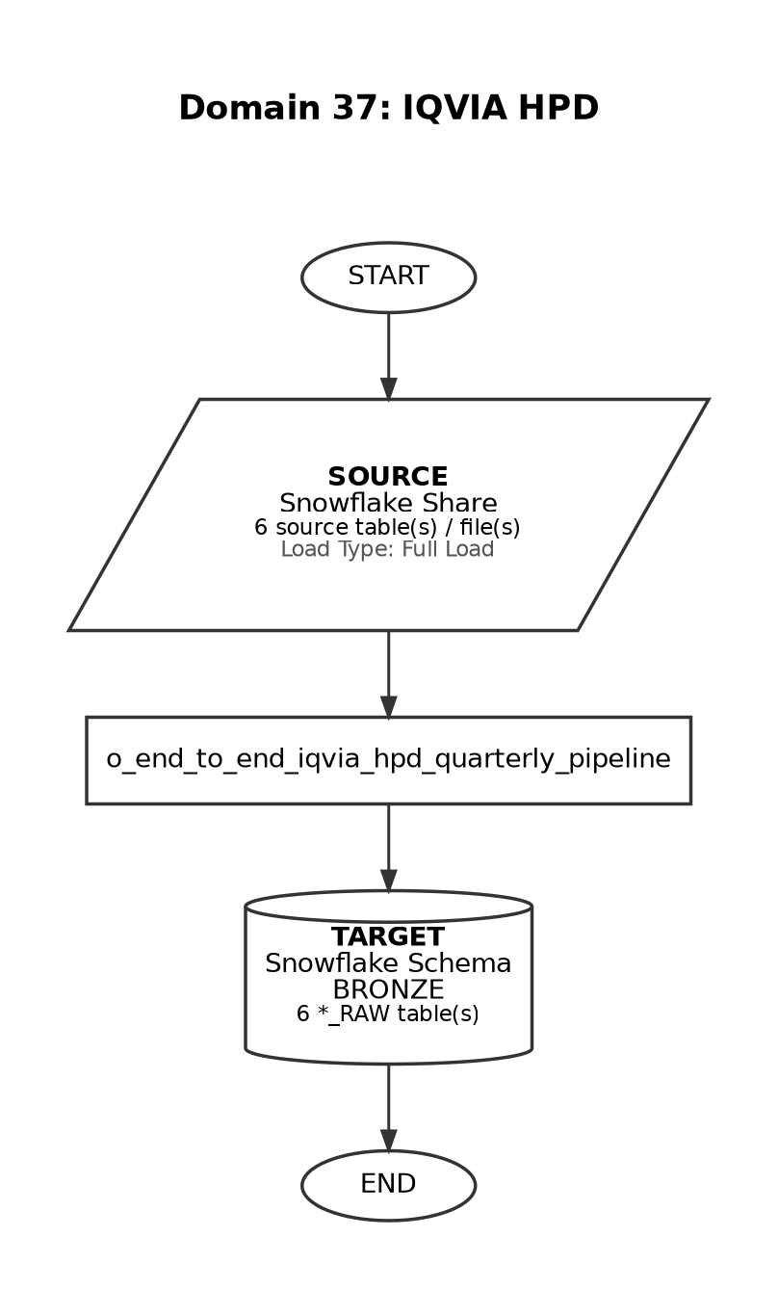

Domain 38

IQVIA LAAD MG Weekly
Frequency: Weekly
At 19:00, Thursday-Friday (America/New_York timezone)
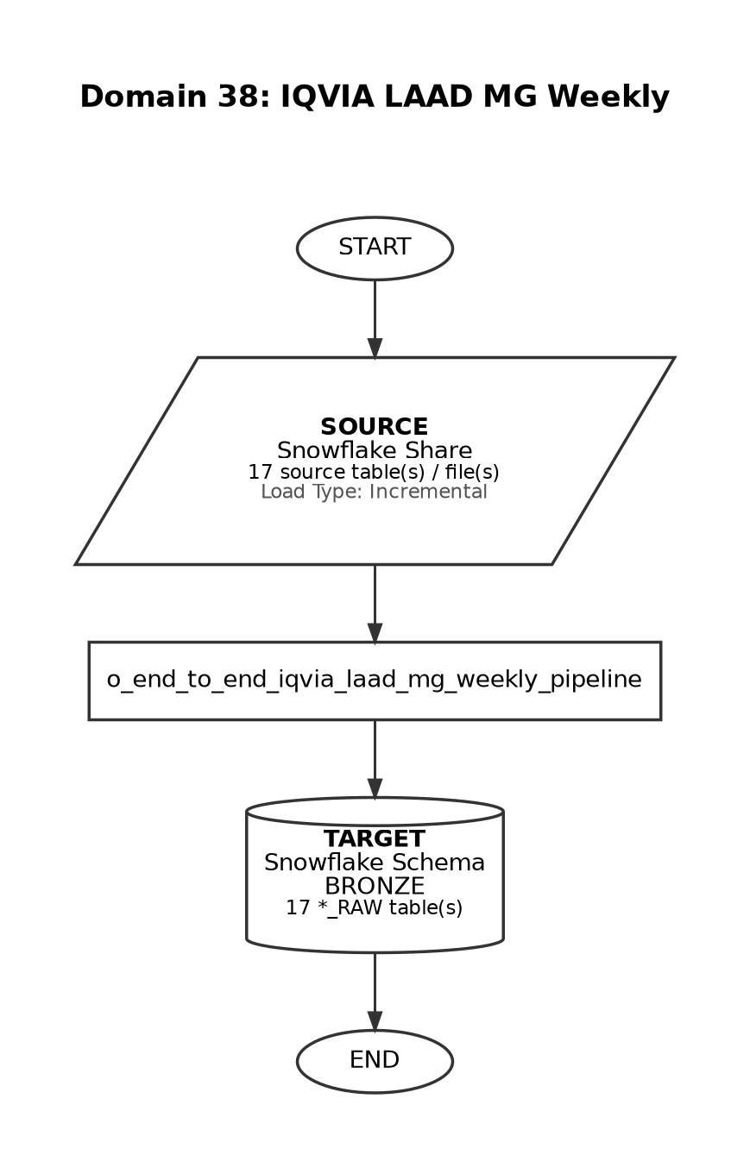

Domain 39

IQVIA LAAD MG Monthly
Frequency: Monthly
At 19:00, between day 15 and 20 of the month
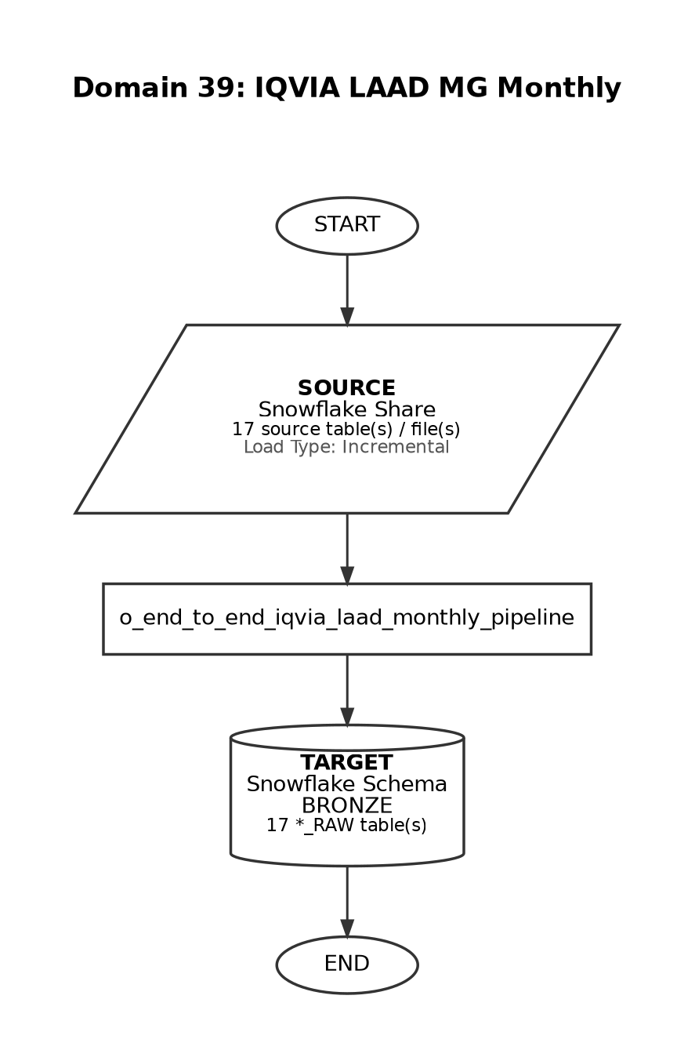

Domain 40

IQVIA LAAD CIDP Monthly
Frequency: Monthly
At 19:00, between day 15 and 20 of the month (same pipeline as IQVIA LAAD MG Monthly)
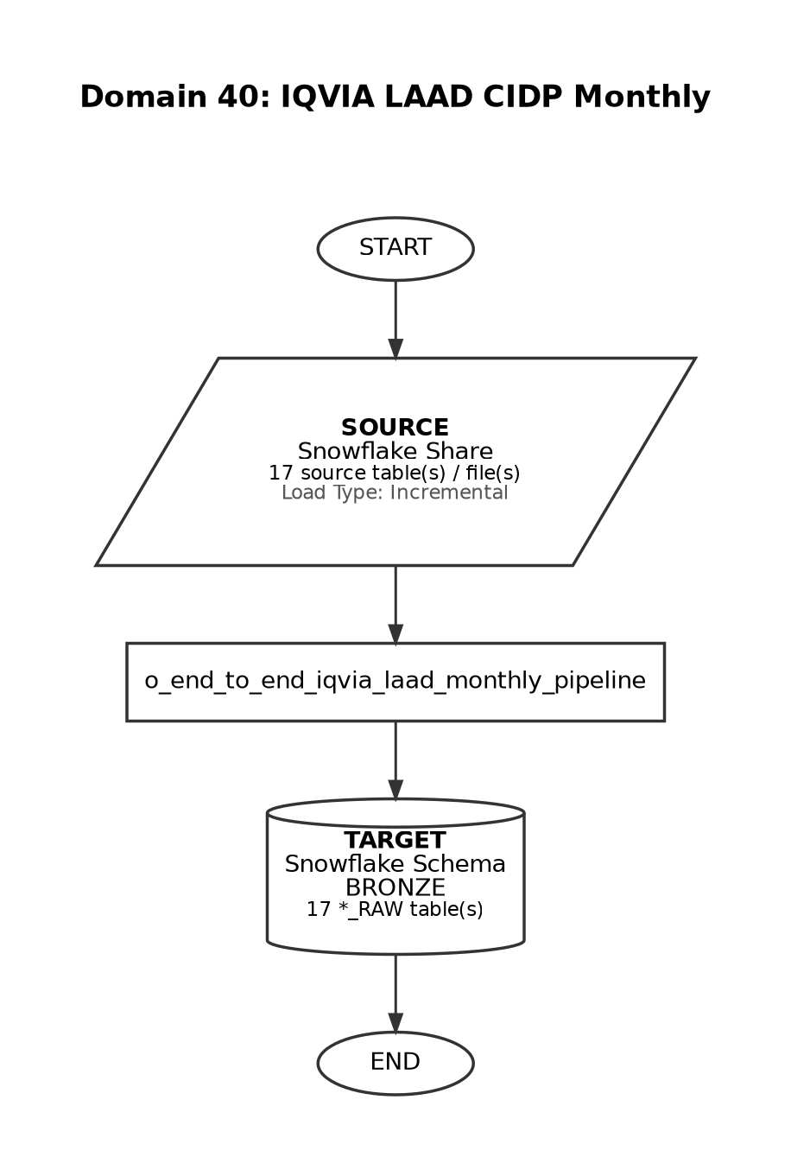

Domain 41

NCM (PSP)
Frequency: Weekdays
Trigger-based: runs after Non-PSP Patient Silver and Gold complete (12:45-1:15 am EST)
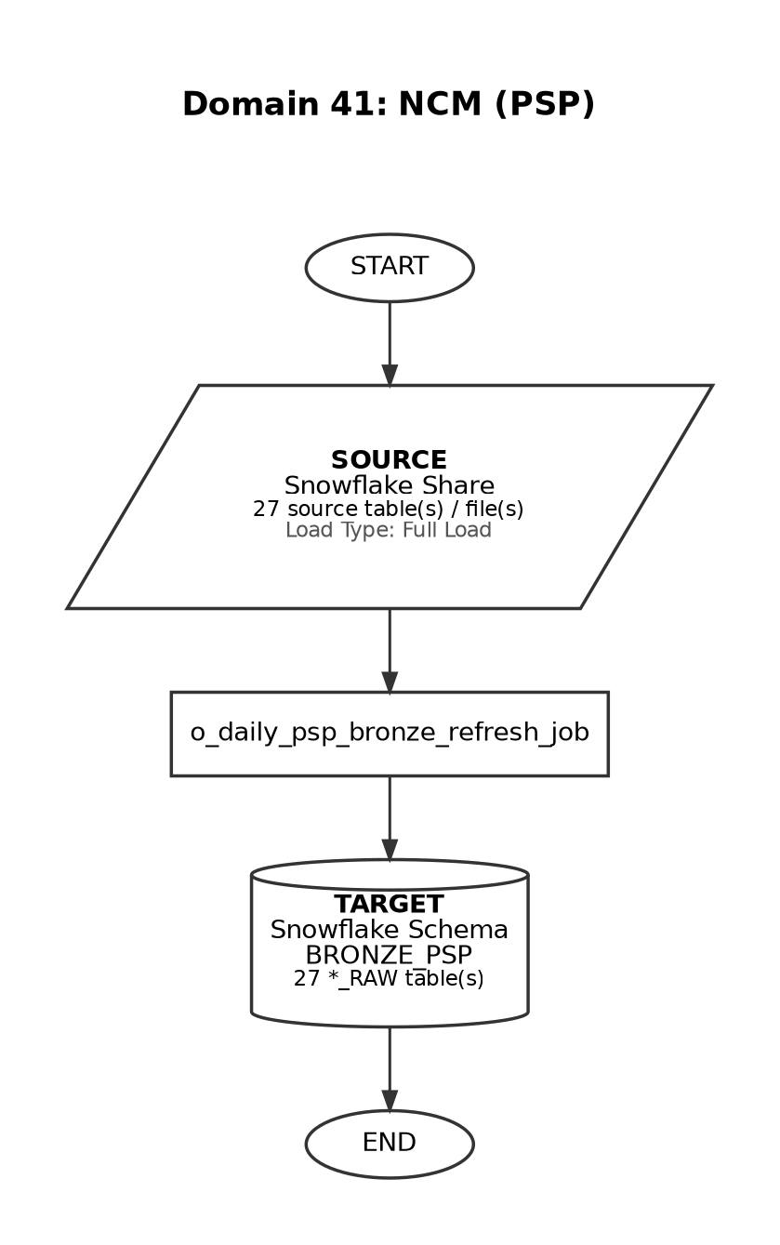

Domain 42

NCM (Non-PSP)
Frequency: Weekdays
Daily ingestion via clone pipeline - precedes PSP execution chain
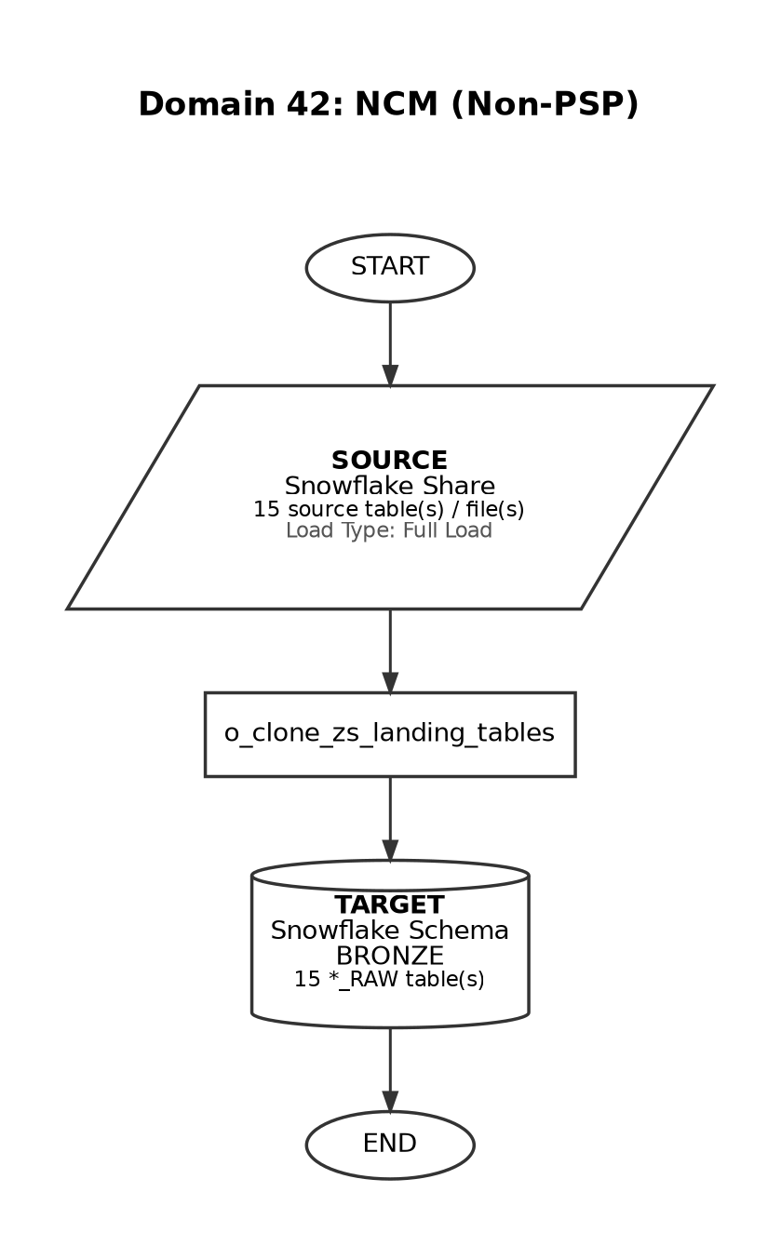

Domain 43

Marketo
Frequency: Weekdays
Daily ingestion via clone pipeline
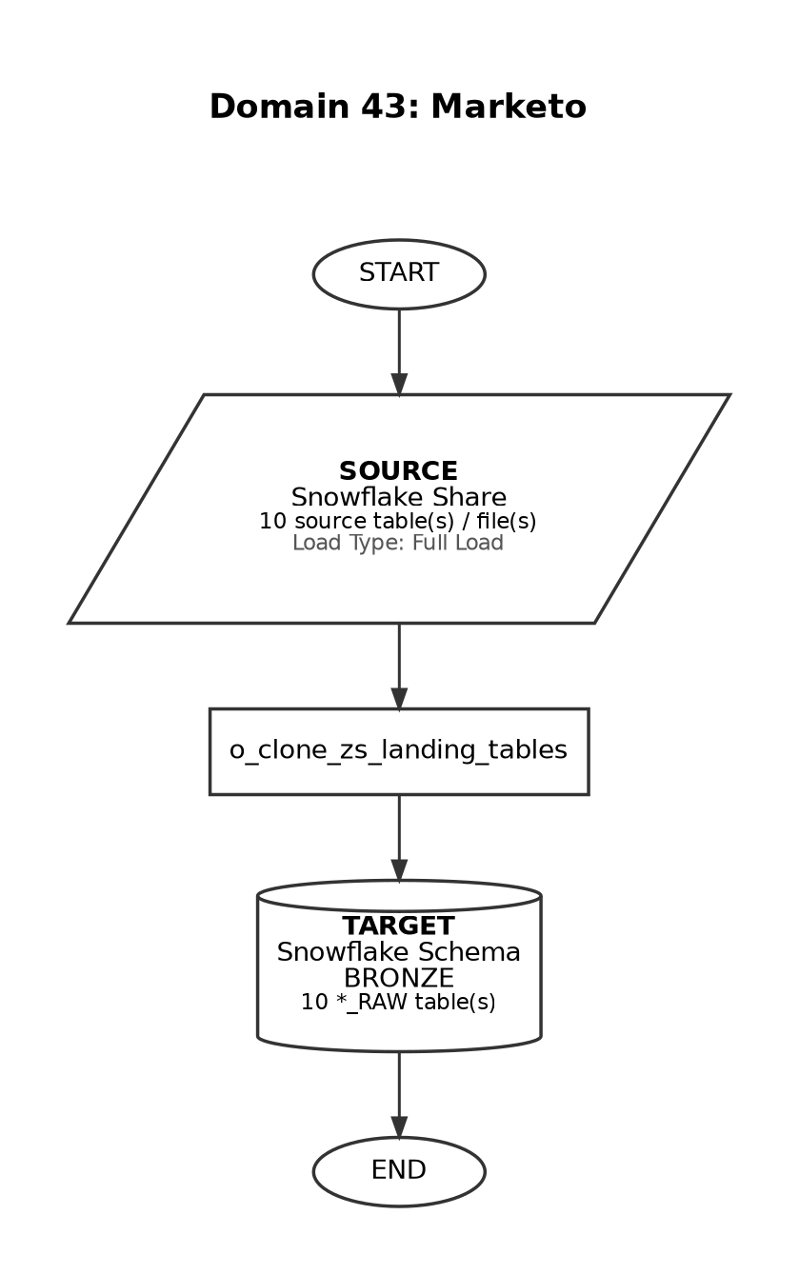

Domain 44

SP (Non-PSP) - Specialty Pharmacy
Frequency: Weekdays
Daily ingestion via clone pipeline
