INTERNAL — CONFIDENTIAL
PRODUCT & TECHNICAL DESIGN PACKAGE
Auto Quality Review Automation
(Auto QRA)
Microsoft Azure · AKS · NVIDIA A100 80GB
Monthly Infrastructure Ceiling: USD $5,000
Classification | Internal — Confidential
Version | 1.2
Date | July 2026
Cloud | Microsoft Azure
Orchestration | Azure Kubernetes Service (AKS)
GPU | NVIDIA A100 80GB (single node)
Monthly Budget | USD $5,000 hard ceiling
Inference | Self-hosted vLLM (3B / 7B quantized)

Auto Quality Review Automation (Auto QRA)
  - Internal Design Package — Azure AKS · A100 · $5,000/month
Product Management · Enterprise Architecture · AI Solution Architecture
July 2026 · Version 1.2
Table of Contents

Auto QRA - Internal Product and Technical Design

1. Document Control (Internal v1.2, Confidential Internal)

Purpose
This document defines the internal product, architecture, operating, security, AI/ML, DevOps, and cost design for Auto Quality Review Automation (Auto QRA) under a hard infrastructure budget ceiling of USD $5,000 per month. It is written for internal leadership, engineering, AI/ML, DevOps, security, and finance stakeholders who need a realistic production design rather than an aspirational reference architecture.

Description
Auto QRA automates first-pass quality review for customer conversations using a self-hosted large language model served through vLLM on Microsoft Azure. The design evaluates approximately 60,000 audits per month, or about 2,000 audits per day, across 30 QA parameters. Each audit is planned at 3,200 tokens end to end, including transcript input, rubric context, reasoning constraints, structured scoring output, citations, and confidence metadata.
The design is intentionally budget-constrained. The locked infrastructure decision is one production NVIDIA A100 80GB GPU node on Azure Kubernetes Service (AKS). The document does not recommend dual GPU high availability because the USD $5,000 monthly cap cannot credibly fund two A100 production nodes plus managed data, observability, security, and networking services. Non-GPU services are designed to be resilient within the budget; the GPU inference layer remains the primary single point of failure.

Business Justification
The business case is to increase QA coverage, reduce repetitive manual review, improve scoring consistency, and accelerate coaching feedback while preserving human accountability. The design also supports data control through Azure-native security, private networking, PII masking, encryption, audit logs, and role-based access control.
The business tradeoff is explicit: Auto QRA can meet the target monthly volume and latency goals on a single A100 if workload assumptions and batching performance hold, but it cannot provide full N+1 GPU resiliency under the stated budget. This is a finance and risk decision, not an engineering preference.

Technical Details
Field | Value
Document title | Auto QRA - Internal Product and Technical Design
Version | Internal v1.2
Classification | Confidential Internal
Status | Budget-constrained architecture baseline
Date | July 2026
Cloud | Microsoft Azure
Orchestration | Azure Kubernetes Service (AKS)
GPU | NVIDIA A100 80GB only
Inference | Self-hosted vLLM
Model class | 3B or 7B quantized
Monthly infrastructure budget | USD $5,000 hard ceiling
Volume | 60,000 audits/month; about 2,000/day
Token plan | 3,200 tokens/audit
QA rubric | 30 parameters
Latency target | <60 seconds end to end
Quality targets | >90% human agreement; <5% hallucination
Human override | Required for production workflow
Availability posture | Budget-constrained; target 99.5% service availability

Best Practices
Practice | Application to Auto QRA
Use locked design assumptions consistently | All cost, capacity, and architecture decisions assume Azure, AKS, A100 80GB, and vLLM.
Separate product automation from final accountability | Auto QRA produces structured recommendations; human reviewers retain override authority.
Tie cost decisions to architecture decisions | The $5,000 cap directly constrains HA, node count, log retention, and managed service tiers.
Use measurable AI gates | Model selection, prompt releases, and automation thresholds require agreement and hallucination evidence.

Risks
Risk | Impact | Current position
Single production GPU | Inference unavailable during GPU node failure, maintenance, quota issue, or driver issue | Accepted within budget; documented as explicit risk
Regional A100 pricing variation | Selected Azure region may exceed envelope | Finance must validate final regional pricing before go-live
Quality drift | Human agreement or hallucination target may degrade after rollout | Continuous evaluation and human override required
Underestimated operations cost | Logging, egress, and support tooling can exceed plan | Lean observability and monthly FinOps review required

Recommendations
Recommendation | Owner | Timing
Approve this document as the internal budget-constrained baseline | Leadership | Before pilot funding
Validate A100 quota, region, and reservation economics | Infrastructure and Finance | Before production commitment
Run a benchmark sprint on target model candidates | AI/ML and Platform | Pilot entry
Treat 99.5% as the funded production service availability target | Product and SRE | Architecture approval

2. Executive Summary (include budget & A100 decisions)

Purpose
This section summarizes the product direction, core architecture, budget posture, and leadership decisions required for Auto QRA.

Description
Auto QRA is an internal enterprise AI platform that performs automated quality audits of customer conversations. It evaluates each conversation against a 30-parameter rubric, produces structured scores and evidence, assigns confidence, escalates uncertain or risky cases, and records all decisions for human review and auditability.
The architecture is Azure-native and Kubernetes-based. Application services run on AKS. PostgreSQL stores audit metadata and structured results. Redis supports queues, cache, and rate control. Azure Blob Storage stores masked artifacts, exports, and longer-lived evidence. Superset provides business reporting. Prometheus and Grafana provide operational observability. Entra ID provides SSO. RBAC, PII masking, encryption, and audit logging are mandatory controls.
The inference layer is self-hosted vLLM running a quantized 3B or 7B model on exactly one NVIDIA A100 80GB production GPU node. The A100-only decision is locked. The monthly infrastructure budget is capped at USD $5,000. Under that cap, the recommended design cannot include a second production A100 for N+1 high availability. The production architecture is therefore best described as budget-constrained resilient service design, not fully highly available inference design.

Business Justification
Manual QA programs often audit only a small sample of interactions because each review is labor-intensive. At 60,000 audits per month, Auto QRA enables broader coverage, faster coaching, more consistent scoring, and better trend analytics. The value is not only labor leverage; it is also the ability to detect recurring quality issues earlier and support supervisors with structured evidence.
The strongest business argument for the constrained design is that it delivers a production-capable first-pass automation platform inside a defined budget. The strongest business risk is that availability is intentionally lower than a fully redundant design. Leadership should approve this design only with clear understanding that the GPU layer is a single point of failure.

Technical Details
Decision area | Approved direction | Executive implication
Cloud | Microsoft Azure | Aligns with enterprise identity, networking, security, and procurement
Orchestration | AKS | Standard Kubernetes deployment and operations model
GPU | 1x NVIDIA A100 80GB production node | Meets capacity target but does not provide GPU HA
Model serving | Self-hosted vLLM | Data stays under internal control; requires ML platform operations
Model size | 3B or 7B quantized | Benchmark controls final selection
Budget | USD $5,000/month hard ceiling | Forces lean managed services and single GPU
Availability posture | Target 99.5% service availability | Best effort toward 99.9% only for non-GPU layers
Human override | Mandatory | Automation supports decisions; humans can correct outcomes
Security | Entra ID, RBAC, PII masking, encryption, audit logs | Enterprise control baseline

Best Practices
Executive practice | Implementation
Approve constraints explicitly | Record the $5,000 cap, one-A100 design, and availability tradeoff in ADRs.
Govern AI with measurable gates | Move from pilot to GA only when human agreement and hallucination targets are met.
Require financial telemetry | Track cost per audit, GPU utilization, and monthly spend from day one.
Preserve human accountability | Require review queues, override reasons, and reviewer attestation.

Risks
Risk | Executive concern | Mitigation
A100 outage | Production audit automation pauses | Queue audits, fall back to manual QA, repair or replace GPU node
Budget pressure | Cost may exceed cap in higher-cost Azure regions | Validate regional pricing and use reservation/savings plan economics
Model underperformance | Quality targets may not be reached | Benchmark 3B and 7B quantized models before GA
User trust | Reviewers may reject automation if explanations are weak | Require citations, confidence, and override workflows

Recommendations
Leadership should approve the design as a cost-contained production baseline for pilot and limited production, not as a premium HA architecture. The go/no-go decision for GA should be based on measured latency, quality, cost, operational stability, and review team adoption. If leadership later requires 99.9% end-to-end availability including inference, the budget must be reopened for a second A100 production node and related capacity.

3. Locked Decisions / ADR Summary table (model, prompt, automation threshold, infra class, GPU=A100, budget=$5k)

Purpose
This section records the locked decisions and open architecture decision records that govern the design.

Description
The following ADR summary is the control plane for the document. Any future proposal that changes cloud, orchestration, GPU class, budget, inference hosting, human override, or security baseline must be treated as a formal ADR change, not an implementation detail.

Business Justification
The program involves many stakeholder groups. A clear decision table prevents architecture drift, inconsistent financial assumptions, and accidental expansion beyond budget. It also gives finance and leadership a common reference for tradeoffs.

Technical Details
ADR ID | Topic | Locked / proposed decision | Status | Rationale | Change authority
ADR-001 | Cloud | Microsoft Azure | Locked | Aligns with enterprise identity, networking, security, and procurement | CIO / Architecture
ADR-002 | Orchestration | Azure Kubernetes Service | Locked | Required for containerized app, vLLM, GPU scheduling, and operational consistency | Platform Architecture
ADR-003 | GPU | NVIDIA A100 80GB only; 1x production node under $5k | Locked | Provides 80GB memory for 3B/7B quantized inference and batching | Leadership / Finance
ADR-004 | Budget | USD $5,000/month infrastructure hard ceiling | Locked | Program funding constraint | Finance / Sponsor
ADR-005 | Inference | Self-hosted vLLM | Locked | Data control, predictable serving, no third-party model API dependency | AI/ML Architecture
ADR-006 | Model | 3B or 7B quantized | Locked range; final model open | A100 can handle both; final choice depends on quality and throughput | AI/ML
ADR-007 | Prompt | Rubric-grounded structured prompt with JSON schema output | Proposed | Improves explainability and validation | AI/ML + Product
ADR-008 | Automation threshold | High-confidence recommendation only; human override required | Locked | Controls quality risk and preserves accountability | Product + QA
ADR-009 | Infrastructure class | Budget-constrained production, not full HA inference | Locked | Dual A100 HA cannot fit $5k | Leadership / Finance
ADR-010 | Availability | 99.5% service target; best effort toward 99.9% non-GPU layers | Locked | Matches funded architecture | Product + SRE
ADR-011 | Data platform | Azure Database for PostgreSQL, Azure Cache for Redis, Azure Blob Storage | Locked | Meets data, queue, cache, and artifact requirements | Architecture
ADR-012 | Security baseline | Entra ID SSO, RBAC, encryption, audit logs, PII masking | Locked | Required for enterprise use | Security

Best Practices
Practice | Control
Decision traceability | ADRs reference benchmark evidence, cost model, and risk acceptance.
Explicit ownership | Each locked item has an accountable business or technical owner.
No silent upgrades | Adding GPU HA, premium managed services, or longer log retention requires budget review.
Quality-linked model change | Model or prompt changes require evaluation against human agreement and hallucination gates.

Risks
Risk | Consequence
ADR bypass | Teams may make local choices that exceed budget or weaken controls.
Ambiguous automation threshold | Reviewers may treat recommendations as final decisions.
Prompt drift | Quality metrics may become incomparable across releases.

Recommendations
Maintain ADRs in the repository with this document. Require architecture, finance, and security review for any change that affects cost, availability, model behavior, data exposure, or human review obligations.

4. Business Objectives & Success Metrics

Purpose
This section defines the measurable business outcomes Auto QRA must deliver.

Description
Auto QRA is intended to improve quality review coverage and consistency while reducing manual effort on routine first-pass scoring. The platform should help QA teams review more interactions, focus human attention on exceptions, and produce better analytics for supervisors and process owners.

Business Justification
The program is justified when the cost of automation plus human review produces better coverage, faster feedback, and more consistent scoring than manual sampling alone. Success must be measured across quality, operations, adoption, and finance rather than only model accuracy.

Technical Details
Objective | Metric | Target | Measurement source | Gate
Increase QA coverage | Audits processed per month | 60,000 | PostgreSQL workflow tables | Limited production
Maintain turnaround | End-to-end audit latency | p95 <60s | Prometheus workflow metrics | Pilot and GA
Preserve review quality | Human agreement | >90% | Reviewer comparison sample | Pilot exit
Control hallucination | Unsupported finding rate | <5% | Human adjudication and eval set | Pilot exit
Reduce manual load | Share of audits not requiring deep manual rework | >60% after pilot | Reviewer workbench | Limited production
Maintain accountability | Override availability | 100% of results | Product workflow audit logs | GA
Control cost | Infrastructure spend | <=USD $5,000/month | Azure Cost Management | Monthly
Keep operations stable | Service availability | 99.5% | SLO dashboard | GA
Improve coaching cycle | Time from interaction to QA result | Same day | Workflow timestamps | Limited production
Protect sensitive data | Unmasked PII in logs/prompts | Zero known high-severity events | DLP checks and log scans | Always

Best Practices
Practice | Implementation
Balance AI and workflow metrics | Track human agreement, hallucination, latency, and reviewer acceptance together.
Use stratified samples | Compare model output against humans across teams, channels, languages if applicable, and issue types.
Measure cost per audit | Divide monthly infrastructure cost by completed audits and trend over time.
Review false positives and false negatives | Quality issues should be classified by rubric category and prompt version.

Risks
Risk | Business impact | Mitigation
Automation overtrust | Incorrect recommendations may influence coaching | Human override and reviewer attestation
Low reviewer adoption | Benefits may not materialize | Training, transparent evidence, clear override UX
Hidden manual rework | Cost savings may be overstated | Measure rework time and disagreement reasons
Metric gaming | Teams may optimize for pass rates rather than quality | Audit sampling and governance review

Recommendations
Use a monthly executive scorecard with four lenses: business value, AI quality, operating health, and cost. Do not expand to GA unless the product can show both quality evidence and budget compliance for a sustained limited-production period.

5. Scope / Out of Scope

Purpose
This section defines what the initial Auto QRA release will and will not deliver.

Description
The scope is deliberately focused on first-pass quality audit automation for conversation transcripts, structured scoring, confidence, evidence, human review, reporting, and operations. It does not include broad contact center transformation or fully autonomous employment, compliance, or disciplinary decisions.

Business Justification
A bounded scope makes the $5,000 infrastructure cap workable and reduces AI governance risk. It also allows the organization to prove value through a measurable use case before expanding into more complex workflows.

Technical Details
In scope | Description
Transcript ingestion | API or batch ingestion of conversation text and metadata
PII masking | Masking before prompt construction and storage of model-facing artifacts
30-parameter QA rubric | Structured scoring for agreed QA parameters
vLLM inference | Self-hosted 3B or 7B quantized model on 1x A100 80GB
Confidence scoring | Composite score based on model output, rubric fit, evidence coverage, and validation
Human override | Reviewer can accept, modify, reject, or escalate results
Audit logging | Immutable record of system, model, and human decisions
Reporting | Superset dashboards for QA, operations, and leadership
Observability | Prometheus and Grafana for service and model health
Security | Entra ID SSO, RBAC, encryption, Key Vault, Private Link where budget permits

Out of scope | Reason
Fully autonomous final QA closure | Human override is required
Dual A100 production HA | Cannot fit the $5,000 monthly ceiling
Real-time agent assist | Latency and product workflow differ from post-interaction audit
Voice transcription engine | Assumes transcript text is supplied by upstream systems
Workforce management integration | Future phase after QA workflow proof
Custom model training from scratch | Too expensive and unnecessary for the first release
Premium enterprise SIEM ingestion at high volume | Logging must remain lean under budget
Multi-region active-active design | Not fundable under current budget

Best Practices
Practice | Scope control
Keep audit automation separate from upstream transcription | Avoid coupling release dates to call recording and speech systems.
Treat human override as product scope | Do not defer review UX or audit logging.
Use the minimum managed service tier that meets risk | Upgrade only after budget approval or measured pressure.
Use phased rollout | Scope expands only after gates are passed.

Risks
Risk | Impact
Scope creep into real-time use cases | GPU and latency budget may fail.
Attempting to absorb transcription | Adds cost, latency, and privacy complexity.
Deferring reviewer workflow | AI output becomes difficult to trust and govern.

Recommendations
Approve the first release as post-interaction QA automation with mandatory human override. Treat adjacent use cases as backlog candidates that require separate cost and risk analysis.

6. Solution Architecture (Azure/AKS/A100) + Mermaid

Purpose
This section describes the end-to-end solution architecture on Azure.

Description
Auto QRA is composed of ingestion services, security and masking services, audit workflow services, vLLM inference, storage services, review workflow, reporting, and observability. The AKS cluster is the runtime boundary for application and inference workloads. Managed Azure services provide database, cache, storage, identity, secrets, and networking capabilities.

Business Justification
The architecture balances cost control and enterprise readiness. AKS supports GPU scheduling and standard DevOps patterns. Azure managed services reduce operational burden without requiring premium tiers. Self-hosted vLLM keeps model inference and audit data inside the enterprise environment.

Technical Details
Figure 1
Figure 1
Component | Azure / platform choice | Primary responsibility | Budget note
AKS | Managed Kubernetes | Runs APIs, workers, vLLM, Superset, Prometheus, Grafana | Use lean node pools
GPU node | 1x A100 80GB-capable node | Hosts vLLM inference | Largest cost line
PostgreSQL | Azure Database for PostgreSQL Flexible Server | Stores metadata, results, users, workflow state | Small/burstable tier initially
Redis | Azure Cache for Redis | Queue, cache, distributed locks, rate limiting | Basic or Standard tier
Blob Storage | Azure Blob Storage | Masked artifacts, exports, evidence bundles | Lifecycle policies required
Identity | Entra ID | SSO and group-based access | Existing enterprise capability
Secrets | Azure Key Vault | Secrets, keys, certificates | Private access where feasible
Networking | VNet, Private Link, ingress-nginx | Private service access and controlled ingress | Avoid premium ingress unless mandated
Reporting | Superset | QA and leadership dashboards | Run inside app pool
Observability | Prometheus/Grafana | Metrics, alerts, SLOs | Keep log ingestion lean

Best Practices
Practice | Implementation
Isolate model serving | Use taints, tolerations, and node selectors for the A100 node.
Use private dependencies | Connect PostgreSQL, Redis, Blob, and Key Vault over private networking where budget and service tier allow.
Validate all model output | Enforce JSON schema and deterministic post-processing before persistence.
Store masked artifacts | Do not store raw prompt or raw transcript in model artifacts unless explicitly approved.

Risks
Risk | Impact | Mitigation
vLLM pod or GPU failure | Audit processing pauses | Queue work, alert, restart, manual fallback
Redis outage | Queue processing delays | Managed Redis, retry policy, idempotent jobs
PostgreSQL bottleneck | Result persistence delays | Connection pooling, indexes, retention
Blob growth | Cost pressure | Lifecycle management and compression

Recommendations
Deploy a minimal but production-grade Azure architecture with one A100 inference node, small app and system node pools, and managed data services. Prove throughput and quality before increasing service tiers.

7. Deployment Architecture on AKS (node pools: system, app, gpu-a100) + Mermaid

Purpose
This section defines the AKS deployment topology and node pool design.

Description
The AKS cluster uses three logical node pools: system, app, and gpu-a100. The system pool hosts Kubernetes system services and core controllers. The app pool hosts APIs, workers that do not require GPU, Superset, observability components, ingress-nginx, and scheduled jobs. The gpu-a100 pool contains exactly one A100 80GB production GPU node dedicated to vLLM.

Business Justification
Separating node pools improves operational control without adding unnecessary compute cost. The design protects the GPU from unrelated workloads and keeps smaller services on lower-cost CPU nodes. It also makes the budget tradeoff visible: only the GPU node is expensive enough to prevent N+1 under the cap.

Technical Details
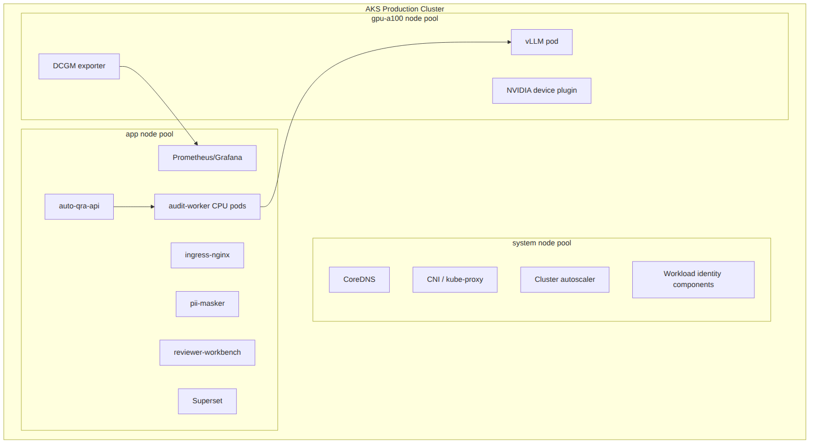
Figure 2
Figure 2
Node pool | Minimum count | Maximum count | Workload | Sizing posture | Notes
system | 2 | 2 | Kubernetes system pods | Small general purpose | Keeps cluster stable during app changes
app | 2 | 3 | APIs, CPU workers, UI, Superset, monitoring | Small general purpose, autoscale if needed | Scale only when queue or CPU pressure proves need
gpu-a100 | 1 | 1 | vLLM inference | A100 80GB-capable Azure VM | No N+1; single point of failure

Kubernetes control | Decision
Namespace strategy | auto-qra-prod, observability, ingress, security
GPU isolation | Taints and tolerations on gpu-a100; no non-vLLM workloads
Pod disruption budgets | Required for API, worker, workbench, Superset, Prometheus; vLLM PDB is best effort because only one replica exists
Horizontal scaling | APIs and CPU workers can scale; vLLM remains one replica
Deployment method | Helm or Kustomize through CI/CD
Secrets | Azure Key Vault via Workload Identity and CSI driver
Image source | Azure Container Registry Basic

Best Practices
Practice | Implementation
Pin GPU workloads | Use node selectors and tolerations for vLLM.
Set resource requests | Reserve CPU and memory to avoid noisy-neighbor failures.
Use readiness probes | Prevent traffic to pods that cannot serve or validate dependencies.
Keep app pods stateless | Persist state in PostgreSQL, Redis, or Blob Storage.
Control rollouts | Use canary or blue-green for APIs; use benchmarked rolling process for vLLM.

Risks
Risk | Impact | Mitigation
GPU driver mismatch | vLLM fails to start | Pin NVIDIA device plugin, CUDA image, and tested vLLM image
Node pressure on app pool | API or worker latency increases | Autoscale app pool within budget buffer
Prometheus disk growth | Storage and node pressure | Short retention, remote export only if funded
Single vLLM pod | No zero-downtime model restart | Schedule maintenance windows and queue work

Recommendations
Use a private or restricted AKS cluster with three node pools exactly as described. Keep gpu-a100 count at one unless the monthly budget is formally increased.

8. AI Pipeline & Confidence / Human Override

Purpose
This section defines how Auto QRA converts conversations into governed QA recommendations.

Description
The AI pipeline masks PII, builds a rubric-grounded prompt, calls vLLM, validates structured output, scores confidence, applies business rules, and sends all results through a human override-capable workflow. The system never treats model output as inherently final. Human reviewers can override scores and must provide reason codes for changes.

Business Justification
The product succeeds only if review teams trust the output. Trust requires evidence, confidence, escalation, and the ability to correct the system. Human override also reduces legal, compliance, and employee-relations risk by preventing the model from becoming an unreviewed decision-maker.

Technical Details
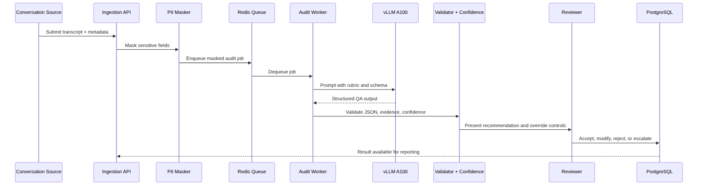
Figure 3
Figure 3
Pipeline stage | Function | Control
Intake | Validate source, tenant, required metadata | Schema validation and RBAC
PII masking | Redact names, account numbers, emails, phone numbers, addresses, protected identifiers | Masking version logged
Prompt construction | Combine transcript, QA rubric, scoring rules, examples, and output schema | Prompt version controlled
Inference | Generate structured scores and evidence through vLLM | A100 GPU metrics and timeouts
Output validation | Enforce JSON schema, required fields, score ranges, evidence references | Invalid outputs retried or escalated
Confidence scoring | Combine model confidence, evidence coverage, rubric completeness, validation quality | Threshold controls
Business rules | Apply deterministic overrides, severity logic, and escalation criteria | Versioned rules
Human override | Reviewer accepts, edits, rejects, or escalates | Override reason required
Persistence | Store final score, model recommendation, reviewer action, versions, and audit trail | PostgreSQL and Blob evidence

Confidence band | Suggested handling | Automation status
>=0.85 | Present as high-confidence recommendation | Human override still available and required in workflow
0.70-0.84 | Send to standard reviewer queue | Not auto-accepted
0.50-0.69 | Send to senior QA review | Requires explicit adjudication
<0.50 | Escalate as low-confidence / possible prompt failure | No automated scoring reliance
Any critical rule violation | Escalate regardless of score | Deterministic control

Quality metric | Definition | Target
Human agreement | Share of sampled model recommendations matching adjudicated human score within agreed tolerance | >90%
Hallucination rate | Share of findings with unsupported evidence or invented facts | <5%
Schema validity | Share of outputs passing JSON and business validation | >99%
Evidence coverage | Share of scored parameters with cited transcript evidence or explicit not-observed rationale | >95%
Override rate | Share of recommendations materially changed by reviewers | Declining trend after prompt stabilization

Best Practices
Practice | Implementation
Use structured outputs | Require JSON schema with scores, reasons, evidence spans, and confidence.
Keep prompts versioned | Store prompt template, rubric version, model version, and parameter set.
Separate scoring from policy | Deterministic business rules should be outside the LLM when possible.
Sample continuously | Compare model output to human review across live production cases.

Risks
Risk | Impact | Mitigation
Hallucinated evidence | Reviewer trust and compliance risk | Evidence validation, human review, sampling
Overly permissive threshold | Incorrect recommendations pass too easily | Conservative thresholds and pilot gates
Prompt regression | Quality drops after release | Prompt versioning and eval suite
Bias or inconsistent scoring | Fairness and HR risk | Stratified review and governance

Recommendations
Start with conservative automation handling. Optimize first for trust, agreement, and hallucination control; then increase throughput of high-confidence recommendations as evidence improves.

9. Security Architecture (Entra ID, Key Vault, Private Link) + Mermaid

Purpose
This section defines the security architecture for identity, access, secrets, networking, data protection, and auditability.

Description
Auto QRA processes sensitive conversation content and quality findings. Security controls must apply before, during, and after model inference. The baseline includes Entra ID SSO, group-based RBAC, Azure Key Vault, encryption at rest and in transit, PII masking, audit logs, private networking, and least privilege access through workload identities.

Business Justification
Security is a condition of adoption. QA data can contain customer information, employee performance indicators, regulated identifiers, and commercially sensitive operational details. A breach or uncontrolled exposure would undermine business value and create compliance risk.

Technical Details
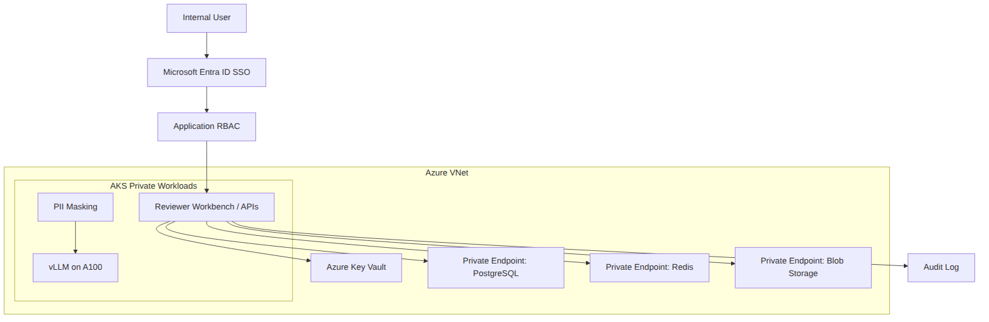
Figure 4
Figure 4
Control area | Design
Authentication | Entra ID SSO with conditional access inherited from enterprise policy
Authorization | Application RBAC mapped from Entra ID groups
Secrets | Azure Key Vault accessed through Workload Identity
Network | VNet-isolated AKS, private endpoints for managed services where enabled
Ingress | ingress-nginx behind Azure Load Balancer; App Gateway only if separately funded or mandated
Encryption in transit | TLS for all external and internal service communication where supported
Encryption at rest | Azure-managed encryption for PostgreSQL, Redis, Blob, disks, and backups
PII protection | Mask before prompt construction; block raw PII in logs and traces
Audit logs | Record user actions, model versions, prompt versions, overrides, exports, and admin changes
Admin access | Just-in-time privileged access where enterprise tooling supports it

Role | Allowed actions | Restricted actions
QA Reviewer | View assigned audits, accept/edit/reject recommendations, add override reasons | Change rubric, model, prompt, or system config
QA Lead | Review escalations, manage reviewer queues, view team dashboards | Access secrets or infrastructure
Product Owner | View metrics, configure business thresholds through approved workflow | Direct database writes
AI/ML Engineer | Manage prompt/model versions in non-prod, view eval metrics | View raw production PII unless approved
SRE / DevOps | Deploy services, monitor health, manage cluster operations | Modify QA scores
Security | Review audit logs, access reports, and policy events | Modify model outputs
Finance | View cost dashboards | Access audit content

Best Practices
Practice | Implementation
Least privilege | Grant role-specific access only.
Mask early | Remove PII before prompt construction and model inference.
Log safely | Use structured logs without raw transcript or prompt content.
Use private paths | Prefer Private Link for managed data services.
Rotate credentials | Use managed identities and Key Vault rotation policies.

Risks
Risk | Impact | Mitigation
PII in prompts or logs | Privacy and compliance incident | Masking, DLP scans, log guards
Overbroad RBAC | Unauthorized access to audit outcomes | Group review and access recertification
Cost pressure on security tooling | Reduced retention or scanning depth | Prioritize critical logs and controls
Public exposure misconfiguration | Data exfiltration risk | Private endpoints, network policies, ingress review

Recommendations
Security should approve the first production release only after validating RBAC mappings, PII masking effectiveness, audit log coverage, private endpoint configuration, and incident response runbooks. Any reduction in these controls for cost reasons requires explicit risk acceptance.

10. Capacity & Performance on 1x A100 (math for 60k audits)

Purpose
This section validates whether one A100 80GB node can support the target volume and latency.

Description
The target workload is modest in request rate but meaningful in token volume. The key capacity question is not average requests per second; it is whether the single A100 can process peak audit batches within the <60s latency target while leaving enough operational headroom for retries, prompt variance, and maintenance.

Business Justification
The single A100 decision is what makes the $5,000 budget possible. Capacity math must be clear enough for leadership and finance to understand that the design is feasible for throughput but exposed on availability.

Technical Details
Workload input | Value
Monthly audits | 60,000
Days/month assumption | 30
Daily audits | 2,000
QA parameters per audit | 30
Tokens per audit | 3,200
Monthly tokens | 192,000,000
Daily tokens | 6,400,000
Average audits/hour | 83.3
Average audits/minute | 1.39
Peak multiplier | 3x
Peak audits/hour | 250
Peak audits/minute | 4.17

Capacity formula | Result
Average tokens/hour | 6,400,000 / 24 = 266,667
Average tokens/second | 266,667 / 3,600 = 74
Peak tokens/second at 3x | 74 x 3 = 222
Required average audit completion | 1.39 audits/minute
Required peak audit completion | 4.17 audits/minute
Per-audit token budget | 3,200 tokens
Maximum latency target | <60 seconds

Conservative throughput scenario | Effective mixed throughput | GPU busy time/day | Peak feasibility
7B quantized conservative | 300 tokens/sec | 6,400,000 / 300 = 21,333 sec = 5.9 hours | Meets 222 tokens/sec peak with limited headroom
7B quantized expected | 500 tokens/sec | 12,800 sec = 3.6 hours | Meets peak with better headroom
3B quantized expected | 800 tokens/sec | 8,000 sec = 2.2 hours | Strong throughput headroom
The table uses effective mixed throughput, not ideal benchmark tokens/sec. It accounts for prompt prefill, generation, batching inefficiency, validation, and request orchestration. Actual throughput must be measured with the production prompt, 30-parameter output schema, target context length, concurrency settings, and Azure A100 SKU.
Latency budget component | Target allocation
API validation and auth | 1-2s
PII masking | 2-5s
Queue wait at normal load | 0-10s
Prompt construction | 1-3s
vLLM inference | 15-40s
Output validation and confidence | 2-5s
Persistence and publish | 1-3s
Total target | <60s

vLLM setting | Initial recommendation
Model | 7B quantized if quality gain over 3B is material; otherwise 3B quantized
Quantization | 4-bit or equivalent validated quantization
Batching | Enable continuous batching
Max concurrency | Benchmark-driven; start conservative and increase
Timeout | Set below workflow timeout to allow retry/escalation
Output format | Structured JSON with schema validation
GPU memory target | Leave operational headroom; avoid running at sustained >90% memory

Best Practices
Practice | Implementation
Benchmark with real prompts | Synthetic short prompts will overstate throughput.
Track queue age | Queue age is the strongest early warning for latency breach.
Use continuous batching | Improve GPU utilization across small audit requests.
Control output length | Long explanations can consume latency and budget.
Keep retries bounded | Retry invalid outputs once, then escalate.

Risks
Risk | Impact | Mitigation
Peak load above 3x | Queue grows and p95 latency breaches | Rate limits and priority queues
7B too slow after real prompt | Latency target at risk | Fall back to 3B or reduce output verbosity
Quantization harms quality | Human agreement may fall | Compare 3B/7B and quantization variants
GPU maintenance window | Backlog accumulates | Schedule low-volume maintenance and manual fallback

Recommendations
Proceed with one A100 for pilot and limited production, subject to benchmark confirmation. The capacity plan is credible for 60,000 audits/month if effective throughput is at least 300 mixed tokens/sec and peak traffic remains near the 3x planning assumption.

11. Cost Model — $5,000 Monthly Envelope (detailed table; must sum <=5000)

Purpose
This section provides the monthly infrastructure cost model that fits the hard USD $5,000 ceiling.

Description
The cost model is a budget envelope, not a procurement quote. Azure regional pricing, committed-use discounts, taxes, support contracts, enterprise agreements, and data retention policies can change actual spend. The envelope intentionally uses lean service tiers and assumes active FinOps management. It does not include personnel, enterprise support, security operations staffing, reviewer labor, or upstream transcription.

Business Justification
The budget ceiling is the most important non-functional constraint. The architecture must be financially credible without hiding the availability tradeoff. The design uses one production A100 and lower-cost managed services to keep monthly infrastructure spend at or below USD $5,000.

Technical Details
# | Cost item | Assumption | Monthly estimate (USD)
1 | 1x A100 80GB GPU node | A100-capable Azure VM, 730 hours/month, reservation/savings-plan target economics | 3,100
2 | AKS system + app CPU nodes | Small general-purpose nodes, 2 system + 2 app, autoscale kept within cap | 260
3 | Managed disks | OS disks, small persistent volumes for monitoring and app data | 130
4 | Azure Database for PostgreSQL | Flexible Server, burstable/small tier, modest storage and backup | 210
5 | Azure Cache for Redis | Basic or Standard small tier depending on private networking requirement | 90
6 | Azure Blob Storage | Hot tier for artifacts plus lifecycle to cool/archive/delete | 80
7 | Azure Container Registry | Basic tier | 5
8 | Networking | Load Balancer, public IP, NAT, Private Link/private DNS, ingress-nginx | 190
9 | Azure Key Vault | Secrets, keys, certificate operations | 25
10 | Monitoring/logging | Prometheus/Grafana in-cluster plus lean Log Analytics ingestion | 220
11 | Backups/snapshots | PostgreSQL backup expansion, storage snapshots, retained exports | 100
12 | Egress and data operations | Limited internal exports, dashboard usage, storage transactions | 150
13 | Contingency reserve | Price variance and small operational overages | 350
 | Total planned monthly infrastructure | Must remain at or below hard ceiling | 4,910

Budget rule | Position
Hard ceiling | Do not exceed USD $5,000/month infrastructure without sponsor approval.
GPU economics | If selected-region on-demand A100 cost exceeds the GPU envelope, use reservation/savings-plan pricing or the design does not meet 24/7 production within budget.
Dual GPU HA | Not fundable under the ceiling.
Premium ingress | Avoid Azure Application Gateway unless separately funded or mandated by security.
Redis tier | Use Basic if acceptable; use small Standard only if required for operational resilience or networking.
PostgreSQL tier | Start small/burstable; scale only based on measured CPU, connection, I/O, and storage pressure.
Logs | Keep lean retention and controlled cardinality; avoid high-volume raw log ingestion.
Non-prod | Use spot or scheduled shutdown only for non-prod if risk-accepted; do not depend on spot for production GPU.

Cost saver | Expected effect | Risk
ingress-nginx instead of premium ingress | Saves hundreds per month | Requires careful maintenance and security review
ACR Basic | Low image registry cost | Fewer enterprise features
Small PostgreSQL tier | Keeps database spend low | May require upgrade if query load grows
Basic/Standard small Redis | Keeps queue/cache cost low | Lower resilience than premium tiers
Lean Log Analytics | Prevents monitoring cost creep | Shorter forensic retention
Blob lifecycle policies | Controls artifact growth | Requires clear retention policy
Superset in app pool | Avoids separate BI hosting | Shares CPU resources

Best Practices
Practice | Implementation
Create Azure budgets | Alerts at 50%, 75%, 90%, and 100% of monthly cap.
Tag all resources | Use app=auto-qra, env=prod, owner, cost-center, and data-classification.
Review GPU utilization | Low utilization suggests schedule or batching opportunities; high utilization suggests capacity risk.
Control logs by design | Reject raw prompt/transcript logging and high-cardinality labels.
Reforecast monthly | Compare actual spend, audit volume, and cost per audit.

Risks
Risk | Financial impact | Mitigation
A100 regional price higher than estimate | Budget breach | Validate pricing before deployment and secure commitment discount
Log ingestion growth | Budget creep | Sampling, retention controls, metric-first observability
Storage retention expansion | Increased Blob and backup costs | Lifecycle policies and data retention governance
App pool autoscaling | Compute spend exceeds envelope | Budget-aware autoscaling limits

Recommendations
Finance, platform, and product should approve the $4,910 envelope with an explicit requirement that monthly Azure Cost Management reports are reviewed during pilot and limited production. If actual A100 pricing cannot be held near the modeled amount, the program must either reduce operating hours, accept non-24/7 production, secure committed pricing, or increase budget.

12. HA / DR under budget constraints (honest tradeoffs)

Purpose
This section defines the funded high availability and disaster recovery posture.

Description
The Auto QRA architecture is resilient for non-GPU services within a lean budget, but it is not end-to-end highly available. The GPU inference layer uses one A100 production node and is therefore a single point of failure. The appropriate availability posture is budget-constrained service availability with a target of 99.5% overall and best effort toward 99.9% for non-GPU layers.

Business Justification
A second A100 production node would materially improve inference availability but would likely break the $5,000 monthly ceiling before adding database, Redis, storage, monitoring, and networking costs. The business must choose between strict budget compliance and full inference HA. This design chooses strict budget compliance because that is the locked decision.

Technical Details
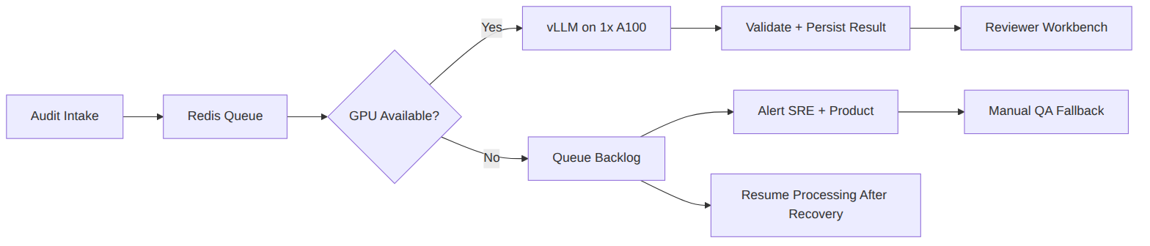
Figure 5
Figure 5
Layer | HA posture | Budget-constrained design | Residual risk
Ingress/API | Multiple replicas on app pool | Kubernetes service, readiness probes, PDBs | App pool node pressure
Workers | Multiple CPU worker pods | Horizontal scaling within app pool | Queue backlog if GPU unavailable
GPU inference | Single A100 node and vLLM pod | Restart and node repair only | Single point of failure
PostgreSQL | Managed service backups; optional zone redundancy only if budget allows | Small tier with backups | Lower RTO/RPO than premium HA
Redis | Basic or small Standard tier | Retry and idempotent queues | Cache/queue outage delays
Blob Storage | Azure-managed durability | Lifecycle and backups for critical exports | Access outage or policy misconfig
Superset | App pool deployment | Restore from config and database | Dashboard outage
Observability | In-cluster Prometheus/Grafana | Short retention and alerts | Monitoring impact during cluster issue

Availability target | Funded position
Overall Auto QRA service | 99.5% target
Non-GPU app/API layers | Best effort toward 99.9%
GPU inference layer | No HA target beyond repair/restart under one-node design
RPO | PostgreSQL backup target <=24h unless higher tier funded
RTO for non-GPU service | Hours depending on managed service recovery
RTO for GPU failure | Dependent on Azure node recovery/quota; could exceed target during regional capacity issue

Failure scenario | Expected behavior | Operator action
vLLM pod crash | Kubernetes restarts pod; queue waits | Alert, inspect GPU logs, redeploy if needed
A100 node failure | Inference stops; jobs remain queued | Open Azure support path, replace node, communicate delay
PostgreSQL outage | Intake may degrade or pause | Fail closed for writes, restore managed service
Redis outage | Queue operations fail | Pause intake or use degraded persistence-backed queue if implemented
Blob outage | Artifact storage delayed | Retry and mark artifacts pending
AKS control plane issue | Existing pods may run; deploys unavailable | Avoid changes until control plane recovers

Best Practices
Practice | Implementation
Design for graceful backlog | Audits should queue rather than disappear during GPU outage.
Make jobs idempotent | Retries must not duplicate final audit records.
Publish status | Product and operations need clear degraded-mode messaging.
Test restore | Run PostgreSQL and configuration restore tests before GA.
Keep manual fallback | QA must be able to operate when automation is paused.

Risks
Risk | Consequence
GPU quota shortage during failure | Replacement may be delayed.
Backlog after outage | SLA breach and reviewer load spike.
Lower managed service tiers | Recovery features may be limited.
Budget pressure | Teams may defer DR testing, increasing recovery risk.

Recommendations
Document this as a formal risk acceptance: the funded design targets 99.5% service availability and accepts GPU single-point-of-failure risk. If 99.9% end-to-end availability becomes mandatory, fund a second A100 production node, more resilient managed service tiers, and expanded observability retention.

13. Monitoring, Alerting, Ops

Purpose
This section defines how Auto QRA will be operated in production.

Description
Operations focus on workflow completion, latency, AI quality, GPU health, cost, and security. Prometheus collects metrics from application services, vLLM, Kubernetes, Redis exporters, PostgreSQL exporters where feasible, and NVIDIA DCGM Exporter. Grafana provides dashboards. Alertmanager routes actionable alerts to on-call teams.

Business Justification
Auto QRA is a decision-support workflow. Silent failure is unacceptable because missed audits, delayed reviews, or unsupported model findings can affect customers, employees, and compliance posture. Monitoring protects service reliability, reviewer trust, and budget discipline.

Technical Details
SLO / metric | Target | Alert threshold
Audit completion latency | p95 <60s | p95 >60s for 15m
API availability | >=99.5% | 5xx >2% for 10m
Queue age | <60s normal | Oldest job >300s
vLLM request failures | <1% | >3% for 10m
GPU utilization | Healthy under load | >95% for 10m or <10% while queue grows
GPU memory | <90% sustained | >95% for 5m
PostgreSQL connections | <80% max | >90% for 10m
Redis memory | <75% | >85%
PII masking failures | 0 high-severity escapes | Any high-severity event
Monthly spend | <=USD $5,000 | Forecast >90% before day 24

Dashboard | Audience | Panels
Executive Health | Leadership, Product | Monthly audits, latency SLO, agreement, hallucination, cost per audit
Operations Overview | SRE, DevOps | API errors, queue depth, worker state, dependency latency
vLLM and GPU | AI/ML, Platform | tokens/sec, waiting requests, batch size, GPU utilization, memory
Quality Review | QA Leads | confidence bands, overrides, disagreement reasons, escalations
Security | Security | SSO failures, RBAC denials, PII masking events, audit log health
FinOps | Finance, Product | month-to-date spend, forecast, GPU utilization, storage growth

Runbook | Trigger | First action
GPU unavailable | vLLM health down or DCGM error | Confirm pod, node, driver, and Azure VM health
Latency breach | p95 audit latency >60s | Check queue age and vLLM waiting requests
Quality regression | Agreement below threshold | Stop prompt rollout and review sample
Budget breach forecast | Spend forecast >USD $5,000 | Freeze scaling and identify cost driver
PII event | Masking escape detected | Contain, revoke access if needed, notify security

Best Practices
Practice | Implementation
Alert on symptoms | Prioritize latency, failure rate, queue age, and PII events.
Use recording rules | Reduce expensive Prometheus queries.
Limit metric cardinality | Avoid raw user IDs, transcript IDs, or free text as labels.
Keep runbooks short | Each critical alert needs a first 15-minute response path.
Review weekly during pilot | Tune thresholds after observing real traffic.

Risks
Risk | Impact | Mitigation
Alert fatigue | Operators ignore signals | Actionable alerts only
Costly log ingestion | Budget pressure | Metrics-first operations and lean logs
Missing AI quality alerts | Bad outputs persist | Quality dashboards and sampled review
Incomplete runbooks | Longer incidents | Tabletop tests before GA

Recommendations
Make monitoring and runbooks production readiness gates. Do not launch limited production without dashboards for latency, queue age, vLLM health, GPU health, budget, and quality.

14. Rollout Plan (Pilot → Limited → GA) with gates

Purpose
This section defines the phased rollout plan and promotion gates.

Description
Auto QRA should roll out in controlled phases: pilot, limited production, and general availability. Each phase increases volume and business reliance only after quality, latency, security, operations, and cost gates are met.

Business Justification
The phased rollout reduces risk from model behavior, workflow adoption, and infrastructure assumptions. It also gives finance actual spend data before the platform is treated as a stable production capability.

Technical Details
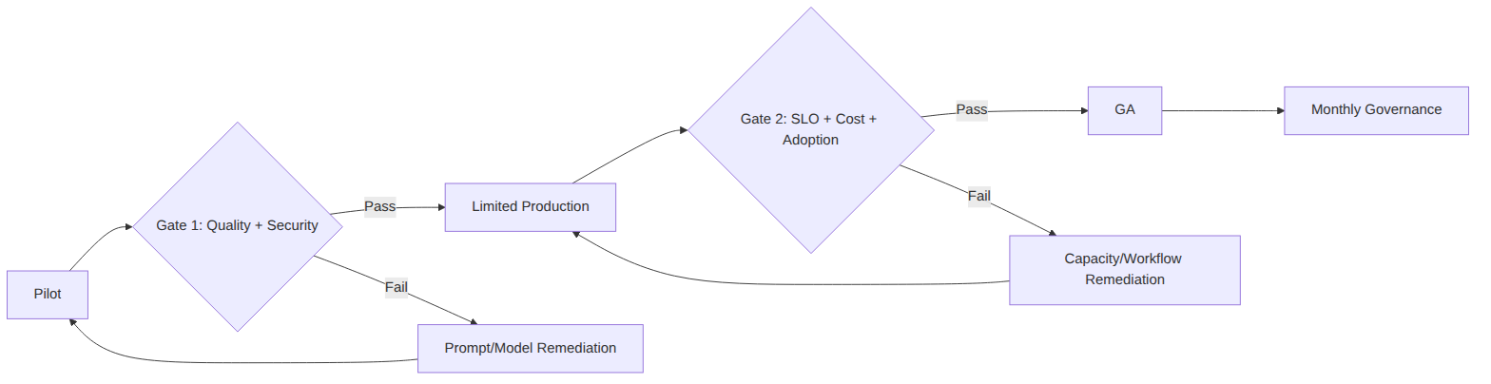
Figure 6
Figure 6
Phase | Volume | Users | Objective | Exit gate
Pilot | 2,000-5,000 audits/month | Small QA group | Prove model quality, workflow, security | Agreement >90%, hallucination <5%, no critical security gaps
Limited production | 15,000-30,000 audits/month | Selected teams | Prove operations, cost, adoption, latency | p95 <60s, spend forecast <=$5k, override workflow stable
GA | Up to 60,000 audits/month | Full target audience | Scale within budget | Monthly governance and SLO compliance

Gate | Required evidence | Owner
Model gate | Eval set, human comparison, hallucination analysis | AI/ML
Security gate | RBAC test, PII masking test, audit log review, private access review | Security
Ops gate | Dashboards, alerts, runbooks, backup restore test | SRE / DevOps
Finance gate | Azure spend forecast, cost per audit, reservation validation | Finance
Product gate | Reviewer workflow acceptance, override taxonomy, training | Product / QA
Leadership gate | Formal acceptance of GPU SPOF and 99.5% target | Sponsor

Best Practices
Practice | Implementation
Freeze prompt during gate tests | Avoid changing prompts while measuring quality.
Use adjudicated samples | Human reviewers must agree on gold labels.
Test degraded mode | Simulate GPU outage and validate backlog/manual fallback.
Train reviewers | Ensure override reasons are consistent.
Track actual spend | Use live cost data before GA.

Risks
Risk | Impact | Mitigation
Pilot sample too easy | GA quality disappoints | Stratify sample by channel, issue type, and team
Skipping limited production | Operational risks emerge at full volume | Require phase gates
User resistance | Reviewers bypass system | Training and workflow feedback
Budget surprise | GA exceeds cap | Finance gate with month-to-date data

Recommendations
Use the rollout gates as hard controls. Do not let schedule pressure override agreement, hallucination, security, latency, or cost gates.

15. Risks & Mitigations (budget, single GPU, quality)

Purpose
This section consolidates the primary risks and mitigations.

Description
The highest risks are budget pressure, single-GPU availability, and AI quality. These risks are manageable for a constrained first production release if they are acknowledged and governed. They are not eliminated by the current design.

Business Justification
Leadership needs a clear risk register to decide whether the value of broader QA automation justifies the funded availability and quality posture. Engineering and operations need the same register to prioritize controls.

Technical Details
Risk | Probability | Impact | Mitigation | Residual risk
$5k budget exceeded | Medium | High | Cost envelope, budgets, reservation validation, lean logs | Regional pricing may still break model
Single A100 failure | Medium | High | Queue backlog, alerting, runbooks, manual fallback | Inference outage remains
A100 quota unavailable | Medium | High | Early quota request and region validation | Region migration may be needed
7B quantized too slow | Medium | Medium | Benchmark and fall back to 3B if needed | Quality may differ
3B quality insufficient | Medium | High | Compare models, improve prompt, use 7B if within latency | May delay GA
Hallucination >5% | Medium | High | Evidence validation, confidence thresholds, human override | Manual workload increases
Human agreement <90% | Medium | High | Prompt tuning, rubric clarification, model selection | Business value may reduce
PII masking failure | Low/Medium | High | Masking tests, DLP scans, log guards | Incident response still required
Reviewer adoption low | Medium | Medium | Training, UX feedback, explainability | Benefits delayed
Log/monitoring cost growth | Medium | Medium | Retention controls and cardinality review | Reduced diagnostics

Best Practices
Practice | Implementation
Own each risk | Assign product, engineering, security, finance, or SRE owner.
Quantify residual risk | Do not describe single GPU as highly available.
Link risk to gates | Pilot and GA cannot pass if quality or security risks are unresolved.
Review monthly | Risk posture changes with traffic, spend, and model behavior.

Risks
The central meta-risk is miscommunication: treating this design as if it provides enterprise-grade N+1 inference HA would create false expectations. Another meta-risk is optimizing for the budget so aggressively that quality review teams lose confidence due to underinvestment in evaluation, reviewer workflow, or operations.

Recommendations
Maintain a live risk register and include the single-GPU risk in leadership status reporting. If the organization cannot tolerate inference outages, the correct mitigation is additional budget, not architectural wording.

16. Production Readiness Checklist (condensed but useful)

Purpose
This section defines the minimum checklist required before production launch.

Description
The checklist is concise but covers product, AI/ML, platform, security, operations, finance, and support readiness. It should be used as a go-live control for limited production and GA.

Business Justification
Production readiness protects business stakeholders from launching an AI workflow that is fast but ungoverned, inexpensive but unreliable, or secure but unusable. It also creates accountability across teams.

Technical Details
Area | Readiness item | Owner | Required for
Product | 30-parameter rubric approved and versioned | Product / QA | Pilot
Product | Human override workflow implemented | Product / Engineering | Pilot
Product | Override reason taxonomy defined | QA Leads | Pilot
AI/ML | 3B and 7B quantized benchmark completed | AI/ML | Pilot
AI/ML | Human agreement >90% on adjudicated sample | AI/ML / QA | Limited production
AI/ML | Hallucination <5% on adjudicated sample | AI/ML / QA | Limited production
AI/ML | Prompt and model version logging enabled | Engineering | Pilot
Platform | AKS node pools configured: system, app, gpu-a100 | DevOps | Pilot
Platform | vLLM deployed on A100 with health checks | AI Platform | Pilot
Platform | Redis queue idempotency validated | Engineering | Limited production
Data | PostgreSQL schema, indexes, backups validated | Engineering / DBA | Pilot
Data | Blob lifecycle policy configured | DevOps | Limited production
Security | Entra ID SSO and RBAC tested | Security | Pilot
Security | PII masking validation passed | Security / AI/ML | Pilot
Security | Key Vault and workload identity configured | DevOps / Security | Pilot
Security | Audit logs reviewed for required events | Security | Limited production
Ops | Prometheus/Grafana dashboards live | SRE | Pilot
Ops | Critical alerts routed and tested | SRE | Limited production
Ops | GPU outage runbook tested | SRE / AI Platform | Limited production
Finance | Azure budget alerts configured | Finance / DevOps | Pilot
Finance | Spend forecast <=USD $5,000 | Finance | Limited production
Support | Reviewer training completed | Product / QA | Limited production
Governance | Single-GPU risk accepted | Leadership | GA

Best Practices
Practice | Implementation
Treat checklist as evidence-based | Each item needs proof, not verbal status.
Separate pilot and GA criteria | Early learning is acceptable; unmanaged production risk is not.
Include finance in readiness | Budget compliance is a production requirement.
Retest after major changes | Model, prompt, GPU image, and schema changes can affect readiness.

Risks
Risk | Impact
Checkbox compliance | Teams mark items complete without evidence.
Missing owner | Readiness gaps persist until launch pressure.
Skipping restore tests | DR assumptions remain unproven.

Recommendations
Use this checklist in a formal go-live review. Keep evidence links in the release record, including benchmark reports, security test results, dashboard screenshots, cost reports, and signed risk acceptance.

17. Internal Recommendations & Open ADRs

Purpose
This section provides final internal recommendations and identifies open decisions.

Description
Auto QRA is feasible as a budget-constrained Azure AKS service using one NVIDIA A100 80GB GPU node and self-hosted vLLM. It is not feasible to provide dual-A100 production HA within the USD $5,000 monthly infrastructure ceiling. The design should proceed only with explicit acceptance of this distinction.

Business Justification
The recommended path allows the organization to realize meaningful QA automation value quickly while limiting monthly infrastructure spend. It also keeps leadership aware of the funded risk boundary and avoids overpromising availability.

Technical Details
Recommendation | Rationale | Decision needed
Proceed with 1x A100 production pilot | Capacity math supports 60,000 audits/month if benchmarks confirm throughput | Approve pilot funding
Keep the $5k budget visible in all architecture reviews | Cost is a locked constraint, not a preference | Finance sign-off
Use 99.5% as the funded service availability target | Single GPU prevents credible 99.9% end-to-end claim | Leadership risk acceptance
Benchmark 3B and 7B quantized models | Final model should balance quality, latency, and cost | AI/ML recommendation
Launch with conservative confidence thresholds | Trust is more important than early automation rate | Product and QA approval
Require human override in every workflow | Preserves accountability and reduces AI risk | Product requirement
Keep observability lean but complete | Budget does not allow uncontrolled log growth | SRE and FinOps approval
Use ingress-nginx unless premium ingress is mandated | Saves cost under the cap | Security review

Open ADR | Options | Recommended next step
Final model | 3B quantized vs 7B quantized | Run benchmark with production prompt and adjudicated sample
Prompt format | Single-pass scoring vs staged extraction/scoring | Start single-pass; evaluate staged approach if hallucination exceeds target
Confidence threshold | 0.85 high-confidence vs stricter threshold | Start at 0.85 and tune after pilot
PostgreSQL HA tier | Small non-zone redundant vs zone-redundant if budget allows | Start small; upgrade only if cost envelope remains safe
Redis tier | Basic vs Standard | Choose based on private networking and queue resilience needs
Log retention | 14, 30, or 90 days | Use 14-30 days detailed logs, longer aggregate metrics if affordable
Ingress | ingress-nginx vs managed gateway | Use ingress-nginx unless security mandates gateway funding
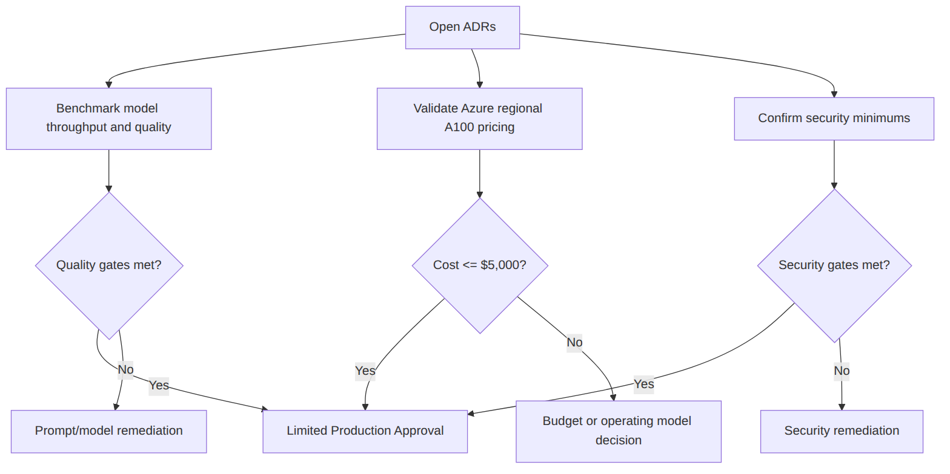
Figure 7
Figure 7

Best Practices
Practice | Implementation
Keep recommendation language precise | Say “budget-constrained” and “single GPU” plainly.
Make open ADRs time-bound | Resolve before GA, not during incident response.
Keep finance in the loop | Cost decisions are architecture decisions in this design.
Preserve auditability | Every model, prompt, threshold, and override must be traceable.

Risks
Risk | Impact
Leadership expects HA without funding it | Incident dissatisfaction and credibility loss
Model choice made on throughput alone | Quality targets missed
Security control reductions made informally | Compliance exposure
Cost optimization reduces reviewer trust | Lower adoption and weaker business case

Recommendations
Approve Auto QRA as a budget-constrained internal production design on Azure AKS with one A100 80GB GPU node. Move into pilot only after A100 quota and pricing are validated. Move into limited production only after human agreement exceeds 90%, hallucination is below 5%, p95 latency is below 60 seconds, and the month-to-date Azure forecast remains at or below USD $5,000. Reopen the budget if leadership requires end-to-end 99.9% availability or GPU N+1 high availability.

