SIMATS ENGINEERING
ASSESSMENT TOOL 1
COURSE NAME: Cryptography and Network Security
COURSE CODE: CSA51
COURSE OUTCOME COVERED
CO3: Examine cryptographic hash algorithms, digital signature schemes, and assess Kerberos and X.509 authentication frameworks for ensuring integrity, authentication, and non-repudiation. CO (BL4, BL5)
Assessment Tool Weightage: 40%
QUESTIONS: 5 TOTAL MARKS: 25
EXPERIMENTS

Code of Conduct
I V Bharathwaj Reddy (192372213) certify that this submission is my original work and that I have adhered to the guidelines specified for this assessment.
I understand that any violation of academic integrity rules will result in disciplinary action.
Signature of the student: V Bharathwaj Reddy

Annexure A — Experiments
1. Implement and compare MD5 and Secure Hash Algorithm (SHA-256) in Python by hashing multiple input messages. Analyze their collision resistance and performance differences.
2. Develop a Python program to implement a Digital Signature scheme using RSA. Demonstrate message signing and signature verification, and analyze its effectiveness in ensuring integrity and authentication.
3. Design and implement a secure file-integrity verification system using MD5 and SHA-256. The system should generate hash values for a file, store the reference hashes, and later verify whether the file has been modified.
4. Write a Python program to generate the SHA-256 hash of a given message and demonstrate the avalanche effect by changing one character.
5. Implement MD5 and SHA-256 hashing algorithms using Python's hashlib library. Compare their outputs for the same input.
6. Write a Python program to generate the MD5 hash value of a given text message. Input: "Hello World". Output: 32-character hexadecimal MD5 digest.
7. Write a Python program to compare MD5 and SHA-256 for the same input message. Display: Original message, MD5 digest, SHA-256 digest, Digest length.

Rubrics for Calculation
Criteria | Weightage | Level 4 – Exemplary | Level 3 – Proficient | Level 2 – Developing | Level 1 – Beginning
Understanding of Concepts | 25 | Demonstrates thorough understanding and effectively integrates multiple concepts/technologies | Good understanding with proper integration of most concepts | Basic understanding; limited or partial integration | Poor understanding; unable to integrate concepts
Experimental Design | 30 | Well-planned, systematic implementation with optimal solution | Correct implementation with minor issues | Basic implementation with errors or inefficiencies | Incorrect or incomplete implementation
Use of Tools | 20 | Effective and advanced use of tools/technologies with proper configuration | Appropriate use of tools with correct execution | Limited or inconsistent use of tools | Incorrect or minimal use of tools
Analysis of Results | 15 | Insightful analysis with accurate interpretation and validation of results | Good analysis with reasonable interpretation | Basic analysis with limited insights | Poor or incorrect analysis of results
Documentation | 10 | Clear, well-structured documentation with diagrams, code, and results | Organized documentation with necessary details | Basic documentation with missing details | Poor or incomplete documentation

ANSWERS
Name: V Bharathwaj Reddy
Registration No: 192372213

Experiment 1
Implement and compare MD5 and Secure Hash Algorithm (SHA-256) in Python by hashing multiple input messages. Analyze their collision resistance and performance differences.

Python Code
"""
Experiment 1
Implement and compare MD5 and SHA-256 in Python by hashing multiple input
messages. Analyze their collision resistance and performance differences.
"""

import hashlib
import time

def get_md5(message: str) -> str:
"""Return the MD5 hex digest of a message."""
return hashlib.md5(message.encode()).hexdigest()

def get_sha256(message: str) -> str:
"""Return the SHA-256 hex digest of a message."""
return hashlib.sha256(message.encode()).hexdigest()

def measure_performance(hash_func, message: str, iterations: int = 100000) -> float:
"""Time how long it takes to hash `message` `iterations` times. Returns seconds."""
start = time.perf_counter()
for _ in range(iterations):
hash_func(message)
end = time.perf_counter()
return end - start

def compare_messages(messages):
"""Hash each message with MD5 and SHA-256 and print a comparison table."""
print(f"{'Message':<20}{'MD5 Digest':<35}{'SHA-256 Digest'}")
print("-" * 110)
results = []
for msg in messages:
md5_digest = get_md5(msg)
sha_digest = get_sha256(msg)
results.append((msg, md5_digest, sha_digest))
print(f"{msg:<20}{md5_digest:<35}{sha_digest}")
return results

def collision_resistance_demo():
"""
Show how a tiny change in input produces a completely different digest
(a quick informal illustration of collision resistance / avalanche effect).
"""
msg1 = "Hello World"
msg2 = "Hello World!" # one character added

print("\nCollision Resistance Illustration")
print("-" * 60)
print(f"Message 1: {msg1}")
print(f"Message 2: {msg2}\n")

md5_1, md5_2 = get_md5(msg1), get_md5(msg2)
sha_1, sha_2 = get_sha256(msg1), get_sha256(msg2)

print(f"MD5(msg1): {md5_1}")
print(f"MD5(msg2): {md5_2}")
print(f"MD5 identical? {md5_1 == md5_2}\n")

print(f"SHA256(msg1): {sha_1}")
print(f"SHA256(msg2): {sha_2}")
print(f"SHA256 identical? {sha_1 == sha_2}")

def performance_comparison():
"""Compare raw hashing speed of MD5 vs SHA-256."""
sample_message = "The quick brown fox jumps over the lazy dog"
iterations = 100000

md5_time = measure_performance(get_md5, sample_message, iterations)
sha_time = measure_performance(get_sha256, sample_message, iterations)

print("\nPerformance Comparison")
print("-" * 60)
print(f"Iterations: {iterations}")
print(f"MD5 total time: {md5_time:.4f} sec")
print(f"SHA-256 total time: {sha_time:.4f} sec")
faster = "MD5" if md5_time < sha_time else "SHA-256"
print(f"=> {faster} is faster for this workload.")

# ---------------------------------------------------------------------------
# TEST CASES
# ---------------------------------------------------------------------------
def run_tests():
print("Running test cases for Experiment 1...\n")

# Test 1: Known MD5 digest for "Hello World"
assert get_md5("Hello World") == "b10a8db164e0754105b7a99be72e3fe5", \
"MD5 digest of 'Hello World' incorrect"
print("Test 1 passed: MD5('Hello World') matches known digest.")

# Test 2: Known SHA-256 digest for "Hello World"
assert get_sha256("Hello World") == (
"a591a6d40bf420404a011733cfb7b190d62c65bf0bcda32b57b277d9ad9f146e"
), "SHA-256 digest of 'Hello World' incorrect"
print("Test 2 passed: SHA-256('Hello World') matches known digest.")

# Test 3: Digest lengths are correct (MD5 = 32 hex chars, SHA-256 = 64 hex chars)
assert len(get_md5("test")) == 32, "MD5 digest length should be 32"
assert len(get_sha256("test")) == 64, "SHA-256 digest length should be 64"
print("Test 3 passed: Digest lengths correct (MD5=32, SHA-256=64).")

# Test 4: Same input always produces same digest (determinism)
assert get_md5("repeat") == get_md5("repeat")
assert get_sha256("repeat") == get_sha256("repeat")
print("Test 4 passed: Hash functions are deterministic.")

# Test 5: Different inputs produce different digests (no trivial collisions)
assert get_md5("abc") != get_md5("abd")
assert get_sha256("abc") != get_sha256("abd")
print("Test 5 passed: Different inputs give different digests.")

# Test 6: Empty string handling
assert get_md5("") == "d41d8cd98f00b204e9800998ecf8427e"
assert get_sha256("") == (
"e3b0c44298fc1c149afbf4c8996fb92427ae41e4649b934ca495991b7852b855"
)
print("Test 6 passed: Empty string hashes correctly.")

print("\nAll test cases passed!\n")

if __name__ == "__main__":
run_tests()

messages = ["Hello World", "Hello World!", "Cryptography", "Network Security"]
compare_messages(messages)
collision_resistance_demo()
performance_comparison()

Output
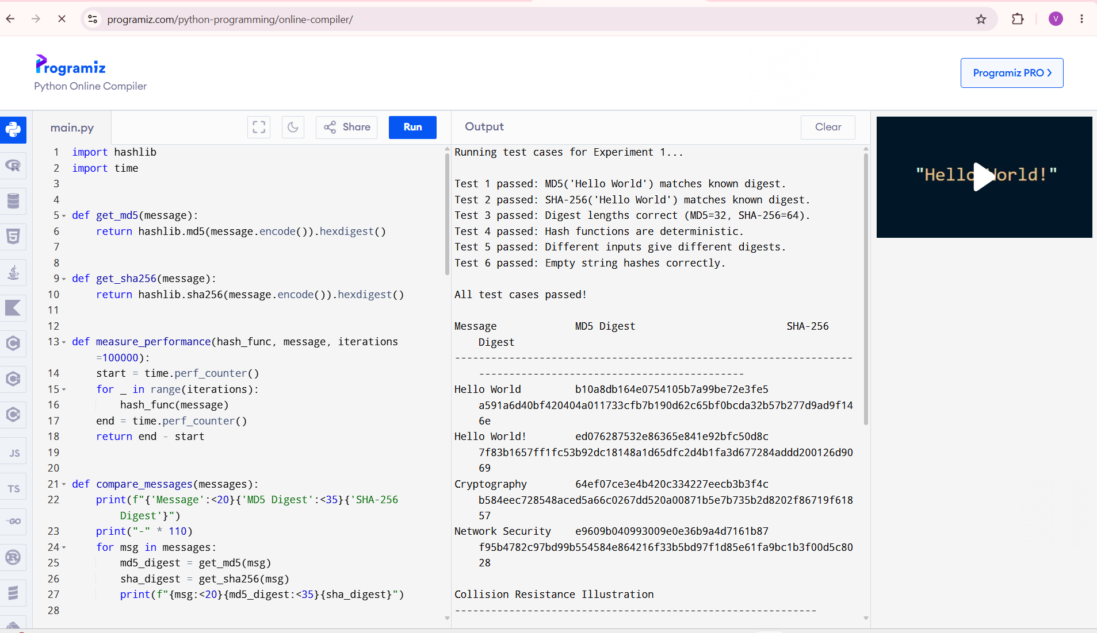

Experiment 4
Write a Python program to generate the SHA-256 hash of a given message and demonstrate the avalanche effect by changing one character.

Python Code
"""
Experiment 4
Write a Python program to generate the SHA-256 hash of a given message and
demonstrate the avalanche effect by changing one character.
"""

import hashlib

def sha256_hash(message: str) -> str:
"""Return the SHA-256 hex digest of a message."""
return hashlib.sha256(message.encode()).hexdigest()

def hamming_distance_bits(hex1: str, hex2: str) -> int:
"""
Count how many bits differ between two equal-length hex digests.
This is the standard way to measure the avalanche effect.
"""
bin1 = bin(int(hex1, 16))[2:].zfill(len(hex1) * 4)
bin2 = bin(int(hex2, 16))[2:].zfill(len(hex2) * 4)
return sum(b1 != b2 for b1, b2 in zip(bin1, bin2))

def demonstrate_avalanche(original: str, modified: str):
"""Hash both messages and show how much the digest changed."""
digest1 = sha256_hash(original)
digest2 = sha256_hash(modified)

total_bits = len(digest1) * 4 # each hex char = 4 bits
diff_bits = hamming_distance_bits(digest1, digest2)
percent_change = (diff_bits / total_bits) * 100

print(f"Original message : {original}")
print(f"Modified message : {modified}")
print(f"SHA-256(original): {digest1}")
print(f"SHA-256(modified): {digest2}")
print(f"Bits changed : {diff_bits}/{total_bits} ({percent_change:.2f}%)")
print("-" * 70)

return digest1, digest2, diff_bits, percent_change

# ---------------------------------------------------------------------------
# TEST CASES
# ---------------------------------------------------------------------------
def run_tests():
print("Running test cases for Experiment 4...\n")

# Test 1: Known SHA-256 digest
assert sha256_hash("Hello World") == (
"a591a6d40bf420404a011733cfb7b190d62c65bf0bcda32b57b277d9ad9f146e"
), "SHA-256 digest incorrect"
print("Test 1 passed: SHA-256('Hello World') matches known digest.")

# Test 2: Digest length must always be 64 hex characters (256 bits)
assert len(sha256_hash("test")) == 64
assert len(sha256_hash("")) == 64
print("Test 2 passed: Digest length is always 64 hex chars.")

# Test 3: Hamming distance calculation sanity check
# Same digest -> 0 bits different
d = sha256_hash("same input")
assert hamming_distance_bits(d, d) == 0
print("Test 3 passed: Identical digests show 0 bit difference.")

# Test 4: Avalanche effect - one character change should flip
# roughly half the bits (good hash functions land near 50%)
digest1, digest2, diff_bits, percent_change = demonstrate_avalanche(
"Hello World", "Hello World!"
)
assert digest1 != digest2, "Digests should differ after a character change"
assert diff_bits > 0, "At least some bits must change"
print(f"Test 4 passed: {diff_bits} bits differ, an avalanche effect occurred.")

# Test 5: Single-character-case change (H -> h) also triggers avalanche
digest3, digest4, diff_bits2, _ = demonstrate_avalanche(
"Hello World", "hello World"
)
assert digest3 != digest4
assert diff_bits2 > 50, "Expected a large number of bits to flip"
print(f"Test 5 passed: case change flipped {diff_bits2} bits.\n")

print("All test cases passed!\n")

if __name__ == "__main__":
run_tests()

print("Additional Demonstration")
print("=" * 70)
demonstrate_avalanche("CryptographyLab", "cryptographyLab")
demonstrate_avalanche("Password123", "Password124")

Output
