# Smarter Cities: Comparison of Python libraries for static and interactive visualizations of large vector data

## Abstract

Local governments, as part of ‘smart city’ initiatives and to promote interoperability, are increasingly incorporating open-source software into their data management, analysis, and visualisation workflows. Python, with its concise and natural syntax, presents a low barrier to entry for municipal staff without computer science backgrounds. However, with regard to geospatial visualisations in particular, the range of available Python libraries has diversified to such an extent that identifying candidate libraries for specific use cases is a challenging undertaking. This study therefore assesses prominent, actively-developed visualisation libraries in the Python ecosystem with respect to their suitability for producing visualisations of large vector datasets. A simple visualisation task common in urban development is used to produce near-identical thematic maps across static and an interactive ‘tracks’ of comparison. All short-listed libraries were able to generate the sample map products for both a small and larger dataset. Code complexity differed more strongly for interactive visualisations. Formal and informal documentation channels are highlighted to outline available resources for flattening learning curves. CPU runtimes for the Python-based portion of the process chain differed starkly for both tracks, pointing to avenues for further research. These results demonstrate that the Python ecosystem offers local governments powerful tools, free of vendor lock-in and licensing fees, to produce performant and consistently formatted visualisations for both internal and public distribution.

**Keywords:** Python, open-source, visualisation, vector data, Smart City

## Introduction

The ‘smart city’ paradigm hinges on the idea that modern information and communications technology can be harnessed to ‘automate routine functions serving individual persons, buildings, [and] traffic systems’ and ‘enable us to monitor, understand, analyse and plan the city to improve the efficiency, equity and quality of life for its citizens in real time’ (Batty et al., 2012). While the term ‘smart city’ remains a fuzzy concept, the literature broadly agrees that approaches under this umbrella can ‘contribute to the legitimacy of urban governance’ by helping improve outcomes of decision-making and strengthen democratic forms of government through knowledge creation, knowledge exchange and innovation (Meijer and Rodrigues Bolivar, 2015).

A crucial condition for fulfilling this promise will be the ability of local governments to analyse ever larger volumes of data and move from reactive to predictive, targeted service delivery (Al Nuaimi et al., 2015; Davenport et al*.*, 2012; Malomo and Sena, 2016). In the UK, measures related to expanded use of dedicated and shared data analysis capacities leading to better

allocation of resources was estimated to yield public sector savings of between GBP10 billion and GBP23.4 billion over five years (Copeland, 2015). Considering the post-2020 “scissors effect” of increasing expenditures and declining revenues (OECD, 2020), stakeholders will need to find new ways to realise these savings.

In recent years, examples of innovative applications of data science by, or simply “in”, cities have proliferated, ranging from more accurately estimating neighbourhood incomes (Glaeser et al., 2015); improving solid waste management (Watson and Ryan, 2020); or providing night- time public transport (Hong et al., 2019). A review by De Souza et al. (2019) found predictive analytics to be the most fertile application for machine learning in the ‘smart city’ context.

Several studies have pointed out that scaling up these initiatives will not be easy, especially in a likely “do-more-with-less” resource environment. While some organisations have yet to optimally manage and de-silo the ‘small data’ they currently possess (Copeland, 2015; Malomo and Sena, 2016; Oates, 2018; Oxford Internet Institute, 2019; Ross et al*.*, 2013), others will need to find ways to exploit cross-organisational economies of scale by reducing duplication of hardware, systems and personnel (Copeland, 2015), and all will have to address questions of inequitable data access, biased data collection, and politicisation of ‘smartness’ itself (Kitchin, 2014; Watson, 2013; Zanmiller, 2015). Finally, developing the technical and human capacities for more advanced urban analytics will only be an intermediate step towards efficiently structuring these capacities into teams and departments (Günther et al., 2017) and reforming governance structures to respond to data-driven decision-making (Sharma et al., 2014).

In any case, what should precede reforms in any data domain relevant to making cities ‘smart*er*’, from data acquisition and management, to analysis and visualisation, is an objective evaluation of available tools and their respective barriers to entry. In this study, open-source data visualisation as an important step in the data value chain is used to illustrate such an evaluation.

The paper first presents the context in which local governments may wish to explore open- source approaches to data visualisation as well as the challenges this may pose. It then presents an overview of the Python visualisation landscape with a focus on geospatial applications. A common visualisation task was developed and implemented using Python libraries across two separate competitive ‘tracks’, producing static and interactive visualisations, respectively. Both ‘soft’ performance indicators, such as available project documentation and code complexity are examined alongside quantitative comparative indicators such as output file size and cumulative CPU runtime. Finally, implications for local authorities arising from engaging with the underlying open-source business model are outlined.

## New approaches to data visualisation for local government

As limitations on bandwidth and server capacity are lifted, geospatial visualisations are, in many contexts, moving beyond the provision of image tiles (Stefanakis, 2017) towards high- resolution, on-demand, and even real-time representations. With local governments both gathering, and becoming aware of the utility of, ever-larger amounts of data, the need increases for ‘new approaches to an efficient, consistent, and compliant mapping of massive polyline geometries representing geographic features or trajectories’ (Breunig et al., 2020).

Given increasing time demands on municipal workers (Oxford Internet Institute, 2019), it is not implausible to assume that the more intuitive these new approaches are to master and apply, the more likely they are to take hold in local government.

Obviously, staff training will only be part of the solution. Another will be the identification and development of appropriate systems satisfying an expansive list of requirements (Daneva and

Lazarov, 2018). The question is, which systems for which services? Concerning software solutions, some municipal functions can and certainly will be supported by proprietary solutions, though a growing number of local governments are choosing open-source alternatives (European Commission, 2021). In the realm of data management, analysis and visualisation, the capabilities of, among others, PostgreSQL, R, and Python offer an increasingly competitive value free of vendor lock-in and licensing fees (Burger, 2019; Oxford Internet Institute, 2019).

Python in particular presents low barriers to entry to newcomers due to its concise, natural syntax. It is also a highly innovative ecosystem. Suites of related functionalities are bundled into hundreds of ‘packages’ or ‘libraries’ distributed to users on request or automatically as part of other libraries’ dependencies. Due to Python’s open-source nature, each of these libraries can leverage functionalities from another in the same production environment without data having to be mediated through files (Lin, 2012). This enables organisations dealing with an ever-expanding kaleidoscope of data sources and consumers to establish lean data manipulation and management workflows.

A first barrier to uptake is the challenge of identifying suitable libraries. The questions which this study seeks to answer on behalf of new organisational users are:

1. Does this library support the type of map product we wish to produce?
2. What kind of input and output data formats are supported, and is elaborate pre- processing required?
3. Can large datasets be visualised while retaining high performance, both during development and production?
4. How complex are its underlying concepts and syntax, and what resources are available to master it?
5. Is the developer and user community active and stable, ensuring that the library will be supported well into the future?

## The geospatial Python visualisation landscape

In recent years, the number of Python libraries with geospatial functionalities has multiplied significantly. **Error! Reference source not found.**, an expansion on VanderPlas (2017), presents a non-exhaustive overview of some of the most prominent Python libraries involved in data visualisation. The landscape is centred around three main clusters: primarily static visualisations building on *Matplotlib* (Barrett et al., 2005; Hunter, 2007), interactive visualisations interfacing with HTML and *JavaScript*, and advanced 2D/3D visualisations and

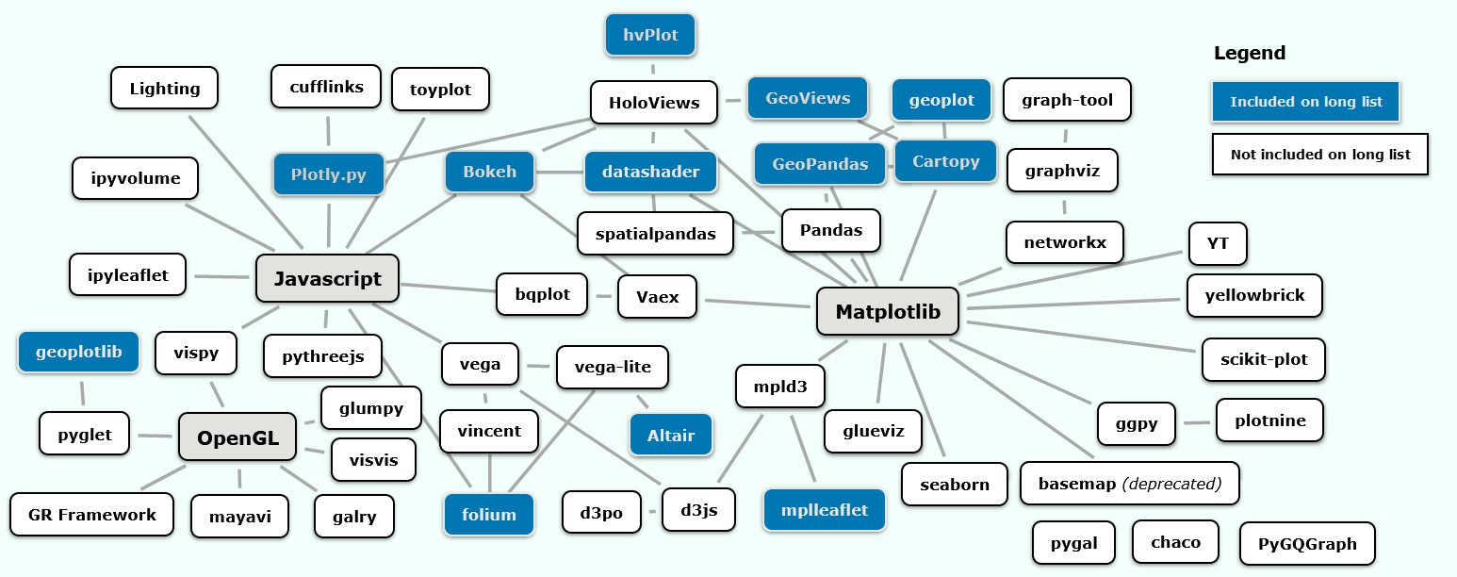

**Figure 1:** The Python visualisation landscape, adapted from VanderPlas (2017)

animations relying on the *OpenGL* application programming interface (API). Libraries included in this study’s long list are highlighted.1

*Matplotlib* has been the de-facto standard for scientific plotting for nearly two decades. Numerous other libraries build on *Matplotlib* and try to expand on and/or simplify its complex, highly customisable, functionalities (see examples in Matplotlib, 2021). *Matplotlib*, in combination with other libraries, is also capable of rendering geospatial data. Initial milestones in this achievement were the translation of common GIS formats into Python mappings (Gillies, 2011) which enabled the spatialisation of the popular *Pandas* data analysis library (Stancin and Jovic, 2019) through the implementation of *Shapely* geometries by *GeoPandas,* a library with a central position for geospatial operations in Python (Jordahl, 2014). Since its inception, *GeoPandas* has provided a high-level interface with *Matplotlib* (GeoPandas, 2021). The early to mid-2010s also saw an ever-increasing range of libraries interface with the JavaScript or OpenGL clusters to produce interactive graphs.

Across all clusters, libraries differ between *imperative* or *declarative* visualisation approaches: in an imperative approach, the user manually specifies *how* something should be rendered, including individual plotting steps; specification and execution are intertwined. In a declarative approach, the user only specifies *what* should be rendered, with plotting details determined automatically. This separates specification from execution (VanderPlas, 2017).

## Data and methods

* 1. *General approach, data source and software environment*

This study sought to identify visualisation libraries in the Python ecosystem suitable for visualising ‘large’ datasets, while at the same time providing a relatively easy to learn syntax, a vibrant developer and user community, and reasonable performance.

As static and interactive visualisations differ in the way they are produced, distributed, and consumed (Bednar 2018a), the comparison was conducted along two separate tracks: static and interactive, with libraries in each track representing both the imperative and declarative approach.

In both tracks, a map ‘template’ following a uniform symbology with standardised map elements was reproduced, displaying two tables from the complete city of Dresden’s real- estate cadastre, and a smaller subset (Table 1).

**Table 1:** Spatial tables selected from Dresden’s real estate cadastre

|  |  |  |  |  |
| --- | --- | --- | --- | --- |
| **Original table name** | **Feature type** | **Geometry type** | **Feature count (complete)** | **Feature count (subset)** |
| *AX_Gebaeude* | Buildings | CurvePolygon | 143,575 | 2,645 |
| *AX_Fliessgewaesser* | Rivers or streams | CurvePolygon | 1,152 | 12 |

Each dataset was converted to a separate locally-hosted PostGIS v3.0.0-enabled PostgreSQL v12.4 database. Through the Visual Studio Code (VSCode) v1.59.1 Python Extension, data was loaded into a Python v3.8.8. kernel via *GeoPandas’* from_postgis() function. Further

1 Libraries shown here can be broadly grouped into two categories: core plotting libraries performing the bulk of the visualisation directly, often by relying on more fundamental low-level technologies (e.g. *Matplotilb, Bokeh, Vega* or *pyglet*), and libraries offering high-level interfaces to the former (e.g. *Pandas* and its derivatives, HoloViz products such as *hvPlot* or *GeoViews,* or *Altair* and *geoplotlib*).

details on system specifications, the data source and pre-processing steps are outlined in the

*Data and methods* section of the Supplementary Material.

* 1. *Library selection*

To gain an overview of candidate libraries, a “long list” based on the list collated by PyViz.org (2019) was compiled, including metadata such as:

1. Output formats;
2. general implementation strategy;
3. Installation channels and requirements;
4. Input formats and required data conversions;
5. Proxies suggesting the vibrancy of the developer and user community.

The complete long list for both tracks is presented in section S1.2 and Tables S1 and S2 of the Supplementary Material.

The long list confirms that limited support for input formats is not a concern. Through *GeoPandas*, users gain access to GDAL/OGR’s 90 vector and 166 raster drivers (GDAL, 2021a, 2021b), with most libraries able to process GeoDataFrames either directly or after at most two conversion steps.

Based on this long list, for each track a final short list (Table 2) consisting of five libraries or library combinations (hereafter referred to as ‘implementations’) was created.

|  |  |  |  |  |  |  |  |  |
| --- | --- | --- | --- | --- | --- | --- | --- | --- |
| **Static** | | | | **Interactive** | | | | |
| **Imperative** | | | **Declarative** | **Imperative** | | | **Declarative** | |
| *GeoPandas* (Jordahl et *Matplotlib* | al., | v0.9.0 2021) *+* | *datashader* v0.13.0 (Bednar et al., 2021) | *Bokeh* v2.3.2 (Bokeh Develop- ment Team, 2018) | | | *GeoViews + Bokeh* | |
| *Cartopy* v0.18.0 (Met Office, 2021) *+ Matplotlib* | | | *Altair* v4.1.0 (VanderPlas et al., 2018) *+ Vega-Lite*  (Satyanarayan et al., 2017) | *GeoViews* v1.9.1 (Rudiger et al., 2021a) *+ datashader + Bokeh (Bokeh Server)* | | | *hvPlot* v0.7.3 (Rudiger et 2021b) *+ GeoViews + Bokeh* | al., |
| *geoplot* v0.4.3 (Bilogur et al., 2021) *+ Matplotlib* | | |  | *Plotly.py* v4.14.3 nologies Inc., 2015) | (Plotly | Tech- |  | |

**Table 2:** Library short list

The short list tried to include both large-community projects (e.g., *Bokeh* and *Plotly*) as well as libraries relying on a more limited number of contributors (e.g., *geoplot*). All short-listed libraries needed to show on-going development in the last year (hence the exclusion of *mplleaflet* and *geoplotlib*) and needed to be able to plot geometries without employing a Web Tile Service (hence the exclusion of *folium*). A variety of backends and both imperative and declarative approaches are included. Finally, *datashader* was included in the static track ‘out of competition’, to first demonstrate its ‘as-is’ functionality before employing it in the interactive track in conjunction with a core plotting library*.*

* 1. *Library comparison*

The short-listed libraries were compared with regard to:

1. the range of available documentation, based on common documentation ‘elements’ and code examples consulted to implement the task;
2. the number of lines of code needed to reproduce the map template, excluding comments and blank lines. This provided a proxy measure for code complexity, using a ‘reduced’ version of the more feature-rich extended scripts. The reduced versions do not wrap rendering-related assignment statement in a function (the renderFigure()

function of the extended scripts) and exclude optional user inputs. To improve code legibility and comparability, the same level of intermediate assignment statements across libraries were used.2;

1. the ability to reproduce the map template including a legend and base map;
2. resource requirements (output file size after export to SVG/PNG or HTML; for interactive visualisations, a subjective assessment of ‘responsiveness’ on pan and zoom);
3. the cumulative CPU runtime required for the Python-based portion of the main renderFigure() function to complete, indicated as an average across a total of 10 runs. To increase comparability, the rendering function excluded both data acquisition and any data pre-processing, reprojection or conversion steps. CPU runtimes were measured using the *cProfile* module (Python Software Foundation, 2021) before writing the results of individual runs to labelled *cProfile* output files in the binary .prof format for analysis. As rendering is ultimately performed by the execution of JavaScript code, *cProfile* will not capture the entirety of the processing costs for the interactive track. See section S1.2 of the Supplementary Material for details on measures taken to enhance comparability of CPU runtimes. All scripts and.prof files are provided as part of a public GitHub repository (Herda, 2022).
   1. *Study limitations*

Limitations for two of the chosen indicators should be highlighted here. Employing any of the short-listed libraries involves multiple complex technologies, some of which exist outside the Python ecosystem (e.g., Jupyter Notebook or the JavaScript libraries underlying both *Bokeh* and *Plotly.py*). Due to these confounding variables, the various adjustments in Table S3 are unlikely to have established a truly level playing field with regard to comparing CPU runtimes. What the *cProfile* results seek to demonstrate is a *relative* comparison of the user experience and the approximate time required to generate a map product on screen.

Due to the subjectivity of lines of code as a measure for code complexity, an alternative methodology could see groups of experts for each implementation develop a ‘best practice’ code sample, though this may further reduce comparability.

It must also be acknowledged that the static map products would not be considered useful outputs in most real-world scenarios: due to significant overplotting, a building-level analysis would rarely be presented at such a small representative fraction. Additionally, when converting figures to SVG on the static track, the large file sizes using the complete dataset would cause most viewing applications to become unresponsive. The same is true for saving to HTML on the interactive track, as noted by Cuttone et al. (2016). Except for live server-side aggregation and rasterisation as demonstrated by the *GeoViews + datashader + Bokeh Server* implementation, most workflows targeting web-based distribution would involve prior conversion to a series of map tiles to then be served by client-side Web Tile Services (see, e.g., Morgan and Lovelace, 2020).

Similarly, the simplicity of the chosen visualisation task also meant that more advanced, and for local authorities potentially more interesting, use cases such as dashboarding were not demonstrated. Both *Bokeh’s* and *Plotly*’s native dashboarding capabilities as well as HoloViz’s *Panel* library are therefore mentioned here.

2 It should be noted that the degree to which new Python objects are created by way of an assignment statement to then be referenced later, instead of making them a key or positional argument directly, remains a question of personal choice.

Finally, due to the interconnectedness of the Python ecosystem, a library’s functionalities and performance cannot be solely attributed to its own codebase. All libraries as well as their dependencies are under constant development. As such, the state of play outlined here represents merely a snapshot.

## Results and discussion

* 1. *General notes on library documentation and learning pathways*

The comprehensiveness of official documentation and community-provided examples is arguably the most significant determinant in how quickly new users pick up underlying concepts and apply a library’s functionality to a particular use case. Over the years, the structure and content of Python documentation has coalesced into a near-standard set of ‘elements’.

A “quick start” or “getting started” section can be found in most libraries. These are usually structured as explanatory text alternating with sample code . Libraries targeting a broad data science audience, rather than the geospatial community, typically visualise simple mathematical functions in cartesian space (Altair-Viz, 2021). New learners without a background in data science or mathematics may find this an initial hurdle, especially once more advanced features are demonstrated using more complex functions (e.g., the data sample provided by Anaconda, Inc., 2021). Finding the right range and difficulty of examples for students of different backgrounds is a known problem in data science education (Hardin et al., 2015; Pournaras, 2017), and Python-based data visualisation is no exception.

While “getting started” sections are available as static web pages, they are often conversions of Jupyter Notebooks which allow users to edit and execute code themselves in a locally-run Python kernel. This popular channel for teaching Python, though superficially ‘interactive’, follows the vein of *behaviouristic* learning theory where teaching content is divided into small learning units and learners’ initial role is to ‘passively receive knowledge and follow instructions without involving peers in the learning process’ (Zendler, 2019).

A second element present in all short-listed libraries were more extensive ‘user guides’. These often covered advanced features and concepts of increasing complexity.

Thirdly, all libraries, except *hvPlot*, featured a so-called “API reference”. This can be thought of as the official ‘code registry’ or ‘code index’, listing all functions and classes accessible to users, including requirements for positional or keyword arguments. API references largely reproduce the “docstrings”, or non-code explanatory text, appended to a function, method, or class definition in Python code. Except for more advanced users, the API reference rarely serves as the first learning resource users engage with, but it is essential for exploring more advanced features.

Users will also find “example galleries” or “reference galleries” a helpful resource. These provide output examples along with sample data and underlying code. In an ideal case, they can significantly flatten the learning curve by requiring only minor adjustments to adapt to one’s particular use case.

The formal documentation will not always be sufficient to help users understand underlying concepts or implement a particular use case. In these situations, two powerful community channels exist to help learners. The first is a library’s GitHub repository, which allows for creating either an ‘issue’ (e.g., feature request or bug report) or a ‘discussion’ (e.g., for usage questions or general feedback). The second channel is appropriately tagged questions on the website StackOverflow (www.stackoverflow.com), which are often answered by members of a library’s core developer team. These community-based resources expand the learning

pathway towards the *cognitivist* approach, with learners actively organizing and reorganizing information, and peers being involved in, and influencing, the learning process (Zendler, 2019). Here, the Python community’s “peer dynamic” exhibits similarities to beneficial qualities identified in *transformative* learning theory for peer-learning partnerships, namely “non- hierarchical status, non-evaluative feedback, voluntary participation, partner selection, authenticity, and establishment of mutual goals” (Taylor, 2008).

For this study, the degree to which the two community channels had to be utilised, for instance to overcome an impasse or clarify a point in the documentation, varied significantly between libraries. Some required multiple elaborate questions to be posted (e.g., *GeoViews, datashader*, *Altair*), and others (e.g., *Cartopy, GeoPandas, Plotly.py*) required no interaction. This could be due to a genuine gap in documentation , or insufficient user knowledge about the respective API. For this reason, this aspect was not considered as a viable comparative indicator.

The overall ‘chances of success’ in engaging with these informal channels also differed: Subject to the availability of community resources and time—note Taylor’s (2008) reference to ‘voluntary participation’—and assuming a user’s question happens to match another user’s prior knowledge, it is not uncommon that questions are resolved in a matter of hours. At other times, responses may never materialise or fail to solve a particular issue. During this study, both scenarios occurred, though the latter with much less frequency. It can be assumed that libraries with a larger user base (see Table S2 and S3) are more likely to provide timely support to new users.

* 1. *Static visualisations*
     1. *Documentation*

**Table 3**summarises the documentation structure for each library in the static track as well as useful examples for implementing the visualisation task, producing categorical choropleth maps along with tiled base maps. API references are not listed.

|  |  |  |
| --- | --- | --- |
| **Library** | **Documentation structure** | **Useful examples** *+ respective source document* |
| *GeoPandas* | [“Introduction”](https://geopandas.org/getting_started/introduction.html) page, [“User Guide”](https://geopandas.org/docs/user_guide.html), a nascent [“Advanced](https://geopandas.org/docs/advanced_guide.html) [Guide”](https://geopandas.org/docs/advanced_guide.html), and an [“Examples](https://geopandas.org/gallery/index.html)” page | *Examples:* [Categorical legend,](https://geopandas.org/gallery/choro_legends.html#Categorical-Data) [adding tiled base](https://geopandas.org/gallery/plotting_basemap_background.html#Adding-a-background-map-to-plots) [maps](https://geopandas.org/gallery/plotting_basemap_background.html#Adding-a-background-map-to-plots) |
| *Cartopy* | [“Getting started”](https://scitools.org.uk/cartopy/docs/v0.13/index.html#getting-started) guide containing both API reference- style sections and examples, also a [“Gallery](https://scitools.org.uk/cartopy/docs/v0.13/gallery.html)” | *Getting started*: [Matplotlib integration;](https://scitools.org.uk/cartopy/docs/v0.13/matplotlib/geoaxes.html) *Gallery:*  [categorical legend,](https://scitools.org.uk/cartopy/docs/v0.13/examples/hurricane_katrina.html) [adding tiled base maps](https://scitools.org.uk/cartopy/docs/v0.13/examples/image_tiles.html) |
| *geoplot* | [“Quickstart”](https://residentmario.github.io/geoplot/quickstart/quickstart.html), [“User Guide”](https://residentmario.github.io/geoplot/user_guide/Working_with_Geospatial_Data.html) and a [“Gallery”](https://residentmario.github.io/geoplot/gallery/index.html) | *User Guide:* [Categorical legend and base map](https://residentmario.github.io/geoplot/plot_references/plot_reference.html#polyplot) |
| *Altair* | [“Getting started”](https://altair-viz.github.io/getting_started/overview.html), [“Tutorial”](https://altair-viz.github.io/altair-tutorial/README.html), [“User Guide”](https://altair-viz.github.io/user_guide/data.html), [“Advanced](https://altair-viz.github.io/user_guide/importing.html) [Usage”](https://altair-viz.github.io/user_guide/importing.html) and [“Example Gallery](https://altair-viz.github.io/gallery/index.html)” | *GitHub issue #588:* [GDF to](https://github.com/altair-viz/altair/issues/588#issuecomment-380958186) mark_geoshape;  *Tutorial:* [choropleth maps,](https://altair-viz.github.io/altair-tutorial/notebooks/09-Geographic-plots.html#choropleth-maps) *User Guide:* [using](https://altair-viz.github.io/user_guide/customization.html#color-domain-and-range)  alt.Scale for imperative colormapping; |
| *datashader* | [“Getting started”](https://datashader.org/getting_started/index.html) guide, [“user guide”](https://datashader.org/user_guide/index.html), datashader- specific [“Topics”](https://datashader.org/topics/index.html) and [PyViz examples gallery](https://examples.pyviz.org/) covering datashader and other HoloViz products | *Getting started:* [categorical transformation](https://datashader.org/getting_started/Pipeline.html#transformation) |
| *GeoViews* | [“Introduction”](https://geoviews.org/index.html), [“User Guide”](https://geoviews.org/user_guide/index.html), [“Gallery”](https://geoviews.org/gallery/index.html), [“Topics](https://geoviews.org/topics.html)” and [PyViz examples gallery](https://examples.pyviz.org/) | *HoloViews User Guide:* [categorical colormapping;](https://holoviews.org/user_guide/Applying_Customizations.html#when-to-use-multiple-opts-calls)  *Gallery:* [adding tiled base maps](https://geoviews.org/gallery/matplotlib/tile_sources.html) |

**Table 3:** Overview of library documentation structure and possible code examples

Newcomers may have to combine and adapt approaches from multiple sources, in some cases from related libraries, to implement a particular use case. The referenced *Altair* GitHub issue is an instance where examples useful for a particular use case are public though not (yet) included in the official documentation. All projects actively encourage users to submit ‘pull requests’, i.e. community-developed changes to the code base, to improve and expand on documentation (for example, Bednar 2018b).

* + 1. *Code complexity*

Figure 2 compares the proxy measure for code complexity, the number of lines of code.

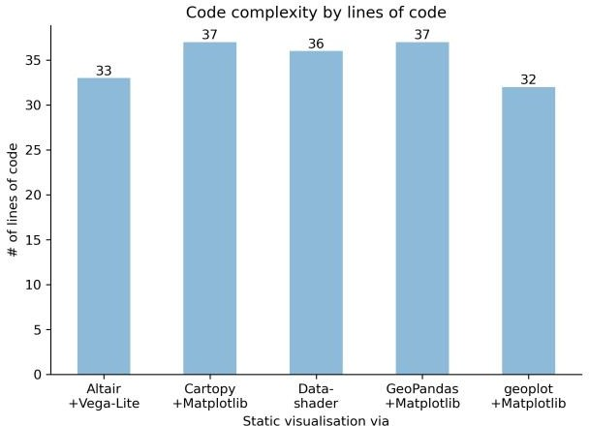

**Figure 2:** Static track code complexity

Code complexity is largely comparable. Generally, the use case in combination with available features has a significant impact on code verbosity. Especially with non-geospatial use cases from traditional data science, declarative approaches can be far more economical once key and value dimensions have been declared. Due to the imperative nature of the chosen visualisation task which required additional lines of code otherwise not necessary in a purely declarative approach, this relative advantage of declarative approaches is not apparent here.

* + 1. *Adherence to map template and resource use*

Outputs using the complete dataset for all five implementations are presented in Figure 3. The panel descriptions indicate the main function or method through which the user interacts with the respective library.

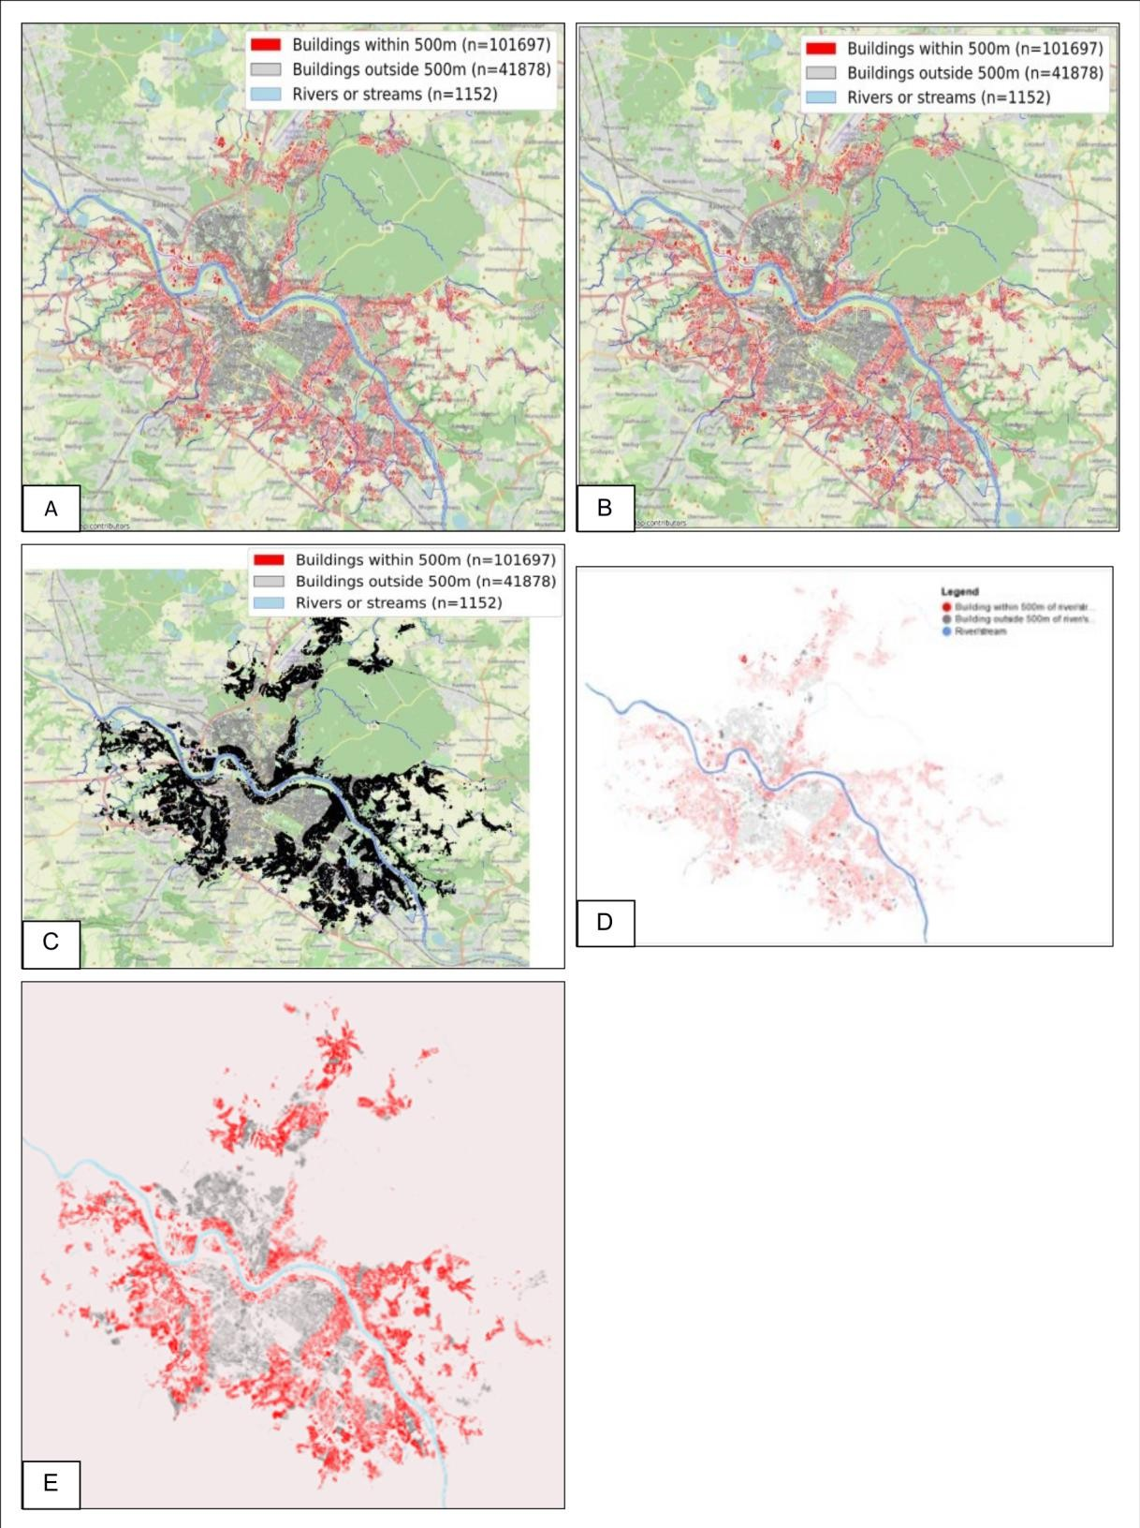

**Figure 3:** Static track comparison of outputs: (A) *GeoPandas*’ GeoDataFrame.plot()

method, (B) *Cartopy*'s add_geometries() function, (C) *Geoplot*'s polyplot() function,

(D) *Altair’*s Chart class, (E) *Datashader*'s transfer_functions.shade()function Key metadata and observations on the generated map products are summarised in **Table 4**.

|  |  |  |  |  |  |  |
| --- | --- | --- | --- | --- | --- | --- |
| **Library** | **Legend** | **Base map** | **Format** | **File Size3** | | **Comment on complete dataset output** |
| **Subset** | **Complete** |
| *GeoPandas*  + Matplotlib | Yes | Yes (*contextily*) | .svg | 2.2MB | 43.6MB | - |
| *Cartopy* + Matplotlib | Yes | Yes (*contextily*) | .svg | 0.9MB | 40.5MB | - |
| *geoplot* + Matplotlib | Yes | Yes (contextily) | .svg | 2.7MB | 68.7MB | Legend position slightly off-figure on the complete dataset, but rendering normally on the subset dataset. At low zoom levels, colours seem to diverge from  *GeoPandas/cartopy* despite identical keyword arguments. |
| *Altair* +  *Vega-Lite* | Yes | No | .png4 | 61.8KB | 136KB | Base map support by Vega-Lite currently in  development (see Vega-Lite GitHub issue #5758) |
| *datashader* | No | No | .png | 29.5KB | 103KB | *Included for illustration only:* No legends or axis elements when employed on its own. Main use case targets rasterisation/aggregation of large datasets prior to plotting, in tandem with core plotting  libraries |

**Table 4:** Static track map elements and output metadata

* + 1. *CPU runtime*

The mean CPU runtimes for the renderFigure() function measured using *cProfile* are presented in Figure 4.

|  |  |
| --- | --- |
|  |  |

**Figure 4:** Static track performance benchmark for the subset (left) and complete dataset (right), error bars indicating the standard deviation

Of the three *Matplotlib-*based libraries, *geoplot*’s mean CPU runtime is consistent with the behaviour observed in the interpreter, but was only revealed through *cProfile* following the adjustment indicated in Table S3. Without the adjustment, *geoplot*’s average CPU runtime on the complete dataset stood at 36.29 seconds. The stark difference to, for instance, *Cartopy* may be due to different entry points to *Matplotlib*: *geoplot* initially calls the matplotib.pyplot.gca() (‘get current Axes’) function, whereas *Cartopy*’s add_geometries() function instantiates *Matplotlib*’s FeatureArtist class. At the time of submission, despite contacting the respective developer communities and a review of the code base, it was not possible to determine why the performance of these *Matplotlib* entry points differed so significantly, suggesting an area for future research.

3 This is the file size when saving the map product to disk.

4 Saving to .svg is supported through the *Altair Saver* extension, though the package had reportedly not been tested for Windows and could not be successfully implemented prior to submission.

*Cartopy* marginally outperforms *GeoPandas,* while *Altair*’s interface to *Vega-Lite* ran three times longer than these two *Matplotlib* interfaces.

*Datashader*’s large standard deviation of 1.853 seconds with a mean of 1.564 seconds is due to its use of the *Numba* compiler, which provides similar performance to a traditional compiled language (Lam et al., 2015). The significant performance gains through *Numba* materialise only after compilation in the first run. This bears out in the individual *datashader* CPU runtimes observed, presented in Table S4.

* 1. *Interactive visualisations*
     1. *Documentation*

|  |  |  |
| --- | --- | --- |
| **Library** | **Documentation structure** | **Useful examples** |
| *Bokeh* | [“First Steps”](https://docs.bokeh.org/en/latest/docs/first_steps/first_steps_1.html), [“User guide”](https://docs.bokeh.org/en/latest/docs/user_guide.html), [“Gallery”](https://docs.bokeh.org/en/latest/docs/gallery.html), interactive [Binder](https://mybinder.org/v2/gh/bokeh/bokeh-notebooks/master?filepath=tutorial%2F00%20-%20Introduction%20and%20Setup.ipynb) [Tutorial](https://mybinder.org/v2/gh/bokeh/bokeh-notebooks/master?filepath=tutorial%2F00%20-%20Introduction%20and%20Setup.ipynb) | User guide: [mapping geo data and adding tiled](https://docs.bokeh.org/en/latest/docs/user_guide/geo.html) [base maps;](https://docs.bokeh.org/en/latest/docs/user_guide/geo.html) First steps: [adding a legend](https://docs.bokeh.org/en/latest/docs/first_steps/first_steps_3.html) |
| *GeoViews + Bokeh* | *GeoViews:* [“Introduction”](https://geoviews.org/index.html), [“User Guide”](https://geoviews.org/user_guide/index.html), [“Gallery”](https://geoviews.org/gallery/index.html), [“Topics”](https://geoviews.org/topics.html) and [PyViz examples gallery](https://examples.pyviz.org/) | HoloViews User Guide: [overlays,](http://holoviews.org/user_guide/Composing_Elements.html) [using](https://holoviews.org/user_guide/Applying_Customizations.html#when-to-use-multiple-opts-calls) group for  categorical colormapping; GeoViews User Guide: [geometries;](https://geoviews.org/user_guide/Geometries.html) Gallery: [adding tiled base maps](https://geoviews.org/gallery/bokeh/tile_sources.html) |
| *GeoViews + datashader*  *+ Bokeh* | *HoloViews:* [“Getting started”](http://holoviews.org/getting_started/index.html) guide, [“User guide”](http://holoviews.org/user_guide/index.html), [“Reference Gallery”](http://holoviews.org/reference/index.html); *GeoViews:* [“Introduction”](https://geoviews.org/index.html), [“User](https://geoviews.org/user_guide/index.html) [Guide”](https://geoviews.org/user_guide/index.html), [“Gallery”](https://geoviews.org/gallery/index.html), [“Topics”](https://geoviews.org/topics.html) and [PyViz examples gallery;](https://examples.pyviz.org/) *datashader*: [“Getting started”](https://datashader.org/getting_started/index.html) guide, [“User guide”](https://datashader.org/user_guide/index.html),  *datashader*-specific [“Topics”](https://datashader.org/topics/index.html), [PyViz examples gallery](https://examples.pyviz.org/) for all three libraries | HoloViews User Guide: [working with large data;](http://holoviews.org/user_guide/Large_Data.html) PyViz gallery: [datashaded polygons +](https://examples.pyviz.org/nyc_buildings/nyc_buildings.html#nyc-buildings-gallery-nyc-buildings) inspect_polygons enabling Bokeh hover tools; Bokeh User Guide: [running a Bokeh Server](https://docs.bokeh.org/en/latest/docs/user_guide/server.html) |
| *Plotly.py* | [“Getting started”](https://plotly.com/python/getting-started/) and several “Examples” pages covering Plotly [fundamentals](https://plotly.com/python/plotly-fundamentals/) and different chart types including [maps](https://plotly.com/python/maps/) | Gallery: [map configuration and styling,](https://plotly.com/python/map-configuration/) [adding tiled](https://plotly.com/python/mapbox-county-choropleth/) [base maps to a choropleth map,](https://plotly.com/python/mapbox-county-choropleth/) [discrete](https://plotly.com/python/discrete-color/)  [colormapping;](https://plotly.com/python/discrete-color/) StackOverflow: [determining zoom](https://stackoverflow.com/questions/63787612/plotly-automatic-zooming-for-mapbox-maps) [levels for choropleth_mapbox](https://stackoverflow.com/questions/63787612/plotly-automatic-zooming-for-mapbox-maps) |

**Table 5:** Overview of library documentation structure and possible code examples

The StackOverflow thread referenced in **Table 5**concerning *Plotly.py* is highlighted as illustrative of a general phenomenon when dealing with software, including open-source solutions: a non-obvious gap in documentation, requiring users to consult with the wider community through channels outside the official documentation. In this case, *Plotly.py’s* documentation outlined a method for determining a suitable zoom level for its regular mapping functions such as express.choropleth() but does *not* mention that the same approach does not (yet) apply to another almost identical function, namely express.mapbox_choropleth().

* + 1. *Code complexity*

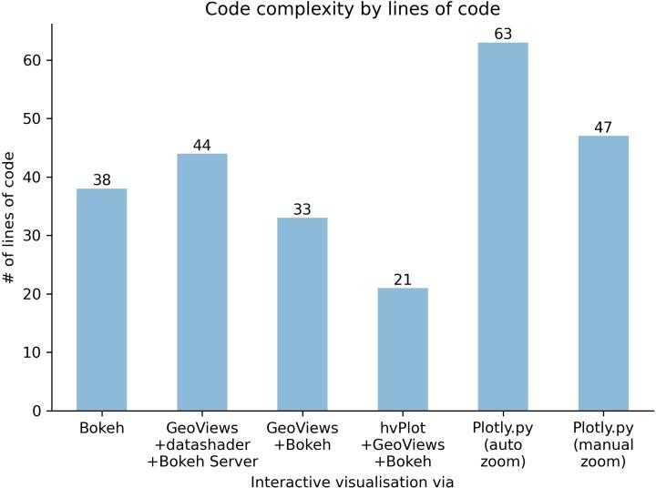

**Figure 5:** Interactive track code complexity

As shown in Figure 5, code complexity in the interactive track differed more widely.

When applied to this study’s use case, *Plotly.py’*s syntax was the most complex despite employing the more user friendly *Plotly Express* interface. This is due to the need to write an intermediary JSON file containing the geometries to disk (Plotly Technologies Inc., 2021). *Plotly.py*’s line count remains high even without adding auto zoom functionality.

*GeoViews* and *hvPlot* significantly simplify interacting with *Bokeh*’s standard API, with *hvPlot* offering the most succinct plotting interface of all short-listed libraries. These additional layers of abstraction may lead to a decrease in overall performance, however (see section 5.3.4).

* + 1. *Adherence to map template and resource use*

Outputs using the complete dataset for all five libraries are presented in Figure 6, demonstrating their ability to present at least four data attributes simultaneously: two attributes representing geographic location, one attribute conveyed through symbology, and at least one additional attribute conveyed through the hover tool. The latter can be extended to display as many attributes as can comfortably fit the screen (as demonstrated in Figure 6 C, D).

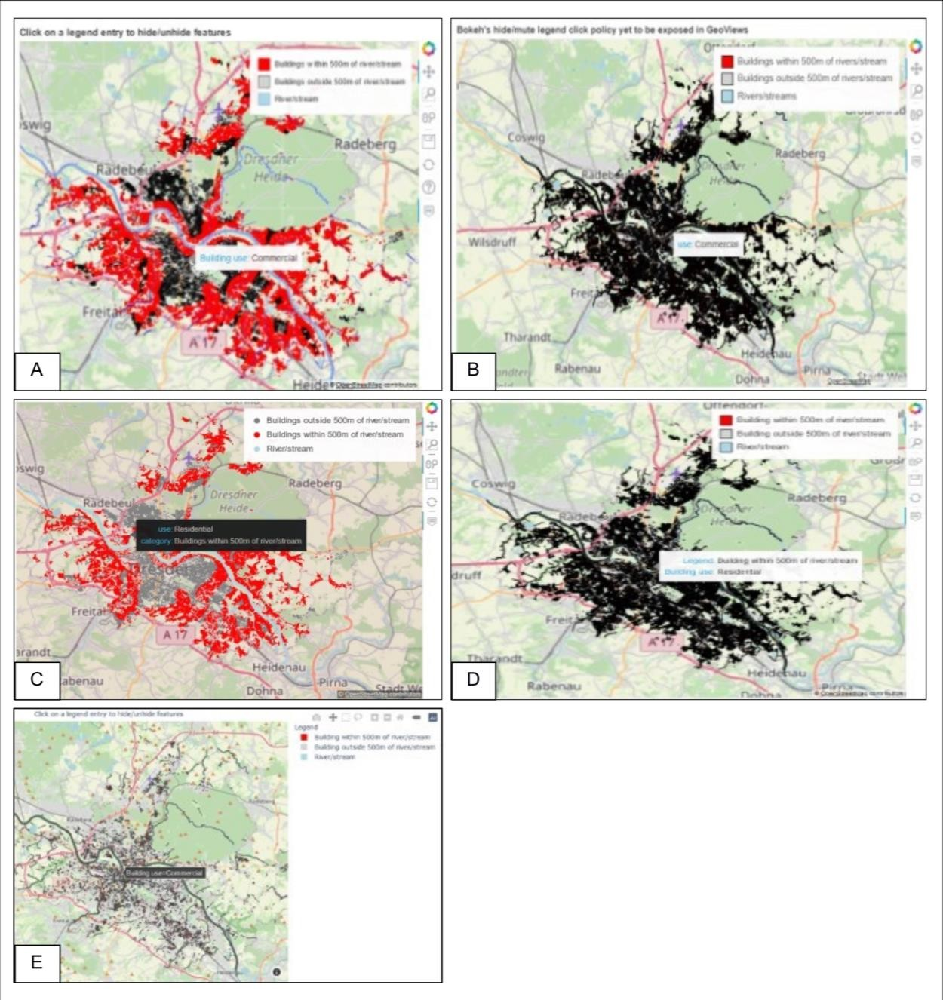

**Figure 6:** Interactive track output comparison, (A) *Bokeh*'s figure.patches()function,

(B) *GeoViews*' Polygons class + *Bokeh* backend, (C) *GeoViews’* Polygons class *+ datashader’*s datashade function *+ Bokeh Server*, (D) *hvPlot*'s hvplot() method, (E)

*Plotly.py*'s express.choropleth_mapbox() function

Key metadata and observations on the generated map products are summarised in **Table 6**.

|  |  |  |  |  |  |  |
| --- | --- | --- | --- | --- | --- | --- |
| **Library** | **Legend** | **Base map** | **Format** | **File Size** | | **Comment on complete dataset output** |
| **Subset** | **Complete** |
| *Bokeh* | Yes | Yes | .html | 1.6MB | 70.4MB | Slow to respond on pan and zoom |
| *GeoViews + Bokeh* | Yes | Yes | .html | 2.1MB | 94.2MB | Slow to respond on pan and zoom. Colours differ from *Bokeh* at low zoom levels only. |
| *GeoViews +*  *datashader + Bokeh Server* | Yes | Yes | .html | 864KB | 864KB | Rasterised polygons dynamically recalculated with every pan and zoom, highly responsive.  Colours differ from *Bokeh* at low zoom levels only, possibly due to less overplotting. |
| *hvPlot* +  *GeoViews* +  *Bokeh* | Yes | Yes | .html | 1.1MB | 54.4MB | Slow to respond on pan and zoom. Colours differ from *Bokeh* at low zoom levels only. |
| *Plotly.py* | Yes | Yes | .html | 8.8MB | 247.2MB | Highly responsive on pan and zoom |

**Table 6:** Interactive track map elements and output metadata

The complete dataset presented challenges for almost all visualisation strategies, both during production and consumption of the map product.

There are large differences in file size, with *Plotly.py* being a clear outlier. Even though the output is highly responsive once fully loaded in the browser, the large file size makes it impractical for embedding into public-facing webpages. Online distribution would therefore require an on-demand download or prior map tile conversion.

While the file size for the *datashader-*based implementation is explained by *Bokeh* receiving, in essence, a raster image at a set resolution of the polygons currently visible in the viewport, the cause of the variation between the other three *Bokeh* implementations could not be ascertained. The *HoloViz* default to inline *BokehJS* instead of accessing it through a content delivery network, as is done by *Bokeh’*s default API, only accounts for a marginal increase in file size. It also fails to explain why *GeoViews* and *hvPlot,* both *HoloViz* products, differ from *Bokeh*’s file size in opposite directions.

* + 1. *CPU runtime*

The mean CPU runtimes for the renderFigure()function on the interactive track are presented in Figure 7.

|  |  |
| --- | --- |
|  |  |

**Figure 7:** Interactive track performance benchmark for the subset (left) and complete dataset (right), error bars indicating the standard deviation

Stark differences in mean CPU runtime between the three *Bokeh-*based implementations making no use of *datashader* were observed: interfacing with *Bokeh* through *hvPlot* proved to be 3.7 times faster than interacting with *Bokeh* through *GeoViews*. Engaging with *Bokeh’*s API directly outperformed *hvPlot* and *GeoViews* by a factor of 15.5 and 58, respectively. Despite consultations with the developers, it was not possible to ascertain the reasons for *GeoView’s* apparently poor performance. One possible explanation is the additional layers of abstraction between *GeoViews* and *Bokeh* (via *HoloViews*), although *hvPlot* employs an even higher level of abstraction without incurring a similar penalty in performance.

The *GeoViews + datashader + Bokeh Server* implementation performed the best, combining *Bokeh’s* interactive features with low client-side resource use. Runtimes in subsequent runs were reduced drastically (see Table S5), similar to what was demonstrated in Table S4.

## Conclusions

* 1. *Python for Smarter Cities: the give and take of open-source software*

To put the study’s results into a wider perspective, it must be emphasised that current library features, performance, comprehensiveness of documentation and support capabilities can, to a large extent, be attributed to funding availability, as well as time volunteered by contributors.

In 2015, the European Innovation Partnership on Smart Cities and Communities (EIP SCC) initiated a Memorandum of Understanding intent on avoiding proprietary and custom-built offerings, while promoting interoperability and common open standards (European Innovation Partnership on Smart Cities and Communities, 2015). This led to the DIN SPEC 91357:2017-

12 standard, Reference Architecture for Model Open Urban Platforms (DIN SPEC 91357:2017-12). If cities are committed to a publicly-owned open data architecture, local authorities are not only in a position to enhance the sustainability of underlying software but should, in fact, be encouraged to do so. If the EIP SCC’s vision is realised, open-source software applied to smart city initiatives is as much part of publicly-managed infrastructure as traditional hard assets, along with concomitant needs for investments in maintenance.

Organisations are already opting for supporting projects financially (NumFOCUS, Inc., 2021), either through unrestricted contributions or funding aimed at adding a particular functionality. Google, Microsoft and ESRI’s support for the Geospatial Data Abstraction Library (GDAL, 2021c), the fundamental infrastructure underpinning the geospatial capabilities of the Python libraries presented here and many well-known commercial products, is one illustration of this. Alternatively, projects can be supported by allowing staff time to improve project documentation and functionality.

* 1. *Conclusion*

This study demonstrates that the Python ecosystem offers numerous options for generating engaging, consistently-formatted static and interactive map products. For some workflows, the value for local authorities compared to commercial desktop GIS applications is noteworthy: streamlined file management (Lin, 2012), high reproducibility (Ince et al., 2012; Lazer et al., 2014) that enhances institutional memory, and avoidance of licensing fees and vendor lock- ins.

The presented solutions’ foundation in open source combined with their active development and a growing number of firms specialising in open-source GIS (e.g., QGIS.org, 2021) also means that unnecessarily bespoke, rather than multi-authority, shared solutions can be avoided (Copeland 2015) without having to forego professional support.

The long list review indicates that support for any geospatial data format is virtually guaranteed. In addition, all short-listed libraries were supported both by core teams of developers and an active user base.

The comparative measures presented offer initial assistance in selecting suitable candidates for specific user needs: for simple applications where ease of use is of greater importance than the details of symbology or the fine-tuning of map elements, high-level imperative or declarative approaches such as *hvPlot* or *Altair* provide clear advantages. On the other hand, interacting directly with *Matplotlib* or lower-level libraries such as *Bokeh* and *Plotly* offers a higher degree of customisability at the cost of a steeper learning curve.

Documentation and community support proved to be vital tools in flattening this curve. Formal documentation was of generally high quality across both tracks, providing a range of examples

requiring only minor adjustments. Community support channels such as GitHub and StackOverflow were also invaluable resources.

The static track presented low variability in code complexity. This may be due to the imperative nature of the visualisation task, thus slightly disadvantaging declarative approaches. The interactive track had the largest variability in code complexity, ranging from the intuitive to the more verbose, requiring users to familiarise themselves with library-specific concepts. For the chosen use case, *hvPlot* offered the most succinct interface and *Plotly Express* the most complex, even when disregarding automatic zoom level detection as a necessary feature.

CPU runtime may be of minor importance when dealing with smaller datasets, with all short- listed libraries able to handle the subset dataset without difficulties. This was not the case for the full dataset. For static visualisations, *Cartopy’s* interface to *Matplotlib*, closely followed by *GeoPandas’*, performed the best for both datasets, completing the rendering function almost three times faster than *Altair.* Several libraries showed significant differences despite all interfacing with *Matplotlib*, suggesting an area for further investigation.

For interactive visualisations, there were stark differences in mean CPU runtime between the three *Bokeh-*based implementations not relying on *datashader*: Engaging with *Bokeh’*s API directly outperformed both interfacing via *hvPlot* and *GeoViews* by a factor of 15.5 and nearly 60, respectively. Combining *GeoViews, datashader* and *Bokeh Server* proved to be the most performant, highlighting the advantages gained through on-demand aggregation and transformation when handling large datasets.

It must be noted that with libraries relying on other complex technologies, some of which are not based on Python, it is possible that the study design did not establish a fully level playing field. Additional layers of abstraction between any core plotting library and the user-facing API are likely to lead to losses in performance, unless data aggregation and transformation strategies are applied as well.

In summary, Python-based visualisation offers local authorities powerful tools, free of vendor lock-in and licensing fees, to produce performant and consistently-formatted visualisations for both internal and public distribution.

## Glossary

|  |  |
| --- | --- |
| *Declarative visualisation approach* | The user only specifies what should be rendered, with plotting details determined automatically. This separates specification from execution. |
| *Imperative visualisation approach* | The user manually specifies how something should be rendered, including individual plotting steps. Specification and execution are intertwined. |

**Funding**

This research did not receive any specific grant from funding agencies in the public, commercial, or not-for-profit sectors.

## Acknowledgements

The authors would like to thank the developers and users of the libraries profiled here. Without their feedback and patience, this study would not have been possible