ShopNest Store
Power BI Capstone Project Report
Business Analytics Dashboard

Prepared by: Bharath Sreedhar
Date: 14th June 2026

Dashboard Overview
This report presents a comprehensive Power BI dashboard designed for ShopNest Store, a leading e-commerce marketplace in Portugal. The dashboard addresses 8 key business analytics questions using 9 interconnected datasets containing customer, order, product, payment, and review information.
The dashboard provides actionable insights into sales performance, delivery efficiency, customer payment preferences, product ratings, regional distribution, and revenue trends. Interactive slicers allow stakeholders to filter data by year and month for deeper analysis.
Total Revenue Generated: R$ 16.01 million (2016-2018)

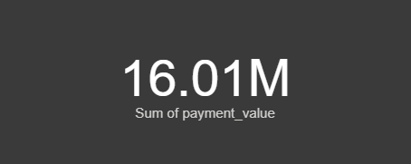
Figure: KPI Card showing Total Revenue

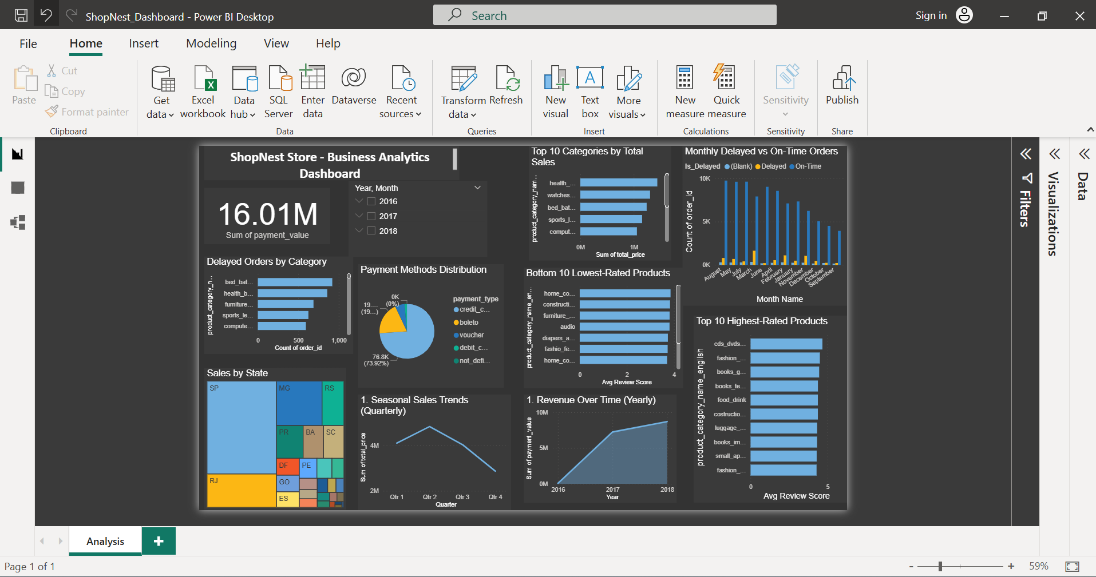
Figure: Complete ShopNest Store Business Analytics Dashboard

1. Top Categories by Total Price
Question: Identify and visually represent the top 10 product categories by total sales.

Visualization
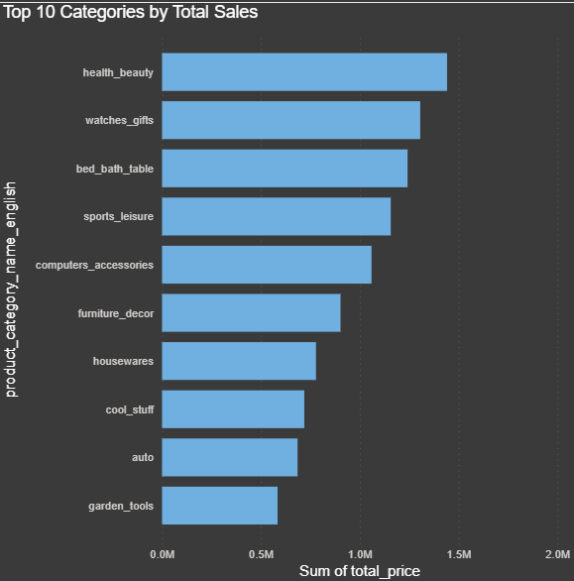
Figure 1: Top 10 Categories by Total Sales (Sum of total_price)

Explanation
The horizontal bar chart identifies the top 10 product categories generating the highest total sales revenue. The chart uses Sum of total_price (price + freight) as the measure, providing a complete view of revenue per category.
- health_beauty dominates with the highest total sales (~R$ 1.4M), indicating strong customer demand for personal care products
- watches_gifts ranks second (~R$ 1.3M), suggesting a strong gifting culture among customers
- bed_bath_table ranks third (~R$ 1.2M), reflecting consistent demand for home essentials
- sports_leisure and computers_accessories complete the top 5, each exceeding R$ 900K
- furniture_decor, houseware, cool_stuff, auto, and garden_tools round out the top 10
- The significant gap between health_beauty (~R$ 1.4M) and garden_tools (~R$ 400K) shows revenue concentration in top categories

2. Delayed Orders Analysis
Question Statement: Determine the number of delayed orders in each category. An order is considered delayed if the actual delivery date is later than the estimated delivery date.

Visualization
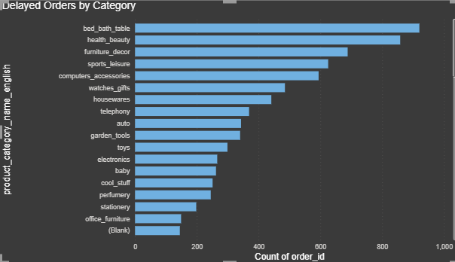
Figure 2: Delayed Orders by Product Category (Count of order_id)

Explanation
The bar chart displays the count of delayed orders across all product categories. An order is classified as "Delayed" when order_delivered_customer_date exceeds order_estimated_delivery_date.
- bed_bath_table has the highest number of delayed orders (~1,000), likely due to larger/heavier items requiring complex logistics
- health_beauty follows with approximately 900 delayed orders, attributable to its high overall order volume
- furniture_decor (~700) and sports_leisure (~600) show significant delays, consistent with bulkier products
- computers_accessories (~550) and watches_gifts (~500) also appear in the top delayed categories
- Categories in the long tail (office_furniture, stationery, Blank) have minimal delays
- Recommendation: Focus logistics optimization on bed_bath_table and health_beauty for maximum impact

3. Monthly Comparison of Delayed and On-Time Orders
Question Statement: Create a dynamic visual that compares the number of delayed orders to the number of orders received earlier for each month. Utilize the drill-through cross-report feature to provide a detailed analysis of late and on-time deliveries.

Visualization
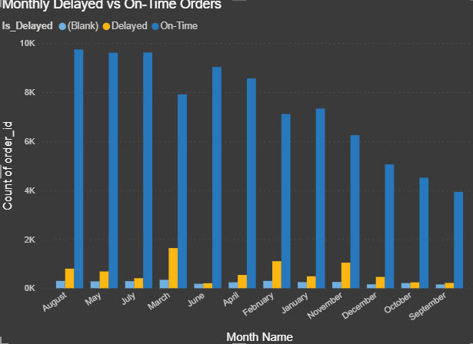
Figure 3: Monthly Delayed vs On-Time Orders (Clustered Column Chart)

Explanation
The clustered column chart provides a month-by-month comparison of delivery performance. Blue bars represent On-Time deliveries, yellow/orange bars represent Delayed orders, and grey bars represent orders with blank status (pending delivery or missing data).
- On-time deliveries (blue) consistently dominate across all months, demonstrating overall strong logistics performance
- August and May record the highest order volumes (~10K on-time deliveries each)
- Delayed orders (yellow) remain at approximately 1,000-2,000 per month
- The delay ratio appears relatively consistent, suggesting systemic rather than seasonal issues
- September and October show lower overall volumes, possibly reflecting seasonal patterns or data cutoff
- The drill-through cross-report feature enables users to click any bar for detailed order-level analysis

4. Payment Method Analysis
Question Statement: Analyze the most frequently used payment methods by customers using a visually appealing representation, such as a pie chart or other suitable visuals.

Visualization
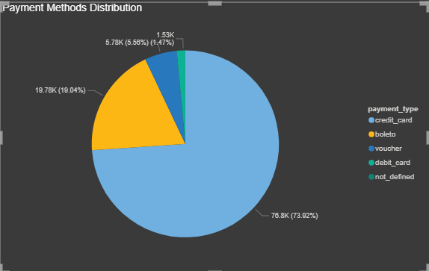
Figure 4: Payment Methods Distribution (Pie Chart)

Explanation
The pie chart provides a clear breakdown of payment methods preferred by ShopNest customers. Each segment shows both the count and percentage, making it easy to identify dominant payment preferences.
- Credit card is overwhelmingly the most popular at 73.92% (76.8K transactions), reflecting customer preference for installment options
- Boleto (Brazilian bank payment slip) accounts for 19.04% (19.78K transactions), a common method in Brazilian e-commerce
- Voucher usage is 5.58% (5.78K transactions), indicating moderate use of promotional credits and gift cards
- Debit card represents only 1.47% (1.53K transactions), surprisingly low for a digital payment method
- The "not_defined" category is negligible, showing clean data capture across payment systems
- The credit card dominance (74%) suggests ShopNest should maintain competitive installment plans and consider partnerships with card issuers

5. Product Rating Analysis
Question Statement: Determine the top 10 highest-rated products and the bottom 10 lowest-rated products using a bar or column chart.

Visualization
Top 10 Highest-Rated Product Categories:
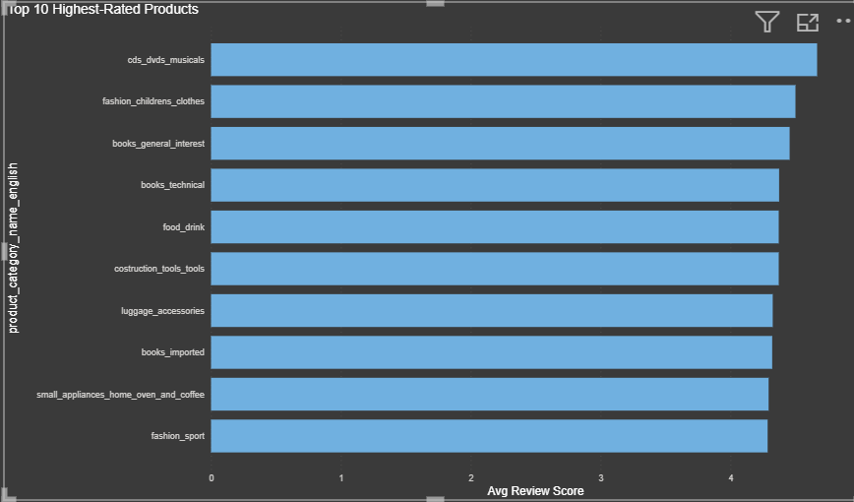
Figure 5a: Top 10 Highest-Rated Categories by Average Review Score
Bottom 10 Lowest-Rated Product Categories:
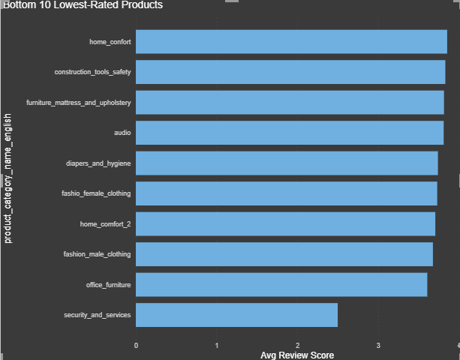
Figure 5b: Bottom 10 Lowest-Rated Categories by Average Review Score

Explanation
Two bar charts compare the highest and lowest-rated product categories based on average customer review scores on a 1-5 scale.
Top 10 Highest-Rated Findings:
- cds_dvds_musicals leads with the highest average rating (~4.6), likely due to predictable product quality
- fashion_childrens_clothes and books_general_interest score ~4.4-4.5
- books_technical, food_drink, and costruction_tools_tools all perform above 4.3
- Pattern: Low-complexity, well-described products with predictable quality tend to rate higher
Bottom 10 Lowest-Rated Findings:
- security_and_services has the lowest rating (~2.5), indicating serious customer dissatisfaction
- office_furniture (~3.5) and fashion_male_clothing (~3.6) score below the platform average
- home_confort, construction_tools_safety, and audio hover around 3.5-3.7
- Pattern: Categories requiring physical fit, installation, or subjective quality tend to underperform
- Recommendation: Improve product descriptions and set accurate expectations for low-rated categories

6. State-wise Sales Analysis
Question Statement: Identify and visually represent states with high and low sales, providing a clear understanding of regional sales performance.

Visualization
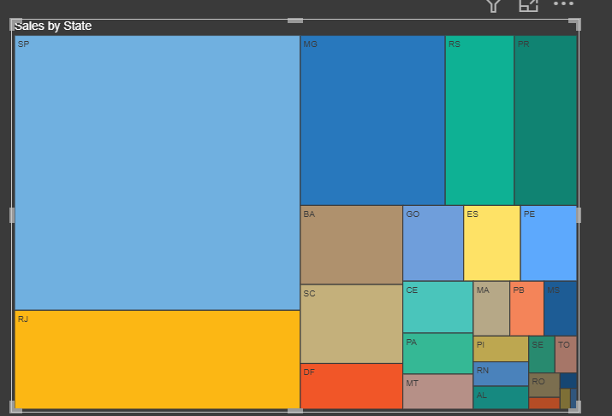
Figure 6: Sales by State (Treemap Visualization)

Explanation
The treemap visualization provides an intuitive view of sales distribution across Brazilian states. Each rectangle is proportional to total sales revenue, with color differentiation making regional patterns immediately visible.
- SP (Sao Paulo) dominates with the largest area, consistent with being Brazil's economic and population center
- MG (Minas Gerais) and RS (Rio Grande do Sul) form the second tier of markets
- PR (Parana) and RJ (Rio de Janeiro) are significant contributors
- BA (Bahia), GO (Goias), ES (Espirito Santo), and SC (Santa Catarina) represent the mid-tier
- Smaller states (PE, CE, MA, PB, DF, MT, PA, PI, RN, AL, MS, SE, TO, RO) collectively offer growth opportunities
- Geographic concentration in southeastern Brazil (SP, MG, RJ) indicates opportunity for expansion in northern and northeastern regions

7. Seasonal Sales Patterns
Question Statement: Investigate and visualize any seasonal patterns (Quarterly) or trends in sales data over the course of the year.

Visualization
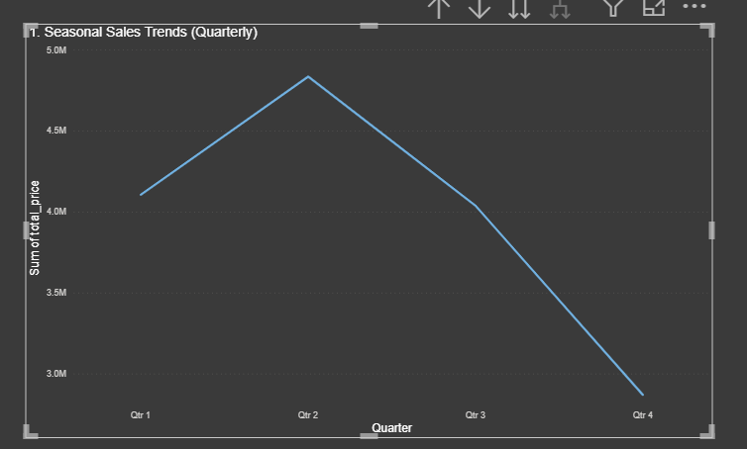
Figure 7: Seasonal Sales Trends by Quarter (Line Chart)

Explanation
The line chart reveals quarterly sales patterns, showing how total sales (Sum of total_price) fluctuate throughout the year. This insight is critical for inventory planning and promotional strategy.
- Q1 (January-March) starts at approximately R$ 4.0M
- Q2 (April-June) represents the peak selling season, reaching nearly R$ 5.0M
- Q3 (July-September) shows a significant decline to approximately R$ 4.0M
- Q4 (October-December) drops to the lowest point at about R$ 2.8-3.0M
- The peak in Q2 may correlate with promotional events or seasonal buying patterns in the Brazilian market
- The steep decline from Q2 to Q4 suggests the business should implement targeted promotions and marketing campaigns during the second half
- Inventory planning should account for 40-60% higher demand in Q1-Q2 compared to Q4

8. Revenue Analysis
Question Statement: Determine the total revenue generated by ShopNest Store, and analyse how it changes over time (Yearly). Represent this information through suitable visuals to highlight trends and patterns.

Visualization
Figure 8a: Total Revenue KPI Card (R$ 16.01 Million)
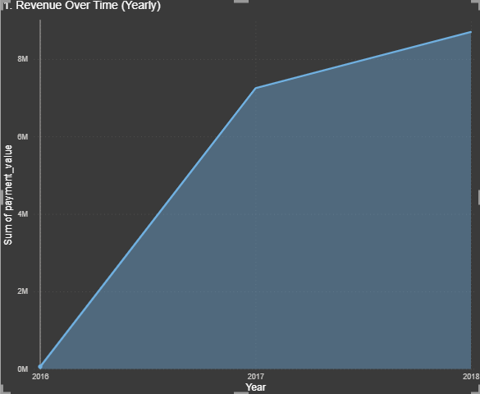
Figure 8b: Revenue Over Time - Yearly (Area Chart)

Explanation
The KPI card prominently displays the total revenue of R$ 16.01 Million (Sum of payment_value), while the area chart with filled shading visualizes the cumulative revenue growth from 2016 to 2018.
- Total revenue generated by ShopNest Store: R$ 16.01 Million
- 2016: Minimal revenue (near zero) — platform was in its initial launch phase
- 2017: Explosive growth to approximately R$ 7M — successful market penetration and rapid customer acquisition
- 2018: Continued upward trajectory reaching ~R$ 8-9M — sustained growth momentum
- The steep growth curve from 2016 to 2017 reflects ShopNest's successful go-to-market strategy
- Year-over-year growth from 2017 to 2018 shows the platform maturing while maintaining growth
- The filled area chart effectively communicates the cumulative nature of revenue accumulation over time

Conclusion
The ShopNest Store Power BI dashboard delivers a comprehensive, data-driven view of business performance across eight critical dimensions. Interactive slicers for Year and Month enable stakeholders to drill into specific time periods for deeper analysis.

Key Takeaways
- Revenue Growth: Strong trajectory from near-zero in 2016 to R$ 16.01M cumulative, with 2018 showing sustained momentum
- Top Categories: health_beauty (R$ 1.4M) and watches_gifts (R$ 1.3M) are primary revenue drivers
- Payment Preferences: Credit card dominates at 73.92%, followed by boleto at 19.04%
- Delivery Performance: bed_bath_table leads delayed orders (~1,000); overall on-time rate is strong
- Customer Satisfaction: Platform average ~4.07/5; security_and_services (2.5) needs urgent attention
- Regional Distribution: SP dominates sales; northern/northeastern states offer expansion potential
- Seasonal Patterns: Q2 is peak (R$ 5M); Q4 is lowest (R$ 2.8M) — requires promotional intervention

Recommendations
- Optimize logistics for high-delay categories: bed_bath_table, health_beauty, furniture_decor
- Expand marketing in underserved states beyond SP, MG, and RJ
- Implement Q3-Q4 promotional campaigns to counter seasonal decline
- Investigate and address quality/expectation gaps in bottom-rated categories
- Maintain competitive credit card installment options to support dominant payment preference
- Consider dedicated logistics partnerships for bulky/heavy product categories

