01. Write a R program to find basic program
- Odd or even
- Addition
- subtraction
02. write a R program to find Data Dispersion Measures .
- Mean
- Median
- Mode
- dataframe
03. Write a R program to find Central Tendency.
- IQR
- Range
- Quantile
- summary
04. Write a R program to Plotting graphs for boxplot and two types of barplot.
- Boxplot
- Barplot
- Horizontal barplot
05. Write a R program to Plotting graphs for histogram and scatterplot.
- Histogram
- scatterplot
06. Write a R program to find the Corelation Analysis and Zscore normalization.
07. Write a R program to find Min Max normalization and decimal scalling normalization.
- Min Max Normalization
  - Mean
  - Minimum
  - Maximum
  - Min Max
08. Write a R program to get and perform the Linear Regression using given datasets.
09. Write a R program to perform the Multiple Regression using given Datasets.
10. a.Data Preprocessing And Analysis for "diabetes" Dataset Using WEKA.
- Attributes type
- Preprocess
- cluster
10. b.Data Preprocessing And Analysis for "travel-times" Dataset usng WEKA.
- Attributes type
- Preprocess
- cluster

11. Data Segementation by k-mean cluster using WEKA.
- Preprocess
- Cluster
12.Data Segmentation by Expectation Maximisation (EM) Algorithm and K-means through WEKA using “cancer” dataset.
- Cluster
- visualize
13. Data Segmentation by COBWEB-HIERARCHIAL clustering Algorithm and K-means through WEKA using “cancer” dataset.
14. Frequent Pattern Mining usng WEKA using “2015” dataset.
- Cluster
15. PREDICTION OF CATEGORICAL DATA USING BAYESIAN ALGORITHM USING WEKA.
16. DATA ANALYSIS BY DENSITY BASED CLUSTERING ALGORITHM USING WEKA.
17. FP GROWTH ALGORITHM USING WEKA.
18. KNOWLEDGE MINING USING ASSOCIATION RULE USING WEKA.
19. USING R PROGRAM MAKE A HISTOGRAM FOR THE “AIRPASSENGERS “DATASET, START AT 100 ON THE X-AXIS, AND FROM VALUES 200 TO 700, MAKE THE BINS 150 WIDE.
20. GIVING THE FOLLOWING DATABASE WITH 5 TRANSACTIONS AND A MINIMUM SUPPORT THRESHOLD OF 60% AND A MINIMUM CONFIDENCE THRESHOLD OF 80%, FIND ALL FREQUENT ITEMSETS USING (A) APRIORI AND (B) FP-GROWTH.
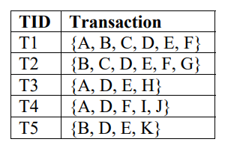
21. THE 'DATABASE' BELOW HAS NINE TRANSACTIONS. WHAT ASSOCIATION RULES CAN BE FOUND IN THIS SET, IF THE
MINIMUM SUPPORT (I.E COVERAGE) IS 60% AND THE MINIMUM CONFIDENCE (I.E. ACCURACY) IS 80% ?
TRANS_ID ITEMLIST
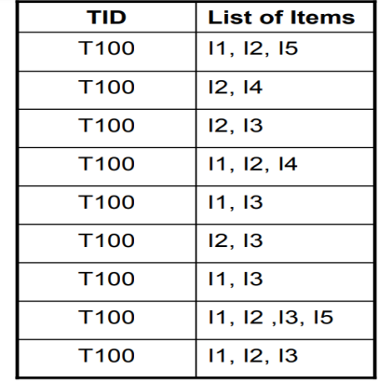
22. OBTAIN MULTIPLE LINES IN LINE CHART USING A SINGLE PLOT FUNCTION IN R.USE ATTRIBUTES“MPG”AND“QSEC”OF THE DATASET “MTCARS”
23. USING R PROGRAM MAKE A HISTOGRAM FOR THE “TOOTHGROWTH”DATASET, START AT 100 ON THE X-AXIS, AND FROM VALUES 200 TO 700, MAKE THE BINS 150 WIDE
24. ETL AND OLAP OPERATION USING KNIME DATA ANALYTICS PLATFORM.
25. USING R PROGRAM CREATE A 3D PIE CHART FOR THE DATASET “POLITICAL KNOWLEDGE” WITH SUITABLE LABELS AND COLOURS.

