Basic COCOMO QUESTION EXAMPLE

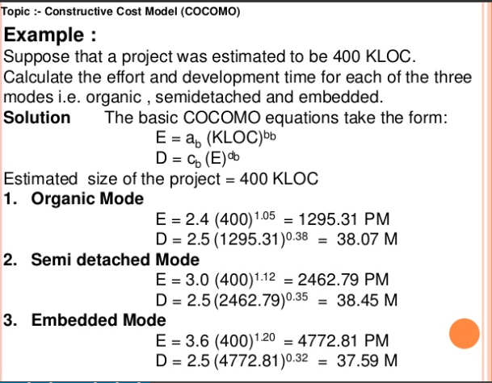

**Basic COCOMO QUESTION WITH ANSWER EXAMPLE**



**INTERMEDIATE COCOMO QUESTION EXAMPLE**

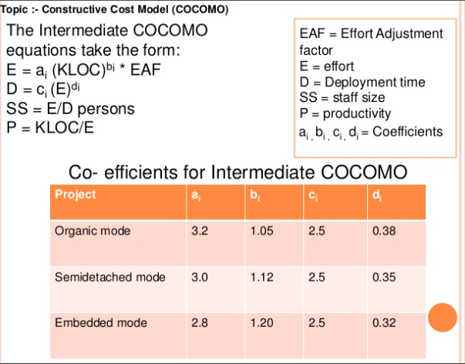

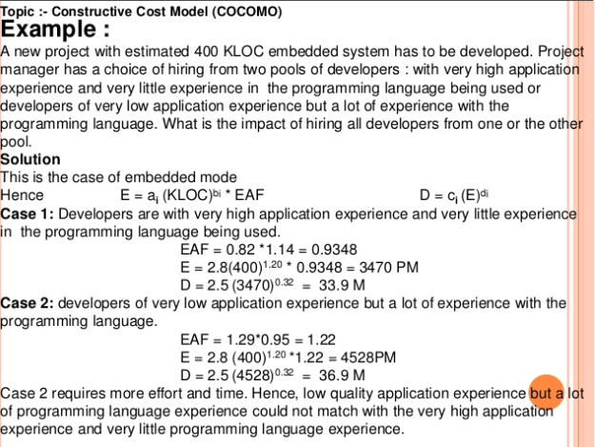

**INTERMEDIATE COCOMO QUESTION WITH ANSWER EXAMPLE**



**INTERMEDIATE COCOMO QUESTION EXAMPLE**

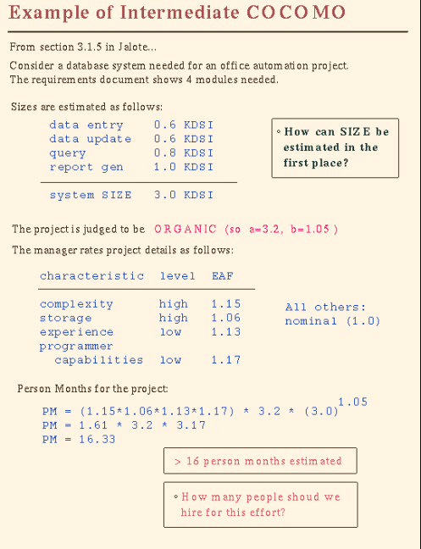

**INTERMEDIATE COCOMO QUESTION WITH ANSWER EXAMPLE**



