ROUTER CONFIGURATION, CREATING PASSWORD

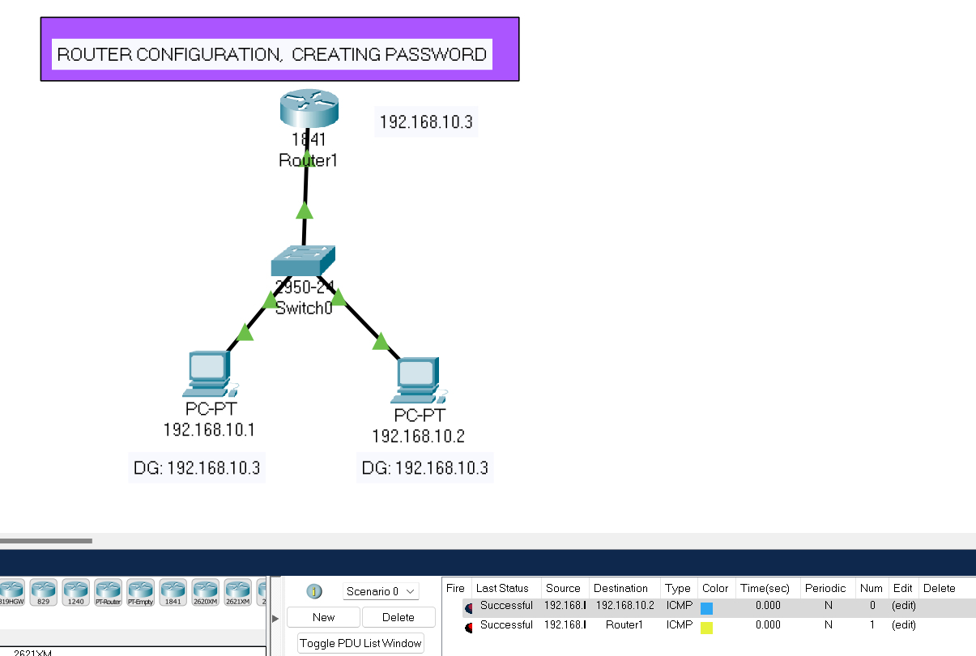

ROUTER

1. SECRET PASSWORD

ROUTER# enable

ROUTER# config t

ROUTER# enable secret abc

ROUTER# exit

ROUTER# exit

Password:

ROUTER# enable

Password: abc

2. LOGIN PASSWORD

ROUTER# enable

ROUTER# config t

ROUTER# line console 0

ROUTER# password 123

ROUTER# login

ROUTER# exit

ROUTER# exit

Exit

Password:

ROUTER# enable

Password: abc

Password: 123

3. LINE VTY PASSWORD

ROUTER# enable

ROUTER# config t

ROUTER# line vty 04

ROUTER#password apple

ROUTER#login

ROUTER# exit

ROUTER# exit

exit

Password:

ROUTER# enable

Password: abc

Password: 123