**Name:** Harshit V

**Reg. No.:** RA2011026020086

**Subject:** DBMS

**Dept.:** CSE AIML B

**ER DIAGRAM FOR SWIGGY MANAGEMENT SYSTEM**

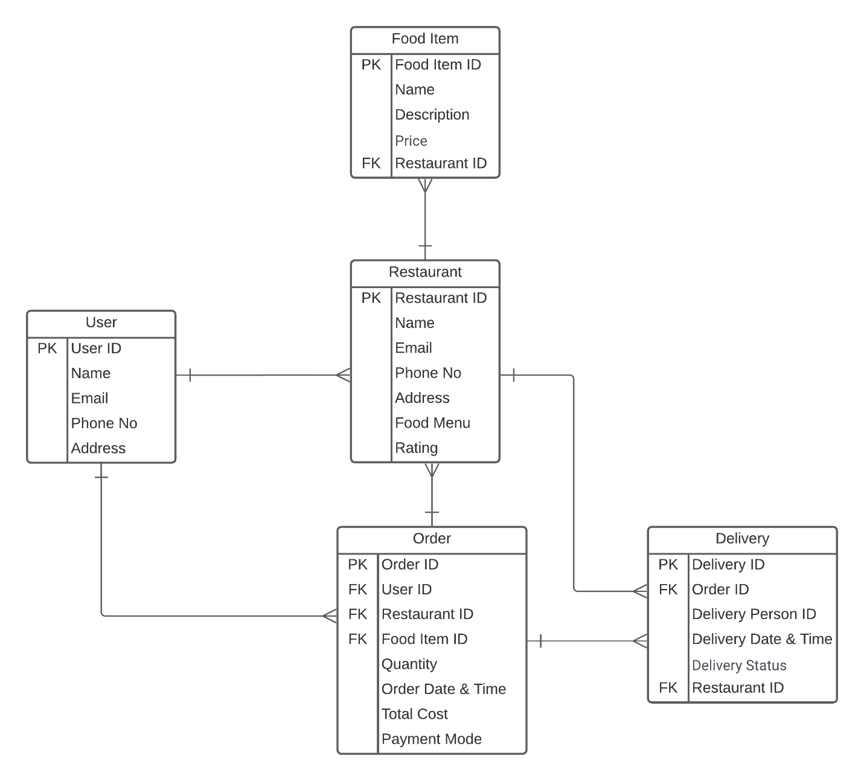

**How it Works:**

1. A User places one or more Orders.
2. An Order can contain one or more Food Items.
3. An Item belongs to one Restaurant.
4. A Delivery is made for one Order.
5. A Restaurant provides one or more Food Items.

**Description:**

In this ER Diagram, we will have 6 entities:

* User
* Restaurant
* Food Item
* Order
* Delivery

**Attributes:**

* User Entity:

1. Name
2. User ID
3. Email
4. Phone No
5. Address

* Restaurant Entity:

1. Restaurant ID
2. Name
3. Address
4. Rating
5. Food Menu
6. Phone No

* Food Item Entity:

1. Food Item ID
2. Name
3. Price
4. Description

* Order Entity:

1. Order ID
2. Quantity
3. Payment Mode
4. Total Cost
5. Date & Time

* Delivery Entity:

1. Delivery ID
2. Deliverer ID
3. Status
4. Date & Time

**Mapping Cardinalities:**

* One-to-Many Relationship:

In this ER Diagram, the entity **USER** is associated with the entities **RESTAURANT** and **ORDER.**

Similarly, the entity **RESTAURANT** is associated with the entities **FOOD ITEM** and **DELIBERY.**

Similarly, the entity **ORDER** is associated with the entities **RESTAURANT** and **DELIVERY.**