1.The problem of determining a point’s 3D position from a set of corresponding image locations and known camera positions is _.

**a. Triangulation**

b. Factorization

c. Bundle adjustment

d. Orthographic projection

2.The___ refers to the fact that motion estimation is highly ambiguous when the observation window is very small.

a. panoptic segmentation

**b. aperture problem**

c. geometric reasoning

d. calibration error

3.One if the useful property of Fourier transforms is that convolution in the spatial domain corresponds to __ in the Fourier domain

a. addition

b. subtraction

**c. multiplication**

b. division

4.Bundle adjustment is now the standard method of choice for most _ problems and is commonly applied to problems with hundreds of weakly calibrated images and tens of thousands of points.

a. motion-from-structure

**b. structure-from-motion**

c. motion-from-motion

d. structure-from-structure

5.Which of the following can also be computed on the basis of line matches alone?

**a. Trifocal Tensor**

b. Tensor Flow

c. Stack overflow

d. both Tensor Flow and Stack overflow

6.__ technique can be used to estimate a series of rotation matrices and focal lengths, which can be chained together to create large panoramas.

a. bundle adjustment

b. Parallax removal

**c. Gap closing**

d. Composting

7.Before we can register and align images, we need mathematical relationships that __ from one image to another.

a. align an image

**b. map pixel coordinates**

c. rotate pixel

d. compare image

8.In ____ images are translated, optionally rotated and scaled.

**a. panography**

b. cryptography

c. photography

d. cartography

9.An alternative to using homography or 3D motions to align images is to first warp the images into _ and then use a pure translational model to align them.

a. Spherical coordinates

**b. Cylindrical coordinates**

c. Planar coordinates

d. Vector coordinates

10.If the user takes images in sequence so that each image overlaps its predecessor and also specifies the first and last images to be stitched, bundle adjustment combined with the process of ___ can be used to automatically assemble a panorama.

**a. topology inference**

b. mean difference

c. sum of squared difference

d. change in image

11.The fundamental matrix is given by ____.n(options not given)

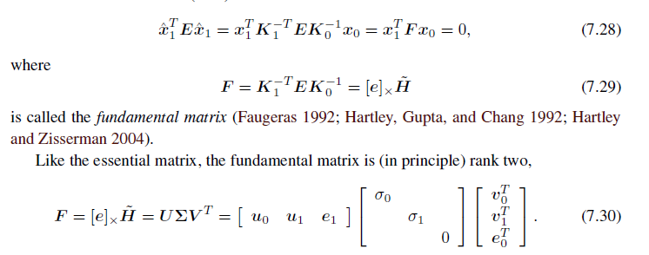

12.Most modern cameras have __ pixels and an image center near the ____ of the image

a. round, center

b. rectangle, corner

**c. square, middle**

d. round, edge

13.Which one of the following is the point of intersection of the line joining the camera centers with the image plane?

**a. Epipole**

b. Axis

c. Point of projection

d. Point at infinity

14.Fourier-based alignment relies on the fact that the Fourier transform of a shifted signal has the same magnitude as the original signal, but a _____ phase

a. exponentially varying

**b. linearly varying**

c. unvarying

d. constant

15.Structure from motion is a ____in structure and motion.

**a. Bipartite problem**

b. Graph Coloring Problem

c. Travelling salesman problem

d. Normalized Cut

16.Triangulation is the converse of ___ problem.

a. Direct Linear Transform

**b. Pose Estimation**

c. 2D Motion Estimation

d. Rigid Transform

17.For converting a projective reconstruction into a metric one, _____ techniques have been developed.

a. Orthographic Projection

b. Projection Matrix

**c. Self-calibration**

d. Epipolar

18.The normal vector perpendicular to the line can be expressed as a function of two angles using ______.

**a. Spherical coordinates**

b. Cylindrical coordinates

c. Planar coordinates

d. Vector coordinates

19.Professional panoramic photographers often use pan-tilt heads that make it easy to control the tilt and to stop at specific ___in the rotation angle.

a. error

b. bias

c. weight

**d. detents**

20.Radial distortion can be estimated ____.

**a. ahead of time**

b. Just in time

c. using alignment

d. by matching pixels