**ABSTRACT**

The objective of this study is to apply business intelligence in identifying potential customers by providing relevant and timely data to business entities in the Retail Industry. The data furnished is based on systematic study and scientific applications in analyzing sales history and purchasing behavior of the consumers. The curated and organized data as an outcome of this scientific study not only enhances business sales and profit, but also equips with intelligent insights in predicting consumer purchasing behavior and related patterns.

In order to execute and apply the scientific approach using K-Means algorithm, the real time transactional and retail dataset are analyzed. Spread over a specific duration of business transactions, the dataset values and parameters provide an organized understanding of the customer buying patterns and behavior across various regions.

This study is based on the RFM (Recency, Frequency and Monetary) model and deploys dataset segmentation principles using K-Means Algorithm. A variety of dataset clusters are validated based on the calculation of Silhouette Coefficient. The results thus obtained with regard to sales transactions are compared with various parameters like Sales Recency, Sales Frequency and Sales Volume.

**TABLE OF CONTENTS**

| **S.NO** | **CONTENTS** | **PAGE NO** |
| --- | --- | --- |
| **1.** | **INTRODUCTION**  1.1 Introduction  1.1.1 Problem Statement  1.2 Aim of the Project  1.3 Project Domain  1.4 Scope of the Project  1.5 Methodology | 1 - 3 |
| **2.** | **LITERATURE SURVEY** | 4 - 7 |
| **3.** | **PROJECT DESCRIPTION**  3.1 Existing System  3.2 Proposed System  3.3 Feasibility Study  3.4 System Specification | 8 - 11 |
| **4.** | **MODULE DESCRIPTION**  4.1 General Architecture  4.2 Design Phase  4.2.1 Data Flow Diagram  4.2.2 UML Diagram  4.3 Module Description | 12 - 19 |
| **5.** | **IMPLEMENTATION AND TESTING**  5.1 Input and Output  5.2 Testing | 20 - 22 |

| **S.NO** | **CONTENTS** | **PAGE NO** |
| --- | --- | --- |
| **6.** | **RESULTS AND DISCUSSIONS**  6.1 Efficiency of Proposed System | 23 |
| **7.** | **SOURCE CODE IMPLEMENTATION AND POSTER PRESENTATION**  7.1 Sample Code  7.2 Poster Presentation | 24 - 35 |
| **8.** | **CONCLUSION AND FUTURE ENHANCEMENTS**  8.1 Conclusion  8.2 Future Enhancements | 36 - 37 |
| **9.** | **REFERENCES** | 38 - 39 |

**CHAPTER 1**

**INTRODUCTION**

* 1. **Introduction**

In the modern era of innovation, where there is a large competition to be better than everyone, the business strategy needs to be according to the modern conditions. The business done today runs on the basis of innovative ideas as there are a large number of potential customers who are confounded to what to buy and what not to buy. The companies doing the business are also not able to diagnose the target potential customers. This is where machine learning comes into picture, the various algorithms are applied to identify the hidden patterns in the data for better decision making.

The concept of which customer segment to target is done using the customer segmentation process using the clustering technique. The customer segmentation has the importance as it includes, the ability to modify the programs of market so that it is suitable to each of the customer segment, support in business decision; identification of products associated with each customer segment and to manage the demand and supply of that product; identifying and targeting the potential customer base, and predicting customer defection, providing directions in finding the solutions.

**1.1.1 Problem Statement**

In the ever-growing competition and increasing complexity of the business environment, segmentation and its systematic study improves customer loyalty and enhances enterprise-level for long lasting relationships by widening profitable customer databases. The major industries wherein customer segmentation and for data mining can be applied are the Retail Industry, because it requires a vast amount of data on sales, transportation, consumption ratio, redelivery service and many others.

Also, Retail data mining helps in identifying and effectively mapping customer behavior and related patterns during the entire life-cycle of business transactions. This ultimately, leads to improved customer service, effective sales and distribution strategies and many more. This work mainly focuses on tracking the historical purchasing behavior of customers with the aim to find the maximum amount of sale possible in the specific area. Based on the statistical results and indicators, companies in the retail industry can design various sales and marketing strategies like promotional campaigns, extending seasonal discounts or floating sales enabling coupons to increase the sales and improve customer retention.

* 1. **Aim of the Project**

The objective of this study is to apply business intelligence in identifying potential customers by providing relevant and timely data to business entities in the Retail Industry. Also to decide how to relate to customers in each segment in order to maximize the value of each customer to the business.

* 1. **Project Domain**

The domain of the project is Machine Learning. The progress of machine learning techniques has been challenging when it comes to Data Clustering and RFM Analysis. Machine learning uses K-Means Clustering, which is one of the Unsupervised machine learning algorithms.

* 1. **Scope of the Project**

In general, the methods used to gather the data for this project can easily be extended into other relevant contexts/analyses. While there is clear value in using the same data to investigate purchasing patterns or to build an item-based collaborative filtering recommender system, neither of these is the focus for this paper. The scope of the paper is limited to the following four intertwined Goals:

* To cluster customers based on common purchasing behaviors for future operations/marketing projects
* To incorporate best mathematical, visual, programming, and business practices into a thoughtful analysis that is understood across a variety of contexts and disciplines
* To investigate how similar data and algorithms could be used in future data mining projects.
* To create an understanding and inspiration of how data science can be used to solve real-world problems. Before delving into the details of the project and its implications, the next chapter discusses what customer segmentation analysis actually is and the reasons for its importance.
  1. **Methodology**

This Methodology is based on RFM analysis. When we are provided with raw data extracted from a database, it might be messy and non-informative to look at individual records.

* RFM analysis is applied to present data at aggregate level and is used to segment customers into homogenous groups.
* These three values are important as **F** and **M** indicate value of customers, and **R** indicate customers’ engagement and satisfaction.
* The values are easy to obtain from the basic set of information for each purchasing history.
* FM technique is a **cost-efficient marketing strategy** based on customer behavior segmentation.
* With this system the accuracy can be increased by about **20.4%** than the existing system.

| **Recency** | **Frequency** | **Monetary** |
| --- | --- | --- |
| When is your last purchase? | How many times have you placed or purchased? | How much have you spent? |
| **Example:**  Length of duration since last purchase. | **Example:**  Number of orders over selected analysis period. | **Example:**  Sum of total amount spent over the period. |

**CHAPTER 2**

**LITERATURE REVIEW**

**Paper - I**

**Title:** A Systematic Approach to Customer Segmentation and Buyer Targeting for Profit Maximization

**Authors**: Bhade Kalyani, Vedanti Gulalkari, Nidhi Harwani and Sudhir N Dhage

**Methodology**:

* K-Means clustering was used for customer segmentation and Singular Value Decomposition was used for providing appropriate recommendations to the customers.

**Technical Gap**: Drawbacks of the recommender system like sparsity, cold start problem etc and how they can be overcome.

**Description**: Proposed a systematic approach for targeting customers and providing maximum profit to the organizations. An important initial step was to analyze the data of sales acquired from the purchase history and determine the parameters that have the maximum correlation. Based on respective clusters, proper resources can be assigned towards profitable customers using machine learning algorithms.

**Paper - II**

**Title:** Customer Segmentation using K-means Clustering

**Authors**: Kansal, Tushar, Suraj Bahuguna, Vishal Singh, and Tanupriya Choudhury

**Methodology**:

* Performed customer segmentation using K-means clustering.

**Technical Gap**: By applying clustering, 5 segments of cluster were formed labeled as Careless, Careful, Standard, Target and Sensible customers. However, the authors got two new clusters on applying mean shift clustering labeled as High buyers and frequent visitors and High buyers and occasional visitors.

**Description**: A python program was developed and the program was trained by applying standard scaler onto a dataset having two features of 200 training samples taken from local retail shops. Both the features are the average of the amount of shopping by customers and average of the customer's visit to the shop annually.

**Paper - III**

**Title:** Analysis of Customer Segmentation Based on Broad Learning System

**Authors**: Wang, Zhenyu, Yi Zuo, Tieshan Li, CL Philip Chen, and Katsutoshi Yada

**Methodology**:

* Analyzed customer segmentation based on a broad learning system which provides an alternative view of learning in deep structure.

**Technical Gap**: The customer behavior data used in this paper was collected from a real-world supermarket in Japan. Customer segmentation was considered as a multi-label classification problem based on both POS data and RFID data.

**Description**: Firstly, in addition to customer purchasing behavior, RFID (Radio Frequency Identification) data was also included, which can accurately represent the consumers' in-store behavior. Secondly, this paper used the Broad Learning System (BLS) to analyze consumer segmentation. BLS is one of the finest machine learning techniques, and quite efficient and effective for classification tasks.

**Paper - IV**

**Title:** Research on customer segmentation in retailing based on clustering model

**Authors**: Li, Zeying

**Methodology**:

* Proposed a method in which a retail supermarket was taken as a research object, and data mining methods were used to retail enterprise customer segments, and then association rules obtained using Apriori algorithm.

**Technical Gap**:

First, it has been shown that the worst case running time of the algorithm is super-polynomial in the input size. Second, the approximation found can be arbitrarily bad with respect to the objective function compared to the optimal clustering.

**Description**: Apriori algorithms were used to different groups of customers and get rules about customer characteristics to make customer characteristic analysis efficiently. Finally, the author gave some references to the supermarket's marketing and management work, which helped in understanding it in detail. Data mining was used efficiently to deal with the large amount of historical and current data, from the database to find some potential, useful and valuable information for the retail stores which help us target customers.

**Paper - V**

**Title:** K-Means Clustering Approach for Intelligent Customer Segmentation Using Customer Purchase Behavior Data

**Authors**: Kayalvily Tabianan, Shubashini Velu and Vinayakumar Ravi

**Methodology**:

* Data Mining and K Means Clustering Elbow method used

**Technical Gap**: There are some limitations such as working with microdata both making comparisons and modeling and clustering, especially if they are business management and sales financial data. The difficulties of working with indicators, indexes, and rates complicate the data mining process and, later, the reading of the results.

**Description**: This research aims to help researchers and other E commerce stakeholder for a comparison of the structuring and grouping of the E-commerce purchasing pattern in small areas. It also endeavors to show an optimal way of transforming and working on datasets to facilitate the resulting groupings. Therefore, this research allows us to segment a cohort from E-commerce behavior data from multiple category store and purchasing histories. In Addition, it would capture the inequality that can be observed between the high profitable segments and low profitable segments in the category of products better.

**Paper - VI**

**Title:** Customer Segmentation using K-means Clustering

**Authors**: Hemashree Kilari, Sailesh Edara, Guna Ratna Sai Yarra, Dileep Varma Gadhiraju

**Methodology**:

* K Means Clustering Silhouette method without RFM Analysis.

**Technical Gap**: You can choose the number of clusters by visually inspecting your data points, but you will soon realize that there is a lot of ambiguity in this process for all except the simplest data sets.This is not always bad, because you are doing unsupervised learning and there's some inherent subjectivity in the labeling process. Here, having previous experience with that particular problem or something similar will help you choose the right value.

**Description**: This study demonstrates that client segmentation in shopping malls is achievable despite the fact that this form of machine learning application is highly useful in the market. A manager can concentrate all of his or her attention on each cluster that has been discovered and meet all of their requirements.

**CHAPTER 3**

**PROJECT DESCRIPTION**

* 1. **Existing System**

In the current system, the K Means Initialization method and Elbow method are used to find the optimal no of clusters (k).

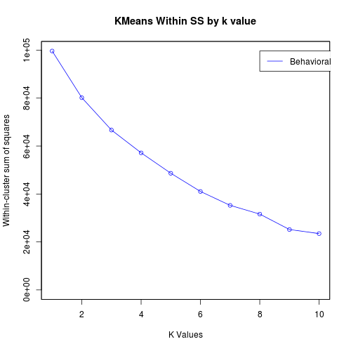

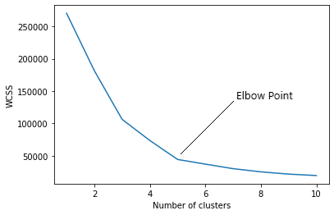

* The elbow method doesn't always work well, especially if the data is not very clustered.
* Because of that it will produce a smooth curve which makes it difficult to find the optimal no of clusters (k).
* Also, RFM technique (which is specifically used in customer segmentation) is not implemented in the current system.

**3.2 Proposed System**

In our system we are using **K Means silhouette method** to find the optimal clusters (k) and **RFM technique** to improve the accuracy of the clustering based on the customer history, and then it’s visualized.

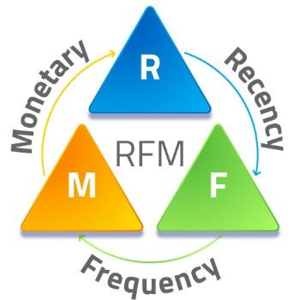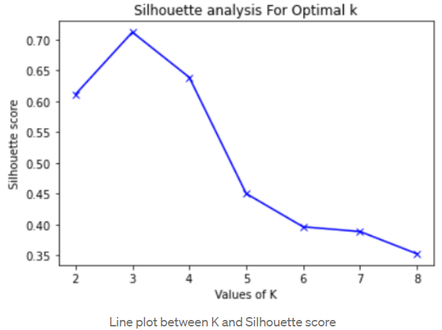

* RFM technique is a cost-efficient marketing strategy based on customer behavior segmentation.
* RFM stands for **Recency, Frequency, Monetary**. Simply, it groups customers based on their purchase history.
  + Recency - How recent was the customer's last purchase?
  + Frequency - How often did this customer make a purchase in a given period?
  + Monetary - How much money did the customer spend in a given period?
* With this system the accuracy can be increased by about **20.4%** than the existing system.

**3.3 Feasibility Study**

A Feasibility study is carried out to check the viability of the project and to analyze the strengths and weaknesses of the proposed system. The application of usage of masks in crowd areas must be evaluated. The feasibility study is carried out in three forms:

* Economic Feasibility
* Technical Feasibility
* Social Feasibility

**3.3.1 Economic Feasibility**

The proposed system does not require any high-cost equipment. This project can be developed within the available software.

**3.3.2 Technical Feasibility**

The proposed system is completely a Machine learning model. The main tools used in this project are Anaconda prompt, Visual studio, Kaggle datasets, Jupyter Notebook And the language used to execute the process in Python. The above-mentioned tools are available for free and technical skills required to use these tools are practicable. From this we can conclude that the project is technically feasible.

**3.3.3 Social Feasibility**

Social feasibility is a determination of whether a project will be acceptable or not. Our project is Eco-friendly for society and there are no social issues. our project must not be threatened by the system instead must accept it as a necessity. since our project is applicable for every individual in the society to take care about the society and environment. The level of acceptance of the System is very high and it depends on the methods deployed in the system. our system is highly familiar with society.

**3.4 System Specification**

**3.4.1 Hardware Specification**

| PROCESSOR | Intel i5-8250 @ 3.40GHz |
| --- | --- |
| STORAGE | 512 GB SSD |
| RAM | 16 GB |
| GPU | Nvidia GTX 1650 Ti |
| OPERATING SYSTEM | Windows 11 x64 Bit |

**3.4.2 Software Specification**

| Windows 10, 11 |
| --- |
| Anaconda Jupyter Notebook |
| Python 3.10 |
| Machine Learning Modules |

**CHAPTER 4**

**MODULE DESCRIPTION**

* 1. **General Architecture**

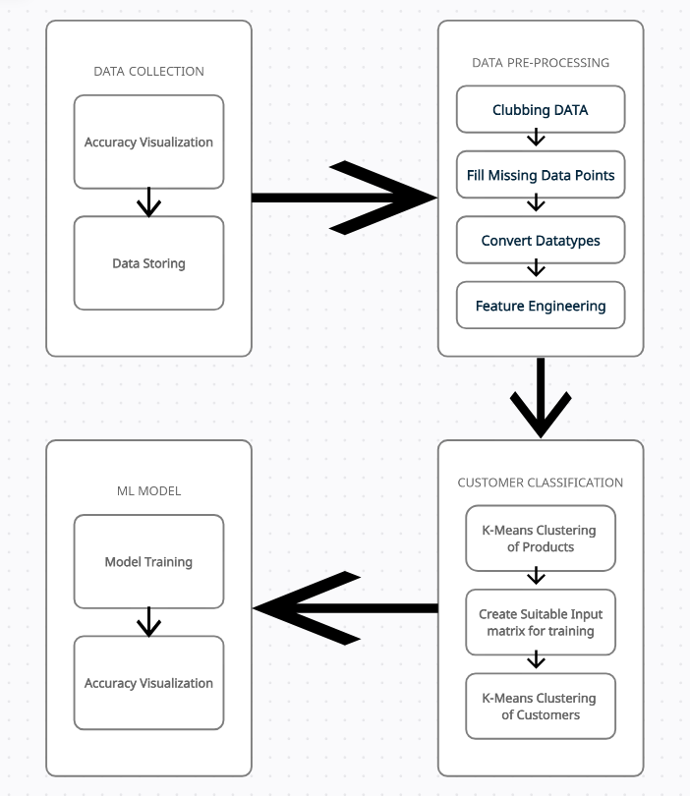

Figure 4.1: **Architecture Diagram**

The data set obtained is passed to the pre-processing stage where duplicates and null rows are dropped. A dataset may contain cancelled orders which are removed as well. The datatype of columns is converted to the required datatype for pre-processing. The refined data set is then used to classify the customers into different categories by un-supervised learning through K-Mean algorithm. The resultant dataset or matrix which contains customer and its categories is used to train and test supervised training models such as Random Forest, K-Nearest Neighbors, and Gradient Boost.

* 1. **Design Phase**
     1. **Data Flow Diagram**

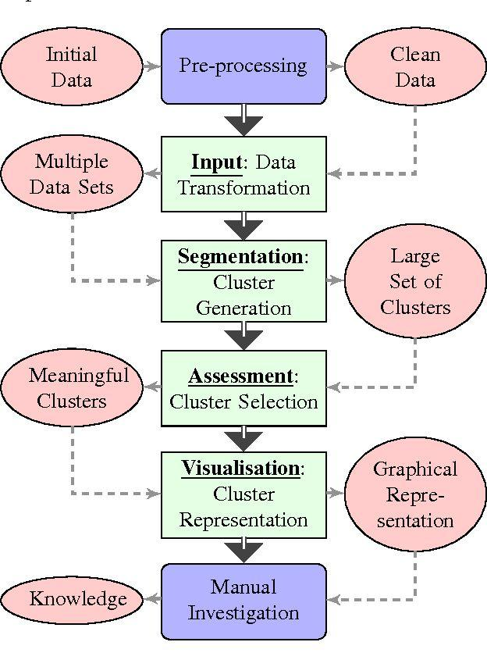

Figure 4.2: **Data Flow Diagram**

A Data Flow Diagram (DFD) is a traditional visual representation of the information flows within a system. It shows how data enters and leaves the system, what changes the information, and where data is stored. It can be manual, automated, or a combination of both. At First, the data is preprocessed using pandas py module.

Secondly, the required data is selected from the Pre-processed dataset, and splitted in 80:20 ratio for the train set and test set. Then it is clustered using K-Means clustering algorithm, which is one of the unsupervised machine learning models. Now the result is visualized for manual analysis.

**4.2.2 UML Diagram**

A UML diagram is a diagram based on the UML (Unified Modeling Language) with the purpose of visually representing a system along with its main actors, roles, actions, artifacts, or classes, to better understand, or document information about the system. For our project we have drawn 2 Diagrams:

**1. Use Case Diagram**

A use case diagram is a graphical depiction of a user's possible interactions with a system. A use case diagram shows various use cases and different types of users the system has and will often be accompanied by other types of diagrams as well.

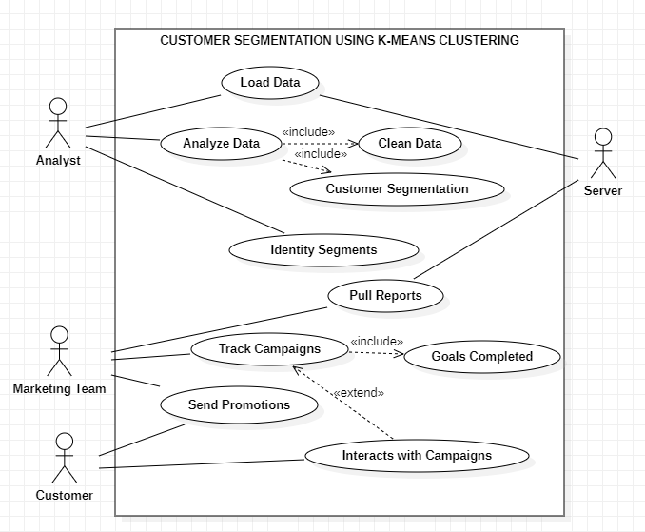

**2. Sequence Diagram**

Sequence Diagrams are interaction diagrams that detail how operations are carried out. They capture the interaction between objects in the context of a collaboration. Sequence Diagrams are time focused, and they show the order of the interaction visually by using the vertical axis of the diagram to represent time, what messages are sent and when.

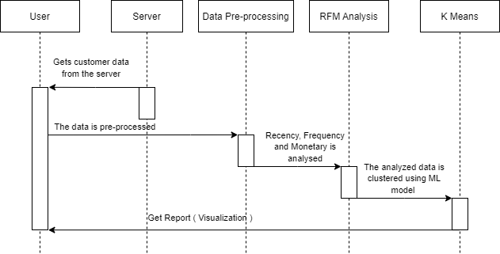

**4.3 MODULE DESCRIPTION**

Our entire project is divided into five modules:

Step 1: Data Collecting

Step 2: Pre-processing of Data

Step 3: RFM Analysis

Step 4: Clustering the analyzed data

Step 5: Visualization

**4.3.1 Data Collecting**

There are many different ways your online store collects data from consumers. It is vital for eCommerce companies to collect this data responsibly.

There are three basic approaches on collecting data about online store customers:

1. Direct user inquiry (in the case of personal data, informing the user and their consent is mandatory)
2. Indirectly tracking users' movements through the store's tabs
3. By adding customer data from other sources

Depending on the chosen approach, there are several ways and tools to obtain information about individual clients:

* Cookies
* Customer surveys and feedback forms
* Placing orders
* Social media
* Chatbots

**4.3.2 Pre-Processing Of Data**

Data preparation and filtering steps can take a considerable amount of processing time. Examples of data preprocessing include cleaning, instance selection, normalization, one hot encoding, transformation, feature extraction and selection, etc. The product of data preprocessing is the final training set.

**4.3.3 RFM Analysis**

RFM stands for Recency, Frequency, and Monetary value, each corresponding to some key customer trait. These RFM metrics are important indicators of a customer’s behavior because frequency and monetary value affects a customer’s lifetime value, and recency effects retention, a measure of engagement. Businesses that lack the monetary aspect, like viewership, readership, or surfing-oriented products, could use Engagement parameters instead of Monetary factors. This results in using RFE – a variation of RFM. Furthermore, this Engagement parameter could be defined as a composite value based on metrics such as bounce rate, visit duration, number of pages visited, time spent per page, etc.

**4.3.4 Clustering The Analyzed Data**

In the context of customer segmentation, customer clustering analysis is the use of a mathematical model to discover groups of similar customers based on finding the smallest variations among customers within each group. The goal of cluster analysis in marketing is to accurately segment customers in order to achieve more effective customer marketing via personalization.

A common cluster analysis method is a mathematical algorithm known as k-means cluster analysis, sometimes referred to as scientific segmentation. The clusters that result assist in better customer modeling and predictive analytics, and are also used to target customers with offers and incentives personalized to their wants, needs and preferences.

**4.3.5 Visualization**

Now the clustering is visualized in a scatter plot using matplotlib. The marketing team will now analyze and makes changes to its recommendation system.

**4.3 Datasets Sample**

**DATASET SAMPLE 1**

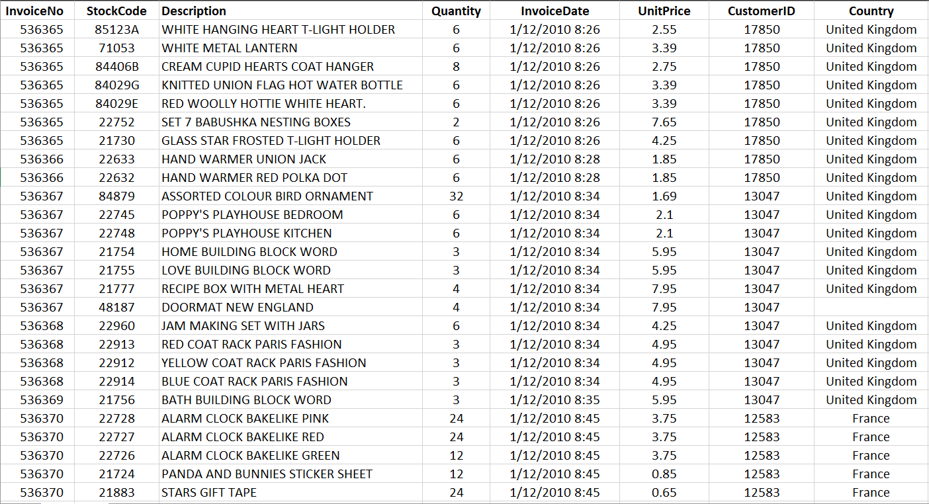

**DATASET SAMPLE 2**

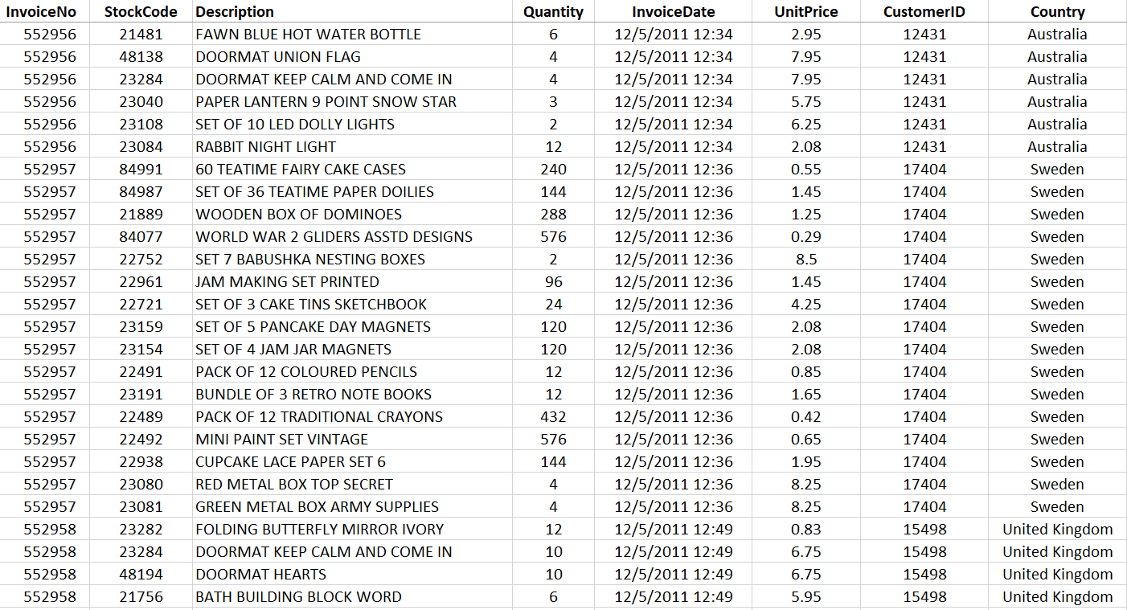

**Chapter 5**

**IMPLEMENTATION AND TESTING**

**5.1 Input and Output**

**INPUT:**

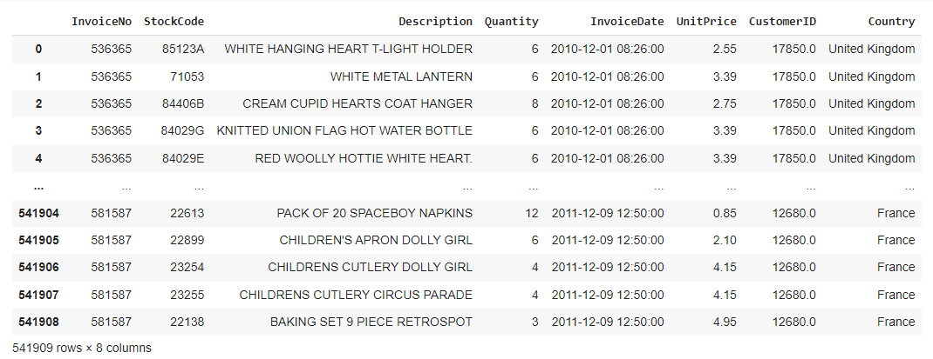

**OUTPUT:**

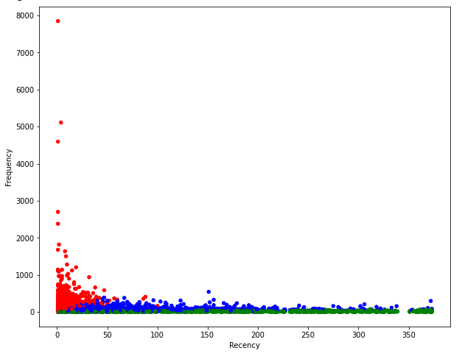

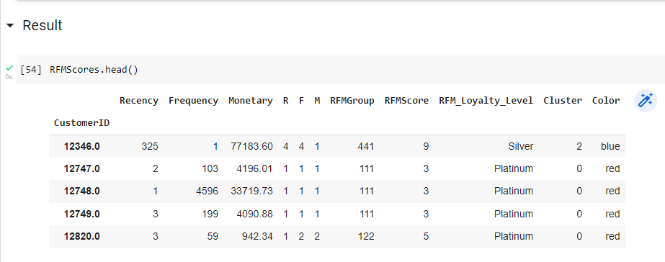

**5.2 Testing**

Testing is the process of evaluating a system or its component(s) with the intent to find whether it satisfies the specified requirements or not.

**5.2.1 Types of Testing**

**1. Unit Testing**

Unit testing is a beneficial software testing method where the units of source code are tested to check the efficiency and correctness of the program.

**2. Integration Testing**

In this testing, units or individual components of the software are tested in a group. The focus of the integration testing level is to expose defects at the time of interaction between integrated components or units.

**3. Functional Testing**

Functional testing is also called as black-box testing, because it focuses on application specification rather than actual code. Testers must test only the program rather than the system. Goal of functional testing.

**5.3 Test Result**



**CHAPTER 6**

**RESULTS AND DISCUSSIONS**

**6.1 Efficiency of Proposed System**

The proposed work aims to classify online e-commerce customers into various categories based on their characteristics like spending amount, type of product they buy, and how frequently purchase happens etc. Initially the products were classified into 5 categories using K-means and through this result along with other characteristics like amount spent, frequency etc. online ecommerce customers were classified into 11 categories using unsupervised method i.e. K-means Clustering. To measure the accuracy, silhouette scoring was used. Later different classifiers were trained using the data obtained so far. Our proposed model is 20% more efficient than the existing model.

In order to execute and apply the scientific approach using K-Means algorithm, the real time transactional and retail dataset are analyzed. Spread over a specific duration of business transactions, the dataset values and parameters provide an organized understanding of the customer buying patterns and behavior across various regions.

This study is based on the RFM (Recency, Frequency and Monetary) model and deploys dataset segmentation principles using K-Means Algorithm. A variety of dataset clusters are validated based on the calculation of Silhouette Coefficient. The results thus obtained with regard to sales transactions are compared with various parameters like Sales Recency, Sales Frequency and Sales Volume.

**CHAPTER 7**

**SOURCE CODE & POSTER PRESENTATION**

**7.1 SOURCE CODE**

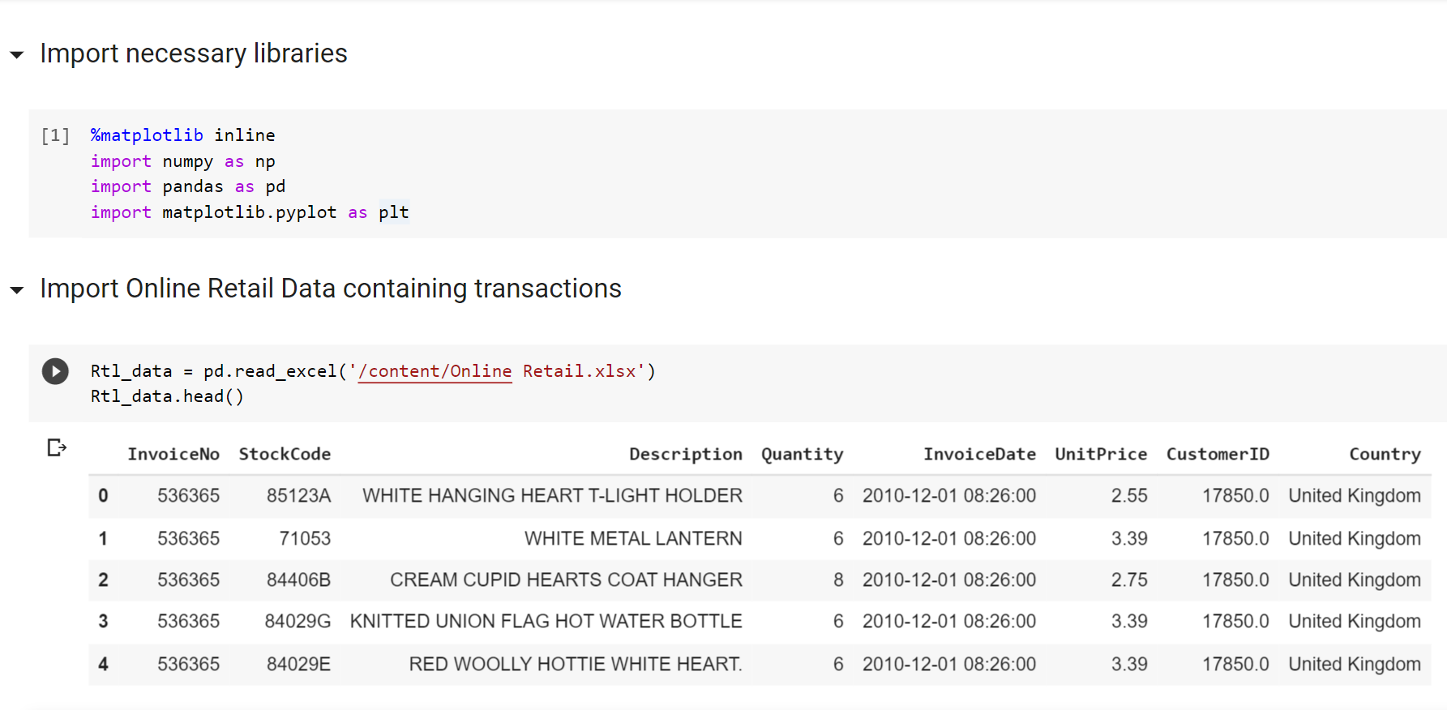

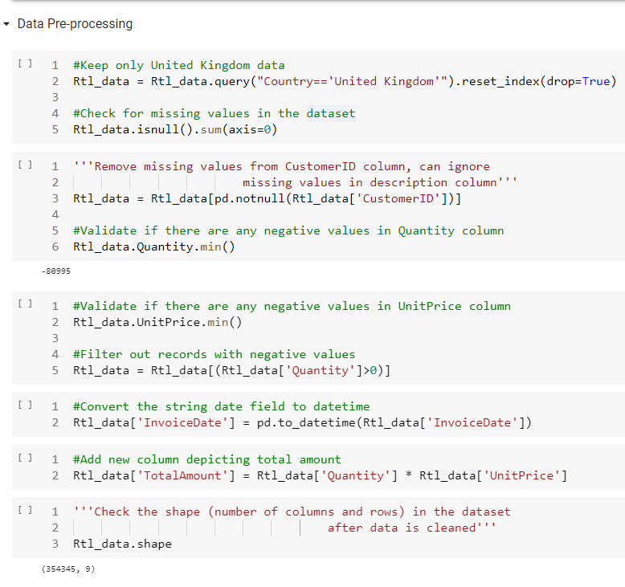

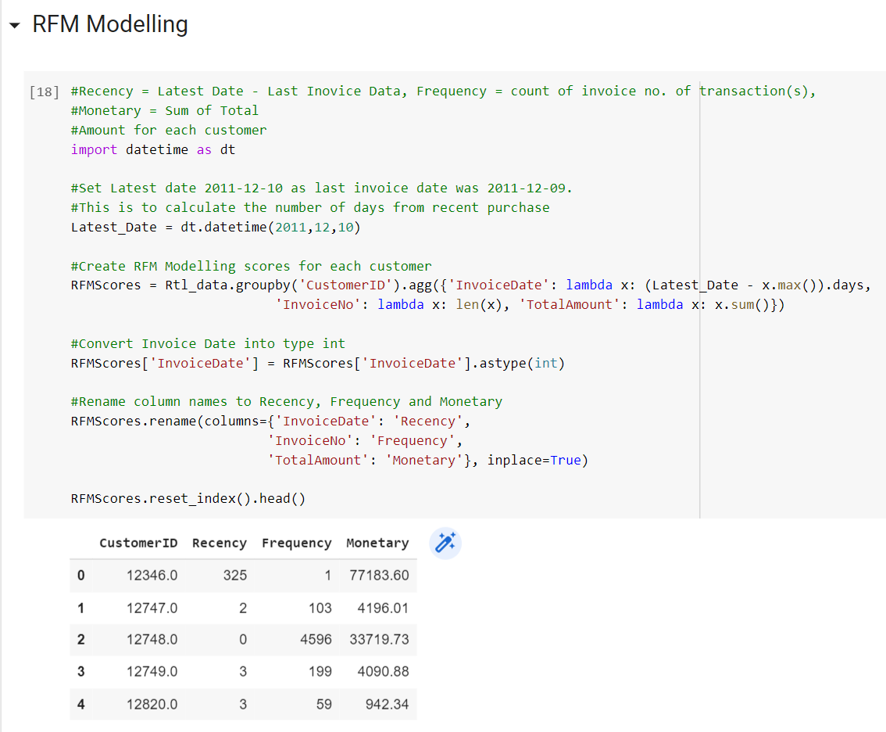

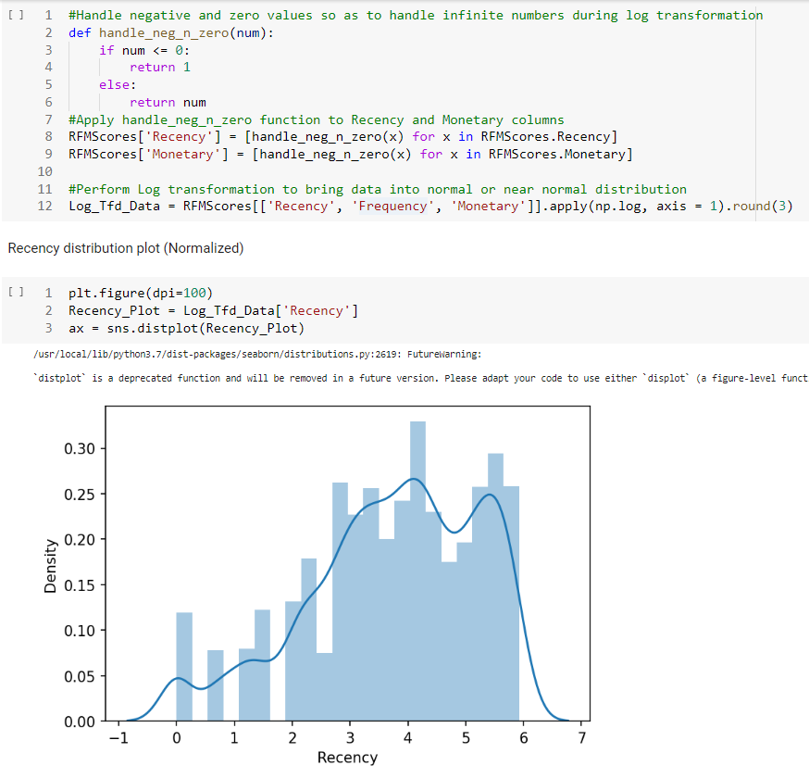

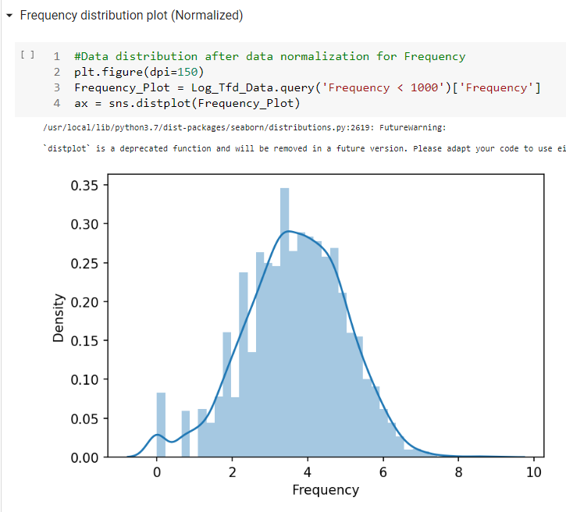

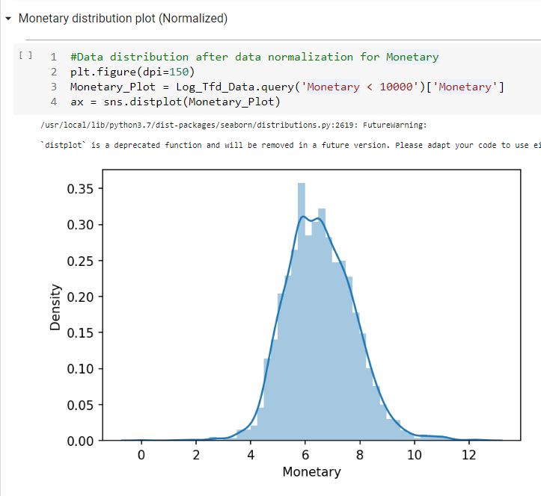

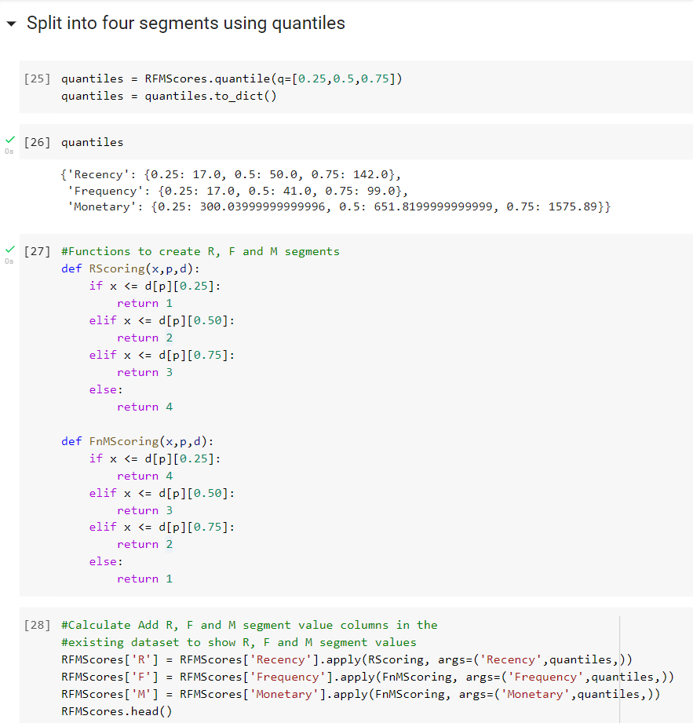

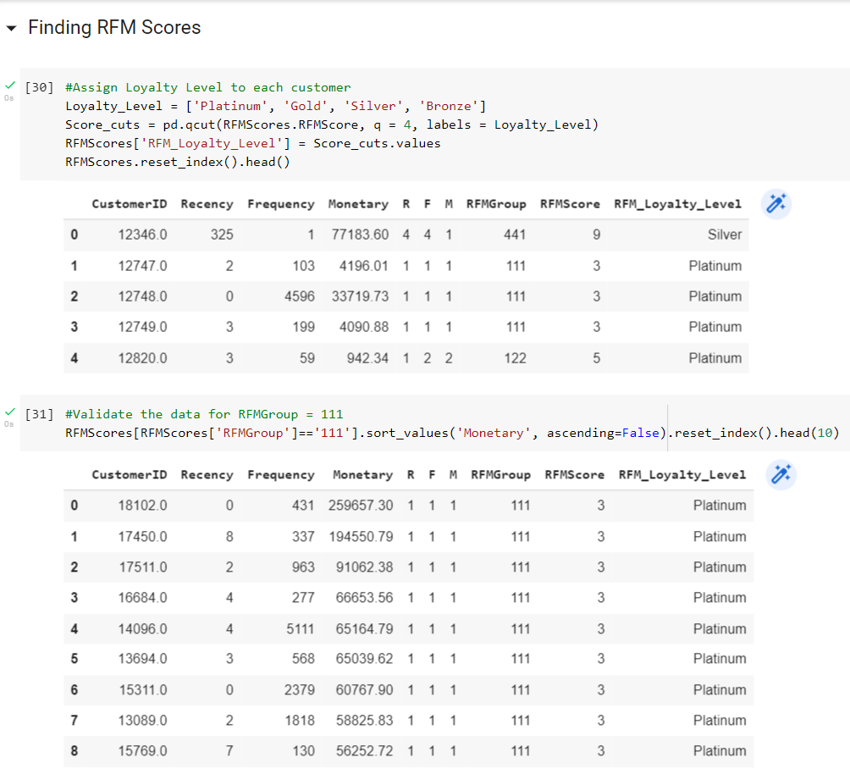

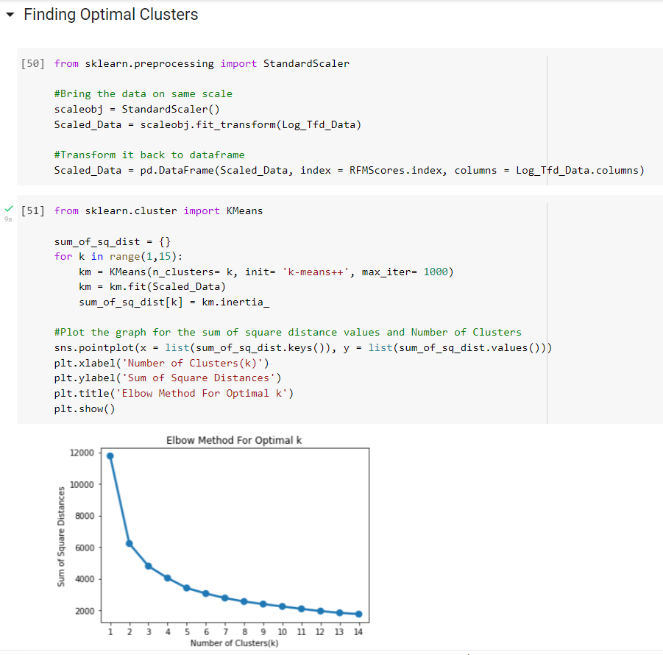

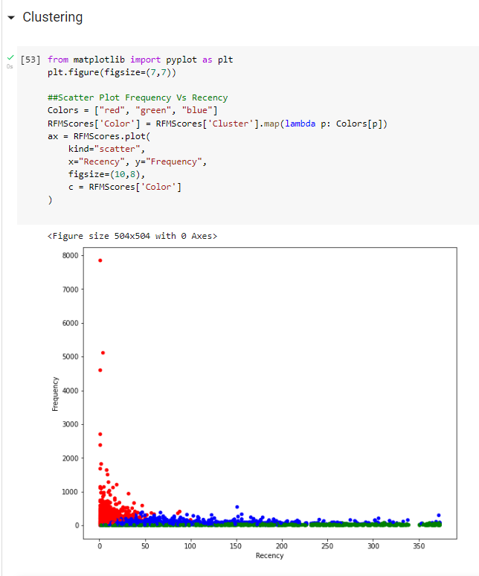



**7.2 POSTER PRESENTATION**

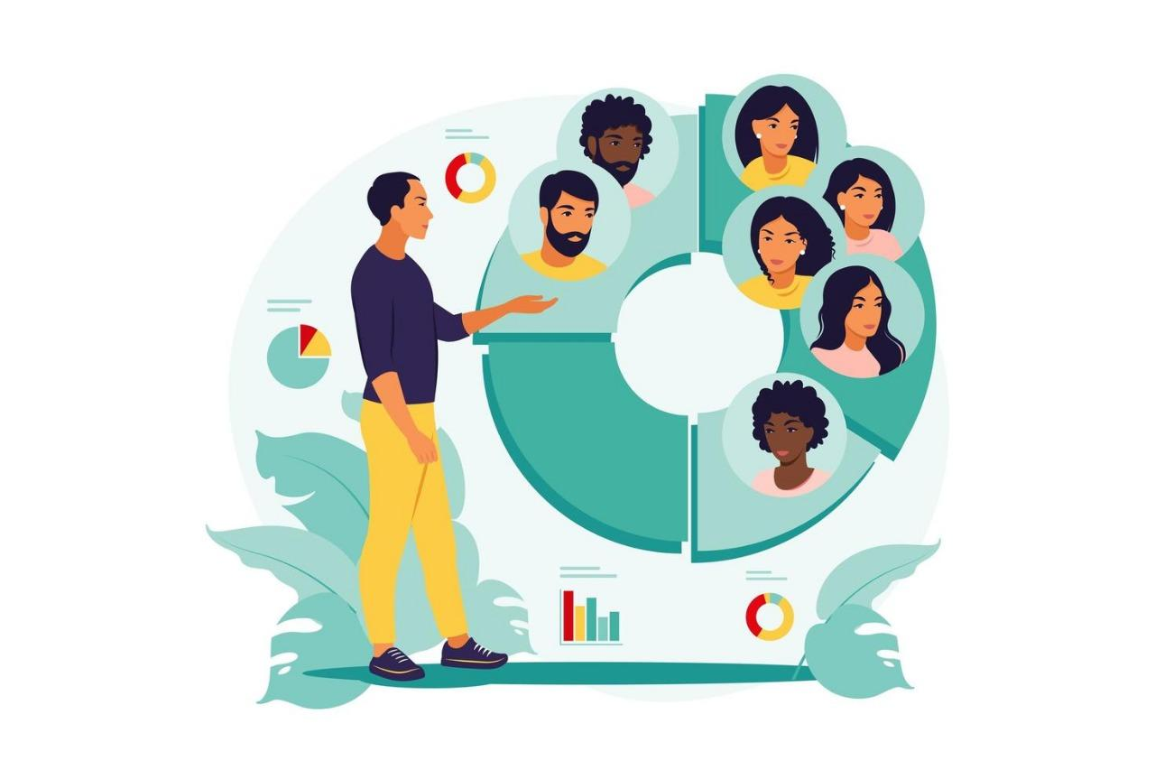



**CHAPTER 8**

**CONCLUSION AND FUTURE ENHANCEMENTS**

**8.1 CONCLUSION**

Customer segmentation is a way to improve communication with the customer, to know the wishes of the customer, customer activity so that appropriate communication can be built. Customer Segmentation needed to get potential customers used to increase profits. Potential customer data can be used to provide service the characteristics of customer including ecommerce services as a media buying and selling online. This paper discusses several components to do customer segmentation, which is: Customer segmentation is an activity to divide customers or item into groups that have the same characteristics.

Data that needed for customer segmentation are internal data and external data. The internal data include demographic data and data purchase history, while the external data include cookies and server logs. Internal data can be obtained from a database when customer do registration or transactions and external data can be obtained from web server or other source. Methods of Customer Segmentation can be classified into Simple technique, RFM technique, Target technique, and Unsupervised technique. On Target technique, researcher focus on one variable, it can be product or purchase. Unsupervised technique was used when clustering process researchers have many variables. Process of Customer Segmentation can be simplified into defining business objectives, collecting data, data preparation, and analyzing variables.

**8.2 FUTURE ENHANCEMENTS**

Going forward, the recommendations created by the system should be evaluated with real users from the marketplace. Feedback from users should give a clear picture of whether or not the clusters are good. it was quite clear that the results from the silhouette scores and elbow method were not optimal. In order to achieve better clusters, a better rating system for brands should be implemented that utilizes views, likes and conversations to construct ratings. A more extensive analysis of how the data should be preprocessed and weighted needs to be made in order to get a better result from the clustering algorithm. Furthermore, K-means was used as the only clustering algorithm which might not be optimal in this case.

The K-means algorithm is a simple yet popular method for clustering analysis. Its performance is determined by initialisation and appropriate distance measure. There are several variants of K-means to overcome its weaknesses:

* **K-Medoids**: resistance to noise and/or outliers
* **K-Modes**: extension to categorical data clustering analysis
* **CLARA**: dealing with large data sets
* **Mixture models (EM algorithm)**: handling uncertainty of clusters

Therefore, other clustering techniques should be tested and compared to the K-means implementation. Another vital part of the success of the algorithm is which users and brands should be filtered out. In order to test different thresholds for minimum user activity and brand views, the visualization tool shown in this report should give the Plick team the possibility to alter the User-Brand matrix analyzed by the clustering algorithm by e.g. setting different thresholds and by adding/removing brands. For each run, evaluation plots should be updated and made visible in order to compare different runs.

**REFERENCES**

1. Haotian Wu and Bohua Li, Research on Customer Purchase Prediction Based on Improved Gradient Boosting Decision Tree Algorithm, 2022 2nd International Conference on Consumer Electronics and Computer Engineering (ICCECE), IEEE, 2022
2. V. Arul, Ashutosh Kumar, Aman Agarwal, Segmenting Mall Customers Data to Improve Business into Higher Target using K-Means Clustering, 2021 3rd International Conference on Advances in Computing, Communication Control and Networking (ICAC3N), IEEE, 2021
3. Ruiyu Zhao, Chen Li, Research on E-commerce Customer Segmentation Based on RFAC Model, 2021 IEEE International Conference on Power, Intelligent Computing and Systems (ICPICS), IEEE, 2021
4. Ravi Sista, Riya Singh, Sunil Kumar Kumawat, Ritesh Dhanare, Techniques used by E-commerce industries for Customer analysis, 2021 International Conference on Computer Communication and Informatics (ICCCI), IEEE, 2021
5. Yong Huang, Mingzhen Zhang, Yue He, Research on improved RFM customer segmentation model based on K-Means algorithm, 2020 5th International Conference on Computational Intelligence and Applications (ICCIA), IEEE, 2020
6. Sahar Allegue, Takoua Abdellatif, Khalil Bannour, RFMC: a spending-category segmentation, 2020 IEEE 29th International Conference on Enabling Technologies: Infrastructure for Collaborative Enterprises (WETICE), IEEE, 2020
7. Rahul Pradhan, Customer Segmentation Using Clustering Approach Based on RFM Analysis, 2021 5th International Conference on Information Systems and Computer Networks (ISCON), IEEE, 2021
8. Asmin Alev Aktaş, Okan Tunal, Ahmet Tuğrul Bayrak, Comparative Unsupervised Clustering Approaches for Customer Segmentation, 2021 2nd International Conference on Computing and Data Science (CDS), IEEE, 2021
9. Ritu Punhani, V. P. S Arora, Sai Sabitha, Application of Clustering Algorithm for Effective Customer Segmentation in E-Commerce, 2021 International Conference on Computational Intelligence and Knowledge Economy (ICCIKE), IEEE, 2021
10. V. Chandra Shekhar Rao, Ishwarya Modika, Niranjan Polala, Customer Segmentation with K-Means++ as Initialization Algorithm, 2022 International Conference on Advances in Computing, Communication and Applied Informatics (ACCAI), IEEE, 2022