**DEPARTMENT OF CDC**

**18PDH201T - EMPLOYABILITY SKILLS AND PRACTICES**

**DATA INTERPRETATION- (Concepts and Questions)**

**YEAR/SEM: III / VI**

Directions (Q1 – Q5): Six players, Kramnik, Topalov, Shirov, Leko, Polgar and Anand participate in a chess tournament.

In the first round, each player plays one match against every other player. The winning player is awarded 3 points and the losing player gets 1 point.

In case of a draw, each player is awarded 2 points. The player with the highest number of points enters the final.

The semifinal is played between the next two players. The winner of the semifinal enters the final. The winner of the finals is declared the champion.

There can be no draws in the final and the semifinal. The results of all the matches played by the players at the end of the tournament are given below.

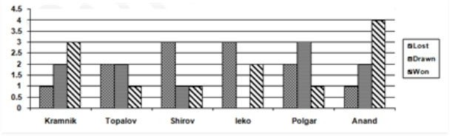

**1.** Who is the champion?

a) Kramnik b)Topalov c)Leko d)Anand

2. The semifinal is played between players

a)Kramnik and Topalov b)Topalov and Polgar c)Kramnik and Anand d)Polgar and Anand

3.Find the points of the semifinalists before the semifinal

a) 9,10 b)10,10 c)10,11 d)11,11

4. Which two players played the final?

a) Kramnik and Topalov b) Topalov and Leko c) Kramnik and Anand d) Topalov and Anand

5. Which of the following is/are true?

I) The top three rankings at the end of the tournament are the same as those at the end of the first round.

II) Anand won the maximum number of matches in the first round.

III) Kramnik has the highest number of points at the end of first round.

a) I only b) II only c)III only d)I, II and III

**Directions (6-10 )Study the information given below and answer the following questions:**

Mr. X has built a mansion with 10 rooms. He was confused about the colors he should use while painting each room. He had the following choice of colors: blue, hazy grey, jumping yellow, teal, violet latte, Terry Cherry and happy pink. It was also known that he could paint more than 1 room with a single color. Finally, he set up an algorithm to decide the colors that he would be using.

* If he painted any room teal, then he did not paint any other room happy pink.
* If he painted any room blue, then he did not paint any other room jumping yellow.
* If he painted any room blue, then he painted at least one room happy pink.
* If he painted any room jumping yellow, then he painted at least one room violet latte.
* If he painted any room violet latte, then he painted at least one room happy pink.

6. Which one of the following could be a complete list of the number of rooms and colors that Mr. X used to paint some of the rooms of his house?

a)one blue, one Terry cherry, one violet latte, two happy pink

b) one blue, one teal, one Terry cherry, three happy pink

c) two blue, one teal, three Terry Cherry

d) one jumping yellow, one Terry cherry, two violet latte and one happy pink

7. If Mr. X did not paint any room happy pink, what was the maximum number of the different types of colors that he could paint ?

a )two b) three c) four d) five

8. Which one of the following statements must be false?

a) Mr. X painted exactly four rooms with colors, one of which was a violet latte.

b) Mr. X painted exactly three rooms with colors, one of which was a happy pink.

c) Mr. X painted exactly four rooms with colors, one of which was a blue.

d) None of these

9. If Mr. X painted as many different types of colors as possible, then it must be true that he did not paint one of the following types of color?

a)blue b)hazy grey c)teal d)jumping yellow

10. If Mr. X painted at least one room, find out which one of the following are the minimum and the maximum numbers of the types of colors that he could paint ?

a) 1, 4 b) 1, 5 c) 1, 6 d) 2, 5

**Directions (11-15):** Answer the questions based on the information given below:

The following line graph shows revenue and expenditure of a company A for 5 year (in Lakhs): 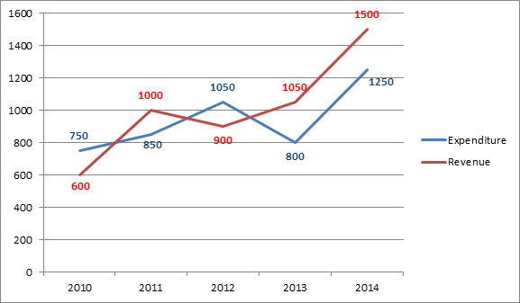

11.What is the average revenue of the company over the years?

A. 1000 lakhs B. 1010 lakhs C. 1050 lakhs D. 2020 lakhs E. None of these

12. What is the difference between revenue and expenditure of company A over the year?

A. 350 lakhs B. 250 lakhs C. 200 lakhs D. 300 lakhs E. None of these

13. What is the average expenditure of the company A over the years?

A. 940 lakhs B. 900 lakhs C. 1000 lakhs D. 1010 lakhs E. None of these

14. What is the ratio of sum of expenditure in the year 2012 and 2013 to that of revenue in year 2014?

A. 21: 25 B. 25: 21 C. 30: 37 D. 37: 30 E. None of these

Direction (15&16): Study the pie chart carefully and answer the given questions.  
The pie chart shows the percentage breakup of students in different classes from VI to X in the year 2017

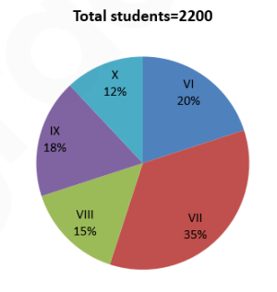

15. The total number of students study in class VI and class IX together is approximately what percentage more than that of the total number of students study in class X?

A. 125% B. 280% C. 217% D. 189% E. 77%

16. What is the difference between the total number of students in class VII and class VIII together to that of the total number of students in class IX and class X together?

A. 480 B. 520 C. 440 D. 400 E. 560

**Directions (17 - 20):** The following bar graph shows the percentage break- up of Sunil’s salary from year 2012 to 2016. With the given information, find the following questions.

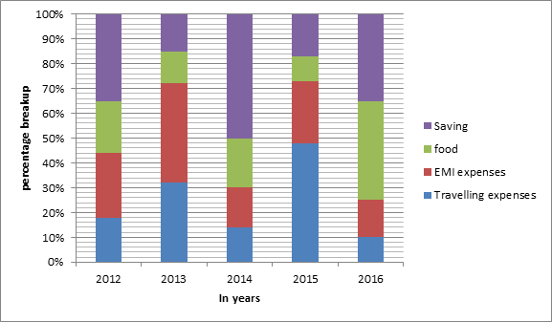

17. If the ratio on saving in the year 2013 and 2016 are in the ratio 3 : 5. Then what is the ratio of EMI expenses in the year 2013 and 2016.

A. 56:5 B. 8:15 C. 56:15 D. Can’t be determined E. none of these

18. Every year there is an increase of 100% in monthly salary as compared to previous year’s monthly salary then what is the ratio of monthly salary in 2016 to the expenses on travelling in 2013.

A. 8:1 B. 1:25 C. 80:3 D. 25:1 E. none of these

19. If the total expenses in year 2011 is INR 3, 00,000 and there is an increase of 18% in 2012. Then how much Sunil has spent on travelling and EMI combine in 2012?

A. INR 1,53,740 B. INR 1,40,330 C. INR 1,50,740

D. INR 92,400 E. INR 1,55,760

20.What approx. percentage of average money spend by Sunil on food to that of average money saved by him during all these years if his salary per annum was INR 5,00,000

A. 65% B. 70% C. 68% D. 69% E. 66%