- Install MongoDB Compass from mongodb.com. Open it. Click Connect with mongodb://localhost:27017/. click Connect. Click Create Database.
- Database Name: mydb
Collection Name: users
Click Create.
- In PyCharm, create new project. Create file app.py.
from pymongo import MongoClient
client = MongoClient("mongodb://localhost:27017/")
db = client["mydb"]
print("Connected! Databases:", client.list_database_names())
- In PyCharm go to File > Settings > Project > Python Interpreter. Click + (plus) on top Search flask, click Install. Then search pymongo, click Install.

- Create a file main.py
from flask import Flask, render_template, request, redirect
from pymongo import MongoClient
app = Flask(__name__)
client = MongoClient("mongodb://localhost:27017/")
db = client["mydb"]
users = db["users"]
@app.route('/')
def home():
return redirect('/login')
@app.route('/register', methods=['GET','POST'])
def register():
if request.method == 'POST':
username = request.form['username']
password = request.form['password']
if users.find_one({"username": username}):
return "User already exists! <a href='/register'>Try again</a>"
users.insert_one({"username": username, "password": password})
return redirect('/login')
return render_template('register.html')
@app.route('/login', methods=['GET','POST'])
def login():
if request.method == 'POST':
username = request.form['username']
password = request.form['password']
user = users.find_one({"username": username, "password": password})
if user:
return f"<h2>Welcome {username}! Login Successful</h2>"
else:
return "Invalid login! <a href='/login'>Try again</a>"
return render_template('login.html')

if __name__ == '__main__':
app.run(debug=True)

- Right click your project > New > Directory > name it templates. Inside templates, create login.html and register.html.

Login.html
<html>
<body>
<h2>Login</h2>
<form method="POST">
Username: <input type="text" name="username" required><br><br>
Password: <input type="password" name="password" required><br><br>
<input type="submit" value="Login">
</form>
<a href="/register">New user? Register</a>
</body>
</html>
Register.html
<html>
<body>
<h2>Register</h2>
<form method="POST">
Username: <input type="text" name="username" required><br><br>
Password: <input type="password" name="password" required><br><br>
<input type="submit" value="Register">
</form>
<a href="/login">Already have account? Login</a>
</body>
</html>

- Go to http://127.0.0.1:5000/register in browser. Type username: bharathy, password: jaya, click Register. It will go to login page.
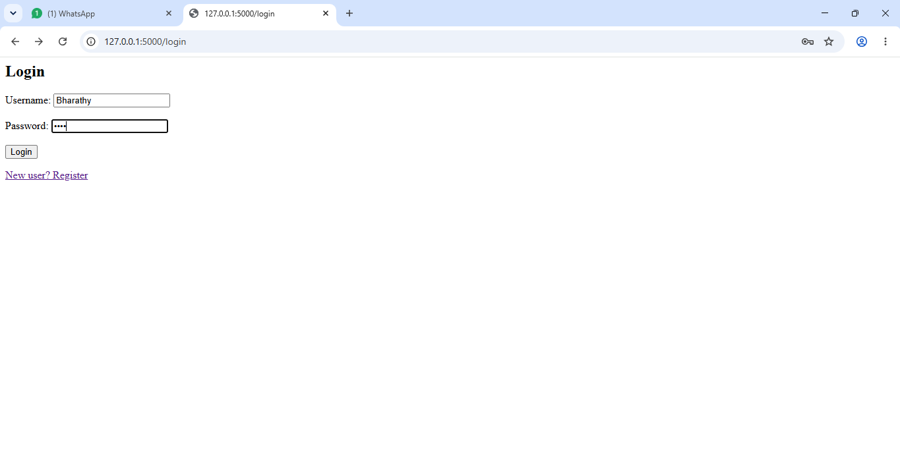
- Open Compass. Left side click mydb > users. Click Refresh button on top right. It will show username and password.


